Input Contribution
Meeting ID* | TP-38
Title:* | Use case: protocol selection in gateway for vehicle
Source:* | Joonyoung Kim, Hyundai Motors, jkim@hyundai.com  Minbyeong Lee, Hyundai Motors, minbyeong.lee@hyundai.com  Youngjin Na, Hyundai Motors, yjra@hyundai.com
Date:* | 2018-11-26
Input related to* | TR-0026, Adding new use cases about Use case: protocol selection in gateway for vehicle
Intended purpose of  document:* | Decision  Discussion  Information  Other <specify>
Impacted other TS/TR(s)
Decision requested or recommendation:* | Add new case of Use case: protocol selection in gateway for vehicle to TR-0026.
Template Version: January 2017 (Do not modify)

oneM2M Notice
The document to which this cover statement is attached is submitted to oneM2M. Participation in, or attendance at, any activity of oneM2M, constitutes acceptance of and agreement to be bound by terms of the Working Procedures and the Partnership Agreement, including the Intellectual Property Rights (IPR) Principles Governing oneM2M Work found in Annex 1 of the Partnership Agreement.

6.x Protocol Gateway Selection for Vehicle

6.x.1 Description
Vehicle has many different communication and application interface protocols to communicate with external platforms. Throughout physical layers to application layers, vehicle has different characteristics as compared to conventional devices like smartphone and small Internet of Things (IoT) devices. First of all, vehicle must assure its security due to the fact that the first priority of the vehicle is to offer transportation capability. Any defection in the vehicle can cause human injury or casualty even in very small malfunction in the vehicle. In addition, vehicle has to assure that it can operate under any weather, traffic circumstance such as rainy/snowy weather, high speed/temperature situations. In order to handle all of those, vehicle must have capabilities of environmental endurance and, especially, adaptive communication abilities.
In order to adaptively change communication modules and guarantee its own security, it is reasonable that vehicle needs to apply multiple different interface protocols to communicate with external services and application. To secure the vehicles from hackers and intruders, the vehicle also needs a gateway system that handles traffic condition between services and vehicles, and prevents hacking intrusion attacks towards vehicles. Its overall structure is shown on Figure 1.
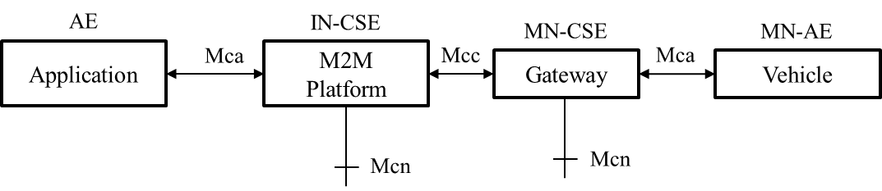
Figure 6.XX.1: Example oneM2M Structure of Protocol Selection in Gateway for Vehicle

Figure 1 shows the connection between applications and vehicles. Once the application is connected to the platform, the application sends information through platforms and gateway for the vehicle. Note that the vehicle has no prior-information about application, and vehicle initializes an agreement of protocol selection with the gateway.
However, some of the services need constant streaming and pre-selected protocol may not be sufficient to communicate between applications and vehicle. In addition, if the traffic cost becomes a matter to maintain infrastructure, high data rate protocol can result the high cost of operation and management. In order to resolve the issues, M2M platform may need to adaptively select suitable protocols based on the throughput rate from application. We have two scenarios for this.
1. Music streaming case
In case of music streaming, streaming connection has to be constant and persistent. If the protocol supports only TCP, it is not suitable for streaming cases since the quality of service is not determined by guaranteed receives. In that case, the protocol needs to switch from TCP to UDP.
2. Home monitoring case
Home monitoring case is also another case that intrusion recording has to be sent to the vehicle. If the protocol does not sufficiently support to transmit large quantity of data such as GSM network, it has to switch to 3G or LTE. Note that the type of data can be any kind of format including binary data.

6.x.2 Source
REQ-2018-00XX- Protocol selection in gateway for vehicle

6.x.3 Actors
- Vehicle
Vehicle is a MN-CSE monitored by M2M System. It is equipped with a telecommunication unit as a form of modem hardware. (E.g. 3G, LTE modem).
- Application
Application is the IN-AE monitored by IN-CSE. This application provides services for the vehicle. Note that this application can be various from chatting to video streaming.
- Gateway
Gateway is the collection of protocols saved for vehicle communication. Note that the protocol can be updated and other protocol can be applicable when the vehicle has the capability of doing that.
- M2M Platform
In charge of providing common functionalities for the M2M services.

6.x.4 Pre-conditions
- Vehicle must contain communicative modules that externally connect to other platforms.
- Vehicle must be capable of updating protocols.
- Vehicle must be connected to the gateway for communication.

6.x.5 Triggers
- None.

6.x.6 Normal Flow

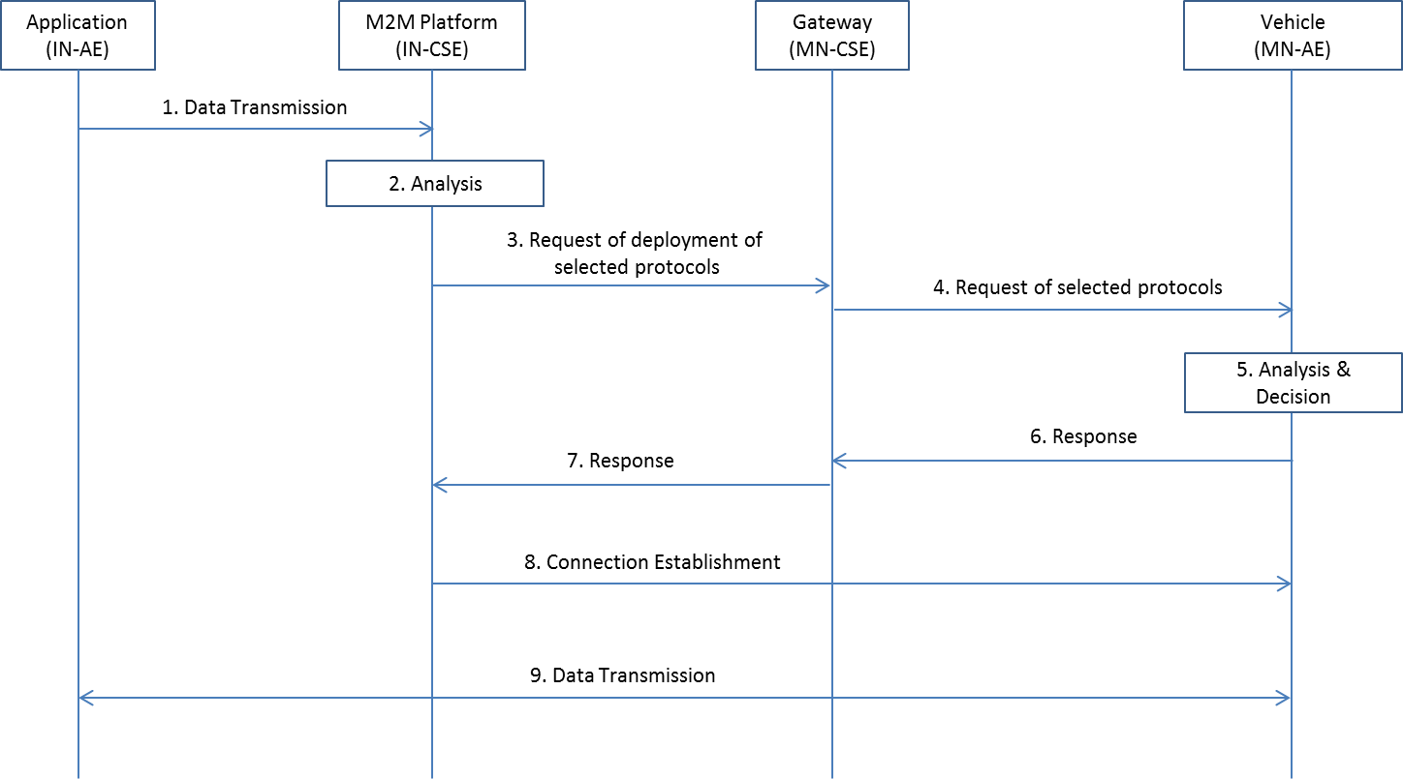
Figure 6.XX.2: Normal Flow – SDR Application for Vehicle
- Once Application is connected to M2M Platform, it sends the data.
- After M2M Platform receives the data, it analyses headers, data types and anticipated throughput rate of it. Based on the analysis result, it determines the optimal protocol in the gateway.
- M2M platform sends the request to the gateway for deployment of selected protocols.
- Gateway sends the request of select protocols to establish the new connection of selected protocols
- Vehicle analyses the request, and decide the usage of selected protocols.
- Once the decision is made, the vehicle sends the response to the gateway for the decision of the protocols.
- Gateway responses to M2M platform for the usage of protocols.
- M2M platform establishes the new protocol connection to the vehicle
- Once the connection is established, application streams the data to the vehicle.

6.x.7 Alternative Flow
None

6.x.8 Post-conditions
None

6.x.9 High Level Illustration

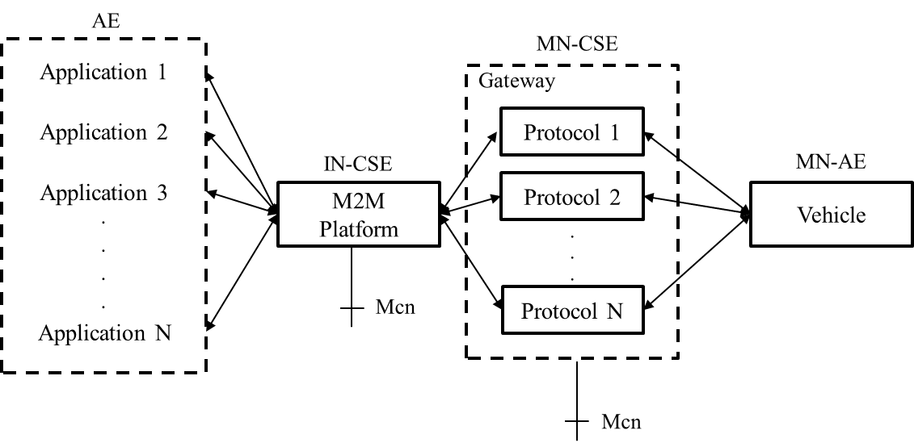
Figure 6.XX.3: High Level Illustration – Vehicle Remote Control using External Platform

6.x.10 Potential requirements
1) The oneM2M System shall support the selection capability of communication protocol between MN-AE and MN-CSE.
2) The oneM2M System shall enable CSE to establish multiple protocols to devices for sustainable device connection.
3) The oneM2M System shall support management and configuration of protocols in CSE for sustainable device connection.
.

