Input Contribution
Meeting ID* | TP-38
Title:* | Use case: Software-defined radios (SDR) application for vehicle
Source:* | Joonyoung Kim, Hyundai Motors, jkim@hyundai.com
Date:* | 2018-12-06
Input related to* | TR-0026, Adding new use cases about Software-defined radios (SDR) application for vehicle
Intended purpose of  document:* | Decision  Discussion  Information  Other <specify>
Impacted other TS/TR(s)
Decision requested or recommendation:* | Add new case of Software-defined radios (SDR) application for vehicle to TR-0026.
Template Version: January 2017 (Do not modify)

oneM2M Notice
The document to which this cover statement is attached is submitted to oneM2M. Participation in, or attendance at, any activity of oneM2M, constitutes acceptance of and agreement to be bound by terms of the Working Procedures and the Partnership Agreement, including the Intellectual Property Rights (IPR) Principles Governing oneM2M Work found in Annex 1 of the Partnership Agreement.

6.x Software-Defined Radios Application for Vehicle

6.x.1 Description
Software Defined Radio (SDR) is the radio device that can be updated by software packages for their internal radio module such as modulation, sampling rate, frequency shifting, and so on. By doing this, the radio can secure their flexibility encompassing a wide range of radio techniques, and adaptability given their circumstances including underground, tunnel, or heavy network traffic condition.
Since the vehicle radio standard becomes various and costly to apply in a form of hardware, there is a need for a radio module that can handle various radio techniques. SDR is able to be one of the solutions for that. However, we have to overcome a few obstacles before implementing SDR in the vehicle.
At first, the concept of SDR is to develop the communication modules as software packages, and the range of modules does not include radio front-end, such as antenna, carrier frequency oscillators, and maximum sampling rate. This hardware limitation has to be considered before applying SDR. However, most of mobile and vehicle communication standards such as LTE, V2X, WAVE, do not require excessive performance of hardware as compared to current hardware level. It means existing hardware still can deal with those communication standards.
Other obstacle is for the software update and switch. An SDR module in the radio has to be adaptive given situations, and the radios need to update or switch their communication modules by changing their radio software packages. In other words, unless certain triggering is made from base centres or the radio itself, the SDR module will not make any change at all.
In order to overcome this situation, we write use cases of the vehicle where the mounted SDR module is updated given certain network situation. In this case, we have two specific scenarios, and the whole structure is shown on figure 6.xx.1.

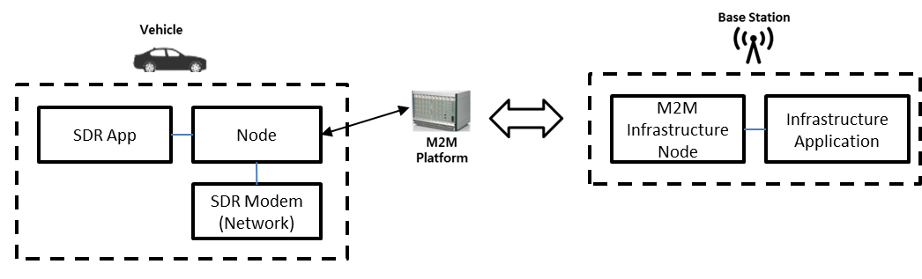
Figure 6.xx.1: Example Structure of SDR Application for Vehicle
1. Heavy network situation
In case of vehicle populated area, the situation of specific communication traffics can be very crowded, and it often causes network congestion and shutdown in the worst case. In order to avoid that situation, the vehicle should be able to distribute their traffic to other communication systems so that the network traffic can be eased and sustained. In that case,
i) Vehicle receives the network traffic condition, and determines the standard by analysing the throughput rate and spectrum condition
ii) Once it is determined, the vehicle decides to update software of SDR module to that standard in the vehicle. After update, the vehicle re-confirms the software update to make sure it is the right version.
iii) After re-confirmation, it communicates with M2M platform and notify about its change of SDR software and M2M platform notifies that to M2M infrastructure.

2. Limited infrastructure situation
In some rural and no-populated area, the lack of infrastructure can disconnect the vehicle communication at all. The desert or agricultural fields are the prime examples of very few infrastructures. To solve this problem, other communication system such as EDGE or satellite communication, can be options for that situation.
i) Vehicle receives the network traffic condition, and determines how many base stations and infrastructure existed in that area.
ii) Once it is determined, the vehicle decides the viable standard that has maximum base station near around the vehicle, and sends the software update requests to SDR module in the vehicle. After update, the vehicle re-confirms the software update to make sure it is the right version.
iii) After re-confirmation, it communicates with M2M platform and notify about its change of SDR software and M2M platform notifies that to M2M infrastructure.

To handle both cases, M2M platform reserves the trigger to either switch or update software of the network. When the M2M platform sends the trigger to the vehicle, the vehicle determines the types of triggers, and starts to switch to the different communication systems or request the new software for the vehicle. Note that once the new software request has to be one of the software packages existed in the M2M platform database.

6.x.2 Source
REQ-2018-0090R02- Use case: Software Defined Radio Application for Vehicle

6.x.3 Actors
- Vehicle
Vehicle is an entity monitored by M2M System. It is equipped with a telecommunication unit as a form of modem hardware. (E.g. 3G, LTE modem).
- Software-Defined Radio (SDR) application
SDR application is the application monitored by the middle node in the vehicle. This application handles the update and switch of communication systems of the vehicle. Note that low-level firmware is updated to the underlying network entity through Mcn and this software is connected to the firmware for the communication.
- M2M Infrastructure
In charge of providing common functionalities for the M2M services.
- M2M Service Platform
In charge of providing common functionalities for the M2M services.

6.x.4 Pre-conditions
- Vehicle must contain communicative modules that externally connect to other platforms.
- Vehicle must be capable of updating software of the device.
- Vehicle must verify that the software which is about to be updated has no risk of hacking from outbound.
- Vehicle must contain service entity, network entity and application entity for software update.

6.x.5 Triggers
None.

6.x.6 Normal Flow

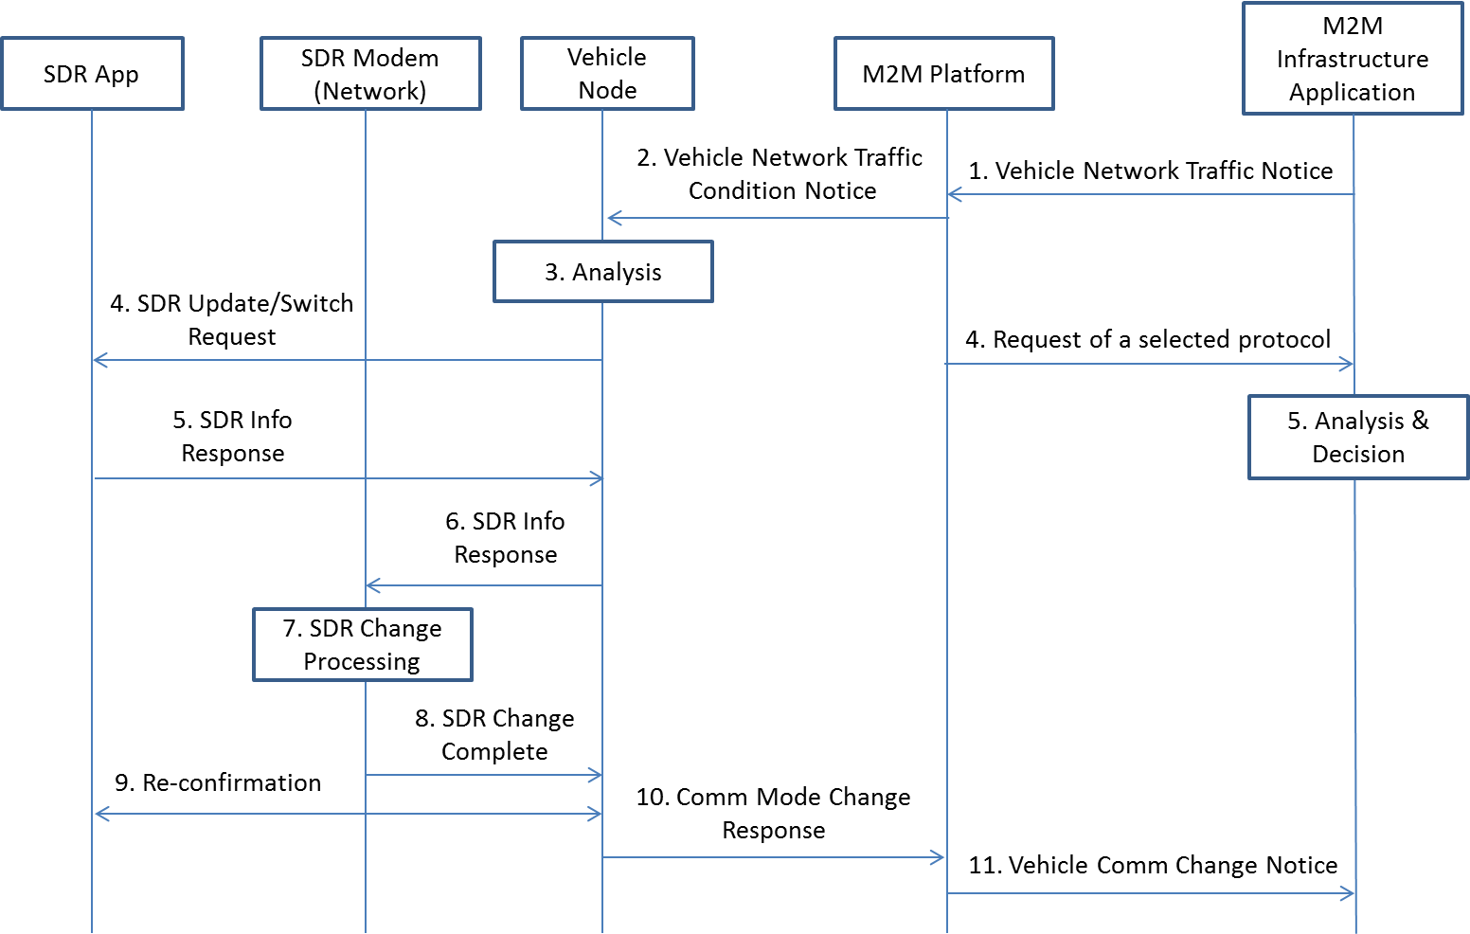
Figure 6.xx.2: Normal Flow – SDR Application for Vehicle
- M2M Infrastructure sends the vehicle network traffic notice to M2M platform if there is any significant change happens.
- M2M platform sends a traffic condition notice of vehicle network to the vehicle node in vehicle.
- Using the information in the notice, the vehicle node in vehicle conducts the analysis to decide the software update of SDR module in the vehicle.
- If decided, the node sends the requests of SDR update/switch to SDR application for the change.
- SDR application sends a response with SDR info including SDR version and types to the node.
- The vehicle node sends the request to SDR Modem (Network) for SDR change.
- Once SDR Modem (Network) receives the request, it processes SDR changes.
- After change is completed, SDR Modem (Network) sends the completion response to the node.
- The vehicle node notifies SDR application and SDR application feedbacks with re-confirmation response.
- The vehicle node in vehicle sends the response to the M2M platform for communication node change.
- M2M platform sends the response to M2M infrastructure about the communication module situation of the vehicle node in the vehicle.

6.x.7 Alternative Flow
None

6.x.8 Post-conditions
None

6.x.9 High Level Illustration

Figure 6.XX.3: High Level Illustration – SDR Application for Vehicle

6.x.10 Potential requirements
1) The oneM2M System shall support the management and configuration of software module in network entity settings for device control and communication
2) The oneM2M System shall support methods for managing and configuring the change of the underlying network interfaces.

