CHANGE REQUEST
Group Name:* | TP#15
Source:* | Seongyoon Kim, LG Electronics, seongyoon.kim@lge.com
Format:* | Plenary
Date:* | 2015-01-22
Contact:* | seongyoon.kim@lge.com
Reason for Change/s:* | Editorial Chages Figures
CR against: Release* | Release 1
CR against: TS/TR* | TS-0003 v0.8.1
Clauses/Sub Clauses*
Type of change: * | Editorial change  Bug Fix or Correction  Change/correction to existing feature or functionality  New feature or functionality
Post Freeze checking:* | This CR contains only essential changes and corrections  YES NO

oneM2M Notice
The document to which this cover statement is attached is submitted to oneM2M. Participation in, or attendance at, any activity of oneM2M, constitutes acceptance of and agreement to be bound by terms of the Working Procedures and the Partnership Agreement, including the Intellectual Property Rights (IPR) Principles Governing oneM2M Work found in Annex 1 of the Partnership Agreement.

Introduction
This contribution contains editorial changes for 2 figures: 8.3.1.2-1 and 8.3.2.1-1.
8.3.1.2-1: Kee → Kpm
8.3.2.1-1: Krp → Kpm

-----------------------Start of change 1-------------------------------------------

8.3.1.2 Overview on Remote Security Provisioning Frameworks
An AE or CSE that requires remote provisioning of a Master Credential and Master Credential Identifier or a Provisioned Secure Connection Key (Kpsa) and Provisioned Secure Connection Key Identifier (KpsaId) is called an Enrolee. The AE or CSE with whom the enrolee is to establish a security association is called Enrolee B. The AE or CSE or M2M Authentication Function with whom the enrolee is to establish a shared key is called an Enrolment Target.
The oneM2M system supports the following Security Bootstrap Frameworks:
- Pre-Provisioned Symmetric Enrolee Key Remote Security Provisioning Framework: A symmetric key is pre-provisioned to the Enrolee and M2M Enrolment Function for the mutually authentication of those entities. For more details, see clause 8.3.2.1.
- Certificate-Based Remote Security Provisioning Framework: The Enrolee and M2M Enrolment Function are each issued with
- a Private Signing Key that is known only to that entity,
- a Certificate containing the corresponding Public Verification Key, and
- (In the case of a device certificate, CSE-ID certificate or AE-ID certificate) a Certificate Chain from the entity's Certificate to a Trust Anchor Certificate.
The Enrolee and M2M Enrolment Function shall validate each other's Certificate before trusting the Public Verification Keys in the Certificate. Within the Security Handshake, the M2M Enrolment Function creates a digital signature of the session parameters using its private signing key and the Enrolee verifies the digital signature using the M2M Enrolment Function's public verification key. Then the roles are reversed: the Enrolee creates a digital signature and the M2M Enrolment Function verifies it. For more details see clause 8.3.2.2.
- GBA-based Remote Security Provisioning Framework. In this case, the role of the M2M Enrolment Function is performed by a GBA Bootstrap Server Function. This framework uses 3GPP or 3GPP2 symmetric keys to authenticate the Enrolee and the M2M Enrolment Function (which is also a GBA BSF). The details are specified by 3GPP [13] and 3GPP2 [14]. For more details see clause 8.3.2.3.
For a more detailed description of the above Remote Security Provisioning Frameworks, it is useful to compare the following aspects of the Remote Security Provisioning Frameworks.
- Bootstrap Credential Configuration: The Enrolee and M2M Enrolment Function are pre-provisioned with the Bootstrap Credential that the entity will use to authenticate itself to the other entity. The mechanisms for this pre-provisioning are not described in this specification.
- Bootstrap Instruction Configuration: The Enrolee and M2M Enrolment Function are provided with
- Either the M2M Authentication Function Identifier (MAF-ID) identifying the M2M Authentication Function for which the Enrolee is to be remotely provisioned when used in conjunction with a MAF-based security association establishment framework; or the identifier of Enrolee B (Enrolee B-ID), when used in conjunction with a Provisioned Symmetric Key Security Association Establishment.
NOTE 1: The identity of the M2M Authentication Function or the Enrolee B is assumed to have been configured prior to the Bootstrap Instruction Configuration phase.
- The M2M Enrolment Function is provided with the CSE-ID or AE-ID that the M2M Authentication Function or Enrolee B is to associate with the Enrolee.
Additionally, in the case of Certificate-Based Remote Security Provisioning Framework:
- The Enrolee is configured with the M2M Enrolment Function URI (for the purpose of routing the (D)TLS messages to the M2M Enrolment Function), M2M Enrolment Function Certificate Name and M2M Enrolment Function Trust Anchor Certificatesthat the Enrolee will use to verify the M2M Enrolment Function.
- The M2M Enrolment Function is configured with the Enrolee Certificate Name and Enrolee Root of Trust that the M2M Enrolment Function will use to verify the Enrolee.
- Bootstrap Enrolment Handshake: Identification, authentication and security context establishment between the Enrolee and M2M Enrolment Function.
- Enrolment Key Generation: generating a symmetric Enrolment Key,(Ke) and corresponding Enrolment Key Identifier (KeId) shared by the Enrolee and M2M Enrolment Function, which is used for subsequent generation of the Master Credential (Km) or Provisioned M2M Symmetric Key (Kpsa).
- Integration to the Association Security Handshake:
For MAF-based symmetric Key Security Association, the following steps occur during the MAF Handshake of the MAF-Based Security Association Establishment:
- The Enrolee derives the Master Credential (Km) from the Enrolment Key (Ke) and M2M Authentication Function Identifier (MAF-ID). Details of the derivation are provided in clause 9.4.
- The Enrolee generates the Master Credential Identifier (KmId) from Master Credential (Km) as described in clause 9.1, and stores Km and KmId.
- The Enrolee passes the Enrolment Key Identifier (KeId) to the M2M Authentication Function (see "MAF Handshake" in clause 8.2.2.3)
NOTE 2: When the Enrolee first communicates with the M2M Authentication Function, then the M2M Authentication Function has not yet retrieved the Km from the M2M Enrolment Function. Consequently, the Enrolee provides the KeId to the M2M Authentication function, which is then passed to the M2M Enrolment Function to identify the Enrolment Key. The M2M Enrolment Function then returns the Km from which the M2M Authentication Function can derive the KmId. In subsequent Security Establishments, the Enrolee may provide the KmId or the KeId, and the M2M Authentication Function will know that both identifiers indicate the retrieved Km. For more details, see "MAF Handshake" in clause 8.2.2.3.
- Upon receipt of the KeId, the M2M Authentication Function determines if it already has the corresponding Km and CSE-ID or AE-ID of the Enrolee
- If the M2M Authentication Function already has the corresponding Km and CSE-ID or AE-ID of the Enrolee, then the Km is used for mutual authentication (see "MAF Handshake" in clause 8.2.2.3)
- If the M2M Authentication Function does not have the corresponding Master Credential (Km) and CSE-ID or AE-ID of the Enrolee, then the following steps are followed.
- The M2M Authentication Function (securely) passes the KeId to the M2M Enrolment Function, along with the M2M Authentication Function's URI.
- The M2M Authentication Function initiates establishing a mutually-authenticated TLS Session with the M2M Enrolment Function.
      - The M2M Authentication Function authenticates itself to the M2M Enrolment Function using an FQDN certificate containing the FQDN of the M2M Authentication Function.
      - The M2M Enrolment Function authenticates itself to the M2M Authentication Function using an FQDN certificate containing the FQDN of the M2M Enrolment Function.
- The M2M Enrolment Function derives the Km from the Ke and MAF-ID. Details of the derivation are provided in clause clause 10.3.2 “Derivation of Master Credential from Enrolment Key”.
- The M2M Enrolment Function returns the Km to the M2M Authentication Function. The M2M Enrolment Function also passes the CSE-ID or AE-ID of the Enrolee.
- The M2M Authentication Function generates the Master Credential Identifier (KmId) from Master Credential (Km) as described in clause 9.1, and stores Km and KmId.
- The Master Credential (Km) is used for mutual authentication and generation of Kc and KcId as described in MAF-Based Security Association Establishment Framework (see "MAF Handshake" in clause 8.2.2.3).
- The Enrolee and M2M Authentication Function set Master Credential Identifier (KmId) to the value of the Enrolment Key Identifier (KeId).
- The Enrolee and M2M Authentication Function store Km and KmId.
For Provisioned Symmetric Key Security Association Establishment, similar procedure applies where Enrolee B plays the role of M2M Authentication Function, Kpsa plays the role of Km, KpsaId is generated instead of KmId. Generation of Kpsa is described in 10.3.3 “Derivation of Provisioned Secure Connection Key from Enrolment Key”.

Figure 8.3.1.2-1 provides a summary of the above defined Remote Security Provisioning Frameworks.

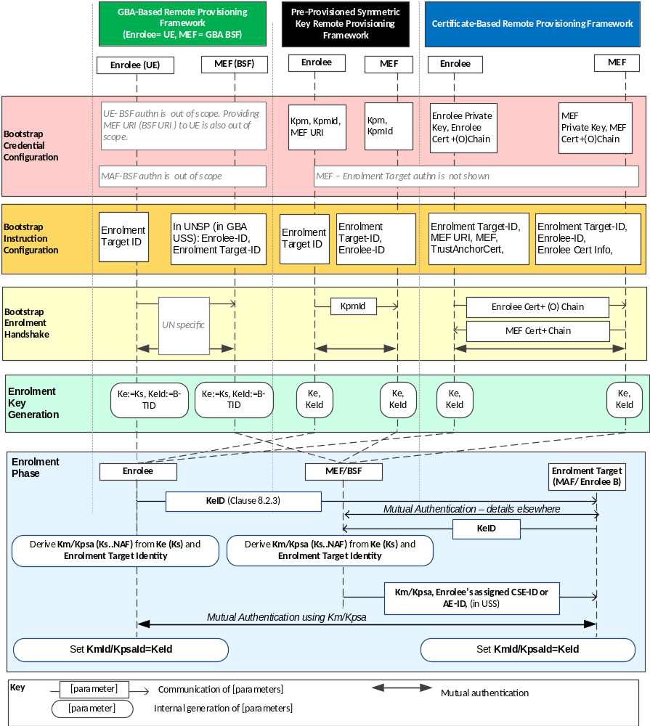
Figure 8.3.1.2-1: Overview of the Remote Security Provisioning Frameworks supported by oneM2M

8.3.2 Detailed Remote Security Provisioning Framework

8.3.2.1 Pre-Provisioned Symmetric Key Remote Security Provisioning Framework
This clause describes the Pre-Provisioned Symmetric Key Remote Security Provisioning Framework. The Bootstrap Credential for this framework is a long-term symmetric key that has been pre-provisioned into the Enrolee and M2M Enrolment Function; this key is called a Pre-Provisioned Symmetric Enrolee Key and is denoted Kpm.
NOTE: Long term Pre-Provisioned Symmetric Enrolee Keys can pose a security risk if not adequately secured, and for this reason it is recommended that Long term Pre-Provisioned Symmetric Enrolee Keys are stored in Secure Environments.
Figure 8.3.2.1-1 illustrates the sequence of events when using the Pre-Provisioned Symmetric Enrolee Key Remote Security Provisioning Framework.

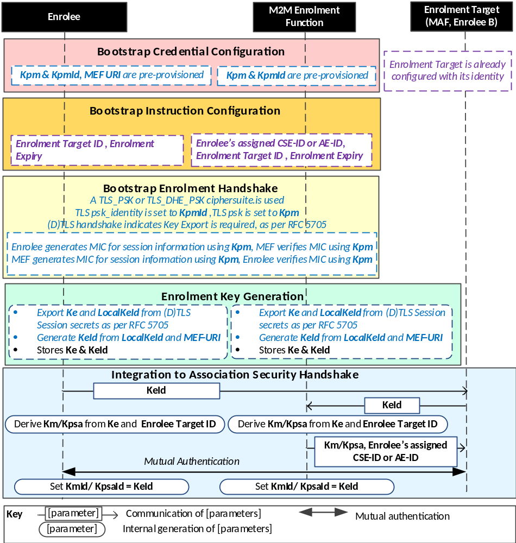
NOTE: The following font colours differentiate the general topic that the text relates to:
Black text contains Remote Security Provisioning-Framework-independent details
Blue italic text highlights details specific to this particular Remote Security Provisioning Framework.
Purple italic text highlights technical actions that may include steps not specified by oneM2M.

Figure 8.3.2.1-1: The sequence of events when using
the Pre-Provisioned Symmetric Key Remote Security Provisioning Framework
Bootstrap Credential Configuration: The Pre-Provisioned Symmetric Enrolee Key (Kpm) and the corresponding Pre-Provisioned Symmetric Enrolee Key Identifier, denoted KpmId, are pre-provisioned to both entities. The Enrolee is also provisioned with the M2M Enrolment Function's URI (MEF URI), for the purpose of routing the (D)TLS exchange.
NOTE 1: This pre-provisioning (by definition) uses mechanisms not specified by oneM2M.
Bootstrap Instruction Configuration: The Enrolee and M2M Enrolment Function are configured with the information needed for authorizing the remote provisioning:
- The Enrolee is configured with (or otherwise obtains) the following arguments to initiate remote provisioning :
- The Enrolment Target identity: Identifying the Enrolment Target for which the Enrolee is to be provisioned.
- The Enrolee associates these arguments with the M2M Enrolment Function. The M2M Enrolment Function can be identified to the Enrolee using the Pre-Provisioned Symmetric Enrolee Key Identifier (KpmId) or the M2M Enrolment Function URI.
- M2M Enrolment Function is configured with the following arguments to authorize the M2M Enrolment Function to remotely provision the Enrolee for an Enrolment Target:
- The Enrolment Target Identity: Identifying the Enrolment Target for which the Enrolee is to be provisioned.
- Enrolee’s assigned CSE-ID or AE-ID (Enrolee-ID). The M2M Enrolment Function is to provide this entity identity for the Enrolee with the Km or Kpsa to the Enrolment Target, when requested by the Enrolment Target.
- The M2M Enrolment Function associates these arguments with an Enrolee. The Enrolee can be identified to the M2M Enrolment Function using the Pre-Provisioned Symmetric Enrolee Key Identifier (KpmId).
Bootstrap Security Handshake: The Enrolee and M2M Enrolment Function perform a (D)TLS-PSK handshake [15] to establish a secure session.
- The "psk_identity" parameter [15] is set to the value of the Pre-Provisioned Symmetric Enrolee Key Identifier (KpmId).
- The "psk" parameter [15] is set to the value of the Pre-Provisioned Symmetric Enrolee Key (Kpm).
- The (D)TLS cipher suite profile for this ’s assigned CSE-ID or AE-ID is specified in clause 10.2.2 “TLS and DTLS Ciphersuites for TLS-PSK-Based Security Frameworks”.
Enrolment Key Generation:
- The Enrolment Key (Ke) and RelativeKeId is generated from the (D)TLS session secrets by the Enrolee and M2M Enrolment Function using TLS Key Export (RFC 5705) [18], as described in clause 10.3.1 “TLS Key Export Details”.
- The Enrolment Key Identifier (KeId) is generated from the RelativeKeId and the M2M Enrolment Function’s FQDN by the Enrolee and M2M Enrolment Function, as described in clause 10.3.4 “Generating KeId”.
- The Enrolee and M2M Enrolment Function store the Enrolment Key (Ke) and Enrolment Key Identifier (KeId).
NOTE 2: The Enrolment Key Generation for the Pre-Provisioned Symmetric Enrolee Key Remote Security Provisioning Framework is identical to the Enrolment Key Generation for the Certificate-Based Remote Security Provisioning Framework.
Integration to the Association Security Handshake: See "Overview of Remote Security Provisioning Frameworks" in clause 8.3.1.

-----------------------End of change 1-------------------------------------------

