CHANGE REQUEST
Meeting:* | SEC#19
Source:* | François Ennesser, Gemalto, francois.ennesser@gemalto.com
Date:* | 2015-08-31
Contact:* | As above
Reason for Change/s:* | This contribution proposes a review of existing frameworks (OAuth, UMA, OpenID Connect) worth considering .
CR against: Release* | 2
CR against: WI* | Active WI-0019  MNT Maintenace / < Work Item number(optional)>  STE Small Technical Enhancements / < Work Item number (optional)>  Only ONE of the above shall be ticked
CR against: TS/TR* | TR-0019 v0.0.3
Clauses/Sub Clauses* | Clause 6 (Introduction)
Type of change: * | Editorial change  Bug Fix or Correction  Change to existing feature or functionality  New feature or functionality  Only ONE of the above shall be ticked
Post Freeze checking:* | This CR contains only essential changes and corrections? YES NO  This CR is a mirror CR? YES NO if YES, please indicate the document number of the original CR:  <Document Number)<CR Number of the original CR to the current Release>
Template Version:23 February 2015 (Dot not modify)
oneM2M Notice
The document to which this cover statement is attached is submitted to oneM2M. Participation in, or attendance at, any activity of oneM2M, constitutes acceptance of and agreement to be bound by terms of the Working Procedures and the Partnership Agreement, including the Intellectual Property Rights (IPR) Principles Governing oneM2M Work found in Annex 1 of the Partnership Agreement.

Introduction
This contribution proposes

-----------------------Start of change 1-------------------------------------------

6 High Level Architecture

6.1 Review of existing frameworks

Note : Materials in this section are inspired from deliverables developed under European Projects SITAC and SUNSEED.

6.1.1 OAuth 2.0

OAuth 2.0[OAuth] is an authorization framework that aims to provide a secure way to allow third-party applications to get access to data on behalf of resource owners through a set of defined request flows. The main purpose of OAuth is to enable the user (resource owner, RO) to grant services and applications (client) access to protected resources stored at a resource server (RS), without sharing user credentials with the application. Instead of using the resource owner's credentials to access protected resources, the client gets an access token. Access tokens are issued to third-party clients by an authorization server (AS) after the approval of the issuance by the resource owner.
This protocol is widely used in the web today, primarily to allow users to register/log in into web platforms using their pre-existing credentials from well-known identity providers, but cannot be directly applied in M2M / IoT scenario. To make it suitable to oneM2M requirements, the main issues that have to be addressed are:
- OAuth-defined flows assume that the user has to operate the third party service that she is authorizing. In oneM2M scenario, in contrast, the user operating the service that requests access to a resource, may not be its owner.
- OAuth resource servers and scopes have to be defined at design time. However, in a distributed IoT architecture where services are deployed by end users at any time, a dynamic registration of resource servers is required to be able to introduce new objects in the oneM2M model.
- The control of user privacy resides on the AS, which is a centralized point in the OAuth architecture. Although OAuth does not prevent to deploy multiple authorization servers, it is a topic not covered in the protocol specification, which raises many issues when using the standard “out-of-the-box” (e.g. authorization servers discovery, how to bind a resource server with a specific AS).
As discussed earlier, the resource owner is the source in all OAuth flows. The whole protocol is designed around that assumption. On the contrary, in IoT scenario, users may be requesting access to resources that they do not own. As a consequence of that, OAuth alone cannot be used to support all oneM2M use cases.
Regarding the third issue described, it could be argued that OAuth also provides ways to deploy distributed authorization schemes. However, it is very focused on resource-owner driven scenario and most of the existing implementations are mainly focused on the register/log in use case. In spite of that, OAuth, because of is extensibility, can be used to accommodate additional requirements.

6.1.2 User Managed Access (UMA)
User-Managed Access [UMA] is a profile of the OAuth 2.0 protocol that is intended to encompass the scenario where a resource owner wants to manage the access control to protected resources by clients operated by requesting parties, other than the resource owner. While the OAuth specification is focused on Alice-to-client sharing model, UMA focuses on Alice-to-Bob sharing model, where Alice can share proactively her resources before Bob even knows they exist. In addition, Bob may request a permission. In that case, a notification will be sent to Alice for her to decide whether she wants to grant access to Bob. Alice will collect these requirements from the AS.
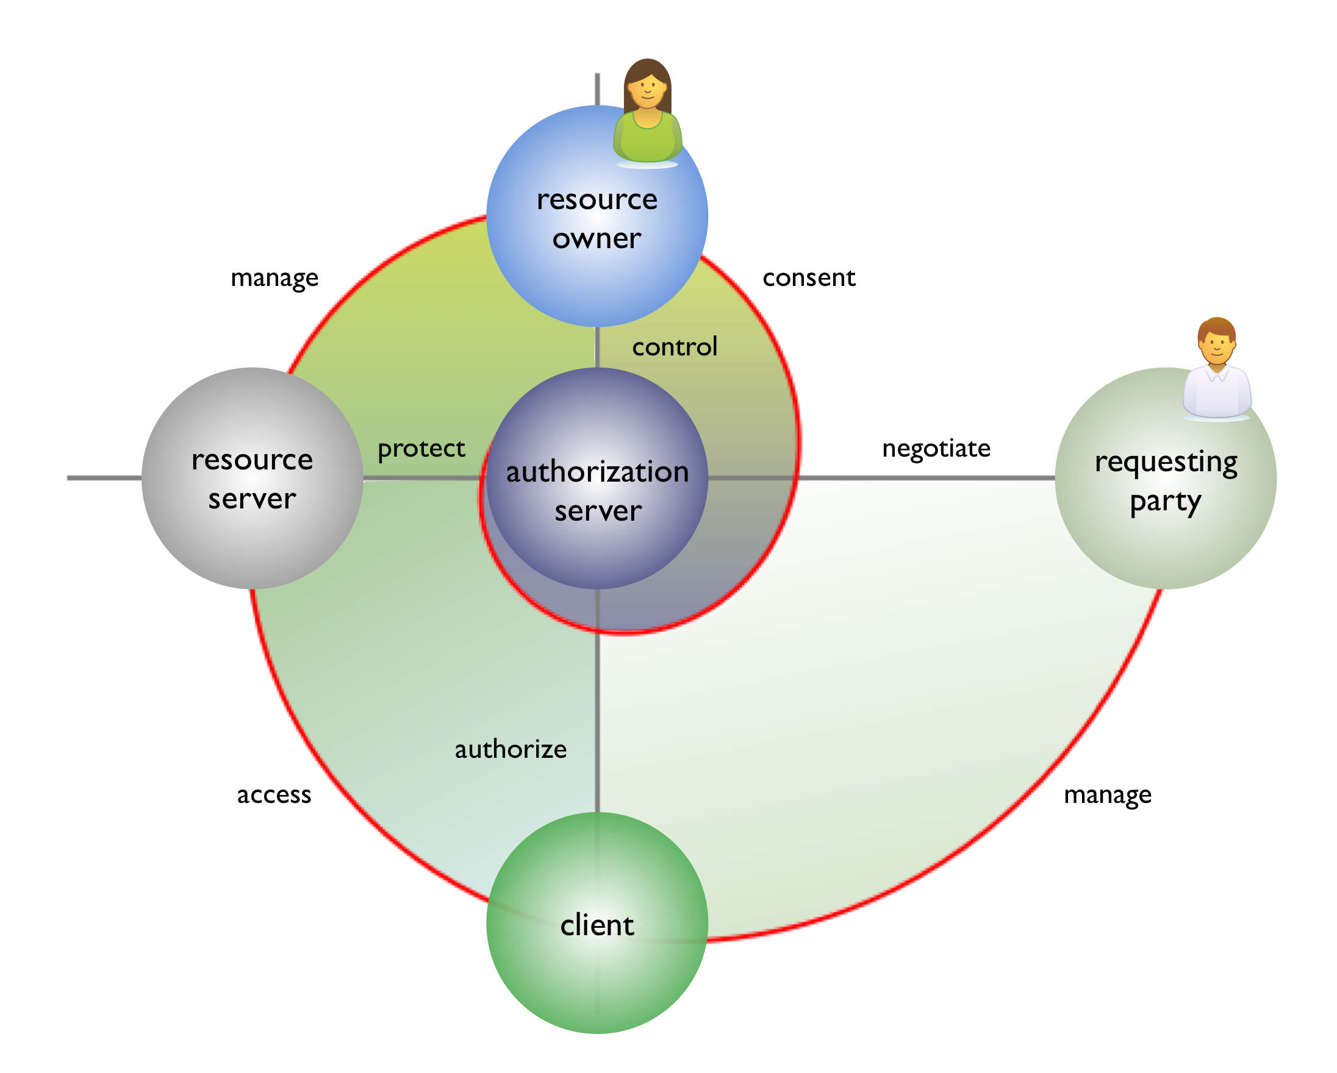
Figure 6.1.2-1 : UMA actors and architecture
To achieve this, UMA defines new roles and interactions on top of OAuth as illustrated in Figure 6.1.2-1. Moreover, the roles defined in OAuth specification are slightly changed to accomplish UMA's objectives. From the UMA viewpoint, RS are clients for the AS, effectively decoupling RS and AS roles. In UMA, an RS can choose the AS where he wants to delegate the authorization. It is important to stress the point that no previous relationship between them is required. The other main difference is the introduction of the requesting party role. A requesting party is an entity that seeks access to a protected resource and may be different to the RO. The whole point of the introduction of this new role is to be able to distinguish between resource owner and resource consumer. Therefore, the RO can share his resources preserving the control over them, while any requesting party other than the resource owner should either request access to the resource or access directly, provided that it has been granted access beforehand.
UMA defines the set of interactions that have to be performed before a requesting party can access a resource. This interactions can be grouped in three phases: protecting a resource, getting access permission for a resource and accessing a resource. UMA is focused on access control management and does not specify data access protocols.
The capability to control access to resources at the action level is referred in this document as “fine grain authorization capability”. Figure 6.1.2-1 shows a resource server holding resources owned by a resource owner. Those resources may need to be accessed by a requesting party using a client application software, e.g. a oneM2M AE operating on its behalf . The administration of the access control to the resources may be cumbersome or difficult in the case where the resource owner owns multiple resources spread among multiple resource servers, because this administration task has to be performed in multiple places. This is where UMA can help, by enabling each resource server to delegate the administration to some or all of the resources it controls on behalf of the resource owner to a separate authorization server. This is done in a first phase by having the resource server register with the authorization server all resources the administration of which it wishes to delegate. In a second step, the client software acting on behalf of the requesting party will negotiate access to the resource with the authorization server. A successful negotiation will result in the client being provided with a Requesting Party Token (RPT), which when presented to the resource server will enable access to the protected resource.
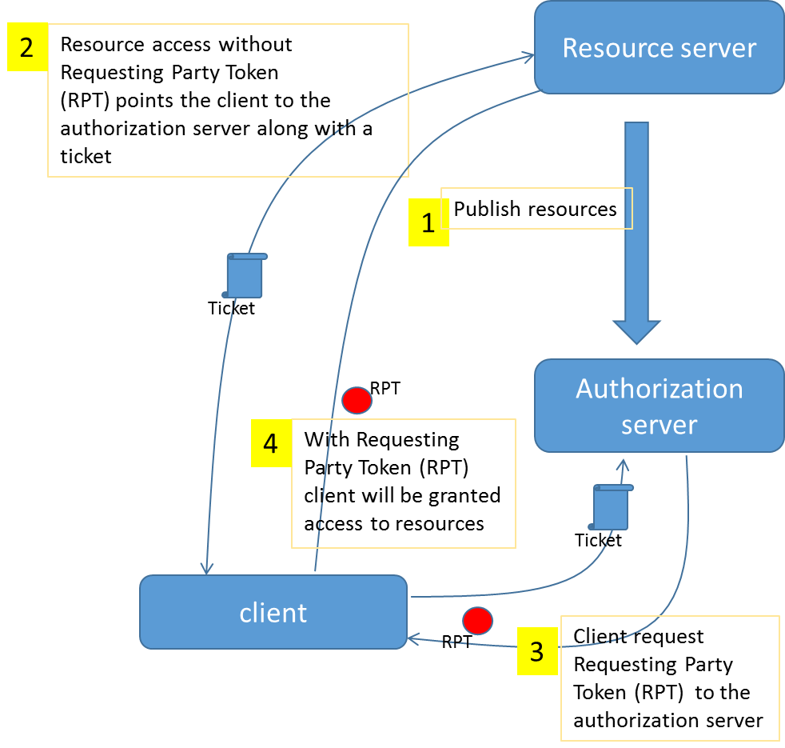

Figure 6.1.2-2 : UMA APIs and flow of operations

Figure 6.1.2-2 shows the different APIs and flows of operation involved in UMA.
In a preliminary phase not shown on this figure the resource server and the authorization server have bootstrapped their relationship and as a result of this the resource server has obtained the possibility to invoke a resource publication REST API exposed by the authorization server for publishing the description of the resources it wishes to place under the protection of the authorization server. (step1).
In step 2, the client attempts to access the resource in the resource server without presenting a requesting party token. It is then pointed to the authorization server and given an “authorization ticket” indicating what needs to be authorized. The list of actions needing to be authorized is described as an array of “scopes”. Upon authentication and check of the authorization policies, the authorization server delivers a Requesting Party Token (RPT) to the client (step 3). Finally, the client is granted access to the resource upon presentation of this token to the resource server (step4).
UMA offers many advantages for M2M / IoT scenarios, where users and organizations want to share their resources while keeping control both over the entities (friends, organizations, services, etc.) that have access to them and over the granularity of the information shared. This scenario can be modeled using UMA features, like resource registration and scope definition. Finally, due to the fact that the RS and the AS are decoupled in UMA, users can choose whom entity they want to delegate the access control of his resources, instead of binding them to a particular provider.
In a dynamic and distributed environment, the access control architecture must be flexible enough not only to accept new entities at any time but also to modify their roles. In the oneM2M ecosystem, users will register new resources when they want to share information, and therefore the architecture must be designed to allow new resource servers at runtime. While OAuth does not allow to introduce new resource servers, UMA is able to handle this case.

6.1.3 OpenID Connect
OpenID Connect [OpenID] represents another extension of OAuth 2.0 protocol, it is focused on the use case of sharing the end-user identity with clients. This use case is usually implemented through OAuth by giving applications an access token that allows them to get information of the user. It is often seen as an “Authorization over my identity” while, in essence, it represents an authentication process. OpenID Connect tries to address this use case and simplifies the protocol flow while preserving extensibility and compatibility with different identity providers.
As oneM2M needs to manage different sources of user identities, OpenID Connect is a good candidate to accomplish this task. UMA can also be integrated with OpenID Connect. While UMA does not enforce the use of unique identifiers in the Authorization Server, unique identifiers are required for access control policies. In this case, the end-user will authorize the AS to query an identity endpoint for their unique (or non-unique) identity data.

----------------End of change 1---------------------------------------------

-----------------------Start of Changes to References Section -------------

2.2 Informative references
Clause 2.2 shall only contain informative references which are cited in the document itself.
The following referenced documents are not necessary for the application of the present document but they assist the user with regard to a particular subject area.
[i.1] oneM2M Drafting Rules (http://member.onem2m.org/Static_pages/Others/Rules_Pages/oneM2M-Drafting-Rules-V1_0.doc)
[i.2] oneM2M TS-0001 “Functional Architecture”
[i.3] oneM2M TS-0003 “Security Solutions”
[i.4] oneM2M TS-0011 “Common Terminology”
[OAuth] IETF RFC 6749: “The OAuth 2.0 Authorization Framework”, 2012
[UMA] User Managed Access Profile of OAuth 2.0, draft-hardjono-oauth-umacore-13, http://tools.ietf.org/html/draft-hardjono-oauth-umacore-13
[OpenID] OpenId foundation. OpenID Connect Dynamic Client Registration 1.0. [Online]. http://openid.net/specs/openid-connect-registration-1_0.html

-----------------------End of Changes to References Section -------------

-Start of changes to Definitions Symbols Abbreviations Acronyms -

3 Definitions, symbols, abbreviations and acronyms

3.1 Definitions
For the purposes of the present document, the terms and definitions given in oneM2M TS-0011 [i.4], oneM2M TS-0003 [i.3] and the following apply:

3.2 Symbols
<symbol> <Explanation>

3.3 Abbreviations and Acronyms
For the purposes of the present document, the abbreviations given in oneM2M TS-0011 [i.4], oneM2M TS-0003 [i.3] and oneM2M TR-0012 [TR-0012] and the following apply:
AS Authorization Server
RO Resource Owner
RPT Requesting Party Token
RS Resource Server
UMA User Managed Access

---End of changes to Definitions, Symbols, Abbreviations, Acronyms ---

