Input Contribution
Meeting ID* | TP# 20 - SEC 20
Title:* | TR-0012_End_to_End_Data_Security_Proposal
Source:* | vinod.choyi@interdigital.com  dale.seed@interdigital.com
Uploaded Date:* | 2015-10-30
Document(s)  Impacted* | TR-0012
Intended purpose of  document:* | Decision  Discussion  Information  Other <specify>
Decision requested or recommendation:* | For discussion and decision to be included into TR-0012
Template Version:23 February 2015 (Dot not modify)

oneM2M Notice
The document to which this cover statement is attached is submitted to oneM2M. Participation in, or attendance at, any activity of oneM2M, constitutes acceptance of and agreement to be bound by terms of the Working Procedures and the Partnership Agreement, including the Intellectual Property Rights (IPR) Principles Governing oneM2M Work found in Annex 1 of the Partnership Agreement.

Introduction
This contribution proposes a detailed end-to-end data / content protection mechanisms when the data is hosted or in-transit between an originator and a consumer client application. It proposes a solution based on leveraging a security association between the originator of data and an M2M Trust Enabling Function (TEF) for credential generation and distribution.

---------------------------------------------------------------------------------------------------

2.2 Informative references
The following referenced documents are not necessary for the application of the present document but they assist the user with regard to a particular subject area.
[i.1] oneM2M Drafting Rules (http://member.onem2m.org/Static_pages/Others/Rules_Pages/oneM2M-Drafting-Rules-V1_0.doc)
[i.2] oneM2M TS-0001 “Functional Architecture”
[i.3] oneM2M TS-0003 “Security Solutions”
[i.4] oneM2M TS-0011 “Common Terminology”
[i.5] IETF RFC 7518: “JSON Web Algorithms (JWA)”, 2015
[i.6] IETF RFC 7526: “JSON Web Encryption (JWE)”, 2015
[i.7] IETF RFC 7527: “JSON Web Key (JWK)”, 2015
[i.8] IETF RFC 7525: “JSON Web Signature (JWS)”, 2015
[i.9] IETF RFC 5869: “HMAC-based Extract-and-Expand Key Derivation Function (HKDF)”, 2010

8.3.3 Bootstrapped procedure for providing data security

8.3.3.1 Overall Description
This section provides detailed description on mechanisms that can be employed for providing security of data both “at-rest” and “in-transit” in an end-to-end manner. If an entity (e.g. AE) has a trust relationship with an M2M Trust Enabling Function (TEF), then that trust can be leveraged in order to generate credentials for integrity / authenticity and or confidentiality of data. Here, the term “data” is used in a generic manner may represent an oneM2M resource, which may be a system resource (e.g. <mgmtObj>) resource or application generated data or instances of application generated data (e.g. <contentInstance>).
8.3.3.2 Detailed Description
Figure 8.3.3.2-1 illustrates a message between entities involved in data generation, data hosting, and generating credentials for data security as well consumer of protected data. The functional roles associated with each entity is further described below:

Originator (AE1):

Has a trust relationship with a M2M Trust Enabler Function (TEF) and associated credentials

Ability to generate data security-specific credentials based on a bootstrapping procedure with the TEF

Ability to request registration of Credential-Id with a TEF and associated ACPs

Generates protected (integrity and or encrypted) data or data instances (contentInstances) using the data-security-specific credentials

Has a trust relationship with a Hosting (HCSE) and establish a secure communications channel with the HCSE

Ability to request hosting of protected data onto a HCSE

Hosting CSE (HCSE):

Has a trust relationship with an Originator AE1 and also a separate trust relationship with Client application AE2 and associated credentials

Ability to process request by Originator AE1 for hosting of protected data and the ability to host protect data and data instances.

Ability to process a Retrieve request by a Client application AE2 for protected data or data instances

Trust Enabler Function (TEF):

Has a trust relationship with an Originator AE1 and also a separate trust relationship with Client application AE2 and associated credentials

Ability to process request by Originator AE1 for performing a bootstrapping process and generate data-security-specific credentials.

Ability to perform Credential-Id registration request from Originator AE1

Ability to process a Retrieve request by a Client application AE2 for data-security-specific credential(s)

Client (AE2):

Has a trust relationship with a M2M Trust Enabler Function (TEF) and associated credentials

Has a trust relationship with a HCSE and associated credentials in order to establish a secure connection with it.

Ability to request a “Retrieve” operation on protected data hosted on a HCSE

Ability to request “Retrieve” operation for credentials identified by a Credential-Id with a TEF

Ability to verify authenticity / integrity of data or data instances and or the ability to decrypt the data or data instances obtained from HCSE using the credentials that were retrieved from TEF.

The detailed messaging steps are provided below:
- The bootstrapping process described within TS-0003 (Release 1) specifications is further enhanced by using the bootstrapping process in order to derive “data security”-specific credentials. The shared credential KpmId / Kpm between an AE and a MEF or a TEF is used to generate session credentials KeId / Ke, as described in TS-0003 (Release 1). The credential Ke is then used to generate data security-specific credentials between the AE and the TEF. Similar mechanisms may be used if the bootstrapping process is used between an AE and CSE leveraging existing security association between AE and CSE. The security association identified by KpsaId / Kpsa as described in oneM2M TS-0003. The Kpsa is then used instead of Ke. Similarly, KmId / Km that is used for establishing security association between an AE and MAF may be used to generate data security credentials between AE and MAF. It must be noted that a more preferable approach is for the AE and TEF to generate the data security credentials.

- A Salt that is a random value that is used as part of the key generation mechanism may have been shared during the bootstrapping process or may computed as a hash value of the initial communications between the AE and the TEF during the bootstrapping process. The Salt may be a cryptographic representation of the channel that is bound between AE1 and the TEF. The channel may be a secure connection established using TLS or DTLS. As part of the “Data Security Credential Generation” process, the AE1 (Enrolee) and the TEF (Enrollment Target) generates data security credentials using the Ke, (Ke_AE1-TEF refers the Ke that is associated between AE1 and TEF) as the master key in order to generate the data security master key, K_AE1_TEF_data_sec_master. Alternatively, if the target is a MAF, then the Km would be used as the master key for the generating the data security master key. An Example of data security Key Generation using RFC 5869 [i.9], where the Enrollee is AE and the Enrollment Target is TEF, is provided below:

K_AE1_TEF_data_sec_master = HMAC-Hash (Salt, Ke_AE1_TEF)
T(0) = empty string (zero length)
Once the K_AE1_TEF_data_sec_master has been generated it is then used for Key Expansion in order to generate unique data authenticity and data confidentiality keys. In some cases, only a single key is generated if the data authenticity as well confidentiality is provided by an algorithm such as the AEAD (e.g. AES-CCM or AES-GCM)
K_AE1_TEF_data_auth = T(1) = HMAC-Hash (K_AE1_TEF_data_sec_master, T(0) | “Data Authenticity and Integrity”| 0x01)
The K_AE1_TEF_data_auth key is used for providing data authenticity and data integrity and is referred to as data authenticity or data integrity key.
K_AE1_TEF_data_conf = T(2) = HMAC-Hash (K_AE1_TEF_data_sec_master, T(1)| “Data Confidentiality Key”|0x02)
The K_AE1_TEF_data_conf key is used for providing data confidentiality and is referred to as the data confidentiality key.
In certain cases, the Kpsa_AE1_CSE1 (which is the Kpsa between AE1 and CSE1) is used instead of Ke_AE1_TEF, and the process described above is used to generate unique keys for data security protection, namely, data authentication / integrity and data confidentiality. Kpsa is used if a CSE is used by the AE as the data security credential registry in place of a TEF.
In certain other cases, only a single session key, K_AE1_TEF_data_auth_conf that is generated from Ke or Kpsa or Kpm is used for providing both data authenticity as well as data confidentiality, when used with AEAD class of algorithms.
- The TEF performs a similar process of key generation. The negotiation of the algorithm, key generation mechanisms, types and number of keys to be generated etc.. are assumed to have been performed during step 0, when the bootstrapping process was carried out between AE1 and TEF.

- AE1 generates content / data, where each instance of the content / data may be protected by unique set of data authenticity and data confidentiality keys or all instances of the content is protected by a single data authenticity key and by a single data confidentiality key. An example key generation where only a single data authenticity and a data confidentiality key for a container that may contain multiple content instances is generated is shown below:

K_AE1_Container-x_data_auth = HMAC-Hash (K_AE1_TEF_data_auth, “Data Authenticity and Integrity”| “Container-x”| Nonce or creationTime) and
K_AE1_Container-x_data_conf = HMAC-Hash (K_AE1_TEF_data_conf, “Data Confidentiality”| “Container-x”| Nonce or creationTime)
Alternatively for each instances of content within a container, a unique set of keys may be generated:
K_AE1_ContentInstance-x_data_auth = HMAC-Hash (K_AE1_TEF_data_auth, “Data Authenticity and Integrity”| “Container-x”| Nonce or creationTime) and
K_AE1_ContentInstance-x_data_conf = HMAC-Hash (K_AE1_TEF_data_conf, “Data Confidentiality”| “ContentInstance”| Nonce or creationTime)
The content is encrypted and or integrity protected using the above generated keys. For encrypting the content a random IV may be generated by AE1 and uses it along with the encryption algorithm and the content (data) in order to generate the encrypted content (R1-EC, the encrypted resource).
If content instance are being encrypted separately, then each content instance has a unique confidentiality key and a new IV is generated each time an encryption process is carried out generating an encrypted content instance; therefore each content instance has an associated separate encrypted content instance.
For integrity protecting or adding authenticity to content / data, a random Nonce along with Time component is used in order to generate an Authentication Tag (AT) of the content.
If each content instance is being protected separately then each content instance has an associated AT. In the case of providing data authenticity in certain cases, it may be preferable to use a single key for generating each individual ATs.
The encrypted content may be represented as the modified oneM2M container or <contentInstance> resource as depicted in Figure 8.3.3.2-2. Alternatively, The encrypted content R1-EC that is created may be based upon the JSON Web Encryption (JWE) specified in Error: Reference source not found, while the R1-AT that is created may be based upon the JSON Web Signature specified in Error: Reference source not found. The appropriate algorithms may be represented in the form as specified in the JSON Web Algorithms (JWA) standards Error: Reference source not found.
As a general case, each key that is generated and used is associated with a unique Credential-Id. The Credential-Id may be generated by the AE1 or provided by the TEF to AE1. In certain cases, the Credential-Id may carry characteristics of the content id or content instance id and the type of credential. An example of a Credential-id may be of the form:
K_AE1_Container-x_data_conf-Id@TEF.com, which is associated with the key, K_AE1_Container-x_data_conf
- AE1 registers the Credential-Id with the TEF. The AE1 Requests to create a Credential resource identified by a Credential-Id and associated Access Control Policies (ACP). The Credential-Id may alternatively be generated and provided by the TEF in order to avoid collision of Credential-Ids that are associated with the TEF. Collisions of Credential-Ids may be avoided if a hash is carried out of the generated id by AE1:
H1 = Hash (K_AE1_Container-x_data_conf-Id)
Credential-Id = H1@TEF.com
- The TEF checks to ensure that AE1 has been authorized to register the credentials with the TEF also verifies the Credential-Id as well as optional Cryptographic Parameters (CryptoParams) that may have been included. The TEF then creates a <credential> resource type and populates it with the necessary attributes, such as, the <accessControlPolicy> values.

- The TEF sends a Response that indicates successful creation of the Credential (<credential>) resource to AE1.

- AE1 and HCSE establishes a secure connection as per TS-0003 security solutions using (D)TLS.

- AE1 Requests to create a secure resource R1, that is encrypted (encrypted resource denoted as: R1-EC) and integrity protected using R1-AT. AE1 also provides the necessary CryptoParams, Credential-Id. The CryptoParams details the type of algorithm to be used, the length of the keys, mechanisms on how the protection is to be carried out etc. The Credential-Id may be part of the CryptoParams or may be sent as separate child resource associated with R1. AE1 also includes the associated ACPs. The ACP may be integrity protected.

- HCSE verifies the request and checks to ensure that AE1 has been authorized to create a resource at HCSE

- HCSE responds with a success message.

- At some point a client (AE2) would like to retrieve R1. The AE2 and HCSE performs a mutual authentication and sets up a secure connection using (D)TLS.

- AE2 sends a Request to “Retrieve” the resource R1, to HCSE. Mechanisms involved in discovering R1 is outside the scope and it is assumed that the AE2 is able to discover the location of a secure version of R1.

- HCSE verifies the authorization of whether AE2 is allowed to perform a retrieve operation using the information within the ACP that was created by AE1.

- The HCSE sends a Response containing the R1-EC, EC-AT as well as R1-CryptoParams. The R1-EC may be represented using e.g. JSON-based notation, JWE, while the EC-AT may be represented using JWS and the R1-CryptoParams may be represented using JWA. Alternatively, both the EC-AT and R1-EC may be represented as JWE especially if the algorithm used for encryption and integrity protection is based on AEAD algorithm (e.g. AES-GCM, AES-CCM). Alternatively, the encrypted content, R1-EC as well the R1-AT may be represented as an oneM2M resource along with the appropriate CryptoParams.

- If the Credential-Id was included as part of the CryptoParams, AE2 extracts the Credential-Id from it.

- The AE2 and TEF performs mutual authentication and sets up a secure connection using (D)TLS.

- AE2 sends a Request message to the TEF in order to perform a retrieve operation by including the Credential-Id as the resource-id within the message. The Credential-Id may be sent using e.g. JSON-based notation such as JWK or using the oneM2M resource structure. The AE2 may also extract a Salt or Nonce from the CryptoParams that is associated with the resource R1 (data). AE2 may also send the Salt or Nonce along with the Credential-Id in order to retrieve resource-specific credentials.

- TEF verifies authorization of AE2 based on the ACP that was created by the AE1 during the credential registration process in 2.

- If AE2 is authorized to retrieve, then the TEF computes the resource-specific credentials sends the credentials over a secure channel to the AE2. In addition the TEF may also send usage info, on how the credentials may be used and the associated algorithms that are to be used. The AE2 may already have possession of the usage info that it obtained from the HCSE as part of the CryptoParams. However, in certain cases where a container may contain a number of contentInstance resources and each with its own encrypted contentInstance and authentication tags and associated credentials then the TEF may be able to provide additional guidance on how the credentials may be used in order to verify contentInstance integrity as well how it may be used to decrypt the contentInstances. If the Salt is sent by then the TEF may generate the:
K_AE1_TEF_data_sec_master, which is then provisioned to the AE2. The AE2 uses the K_AE1_TEF_data_sec_master in order to generate container-specific or contentInstance-specific credentials. The mechanisms to generate K_AE1_TEF_data_auth and K_AE1_TEF_data_conf and associated container or contentInstance-specific credentials may follow similar to the mechanisms detailed earlier.
Alternatively, the TEF may provision either K_AE1_TEF_data_auth and / or K_AE1_TEF_data_conf to the AE2, which then generates the container-specific or contentInstance-specific credentials. In other cases, the TEF may only provision just the container-specific or contentInstance-specific credential(s) to the AE2. The AE2 does not perform any key generation since it is provisioned with the keys and thereby limiting the AE2 from having cryptographic access to specific container or contentInstance(s). It should be noted that for each of the keys the associated Nonce(s) and or creation time associated with the container or content instances may have to be provided to the TEF. In certain cases, when the AE1 performs registration of the credential process in step 4, the AE1 may include the CryptoParams associated with the Credential-Id with the TEF.
From a performance and security perspective, the more preferred approach may be for the TEF to only provision the K_AE1_TEF_data_auth and / or K_AE1_TEF_data_conf to the AE2. It should be noted that all the credentials have an associated life-time associated with it. After the expiration of lifetime, new credentials may have to be generated.
- Using the credentials AE2 verifies the integrity using R1-AT and decrypts R1 using the provisioned or generated container or contentInstance credentials.

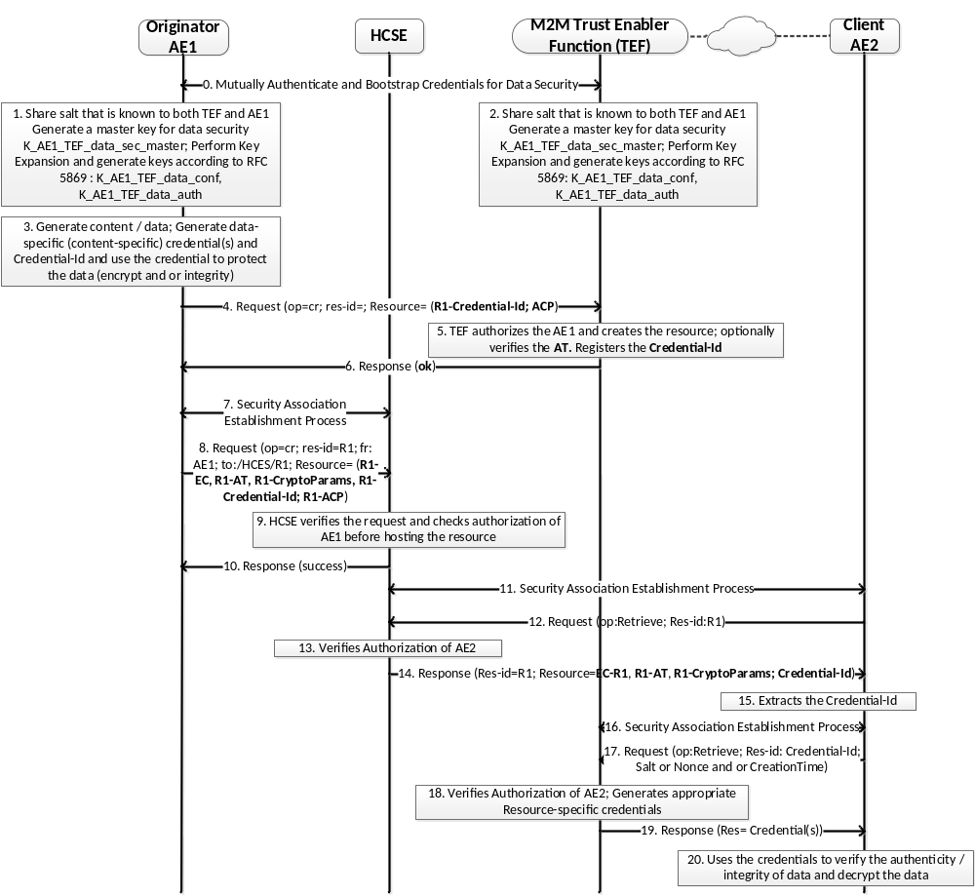

Figure 8.3.3.2-1: Message flow depicting hosting and retrieval of protected content

An example of a protected <contentInstance> is depicted in Figure 8.3.3.2-2. The contentInstance has an encryptedContent as a child resource and associated cryptoParams, the cryptographic parameters that are to be used in order to be able to decrypt the contentInstance. In addition, an authenticationTag or digitalSignature resource and associated cryptoParams, the parameters that are to be used in order to be able to verify the authentication tag or digital signature are added to the existing contentInstance resource.

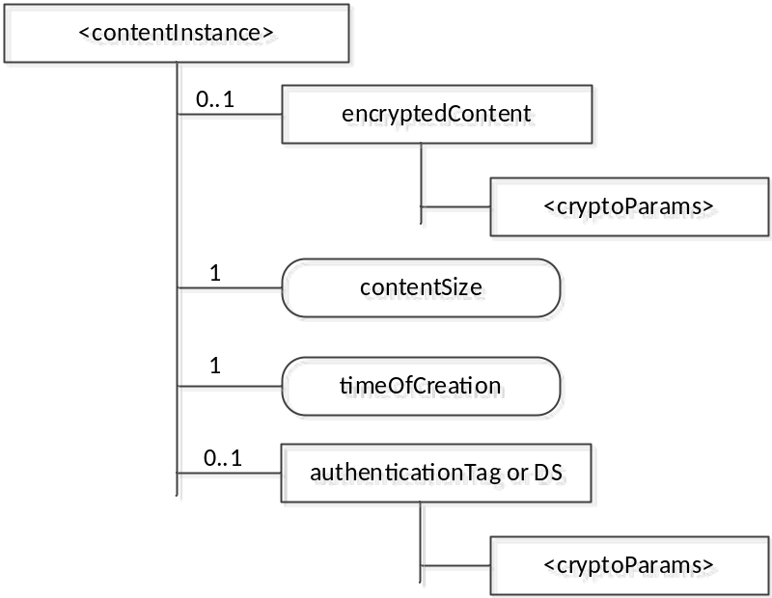

Figure 8.3.3.2-2: Resource structure of a protected <contentInstance>

