CHANGE REQUEST
Meeting:* | SEC 22
Source:* | François Ennesser, Gemalto, francois.ennesser@gemalto.com
Date:* | 2016-03-04
Contact:* | francois.ennesser@gemalto.com
Reason for Change/s:* | This CR provides clean-up on the new Release 2 functionalities inserted during SEC 21. Note that since some information related to intended references were lost between drfat v2.0.0 and v2.0.1, this CR is based purposedly based on v2.0.0 to capture all existing information related to intended references.
CR against: Release* | Release 2
CR against: WI* | Active WI-0019  MNT Maintenance / < Work Item number(optional)>  STE Small Technical Enhancements / < Work Item number (optional)>  Only ONE of the above shall be ticked
CR against: TS/TR* | TS-0003 v2.0.0 (on purpose)
Clauses/Sub Clauses* | 2, 7.1.2, 7.3, 7.4, 8.3.1, 8.3.2, 8.4, 8.5, 8.6, 8.7, 9.2.3, 10.3.6
Type of change: * | Editorial change  Bug Fix or Correction  Change to existing feature or functionality  New feature or functionality  Only ONE of the above shall be ticked
Post Freeze checking:* | This CR contains only essential changes and corrections? YES NO  This CR is a mirror CR? YES NO if YES, please indicate the document number of the original CR:
Template Version:23 February 2015 (Dot not modify)

oneM2M Notice
The document to which this cover statement is attached is submitted to oneM2M. Participation in, or attendance at, any activity of oneM2M, constitutes acceptance of and agreement to be bound by terms of the Working Procedures and the Partnership Agreement, including the Intellectual Property Rights (IPR) Principles Governing oneM2M Work found in Annex 1 of the Partnership Agreement.
GUIDELINES for Change Requests:
Provide an informative introduction containing the problem(s) being solved, and a summary list of proposals.
Each CR should contain changes related to only one particular issue/problem.
In case of a correction, and the change apply to previous releases, a separated “mirror CR” should be posted at the same time of this CR
Follow the principle of completeness, where all changes related to the issue or problem within a deliverable are simultaneously proposed to be made E.g. A change impacting 5 tables should not only include a proposal to change only 3 tables. Includes any changes to references, definitions, and acronyms in the same deliverable.
Follow the drafting rules.
All pictures must be editable.
Check spelling and grammar to the extent practicable.
Use Change bars for modifications.
The change should include the current and surrounding clauses to clearly show where a change is located and to provide technical context of the proposed change. Additions of complete sections need not show surrounding clauses as long as the proposed section number clearly shows where the new section is proposed to be located.
Multiple changes in a single CR shall be clearly separated by horizontal lines with embedded text such as, start of change 1, end of change 1, start of new clause, end of new clause.
When subsequent changes are made to content of a CR, then the accepted version should not show changes over changes. The accepted version of the CR should only show changes relative to the baseline approved text.

Introduction
This CR provides clean-up on the new Release 2 functionalities inserted during SEC 21. Note that since some information related to intended references were lost between drfat v2.0.0 and v2.0.1, this CR is based purposedly based on v2.0.0 to capture all existing information related to intended references.

-----------------------Start of change 1-------------------------------------------

2 References

2.1 Normative references
References are either specific (identified by date of publication and/or edition number or version number) or non-specific. For specific references, only the cited version applies. For non-specific references, the latest version of the reference document (including any amendments) applies.
The following referenced documents are necessary for the application of the present document.
[1] oneM2M TS-0001: "Functional Architecture".
[2] oneM2M TS-0011: " Common Terminology"
[3] Void.
[4] oneM2M TS-0004: "Service Layer Core Protocol Specification".
[5] IETF RFC 5246: "The Transport Layer Security (TLS) Protocol Version 1.2".
[6] IETF RFC 6347: "Datagram Transport Layer Security Version 1.2".
[7] ETSI TS 102 225 (V11.0.0): "Smart Cards; Secured packet structure for UICC based applications (Release 11)".
[8] ETSI TS 102 226 (V11.0.0): "Smart Cards; Remote APDU structure for UICC based applications (Release 11)".
[9] 3GPP TS 31.115 (V10.1.0): "Remote APDU Structure for (U)SIM Toolkit applications (Release 10)".
[10] 3GPP TS 31.116 (V10.2.0): "Remote APDU Structure for (Universal) Subscriber Identity Module (U)SIM Toolkit applications (Release 10)".
[11] 3GPP2 C.S0078-0 (V1.0): "Secured packet structure for CDMA Card Application Toolkit (CCAT) applications".
[12] 3GPP2 C.S0079-0 (V1.0): "Remote APDU Structure for CDMA Card Application Toolkit (CCAT) applications".
[13] 3GPP TS 33.220: "Generic Authentication Architecture (GAA); Generic Bootstrapping Architecture (GBA)".
[14] 3GPP2 S.S0109-A: "Generic Bootstrapping Architecture (GBA) Framework".
[15] IETF RFC 4279: "Pre-Shared Key Ciphersuites for Transport Layer Security (TLS)".
[16] Void.
[17] Void.
[18] IETF RFC 5705: "Keying Material Exporters for Transport Layer Security (TLS)".
[19] IETF RFC 3629: "UTF-8, a transformation format of ISO 10646".
[20] "Unicode Standard Annex #15; Unicode Normalization Forms", Unicode 5.1.0, March 2008.
NOTE: Available at http://www.unicode.org.
[21] GlobalPlatform Device Technology TEE Administration framework, DRAFT.
[22] GlobalPlatform Device Technology TEE System Architecture, Version 1.0.
[23] ETSI TS 102 671: "Smart Cards; Machine to Machine UICC; Physical and logical characteristics".
[24] ETSI TS 102 221: "Smart Cards; UICC-Terminal interface; Physical and logical characteristics".
[25] ETSI TS 102 484: "Smart Cards; Secure channel between a UICC and an end-point terminal".
[26] ISO/IEC 7816-4: "Identification cards - Integrated circuit cards - Part 4: Organization, security and commands for interchange".
[27] ETSI TS 101 220: "Smart Cards; ETSI numbering system for telecommunication application providers".
[28] Void.
[29] Void.
[30] Void.
[31] IETF RFC 6655: "AES-CCM Cipher Suites for Transport Layer Security (TLS)".
[32] IETF RFC 5289: "TLS Elliptic Curve Cipher Suites with SHA-256/384 and AES Galois Counter Mode (GCM)".
[33] IETF RFC 2104: "HMAC: Keyed-Hashing for Message Authentication".
[34] IETF RFC 5280: "Internet X.509 Public Key Infrastructure Certificate and Certificate Revocation List (CRL) Profile".
[35] IETF RFC 6960: "X.509 Internet Public Key Infrastructure Online Certificate Status Protocol - OCSP".
[36] IETF RFC 6961: "The Transport Layer Security (TLS) Multiple Certificate Status Request Extension".
[37] IETF RFC 7250: "Using Raw Public Keys in Transport Layer Security (TLS) and Datagram Transport Layer Security (DTLS)".
[38] IETF RFC 7252: "The Constrained Application Protocol (CoAP)".
[39] National Institute of Standards and Technology (July 1999): "Recommended Elliptic Curves for Federal Government user".
NOTE: Available at http://csrc.nist.gov/groups/ST/toolkit/documents/dss/NISTReCur.pdf.
[40] IETF RFC 6920: "Naming Things with Hashes".
[41] IETF RFC 3548: "The Base16, Base32, and Base64 Data Encodings".
[42] IETF RFC 5487: "Pre-Shared Key Cipher Suites for TLS with SHA-256/384 and AES Galois Counter Mode".
[43] IETF RFC 4492: "Elliptic Curve Cryptography (ECC) Cipher Suites for Transport Layer Security (TLS)".
[44] IETF RFC 6066: "Transport Layer Security (TLS) Extensions: Extension Definitions".
[45] IETF RFC 7251: "AES-CCM Elliptic Curve Cryptography (ECC) Cipher Suites for Transport Layer Security (TLS)".
[46] IETF RFC 5480: "Elliptic Curve Cryptography Subject Public Key Information".
[47] GlobalPlatform Device Technology Secure Element Remote Application Management v1.0 GPD_SPE_008.
[48] IETF RFC 5869: HMAC-based Extract-and-Expand Key Derivation Function (HKDF)
[RFC7515] IETF RFC 7515: “JSON Web Signature (JWS)”, 2015
[49] IETF RFC 7516: “JSON Web Encryption (JWE)”, 2015
[50] IETF RFC 7517: “JSON Web Key (JWK)”, 2015
[51] IETF RFC 7518: “JSON Web Algorithms (JWA)”, 2015
[52] W3C Recommendation “XML Encryption Syntax and Processing v1.1”, 2013, http://www.w3.org/TR/xmlenc-core1/
[53] W3C Recommendation “XML Signature Syntax and Processing v1.1”, 2013, http://www.w3.org/TR/xmldsig-core1/

2.2 Informative references
References are either specific (identified by date of publication and/or edition number or version number) or non-specific. For specific references, only the cited version applies. For non-specific references, the latest version of the reference document (including any amendments) applies.
The following referenced documents are not necessary for the application of the present document but they assist the user with regard to a particular subject area.
[i.1] oneM2M Drafting Rules.
NOTE: Available at http://member.onem2m.org/Static_pages/Others/Rules_Pages/oneM2M-Drafting-Rules-V1_0.doc.
[i.2] Void.
[i.3] Void.
[i.4] oneM2M TR-0008: "Analysis of Security Solutions".
[i.5] eXtensible Access Control Markup Language (XACML) Version 3.0. 22 January 2013. OASIS Standard.
[i.6] Handbook of Applied Cryptography, A. J. Menezes, P. C. van Oorschot, S. A. Vanstone, CRC Press, 1996.
[i.7] Recommendation ITU-T X.509 (10/2012): "Information technology - Open Systems Interconnection - The Directory: Public-key and attribute certificate frameworks".
[i.8] Void.
[i.9] OMA-TS-REST-NetAPI-TerminalLocation-V1-0-20130924-A: "RESTful Network API for Terminal Location", Version 1.0.
[i.10] ISO 3166-1:2013: "Codes for the representation of names of countries and their subdivisions -- Part 1: Country codes".
[i.11] ISO/IEC 7816-5: "Identification cards - Integrated circuit cards - Part 5: Registration of Application Providers".
[i.12] Guide to Attribute Based Access Control (ABAC) Definition and Considerations, NIST Special Publication 800-162.
NOTE: Available at http://nvlpubs.nist.gov/nistpubs/specialpublications/NIST.sp.800-162.pdf.
[i.13] National Institute of Standards and Technology: “Guide to Protecting the Confidentiality of Personally Identifiable Information (PII)"
[i.14] IETF RFC 5166: “An Interface and Algorithms for Authenticated Encryption”, 2008
[i.15] oneM2M TR-0019 “Dynamic Authorization”
[i.16] oneM2M TR-0012 “End to End security”

-----------------------End of change 1-------------------------------------------

-----------------------Start of change 2-------------------------------------------

7.1.2 Parameters of the Request message
This clause specifies the parameters of a request message which are evaluated by the access control mechanism.
The data types applicable to these parameters are defined in clause 6.4 of oneM2M TS-0004 [4].
The parameters are listed in table 7.1.2-1.
For case where an AE initiates a new registration request to a CSE and has no preference for an assigned AE-ID value, the fr parameter shall not be sent in the request. All other requests shall have the fr parameter present in the request.Table 7.1.2-1: Parameters indicated in the request message
Parameter | Description | Mandatory/ Optional | Usage in access control mechanism
to | URI of target resource | M | Selection of accessControlPolicy associated with the target resource
fr | Identifier representing the originator of the request | M* | Evaluated against accessControlOriginators in privileges and selfPrivileges attributes
role | Role of the originator | O | Evaluated against accessControlOriginators in privileges and selfPrivileges attributes
op | Requested operation | M | Evaluated against accessControlOperations in privileges and selfPrivileges attributes
fc | filterUsage condition tag in Filter criteria | O | Differentiation between Retrieve and Discovery operations
Tokens | ESData-protected Tokens | O | Contains authorization information (e.g. Role-IDs) to be used in the decision for the request
Token IDs | tokenIds or Local-Token-ID | O | Identifies Tokens containing authorization information (e.g. Role-IDs) to be used in the decision for the request

* From field is Mandatory in all requests except for AE registration procedure where it is optional.

Table 7.1.2-2 lists the context parameters associated with a request message which are evaluated by the access control mechanism. These parameters are not explicitly included in a request message but can be obtained at the receiver and validated against the context policy parameters as given in table 7.1.2-2.
Table 7.1.2-2: Context parameters associated with a request message
Parameter | Description | Mandatory/ Optional | Usage in access control mechanism
rq_time | Time stamp when the request message was received at the hosting CSE. Obtained by the hosting CSE's system time clock. | O | Validated against accessControlTimeWindow parameter in an access control rule, cf. clause 7.3
rq_loc | Location information about the originator of the request. Obtained over the Mcn reference point. | O | Validated against accessControlLocationRegion parameter in an access control rule, cf. clause 7.3
rq_ip | IP source address associated with the IP packets that carry the request message. Obtained over the Mcn reference point. | O | Validated against accessControlIpAddress parameter in an access control rule, cf. clause 7.3

Tokens, as defined in clause 7.3xx “Token Structure”, may be associated with a request message. A Token may be associated with a request as a result of being included in the Tokens primitive parameter of the request message or identified in the Token IDs primitive parameter of the request message. If the Hosting CSE obtained a token from the Dynamic Authorization System (DAS) Server using Direct Dynamic Authorization, then this Token shall be associated with a request if the holder parameter in the Token matches the Absolute AE-ID or CSE-ID of the Originator of the request; such Tokens are obtained using Dynamic Authorization as specified in clause 7.3.
Editor’s note: There appears to be a need to indicate when the Roles and Tokens included or identified in a request will over-ride the privileges associated with the Originator’s AE-ID or CSE-ID or a Token received via Direct Dynamic Authorization. This functionality is intended to be included in the very near future.

-----------------------End of change 2-------------------------------------------

-----------------------Start of change 3-------------------------------------------

7.3 Dynamic Authorization

7.3.1 Purpose of the Dynamic Authorization
The Dynamic Authorization provides an interoperable framework an Originator to be dynamically issued with a temporary permissions providing the Originator with access to one or more resources on one or more CSEs.
Applicable use cases, requirements and proposals are discussed in TR-0019 [i.15].
The present document specifies the exchanged Dynamic Authorization parameters and associated processing at the Originator and Hosting CSE. The transport of dynamic authorization parameters is specified in TS-0001 [1].

7.3.2 Dynamic Authorization Stage 2 Details

7.3.2.1 Dynamic Authorization Reference Model
Editor’s note: If possible, keep this clause aligned with clause 11.5.1, TS-0001 [1].
The Dynamic Authorization reference model is shown in Figure 7.3.2.1-1 “Dynamic Authorization reference model”.
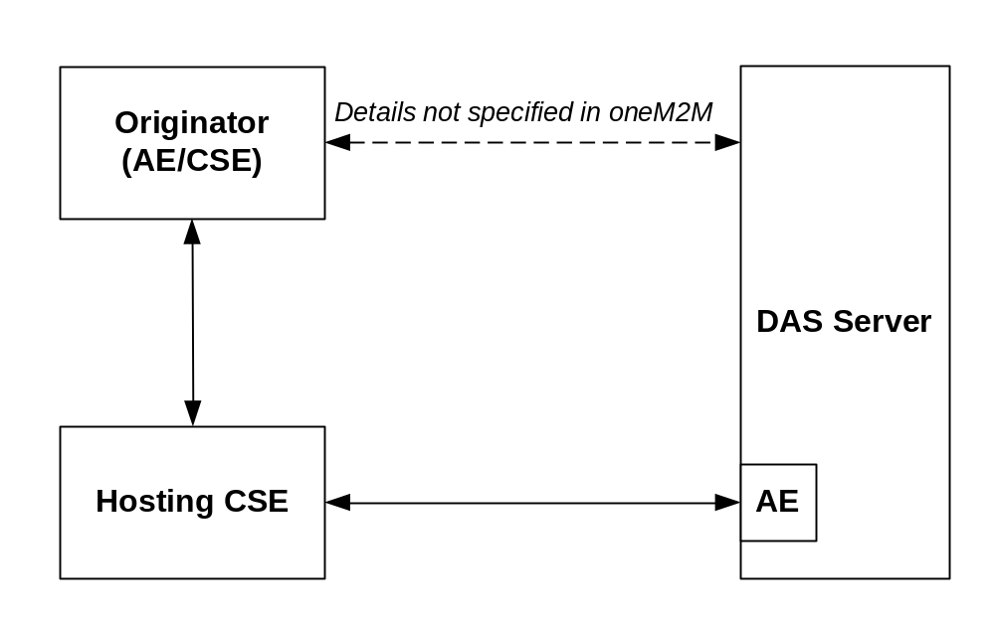
Figure 7.3.1-1 Dynamic Authorization reference model

The Dynamic Authorization reference model introduces the following systems and entities:
- Dynamic Authorization System (DAS): A system supporting dynamic authorization on behalf of resources owners. The present document does not describe the processing and exchange of messages within the Dynamic Authorization System. This system may reside either internally or externally within the service provider network.
- Dynamic Authorization System (DAS) Server: A server configured with policies for dynamic authorization, and provided with credentials for issuing Tokens. The DAS Server may include an AE for interaction with the oneM2M system.
The following Dynamic Authorization procedures are specified:
- Direct Dynamic Authorization, summarized in Figure 7.3.2.1-2. In this procedure, Hosting CSE interacts with the DAS Server to obtain Dynamic Authorization.
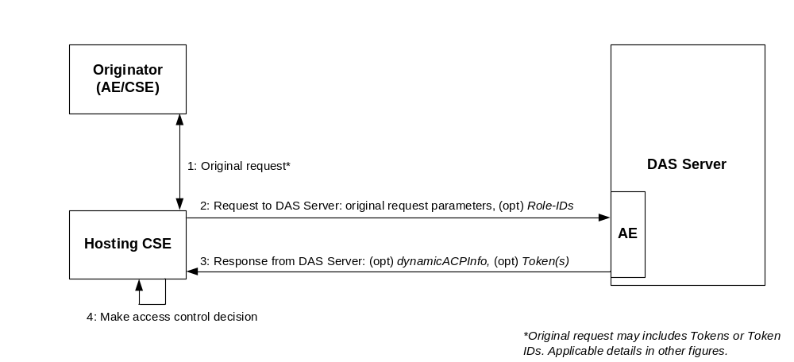
Figure 7.3.2.1-2 Direct Dynamic Authorization
- Indirect Dynamic Authorization, summarized in Figure 7.3.2.1-3.
  - Steps 1-2: The Hosting CSE may provide the Originator with Token Request Information in the unsuccessful response.
  - Steps 3: The Originator interacts with the DAS Server with the intention that the DAS Server issue Tokens authorizing the Originator, and the Originator is provided with the Token or a Token-ID. The interaction is not described in the present specification.
  - Steps 4-7: The Originator provides the Hosting CSE with a Token, Token-ID to indicate that the Token is to be considered in the access decision. In the case of a token-ID, the Hosting CSE retrieves the corresponding Token via an AE of the DAS Server. These are then used in the access decision. The Hosting CSE may provide the Originator with a Local-Token-ID that may be used to identify the Token.
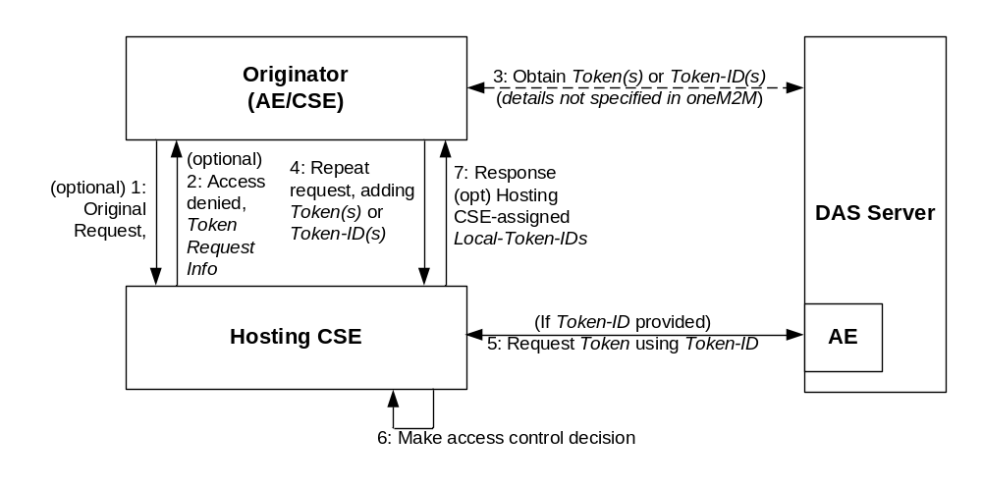
Figure 7.3.2.1-3 Indirect Dynamic Authorization

7.3.2.2 Direct Dynamic Authorization
The present document specifies the exchanged parameters and associated processing at the Hosting CSE. The transport of parameters is specified in clause 11.5.2, TS-0001 [1].
The message flow for the Direct Dynamic Authorization is shown in Figure 7.3.2.2-1 “Message flow for Direct Dynamic Authorization”, and described in the following text.
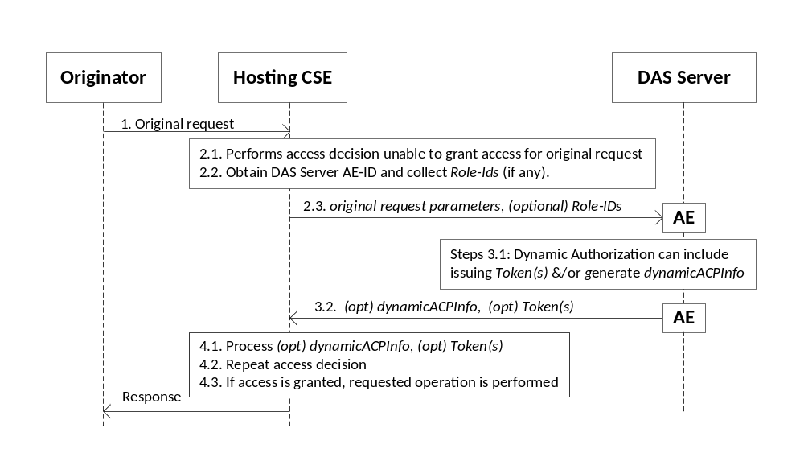
Figure 7.3.2.2-1: Message flow for Direct Dynamic Authorization
- The Originator sends request (called the request from the Originator for this message flow) to the Hosting CSE. This request may include Tokens or Token-IDs; see the clause 7.3.2.3 “Indirect Dynamic Authorization”.
- Initial Hosting CSE processing:
  - If the request from the Originator includes Tokens or Token-IDs then these are processed as described in clause 7.3.2.3 “Indirect Dynamic Authorization”. The Hosting CSE evaluates the access decision algorithm, but is unable to grant access for the request from the Originator based on configured access control policies.
  - The Hosting HCSE determines the set of DAS Servers with which Direct Dynamic Authorization may be performed.
    - The HCSE examines all accessControlRules for which request satisfies the accessControlOperations and accessControlContexts in the <accessControlPolicy> resources linked to the requested resource. The HCSE collects the set of all Role-IDs in the accessControlOperators of these accessControlRules. This Role-IDs are grouped according to the DAS Server AE-ID identified by the Role-ID.
Editor’s note: The parameters comprising the Role-ID are not yet defined, but are assumed to contain at least an identifier for a DAS Server and a label that is unique within the scope of Role-IDs assigned by the DAS Server.
NOTE: Regarding the Role-ID(s) parameter: The Originator would be granted access if a Token(s) is issued which associates the Originator with one or more of the Role-ID(s). Providing this list to the DAS Server allows the DAS Server to select a suitable set of one or more Role-ID(s) to associated with the Originator in Token(s), thereby authorizing the Originator to access the requested resources. The policies configured to the DAS Server would dictate which Role-ID(s) (if any) are included in Token(s) issued to the Originator.

    - The HCSE shall also collect the set of <dynamicAuthorizationConsultation> resources linked to the requested resource, and group these according to the DAS Server AE-ID attribute of the <dynamicAuthorizationConsultation> resource.
  - The Hosting CSE selects a DAS Server (from the set determined in step 2.2) and sends a oneM2M request message containing the information described in Table 7.3.3.2-1 “Information in the Direct Dynamic Authorization message sent from Hosting CSE to DAS Server”. The transport of parameters is specified in step 2.3, clause 11.5.2, TS-0001 [1].

Table 7.3.2.3-1: Information sent from Hosting CSE to DAS Server during the Direct Dynamic Authorization
Parameter | Description | Mandatory/ Optional
oid | Identifier of the Originator of the request received by the Receiver | M
ort | Type of resource targeted by originated request received by Receiver | M
oro | Type of operation specified in originated request received by the Receiver | M
oip | IP address of Originator of request received by Receiver | O
oloc | Location of Originator of request received by Receiver | O
orol | Role of Originator of request received by Receiver | O
otm | Timestamp when originated request was received by Receiver | O
orid | Resource ID targeted by originated request received by Receiver | O
rlt | Proposed lifetime of authorization privileges requested by the Receiver | O
Roles | The set of Dynamic Access Roles in the accessControlDynAuthRole parameters associated with the DAS Server AE-ID. | O

- DAS Server processing:
  - The DAS Server processes the received parameters. The DAS Server may decide to provide Token(s) and/or dynamicACPInfo which will be used by the Hosting CSE to create a dynamic <accesscontrolPolicy> resource. The DAS Server applies the policies with which it is configured to decide on the appropriate actions.
NOTE: The details of this decision are specific to the Dynamic Authorization System being employed; these details are not visible to the oneM2M system, and are not addressed in the present document.
The Token(s) (if any) shall conform to clause 7.3.3.1 “Token Structure”, with the following profile:
    - The “holder” parameter shall contain the Originator’s Absolute CSE-ID or AE-ID received from the HCSE, and may contain other CSE-IDs and AE-IDS.
    - The “audience” parameter shall contain only the HCSEs CSE-ID.
Editor’s note: The “audience” parameter of a Token is not yet defined in clause 7.3.3.1 “Token Structure”.
The DAS Server shall apply a ESData protection option to the individual Tokens with the following requirements
    - The DAS Server may encrypt the Token such that the Token can be decrypted by the Hosting CSE.
    - The Hosting CSE shall be able to verify that the DAS Server issued the token.
The ESData processing results in an ESData envelope which is called the ESData-protected Token for the purposes of this message flow.
If the DAS Server decides to authorize the Hosting CSE to create a dynamic <accesscontrolPolicy> resource, then the DAS Server shall form a dynamicACPInfo parameter containing the following information are listed in table 7.3.2.3-2 “Parameters included in the dynamicACPInfo parameter”.
Table 7.3.2.3-2: Information included in the dynamicACPInfo parameter
Parameter | Description | Mandatory/ Optional
priv | List of granted privileges | O
plt | Lifetime of granted privileges | O

  - The DAS Server shall send the ESData-protected Token(s) (if any) and (optional) dynamicACPInfo parameter via the DAS Server AE to the Hosting CSE. The transport of parameters is specified in step 2.3, clause 11.5.2, TS-0001 [1].
- HCSE Processing:
  - The HCSE processes the ESData-protected Token(s) (if present) and dynamicACPInfo parameter (if present).
    - The HCSE shall perform the following verifications for each ESData-protected Token:
      - The HCSE shall apply ESData processing to the ESData-protected Token to extract the authenticated Token.
      - The HCSE shall perform the following verifications:
        - The “issuer” parameter in the Token shall exactly match the identity of the DAS Server.
        - The HCSE’s CSE-ID shall match the CSE-ID in the “audience” parameter in the Token.
        - The “holder” parameter in the Token shall exactly matches the Absolute CSE-ID or AE-ID of the Originator from whom the request was received.
        - The HCSE shall verify that the Token has not expired, by comparing the current time to the “notAfter” parameter in the Token.
      - The HCSE shall cache the verified Token, and may later delete the verified Token when the Token expires (as defined in step 4.1.2.4)
    - If dynamicACPInfo is provided by the DAS Server, then the Hosting CSE shall create a dynamic <accessControlPolicy> resource matching the dynamicACPInfo
  - The Hosting CSE repeats the access decision mechanism in clause 7.1.4 “Access Control Decision”.
  - If access is granted, then the Hosting CSE performs the operation requested in the request from the Originator, resulting in the Hosting CSE sending a request to the Originator.

7.3.2.3 Indirect Dynamic Authorization
The present document specifies the exchanged parameters and associated processing at the Originator and Hosting CSE. The transport of parameters is specified in clause 11.5.3, TS-0001 [1].
The message flow for Indirect Dynamic Authorization is shown in Figure 7.3.2.3-1 “Message flow for the Indirect Dynamic Authorization”, and described in the following text.
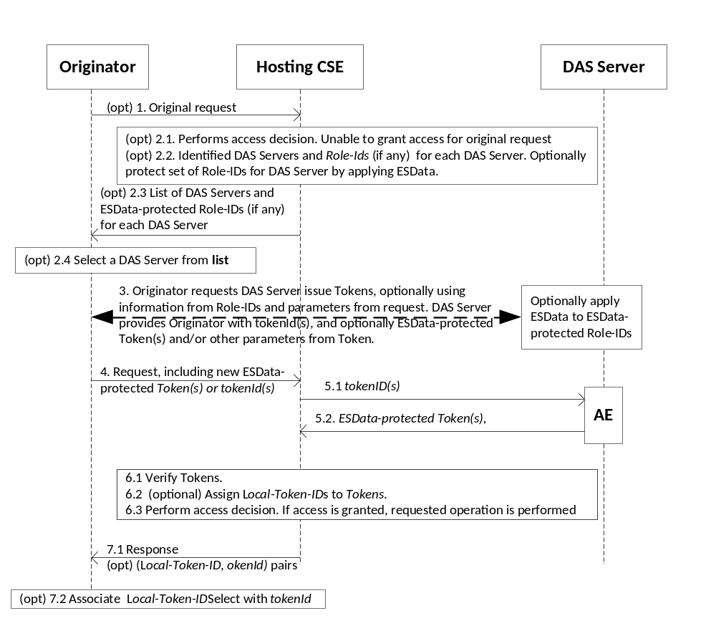
Figure 7.3.2.3-1: Message flow for Indirect Dynamic Authorization

- (Optional) The Originator sends request to the Hosting CSE. The Originator includes an indication that the Originator is prepared to request Tokens from DAS Servers for this request. This request may include a combination of Tokens, tokenIds, Local-Token-IDs but this message flow assumes that these do not provide sufficient permissions for accessing the requested resource.
- (Optional) Initial Hosting CSE processing:
  - Hosting CSE performs the access decision for the request from the Originator. This call flow assumes that the request from the Originator is denied as a result of the access decision. The Hosting CSE observes the indication that the Originator prepared to request Tokens from DAS Servers for this request.
  - The Hosting CSE forms a list of DAS Server’s and associated Role-ID(s) (if any) as described in step 2.2.1 of the Direct Dynamic Authorization in clause 7.3.2.3 “Direct Dynamic Authorization”.
For each DAS Server, then Hosting CSE may apply ESData to the set of Role-IDs for decryption by the DAS Server. For example, the ESData may encrypt the set of Role-IDs so they are not visible to the Originator.
Editor’s note: a mechanism is needed for the DAS Server to tell the Hosting CSE if ESData should be applied to the Role-IDs, as well as indicating the credential to use.
  - The Hosting CSE shall send an unsuccessful response to the Originator, including the list of DAS Servers and associated set of optionally-ESData-protected Role-IDs.
  - The Originator selects a DAS Server identified in the response.
- The Originator shall interact with the DAS Server to request the issuance of a Token. The Originator can provide the optionally-ESData-protected set of Role-IDS to the DAS Server, and parameters from the original resource access request. If the set of Role-IDS is protected using ESData, the the DAS Server applies ESData to extract the set of Role-IDS. The DAS Server issues a Token(s) and provides the tokenId(s) and optionally the ESData-protected Token(s) to the Originator. The DAS Server can also provide the Originator with other parameters from the Token; for example, the time window in which the Token is valid. This interaction is specific to the Dynamic Authorization System technology being used.
- For request that the Originator wishes to have authorized using an issued Token, the Originator shall add ESData-protected Token provided by the DAS Server or tokenId (if no ESData-protected Token was provided) if the corresponding ESData-protected Token(s) was not provided by the DAS Server. In particular, if the request at step 1 was unsuccessful at step 2.3, then the Originator shall repeat the request with new Token(s) and/or tokenId(s). A token may be used in multiple request.
The Originator shall send the request to the Hosting CSE.
- (Optional) If the request includes tokenId(s), then for each tokenId the Hosting CSE identifies the corresponding DAS Server AE from which to request the corresponding Token.
  - The Hosting CSE sends the tokenId(s) to the DAS Server via a DAS Server AE.
  - The DAS Server shall return the corresponding valid ESData-protected Token(s) to the Hosting CSE via the DAS Server AE.
- Hosting CSE Processing
  - Token Processing
    - The Hosting CSE shall apply ESData to the ESData-protected Token(s), either provided in the request or retrieved form the DAS Server, to extract the authenticated Token(s).
    - If a Local-Token-ID was provided in the request, then the Hosting CSE attempts to retrieve the cached token.
    - The HCSE shall perform the following verifications for each authenticated and cached token associated with the request:
      - The HCSE’s CSE-ID shall match one of the Absolute CSE-IDs (optionally including wildcards) in the “audience” parameter in the Token.
Editor’s note: This parameter is not currently defined in clause 7.3.y.z “Token Structure”.
      - The “holder” parameter in the Token shall exactly match the Absolute CSE-ID or AE-ID of the Originator from whom the request was received.
      - The HCSE shall verify that the Token is currently valid and not expired, by comparing the current time to the “notBefore” and “notAfter” parameter in the Token. If a cached Token has expired, then the Token may be removed from the cache.
    - If any identified Token could not be retrieved in steps 5 or 6.1.2, or if any ESData-protected Token-ID failed verification at step 6.1.1, or if any Token failed the verification at step 6.1.3, then the Hosting CSE shall respond with an error.
    - The Hosting CSE may cache any new Token(s).
  - The Hosting CSE may assign Local-Token-ID(s) to cached Token(s).
  - The Hosting CSE shall perform the access decision as described in clause 7.1.4, including the information in the Token(s) identified in the request. If access is granted, then the requested operation shall be performed.
- Response
  - The Hosting CSE sends a response to the Originator. For each new Local-Token-ID(s) that has been assigned, the Hosting CSE provides the Local-Token-ID and corresponding tokenId in the response parameters.
  - The Originator associates the Local-Token-ID with tokenId. In subsequent requests, the Originator may use the Local-Token-ID instead of the Token or tokenId.

7.3.2.4 Token Structure
The structure of token is shown in figure 7.3.3.1-1, it contains the following data fields:
- version: version of the token.
- tokenID: unique ID of the token.
- holder: ID of the token holder.
- Audience : CSE_IDs of the CSE that may use the token
- issuer: ID of the token issuer.
- notBefore: token valid from this time.
- notAfter: token expired after this time.
- tokenName: human readable name of the token.
- appIDs: List of App-IDs that are used for determining what M2M applications this token should be used for.
- privileges: privilege description, i.e. role and/or ACPs. Its structure is described in clause 7.y.3.2.
- extensions: used for store other information, e.g. application-specific information.

Figure 7.3.3.1-1: Structure of token

7.4 Role Based Access Control

7.4.1 Role Based Access Control Architecture
Figure 7.4-1 provides a high level overview of the role based access control architecture in the oneM2M System. The entities related to role issuance are described as follows:
- Role Authority: It is responsible for assigning roles to Originators through creating <role> resources in a Role Repository.
- Role Repository: It is a CSE that is responsible for storing <role> resources created by Role Authorities.
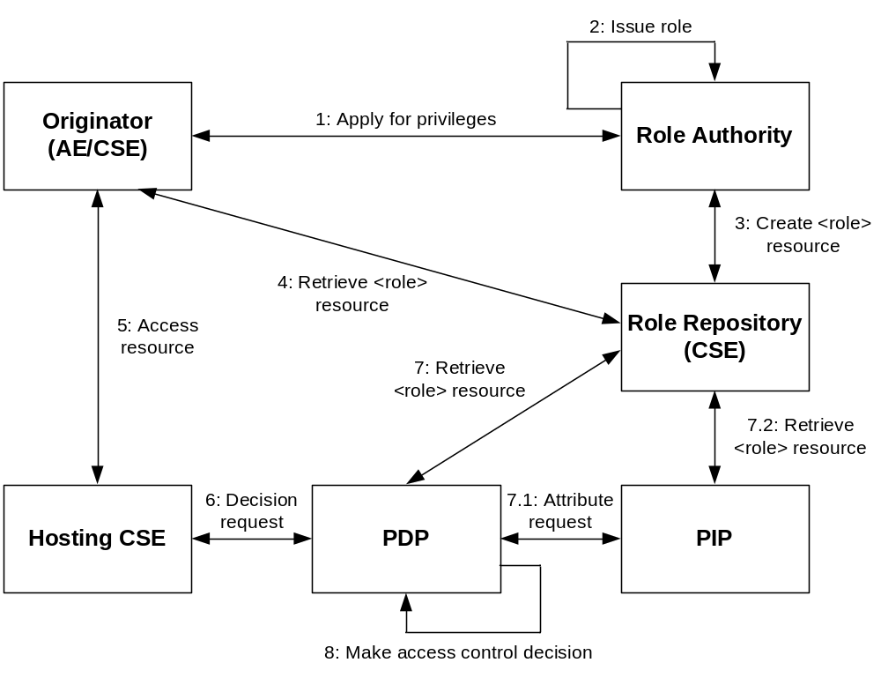
Figure 7.4-1. Role based access control architecture
The generic procedure of this architecture is described as follows:
Step 001: An Originator may apply for a privilege from a Role Authority.
Step 002: The Role Authority shall check if the applied privilege can be assigned to the Originator. If it is permitted, the Role Authority issues a role to the Originator.
Step 003: The Originator shall create a <role> resource in a Role Repository from which the role consumers can retrieve the roles assigned to an AE or CSE.
Step 004: The Originator may retrieve the assigned roles from a Role Repository.
Step 005: The Originator shall send a resource access request in which Role-IDs are included to the Hosting CSE.
Step 006: The Hosting CSE shall send an access decision request to a PDP.
Step 007: The PDP shall retrieve the Originator’s role assignment information according to the Role-IDs from a Role Repository.
Step 008: The PDP shall verify the Originator’s roles and then make an access control decision according to the access control policies and Role-IDs.
NOTE 1: Some steps described here may not be needed in some applications, e.g. a Role Authority may issue roles to an Originator without step 1, or the Originator already have the role information from the Role Authority, and does not need to do the step 4.

7.4.2 Role Issuing Procedure
The general procedure of issuing a role to an Originator is shown in the Figure 7.4.2-1 and described as follows:
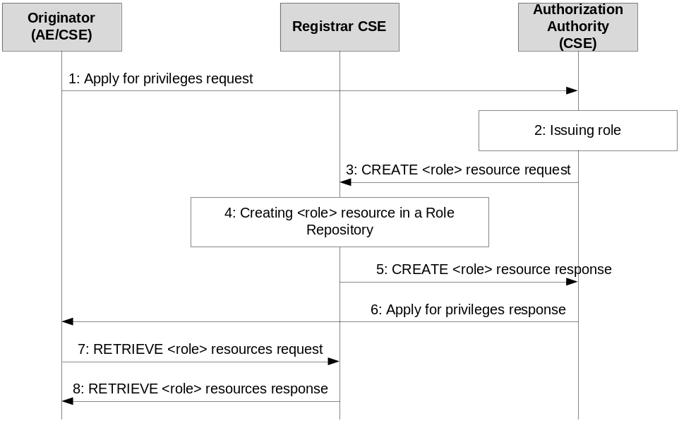

Figure 7.4.2-1: Procedure of issuing a role
Procedure of role issuance is:
- The Originator may send privilege request to the Role Authority.
- The Role Authority shall check if the applied privilege can be assigned to the Originator. After passing the privilege authorization check, the Role Authority shall issue a role to the Originator.
- The Role Authority shall send a <role> resource creation request to the Role Repository.
- The Role Repository shall create a <role> resource according to the creation request.
- The Registrar CSE shall return the result of <role> resource creation back to the Role Authority.
- The Role Authority shall return the result of role issuance back to the Originator. The response may or may not contain the role information.
- The Originator may send <role> resource retrieve request to the Role Repository in order to get the role assignment information.
- The Role Repository shall return retrieved <role> resources back to the Originator.

7.4.3 Role Based Access Control Procedure
The general procedure of using a role in an authorization process is shown in the Figure 7.4.3-1 and described as follows:
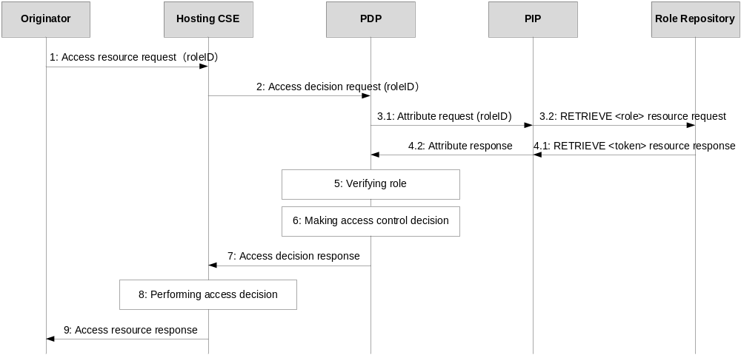

Figure 7.4.3-1: Role based access control procedure
Procedure of using role and/or token is:
- The Originator may select applicable Role-IDs according to the App-IDs attribute of <role> resources, and include them into the request sent to the Hosting CSE.
- The PEP in the Hosting CSE shall generate access decision request according to the request of the Originator, and send the request to a PDP. The Role-IDs received from the Originator shall be included in the request.
- The PDP shall send role attribute request with a Role-ID to a PIP in order to get the role information, and the PIP shall further send a <role> resource retrieve request to the Role Repository. The PDP may directly send <role> resource retrieve request to the Role Repository instead of via a PIP.
- The Role Repository shall retrieve the <role> resource and return the information of <role> resource back to the PIP or directly back to the PDP.
- The PDP shall verify the received role, the verification shall include: role is issued by a valid Role Authority and is still valid. Only valid roles shall be used for access control.
- The PDP shall evaluate the access request of the Originator using access control policies and Role-IDs for making an access control decision.
- The PDP shall return the access control decision back to the PEP.
- The Hosting CSE shall enforce the access control decision, i.e. either perform the resource access on behalf of the Originator or deny the resource access.
- The Hosting CSE shall return the result of resource access back to the Originator.

-----------------------End of change 3-------------------------------------------

-----------------------Start of change 4-------------------------------------------

8.3 Remote Security Provisioning Frameworks

8.3.1 Overview on Remote Security Provisioning Frameworks

8.3.1.1 Purpose of Remote Security Provisioning Frameworks
Remote Security Provisioning Frameworks enable the provisioning of a symmetric key shared between two entities. Those two entities can be either a CSE/AE and a M2M Authentication Function (MAF) or two CSEs/AEs.
The provisioned symmetric key can be used for Provisioned Symmetric Key Security Association Establishment Framework or MAF-based Symmetric Key Security Association Establishment Frameworks. In cases, where the two entities are multiple hops away and end-to-end security is required, then end-to-end symmetric keys shall be generated using the Remote Security Provisioning Frameworks.
- Provisioned Symmetric Key Security Association Establishment
Provisioned Symmetric Key Association Establishment uses a symmetric key Kpsa and corresponding KpsaId, shared between two entities (Entity A and Entity B), to establish security associations between those two entities (CSE/AEs), as described in clause 8.2.2.1. In addition, the symmetric key Kpsa can be used to generate end-to-end security keys between the two entities when the entities are multiple hops away. This symmetric key Kpsa and corresponding KpsaId shall be either pre-provisioned or remotely provisioned to the two CSE/AEs using the Remote Security Provisioning Frameworks. This symmetric key Kpsa and corresponding KpsaId shall be either pre-provisioned or remotely provisioned to the two CSE/AEs thanks to Security Bootstrap Frameworks.
- MAF-based Symmetric Key Security Association Establishment
The MAF-based Security Association Establishment Framework uses a Master Credential (Km) and corresponding Master Credential Identifier (KmId), shared by a CSE/AE and an M2M Authentication Function, to establish security associations between the CSE/AE and other CSEs and/or AEs as described in clause 8.2.3.
The Master Credential (Km) and corresponding Master Credential Identifier (KmId) shall either be pre-provisioned or remotely provisioned to the CSE/AE and M2M Authentication Function.
- General
The method for pre-provisioning can be deployment dependent. An interoperable pre-provisioning framework based on UICC is described in annex D.
Clause 8.3 describes the set of remotely provisioning mechanisms; called Remote Security Provisioning Frameworks. An M2M Enrolment Function facilitates the remote provisioning.

8.3.1.2 Overview on Remote Security Provisioning Frameworks
An AE or CSE that requires remote provisioning of a Master Credential and Master Credential Identifier or a Provisioned Secure Connection Key (Kpsa) and Provisioned Secure Connection Key Identifier (KpsaId) is called an Enrolee. The AE or CSE with whom the enrolee is to establish a security association is called Enrolee B. The AE or CSE or M2M Authentication Function with whom the enrolee is to establish a shared key is called an Enrolment Target.
The oneM2M system supports the following Security Bootstrap Frameworks:
- Pre-Provisioned Symmetric Enrolee Key Remote Security Provisioning Framework: A symmetric key is pre-provisioned to the Enrolee and M2M Enrolment Function for the mutually authentication of those entities. For more details, see clause 8.3.2.1.
- Certificate-Based Remote Security Provisioning Framework: The Enrolee and M2M Enrolment Function are each issued with:
- a Private Signing Key that is known only to that entity;
- a Certificate containing the corresponding Public Verification Key; and
- (In the case of a device certificate, CSE-ID certificate or AE-ID certificate) a Certificate Chain from the entity's Certificate to a Trust Anchor Certificate.
The Enrolee and M2M Enrolment Function shall validate each other's Certificate before trusting the Public Verification Keys in the Certificate. Within the Security Handshake, the M2M Enrolment Function creates a digital signature of the session parameters using its private signing key and the Enrolee verifies the digital signature using the M2M Enrolment Function's public verification key. Then the roles are reversed: the Enrolee creates a digital signature and the M2M Enrolment Function verifies it. For more details see clause 8.3.2.2.
- GBA-based Remote Security Provisioning Framework. In this case, the role of the M2M Enrolment Function is performed by a GBA Bootstrap Server Function. This framework uses 3GPP or 3GPP2 symmetric keys to authenticate the Enrolee and the M2M Enrolment Function (which is also a GBA BSF). The details are specified by 3GPP TS 33.220 [13] and 3GPP2 S.S0109-A [14]. For more details see clause 8.3.2.3.
For a more detailed description of the above Remote Security Provisioning Frameworks, it is useful to compare the following aspects of the Remote Security Provisioning Frameworks.
- Bootstrap Credential Configuration: The Enrolee and M2M Enrolment Function are pre-provisioned with the Bootstrap Credential that the entity will use to authenticate itself to the other entity. The mechanisms for this pre-provisioning are not described in the present document.
- Bootstrap Instruction Configuration:
- The Enrolee and M2M Enrolment Function are provided with either:
  - M2M Authentication Function Identifier (MAF-ID) identifying the M2M Authentication Function for which the Enrolee is to be remotely provisioned when used in conjunction with a MAF-based security association establishment framework; or
  - The identifier of Enrolee B (Enrolee B-ID), when used in conjunction with a Provisioned Symmetric Key Security Association Establishment.
NOTE 1: The identity of the M2M Authentication Function or the Enrolee B is assumed to have been configured prior to the Bootstrap Instruction Configuration phase, as well as,, in the case of Enrolee B :
- an indication of whether the Kpsa can be used for generation of end-to-end security credentials,
- the security capabilities of the Enrolment Target and the associated security parameters that dictate the mechanisms to generate the credentials
- and the mechanisms that shall be used to achieve end-to-end security.
Additionally, in the case of Certificate-Based Remote Security Provisioning Framework:
- The Enrolee is configured with the M2M Enrolment Function URI (for the purpose of routing the (D)TLS messages to the M2M Enrolment Function) and M2M Enrolment Function Trust Anchor information that the Enrolee will use to verify the M2M Enrolment Function.
- The M2M Enrolment Function is configured with the Enrolee’s certificate information that the M2M Enrolment Function will use to verify the Enrolee. The necessary certificate information is dependent on the Enrolee’s certificate’s flavour, with details provided in clause 8.1.2.4 “Information Needed for Certificate Authentication of another Entity”.
- Bootstrap Enrolment Handshake: Identification, authentication and security context establishment between the Enrolee and M2M Enrolment Function.
- Enrolment Key Generation: generating a symmetric Enrolment Key,(Ke) and corresponding Enrolment Key Identifier (KeId) shared by the Enrolee and M2M Enrolment Function, which is used for subsequent generation of the Master Credential (Km) or Provisioned M2M Symmetric Key (Kpsa).
- Integration to the Association Security Handshake:
For MAF-based symmetric Key Security Association, the following steps occur during the MAF Handshake of the MAF-Based Security Association Establishment:
- The Enrolee derives the Master Credential (Km) from the Enrolment Key (Ke) and M2M Authentication Function Identifier (MAF-ID). Details of the derivation are provided in clause 9.4.
- The Enrolee generates the Master Credential Identifier (KmId) from Master Credential (Km) as described in clause 9.1, and stores Km and KmId.
- The Enrolee passes the Enrolment Key Identifier (KeId) to the M2M Authentication Function (see "MAF Handshake" in clause 8.2.2.3).
NOTE 2: When the Enrolee first communicates with the M2M Authentication Function, then the M2M Authentication Function has not yet retrieved the Km from the M2M Enrolment Function. Consequently, the Enrolee provides the KeId to the M2M Authentication function, which is then passed to the M2M Enrolment Function to identify the Enrolment Key. The M2M Enrolment Function then returns the Km from which the M2M Authentication Function can derive the KmId. In subsequent Security Establishments, the Enrolee may provide the KmId or the KeId, and the M2M Authentication Function will know that both identifiers indicate the retrieved Km. For more details, see "MAF Handshake" in clause 8.2.2.3.
- Upon receipt of the KeId as part of the TLS handshake ”ClientKeyExchange” message, the M2M Authentication Function determines if it already has the corresponding Km and CSE-ID or AE-ID of the Enrolee:
- If the M2M Authentication Function already has the corresponding Km and CSE-ID or AE-ID of the Enrolee, then the Km is used for mutual authentication (see "MAF Handshake" in clause 8.2.2.3).
- If the M2M Authentication Function does not have the corresponding Master Credential (Km) and CSE-ID or AE-ID of the Enrolee, then the following steps are followed:
- After receiving the “ClientKeyExchange” as part of the TLS handshake message, the M2M Authentication Function puts the ongoing TLS handshake with the Enrolee on holdwhile it intiates communications with the M2M Enrolment Function. The M2M Authentication Function (securely) passes the KeId to the M2M Enrolment Function, along with the M2M Authentication Function's URI.
- The M2M Authentication Function initiates establishing a mutually-authenticated TLS Session with the M2M Enrolment Function:
* The M2M Authentication Function extracts the M2M Enrolment Function’s FQDN from the KeId and thereby knows the contact address of the M2M Enrolment Function.
* The M2M Authentication Function authenticates itself to the M2M Enrolment Function using an FQDN certificate containing the FQDN of the M2M Authentication Function.
* The M2M Enrolment Function authenticates itself to the M2M Authentication Function using an FQDN certificate containing the FQDN of the M2M Enrolment Function.
- The M2M Enrolment Function derives the Km from the Ke and MAF-ID. Details of the derivation are provided in clause clause 10.3.2 "Derivation of Master Credential from Enrolment Key".
- The M2M Enrolment Function authorizes M2M Authentication Function, i.e. the M2M Enrolment Function shall verify whether the requested Enrolee(i.e. KeId associated with an Enrolee) information and credentials can be provisioned to M2M Authentication Function.
NOTE 3: During Bootstrap Instruction Configuration phase, M2M Enrolment Function is provisioned with the information about the M2M Authentication Functions or the Enrolment Targets for which the M2M Enrolment Function is authorized to provide the credentials of the Enrolee. So when an Enrolment Target requests for credentials of the Enrolee, then the M2M Enrolment Function verifies if the Enrolment Target is indeed authorized to be provisioned with the Enrolee’s credentials.
- The M2M Enrolment Function returns the Km and lifetime of Km as mentioned in clause 10.7 to the M2M Authentication Function. If the CSE-ID or AE-ID of the Enrolee is configured to the M2M Enrolment Function, then the M2M Enrolment Function also passes this CSE-ID or AE-ID to the M2M Authentication Function.
- The M2M Authentication Function generates the Master Credential Identifier (KmId) from Master Credential (Km) as described in clause 9.1, and stores Km and KmId and resumes the TLS handshake with the Enrolee by sending a TLS handshake “Finished” message to the Enrolee.
- The Master Credential (Km) is used for mutual authentication and generation of Kc and KcId as described in MAF-Based Security Association Establishment Framework (see "MAF Handshake" in clause 8.2.2.3).
- The Enrolee and M2M Authentication Function set Master Credential Identifier (KmId) to the value of the Enrolment Key Identifier (KeId).
- The Enrolee and M2M Authentication Function store Km and KmId.
For Provisioned Symmetric Key Security Association Establishment, similar procedure applies where Enrolee B plays the role of M2M Authentication Function, Kpsa plays the role of Km, lifetime of Kpsa corresponds to the lifetime of Km, KpsaId is generated instead of KmId. Generation of Kpsa is described in 10.3.3 "Derivation of Provisioned Secure Connection Key from Enrolment Key".
NOTE 1: If the Enrolment Target hosts a <ServiceSubscribedAppRule> resource, then the fetched credentials from the M2M Enrolment Function or the M2M Authentication Function needs to be stored after the Enrolment Target establishes a secured connection with the Enrolee. A Credential ID value in the format as mentioned in section 10.4 is generated using the credential used for the secured connection establishment and is added into the applicableCredIDs attribute of the <ServiceSubscribedAppRule> resource.
NOTE 2: If the EnroleeID of the Enrolee is retrieved from the M2M Enrolment Function or the M2M Authentication Function, then the same is saved in the allowedAEs attribute of the <ServiceSubscribedAppRule> resource.

Figure 8.3.1.2-1 provides a summary of the above defined Remote Security Provisioning Frameworks.

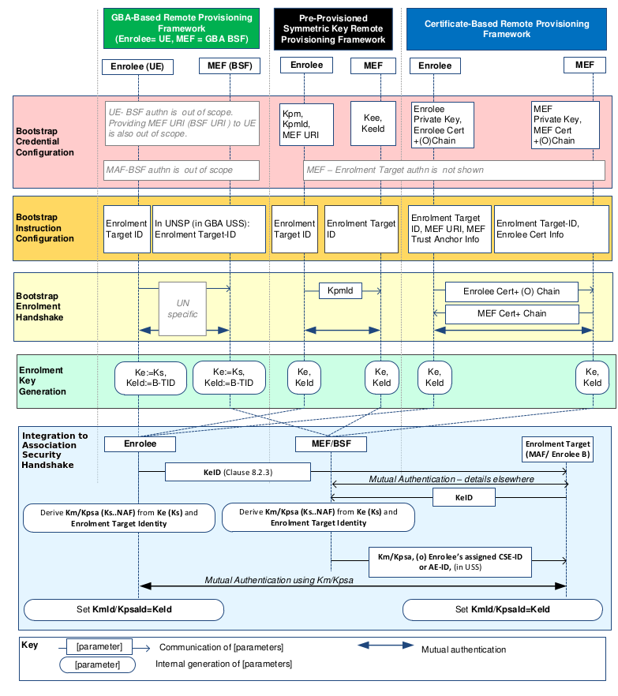
Figure 8.3.1.2-1: Overview of the Remote Security Provisioning Frameworks supported by oneM2M

8.3.2 Detailed Remote Security Provisioning Framework

8.3.2.1 Pre-Provisioned Symmetric Key Remote Security Provisioning Framework
This clause describes the Pre-Provisioned Symmetric Key Remote Security Provisioning Framework. The Bootstrap Credential for this framework is a long-term symmetric key that has been pre-provisioned into the Enrolee and M2M Enrolment Function; this key is called a Pre-Provisioned Symmetric Enrolee Key and is denoted Kpm.
NOTE 1: Long term Pre-Provisioned Symmetric Enrolee Keys can pose a security risk if not adequately secured, and for this reason it is recommended that Long term Pre-Provisioned Symmetric Enrolee Keys are stored in Secure Environments.
Figure 8.3.2.1-1 illustrates the sequence of events when using the Pre-Provisioned Symmetric Enrolee Key Remote Security Provisioning Framework.

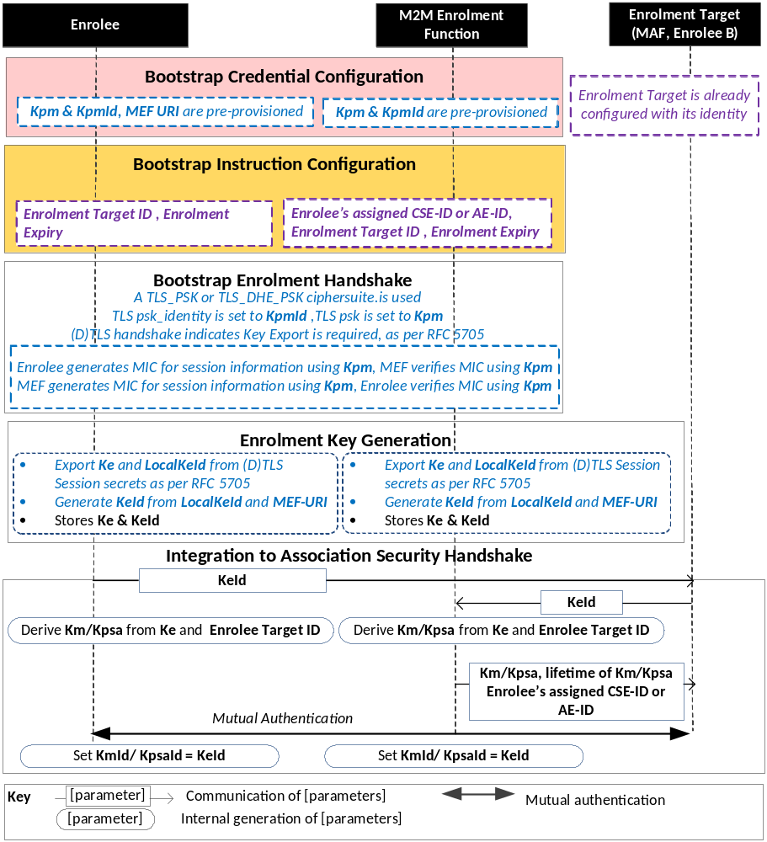
NOTE: The following font colours differentiate the general topic that the text relates to:
Black text contains Remote Security Provisioning-Framework-independent details
Blue italic text highlights details specific to this particular Remote Security Provisioning Framework.
Purple italic text highlights technical actions that may include steps not specified by oneM2M.

Figure 8.3.2.1-1: The sequence of events when using
the Pre-Provisioned Symmetric Key Remote Security Provisioning Framework
Bootstrap Credential Configuration: The Pre-Provisioned Symmetric Enrolee Key (Kpm) and the corresponding Pre-Provisioned Symmetric Enrolee Key Identifier, denoted KpmId, are pre-provisioned to both entities. The Enrolee is also pre-provisioned with the M2M Enrolment Function's URI (MEF URI), for the purpose of routing the (D)TLS exchange.
NOTE 2: This pre-provisioning (by definition) uses mechanisms not specified by oneM2M.
Bootstrap Instruction Configuration: The Enrolee and M2M Enrolment Function are configured with the information needed for authorizing the remote provisioning:
- The Enrolee is configured with (or otherwise obtains) the following arguments to initiate remote provisioning:
- The Enrolment Target identity: Identifying the Enrolment Target for which the Enrolee is to be provisioned.
- The Enrolee associates these arguments with the M2M Enrolment Function. The M2M Enrolment Function can be identified to the Enrolee using the Pre-Provisioned Symmetric Enrolee Key Identifier (KpmId) or the M2M Enrolment Function URI.
Enrolment Expiry: Life Time to be applied for the key generated, i.e. Ke as mentioned in clause 10.7.
- M2M Enrolment Function is configured with the following arguments to authorize the M2M Enrolment Function to remotely provision the Enrolee for an Enrolment Target:
- The Enrolment Target Identity: Identifying the Enrolment Target for which the Enrolee is to be provisioned.
- Enrolee's assigned CSE-ID or AE-ID (Enrolee-ID). The M2M Enrolment Function is to provide this entity identity for the Enrolee with the Km or Kpsa to the Enrolment Target, when requested by the Enrolment Target.
- The M2M Enrolment Function associates these arguments with an Enrolee. The Enrolee can be identified to the M2M Enrolment Function using the Pre-Provisioned Symmetric Enrolee Key Identifier (KpmId).
Enrolment Expiry: Life Time to be applied for the keys generated, i.e. Ke. The M2M Enrolment Function may provides this lifetime along with Km or Kpsa to the Enrolment Target.
Bootstrap Security Handshake: The Enrolee and M2M Enrolment Function perform a (D)TLS-PSK handshake [15] to establish a secure session.
- The "psk_identity" parameter [15] is set to the value of the Pre-Provisioned Symmetric Enrolee Key Identifier (KpmId).
- The "psk" parameter [15] is set to the value of the Pre-Provisioned Symmetric Enrolee Key (Kpm).
- The (D)TLS cipher suite profile for this 's assigned CSE-ID or AE-ID is specified in clause 10.2.2 "TLS and DTLS Ciphersuites for TLS-PSK-Based Security Frameworks".
Enrolment Key Generation:
- The Enrolment Key (Ke) and RelativeKeId is generated from the (D)TLS session secrets by the Enrolee and M2M Enrolment Function using TLS Key Export (IETF RFC 5705 [18]), as described in clause 10.3.1 "TLS Key Export Details".
- The Enrolment Key Identifier (KeId) is generated from the RelativeKeId and the M2M Enrolment Function's FQDN by the Enrolee and M2M Enrolment Function, as described in clause 10.3.4 "Generating KeId".
- The Enrolee and M2M Enrolment Function store the Enrolment Key (Ke) and Enrolment Key Identifier (KeId).
NOTE 2: The Enrolment Key Generation for the Pre-Provisioned Symmetric Enrolee Key Remote Security Provisioning Framework is identical to the Enrolment Key Generation for the Certificate-Based Remote Security Provisioning Framework.
Integration to the Association Security Handshake: See "Overview of Remote Security Provisioning Frameworks" in clause 8.3.1.
NOTE: An Enrolment Target and Enrolee can establish a fresh (D)TLS-PSK handshake using Km or Kpsa at any time within the Enrolment Expiry as described in 10.7. The lifetime of that (D)TLS security association between the Enrolee and the Enrolment Target cannot exceed the Enrolment Expiry value provisioned during the Enrolment Process. If the Enrolment Expiry is exceeded and if the Enrolee initiates a new (D)TLS-PSK handshake towards the the Enrolment Target, the Enrolment Target must reject the handshake procedure, which indicates that the Enrolee has to re-initiate the Remote Security Provisioning procedures as described in this section. at it The Enrolment Target must erase the credential-Id and all the credentials associated with the particular Enrolee.

8.3.2.2 Certificate-Based Remote Security Provisioning Framework
This clause describes the Certificate-Based Remote Security Provisioning Framework. The Bootstrap Credentials for this framework are Certificates.
Figure 8.3.2.2-1 illustrates the sequence of events when using the Certificate-Based Remote Security Provisioning Framework.
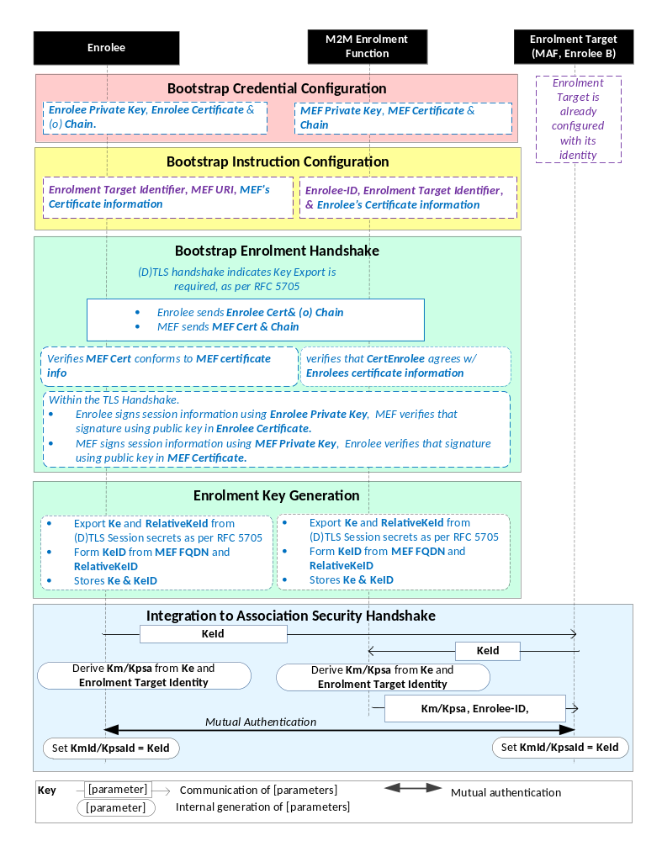
NOTE: The following font colours differentiate the general topic that the text relates to:
Black text contains Remote Security Provisioning -Framework-independent details.
Blue italic text highlights details specific to this particular Remote Security Provisioning Framework.
Purple italic text highlights technical actions that may include steps not specified by oneM2M.
Red italic text highlights security-related properties.

Figure 8.3.2.2-1: The sequence of events when using
the Certificate-Based Remote Security Provisioning Framework
Bootstrap Credential Configuration: For this Remote Security Provisioning Framework, Enrolee and M2M Enrolment Function authenticate each other using a Public Key Certificate. The Bootstrap Credentials for the Enrolee and M2M Enrolment Function are pre-provisioned as described in clause 8.1.2.3 "Credential Configuration for Certificate-Based Security Frameworks".
NOTE 1: The identities of the M2M Enrolment Function and Enrolment Target are assumed to have been configured prior to this phase.
Bootstrap Instruction Configuration: The Enrolee and M2M Enrolment Function are configured with the information needed for authorizing the remote provisioning:
- The Enrolee is configured with (or otherwise obtains) the following arguments to initiate remote provisioning:
- The URI of the M2M Enrolment Function which will facilitate the remote provisioning, for the purpose of routing the (D)TLS exchange.
- Information needed for certificate authentication of the M2M Enrolment Function using an MEF certificate as described in clause 8.1.2.4 "Information Needed for Certificate Authentication of another Entity".
- The Enrolment Target Identity : Identifying the Enrolment Target for which the Enrolee is to be provisioned.
- The M2M Enrolment Function is configured with the following arguments describing Enrolee authorized to perform Security Handshake with M2M Enrolment Function:
- Information needed for certificate authentication of the Enrolee, as described in clause 8.1.2.4 "Information Needed for Certificate Authentication of another Entity".
- The Enrolment Target Identity : Identifying the Enrolment Target for which the Enrolee (authenticated using the above Enrolee Certificate information) is to be provisioned.
- The Enrolee's assigned CSE-ID or AE-ID (Enrolee-ID). The M2M Enrolment Function is to provide this entity identity for the Enrolee with the Km or Kpsa to the Enrolemnt Target, when requested by the Enrolment Target.
Bootstrap Security Handshake: The Enrolee and M2M Enrolment Function perform a (D)TLS handshake as specified in TLS 1,2 IETF RFC 5246 [5] and DTLS 1.2 IETF RFC 6347 [6] specifications.to establish a secure session.
- Each entity (Enrolee and M2M Enrolment Function) verifies the other entity's certificate as described in clause 8.1.2.5 "Certificate Verification".
- The Enrolee and M2M Enrolment Function authenticate each other using the validated certificates as specified in TLS 1.2 IETF RFC 5246 [5] and DTLS 1.2 IETF RFC 6347 [6] specifications.
- The (D)TLS cipher suite profile for this 's assigned CSE-ID or AE-ID is specified in clause 10.2.3 "TLS and DTLS Ciphersuites for Certificate-Based Security Frameworks".
Enrolment Key Generation:
- The steps are identical to those shown for "Enrolment Key Generation" in clause 8.3.2.1 "Pre-Provisioned Symmetric Key Remote Security Provisioning Framework".
Integration to the Association Security Handshake: See "Overview of Remote Security Provisioning Frameworks" in clause 8.3.1.

8.3.2.3 GBA-Based Remote Security Provisioning Framework
To share a long term Master Credential (Km) or Provisioned Secure Connection Key (Kpsa) between an Application Service/Middle Node and an Enrolment Target, the M2M Application Service/Middle Node shall perform a successful GBA bootstrapping and derive a NAF key (Ks_(ext/int)_NAF). This NAF key is the Master Credential (Km) or Provisioned Secure Connection Key (Kpsa).
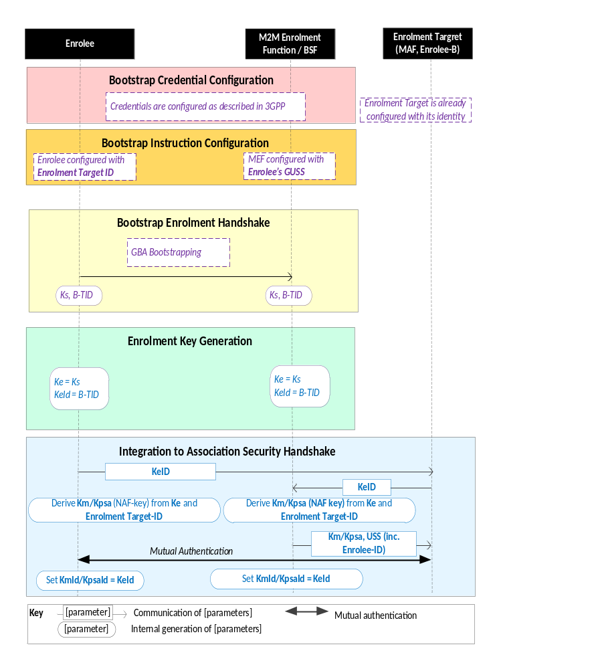
NOTE: The following font colours differentiate the general topic that the text relates to:
Black text contains Remote Security Provisioning -Framework-independent details.
Blue italic text highlights details specific to this particular Remote Security Provisioning Framework.
Purple italic text highlights technical actions that may include steps not specified by oneM2M.
Figure 8.3.2.3-1: The sequence of events when using
the GBA-Based Remote Security Provisioning Framework
Bootstrap Credential Configuration: The credentials configuration for Enrolee and M2M Enrolment Function (MEF) is described in 3GPP specification 3GPP TS 33.220 [13]. The MEF plays the role of the BSF. The credentials used to perform mutual authentication between Enrolee and MEF are UNSP specific.
Bootstrap Instruction Configuration: The Enrolee, the MEF and the Enrolment Target shall be configured with the information needed for authorizing the remote provisioning.
- The Enrolee shall be configured with the Enrolment Target Identity: identifying the Enrolment Target for which the Enrolee is to be provisioned.
- The MEF shall be configured with the Enrolee-ID and the Enrolment Target Identity:
- The Enrolment Target Identity: Identifying the Enrolment Target for which the Enrolee (authenticated using the GBA) is to be provisioned.
- The Enrolee's assigned CSE-ID or AE-ID (Enrolee-ID), The M2M Enrolment Function is to provide this entity identity for the Enrolee with the Km or Kpsa to the Enrolment Target, when requested by the Enrolment Target.
- Enrolee's GBA User Security Settings (GUSS) enables indicating if Enrolee is allowed to establish a NAF-specific key with the Enrolment Target or/and if the BSF can distribute a NAF specific key to the Enrolment Target.
Bootstrap Enrolment Handshake:
The Bootstrap Enrolment Handshake enables the establishment of a GBA bootstrapped key (Ks) shared between the Enrolee and the MEF with associated Bootstrapping Transaction Identifier ( B-TID) and key lifetime, by performing to the GBA Bootstrapping phase described in 3GPP TS 33.220 [13].
If a bootstrapped key Ks is already shared between Enrolee and the MEF and still valid, then the Bootstrap Enrolment Handshake phase is not needed. The Enrolment Key Generation phase can take place with the existing GBA Bootstrapped key Ks.
Enrolment Key Generation phase:
The Enrolment Key (Ke) shall be the GBA Bootstrapped key (Ks) established during the Bootstrap Enrolment Handshake.
The Enrolment Key Identifier (Ke-ID) shall be the Bootstrapping Transaction Identifier ( B-TID) generated during the Bootstrap Enrolment Handshake.
Integration to the Association Security Handshake:
- The Enrolee and the Enrolment Target shall establish the Master Credential (Km) or the Provisioned Secure Connection Key (Kpsa) thanks to procedures described in 3GPP TS 33.220 [13] using the Enrolment Key (Ke) as GBA bootstrapped key Ks and the Enrolment Key Identifier (Ke-ID) as B-TID. The Enrolment Target plays the role of a NAF.
- The Enrolee and the Enrolment Target shall establish NAF-specific key(s) as described in 3GPP TS 33.220 [13]. A key lifetime is associated to the NAF-specific keys. The Enrolment Target also receives the Enrolee's User Security Settings (USS) from the MEF/BSF:
    - The FQDN of the NAF, used as input to generate the Ks_(int/ext)_NAF, shall be set as follows:
      - In the case where the Enrolment Target is an M2M Authentication Function, then the FQDN of the NAF is set to the FQDN of the M2M Authentication Function.
      - In the case where the Enrolment Target is a CSE, then the FQDN of the NAF is set to the public domain name representation of the CSE-ID as defined in TS-0001 [1].
    - In case of GBA_ME, NAF-specific key is Ks_NAF.
    - In case of GBA_U, NAF-specific keys are Ks_int_NAF and Ks_ext_NAF.
- The Master Credential (Km) ) or the Provisioned Secure Connection Key (Kpsa) shall be the NAF-specific key:
- In case of GBA_ME, Km/Kpsa = Ks_NAF.
- In case of GBA_U, Km/Kpsa = Ks_int_NAF if HTTP Client application resides in the UICC. Otherwise, Km/Kpsa = Ks_ext_NAF.
- The Enrolee and the Enrolment Target shall set the Master Credential Identifier (Km-Id) or the Provisioned Secure Connection Key Identifier (Kpsa-Id) to the value of KeId.
Enrolee and Enrolment Target shall perform (D)TLS-PSK handshake (IETF RFC 4279 [15]) with the Master Credential (Km) or Provisioned Secure Connection Key (Kpsa) as Pre-Shared Key in compliance with clause 10.2.2 "TLS and DTLS Ciphersuites for TLS-PSK-Based Security Frameworks". If UICC is used as Secure Environment supporting Remote Security Provisioning, GBA-U with Km/Kpsa = Ks_int_NAF shall be used for authentication and key exchange.

-----------------------End of change 4-------------------------------------------

-----------------------Start of change 5-------------------------------------------

8.4 End-to-End Security of Primitives (ESPrim)

8.4.1 Purpose of E2E Security of Primitives (ESPrim)
End-to-End Security of Primitives (ESPrim) provides an interoperable framework for securing oneM2M primitives so CSEs (forwarding the primitive) do not need to be trusted with the confidentiality and integrity of the primitive. ESPrim provides mutual authentication, confidentiality, integrity protection and a freshness guarantee (bounding the age of ESPrims).
Applicable use cases and requirements are discussed in TR-0012 [i.16].
The present document assumes that the ESPrim end-points are the Originator and Receiver of the primitive.
The present document specifies credential management aspects and data protection aspects for ESPrim. Transport of ESPrims is described in TS-0001 [1].

8.4.2 End-to-End Security of Primitives (ESPrim) Architecture

The credential management aspects and data protection aspects for ESPrim are specified in the present clause. Clause 11.3.2, TS-0001 [1] specifies the transport of ESPrims.
The primitive to be secured is called the inner primitive, and the primitive which is used to transport a secured inner primitive is called the outer primitive. The inner primitive is protected using encryption and integrity protection which takes a symmetric key sessionE2EPrimitiveKey as input. The sessionESPrimKey is derived from a pairwiseESPrimKey, established between the Originator and Receiver, and and a receiverE2ERandObject and originatorE2ERandObject.
Sequence of events for ESPrim consists of three main phases:
- Establishing pairwiseESPrimKey.
- Establishing sessionESPrimKey at the Originator.
- Securing a primitive exchange.
Figures 8.4.2-1 shows the ESPrim message flow for establishing pairwiseESPrimKey and sessionESPrimKey at the Originator. Figure 8.4.2-2 shows the ESPrim message flow for securing a Primitive Exchange.

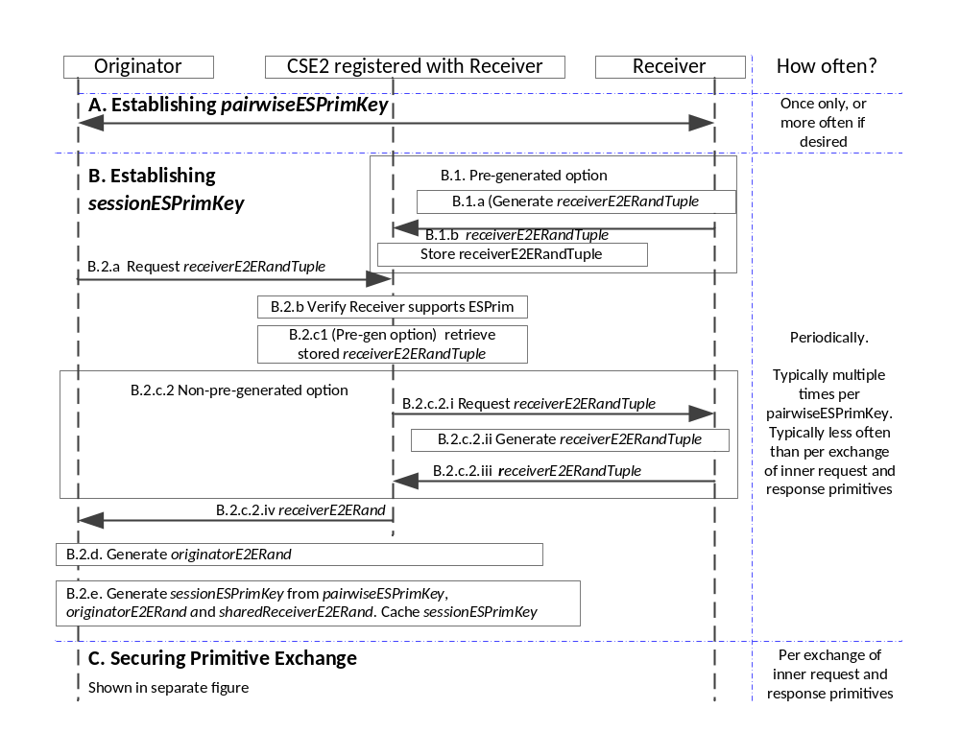
Figure 8.4.2-1: Message flow for establishing pairwiseESPrimKey and establishing sessionESPrimKey at the Originator in the End-to-End Security of Primitives (ESPrim) Procedure.
- Establishing pairwiseESPrimKey: The pairwiseESPrimKey may be established using either of the following frameworks:
  - Provisioned pairwiseESPrimKey Framework: The Originator and Receiver shall be provisioned with pairwiseESPrimKey. This credential shall be provisioned via one of
    - Pre-provisioning;
    - a Remote Security Provisioning Frameworks (RSPF), specified in clause 8.3, or
    - Certificate based End-to-End Security Key Establishment between the Originator and Receiver, specified in clause 8.z “End-to-End Security Key Establishment”.
Editor’s note: The term “End-to-End Security Key Establishment” needs to be added to the definitions in clause 3.1. At present this is intended to occur when the End-to-End Security Key Establishment specification text is provided.
The Originator and Receiver also establish pairwiseESPrimKeyId and optionally pairwiseESPrimKeyLifetime during this process. If no pairwiseESPrimKeyLifetime, is provided, then then pairwiseESPrimKey never expires. The Originator and Receiver cache the (pairwiseESPrimKeyId, pairwiseESPrimKey, (optional) pairwiseESPrimKeyLifetime) object to use for processing subsequent primitives.
  - MAF ESPrim Framework: The Originator and M2M Authentication Function (MAF) authenticate each other using symmetric keys (which may be pre-provisioned or remotely provisioned) and derive a M2M Secure Connection key (Kc) and corresponding key identifier (KcId). The Originator generates pairwiseESPrimKey from Kc and a reserved string. The value of KcId is used in phase C as the pairwiseESPrimKeyId in the JWE/XML-ENC object. The Originator caches the (pairwiseESPrimKeyId, pairwiseESPrimKey) pair to use for processing subsequent primitives. The Receiver retrieves Kc and a credential lifetime from the MAF after it receives an inner request primitive secured using the corresponding pairwiseESPrimKey’ see step C.6.a.
When pairwiseESPrimKey is established using the MAF option, then it typically has a shorter lifetime than the former option.
  - Receiver indicate support for ESPrim: If Receiver supports ESPrim, the Receiver shall ensure the following for the Receiver’s <remoteCSE> resource on all CSEs with which the Receiver is registered:
    - The Receiver’s <remoteCSE> resource shall include the e2ESecurityCapability attribute
    - The e2ESecurityCapability attribute in this resource shall indicate support for ESPrim.
- Establishing sessionESPrimKey at the Originator: The Receiver shall select to either (a) pre-generate a receiverE2ERandObject which is distributed for use by multiple Originators for establishing sessionESPrimKey, or (b) generate a unique receiverE2ERandObject upon request (in which case no action is required prior to receiving such a request).
  - (If the Receiver selected to use pre-generation) Receiver pre-generation of sharedReceiverE2ERandObject:
    - If the Receiver selects to generate a unique receiverE2ERandObject upon request, then In the latter case, the Receiver shall ensure that the sharedReceiverE2ERandObject parameter is not present in the e2eSecurityCapabilities attribute in the Receiver’s <remoteCSE> resource on all CSEs to which the Receiver is registered. The absence of the sharedReceiverE2ERandObject parameter indicates that the Receiver will provide a unique receiverE2ERandObject upon request.
If the Receiver selected to pre-generate and distribute a receiverE2ERandObject, the Receiver performs the following steps every time the Receiver wishes to provide a new shared receiverE2ERandObject
      - The Receiver shall generate a receiverE2ERandObject including the following parameters:
        - The Receiver shall generate a 128-bit fresh random value Value.
        - The Receiver shall assign Expiry, indicating when the receiverE2ERandObject shall cease to be valid.
        - The Receiver shall assign a receiverE2ERandObjectIdentifier satisfying the following criteria: (a) the receiverE2ERandObjectIdentifier shall indicate that the receiverE2ERandObject is shared; (b) the receiverE2ERandObjectIdentifier shall be unique among the shared receiverE2ERandObject issued by the Receiver and valid at the time of issuance. These criteria ensure that the receiverE2ERandObject can be uniquely identified until it expires.
        - The Receiver shall include sessionESPrimKeyGenerationAlgorithmId identifier for algorithms that the Receiver is willing to use for generating sessionESPrimKey using this receiverE2ERandObject.
        - The Receiver shall include AEADAlgorithmId identifier for AEAD algorithms that the Receiver is willing to use with this receiverE2ERandObject.
    - The Receiver shall update the sharedReceiverE2ERandObject parameter of the e2eSecurityCapabilities attribute in the Receiver’s <remoteCSE> resource on all CSEs to which the Receiver is registered.
NOTE: At a given point in time, multiple Originators will be using identical values for the current sharedReceiverE2ERand.
  - Originator obtaining receiverE2ERandObject: The Originator shall perform the following steps whenever the Originator establishes a sessionESPrimKey with the Receiver.
    - The Originator shall perform a Retrieve on the e2ERandLink virtual attribute in the Receiver’s <remoteCSE> resource on a CSE, here denoted CSE2, with which the Receiver is registered.
    - CSE2 examines the e2ESecurityCapability attribute in the Receiver <remoteCSE> resources to determine if the Receiver supports ESPrim. If the Receiver does not support ESPrim, then the CSE2 returns an error message to the Originator and sessionESPrimKey establishment is aborted.
    - CSE2 obtains receiverE2ERandObject
      - (If the Receiver has recently provided a pre-generated receiverE2ERandObject) If the following conditions are met:
        - A sharedReceiverE2ERandObject parameter is present in the e2ESecurityCapability attribute of the Receiver’s <remoteCSE> resource, and
        - The Expiry in sharedReceiverE2ERandObject has not expired,
then CSE2 shall send a Retrieve response with the sharedReceiverE2ERandObject in the Content parameter.
      - (If the Receiver did not choose to use pre-generation). Otherwise,
        - CSE2 shall send a message to the Receiver requesting a receiverE2ERandObject.
        - The Receiver, upon receiving such a request, shall generate a receiverE2ERandObject including the following parameters:
          - The Receiver shall generate a 128-bit fresh random value Value.
          - The Receiver shall assign Expiry, indicating when the receiverE2ERandObject shall cease to be valid.
          - The Receiver shall assign an receiverE2ERandObjectIdentifier satisfying the following criteria: (a) the receiverE2ERandObjectIdentifier shall indicate that the receiverE2ERandObject is not shared; (b) the receiverE2ERandObjectIdentifier shall be unique among the non-shared receiverE2ERandObject issued by the Receiver and valid at the time of issuance. These criteria ensure that the receiverE2ERandObject can be uniquely identified until it expires.
          - The Receiver shall include sessionESPrimKeyGenerationAlgorithmId identifier for algorithms that the Receiver is willing to use for generating sessionESPrimKey using this receiverE2ERandObject.
          - The Receiver shall include AEADAlgorithmId identifier for AEAD algorithms that the Receiver is willing to use with this receiverE2ERandObject.
        - The Receiver shall reply to the CSE2 with the receiverE2ERandObject.
        - CSE2 shall send a Retrieve response with the received receiverE2ERandObject in the Content parameter.
    - The Originator shall generate an originatorE2ERandObject including the following parameters:
          - The Originator shall generate a 128-bit fresh random value Value.
          - The Originator shall assign Expiry, indicating when the originatorE2ERandObject shall cease to be valid. The Expiry is not later than the Expiry in the receiverE2ERand.
          - The Originator shall assign an originatorE2ERandObjectIdentifier satisfying the following criteria: (a) the originatorE2ERandObjectIdentifier shall indicate that the receiverE2ERandObject is not shared; (b) the originatorE2ERandObjectIdentifier shall be unique among the non-shared originatorE2ERandObject issued by the Originator and valid at the time of issuance. These criteria ensure that the originatorE2ERandObject can be uniquely identified until it expires.
          - The Originator shall include sessionESPrimKeyGenerationAlgorithmId identifier for algorithms that the Originator is using for generating sessionESPrimKey using this originatorE2ERandObject. This shall be one of the algorithms identified by sessionESPrimKeyGenrationAlgorithmId in receiverE2ERandObject
          - The Originator shall include AEADAlgorithmId identifier for AEAD algorithms that the Originator is willing to use with this originatorE2ERandObject. This shall be one or more of the algorithms identified by AEADAlgorithmId in receiverE2ERandObject.
    - The Originator shall generate the sessionESPrimKey from the pairwiseESPrimKey, receiverE2ERand Tuple received at step B.2.c and originatorE2ERandTuple generated at step B.2.d.
Editor’s note: Further specific details could be added here as part of the stage 3 details.
NOTE: The sessionESPrimKey used to secure an inner request primitive is always used to protect the corresponding inner response primitive, so sessionESPrimKey should be cached at least until the corresponding inner response primitive is expected to have been received. The Originator typically caches the sessionESPrimKey for a longer period of time since the sessionESPrimKey may be used for securing multiple primitive exchanges.
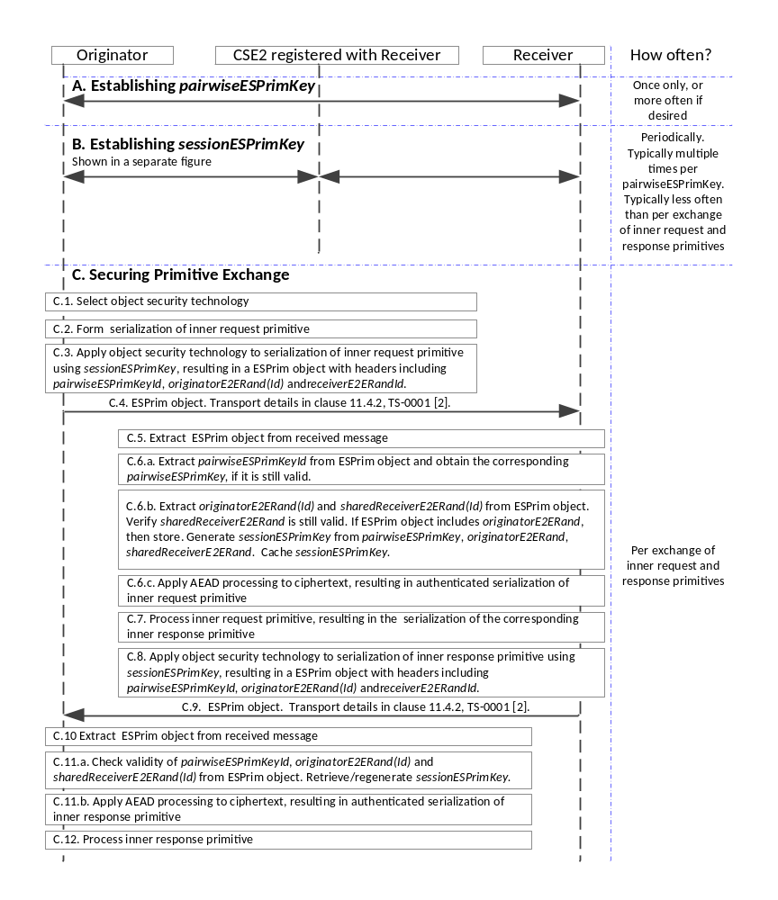
Figure 8.4.2-2: Message flow for securing a primitive exchange in the End-to-End Security of Primitives (ESPrim) Procedure.
- Securing a Primitive Exchange
NOTE: The Originator selects the type of serialization (e.g. JSON, XML) of the inner request primitive to be secured.
  - The Originator selects the object security technology depending on the object security technology supported by the Originator, and the type of serialization of the inner request primitive.
Editor’s note: Further specific details could be added here as part of the stage 3 details.
  - The Originator shall form the serialization of the inner request primitive.
  - The Originator shall produce a ESPrim Object by applying the object security technology as follows:
    - One or more headers of the a ESPrim Object shall include the following information
      - pairwiseESPrimKeyId
      - originatorE2ERandTuple used to generate the sessionESPrimKey, or the corresponding originatorE2ERandTupleId. If there is the possibility that this ESPrim Object could be the first ESPrim Object received by the Receiver which is secured by the Originator using a specific originatorE2ERand, then the full originatorE2ERandTuple shall be included. Otherwise, one of originatorE2ERandTuple or originatorE2ERandTupleId shall be included.
      - receiverE2ERandTupleId of the receiverE2ERandTuple used to generate the sessionESPrimKey.
      - AEADAlgorithmId for the ESPrim Object. This shall be one of the AEAD algorithms identified in originatorE2ERandTuple.
    - The plaintext (to be encrypted) shall be the serialization of the inner request primitive.
    - The sessionESPrimKey shall be used directly as the symmetric key providing authenticated encryption of the plaintext, resulting in the ciphertext in the ESPrim Object. The ciphertext is assumed to include the MIC for verifying integrity of the inner request primitive.
  - The Originator shall form an outer request primitive for transporting the ESPrim Object as described in in TS-0001 [1]. The Originator shall send the outer request primitive to the Receiver.
  - The Receiver processes the received outer request primitive to extract the ESPrim Object as described in in TS-0001 [1].
  - The Receiver shall process the ESPrim Object.
Editor’s note: The step numbers within C.6 are currently not aligned with TS-0001. One or both of the specifications may need editorial changes to align the steps
    - The Receiver shall extract the pairwiseESPrimKeyId from the ESPrim Object headers and obtain the corresponding pairwiseESPrimKey:
If the pairwiseESPrimKeyId is of the form for a Provisioned pairwiseESPrimKey, then the Receiver shall use the corresponding (previously-provisioned) pairwiseESPrimKey.
If the pairwiseESPrimKeyId is of the form for a MAF pairwiseESPrimKey: If this this is the first time that the Receiver received a message with this pairwiseESPrimKeyId, then the following process shall be performed.
      - The Receiver shall identify the MAF from the pairwiseESPrimKeyId (which is a KcId)
      - The Receiver shall establish a secure TLS connection to the MAF. and request the M2M Secure Connection key (Kc) and Kc Lifetime corresponding to pairwiseESPrimKeyId (which is identical to KcId).
      - The MAF shall provide Kc and Kc Lifetime to the Receiver.
      - The Receiver shall generate the pairwiseESPrimKey from Kc and a reserved string.
      - The Receiver shall set pairwiseESPrimKeyLifetime to Kc Lifetime.
      - The Receiver shall cache (pairwiseESPrimKeyId, pairwiseESPrimKey, pairwiseESPrimKeyLifetime) for use for processing subsequent primitives.
If the Receiver has previously cached (pairwiseESPrimKeyId, pairwiseESPrimKey, pairwiseESPrimKeyLifetime), and pairwiseESPrimKeyLifetime has not yet expired, then the Receiver may use the cached pairwiseESPrimKey,
    - The Receiver shall apply the following process to generate the sessionESPrimKey.
      - The Receiver shall extract receiverE2ERandId from the headers of the ESPrim object, and attempt to retrieve the corresponding cached value of receiverE2ERand. If no cached value is found, or the cached value is expired, then the Receiver shall respond to the outer request primitive with an error.
      - The Receiver shall extract the encoding of the originatorE2ERand or originatorE2ERandId from the headers of the ESPrim object, and apply the appropriate decoding. If originatorE2ERand is provided then it shall be cached. If originatorE2ERandId is provided then the Receiver shall retrieve the corresponding cached value of originatorE2ERand.If no cached value is found, or the cached value is considered expired, then the Receiver shall respond to the outer request primitive with an error message.
The Receiver shall process the originatorE2ERand.
        - The Receiver shall check the Expiry in the originatorE2ERand to verify (a) that this Expiry is not already in the past and (b) the Expiry is not later than the Expiry in the receiverE2ERandTuple.
        - The Receiver shall extract sessionESPrimKeyGenerationAlgorithmId and verify that the identified algorithm matches one of the sessionESPrimKeyGenerationAlgorithmId in receiverE2ERandTuple.
        - The Receiver shall generate the sessionESPrimKey from the pairwiseESPrimKey, receiverE2ERand Tuple and originatorE2ERandTuple or retrieve the value of sessionESPrimKey if previously generated and cached.
NOTE: The sessionESPrimKey used to secure an inner request primitive is always used to protect the corresponding inner response primitive, so sessionESPrimKey should be cached at least until the corresponding inner response primitive is sent. The Receiver typically caches the sessionESPrimKey for a longer period of time since the originator may use the sessionESPrimKey for securing multiple primitive exchanges.
Editor’s note: Further specific details could be added here as part of the stage 3 details.
    - Authenticated decryption steps at the Receiver:
      - The Receiver shall extract AEADAlgorithmIds in originatorE2ERand and verify that the identified set of algorithms is a subset of the set in AEADAlgorithmIds in receiverE2ERandTuple.
The Receiver shall process the AEADAlgorithmId in the ESPrim Object headers and verify that the identified algorithm matches one of the AEADAlgorithmIds in originatorE2ERandTuple.
      - The Receiver shall apply the AEAD Algorithm identifier in the ESPrim Object header to the ciphertext parameter in the ESPrim Object resulting in verified plaintext, using The sessionESPrimKey, The ciphertext is assumed to include the MIC for verifying integrity of the inner request primitive. The authenticated serialization of the inner request primitive is the verified plaintext output by the AEAD algorithm.
  - The Receiver shall process the inner request primitive, resulting in a serialization of the corresponding inner response primitive.
NOTE: Steps C.2 to C.7 are mirrored closely by C.8 to C.12, with the Originator and Receiver swapping their participation in the exchange, and the request primitives replaced by response primitives. There are minor differences: in particular some processing in Steps C for the request processing is not required in the response processing since the Originator has already generated sessionESPrimKey; it is only necessary to identify the appropriate sessionESPrimKey, as performed in step C.11.a.
  - The Receiver shall use the same sessionESPrimKey as used in the ESPrim Object received at step C.5. Consequently, pairwiseESPrimKeyId, originatorE2ERandTuple and receiverE2ERandTuple are the same as for the received at step C.5
The Receiver shall produce an ESPrim Object by applying the object security technology as follows:
    - One or more headers of the a ESPrim Object shall include the following information
      - pairwiseESPrimKeyId
      - originatorE2ERandTupleId.
      - receiverE2ERandTupleId
      - AEADAlgorithmId for the ESPrim Object. This shall be one of the AEAD algorithms identified in originatorE2ERandTuple.
    - The plaintext (to be encrypted) shall be the serialization of the inner response primitive.
    - The sessionESPrimKey shall be used directly as the symmetric key providing authenticated encryption of the plaintext, resulting in the ciphertext in the ESPrim Object. The ciphertext is assumed to include the MIC for verifying integrity of the inner request primitive.
  - The Receiver shall form an outer request primitive for transporting the ESPrim Object as described in in TS-0001 [1]. The Originator shall send the outer response primitive to the Receiver.
  - The Originator processes the received outer response primitive to extract the ESPrim Object as described in TS-0001 [1].
  - The Originator shall process the ESPrim Object.
Editor’s note: The step numbers within C.6 are currently not aligned with TS-0001. One or both of the specifications may need editorial changes to align the steps
    - The Originator shall extract, from the headers of the ESPrim object, the values of pairwiseESPrimKeyId, originatorE2ERandId, receiverE2ERandId. These values shall match the pairwiseESPrimKeyId, originatorE2ERandId, receiverE2ERandId of a session that the Originator considers to be currently valid.
If any of these values have expired, then the outer response primitive is discarded.
NOTE: For this reason, the expiry of these values need to be great enough to allow receiving the corresponding inner response primitive.
Otherwise, the Originator shall use the cached value of sessionESPrimKey corresponding to these values, or may regenerate sessionESPrimKey.
    - The Originator shall apply the AEAD Algorithm identified in the ESPrim Object header to the ciphertext parameter in the ESPrim Object resulting in verified plaintext, using sessionESPrimKey, The ciphertext is assumed to include the MIC for verifying integrity of the inner request primitive. The authenticated serialization of the inner request primitive is the verified plaintext output by the AEAD algorithm.
  - The Originator shall process the inner response primitive.

8.5 End-to-End Security of Data (ESData)

8.5.1 Purpose of ESData
End-to-End Security of Data (ESData) provides an interoperable framework for protecting data that ends up transported using oneM2M reference points, in order that so transited CSEs do not need to be trusted with that data. The data to be protected is called the ESData Payload. ESData payload could typically compose all or part of an attribute value (e.g. content attribute value of a <contentInstance> resource) or a primitive parameter (e.g. a signed, self-contained access token communicated in a request primitive to obtain dynamic authorization).
NOTE: Within the scope of clause 8.5, terms including the word “ESData” can be shortened by removing “ESData” to facilitate readability. For example, “ESData Payload” is often shortened to “Payload”.
Applicable use cases and requirements are discussed in TR-0012 [i.16].
ESData assumes that there is a single ESData Source End-Point applying the ESData processing to the Payload to obtain an ESData Envelope containing the secured data and necessary headers, with one or more ESData Target End-Points applying the ESData processing to the Envelope to extract the verified data. The Payload is composed of plaintext (which is to be encrypted and integrity protected) and associated authenticated data (which is to be integrity protected only).
There is no inherent restriction on which entities can be Source End-points and Target End-Points; these end-points may be entities inside a oneM2M system (that is, AEs and CSEs) or entities outside of a oneM2M system (for example, entities which are part of a system that interworks with oneM2M).
The present document specifies credential management aspects and data protection aspects for ESData. The present document does not address transporting ESData Envelopes.

8.5.2 ESData Architecture

8.5.2.1 List of ESData Security Classes and ESData Protection Options
The following ESData security classes are provided:
- Encryption only: (see Note 1) which offers confidentiality and integrity protection. This payload is protected using symmetric keys, and these symmetric keys are established using one or more of the following:
  - Symmetric keys otherwise established with the target end-points. In this case, the source end-point can be authenticated – unless the symmetric key was shared with multiple target end-points.
  - Target end-points certificate. When target end-point certificate are used, the target end-point cannot authenticate the source end-point.
NOTE 1: Strictly speaking, this class provides encryption and integrity protection, but this name aligns usage in protocols such as JSON Web Encryption (JWE) and XML-Encryption which can provide both encryption and integrity protection.
- Signature only: which offers source authentication, integrity protection and (when asymmetric digital signatures are used) non-repudiation. This uses either symmetric keys based MIC or asymmetric digital signatures verified using source end-point certificates.
- Nested Sign-then-Encrypt: This is used in cases where encryption is required in addition to source authentication and/or non-repudiation using a source end-point certificate. A digital signature(s) on the payload is signed first, and then encryptions is applied to combination of the payload and digital signature.
ESData supports using multiple credentials for protecting a single payload unit.
Each ESData Security class supports three ESData protection options, as shown in Table 8.5.2.1-1
Table 8.5.2.1-1: ESData protection options
ESData Security Class | ESData Protection Option | Key Management | Source Verification | Non-Repudiation
Encryption only (8.5.2.2) | Encryption using Provisioned Symmetric ESData Key | Provisioned Symmetric Key | Symmetric | -
Encryption only (8.5.2.2) | Encryption using TEF | TEF | Symmetric | -
Encryption only (8.5.2.2) | Encryption using Target End-Point Certificate | Certificate | - | -
Signature only  (8.5.2.3) | MIC using Provisioned Symmetric ESData Key | Provisioned Symmetric Key | Symmetric | -
Signature only  (8.5.2.3) | MIC using TEF | TEF | Symmetric | -
Signature only  (8.5.2.3) | Digital Signature using End-Point Source End-Point Certificate | Certificate | Certificate | Certificate
Nested-Sign-then Encrypt  (8.5.2.4) | Digital Signature using End-Point Source End-Point Certificate followed by any combination of Encryption-Only Protection Options | Provisioned Symmetric Key(s) and/or TEF(s) and/or Certificate(s) for Encryption. Certificate for Signature | Certificate | Certificate

8.5.2.2 Encryption-Only ESData Security Class

8.5.2.2.1 Encryption-Only ESData Security Class Overview
The ESData protection option supported for the Encryption-Only Security Class are listed in Table 8.5.2.1-1 “ESData protection Options”.
Encryption-Only ESData supports encrypting using any combination of Protection Options and using multiple credentials for each protection option.
ESData Encryption Mode. ESData Security Class supports two main encryption modes:
- ESData Direct Encryption Mode: In this mode, a symmetric key is used directly in the Encryption algorithm for securing the payload. The Direct Encryption mode is recommended only in scenarios meeting the following criterions
  - Scenarios in which minimizing overhead of data objects is a very high priority.
  - The Encryption function will not be used with the same key value more than 2³² times, for the reasons discussed in clause 8.4 of [51].
This mode shall only be used when there is a single symmetric key being used to protect the payload.
- ESData Encrypted Key Mode: In this mode, the Content Encryption Key (CEK) (used in the Encryption algorithm for securing the payload) is encrypted using one or more credentials and the encrypted CEK is provided in a header with the secured data.
Encryption Mode Applicability Constraints. In scenarios where either
- Encryption using Provisioned Symmetric ESData Key is applied using a single provisioned symmetric key, or
- Encryption using TEF is applied using a single TEF-registered symmetric key,
then either Direct Encryption Mode or Encrypted Key Mode may be applied.
In all other scenarios, Encrypted Key Mode shall be applied.
High Level Sequence of Events. The following text describes the sequence of events when using an Encryption-Only Security Class.
NOTE: The present document does not describe the processes by which the Source End-Point and Target End-Point(s) decide on the credentials to be used for securing a payload, and the encryption algorithm to be applied.
- Credential Configuration: The Source End-Point obtains the credentials needed to secure the payload for the intended Target End-Point(s). This can include any combination of the Protection Options, multiple credentials allowed for each Protection Options:
  - Encryption using Provisioned Symmetric ESData Key: The Source End-Point and Target End-Point(s) are provisioned with Provisioned Symmetric ESData Key as described in clause 8.5.2.2.2 “Encryption using Provisioned Symmetric ESData Key”.
  - Encryption using TEF: The Source End-Point generates a random secret TEF-registered symmetric key, and registers this key with the TEF as described in clause 8.5.2.2.3 “Encryption using Trust Enabling Function”.
  - Encryption using Certificates: The Source End-Point obtains the certificate of the Target End-Point as described in clause 8.5.2.2.4 “Encryption using Target End-Point Certificate”.
- Source End-Point CEK Management:
  - If Direct Encryption Mode is to be applied, then the Provisioned Symmetric ESData Key or Registered TEF Symmetric Key shall be used directly as CEK. The use of Direct Encryption Mode shall be indicated in the ESData Headers: header parameters of the ESData Envelope. The Provisioned Symmetric ESData Key or Registered TEF Symmetric Key shall be identified in the headers.
  - Otherwise, the Source End-Point shall generates a random secret value for the Content Encryption Key CEK and shall encrypt CEK using the credential(s) obtained in Phase A “Credential Management”, as described in clauses 8.5.2.2.2, 8.5.2.2.3 and 8.5.2.2.4. Each encrypted CEKs shall be added to the Headers, along with the identifier for the credential which is to be used to decrypt the encrypted CEK. The CEK value may be used for a single payload or may be used for multiple payloads.
- Source End-Point Encryption:
  - The Encryption algorithm shall be identified in the Headers.
  - The Source End-Point shall apply the Encryption encryption process for the identified algorithm to the payload using CEK. The plaintext is encrypted to form the ciphertext, and the combination of plaintext and associated Authenticated Data (AAD) is integrity protected by the generated MIC.
  - The Source End-Point shall form the Envelope from the Headers, ciphertext, AAD and MIC; this process may include encoding data using, for example, base64.
The present document does not specify how the Envelope is obtained or provided to the Target End Point(s). The following steps are applied at each Target End-Point.
- Target End-Point CEK Management:
  - The Target End-Point parses the Envelope, applying any necessary encoding, and extracts the Header parameters
  - If Direct Encryption Mode is indicated in the Headers, then the Target End-Point shall use the credential identifiers in the Headers to obtain the identified Provisioned Symmetric ESData Key or Registered TEF Symmetric Key (as described in clause 8.2.2.2 or 8.5.2.2.3 respectively). The Target End-Point shall use this symmetric key directly as CEK.
  - Otherwise, the Target End-Point shall use the credential identifiers in the Headers to identify an encrypted CEK that can be decrypted by a credential known or available to the Target End-Point. The Target End-Point shall obtain that credential and decrypt the encrypted CEK as described in clauses 8.5.2.2.2 (Provisioned Symmetric ESData Key case), 8.5.2.2.3 (TEF case) and 8.5.2.2.4 (Target End-Point Certificate case). The Target shall use the resulting CEK for processing the secured payload of the Envelope. The Target End-Point may cache the CEK value due to the possibility of that CEK value being used to protect subsequent payloads.
- Target End-Point Decryption:
  - The Target End-Point shall determine the appropriate Encryption algorithm identified in the Headers.
  - The Target End-Point shall apply the Encryption decryption process for the identified algorithm to the ciphertext, AAD and MIC using CEK, outputting the verified plaintext and verified AAD.

8.5.2.2.2 Encryption using Provisioned Symmetric ESData Key
For this Protection Option, the Source End-Point and each Target End-Point shall be provisioned with Provisioned Symmetric ESData Key, Provisioned Symmetric ESData Key Identifier and optionally Provisioned Symmetric ESData Key lifetime. This credential shall be provisioned via one of
- Pre-provisioning;
- a Remote Security Provisioning Frameworks (RSPF), specified in clause 8.3, or
- Certificate based End-to-End Security Key Establishment between the Originator and Receiver, specified in clause 8.7 “End-to-End Key Establishment using Certificates”.

8.5.2.2.3 Encryption using Trust enabling Function
This Remote Provisioning Framework for End-to-end security is specified in clause 8.6.

8.5.2.2.4 Encryption using Target End-Point Certificates

8.5.2.2.4.1 Associating Public Key Certificate with Target End-Points:
For this Protection Option, each Target End-Point shall be provisioned with a public key certificate which the Source End-Point trusts to be associated with the intended Target End-Point. The following options are supported:
- The Target End-Point Certificates may use the following Public Key Certificate flavours identified in clause 8.1.2.1 “Public Key Certificate Frameworks”.
  - In the case of a Raw Public Key Certificate, the Source End-Point shall be securely configured (either directly or remotely) to associate the Target End-Point with the raw public key or its hash. The details of this configuration are not provided in the present specification.
  - In the case of a Device Certificate,
    - The Source End-Point shall be securely configured with the trust anchor in the certificate chain of the Device Certificate; typically during initial provisioning.
    - The Source End-Point shall be securely configured to associate the Target End-Point with the globally unique hardware instance identifier. The details of this configuration are nor provided in the present specification.
  - In the case of an AE-ID certificate or CSE-ID certificate, the Source-End-Point shall be securely configured with the trust anchor in the certificate chain of the AE-ID certificate or CSE-ID certificate; typically during initial provisioning. The Source End-Point then trusts that the Target End-Point with a particular AE-ID or CSE-ID is associated with the certificate that contains that AE-ID or CSE-ID.
- The Target End-Point Certificates may use other Public Key Infrastructures, particularly when the Target End-Point is in a non-oneM2M system interworking with the oneM2M system. The present document provides no interoperability guarantees when such certificates are used
Public keys for verifying signature cannot be used for this Protection Option.

8.5.2.2.4.2 Obtaining Target End-Point Certificates
The Source End-Point is unable to secure a message to the Target End-Point before obtaining the Target End-Point’s certificate. This specification does not mandate the mechanism by which the Target End-Point’s certificate is provided to the Source End-Point using any mechanism, and there are a variety of mechanisms which are suitable. The e2ESecurityParameters is a mechanism provided by oneM2M to allow the Source End-Point to retrieve certificates associated with a CSE or AE.
A Target End-Point AE may make certificates available at the e2ESecurityParameters attribute of the <AE> resource representing that AE. This retrieval process is not a reliably-secure mechanism for associating the Target End-Point with the certificate; clause 8.5.2.2.4.1 “Associating Public Key Certificate with Target End-Points” shall also be applied.
A Target End-Point CSE may make certificates available at the e2ESecurityParameters attribute of the <CSE> and <remoteCSE> resources representing that CSE. This retrieval process is not a reliably-secure mechanism for associating the Target End-Point with the certificate; clause 8.5.2.2.4.1 “Associating Public Key Certificate with Target End-Points” shall also be applied.
Editor’s Note: Consider Interworking Proxies.

8.5.2.3 Signature-Only ESData Security Class

8.5.2.3.1 Signature-Only ESData Security Class Overview
The ESData protection option supported for the Signature-Only ESData Security Class are listed in Table 8.5.2.1-1 “ESData protection Options”.
NOTE: The present specification supports only one Signature-Only ESData Protection Option, but the clause is structure to support additional Signature-Only ESData Protection Options if desired in the future.
Signature-Only ESData supports encrypting using any combination of Protection Options and using multiple credentials for each protection option.
High Level Sequence of Events. The following text describes the sequence of events when using a Signature-Only Security Class.
NOTE: The present document does not describe the processes by which the Source End-Point and Target End-Point(s) decide on the credentials to be used for signing a payload, and the algorithms to be applied.
- Credential Configuration: The Source End-Point obtains the credentials needed to sign the payload for the intended Target End-Point(s). This can include any combination of the Protection Options, multiple credentials allowed for each Protection Options:
  - MIC using Provisioned Symmetric ESData Key: The Source End-Point and Target End-Point(s) are provisioned with Provisioned Symmetric ESData Key as described in clause 8.5.2.2.2 “Encryption using Provisioned Symmetric ESData Key”.
  - MIC using TEF: The Source End-Point generates a random secret TEF-registered symmetric key, and registers this key with the TEF as described in clause 8.5.2.2.3 “Encryption using Trust Enabling Function”.
  - Digital Signature using Source End-Point Certificates: The Source End-Point selects a private key and corresponding Source End-Point Certificate as described in clause 8.5.2.3.2 “Digital Signature using Source End-Point Certificates”.
- Source End-Point Signing:
  - The Payload is encoded, for example, using base 64.
  - For each credential, the Source End-Point shall generate array of data elements as follows:
    - The Source End-Point shall form a Header, identifying the digital signature or MIC algorithm, and the credential which can be used by a Target End-Point to verify the digital signature or MIC. If required, the header is also encoded, for example using base64.
    - The Source End-Point shall generate a signature/MAC by applying the appropriate digital signature or MIC algorithm to the Payload and Header using the appropriate credential, and encoding, for example using base 64.
    - The Source End-Point shall form a data element from the Headers, Payload and signature/MAC
  - The Source End-Point shall form Envelope from the encoded Payload and the array of data elements generated at step B.2.
The present document does not specify how the Envelope is obtained or provided to the Target End Point(s). The following steps are applied at each Target End-Point.
- Target End-Point Verification:
  - The Target End-Point parses the Envelope, extracting the encoded Payload and the array of data elements, each containing a Header and a signature /MAC.
  - The Target End-Point shall examine the array of data elements to identify data elements which can be verified by a credential which may be trusted by the Target End-Point. For each such data element,
    - The Target End-Point shall obtain the identified credential according to clause 8.5.2.2.2 (Provisioned Symmetric ESData Key case), 8.5.2.2.3 (TEF case), 8.5.2.3.2 (using Source End-Point Certificate case).
    - The Target End-Point shall verify the MIC or signature in using the credential.
  - The Target End-Point shall decode the verified encoded Payload – outputting the original Payload - and shall record the credential(s) used to verify the Payload.

8.5.2.3.2 Digital Signature using Source End-Point Certificate

8.5.2.3.2.1 Associating Public Key Certificate with Source End-Point:
For this Protection Option, each Source End-Point shall be provisioned with a public key certificate which the Target End-Point trusts to be associated with the intended Source End-Point. The following options are supported:
- The Source End-Point Certificates may use the following Public Key Certificate flavours identified in clause 8.1.2.1 “Public Key Certificate Frameworks”.
  - In the case of a Raw Public Key Certificate, the Target End-Point shall be securely configured (either directly or remotely) to associate the Source End-Point with the raw public key or its hash. The details of this configuration are not provided in the present specification.
  - In the case of a Device Certificate,
    - The Target End-Point shall be securely configured with the trust anchor in the certificate chain of the Device Certificate; typically during initial provisioning.
    - The Target End-Point shall be securely configured to associate the Source End-Point with the globally unique hardware instance identifier. The details of this configuration are not provided in the present specification.
  - In the case of an AE-ID certificate or CSE-ID certificate, the Target-End-Point shall be securely configured with the trust anchor in the certificate chain of the AE-ID certificate or CSE-ID certificate; typically during initial provisioning. The Target End-Point then trusts that the Source End-Point with a particular AE-ID or CSE-ID is associated with the certificate that contains that AE-ID or CSE-ID.
- The Source End-Point Certificates may use other Public Key Infrastructures, particularly when the Source End-Point is in a non-oneM2M system interworking with the oneM2M system. The present document provides no interoperability guarantees when such certificates are used.
Public keys for verifying signatures shall be used for this Protection Option.

8.5.2.3.2.2 Obtaining Source End-Point Certificates
The Target End-Point is unable to secure a message to the Source End-Point before obtaining the Source End-Point’s certificate. This specification does not mandate the mechanism by which the Source End-Point’s certificate is provided to the Target End-Point using any mechanism, and there are a variety of mechanisms which are suitable. The e2ESecurityParameters is a mechanism provided by oneM2M to allow the Target End-Point to retrieve certificates associated with a CSE or AE.
A Source End-Point AE may make certificates available at the e2ESecurityParameters attribute of the <AE> resource representing that AE. This retrieval process is not a reliably-secure mechanism for associating the Source End-Point with the certificate; clause 8.5.2.3.2.1 “Associating Public Key Certificate with Source End-Points” must also be applied.
A Source End-Point CSE may make certificates available at the e2ESecurityParameters attribute of the <CSE> and <remoteCSE> resources representing that CSE. This retrieval process is not a reliably-secure mechanism for associating the Source End-Point with the certificate; clause 8.5.2.3.2.1 “Associating Public Key Certificate with Source End-Points” must also be applied.
Editor’s Note: Consider Interworking Proxies.

8.5.2.4 Nested Sign-then-Encrypt
For these options, the following high-level steps are performs (Credential Configuration steps and CEK Management steps are not shown):
- The Source End-Point shall generate an inner Envelope containing one or more digital signatures for the inner Payload using one or more certificates according to the “Digital Signature using Source End-Point Certificate” Signature-Only Protection Option in clause 8.5.2.3.
- The Source End-Point shall set the inner Envelope produced by Step 1 to be the plaintext of the outer Payload which is then encrypted using any combination of Encryption-Only Protection Options in clause 8.5.2.2. This results in an outer Envelope.
The present document does not specify how the outer Envelope is obtained or provided to the Target End Point(s). The following steps are subsequently applied at each Target End-Point.
- The Target End-Point shall decrypt the outer Envelope produced by Step 1 using one of the Encryption-Only Protection Options in clause 8.5.2.2, resulting in the outer Payload which is also the inner Envelope.
- The Target End-Point shall verify one or more digital signatures in the inner Envelope using one or more certificates according to the “Digital Signature using Source End-Point Certificate” Signature-Only Protection Option in clause 8.5.2.3, resulting in the verified inner Payload.

8.6 Remote Security Frameworks for End-to-End Security

8.6.1 Overview on Remote Provisioning and Registration of Credentials for End-to-End Security
The Remote Provisioning Framework for End-to-End Security shall involve the ability for an entity to register and provision end-to-end credentials by means of a Trust Enabler Function for end-to-end security. An M2M Enrolment Function, M2M Authentication Function or a MN-CSE that is equipped with the ability to register and provision end-to-end security credentials may act as a Trust Enabler Function for end-to-end security.
The End-to-End Security Credentials derived may be used for providing the following security protection mechanisms:
- Message (primitive) integrity and authenticity using a Message Integrity Code (MIC)
- Message (primitive) confidentiality
- Integrity and authenticity of the data (attributes) using Data Integrity Tag (DIT)
- Confidentiality of data (attributes)
Security protected messages and data (attributes) may be enveloped using ESPrim and ESData respectively using mechanisms described in clause 8.4 “End-to-end security of primitives” and 8.5 “End-to-end security of data”. Message authenticity / integrity and confidentiality are provided using ESPrim, while integrity and confidentiality of application Data (attributes) are provided by using ESData Objects.
End-to-End Security may be provided using:
- Leveraging Remote SecurityProvisioning process based on Clause 8.3 and described in clause 8.6.2
- Using Source-generated Credentials described in 8.6.3

8.6.1.1 Overall Description of Registration and Remote Provisioning for End-to-End Security
This clause provides description of mechanisms that may be employed for generation, registration and provisioning of credential(s) that shall be used for end-to-end security. Based on security requirements or security profile associated with an Entity (e.g. AE) and indicated within the <e2ESecurityCapabilities> resource described in clause 9.6.1.3.2 in TS-0001, appropriate end-to-end security credentials shall be generated. The remote provisioning mechanisms leverages the mechanisms described in Clauses 8.3 on the Remote Security Provisioning Frameworks and extends the mechanism in order that end-to-end Security credentials may be registered and shall be provisioned for entities that are more than one-hop away from one another. Figure 8.6.1.1-1 provides a sequence of high-level steps that may be followed for remote registration and provisioning of end-to-end credentials.
The steps involved in end-to-end security protection involve:
- A Source ESP End-Point identifying the right set of security mechanisms and generating appropriate credentials
- Registering the credentials with a Trust Enabler Function
- The TEF provisions end-to-end credentials to a Target ESP End-Point
- Processing of ESData / ESPrim using the end-to-end credentials
When a Remote Security Provisioning process is used, then steps 1) and 2) shall be primarily performed by a TEF. In the case, where a Source-generated end-to-end security credentials are used, then steps 1) and 2) shall be performed by the Source ESF End-Point.
Figure 8.6.1.1-1 provides a high-level summary of Credential Registration and Provisioning Process

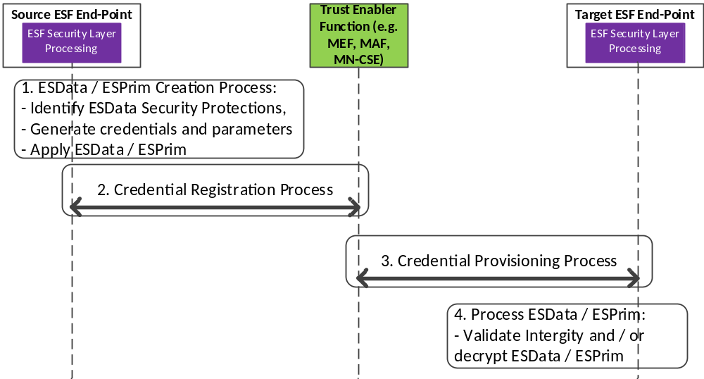

The end-to-end credential registration and provisioning process for providing ESData / ESPrim involves the following steps:
- Creation of ESData / ESPrim by the Source ESF End-Point Process involves:
  - Identification of security protectioning mechanisms based on the security requirements associated with the application data
  - Based upon the security requirements, appropriate security credentials and associated parameters are generated
  - The application data is then protected using the security credential(s) and associated parameters in order to generate the ESData / ESPrim.
NOTE 1: In the case of Remote Security Provisioning process, this steps a) and b) are performed by a Trust Enabler Function. Whereas in the case of Source-generated, the above described steps are followed by the Source.
- Credential Registration Process
  - The Source ESF End-Point registers the credential(s) and associated parameters with a Trust Enabler Function
  - The Source ESP End-Point shall provide the identity of the Target ESF End-Point(s) that is authorized to be provisioned with the end-to-end credentials and associated parameters.
NOTE 2: In the case of Remote Security Provisioning process, the Credential Registration process are performed by a Trust Enabler Function. Whereas in the case of Source-generated, the above described steps are followed by the Source.
- Credential Provisioning / Requisition Process:
  - A Target ESF End-Point may request ESData / ESPrim credentials by using a Credential-Id that was obtained as part of the ESData / ESPrim
  - Based on the authorization information provided as part of the Credential Registration Process and using the Credential-Id, the Trust Enabler Function provisions the appropriate credentials and associated cryptographic parameters to the authenticated and authorized Target ESF End-Point.
- Process the ESData / ESPrim:
  - The Target ESF End-Point uses the credentials provisioned by the Trust Enabler Function in order to process the ESData / ESPrim.
  - Processing of ESData / ESPrim would involve the integrity verification / authentication of the application data and / or decryption of the data and messages respectively.

8.6.2 Remote Security Provisioning Process for Provisioning of End-to-End Security Credentials
This clause describes the Remote Provisioning of Symmetric End-to-End Security credentials. The end-to-end security credentials shall be generated after having completed the Remote Provisioning of symmetric credentials using the Provisioned Symmetric Key or the MAF-based Symmetric Key Security Association Establishment Processes as described in clause 8.3.
Based on the higher-level requirements, appropriate end-to-end credentials may be generated using Remote Security Provisioning process by using pre-provisioned credentials. Illustrated in Figure 8.6.2-1 is a high-level key generation process.
As part of the “End-to-End Key Generation” mechanism, the enrolee and the enrolment target generate end-to-end credentials using the Kpsa as the master key in order to generate the end-to-end master key. If the Enrolee is an AE (Source ESF End-Point), and the Enrolment Target is a CSE (Target ESF End-Point), then an end-to-end master credential, Ke2e_master, is generated. An Example of end-to-end key generation using RFC 5869 [48] is provided below:
Figure 8.6.2-1: high-level summary of the E2E Remote Security Provisioning Frameworks.

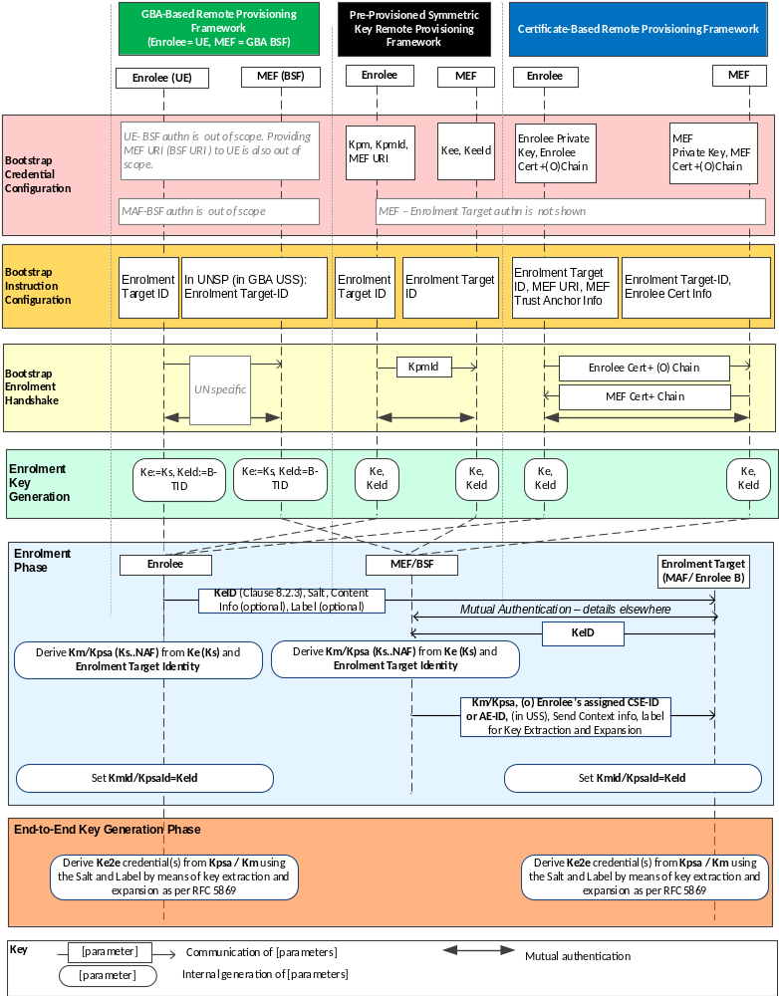

Bootstrap Credential Configuration: The Bootstrap Credential Configuration may be based upon the type of Remote Provisioning Framework that is used. When using Symmetric Key Remote Provisioning, the Enrolee, which could be the Source ESF End-Point and the Enrolment targets (Target ESF End-Point) are either pre-provisioned with the Symmetric Enrolee Key (Kpm) and the corresponding Pre-provisioned Symmetric Key Identifier, denoted KpmId. In addition the Source ESF End-Point is provisioned with the Trust Enabler Function (TEF URI). The mechanisms follows the procedures as described in clause 8.3.2.1.
Bootstrap Instruction Configuration: The Source ESF End-Point (Enrolee) and the Trust Enabler Function are configured with the information needed for authorizing the remote provisioning:

- The Source ESF End-Point (Enrolee) is configured with the following arguments to initiate remote provisioning:

  - The Target ESF End-Point’s security profile: The Target ESF End-Point’s security profile and the associated security capabilities as described in <e2ESecurityCapabilities> resource may be used to identify the types of security protection mechanisms that shall be used for end-to-end security.

  - The Target ESF End-Point identity: Identifying the Target ESF End-Point for which the Source ESF End-Point is to provision end-to-end security credentials.

  - The Target ESF End-Point’s security profile: The Target ESF End-Point’s security profile and the associated security capabilities as described in <e2ESecurityCapabilities> resource can be used to identify the types of security protection mechanisms that shall be used for end-to-end security.

  - The Source ESF End-Point associates these arguments with the Trust Enabler Function (TEF). The Trust Enabler Function can be identified to the Source ESF End-Point using the Pre-Provisioned Symmetric Enrolee Key Identifier (KpmId) and Trust Enabler Function URI.

- M2M Enrolment or Trust Enabler Function is configured with the following arguments to authorize the M2M Enrolment or Trust Enabler Function to remotely provision the Source ESF End-Point for a Target ESF End-Point:
  - The Target ESF End-Point Identity: Identifying the Target ESF End-Point for which the Source ESF End-Point is to be provisioned.
  - Source ESF End-Point's assigned CSE-ID or AE-ID (Source ESF End-Point-ID). The Trust Enabler Function is to provide this entity identity for the Source ESF End-Point with the Km or Kpsa to the Target ESF End-Point, when requested by the Target ESF End-Point.
  - Source ESF End-Point’s Security Profile: The security profile of the Source ESF End-Point provides the expected security level described within the <e2ESecurityCapabilities> resource REFERERENCE to TS-0001 associated with the Source ESF End-Point.
  - Target ESF End-Point’s Security Profile: The security profile of the Target ESF End-Point provides the expected security level described within the <e2ESecurityCapabilities> REFERERENCE to TS-0001 resource associated with the Target ESF End-Point
  - The Trust Enabler Function shall provide detailed key extraction and expansion parameters that are to be used when deriving the end-to-end credentials from the Km or Kpsa to the Source ESF End-Point and the Target ESF End-Point.
  - The Trust Enabler Function has to provide the scope and associated security parameters to the Source ESF End-Point and Target ESF End-Point that determines the protocols and the cryptographic algorithms that shall be used for performing end-to-end security.
- Bootstrap Security Handshake: The Source ESF End-Point and Trust Enabler Function perform a (D)TLS-PSK handshake [15] to establish a secure session. The mechanisms follow similar mechanisms as detailed in clause 8.3.2
- End-to-End Key Generation:
  - The Enrolment Key (Ke) and RelativeKeId is generated from the (D)TLS session secrets by the Source ESF End-Point andTrust Enabler Function using TLS Key Export (IETF RFC 5705 [18]), as described in clause 10.3.1 "TLS Key Export Details". Similarly, the Enrolment Key Identifier (KeId) is generated from the RelativeKeId and the Trust Enabler Function's FQDN by the Source ESF End-Point and Trust Enabler Function, as described in clause 10.3.4 "Generating KeId". The Source ESF End-Point and the Trust Enabler Function stores the Ke and the associated KeId.

  - The end-to-end master key (Ke2e_master) and the E2EKeyId is generated in a similar manner as the Kpsa and the associated KpsaId. If the Source ESF End-Point would like to request the provisioning of end-to-end keys then a key extraction based on Kpsa / Km shall be performed.

  - The End-to-End master Key (Ke2e_master) is used to generate specific security protection keys, such as, end-to-end authentication key, end-to-end confidentiality key and other keys depending upon the key extraction and expansion parameters that was provided. The key extraction and expansion would be based upon RFC 5869 [48].

NOTE 2: The End-to-End Key Generation for the Pre-Provisioned Symmetric Enrolee Key Remote Security Provisioning Framework is identical to the End-to-End Key Generation for the Certificate-Based Remote Security Provisioning Framework.

8.6.3 Detailed Description on Source-Generated End-to-End Credentials
This clause describes the Generation and Registration of Symmetric End-to-End Security credentials by a Source ESF End-Point. The end-to-end security credentials that were self-generated by a Source shall register the credentials with the Trust Enabling Function. Such a mechanism is particularly useful when data (attribute) as well messages targeted for more than one Target is required. In cases, where securing of <contentInstances> resource that is consumed by multiple end entities is required then Source-Generated credentials shall be used.
A Source that generates data that is consumed by one or more end entities, may generate the appropriate credentials so that either a single attribute (e.g. content attribute value of a <contentInstance> resource or customAttribute of a <flexContainer> resource) or a single addressable element within the attribute may be protected for integrity and confidentiality by means of ESData / ESPrim. In the case of dynamic authorization, all or part of a single primitive parameter value (e.g. a signed, self-contained access token communicated in a request primitive to obtain dynamic authorization) may also be protected using ESData / ESPrim. The entity that generated the ESData / ESPrim then registers the credentials with a Trust Enabler Function.

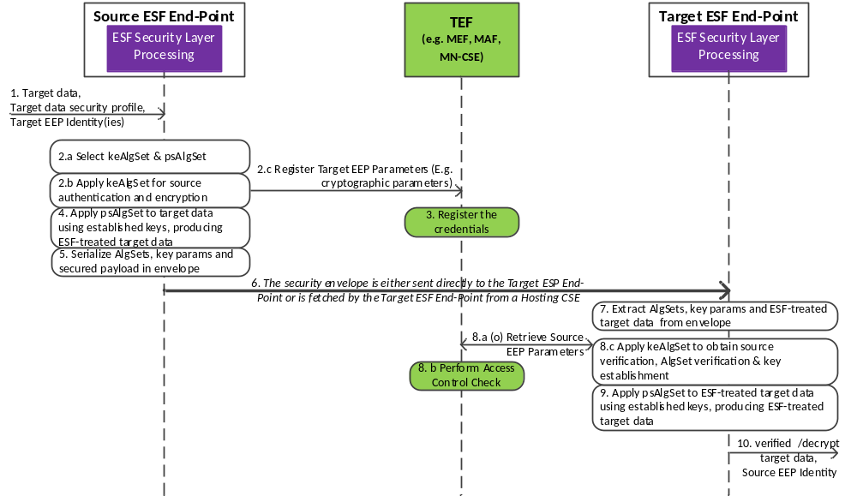
Bootstrap Credential Configuration: It is assumed that the Source ESF End-Point is provisioned with the Ke / KeId that was generated as part of the Remote Provisioning Framework with a Trust Enabler Function (e.g. M2M Enrolment Function) as described in clause 8.2. The Source ESF End-Point may be provisioned with the Km / KmId that was generated as part of the Remote Provisioning Framework with a Trust Enabler Function (i.e. MAF) as described in clause 8.3. The Target ESF End-Point may be provisioned with the Ke/KeId if the Trust Enabler Function is an M2M Enrolment Function. The Target ESF End-Point may be provisioned with the Km/KmId if the security association was established with an M2M Authentication Function.
Bootstrap Instruction Configuration: The Source ESP End-Point as well as the Target ESP End-Points are provisioned with those Trust Enabler Function’s URI that support end-to-end security credential provisioning and registration.

- The Source ESF End-Point is configured with the following arguments to initiate remote provisioning:

  - The identity of the Target ESF End-Point that has to be provided with the ESData / ESPrim and associated End-to-End security credentials.

  - The security requirement associated with the Data (attributes): This is pre-configured and provided by the application. Based on the security protection mechanisms, appropriate security technologies shall be used for protection.

  - Pre-configured with a table listing the security requirement and how that security requirement can be achieved using the appropriate security protection mechanisms (e.g. security protocols, algorithms for integrity, confidentiality, key generation)

  - The Target ESF End-Point Security Profile (optional): The Target ESF End-Point’s security profile and the associated security capabilities of the Target ESP End-Point as described in <e2ESecurityCapabilities> resource can be used to identify the types of security protection mechanisms that shall be used for providing ESData / ESPrim

- The Trust Enabler Function is configured with the following arguments to register the ESData / ESPrim security credentials from the Source ESF End-Point and to authorize the Trust Enabler Function to provision only a set of authorized Target ESF End-Point(s) with the relevant ESData / ESPrim security cryptographic parameters:
  - Cryptographic Parameters: A list of end-to-end cryptographic parameters that is identified by a Credential-Id and having associated cryptographic values such as the credential(s), cryptographic algorithm(s), label(s) and random value(s) (e.g. nonce, IV). These parameters are provided by the Source ESF End-Point during the credential registration process. There may be one or more credentials that are associated with one or more security protection mechanisms (e.g. data integrity, data confidentiality). The list may also include scope and usage of the end-to-end security parameters so that the Target ESF End-Point is able to process ESData / ESPrim (e.g. verify the integrity and / or decrypt the ESData / ESPrim).
  - Identity of Target ESF End-Point: Identity of the Target ESF End-Points that shall be provisioned with the requested credentials identified by a Credential-Id. The authorization may be provided and enforced by means of ACPs.
- The Target ESF End-Point is configured with the following arguments:
  - ESData / ESPrim: The Target ESF End-Point is either sent the ESData / ESPrim directly from a Source ESF End-Point, or the Target ESF End-Point fetches the ESData / ESPrim from a hosting entity (e.g. Hosting CSE).
  - Credential-Id: The Target ESF End-Point is provisioned with the Credential-Id, which may be included as part of the ESData / ESPrim
  - Cryptographic Parameters: The Cryptographic Parameters are provisioned by the Trust Enabler Function after the Trust Enabler Function verifies the access control policies associated with the request from the Source ESF End-Point.
- Security Handshake:
  - The Source ESF End-Point and the Trust Enabler Function perform a (D)TLS handshake [15] to establish a secure session. The mechanisms follow similar mechanisms as detailed in clause 8.3.2. All communications between the Source ESF End-Point and the Trust Enabler Function are secured by means of the established (D)TLS connection.
  - The Target ESF End-Point and the Trust Enabler Function performs a (D)TLS handshake [15] to establish a secure session. The mechanisms follow similar mechanisms as detailed in clause 8.3.2. All communications between the Source ESF End-Point and the Trust Enabler Function are secured by means of the established (D)TLS connection.
- End-to-End Key Generation:
  - The Source ESP End-Point generates credentials that may be based upon:
    - Credentials that have been generated using the Enrolment Key, Ke / KeID that has been generated using the Bootstrapped Remote Credential Provisioning Process.

    - Credentials generated in a random manner by the Source ESP End-Point and registered with the Trust Enabler Function

8.7 Direct End-to-End Key Establishment using Certificates (E2EKey)

8.7.1 Purpose of E2EKey
End-to-End Certificate-based Key Establishment (E2EKey) provides an interoperable framework for two end-points to use certificates for establishing a secret symmetric key called pairwiseE2EKey from which symmetric keys are derived for use in other end-to-end security frameworks such as End-to-End Security of Data (ESData) or End-to-End Security of Primitives (ESPrim).
Applicable use cases and requirements are discussed in TR-0012 [i.16].
The present document specifies the E2EKey messages and associated processing for E2EKey. The transport of E2EKey messages is specified in TS-0001 [1].

8.7.2 E2EKey Architecture

8.7.2.1 E2EKey Reference Model
The entities in the E2EKey reference model are the E2EKey Initiating End-Point which initiates the procedure and the single E2EKey Terminating End-Point with which the E2EKey Initiating End-Point intends to establish a pairwiseE2EKey.
NOTE: Within the scope of clause 8.7, terms including the word “E2EKey” can be shortened by removing “E2EKey” to facilitate readability. For example, “E2EKey Initiating End-Point” is often shortened to “Initiating End-Point”.
The E2EKey Procedure consists of the Initiating End-Point and Terminating End-Point exchanging a sequence of E2EKey Messages and apply processing based on those E2EKey Messages. If the E2EKey Procedure is successful, then the Initiating End-Point and Terminating End-Point export a pairwiseE2EKey based on the parameters exchanged in the E2EKey Messages.
There is no inherent restriction on which entities may be an Initiating End-point; these end-points may be entities inside a oneM2M system (that is, AEs and CSEs) or entities outside of a oneM2M system (for example, entities which are part of a system that interworks with oneM2M).
The only restriction on entities which may be Terminating End-Points is that the Terminating End-Point shall be able to receive the unsolicited E2EKey Message initiating the E2EKey Procedure. Since TS-0001 [1] specifies the transport of E2EKey messages, TS-0001 also specifies which entities may be Terminating End-Points.

8.7.2.2 E2EKey Procedure Message Flow
The E2EKey Messages shall be transported as specified in TS-0001 [1]; for example, the <e2EKeyCSE> resource may be used.
The E2EKey Messages shall contain the TLS v1.2 [5] messages defined in Table 8.7.2.2-1 “E2EKey Message definitions”.
The E2EKey Procedure message flow is shown in Figure 8.7.2.2-1 “E2EKey Procedure message flow”, and described in the following text.

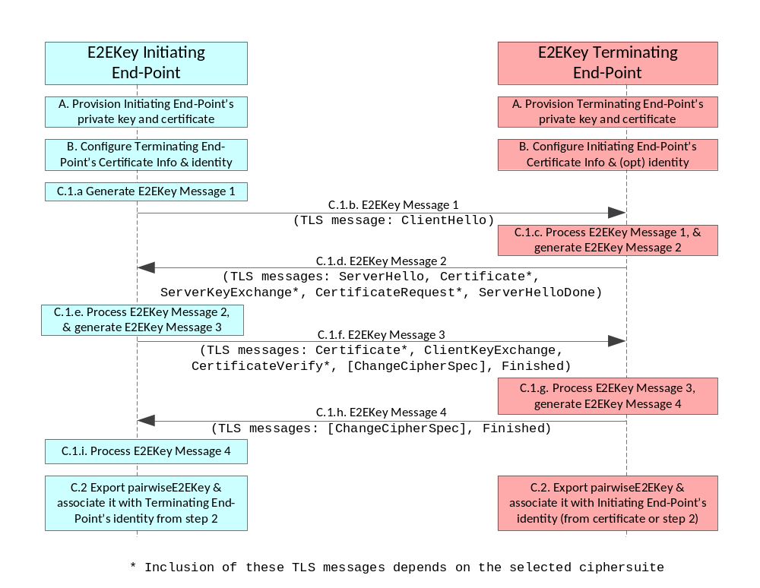
Figure 8.7.2.2-1: E2EKey Procedure message flow
- Provisioning Certificates: The E2EKey endpoints shall be provisioned with private key and certificates described in clause 8.1.2.3 "Credential Configuration for Certificate-Based Security Frameworks". The certificates of the Initiating End-Point and terminating End-Points shall conform to clause 10.1 “Certificate-Based Security Framework Details”.
- Triggering: The Initiating End-Point and Terminating End-Point shall be configured with the information needed for the authentication and identification of the Terminating End-Point and Initiating End-Point respectively:
The Initiating End-Point is commanded to initiate the E2EKey Procedure, and the command shall include the following arguments:
  - The Terminating End-Point’s certificate information: as described in clause 8.1.2.4 "Information Needed for Certificate Authentication of another Entity".
  - The Terminating End-Point’s identity. This identity is used for
    - Determining where E2EKey Message 1 is sent, and
    - Associating with the established pairwiseE2EKey.
The Terminating End-Point shall be configured with the following arguments describing Initiating Entity authorized to perform the E2EKey Procedure:
  - The Initiating End-Point’s certificate information: as described in clause 8.1.2.4 "Information Needed for Certificate Authentication of another Entity".
    - In the case where the Initiating End-Point’s certificate is a raw public key certificate, the Terminating End-Point shall also be configured with an identity to associate with the established pairwiseE2EKey.
The End-Points may be configured in any order.
Editor’s note: Clause 8.1.2.4 “Information Needed for Certificate Authentication of another Entity” currently addresses SAEFs only. Clause 8.1.2.4 requires changing to cover E2EKey. These changes are mostly editorial.
- Establishing pairwiseE2EKey
  - The Initiating End-Point and Terminating End-Point exchange the sequence of four E2EKey Messages. The E2EKey Messages shall be generated and processed according to the handshake protocol of TLS v1.2 [5]. The TLS ciphersuites used for the E2EKey Procedure shall conform to clause 10.2.3 “TLS and DTLS Ciphersuites for Certificate-Based Security Frameworks”.
    - The Initiating End-Point shall generate E2EKey Message 1.
    - The Initiating End-Point shall send E2EKey Message 1 to the Terminating End-Point identified in step 2.
    - The Terminating End-Point shall process E2EKey Message 1, and generate E2EKey Message 2.
    - The Terminating End-Point shall send E2EKey Message 2 to the Initiating End-Point.
    - The Initiating End-Point shall process E2EKey Message 2, and generate E2EKey Message 3.
    - The Initiating End-Point shall send E2EKey Message 3 to the Terminating End-Point.
    - The Terminating End-Point shall process E2EKey Message 3, and generate E2EKey Message 4.
    - The Terminating End-Point shall send E2EKey Message 4 to the Initiating End-Point.
    - The Initiating End-Point shall process E2EKey Message 4.
  - If the TLS handshake protocol is successful, then the Initiating and Terminating End-Points shall export and cache the pairwiseE2EKey using TLS Exporter specification (RFC 5705) [18] as described in clause 10.3.1 “TLS Key Export Details”.
Editor’s note: It will be necessary to add the TLS export details for E2EKey in clause 10.3.2. This is a stage 3 detail.

Table 8.7.2.2-1: E2EKey Message definitions
E2EKey Message | Sending End-Point | Possible TLS v1.2 Messages (success case) [5] | Informative Description (normative description is in TLS v1.2 specification [5])
1 | Initiating | ClientHello | List of allowed ciphersuites, random value, indicator to export pairwiseE2EKey
2 | Terminating | ServerHello | Selected ciphersuite, random value, indicator to export pairwiseE2EKey
2 | Terminating | Certificate* | Terminating End-Point’s certificate (and optionally certificate chain)
2 | Terminating | ServerKeyExchange* | Key exchange parameters generated by the Terminating End-Point. The content of this parameter is dependent on selected ciphersuite
2 | Terminating | CertificateRequest* | Instructs the Initiating End-Point to authenticate itself with a certificate
2 | Terminating | ServerHelloDone | Indicates the end of the message
3 | Initiating | Certificate* | Initiating End-Point’s certificate (and optionally certificate chain)
3 | Initiating | ClientKeyExchange* | Key exchange parameters generated by the Initiating End-Point. The content of this parameter is dependent on selected ciphersuite
3 | Initiating | CertificateVerify | Provides explicit verification of a Initiating End-Point’s certificate
3 | Initiating | [ChangeCipherSpec] | Notifies the Receiving End-Point that subsequent records will be protected under the newly negotiated CipherSpec and keys.
3 | Initiating | Finished | MIC on all preceding parameters exchanged in the procedure. The MIC is generated using session secrets established using the preceding parameters.
4 | Terminating | [ChangeCipherSpec] | See above
4 | Terminating | Finished | MIC on all preceding parameters exchanged in the procedure. The MIC is generated using session secrets.
NOTE: The inclusion of the TLS messages marked with “*” is dependent on the chosen ciphersuite

-----------------------End of change 5-------------------------------------------

-----------------------Start of change 6-------------------------------------------

9.2.3 End-to-End Credential Configuration Procedures and Parameters
The following End-to-End Credential Configuration procedures are described in this clause:
- End-to-End Credential Configuration of Source ESF End-Points and Target ESF End-Points, see clause 9.2.3.1.
- End-to-End Credential Configuration of Trust Enabler Functions, see clause 9.2.3.2.
- Configuration parameters for enabling End-to-End Security at Source ESF End-Points and Target ESF End-Points, see clause 9.2.3.3.

9.2.3.1 End-to-End Credential Configuration of Source ESF End-Points and Target ESF End-Points
It is assumed that the Source ESF End-Point and the Target ESF End-Points are configured with the URI of the Trust Enabler Function and have been configured with the appropriate parameters specific to the Remote Security Provisioning Frameworks as described in clause 9.2. In addition, the end-to-end credentials are provisioned and appropriate security parameters are provisioned to the Target ESF End-Points while the Source ESF End-Point can derive the end-to-end credentials on its own using the relevant security parameters that have been provisioned. Table 9.2.3.1-1 provides a list of the parameters.
Table 9.2.3.1-1 Security Credentials and parameters provisioned to the Target ESF End-Points and Source ESF End-Points
Security Protection | End-to-End Security Provisioning Framework Parameters | Description
End-to-End Security Credentials | KpsaId | This is the provisioned credential-Id of the M2M Provisioned Symmetric Key
End-to-End Security Credentials | Kpsa | This is the M2M Provisioned Symmetric Key. This is used to derive the end-to-end master secret, Ke2e_master as described in 10.3.6
End-to-End Security Credentials | TEF URI | The URI of the trusted-third-party (TEF) entity that is used as the credential generator / registry and enables the registration and generation of end-to-end security credentials
Cryptographic Parameters | Salt | The salt used for generating the end-to-end credentials. Optional parameter.
Cryptographic Parameters | Key Extraction Algorithm: HMAC-Hash | The Key extraction algorithm that is used for generating the various keys shall follow the mechanisms described in [48].
Cryptographic Parameters | Cryptographic Labels | The labels that are used by the cryptographic algorithms. The labels shall be used according to clause 10.3.6.1
Types of Credentials | Message Authenticity (Primitive) | The key used for message authentication and integrity of oneM2M primitives. If the keying material is provided then it is generated by the ESF Target End-Point
Types of Credentials | Message Confidentiality (Primitive) | The key that is used for message confidentiality of oneM2M primitives. If the keying material is provided then it is generated by the Target ESF End-Point
Types of Credentials | Integrity of Data (Attribute) | Key used for providing integrity of data / attribute. If the keying material is provided then it is generated by the Target ESF End-Point
Types of Credentials | Confidentiality of Data (Attribute) | Key used for providing confidentiality of data / attributes. If the keying material is provided then it is generated by the Target ESF End-Point

9.2.3.2 End-to-End Credential Configuration at the M2M Trust Enabler Functions
It is assumed that the Trust Enabler Function is configured with the identities of the entities (ESF Source and Target End-Points) and appropriate parameters specific to the Remote Security Provisioning Frameworks as described in clause 9.2.
In addition, the Trust Enabler Function is provisioned the appropriate security parameters in order that the End-to-End security credentials are derived and the set of the cryptographic parameters are provisioned to the Target ESF End-Points once the Target ESF End-Point has been authenticated. Table 9.2.3.2-1 provides a list of the parameters.
Table 9.2.3.2-1 Security Parameters provisioned at the M2M Enrolment or Trust Enabler Function and Source ESF End-Point
End-to-End Security Protection | End-to-End Security Provisioning Framework Parameters | Description
End-to-End Security Credentials | Kpm | Pre-provisioned credentials between the Source ESF End-Point and TEF
End-to-End Security Credentials | KpmId | The credential identity of the pre-provisioned credentials
End-to-End Security Credentials | Source ESF End-Point identity (AE-ID / CSE-ID)  Target ESF End-Point identity (CSE-ID) | The entity identity that is pre-provisioned with the end-to-end security credentials
List of required Security Protection and Strength | Message Authentication: (Low – High) | Provides a level of the required strength of the message authentication mechanism
List of required Security Protection and Strength | Message Confidentiality: (Low – High) | Provides a level of the required strength for providing message confidentiality mechanism
List of required Security Protection and Strength | Attribute Integrity: (Low – High) | Provides a level of the required strength for providing attribute integrity
List of required Security Protection and Strength | Attribute Confidentiality: (Low – High) | Provides a level of the required strength for providing attribute confidentiality

9.2.3.3 Configuration parameters for enabling End-to-End Security at Source ESF End-Points and Target ESF End-Points
The Source ESF End-Points and the Target ESF End-Points are provisioned with the cryptographic parameters that are used to enable and verify end-to-end security protection. In the case of the Target ESF End-Point, the Trust Enabler Function provisions the parameters to it after a successful authentication and derivation of the Secure Connection Key (Kpsa). In the case of the Source ESF End-Point, the parameters may have been pre-configured or provisioned in a similar manner as the Target ESF End-Point, that is, once the derivation of the Secure Connection Key (Kpsa) is done, and shared between the Source ESF End-Point and the Target ESF End-Point. Table 9.2.3.3-1 provides a list of the parameters.
Table 9.2.3.3-1 Security Parameters provisioned to the Target ESF End-Point and the Source ESF End-Point
End-to-End Security Protection | End-to-End Security Provisioning Framework Parameters | Description
End-to-End Security Credentials | e2e_master | The End-to-End master credential
End-to-End Security Credentials | E2EKeyId | End-to-End Master credential identity
End-to-End Security Credentials | Target ESF End-Point Identity (CSE-ID)  Source ESF End-Point Id (AE-ID / CSE-ID) | The identity of the end entity with which the end-to-end credential is associated with
Cryptographic Parameters | Protocol: JWS / JWE, XML Sec | The type of encoding and representation that is used
Cryptographic Parameters | Class of cryptographic algorithms: AEAD (single key) or non-AEAD | Defines the class of cryptographic algorithms that shall be used
Cryptographic Parameters | Message Authenticity Algorithm / Size: HMAC-SHA-256, HMAC-SHA-512 | Indicates the message authentication algorithm and key size
Cryptographic Parameters | Message Confidentiality Algorithm / Size: AES-192 / 256 | Indicates the message confidentiality algorithm and key size
Cryptographic Parameters | Attribute Confidentiality Algorithm: AES-192 / 256 | Attribute confidentiality algorithm and key size
Cryptographic Parameters | Attribute Authenticity Algorithm / Size: HMAC-SHA-256 | Attribute authenticity and integrity algorithm and key size
Cryptographic Usage | Message / Attribute Authenticity: Nonce | The random value that was used for providing freshness. This is only stored temporarily associated with an expiration time and communicated to the other end
Cryptographic Usage | Message / Attribute Confidentiality: Initialization Vector | This random value that is used as the initialization vector for the confidentiality algorithm

NOTE: If AEAD class of algorithms where only a single key is used, then only a single key would be generated and an associated cryptographic algorithm (e.g. AES-GCM or AES-CCM) identified. In addition, for AEAD class of algorithms both an IV and a Nonce may not be generated, rather only a single random value, Nonce may be generated.

-----------------------End of change 6-------------------------------------------

-----------------------Start of change 7-------------------------------------------

10.3.6 Derivation of End-to-End Master Key from Provisioned Secure Connection Key
This clause describes the details when generating an End-to-End Master Key (Ke2e_master) based on a successful establishment of security association between a Source ESF End-Point and Target ESF End-Point using a Remote Security Provisioning Framework as described in clause 8.3. The mechanisms to generate the End-to-End Master Key then uses a key extraction process using the Provisioned Secure Connection Key, (Kpsa).
The following information shall be used when generating Ke2e from Kpsa:
- The value of the Provisioned Secure Connection Key (Kpsa)
- Source ESF End-Point B's CSE-ID or AE-ID (Source ESF End-Point-B-ID), which shall be encoded to an octet string according to UTF-8 encoding rules as specified in IETF RFC 3629 [19] and apply Normalization Form KC (NFKC) as specified in [20].
The value of Ke2e_master shall be generated as:
- Ke2e_master = HMAC-Hash (Salt, Kpsa)
NOTE: In the case of Source-generated credentials, a random value generated by the Source ESF End-Point is used instead of the Kpsa in order to generate the Ke2e_master.

10.3.6.1 Key Extraction and Expansion of End-to-End Master Key
The End-to-End Master Key (Ke2e_master) is used to generate the security protection-specific keys. The Key Extraction and Expansion parameters along with the scope are used to generate the various keys. The Key extraction and expansion is performed according to the specifications defined in IETF RFC 5869. A list of possible End-to-End keys are shown in Table 10.1.6.1-1
Table 10.1.6.1-1: End-to-End Security Keys
Security Protection | Symmetric Keys Generated
Message Authenticity (Primitive) | Ke2e_msg_auth
Message Confidentiality (Primitive) | Ke2e_msg_conf
Integrity of Data (Attribute) | Ke2e_att_auth
Confidentiality of Data (Attribute) | Ke2e_att_conf

The End-to-End security protection keys that are generated by performing a key expansion of the Ke2e_master using mechanisms specified in RFC 5869 [RFC5869] . Using the generated end-to-end master key, the associated end-to-end message authentication and or end-to-end message confidentiality keys and attribute keys are generated in the following manner:
- T(0) = empty string (zero length)
- End-to-End Message Authenticity Key (Ke2e_msg_auth) = T(1) = HMAC-Hash (Ke2e_master, T(0) | “E2E Message Authentication Key”| 0x01)
- End-to-End Message Confidentiality Key (Ke2e_msg_conf) = T(2) = HMAC-Hash (Ke2e_master, T(1)| “E2E Message Confidentiality Key”|0x02)
- End-to-End Attribute Authenticity Key (Ke2e_att_auth) = T(3) = HMAC-Hash (Ke2e_master, T(2)| “E2E Attribute Authenticity Key”|0x03)
- End-to-End Attribute Confidentiality Key (Ke2e_att_conf) = T(4) = HMAC-Hash (Ke2e_master, T(3)| “E2E Attribute Confidentiality Key”|0x04)
NOTE: If AEAD algorithms are used, where only a single key is used, then either the Ke2e_msg_auth or the Ke2e_msg_conf key may be derived and used for both message authenticity as well as message confidentiality
NOTE: The Target ESF End-Point may be provisioned with all the required keys or is provisioned only with the Master End-to-End key (Ke2e_master) and the associated cryptographic parameters (e.g. labels, random values) which are then used by the Target ESF End-Point in order to generate the keys required for ESPrim and ESData.

-----------------------End of change 7-------------------------------------------

