Input Contribution
Meeting ID* | SEC#22
Title:* | TR-0012 CR: Group Authentication analysis
Source:* | ZUO Min, zuomin@chinamobile.com  QI Minpeng, qiminpeng@chinamobile.com
Uploaded Date:* | 2016-03-06
Document(s)  Impacted* | TR-0012-V0.8.1
Intended purpose of  document:* | Decision  Discussion  Information  Other <specify>
Decision requested or recommendation:* | Agree for inclusion in TR-0012.
Template Version:23 February 2015 (Dot not modify)

oneM2M Notice
The document to which this cover statement is attached is submitted to oneM2M. Participation in, or attendance at, any activity of oneM2M, constitutes acceptance of and agreement to be bound by terms of the Working Procedures and the Partnership Agreement, including the Intellectual Property Rights (IPR) Principles Governing oneM2M Work found in Annex 1 of the Partnership Agreement.

Header
1 Introduction
This contribution proposes an analysis on the benefits of using Group Authentication Solution 1 in clause 8.2.1 of TR-0012.

2 Proposal
******************** Start of Change ****************

8.2.1 Group Authentication Solution 1
Figure 8.2.2-1 illustrates the sequence of events when using the group authentication solution 1 for the static group which corresponding to Clause 6.1.1. In this description, "Entity Ax" or "Entity Ay" corresponds to either a CSE or AE in a group, "Entity B" corresponds to MN-CSE, and "Entity C" corresponds to IN-CSE.
Credential Configuration: The Provisioned Credential for M2M Security Association Establishment (Kpsa_{xm}, Kpsa_{ym}, Kpsa_{mi}, Kpsa_{xi}, and Kpsa_{yi}) and the corresponding Provisioned Credential for M2M Security Association Establishment Identifier, denoted Kpsa_{xm}Id, Kpsa_{ym}Id, Kpsa_{mi}Id, Kpsa_{xi}Id, and Kpsa_{yi}Id are provisioned to both entities either with pre-provisioning or remote provisioning.
NOTE 1: The provisioning (by definition) uses mechanisms not specified by oneM2M. The remote provisioning is performed thanks to Security Bootstrap Frameworks described in clause 8.3 in TS0003 [5].
NOTE 2: Entity Ax, Entity Ay, Entity B, and Entity C shall be configured with the information needed for the authentication and identification during the Inner/Outer Group Authentication and Group Security Association Handshake. For instance, Entity Ax is configured with Entity B identity (IdB) associated with the Provisioned Credential for M2M Security Association Establishment identifier Kpsa_{xm}Id to establish security context by using Kpsa_{xm}. Entity Ax is to use this identity IdB for Entity B authenticating using the related arguments. This identity is also used to route the (D)TLS exchange.
Inner Group Authentication:
- Each Entity Ax (or Ay) in a group and the Entity B perform a (D)TLS-PSK handshake [8] to establish a secure session:
Take Entity Ax as example:
  - The "psk_identity" parameter [8] is set to the value of the Provisioned Credential for M2M Security Association Establishment identifier Kpsa_{xm}Id between the Entity Ax and the Entity B.
  - The "psk" parameter [8] is set to the value of the Provisioned Credential for M2M Security Association Establishment Kpsa_{xm} between the Entity Ax and the Entity B.
- The Entity Ax and the Entity B authenticate each other by verifying Message Integrity Codes (MIC) which was generated using the symmetric key (Kpsa_{xm}) to make mutual authentication.
NOTE 3: Each Entity in a group shall perform inner group authentication with the Entity B.
NOTE 4: This is just an example to use (D)TLS-PSK here, it is not limited to (D)TLS-PSK only.
Outer Group Authentication: Due to the successful Inner Group Authentication, Entity B could be on behalf of all entities in the group to make mutual authentication with the Entity C.
- The Entity B and Entity C perform a (D)TLS-PSK handshake [8] to establish a secure session:
  - The "psk_identity" parameter [8] is set to the value of the Provisioned Credential for M2M Security Association Establishment identifier Kpsa_{mi}Id between the Entity B and the Entity C.
  - The "psk" parameter [8] is set to the value of the Provisioned Credential for M2M Security Association Establishment Kpsa_{mi} between the Entity B and the Entity C.
- The Entity B and Entity C authenticate each other by verifying Message Integrity Codes (MIC) which was generated using the symmetric key (Kpsa_{mi}) to make mutual authentication. After that, each Entity in the group has carried out the authentication with the help of the Entity B.
- The Entity C generates the M2M Group Secure Connection Key for each Entity in the group. Especially, in the IN’s database, there is a mapping between the identifier of MN (e.g. IdB) and each Entity’s identifier (e.g. IdAx) in the group. For instance, Entity C generates Ks_{x} for Entity Ax from the Provisioned Credential (Kpsa_{xi}) between the Ax and C, a random number (Rand) and the identifier of Ax (IdAx). Moreover, Entity C sets the Group Secure Connection Key Identifier (Ks_{x}Id) equal to Kpsa_{xi}Id, and stores the M2M Group Secure Connection Key (Ks_{x}) and the related Identifier (Ks_{x}Id).
NOTE 5: The derivation of the M2M Group Secure Connection Key, e.g. Ks_{x} := HMAC-SHA-256(Kpsa_{xi}, “oneM2M Group Secure Connection Key derivation” || Enrolee-Ax-ID || Rand), where Kpsa_{xi} is the value of the Provisioned Credential between the Enrolee Ax and the IN; Rand is a random number generated by the Entity C; Enrolee Ax’s CSE-ID or AE-ID (Enrolee-Ai-ID), which shall be encoded to an octet string according to UTF-8 encoding rules as specified in IETF RFC 3629 [11] and apply Normalization Form KC (NFKC) as specified in [9]; HMAC-SHA-256 is defined in RFC 2014 [10].
Group Security Association Handshake: The Group Security Association Handshake enables the establishment of the M2M Group Secure Connection Key (e.g. Ks_{x}) and the associated Key Identifier (e.g. Ks_{x}Id) shared between each Entity Ax (or Ay) in the group and the Entity C.
Take Entity Ax as example:
- Entity C sends the random number (Rand) to Entity B.
- Entity B forwards the Rand to the Entity Ax.
- Entity Ax generates the M2M Group Secure Connection Key (Ks_{x}) from the Provisioned Credential (Kpsa_{xi}) between the Entity Ax and the Entity C, the random number (Rand) and the identifier of Ai (IdA), sets the Group Secure Connection Key Identifier (Ks_{x}Id) is Kpsa_{xi}Id, and stores the M2M Group Secure Connection Key (Ks_{x}) and the related Identifier (Ks_{x}Id). After that, Entity Ax sends the Service Request Message to Entity B.
- Entity B forwards the Service Request Message to Entity C.
NOTE 6: The Service Request Message is sent by the entity in a given group when the entity requires the IN to provide the services.
- Upon the Service Request Message, Entity B forwards this message to IN.
NOTE 7: After each Entity in a group (e.g. Ax) sets up security association with IN using the same key (e.g. Ks_{x}), each Entity could be seen as authenticated when the security association works, since the mutual authentication between each Entity (e.g. Ax) and the IN is fulfilled through the proof of possessing the M2M Group Secure Connection Key (e.g. Ks_{x}).
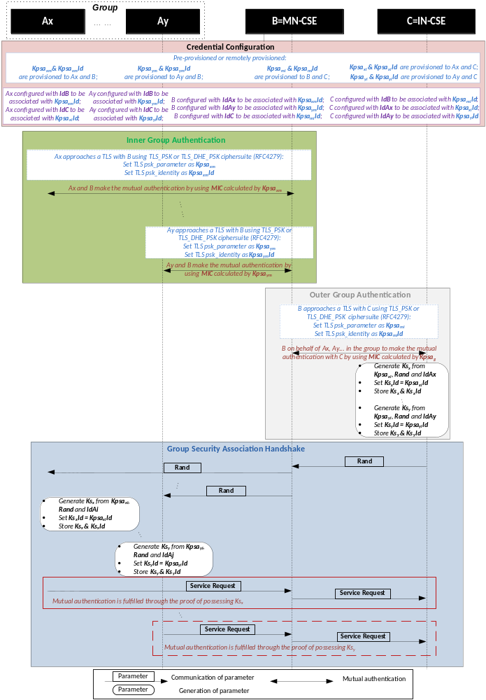
Figure: 8.2.1-1: The sequence of events When using Group Authentication Solution 1
Editor’s note: 1) Credential Configuration part is corrected, Ax/Ay should be configured with IdC ; 2) the last part of this figure is re-organized to avoid confusion, ie. “Mutual authentication is fulfilled …” should be a remark rather than a message.

The benefits of using Group Authentication Solution 1 are twofold:
1) End to end security and privacy between individual M2M Device and M2M Server is protected even with a third party M2M Gateway standing in between.
Each device shares with the server a secret key Ks_{x} after authentication, which is used to protect the end to end communication. These secret keys are unknown to the gateway and other devices in the group.
2) Number of messages the server and the gateway have to handle is decreased compared to the case where the gateway acts as a transparent proxy.
As illustrated in Figure 8.2.1-2, if group authentication solution 1 is used, to fulfil mutual authentication for all the n devices in the group, the server needs to handle n+1 incoming messages and only one outgoing message, the gateway needs to handle 2n+1 incoming messages and 2n+1 outgoing messages. If the gateway acts as a transparent proxy, the server needs to handle 2n incoming messages and n outgoing messages, the gateway needs to handle 3n incoming messages and 3n outgoing messages. As long as n>1, group authentication solution 1 can always leads to a message number deduction for both the server and the gateway.

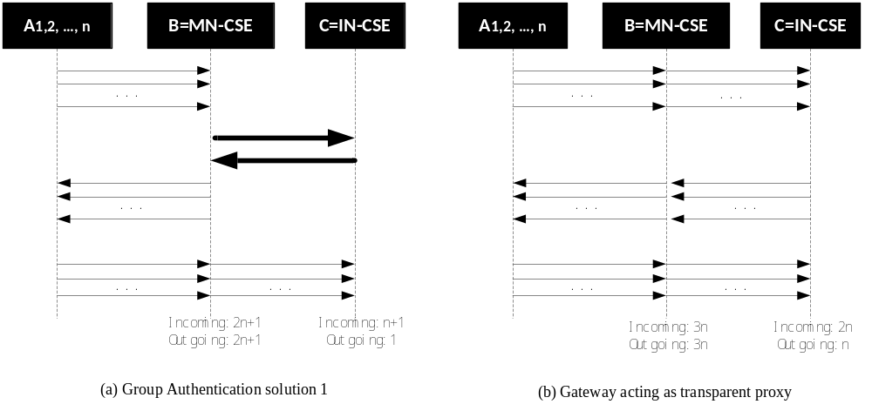
Figure: 8.2.1-2: Comparison of message-handling when using Group Authentication Solution 1

******************** End of Change ****************

