CHANGE REQUEST
Meeting:* | SEC#22
Source:* | Vinod Choyi, vinod.choyi@interdigital.com ,  Dale Seed, dale.seed@interdigital.com  Darshan Appajigowda, darshan.appajigowda@interdigital.com
Date:* | 2016-03-05
Contact:* | As above
Reason for Change/s:* | The change proposes details about the Credential Enrolment Process.
CR against: Release* | Rel-1
CR against: WI* | Active WI-0019  MNT Maintenance / < Work Item number(optional)>  STE Small Technical Enhancements / < Work Item number (optional)>  Only ONE of the above shall be ticked
CR against: TS/TR* | TS-0003
Clauses/Sub Clauses* | Various
Type of change: * | Editorial change  Bug Fix or Correction  Change to existing feature or functionality  New feature or functionality  Only ONE of the above shall be ticked
Post Freeze checking:* | This CR contains only essential changes and corrections? YES NO  This CR may break backwards compatibility with the last approved version of the TS? YES NO  This CR is a mirror CR? YES if YES, please indicate the document number of the original CR: <Document Number) : NO
Template Version:27 May 2015 (Dot not modify)

oneM2M Notice
The document to which this cover statement is attached is submitted to oneM2M. Participation in, or attendance at, any activity of oneM2M, constitutes acceptance of and agreement to be bound by terms of the Working Procedures and the Partnership Agreement, including the Intellectual Property Rights (IPR) Principles Governing oneM2M Work found in Annex 1 of the Partnership Agreement.

Introduction
The M2M Enrolment Function (MEF) aids the Enrolment Targets (like the MAF/CSE) in provisioning the credentials remotely for any Enrolees (like an AE). As part of this remote provisioning (also called as Bootstrap credentials feature), the Enrolment Target needs to communicate with the MEF to fetch the credentials of a particular AE when the AE tries to register to the target. But the TS-0003 V1.3.0 Spec doesn’t define a standard interface and procedures between the MEF and Enrolment Targets. This leads to proprietary implementations which in turn may make interops difficult.
The aim of this CR is to standardize the interface and procedures used between the Enrolment Targets and MEF so that a single MEF can cater to requests from Enrolment Targets of different domain and different operators without any inter-op issues.
The proposed interface between the Enrolment Target and MEF and the applicable procedures described below are with respect to the Pre-Provisioned Enrolee Key based RSPF. The same could be extended to the MAF based RSPF as well.

-----------------------Start of change 1-------------------------------------------

8.3.2.1 Pre-Provisioned Symmetric Key Remote Security Provisioning Framework
This clause describes the Pre-Provisioned Symmetric Key Remote Security Provisioning Framework. The Bootstrap Credential for this framework is a long-term symmetric key that has been pre-provisioned into the Enrolee and M2M Enrolment Function; this key is called a Pre-Provisioned Symmetric Enrolee Key and is denoted Kpm.
NOTE 1: Long term Pre-Provisioned Symmetric Enrolee Keys can pose a security risk if not adequately secured, and for this reason it is recommended that Long term Pre-Provisioned Symmetric Enrolee Keys are stored in Secure Environments.
Figure 8.3.2.1-1 illustrates the sequence of events when using the Pre-Provisioned Symmetric Enrolee Key Remote Security Provisioning Framework.

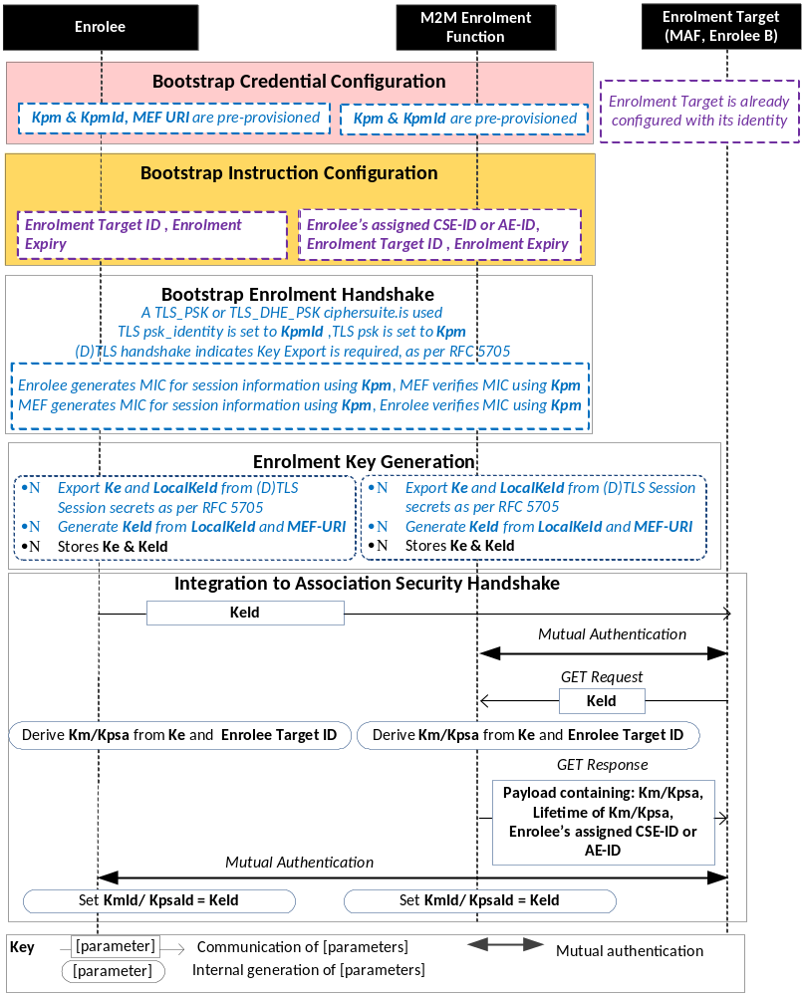
NOTE: The following font colours differentiate the general topic that the text relates to:
Black text contains Remote Security Provisioning-Framework-independent details
Blue italic text highlights details specific to this particular Remote Security Provisioning Framework.
Purple italic text highlights technical actions that may include steps not specified by oneM2M.

Figure 8.3.2.1-1: The sequence of events when using
the Pre-Provisioned Symmetric Key Remote Security Provisioning Framework
Bootstrap Credential Configuration: The Pre-Provisioned Symmetric Enrolee Key (Kpm) and the corresponding Pre-Provisioned Symmetric Enrolee Key Identifier, denoted KpmId, are pre-provisioned to both entities. The Enrolee is also pre-provisioned with the M2M Enrolment Function's URI (MEF URI), for the purpose of routing the (D)TLS exchange.
NOTE 2: This pre-provisioning (by definition) uses mechanisms not specified by oneM2M.
Bootstrap Instruction Configuration: The Enrolee and M2M Enrolment Function are configured with the information needed for authorizing the remote provisioning:
- The Enrolee is configured with (or otherwise obtains) the following arguments to initiate remote provisioning:
- The Enrolment Target identity: Identifying the Enrolment Target for which the Enrolee is to be provisioned.
- The Enrolee associates these arguments with the M2M Enrolment Function. The M2M Enrolment Function can be identified to the Enrolee using the Pre-Provisioned Symmetric Enrolee Key Identifier (KpmId) or the M2M Enrolment Function URI.
- M2M Enrolment Function is configured with the following arguments to authorize the M2M Enrolment Function to remotely provision the Enrolee for an Enrolment Target:
- The Enrolment Target Identity: Identifying the Enrolment Target for which the Enrolee is to be provisioned.
- Enrolee's assigned CSE-ID or AE-ID (Enrolee-ID). The M2M Enrolment Function is to provide this entity identity for the Enrolee with the Km or Kpsa to the Enrolment Target, when requested by the Enrolment Target.
- The M2M Enrolment Function associates these arguments with an Enrolee. The Enrolee can be identified to the M2M Enrolment Function using the Pre-Provisioned Symmetric Enrolee Key Identifier (KpmId).
Bootstrap Security Handshake: The Enrolee and M2M Enrolment Function perform a (D)TLS-PSK handshake [Error: Reference source not found] to establish a secure session.
- The "psk_identity" parameter [Error: Reference source not found] is set to the value of the Pre-Provisioned Symmetric Enrolee Key Identifier (KpmId).
- The "psk" parameter [Error: Reference source not found] is set to the value of the Pre-Provisioned Symmetric Enrolee Key (Kpm).
- The (D)TLS cipher suite profile for this 's assigned CSE-ID or AE-ID is specified in clause 10.2.2 "TLS and DTLS Ciphersuites for TLS-PSK-Based Security Frameworks".
Enrolment Key Generation:
- The Enrolment Key (Ke) and RelativeKeId is generated from the (D)TLS session secrets by the Enrolee and M2M Enrolment Function using TLS Key Export (IETF RFC 5705 [Error: Reference source not found]), as described in clause 10.3.1 "TLS Key Export Details".
- The Enrolment Key Identifier (KeId) is generated from the RelativeKeId and the M2M Enrolment Function's FQDN by the Enrolee and M2M Enrolment Function, as described in clause 10.3.4 "Generating KeId".
- The Enrolee and M2M Enrolment Function store the Enrolment Key (Ke) and Enrolment Key Identifier (KeId).
NOTE 2: The Enrolment Key Generation for the Pre-Provisioned Symmetric Enrolee Key Remote Security Provisioning Framework is identical to the Enrolment Key Generation for the Certificate-Based Remote Security Provisioning Framework.
Integration to the Association Security Handshake:
- The Enrolee uses the KeID/KpsaID during the establishment of secure connection with the Enrolment Target. The Enrolment Target checks to see if it has the credentials associated with KeID/KpsaID and if it does not have the credentials, then the Enrolment Target prepares to fetch the credentials from the MEF.
- The Enrolment Target / MAF has been pre-configured with the MEF’s FQDN / URL and in order to establish a secured connection, it either uses the PSK credentials or certificate which has also been pre-configured between the Enrolment Target and the MEF.
- If the Enrolment Target wishes to fetch any credential information from the MEF, a retrieve request to MEF with the target URI set to /fetchCredentials/<KeId> is formed. The originator field of the retrieve request (e.g. X-M2M-Origin header when using HTTPS) would contain the ID (CSEID/MAFID) of the Enrolment Target/MAF.
- Upon receiving the GET request, the MEF performs the following:
  - The MEF extracts the KeId from the Target URI. The MEF generates the pre-master key for the corresponding KeId, as per the Enrolment Key Generation process defined in clause 8.3.1.2. If the MEF is unable to generate this information, a GET response is sent with an error as per step ‘e’.
  - The Enrolment Target’s ID is extracted from the originator field included in the retrieve request and is validated if the particular Enrolment Target is allowed to fetch credentials for the Enrolee. If the validation fails, a GET response is sent as per step ‘e’. If the validation is successful, then the key is generated with the pre-master key retrieved in step ‘a’ as mentioned in section 10.3.3.
  - The Enrolee ID corresponding to the KeId is determined by the MEF.
  - The Enrolee Lifetime parameter for the KeId is determined by the MEF. This is a pre-configured value which indicates the validity period of the credentials that are provided to the Enrolment Target / MAF.
  - A GET response is composed along with a payload containing the following parameters and values. These parameters could be serialized using, for example, XML or JSON formats.
Parameter Name | Parameter Value
Status | True
Credential | <Key>
EnroleeID | <Enrolee ID Value>
Lifetime | <Lifetime of generated Key>

- Upon any errors in the above steps, the MEF composes a GET response with the following parameters.
Parameter Name | Parameter Value
Status | False
ErrorString | <Failure Reason>

- The Enrolment Target upon receiving the credentials proceeds to create a security association with the Enrolee.

-----------------------End of change 1---------------------------------------------

-----------------------Start of change 2---------------------------------------------

8.3.2.2 Certificate-Based Remote Security Provisioning Framework
This clause describes the Certificate-Based Remote Security Provisioning Framework. The Bootstrap Credentials for this framework are Certificates.
Figure 8.3.2.2-1 illustrates the sequence of events when using the Certificate-Based Remote Security Provisioning Framework.
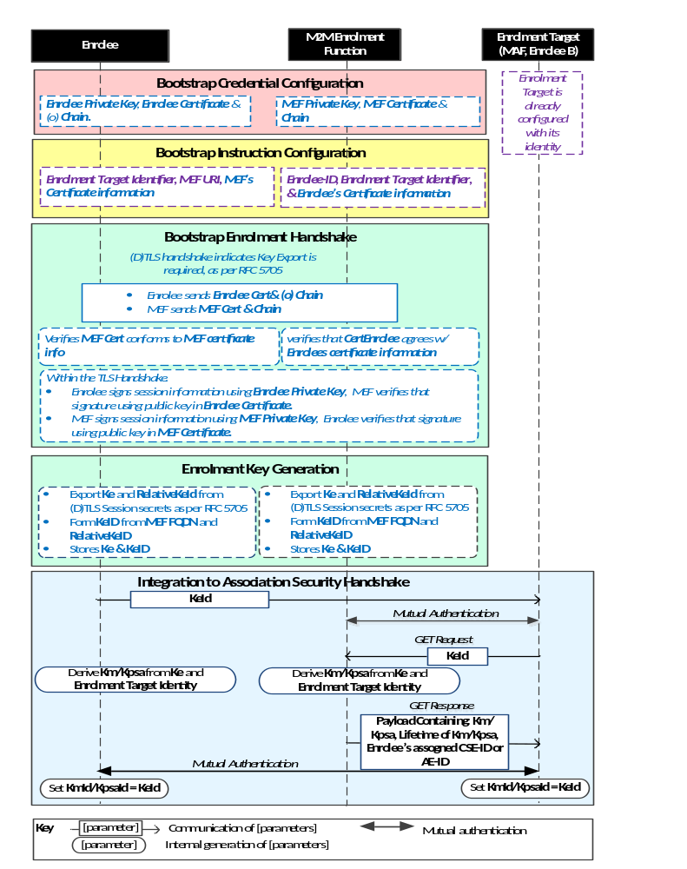

NOTE: The following font colours differentiate the general topic that the text relates to:
Black text contains Remote Security Provisioning -Framework-independent details.
Blue italic text highlights details specific to this particular Remote Security Provisioning Framework.
Purple italic text highlights technical actions that may include steps not specified by oneM2M.
Red italic text highlights security-related properties.

Figure 8.3.2.2-1: The sequence of events when using
the Certificate-Based Remote Security Provisioning Framework

-----------------------End of change 2---------------------------------------------

-----------------------Start of change 3---------------------------------------------

8.3.2.3 GBA-Based Remote Security Provisioning Framework
To share a long term Master Credential (Km) or Provisioned Secure Connection Key (Kpsa) between an Application Service/Middle Node and an Enrolment Target, the M2M Application Service/Middle Node shall perform a successful GBA bootstrapping and derive a NAF key (Ks_(ext/int)_NAF). This NAF key is the Master Credential (Km) or Provisioned Secure Connection Key (Kpsa).
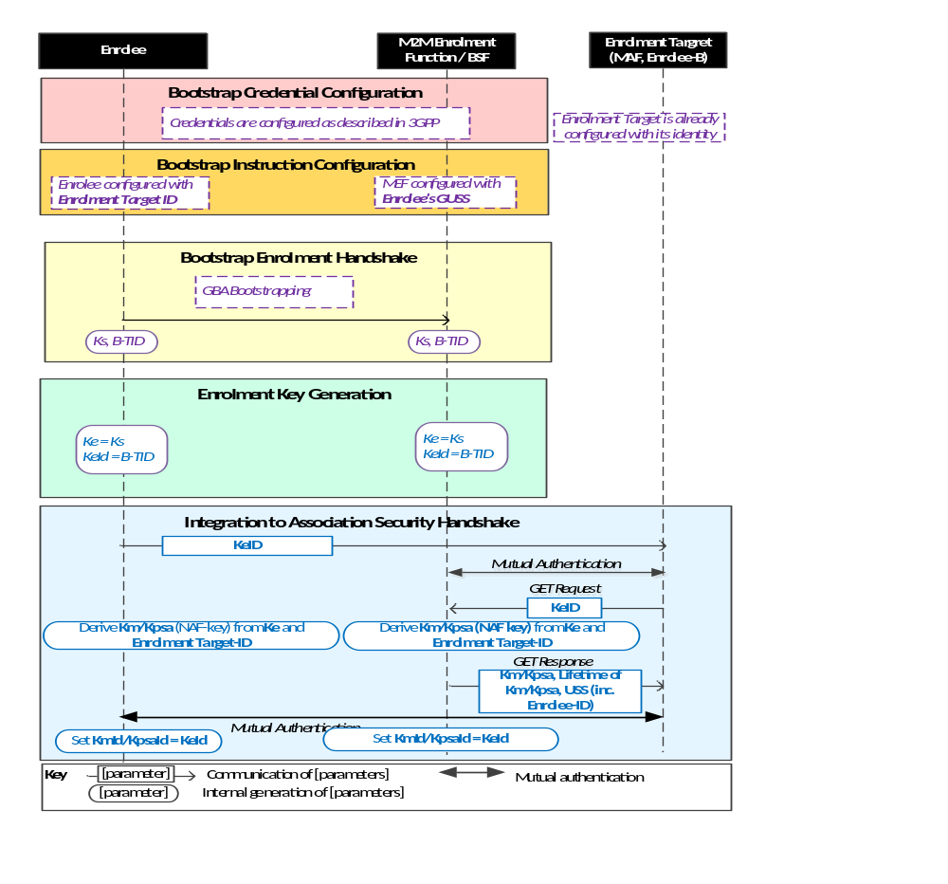

NOTE: The following font colours differentiate the general topic that the text relates to:
Black text contains Remote Security Provisioning -Framework-independent details.
Blue italic text highlights details specific to this particular Remote Security Provisioning Framework.
Purple italic text highlights technical actions that may include steps not specified by oneM2M.
Figure 8.3.2.3-1: The sequence of events when using
the GBA-Based Remote Security Provisioning Framework

-----------------------End of change 3---------------------------------------------

CHECK LIST
- Does this change request include an informative introduction containing the problem(s) being solved, and a summary list of proposals.?
- Does this CR contain changes related to only one particular issue/problem?
- Does this change request make all the changes necessary to address the issue or problem? E.g. A change impacting 5 tables should not only include a proposal to change only 3 tables. Includes any changes to references, definitions, and acronyms in the same deliverable?
- Does this change request follow the drafting rules?
- Are all pictures editable?
- Have you checked the spelling and grammar?
- Have you used change bars for all modifications?
- Does the change include the current and surrounding clauses to clearly show where a change is located and to provide technical context of the proposed change? (Additions of complete sections need not show surrounding clauses as long as the proposed section number clearly shows where the new section is proposed to be located.)
- Are multiple changes in this CR clearly separated by horizontal lines with embedded text such as, start of change 1, end of change 1, start of new clause, end of new clause.?

