CHANGE REQUEST
Meeting:* | SEC 23
Source:* | Phil Hawkes, Qualcomm, phawkes@qti.qualcomm.com  Wolfgang Granzow, Qualcomm, wgranzow@qti.qualcomm.com  Josef Blanz, Qualcomm, jblanz@qti.qualcomm.com
Date:* | 2016-05-16
Contact:* | As above
Reason for Change/s:* | Updates MAF text to support E2E Security, which introduces changes to other SAEF text.
CR against: Release* | 2
CR against: WI* | Active WI-0016 End-to-End Security and Group Authentication  MNT Maintenance / < Work Item number(optional)>  STE Small Technical Enhancements / < Work Item number (optional)>  Only ONE of the above shall be ticked
CR against: TS/TR* | TS-0003 and 2.0.1
Clauses/Sub Clauses* | 8.2, New 8.x “MAF Security Framework Details”, definitions
Type of change: * | Editorial change  Bug Fix or Correction  Change to existing feature or functionality  New feature or functionality  Only ONE of the above shall be ticked
Post Freeze checking:* | This CR contains only essential changes and corrections? YES NO  This CR may break backwards compatibility with the last approved version of the TS? YES NO  This CR is a mirror CR? YES if YES, please indicate the document number of the original CR: <Document Number) : NO
Template Version:27 May 2015 (Dot not modify)

oneM2M Notice
The document to which this cover statement is attached is submitted to oneM2M. Participation in, or attendance at, any activity of oneM2M, constitutes acceptance of and agreement to be bound by terms of the Working Procedures and the Partnership Agreement, including the Intellectual Property Rights (IPR) Principles Governing oneM2M Work found in Annex 1 of the Partnership Agreement.

Introduction
This CR introduces a range of changes, mostly associated with the MAF specifications. The proposed changes are as follows.
- Some generic SAEF details are clarified.
  - Clarification that the (Entity A, Entity B) ordered pair can correspond to one of the following 3 cases
    - (AE, its Registrar CSE)
    - (Registree CSE, Registrar CSE), for HTTP/CoAP bindings of primitive requests with Registree CSE as Originator.
    - (Registrar CSE, Registrar CSE), for HTTP/CoAP bindings of primitive requests with Registrar CSE as Originator.
  - A new phase of “Identity Configuration” is added in between the “Credential Configuration” phase and “Association Configuration” Phase. There are some details for the MAF-based case that needed to be indicated as occurring before “Association Configuration” without mandating that the configuration occurred during “Credential Configuration”.
- Generic procedures are defined which can be used for centralized authenticated key distribution in SAEFs, ESPrim, ESData. These procedures are based on the existing MAF text, with some (necessary) clarifications added. A new clause 8.x is proposed. Some changes to existing MAF text include
  - Entity A can provide a list of possible IdB to the MAF, for example providing a list of discoverable CSE in the local area network, or pre-configured IdB. Previously the only option was that Entity A was configured with IdB.
  - Add support for certificate-based mutual authentication between CSE/AE and MAF
- Since so many procedures are in common, it is proposed to use the term “MAF” for the centralized, authenticated key distribution functions used in each of SAEF, ESPrim and ESData.
- The MAF-based SAEF text is updated
  - The text refer to the Generic MAF procedures as much as possible.
  - The interaction between Entity A and MAF (previously called MAF Handshake) has been moved into “Association Configuration” phase.
Further changes are required to ESPrim text and ESData text, and will be provided in future revisions.
An addition CR is being drafted which adds the ability to provision certificates as part of Enrolment/Remote Provisioning (this direction was agreed in principle in SEC-2016-0549R02, pending CRs).
R01:
- Added “Identity Configuration” phase to PSK SAEF and Certificate SAEF clauses.
- Clarified Identity Configuration phase for MAF in the overview.
- Removed text saying that, if Entity A is a CSE, then it is configured with its CSE-ID. The reason for removing this text is that it has no impact on security.
- Added a note to in 8.x.2 MAF Enrolment Phase to say that when an RSPF is used to provision a symmetric key, then in the first handshake after the RSPF, then the Enrolee needs to provide KeId (rather than KmId) since the MAF will not have retrieved Km and KmId prior to that point. KmId can be used for later handshakes. Details are then added to 8.x.2 “MAF Handshake Procedure”.
- Other clarifications and editorial corrections.
R02
- All changes merged – only a clean version provided
- Changes “MAF Enrolment” to “MAF Credential Configuration Details”, with changes in internal details
- Added “MAF Activation procedure”: activates an End-Point’s service with an M2M Authentication Function, and configures the End-Point with the URIs for performing MAF Key Registration and MAF Key Retrieval and the identity that the MAF will associate with the End-Point. When an RSPF is used to provision the symmetric key Master Credential (Km), then the MAF retrieves this key (from the MEF) during MAF Activation, and the MAF also assigns a corresponding Master Credential Identifier (KmId) and identifier to the End-Point.
- Parameters exchanged in messages are described in tables.
- “Initiating End-Point” renamed to “Source End-Point” -
- Source End-Point tells the MAF exactly who the Target End-Point(s) is – previously the MAF could select the Target End-Point(s).
- This CR and the upcoming revision of 0071 are aligned, particularly in terms of what happens when an RSPF is used to provision the symmetric key Master Credential (Km) (see above).
R03:
- Technical Changes
  - [This change was the result of feedback from Interdigital]. Added clarification (at the end of clause 8.x.1) that the symmetric key distributed by the MAF (Kc) can be used in one of two ways, depending on the requirements of the security protocol using Kc
    - If the security protocol requires a single symmetric key, then the first half of Kc is used as the security protocol symmetric key
    - If the security protocol requires two symmetric keys (e.g. an encryption key and integrity key) then the two halves of Kc are mapped to the two security protocol symmetric keys.
- Editorial changes.
  - Made some language normative (e.g. adding “shall”) where appropriate.
  - Added text clarifying that SUID is used to limit the scope of credentials provisioned by MEF or distributed by MAF.
  - Replaced “type of security protocol” with “security feature” when mentioning SUID. In one place “security protocol” was still the appropriate term to use.
R04
- Text supporting MAF authentication using certificates is restricted to clauses 8.x.2 and 8.x.4 – this text is highlighted with a blue background. If SEC decides to include the text, then the highlighting can be removed in a subsequent revision of this document. If SEC decides to not include the text, then the text can be removed in a subsequent revision of this document.
- Editorial Changes
  - Corrections: “MAF Enrolment” replaced with “MAF Credential Configuration”
  - “MAF Activation Procedure” renamed “MAF KmID Retrieval Procedure” to align with purpose of this procedure.
- Technical Changes
  - MAF KmID Retrieval Procedure (was “MAF Activation Procedure”) is now used only in the case of remotely provisioning a symmetric key, in which case the procedure has two outcomes (1) triggering the MAF to retrieve the key from the MEF and (b) the MAF providing the corresponding KmID (assigned by the MAF) to the End-Point. Impacts the following clauses: 8.2.1 (including Figure 8.2.1-1), 8.2.2.3 (including Figure 8.2.2.3-1), 8.x.1, 8.x.2, 8.x.3
R05
- Editorial Changes
  - Added Figure 8.x.1-1 describing the general sequence of events to use MAF Security Framework procedures in a security feature.
  - Minor editorial corrections.

-----------------------Start of change 1 --------------------------------

8.2.1 Overview on Security Association Establishment Frameworks
In the present document, security associations are restricted to single hop on Mcc, Mcc' or Mca reference point.
The Security Association Establishment Framework end-points are denoted:
- Entity A, which may be an AE or CSE. This entity always acts as the client of the security association (TLS/DTLS session).
- Entity B, which shall be a CSE. This entity always acts as the server of the security association (TLS/DTLS session).

- The oneM2M system supports the following Security Association Establishment Frameworks:
- Security Association Establishment Frameworks:
- Provisioned Symmetric Key Security Association Establishment. A symmetric key is provisioned to the entities: this is called the Provisioned M2M Symmetric Key, and denoted Kpsa. The entities authenticate each other by verifying Message Integrity Codes (MIC) in the Security Handshake which were generated using the symmetric key. For more details see clause 8.2.2.1.
- Certificate-Based Security Association Establishment: The entities are each issued with
- a Private Signing Key that is known only to that entity,
- a Certificate containing the corresponding Public Verification Key, and
- (Optionally) a Certificate Chain from the entity's Certificate to a Root Certificate.
The entities shall validate each other's Certificate before trusting the Public Verification Keys in the Certificate. Within the Security Handshake, entity A creates a digital signature of the session parameters using its private signing key and entity B verifies the digital signature using entity A's public verification key. Then the roles are reversed: entity B creates a digital signature and entity A verifies it. For more details see clause 8.2.2.2.
- M2M Authentication Function (MAF)-based Security Association Establishment. This Security Association Establishment Framework uses mutual authentication of the entity A and the M2M Authentication Function (MAF) and derive a M2M Secure Connection key (Kc) that the MAF delivers to entity B (via separate mutually-authenticated communication). Then entities then authenticate each other using the M2M Secure Connection key (Kc). Each of Entity A and entity B can use either symmetric key credentials or certificates for mutual authentication with the MAF. For more details see clause 8.2.3.1.
For a more detailed description of the above Security Association Establishment Frameworks, it is useful to compare the following aspects of the Security Association Establishment Frameworks:
- Credential Configuration:

- For the Provisioned Symmetric Key Security Association Establishment Framework, Entity A and Entity B are provisioned with the Provisioned M2M Symmetric Key that entities will use to authenticate each other using pre-provisioning or remote provisioning.
- For the Certificate-Based Security Association Establishment Frameworks, Entity A and Entity B are provisioned with the Credential that the entity will use to authenticate itself to the other entity using pre-provisioning or remote provisioning.
- For the MAF-based Security Association Establishment Framework, The MAF Credential Configuration procedure (clause 8.x.2) is performed twice: once to provisions credentials for mutual authentication of Entity A with MA, and once to provision credentials for mutual authentication of Entity B with MAF.
- Identity Configuration: Identity configuration may occur as part of Credential Configuration, or may occur at a later time.
- For the MAF-based Security Association Establishment Framework:
  - If Entity A is a CSE, then the MAF shall be configured with Entity A’s CSE-ID (denoted IdA).
  - If Entity A is an AE, then the MAF may be configured with Entity A’s AE-ID (denoted IdA).
  - The MAF shall be configured with Entity B’s M2M-SP Assigned CSE-ID (denoted IdB).
  - If Entity A (or Entity B respectively) are remotely provisioned with a symmetric key for use with the MAF, then Entity A (or Entity B respectively) shall perform the MAF KmId Retrieval procedure with the MAF to retrieve the KmId to be used for subsequently authentication with the MAF.
NOTE 2: The current oneM2M specifications do not describe how the this information is configured to the MAF.
- Entity A’s knowledge of its identity (IdA) has no impact on the security association establishment, and is not discussed further in clause 8.2.
- Entity B shall be configured with its CSE-ID (IdB) prior to Association Configuration.
- Association Configuration:
- Entity A shall be provided with IdB, the CSE-ID for Entity B.
NOTE 3: the present specification does not describe how Entity A is provided with IdB. Example mechanisms could include configuration via remote management, and discovery mechanisms supported by the Underlying Network(s).

- In the case of Certificate-Based Authentication Framework: each entity (Entity A and Entity B) is additionally configured with the certificate information that the entity will use to verify the other entity. The necessary certificate information is dependent on the flavour of the certificates, with details provided in clause 8.1.2.4 “Information Needed for Certificate Authentication of another Entity”.
- In the case of the MAF-Based Security Association Establishment Framework:
  - The MAF is provided with the identity of Entity B for which the MAF is authorized to facilitate establishing a security association with Entity A.
  - Entity A and the MAF interact, using the MAF Key Registration procedure (clause 8.x.4) to establish M2M Secure Connection Key (Kc) and M2M Secure Connection Key Identifier (KcId) and authorize Entity A to establish a security association with Entity B. This step includes mutual authentication using the MAF Handshake Procedure (clause 8.x.3). This step includes Entity A providing the MAF with IdB. See Note 3 above

- Association Security Handshake: Identification, authentication and security context establishment between the entities.
- In the case of the MAF-based Security Association Establishment Framework:
  - Entity A provides the M2M Secure Connection Key Identifier (KcId) to Entity B.
  - Entity B and the MAF interact using the MAF Key Retrieval procedure (clause 8.x.5). This step includes mutual authentication using the MAF Handshake Procedure (clause 8.x.3). Entity B forwards KcId to the MAF and, if Entity B is authorized, the MAF returns the M2M Secure Connection Key (Kc) and either IdA or a globally unique identifier for the credential used by the MAF to authenticate Entity A during Association Configuration
- The M2M Secure Connection Key (Kc) is then used in the Security Handshake for mutual authentication between Entity A and Entity B.
Entity A associates the resulting security context with IdB: the AE-ID or CSE-ID for Entity B established during Association Configuration.
Entity B associates the security context with one of the following
- A single Absolute CSE-ID, and indication that Entity A is a CSE.
- A single Absolute AE-ID, and indication that Entity A is a AE, or
- A list of allowed Absolute AE-ID values, and indication that Entity A is an AE. This case applies only when Entity A presents a Device Certificate.
This document provides the following approaches for Entity B to determine the applicable CSE-ID or AE-ID(s) prior to registration.
- If Entity A is authenticated using a CSE-ID certificate (or AE-ID certificate), then Entity B extracts the CSE-ID (or AE-ID respectively) from the certificate and associates the security context with this CSE-ID (or AE-ID respectively), as described in the certificate profile in Clause 10.1.1 “Certificate Profiles”.
- In all other cases, Entity B forms a globally unique Credential-ID (see clause 10.4 “Credential-ID Details”) identifying the credential used by Entity A in the security association establishment mechanism. The Credential-ID identifies one of a Kpsa (in the case of a PSK SAEF), certificate (in the case of a Certificate-Based SAEF) or the Km (in the case of an MAF-Based SAEF). Entity B subsequently determines the CSE-ID or AE-ID(s) which are applicable for this Credential-ID.
  - If Entity B assigned the AE-ID(s) corresponding to this Credential-ID, then Entity B is responsible for determining the AE-ID(s) corresponding to this Credential-ID.
  - Otherwise, the CSE-ID or AE-ID(s) shall be made available to Entity B via one of the following approaches.
    - If the Security Association Establishment procedure is facilitated by an M2M Authentication Function, then the M2M Authentication Function may be provided with the CSE-ID or AE-ID and the M2M Authentication Function may provide this to Entity B at the same time as Kc is provided to Entity B. The M2M Authentication Function could have been provided with the CSE-ID or AE-ID during provisioning, including the case where the M2M Authentication Function is provided with the CSE-ID or AE-ID during remote provisioning by an M2M Enrolment Function (which is similar to the case described in the following bullet).
    - If the Security Association Establishment procedure uses a Provisioned Symmetric Key which was remotely provisioned to Entity A and Entity B, then the M2M Enrolment Function may provide Entity B with CSE-ID or AE-ID during the Remote Security Provisioning procedure.
    - If the M2M Service Provider assigns Entity A’s entity identifier(s), then the CSE-ID or AE-ID(s) may be securely configured by the M2M Service Provider to Entity B prior to the Association Security Handshake. For example, the CSE-ID or AE-ID(s) may be configured as part of Credential Configuration or Association Configuration. This specification permits using other mechanisms, with the assumption that the mechanism provides authentication, integrity protection and optionally confidentiality.
      - Example 1. If the M2M Service Provider has the opportunity to configure Entity B prior to deployment, then the M2M Service Provider could configure the CSE-ID or AE-ID(s) to Entity B at this time.
      - Example 2. A secure remote management protocol could be used to configure Entity B with the CSE-ID or AE-ID(s). However, this is not currently an interoperable feature as there is no standardized management object facilitating this management.
    - In the case that Entity A is an AE and Entity B is a CSE, the applicable AE-ID(s) may be obtained by retrieving the applicable <serviceSubscribedAppRule> resources which are linked to by the ruleLinks attribute of the Entity B’s <serviceSubscribedNode> on the IN-CSE as described in clause 10.1.1.2.2 “Application Entity Registration procedure” in TS-0001 [1].

Figure 8.2.1-1 provides a summary of the above defined three Security Association Establishment Frameworks.

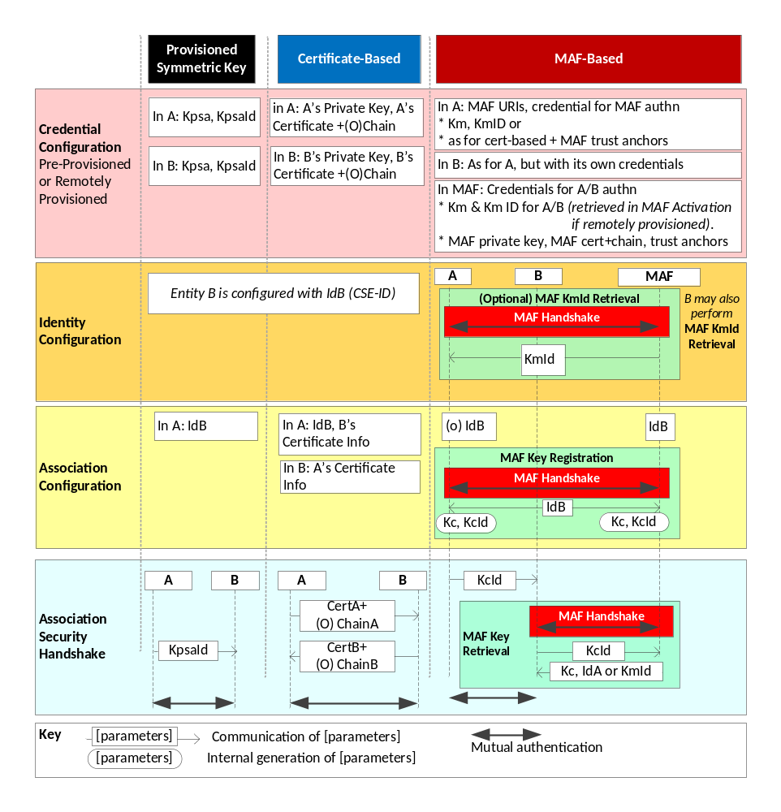
Figure 8.2.1-1: Overview of the Security Association Establishment Frameworks
supported by oneM2M

8.2.2 Detailed Security Association Establishment Frameworks

8.2.2.1 Provisioned Symmetric Key Security Association Establishment Frameworks
This clause describes the Provisioned Symmetric Key Security Association Establishment Framework. This framework enables mutual authentication of two entities corresponding to either two CSEs or a CSE and an AE. The Credential for this framework is a long-term symmetric key that has been provisioned into the entities to be authenticated. This key is called a Provisioned Secure Connection Key and is denoted Kpsa. The provisioning of Kpsa could be a pre-provisioning or a remote provisioning thanks to Remote Security Provisioning Frameworks, as described in clause 8.3. The entities authenticate each other by verifying message authentication codes in the Security Handshake which were generated using the Provisioned Secure Connection Key.
NOTE: Long term Provisioned Secure Connection Keys can pose a security risk if not adequately secured, and for this reason long term Provisioned Secure Connection Keys are recommended to be stored in Secure Environments.
Figure 8.2.2.1-1 illustrates the sequence of events when using the Provisioned Symmetric Key Security Association Establishment Framework. In this description, "Entity A" and "Entity B" correspond to either two CSEs or an AE and a CSE (respectively).

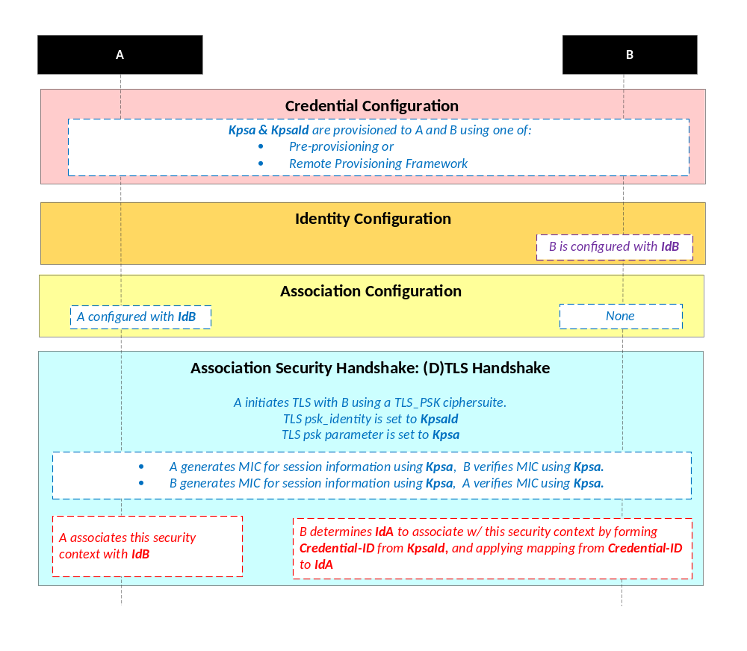
NOTE: The following font colours differentiate the general topic that the text relates to:
Blue italic text highlights details specific to this particular Security Association Establishment Framework.
Purple italic text highlights technical actions that may include steps not specified by oneM2M.
Red italic text highlights security-related properties.

Figure 8.2.2.1-1: The sequence of events when using the Provisioned Symmetric Key
Security Association Establishment Framework
Credential Configuration: The Provisioned Secure Connection Key (Kpsa) and the corresponding Provisioned Secure Connection Key Identifier, denoted KpsaId, shall be provisioned to both entities either with pre-provisioning or remote provisioning. The format of KpsaId is defined in clause 10.5 “KpsaId Format”.
Identity Configuration: See clause 8.3.1.2.
Association Configuration:

- Entity A shall be configured with Entity B identity (IdB). Entity A shall use this identity for Entity B authenticating using the above arguments. This identity is also used to route the (D)TLS exchange.
NOTE 2: Entity A will associate Entity B's identity with messages secured within Security Contexts established using the Provisioned Secure Connection Key Kpsa associated with the Provisioned Secure Connection Key Identifier KpsaId.
- If Entity A is a CSE, then Entity B shall be configured with Entity A’s CSE-ID. If Entity A is an AE, then Entity B may either be configured Entity A identity (IdA), or may determine IdA during registration (Creation of the <AE> resource). Entity B is to use this identity for Entity A authenticating using the above arguments.
NOTE 3: Entity B will associate the configured Entity A identity with messages secured within Security Contexts established using the Provisioned Secure Connection Key Kpsa associated with the Provisioned Secure Connection Key Identifier KpsaId.

Association Security Handshake: The entities shall perform a (D)TLS-PSK handshake [Error: Reference source not found] to establish a secure session.

- The "psk_identity" parameter [Error: Reference source not found] shall be set to the value of the Provisioned Secure Connection Key Identifier KpsaId.
- The "psk" parameter [Error: Reference source not found] shall be set to the value of the Provisioned Secure Connection Key Kpsa.
- The (D)TLS cipher suite profile for the Provisioned Secure Connection Key Security Association Establishment Framework is specified in clause 10.2.2.
- Following successful authentication of Entity B, Entity A shall associate the security context with Id B (Entity B’s entity identifier) configured to Entity A during Association Configuration.
- Following successful authentication of Entity A, Entity B shall associate the security context with a CSE-ID or AE-ID :
  - If Entity B was already provided with the CSE-ID or AE-ID corresponding to KpsaId, then Entity B shall associate the security context with that CSE-ID or AE-ID.
  - Otherwise, Entity B shall associate the security context with the Credential-ID formed from KpsaId as described in clause 10.4 “Credential-ID Details”. Entity B shall then determine CSE-ID or AE-ID from the Credential-ID as described in clause 8.2.1 “Overview on Security Association Establishment Frameworks”.

8.2.2.2 Certificate-Based Security Association Establishment Frameworks
This clause describes the Certificate-Based Security Association Establishment Framework.
Figure 8.2.2.2-1 illustrates the sequence of events when using the Certificate-Based Security Association Establishment Framework. In this description, "Entity A" and "Entity B" correspond to either two CSEs or a CSE and an AE.
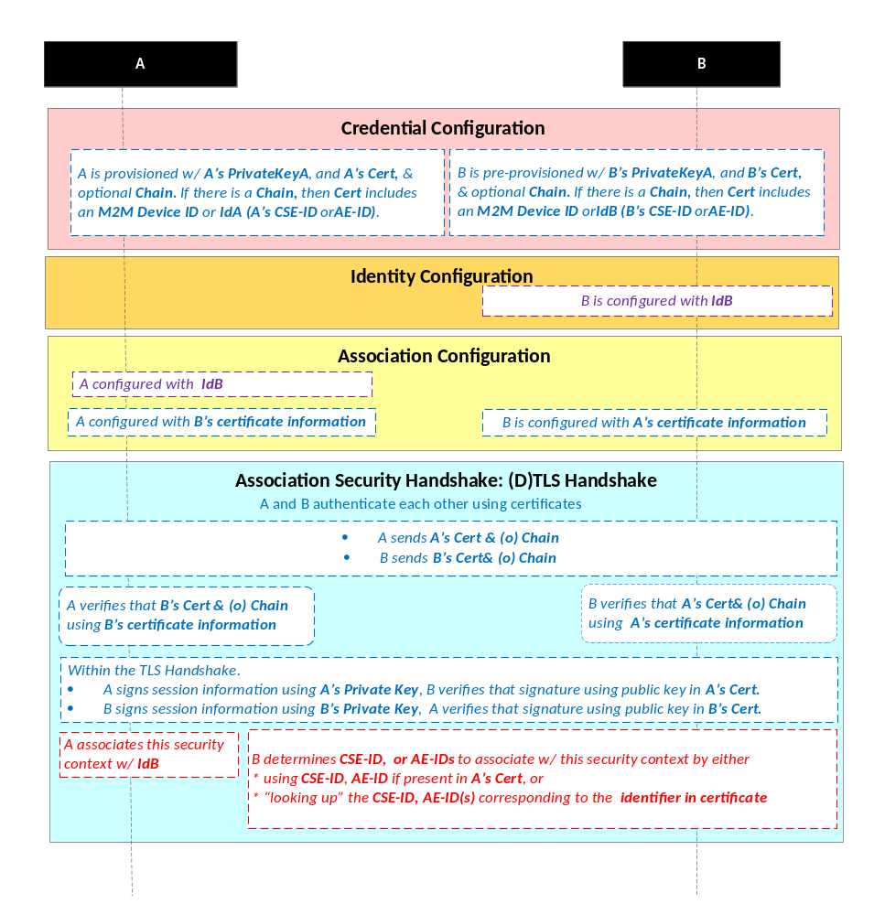
NOTE: The following font colours differentiate the general topic that the text relates to:
Blue italic text highlights details specific to this particular Security Association Establishment Framework.
Purple italic text highlights technical actions that may include steps not specified by oneM2M.
Red italic text highlights security-related properties.

Figure 8.2.2.2-1: The sequence of events when using the Certificate-Based Security
Association Establishment Framework
Credential Configuration: The private keys and certificates for each entity shall be pre-provisioned as described in clause 8.1.2.3 "Credential Configuration for Certificate-Based Security Frameworks". If Entity A is a CSE, then Entity A shall also be configured with its CSE-ID (not shown in the figure).
Identity Configuration: See clause 8.2.1.
Association Configuration: Entity A and Entity B shall be configured with the information needed for the authentication and identification (during Security Handshake) of Entity B and Entity A respectively:
- Entity A shall be commanded to initiate a Security Handshake, and the command includes the following arguments:
- Entity B's certificate information: as described in clause 8.1.2.4 "Information Needed for Certificate Authentication of another Entity".
- Entity B's identity (IdB). Entity A shall use this identity for Entity B authenticating using the above arguments. This is used to route the (D)TLS exchange.
NOTE 1: The Entity A will associate Entity B's identity with messages secured within Security Contexts established in accordance with the configured Entity B‘s certificate information.
- The Entity B shall be configured with the following arguments describing Entity A authorized to perform Security Handshake with Entity B:
- Entity A's certificate information: as described in clause 8.1.2.4 "Information Needed for Certificate Authentication of another Entity".
Association Security Handshake:

- Each entity shall verify the other entity's certificate as described in clause 8.1.2.2 "Certificate Verification".
- The entities shall authenticate each other using the validated certificates as specified in TLS 1.2 IETF RFC 5246 [Error: Reference source not found] and DTLS 1.2 IETF RFC 6347 [Error: Reference source not found] specifications.
- The (D)TLS cipher suite profile for the Certificate-Based Security Association Establishment Framework is specified in clause 10.2.3.
- Following successful authentication of Entity B, Entity A shall associate the security context with IdB (Entity B’s entity identifier) configured to Entity A during Association Configuration.
- Following successful authentication of Entity A, Entity B shall associates the security context with a CSE-ID, AE-ID or list of allowed AE-IDs:
  - If Entity A establishes a security context by presenting a CSE-ID certificate, then Entity B shall associate the security context with the CSE-ID in the certificate.
  - If Entity A establishes a security context by presenting an AE-ID certificate, then Entity B shall associate the security context with the Absolute AE-ID in the certificate.
  - If Entity A establishes a security context by presenting a device certificate, then Entity B shall associate the security context with the Credential-ID formed from the globally unique hardware instance identifier in the certificate as described in clause 10.4 “Credential Details”. Entity B then shall use Credential-ID to determine the CSE-ID, AE-ID or list of allowed AE-IDs as described in clause 8.2.1 “Overview on Security Association Establishment Frameworks”.
  - If Entity A establishes a security context by presenting a raw public key certificate, then Entity B shall associate the security context with the Credential-ID formed from the corresponding public key identifier described in clause 10.1.2 “Public Key Identifiers”. Entity B shall then use Credential-ID to determine the CSE-ID or AE-ID as described in clause 8.2.1 “Overview on Security Association Establishment Frameworks”.

8.2.2.3 MAF-based Security Association Establishment Framework
This clause describes the MAF-based Security Association Establishment Framework.
This framework uses the MAF Common procedures in clause 8.x, with the following mapping of functional roles:
- Entity A plays the role of the Source End-Point.
- Entity A plays the role of the Target End-Point.
The present clause refers to the entities using only the terminology of Entity A and Entity B.
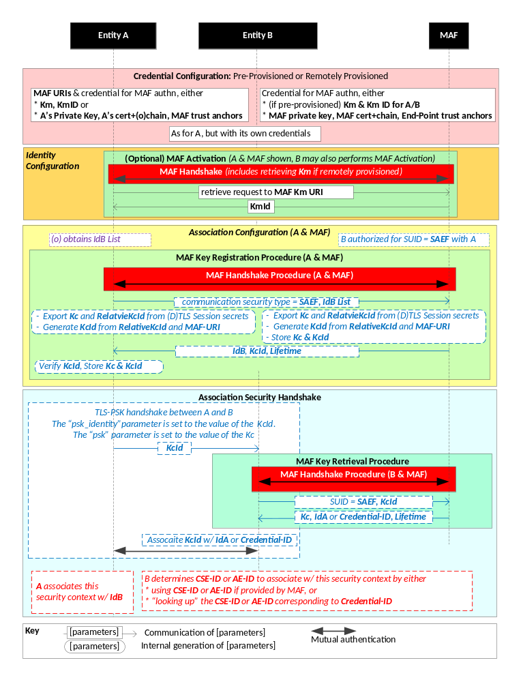

NOTE 1: The following font colours differentiate the general topic that the text relates to:
Blue italic text highlights details specific to this particular Security Association Establishment Framework.
Purple italic text highlights technical actions that may include steps not specified by oneM2M.
Red italic text highlights security-related properties.

Figure 8.2.2.3-1: The sequence of events when using the
MAF-Based Security Association Establishment Framework
Credential Configuration:

- Entity A (and Entity B respectively) shall be individually provisioned with credentials for mutual authentication with the MAF, as described in MAF Credential Configuration (clause 8.x.2). Pre-provisioning or remote provisioning may be applied. In the case of remote provisioning symmetric keys, the MAF retrieves the symmetric keys from the MEF during the MAF Activation procedure in Identity Configuration.
Identity Configuration:
- If Entity A (or Entity B respectively) are remotely provisioned with a symmetric key for use with the MAF, then Entity A (or Entity B respectively) shall individually perform the MAF KmId Retrieval procedure (clause 8.x.3) with the MAF. This procedure is used to trigger the MAF to (a) retrieve Km form the MEF, and (b) provide the End-Point with the KmId to be used for subsequently authentication with the MAF at step 5.

- Association Configuration: Entity A and the MAF shall be configured with the information needed for the authentication and identification during MAF Handshake and Association Security Handshake:

- Authorizing the SAEF.
  - Entity A shall be provided with IdB, the CSE-ID for Entity B. See Note 3 in clause 8.2.1.
  - The MAF shall be configured with the Entity B Identity (IdB) for which it is authorized to provide Kc for an SAEF.
- Entity A and the MAF shall establish a mutually authenticated secure channel for communication using the MAF Handshake procedure (clause 8.x.4), using the credentials provisioned during Credential Configuration.
- Entity A shall initiate the MAF Key Registration procedure (clause 8.x.5) with the MAF. The MAF Key Registration shall include the Security Usage Identifier (SUID) associated with the MAF-Based SAEF and IdB. This procedure results in
  - Entity A and the MAF establishing a M2M Secure Connection Key (Kc) and associated M2M Secure Connection Key Identifier (KcId).

  - MAF providing the lifetime for the M2M Secure Connection Key (Kc)
The SUID limits the scope within which Kc is authorized to be used. In this case, the SUID is used to ensure that the Entity A shall use Kc only with the MAF-Based SAEF.
Association Security Handshake:

- Entity A shall initiate a (D)TLS-PSK handshake with Entity B identified by the MAF, according to clause 10.2.2
- Entity A shall send KcId to Entity B as the “psk_identity” parameter in a (D)TLS_PSK handshake.
- Entity B recognizes the MAF-FQDN part of KcId in the “psk_identity” parameter, and determines that the corresponding M2M Secure Connection Key (Kc) shall be retrieved from the corresponding MAF.
- Entity B and the MAF shall perform the MEF Key Retrieval procedure described in clause 8.x.6.

NOTE 2: The MEF Key Retrieval procedure includes establishing a mutually authenticated secure channel for communication using the MAF Handshake procedure (described in clause 8.x.43), using the credentials provisioned during Credential Configuration.

Entity B shall provides the Security Usage Identifier (SUID) associated with the MAF-Based SAEF and IdB KcId to the MAF, and t
he MAF shall return Kc, Kc Lifetime and an identity for Entity A to Entity B. The SUID limits the scope within which Kc will be used. In this case, the SUID is used to ensure that the Entity B shall use Kc only with the MAF-Based SAEF.

  - NOTE 5: Assigning Kc Lifetime is the responsibility of the MAF.
- Entity A and Entity B shall complete the (D)TLS-PSK handshake with the “psk” parameter set to the value of the M2M Secure Connection Key (Kc).
- The (D)TLS cipher suite profile for the MAF-Based Security Association Establishment Framework is specified in clause 10.2.2.
- Following successful authentication of Entity B, Entity A shall associate the security context with Id B (Entity B’s entity identifier) configured to Entity A during Association Configuration.
- Following successful authentication of Entity A, Entity B shall associate the security context with a CSE-ID or AE-ID :
  - If the MAF provided Entity B with a CSE-ID or AE-ID, then Entity B shall associate the security context with that CSE-ID or AE-ID.
  - Otherwise, Entity B shall associate the security context with the Credential-ID formed from KmId (provided by the MAF) as described in clause 10.4 “Credential-ID Details”. Entity B shall then determines CSE-ID or AE-ID from the Credential-ID as described in clause 8.2.1 “Overview on Security Association Establishment Frameworks”.
- Entity A and Entity B may establish a fresh (D)TLS-PSK handshakes using Kc at any time within the Kc Lifetime. Once Kc Lifetime expires, then Entity B shall fail the (D)TLS-PSK handshake, which indicates to Entity B that a fresh MAF Handshake is required.

-----------------------End of change 1 -------------------------------------------

Add the following new clause somewhere in clause 8.

-----------------------Start of change 2 (clause 8.x)--------------------------------

8.x MAF Security Framework Details

8.x.1 Introduction to the MAF Security Framework Details
Clause 8.x describes the common details and procedures used in the MAF-based Security Frameworks; in the present specification these frameworks include:
- The MAF-Based Security Association Establishment Framework (SAEF).
- The MAF-Based End-to-End Security of Primitives (ESPrim) Framework.
- The MAF-based End-to-End Security of Data (ESData) Framework.
These frameworks use a MAF to provide authentication and distribution of symmetric key for use by a Source End-Point initiating establishing the symmetric key, and one or more Target End-Points. Table 8.x.1-1 “Mapping of Generic MAF Framework Roles to specific MAF-Based Framework Roles” describes the mapping of Source End-Point and Target End-Point to roles in the specific MAF-Based Frameworks, and the allowed number of Target End-Points.
Table 8.x.1-1: Mapping of Generic MAF Security Framework Roles to specific MAF Security Framework Roles
MAF-Based Security Framework | Source End-Point | Target End-Point | Number of Target End-Points
Security Association Establishment Framework (SAEF) | Entity A | Entity B | 1
End-to-End Security of Primitives (ESPrim) | Originator | Receiver | 1
End-to-End Security of Data (ESData) | Source ESData End-Point | Target ESData End-Point | Any

The generic MAF security framework details specified in clause 8.x are:
- MAF Credential Configuration (clause 8.x.2): describing the credentials and associated information provisioned to an End-Point and the MAF to enable the End-Point to use the services of the MAF.
- MAF KmId Retrieval Procedure (clause 8.x.3): If a CSE or AE is remotely provisioned with a symmetric key for use with the MAF, then this procedure is used to trigger the MAF to retrieve Km from the MEF. The MAF then provides the End-Point with the KmId to be used for subsequently authentication with the MAF.
- MAF Handshake Procedure (clause 8.x.4): establishing a mutually-authenticated TLS or DTLS session between an End-Point and a MAF.
- MAF Key Registration Procedure (clause 8.x.5): The Source End-Point and MAF perform the MAF Handshake procedure. The Source End-Point may provide a list of possible Target End-Point(s) to the MAF. The MAF and Source End-Point establish a symmetric key and symmetric key identifier, and negotiate information about the credential, which can include:
  - Security Usage Identifier (SUID) for the security feature which is authorized to be secured use this credential. That is, the SUID limits the scope within which the credential may be used.
  - Identity(ies) of the Target End-Point(s) which will be provided with this credential,
  - Lifetime of the credential.

MAF Key Retrieval Procedure (clause 8.x.6): The Target End-Point and MAF perform the MAF Handshake procedure. The Target End-Point provides the symmetric key identifier and SUID to the MAF. The MAF provides:
  - The symmetric key

  - Identity of the Source End-Point, or an identifier for the credential that the Source End-Point used for mutual authentication with the MAF during the MAF Key Registration procedure..
  - Lifetime of the credential.
The general sequence for using these procedures is shown in Figure 8.x.1-1 and described as follows:
- Each of the Source End-Point and Target End-Point(s) separately establish credentials for mutual authentication with the MAF, and are configured with the URIs for the MAF Key Registration Procedure and MAF Key Retrieval Procedure. If a symmetric key is remotely provisioned for mutual authentication with the MAF, then the Source End-Point is also provided with the MAF KmId Retrieval URI.
- If the Source End-Point is remotely provisioned for mutual authentication with the MAF, then the Source End-Point performs the MAF KmId procedure to trigger the MAF to retrieve the Source End-Point’s Master Credential from the MEF. The MAF then provides the Source End-Point with the KmId to be used for subsequently authentication with the MAF.
The same procedures is performed by a Target End-Point which is remotely provisioned for mutual authentication with the MAF.
- The Source End-Point performs the MAF Key Registration procedure to establish a symmetric key and corresponding identifier. The Source End-Point also provides the Security Usage Identifier (SUID) limiting the scope of the credential by identifying the security feature (SAEF, ESPrim, ESData). This procedure includes the MAF Handshake procedure for mutual authentication of the Source End-Point and MAF.
- The Source End-Point provides, to the Target End-Point(s), the symmetric key identifier established in the MAF Key Registration procedure. The details of this step depend on the security feature as identified by the SUID.
- The Target End-Point performs the MAF Key Retrieval procedure, to retrieve the symmetric key and corresponding information. This procedure includes the MAF Handshake procedure for mutual authentication of the Target -End-Point and MAF.
- The symmetric key is used in the security protocol between the Source End-Point and Target End-Point. If the security protocol requires a single symmetric key, then the first half of the distributed symmetric key is used. If the security protocol requires two symmetric keys (for example, an encryption key and a separate integrity key), then the two halves of the distributed symmetric key are used as the two security protocol symmetric keys. The details of this step depend on the security feature.
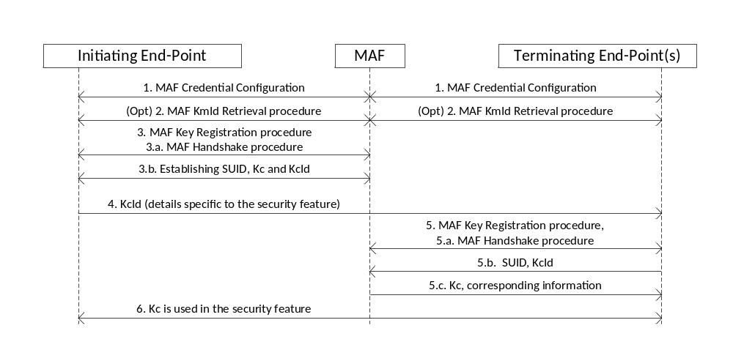
Figure 8.x.1-1: The sequence of events when using the MAF Security Framework as part of a security feature

8.x.2 MAF Credential Configuration Details
The End-Point needs configuring with the following parameters if it is to use the services of an MAF:
- Credentials for mutual authentication of the End-Point and MAF.
- The MAF Key Registration URI.
- The MAF Key Retrieval URI.
- (If remote provisioning is used to establish a symmetric key between an End-Point and the MAF) The MAF KmId Retrieval URI.
The credentials for mutual authentication shall be either pre-provisioned or remotely provisioned thanks to Remote Security Provisioning Frameworks. Either symmetric key credentials or certificate credentials maybe provisioned. Symmetric key credentials may be for authenticating some End-Points and use certificate credentials for authenticating other End-Points. The selection may be based on the capabilities of the End-Point being enrolled.
The details depend on the type of credential (symmetric key or certificates) and, in the case of symmetric keys, the type of provisioning (pre-provisioning or remote provisioning).
- Details specific to Pre-Provisioned Symmetric Keys: the Master Credential (Km) and corresponding Master Credential Identifier (KmId) shall be provisioned to the Enrolee and the MAF. The format of KmId is defined in clause 10.6 “KmId Format”.
- Details specific to Remotely-Provisioned Symmetric Keys:
  - The End-Point and an M2M Enrolment Function (MEF) shall establish an Enrolment Key (Ke) and corresponding Enrolment Key Identifier (KeId) using any Remote Security Provisioning Framework as described in clause 8.3. The MEF shall trigger the End-Point to enrol with the MAF using symmetric key credentials, as described in step 10 in clause 8.3.2.1. The End-Point and MEF shall generate the Master Credential (Km) from the Enrolment Key (Ke) as described in clause 10.3.x with the Enrolment-Target-ID set to the FQDN of the MAF, and the Security Usage Identifier (SUID) set to indicate “MAF Provisioning”. The SUID limits the scope within which the provisioned is authorized to be used. In this case, the SUID is used to ensure that the End-point shall use the provisioned key only for authenticating to an MAF.
  - The MAF and MEF shall be provisioned with credentials for establishing a mutually authenticated TLS or DTLS connection.
NOTE: The present document does not standardize these credentials and does not describe how these credentials are established. In general, FQDN certificates should suffice.
  - In this case, the MEF Credential Configuration does not configure all the required information to the MAF:
    - The MAF must retrieve Km from the MEF as part of MAF Activation.
    - The MAF must assign the Master Credential Identifier (KmId), and communicates KmId to the End-Point, as part of the MAF Activation,
- Details specific to Certificates (whether pre-provisioned or remotely provisioned):
  - The End-Point shall be provisioned with an End-Point certificate with optional certificate chain, and one or more MAF trust anchor CA certificates.
Editor’s note: an End-Point certificate profile might be required. Further investigation is required.
  - The MAF shall be provisioned with an MAF-Point certificate chaining to an MAF trust anchor CA certificate, and the End-Point’s Certificate Information as defined in clause 8.1.2.4.
Editor’s note: a MAF certificate profile is required.

8.x.3 MAF KmID Retrieval Procedure
Purpose: This procedure is used when remote provisioning is used to establish a symmetric key between an End-Point and the MAF. The End-Point triggers the MAF to retrieve Km from the MEF, and the MAF provides the End-Point wit the Master Credential Id (KmID) to use in subsequent MAF Handshake Procedures.
Pre-Conditions: The End-Point, MAF, and (where applicable) MEF have been provisioned with the parameters described in clause 8.x.2 “MAF Credential Configuration Details”. The details depend on the type of provisioning (pre-provisioning or remote provisioning) and the type of credential (symmetric key or certificates).
Procedure description:
- The End-Point shall establish a TLS (or DTLS) session with the MAF as shown in steps (b) onwards in the “Use of Provisioned Credential” in clause 8.3.2.1 shall be performed by the End-Point (assuming the role of Enrolee), MEF and MAF (assuming the role of Enrolment Target). The MAF retrieves Km from the MEF as part of this process.
- The End-Point shall send a retrieve request to the MAF KmId Retrieval URI configured by the MEF as part of MAF Credential Configuration.
- Upon receiving the request, the MAF shall compose a response a containing the following parameters.
Parameter Name | Parameter Description
Status | Status of the request
Master Credential Id | MAF-Assigned Master Credential ID (KmId).

The MEF shall send the response to the End-Point.
- The End-Point and MAF shall store the parameters.
- The End-Point uses this Master Credential ID hereafter when establishing TLS (or DTLS) sessions with the MAF.
- The MAF shall terminate the TLS/DTLS session.

8.x.4 MAF Handshake Procedure
Purpose: A MAF Handshake procedure establishes a mutually authenticated TLS or DTLS session for protecting the communication between an End-Point and MAF. In the case of the MAF Key Registration procedure, the TLS or DTLS session may be used by the Source End-Point and MAF to establish the M2M Secure Connection Key (Kc) and M2M Secure Connection Key Identifier (KcId).
Pre-Conditions: One of the following conditions must hold:
- The End-Point and MAF have been provisioned with certificates as described in the MAF Credential Configuration details in clause 8.x.2.
- The End-Point and MAF have established a symmetric Master Credential (Km) with corresponding Master Credential Identifier (KmId). The Km and KmId may be pre-provisioned (see clause 8.x.2), or established using
NOTE: In the case of establishing Kc via remote provisioning, MAF Handshake cannot be performed during MAF Activation because (a) the MAF does not know Kc prior to MAF Activation and (b) KmId has not been assigned prior to MAF Activation.
Procedure description:
- If the MAF Credential Configuration provisioned a symmetric key to the End-Point, then the End-Point and MAF shall establish the TLS or DTLS session using the TLS-PSK handshake according to clause 10.2.2, with the following details:
  - The "psk_identity" parameter [Error: Reference source not found] shall be set to the value of the Master Credential Identifier (KmId) established during MAF Credential Configuratiot.
  - The "psk" parameter [Error: Reference source not found] shall be set to the value of the Master Credential (Km) established during MAF Credential Configuratiot.
- If the End-Point and MAF are to authenticate using certificates, then the End-Point and MAF shall establish the TLS or DTLS session using the certificate-based TLS handshake according to clause 10.2.2, with the following details:
  - The TLS server certificate shall be the MAF’s certificate. The End-Point shall verify the MAF’s certificate against the set of provisioned MAF certificate trust anchors as described in clause 8.1.2.5.
  - The TLS client certificate shall be the End-Point’s certificate. The MAF shall verify the End-Point’s certificate against the provisioned End-Point Certificate Information as described in clause 8.1.2.5.

8.x.5 MAF Key Registration Procedure
Purpose: This procedure enables a Source End-Point to establish a symmetric key with the MAF which can be retrieved for use by one or more Target End-Points.
This procedure is performed between the Source End-Point and the MAF.
Pre-Conditions:
- The Source End-Point has performed the MAF Credential Configuration (clause 8.x.2) with the MAF, including configuration of the MAF Key Registration URI.
- The Source End-Point has determined a set of Target End-Points with which a symmetric key needs to be established.
Procedure Description. The procedure comprises the following steps:
- The Source End-Point shall establish a TLS or DTLS session with the MAF using the MAF Handshake procedure, described in clause 8.x.3. A by-product of the MAF Handshake procedure is that the MAF establishes an authenticated identity for the Source End-Point.
- The Source End-Point shall determines the value of the M2M Secure Connection Key (Kc) to be distributed by the MAF.
  - The Source End-Point may generate M2M Security Connection Key (Kc) and RelativeKcId from the (D)TLS session secrets using TLS Key Export (RFC 5705) [18], as described in clause 10.3.1 “TLS Key Export Details”.
  - The value of Kc may be self-generated by the Source End-Point, independently of the (D)TLS session secrets.
- The Source End-Point shall compose a list of Target End-Points to whom the MAF is authorized to provide Kc:
  - In the case of MAF-Based SAEF or MAF-Based ESPrim: The list shall contain exactly one Absolute AE-ID or Absolute CSE-ID.
  - In the case of MAF-Based ESData: The list shall contain any non-zero number of Absolute AE-ID or Absolute CSE-IDs.
NOTE 1: The present specifications do not provide any details about how the Source End-Point selects the list of Target End-Points.
- The Source End-Point shall send a request, to the MAF Key Registration URI, containing the following parameters.
Parameter Name | Parameter Description
SUID | The Security Usage Identifier limiting the security feature in which the symmetric key may be used.
Target End-Point ID List | The list of zero or more identifiers for the initial set of Target End-Points authorized to retrieve the symmetric key.
M2M Secure Connection Key | (Optional) If present, this parameter contains a value for Kc which is self-generated by the Source End-Point. If this parameter is not present, then the Source End-Point and MAF will generate Kc using TLS Exporter
Editor’s note: data types for the above parameters need to be specified, either in TS-0003 or in TS-0004
- The MAF shall authorize establishing an M2M Security Connection Key (Kc), based on the authenticated identity for the Source End-Point.
NOTE 2: The present specification provides no details for the authorization of this request.
- If the request included a value in the M2M Secure Connection Key parameter, then the MAF shall store this value as Kc. Otherwise, the MAF shall generate Kc from the (D)TLS session using TLS Key Export (RFC 5705) [18], as described in clause 10.3.1 “TLS Key Export Details”.
- The MAF shall initialize the list of authorized Target End-Points (those End-Points which may to retrieve this credential) to the list provided in the request.
  - In the case of MAF-Based ESData: This list may be further updated by authorized entities during or after the MAF Key Registration procedure.
NOTE 3: The present specifications do not provide any details about updating the list of authorized Target End-Points on the MAF. The MAF could provide its own logic and interface allowing subscribers to manage this list.
- The MAF shall select a previously-unused value of RelativeKcId.
- The MAF shall send a response, to the Source End-Point, containing the following parameters.
Parameter Name | Parameter Description
RelativeKcId | The RelativeKcId associated with the M2M Secure Connection Key.
Editor’s note: data types for the above parameters need to be specified, either in TS-0003 or in TS-0004
- The Source End-Point and MAF shall store the M2M Secure Connection Key (Kc) and M2M Secure Connection Key Identifier (KcId).
  - The M2M Secure Connection Key Identifier (KcId) is generated from the RelativeKcId and the M2M Authentication Function’s FQDN by the Source End-Point and MAF, as described in clause 10.3.5 “Generating KcId”.
- The MAF shall terminate the TLS or DTLS session between the Source End-Point and MAF.

8.x.6 MAF Key Retrieval Procedure
Purpose: This procedure enables a Target End-Point to retrieve Kc from a MAF corresponding to a KcId received by the Target End-Point.
Pre-Conditions:
- The Target End-Point has performed the MAF Credential Configuration (clause 8.x.2) with the MAF, including configuration of the MAF Key Retrieval URI.
- The Source End-Point has performed the MAF Key Registration Procedure (clause 8.x.2) with the MAF, resulting in an M2M Secure Connection Key (Kc) and M2M Secure Connection Key Identifier (KcId) for a specific Security Usage Identifier (SUID).
- The Target End-Point received an M2M Secure Connection Key Identifier (KcId) from the Initiating-End-Point in a security feature with the SUID which the Source End-Point provided to the MAF during the MAF Key Registration Procedure (clause 8.x.2)
- The Target End-Point may expect that it is authorized to obtain the corresponding M2M Secure Connection Key (Kc), and
NOTE: The Target End-Point should not repeat this procedure if the Target End-Point is already in possession of the corresponding M2M Secure Connection Key (Kc).
Procedure Description. The procedure comprises the following steps:
- The Target End-Point shall establish a TLS or DTLS session with the MAF using the MAF Handshake procedure, described in clause 8.x.3. A by-product of the MAF Handshake procedures is that the MAF establishes an authenticated identity for the Target End-Point.
- The Target End-Point shall send a request, to the MAF Key Retrieval URI, containing the following parameters:
Parameter Name | Parameter Description
SUID | Security Usage Identifier for security feature in which the M2M Secure Connection Key Identifier (KcId) was received. This limits the use of Kc to the corresponding security
M2M Secure Connection Key Identifier | The value of KcId received from the Source End-Point
Editor’s note: data types for the above parameters need to be specified, either in TS-0003 or in TS-0004
- The MAF shall identify the M2M Security Connection Key (Kc) using M2M Secure Connection Key Identifier (KcId), and verify that the identifier for the type of communication security is correct.
- The MAF shall determine if the Target End-Point is authorized to access the M2M Security Connection Key (Kc) by comparing the authenticated identifier for Target End-Point against the list of identifiers for authorized Target End-Points. If the Target End-Point is not authorized, then the MAF shall sends, to the Target End-Point, an error message and terminate the TLS or DTLS session. Otherwise, the MAF shall proceed to the next step.
- The MAF shall send a response, to the Target End-Point, containing the following parameters:
Parameter Name | Parameter Description
Status | Status of the request
M2M Secure Connection Key | The value of the M2M Secure Connection Key (Kc)
End-Point ID | The identity which the MAF associates with the Source End-Point.
Lifetime | Lifetime of the M2M Secure Connection Key
Editor’s note: data types for the above parameters need to be specified, either in TS-0003 or in TS-0004
- The Target End-Point shall associate the parameters with KcId.
- The MAF shall terminates the TLS or DTLS session between the Target End-Point and MAF.

-----------------------End of change 2 -------------------------------------------

------------Start of changes to definitions (clause 3.1)--------------------------------
<snip>
message integrity code: tag computed from a message and a symmetric key, and attached to a message
NOTE 1: The purpose of a messages integrity code is to facilitate, without the use of any additional mechanisms, assurances regarding both the source of a message and its integrity.
NOTE 2: A Message Integrity Code is sometimes called a "Message Authentication Code" - we have used "Message Integrity Code" since the abbreviation of "Message Authentication Code" (MAC) might be misunderstood to refer to "Media Access Control". The definition is based on text from [Error: Reference source not found] (p323).
M2M secure connection key: symmetric key established between two entities (CSEs or AEs), by an M2M Authentication Function, in order to secure the communication between those two entities

MAF Credential Configuration procedure: a MAF Security Framework procedure used for Enrolment Phase of an End-Point by establishing credentials for mutual authentication between an End-Point and an MAF
MAF handshake procedure: a MAF Security Framework procedure in which an entity and the MAF perform mutual authentication and generate a Symmetric Key which can then be used in the Association Security Handshake for mutual authentication between that entity and other entities
MAF key registration procedure: a MAF Security Framework procedure in which an Source End-Point and the MAF generate a Symmetric Key which can then be used for mutual authentication between the Source End-Point and one or more other Target End-Points
MAF key retrieval procedure: a MAF Security Framework procedure in which a Target End-Point and retrieves the Symmetric Key previously generated by the MAF and an Source End-Point, to enable mutual authentication between the Source End-Point and the Target End-Point

master credentials: credentials used to mutually authenticate between an ASN/MN-CSE and the MAF. This is done to secure access to the infrastructure of an M2M Service Provider
NOTE: The Master Credentials are either pre-provisioned or remotely provisioned (without relying on those credentials).

------------End of changes to definitions and abbreviations (clause 3) --------

