CHANGE REQUEST
Meeting:* | SEC23.2
Source:* | Min ZUO, China Mobile, zuomin@chinamobile.com  Phil Hawkes, Qualcomm, phawkes@qti.qualcomm.com  Mihai Moraru, NEC Europe, mihai.moraru@neclab.eu
Date:* | 2016-06-08
Contact:* | As above
Reason for Change/s:* | Resolves editor’s notes and provides some other minor editorial corrections.
CR against: Release* | 2
CR against: WI* | Active WI-0016  MNT Maintenance / < Work Item number(optional)>  STE Small Technical Enhancements / < Work Item number (optional)>  Only ONE of the above shall be ticked
CR against: TS/TR* | TR-0012 and v0.9.9
Clauses/Sub Clauses* | Many
Type of change: * | Editorial change  Bug Fix or Correction  Change to existing feature or functionality  New feature or functionality  Only ONE of the above shall be ticked
Post Freeze checking:* | This CR contains only essential changes and corrections? YES NO  This CR may break backwards compatibility with the last approved version of the TS? YES NO  This CR is a mirror CR? YES if YES, please indicate the document number of the original CR: <Document Number) : NO
Template Version:27 May 2015 (Dot not modify)

oneM2M Notice
The document to which this cover statement is attached is submitted to oneM2M. Participation in, or attendance at, any activity of oneM2M, constitutes acceptance of and agreement to be bound by terms of the Working Procedures and the Partnership Agreement, including the Intellectual Property Rights (IPR) Principles Governing oneM2M Work found in Annex 1 of the Partnership Agreement.

Introduction
This CR addresses most of the Editor’s Notes in TR-0012 v0.9.9 except the following:
- Clause 3.1 Definitions. Editor’s note says “the definitions are subject to further refinement”

-----------------------Start of change------------------

5.3.5 Potential requirements

5.3.5.1 Static group potential requirements
It should statisfy the potential requirements defined in clause 5.2.5 for the static group authentication in remote vehicle management.

5.3.5.2 Dynamic group potential requirements
FFS (For Further Study).

-----------------------End of change -------------------------------------------

-----------------------Start of change (end of clause 6.2.1)------------------
In which oneM2M specifications are the ESF layers proposed to be detailed? The functional architecture of the ESF Preparation Layer and ESF Integration Layer are proposed to be specified in TS-0001 [i.6], with protocol-level details proposed to be specified TS-0004 [i.9]. As stated at the beginning of the present clause, the ESF Security Layer details are proposed to be specified in TS-0003 [i.8].

ESF Security Layer High Level Architecture

-----------------------End of change -------------------------------------------

-----------------------Start of change-------------------------------------------

6.2.2.2.2.1 ESF-S1 Macro-Considerations
There are no ESF-S1-specific macro-considerations in addition to the macro-considerations in clause 6.2.2.2.1.1 “ESF Security Layer Macro-Considerations”, the following ESF-S1-specific macro-considerations are proposed:

6.2.2.2.2.2 ESF-S1 Payload Security Requirements
A Payload Security Algorithm Class (psAlgCl) describes the type of protection that is afforded the input payload; suggested Payload Security Algorithm Classes for oneM2M Release 2 are listed in Table 6.2.2.2.2.2-1 “List of ESF-S1 Payload Security Algorithm Class (AlgCl) options”. This list is not necessarily exhaustive, and other options could be available.

The selection of algorithms for each AlgCl is discussed in clause 7 “Available Options”.

Payload Security Algorithm Class | Example mechanism | Brief Description | Target Data | Keys that must be established
Symmetric integrity protection only | MIC | Source EEP and Target EEP(s) use a symmetric key for integrity protection, but not confidentiality. Target EEPs can impersonate the Source EEP. For this psAlgCl, ESF does not perform encryption. | AAD only | Payload security processing requires a symmetric envelope master key established between the Source EEP and Target EEP(s)
Symmetric confidentiality and integrity protection | AEAD | Source EEP and Target EEP(s) use a symmetric key for confidentiality and integrity protection. Target EEPs can impersonate the Source EEP | Plaintext + (optional) AAD
Symmetric confidentiality and non-repudiation protection | AEAD + Digital Signature | Source EEP and Target EEP(s) use a symmetric key for confidentiality and digital signature for non-repudiation. Target EEPs cannot impersonate the Source EEP. Use of Authenticated Encryption is suggested. | Plaintext + (optional) AAD | Payload security processing requires a symmetric envelope master key established between the Source EEP and Target EEP(s); additionally the Source EEP uses a digital signature private signing key and the Target EEP(s) use a digital signature public verification key.
Non-repudiation protection only | Digital Signature | Source EEP and Target EEP(s) use a digital signature for non-repudiation. For this psAlgCl, ESF does not perform encryption. | AAD only | Source EEP uses a digital signature private signing key and the Target EEP(s) use a digital signature public verification key.
Table 6.2.2.2.2.2-1 List of ESF-S1 Payload Security Algorithm Class (psAlgCl) options.

6.2.2.2.2.3 ESF-S1 Key Establishment Requirements
The psAlgCl in Table 6.2.2.2.2.2-1 “List of ESF-S1 Payload Security Algorithm Class (AlgCl) options” which require a digital signature public verification key are:
- AEAD + Digital Signature, and
- Digital Signature.
If one of these psAlgCl are used, then a digital signature public verification key is provided for additional verification of the input payload. The digital signature public verification key could be provided in a certificate communicated as key establishment parameter in envelope or via Facilitator. The Target EEP verifies the certificate prior to verifying the digital signature on the target data.
The psAlgCl in Table 6.2.2.2.2.2-1 “List of ESF-S1 Payload Security Algorithm Class (psAlgCl) options” which require an envelope master key are:
- Symmetric integrity protection
- Symmetric confidentiality and integrity protection, and
- Symmetric confidentiality and integrity protection + non-repudiation.
A Key Establishment Algorithm Class (keAlgCl) describes the type of key establishment mechanisms used to establish an envelope master key; suggested Key Establishment Algorithm Classes for oneM2M Release 2 are listed in Table 6.2.2.2.2.3-1 “List of ESF-S1 Key Establishment Key Establishment Algorithm Class (AlgCl) options”. This list is not necessarily exhaustive, and other options could be available. This list is not intended to constrain the options considered for establishing an envelope master key.

Name | Brief Description
Trusted Third Party (TTP) | The Source EEP requests a Facilitator to store the envelope master key with an associated set of permissions. The Facilitator could optionally generate the envelope master key for the Source EEP. The Source EEP and Facilitator agree on a unique envelope master key identifier for the envelope master key, and this envelope master key identifier is provided in the envelope. After the Target EEP retrieves the envelope, then the Target EEP provides the envelope master key identifier to the Facilitator. If the Target EEP has the necessary permissions, then the Facilitator provides the envelope master key to the Target EEP. This requires a high degree of trust in the Facilitator, and communication with the Facilitator (from both the Source EEP and Target EEP) must be mutually authenticated and secured.
Pre-Provisioned Shared Key | The envelope master key is provided to the Source EEP and Target EEP(s) via mechanisms not specified by oneM2M (e.g. manual input, pre-provisioning).
Key Encryption | The Source EEP selects a set of Target EEPs for which the Source EEP knows a public encryption key of the Target EEP (for example, the public encryption keys could be in certificates, or Identity Based Encryption might be applied) or the Source EEP shares a symmetric key encryption key (KEK). For each Target EEP, then Source EEP encrypts the envelope master key using either the public encryption key or KEK and includes the resulting encrypted envelope master key in the envelope. The envelope includes an encrypted envelope master key for each Target EEP. After the Target EEP retrieves the envelope, then the Target EEP uses its private decryption key or KEK (shared with the Source EEP) to decrypt its encrypted envelope master key and obtain the envelope master key. The mechanism could optionally authenticate the Source EEP; e.g by including a digital signature that can be verified using a certificate of the Source EEP.
Key Agreement | (This approach can work only if there is a single Target EEP). The Source EEP and Target EEP applies a key agreement protocol to establish a shared key. For example, the Source EEP could use a Diffie-Hellman protocol [i.45] using a public key in a certificate of the Target EEP. The mechanism could optionally authenticate the Source EEP; e.g. by including a digital signature that can be verified using a certificate of the Source EEP.
Table 6.2.2.2.2.3-1 List of ESF-S1 Key Establishment Algorithm Class (AlgCl) options which could be considered for establishing an envelope master key.

6.2.2.2.2.4 ESF-S1-Specific ESF Facilitation Requirements
Proposed ESF-S1-specific Requirements. In addition to the generic requirements in clause 6.2.2.2.1.3 “Generic ESF Key Establishment Requirements”, the following ESF-S1-specific requirements are proposed:
- ESF Facilitation shall support Facilitators acting as a repository of long-term key parameters associated with an ESF End-Point which could include
  - List of supported ksAlgSets.
  - List of supported psAlgSets.
  - List of Certificates or public keys.
These parameters could be used in the Key Encryption, Key Agreement and Digital Signature Algorithm Classes in Table 6.2.2.2.2.3-1 “List of ESF-S1 Key Establishment Algorithm Class (AlgCl) options”
- ESF Facilitation may support Facilitator acting as a repository of the latest provided short-term key parameters associated with an ESF End-Point, which could include
  - A short-lifetime randomly-generated, non-secret value – e.g. for use as challenges in authentication or for adding non-secret entropy to key generation.
  - A short-lifetime public key value – e.g. EC-DH public key for adding perfect forward secrecy (PFS).
NOTE: The case of using a short-lifetime secret value – e.g. for use as adding secret entropy to key generation – is already covered by the first ESF Facilitation requirement “The reference point supports EEPs obtaining symmetric (secret) keys through interaction with trusted Facilitators” in clause 6.2.2.2.1.3 “Generic ESF Key Establishment Requirements”.
These parameters could be used in the Key Encryption, Key Agreement and Digital Signature Algorithm Classes in Table 6.2.2.2.2.3-1 “List of ESF-S1 Key Establishment Algorithm Class (AlgCl) options”

6.2.2.2.2.5 ESF-S1 Envelope Serialization Requirements
Proposed ESF-S1 Envelope Serialization requirements. In addition to the generic requirements in clause 6.2.2.2.1.5 “Generic ESF Envelope Serialization Requirements”, the following ESF-S1-specific Envelope Serialization requirements are proposed:
- The ESF-S1 Envelope Serialization supports representing secured payloads for the Payload Security Algorithm Classes in clause 6.2.2.2.2.2 “ESF-S1 Payload Security Requirements”.
- The ESF-S1 Envelope Serialization supports representing key establishment parameters for the Key Establishment Algorithm Classes in clause 6.2.2.2.2.3 “ESF-S1 Payload Security Requirements”.
- The ESF-S1 Envelope Serialization supports representing the keAlgSet and psAlgSet”.
JSON Representations. The IETF JOSE specifications [i.3] can provide a JSON representation of the ESF-S1 secured payload and key establishment parameters. The generic envelope serialization requirements and the proposed ESF-S1 Envelope requirements could be satisfied by an envelope which is a JSON element comprised of
- An identifier for the security session type (in this case indicating S1), followed by
- One or more JOSE data elements containing the ESF-S1 key establishment parameters and ESF-S1 secured payload.
XML Representations. The W3C XML-SIG [i.10] and XML-ENC [i.11] can provide a XML representation of the ESF-S1 secured payload and key establishment parameters. The generic envelope serialization requirements and the proposed ESF-S1 Envelope requirements could be satisfied by an envelope which is a XML element comprised of
- An identifier for the security session type (in this case indicating S1), followed by
- One or more XML-SIG and/or XML-ENC data elements containing the ESF-S1 secured payload and key establishment parameters.

6.2.2.2.3 ESF-Sm Requirements

6.2.2.2.3.1 ESF-Sm Macro-Considerations
In addition to the generic considerations in clause 6.2.2.2.1.1 “ESF Security Layer Macro-Considerations”, the following ESF-S1-specific macro-considerations: are proposed
- The ESF-Sm security layer shall support a signaling messages including the ability to end an existing ESF-Sm session. An example of such a signaling messages are the alert messages of TLS v1.2 (see RFC 5246 [i.12]) and DTLS v1.2 (see RFC 6347 [i.13]).

6.2.2.2.3.2 ESF-Sm Payload Security Requirements
Proposed ESF-Sm Payload Security Requirements. In addition to the generic requirements in clause 6.2.2.2.1.2 “Generic Payload Security Requirements”, the following ESF-Sm-specific Payload Security requirements are proposed:
- Replay detection shall be supported by ESF-Sm.
Possible ESF-Sm Payload Security Solutions.
Encryption and Integrity protection can be provided by either
- A combination of an encryption algorithm and an independent MIC algorithm.
- An Authenticated Encryption with Associated Data (AEAD) algorithm.
Replay detection can be provided by including a sequence number which is protected by the integrity protection calculation.
All of the above mechanisms are supported by appropriate choices of ciphersuites for TLS v1.2 in RFC 5246 [i.12] and DTLS v1.2 in RFC 6347 [i.13]. The selection of appropriate ciphersuites is discussed in clause 7 “Available Options”.
TLS assumes a reliable transport (such as TCP); consequently, TLS cannot be used in all oneM2M scenarios. DTLS does not assume a reliable transport; consequently, DTLS can be used in all oneM2M scenarios. For this reason, DTLS is preferable to TLS.
There are other security protocols which could provide the functionality required for ESF-Sm Payload Security, however these are not as widely used as TLS and DTLS.
Recommendation: DTLS v1.2 record payload protection is the recommended solution for ESF-Sm Payload Security.

6.2.2.2.3.3 ESF-Sm Key Establishment Requirements
Proposed ESF-Sm Key Establishment Requirements. In addition to the generic requirements in clause 6.2.2.2.1.3 “Generic ESF Key Establishment Requirements”, the following ESF-Sm-specific Key Establishment requirements are proposed:
- Perfect Forward Secrecy countermeasures (e.g. the ephemeral Diffie-Hellman protocol or ephemeral Elliptic Curve Diffie-Hellman protocol) is required to be supported by ESF-Sm and optional to be used.
- Replay detection of ESF-Sm Key Establishment handshake messages is required to be supported by ESF-Sm Key Establishment and required to be used.
This list is not necessarily exhaustive, and other options could be available. This list is not intended to constrain the options considered for establishing symmetric (secret) keys for use in the EF-Sm Payload Security reference point.
Possible ESF-Sm Key Establishment Solutions. All of the above mechanisms are supported by appropriate choices of ciphersuites for TLS v1.2 (see RFC 5246 [i.12]) and DTLS v1.2 (see RFC 6347 [i.13]).
TLS assumes a reliable transport (such as TCP); consequently, TLS cannot be used in all oneM2M scenarios. DTLS does not assume a reliable transport; consequently, DTLS can be used in all oneM2M scenarios. For this reason, DTLS is preferable to TLS.
There are other security protocols which could provide the functionality required for ESF-Sm Payload Security, however these are not as widely used as TLS and DTLS.
Recommendation: The DTLS v1.2 handshake is the recommended solution for ESF-Sm key establishment.

6.2.2.2.3.4 ESF-Sm-Specific ESF Facilitation Requirements
There are no ESF-Sm-specific requirements proposed in addition to the generic requirements in clause 6.2.2.2.1.3 “Generic ESF Facilitation Requirements”.
NOTE: In theory, ESF-Sm could support a Facilitator enabling an faster ESF-S1 key establishment by acting as a repository of the latest provided short-term, non-secret key establishment parameters associated with an ESF End-Point. Such short-term parameters could include
  - A short-lifetime secret value – e.g. for use as adding secret entropy to key generation. This options requires trusting the Facilitator to maintain the confidentiality of the value.
  - A short-lifetime public key value – e.g. EC-DH public key for adding perfect forward secrecy (PFS).
There is a problem, because the DTLS v1.2 handshake (recommended for ESF-Sm Key Establishment handshake) does not support integrating such parameters into a faster key exchange. If DTLS v1.2 handshake is used, then storing short-term, non-secret key establishment parameters for ESF-Sm Key Establishment provides no value. For this reason, there is no proposal to store short-term, non-secret key establishment parameters for ESF-Sm key establishment.

6.2.2.2.3.5 ESF-Sm Envelope Requirements
Solutions providing ESF-Sm Key Establishment and Payload Security. The discussion in previous clauses indicates the following:
- The DTLS v1.2 handshake (see RFC 6347 [i.13]) is the preferred existing solution providing the functionality required for ESF-Sm Key Establishment key establishment (see clause 6.2.2.2.3.3).
- The DTLS v1.2 record payload protection is the preferred existing solution providing the functionality required for ESF-Sm Payload Security payload security (see clause 6.2.2.2.3.3).
Consequently, DTLS v1.2 is a preferable solution for ESF-Sm Key Establishment and ESF-Sm Payload Security.
However, DTLS messages are binary data, while resources and primitives use a JSON or XML representation. This prevents using the binary DTLS messages directly in a resource or primitive
Proposed ESF-Sm Envelope requirements. In addition to the generic requirements in clause 6.2.2.2.1.5 “Generic ESF Envelope Requirements”, the following ESF-Sm-specific Envelope requirements are proposed:
- ESF-Sm Envelope is required to support transporting DTLS records, where these records contain
  - DTLS handshake messages, providing the ESF-Sm Key Establishment functionality
  - DTLS protected payloads, providing the ESF-Sm Payload Security functionality. Since DTLS allows tunneling DTLS handshake messages inside an established DTLS session, the DTLS protected payloads can provide the ESF-Sm Key Establishment functionality.
- ESF-Sm Envelope is required to encode binary DTLS records in an ASCII character space allowed by the values in JSON and XML data elements.
JSON Representations. The generic envelope serialization requirements and the proposed ESF-Sm Envelope requirements could be satisfied by an envelope which is a JSON element comprised of
- An identifier for the security session type (in this case indicating Sm), and
- A JSON data element containing a base64 encoding [i.14] of a DTLS message.
XML Representations. The generic envelope serialization requirements and the proposed ESF-Sm Envelope requirements could be satisfied by an envelope which is a XML element comprised of
- An identifier for the security session type (in this case indicating Sm), and
- A XML data element containing a base64 encoding [i.14] of a DTLS message.

6.2.2.3 ESF-S1 Processing flow
ESF-S1 supports an envelope having a single Source EEP and one or more Target EEPs.
Figure 6.2.2.3-1 shows the processing flow when using this session type.
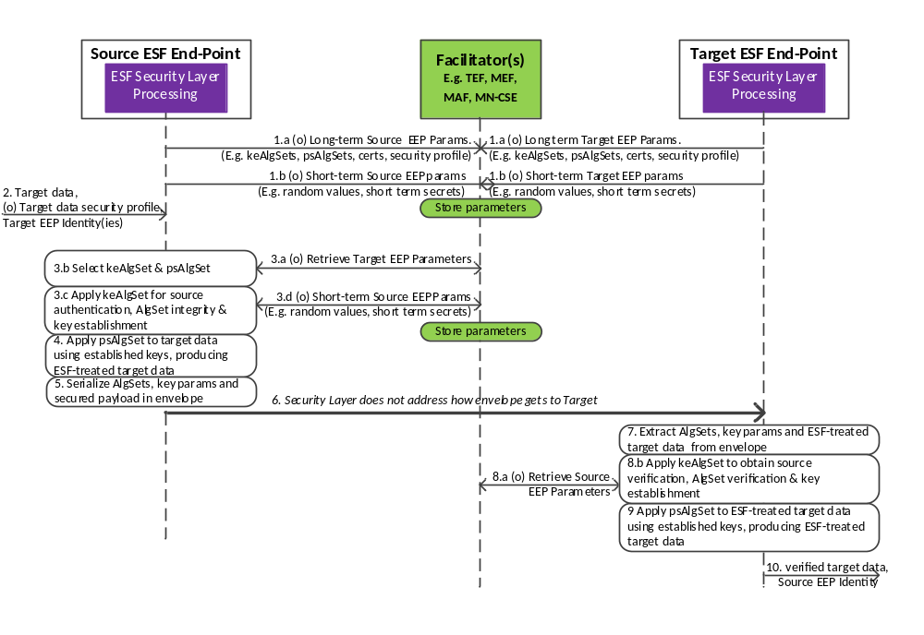Figure 6.2.2.3-1 Processing flow for single envelope session type (S1).
- EEPs can interact with Facilitators to provide the Facilitators with long-term parameters (that is, parameters with long lifetime) and/or short-term parameters (that is, parameters with a short lifetime). This step is not expected to be mandatory.
  - (Optional). EEPs could provide interaction with one or more Facilitators to provide long-term parameters (that is, parameters with long lifetime) that the other EEPs can use either for
    - Generating S1 session envelopes, as Source EEPs, or
    - Processing received envelopes, as Target EEPs.
Example long-term parameters include
    - List of supported Key Establishment Algorithm-Sets (keAlgSets)
    - List of supported Payload Security Algorithm-Sets (psAlgSets)
    - Certificates
    - Security Profile
This interaction is expected to happen relatively infrequently – possibly only once in the lifetime of the EEP. The Facilitator(s) store the parameters and make them available for retrieval. Access control rules could be provided to the Facilitator(s) so that Facilitator(s) may restrict access to the parameters.

  - (Optional). EEPs could provide interaction with one or more Facilitators to update short-term parameters that can be provided to other EEPs either for
    - Generating S1 session envelopes, as Source EEPs, or
    - Processing received envelopes, as Target EEPs.
Example, short-term parameters include
    - Random values with short lifetime; these might be used as challenges for authentication.
    - Secret keys with short lifetime; these might be used as challenges for authentication.
The Facilitator(s) store the parameters and make them available for retrieval.
This interactions are expected to happen relatively infrequently – possibly only once in the lifetime of the EEP. Access control rules could be provided to the Facilitator(s) so that the Facilitator(s) may restrict access to the parameters.

- The Source EEP provides the Security Layer Functions with
  - Target Data, and
  - (Optional) Security profile applicable to the Target Data,

  - Identifiers for the intended Target EEPs. This could include individual identifiers and group identifiers.
This triggers the resulting call flow.
- Source EEP Key Establishment processing:
NOTE: The present document does not specify how the Source EEP determines the minimum security levels to be applied and what session type should be applied, although this could be considered in future versions. Interaction with security profiles should be considered. It is also worth considering where the decision is made – ESF Preparation Layer, ESF Security Layer or ESF Integration Layer.

(Optional) The Source EEP could retrieve the Target EEP(s)’ long-term and/or short-term parameters from the Facilitator(s). Access to the parameters may be controlled, for example, using <accessControlPolicy> resources. The Facilitator(s) could be a CSE(s) with which the Target EEP is registered, although other options are also possible.

  - The Source EEP selects one or more Key Establishment Algorithm-Sets (keAlgSet) and Payload Security Algorithm-Set (psAlgSet).

-----------------------End of change -------------------------------------------

-----------------------Start of change (clause 7.2.1) ----------------------

Figure: 7.2.1-1: The sequence of events When using Group Authentication Solution 1

The benefits of using Group Authentication Solution 1 are twofold:

-----------------------End of change -------------------------------------------

-----------------------Start of change ----------------------

7.3 A Solution for providing security of data “at-rest”

7.3.1 General procedure for hosting and accessing secure data
The generic procedure for hosting and accessing secure data is illustrated in Figure 7.3.2-1 and described as follows:
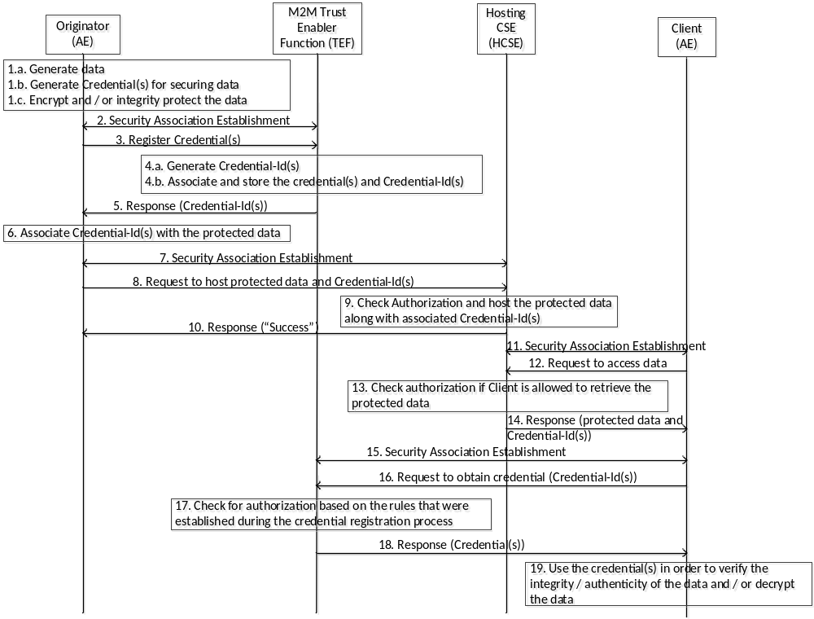
Figure 7.3.2-1: Hosting and accessing secure data

- The Originator of data (AE) would like to provide protection (integrity /authenticity and / or confidentiality) to the data that it generates and hosts onto a Hosting CSE.

-----------------------End of change -------------------------------------------

-----------------------Start of change ----------------------

Add the following informative reference

-----------------------Start of change (Informative references clause 2.2)---------
[i.45] W. Diffie and M. Hellman, "New directions in cryptography", IEEE Transactions on Information Theory 22 (6): 644–654, 1976

-----------------------End of change (Informative references clause 2.2)---------

-----------------------Start of change------------------

Annex <B>: Use case for remote attestation

B.1 Description

-----------------------End of change -------------------------------------------

