Input Contribution
Meeting ID* | SEC 27
Title:* | Use case for Security Developer’s Guide TR-0038
Source:* | Norihiro Okui, KDDI, no-okui@kddi.com
Uploaded Date:* | 2017-02-16
Document(s)  Impacted* | TR-0038 v0.0.1
Intended purpose of  document:* | Decision  Discussion  Information  Other <specify>
Decision requested or recommendation:* | include the text proposed in this contribution into TR-0038.
Template Version:23 February 2015 (Dot not modify)

oneM2M Notice
The document to which this cover statement is attached is submitted to oneM2M. Participation in, or attendance at, any activity of oneM2M, constitutes acceptance of and agreement to be bound by terms of the Working Procedures and the Partnership Agreement, including the Intellectual Property Rights (IPR) Principles Governing oneM2M Work found in Annex 1 of the Partnership Agreement.

Introduction
This contribution provides an usecase for security developer guide. The use case is based on remote light control usecase which is described in TR-0025, but the use case changed field devices from lights to doors in order to emphasis importance of security.

======== Text proposed for TR-0038 starts here =============================

Use case
This guide is based on a smart key use case involving front and back doors in a home that can be remotely controlled by a user's smartphone leveraging the capabilities of oneM2M. For example, the user can remotely open the doors when friends, relatives, housekeeper or babysitter come to the user’s home. However, if a system of the use case is not secured, attackers can easily open the doors by spoofing.
An overview of the use case is shown in figure 5.1 and the main components are introduced as follows:

- The doors are deployed in a home and are connected to a home gateway.
- The home gateway communicates with a cloud service platform allowing the doors to be controlled remotely by the smartphone.
- The cloud service platform supports a set of services to enable the smartphone to more easily control the doors in the home. Some examples of services include registration, discovery, data management, group management, subscription/notification etc
- The smartphone hosts an application used to remotely control the doors in the home and supports the following capabilities:
  - Discovery of doors deployed in the home.
  - Sending commands to change door states i.e. OPENED and CLOSED.
  - Retrieval of door states.
  - Receiving notifications when certain events occurred.
- M2M Authentication Function (MAF) Server is used when employing MAF-based Security Association Establishment (SAE) between field nodes and infrastructure nodes. When using Pre-Shared Key or Certificate-based SAE, the MAF is not required.
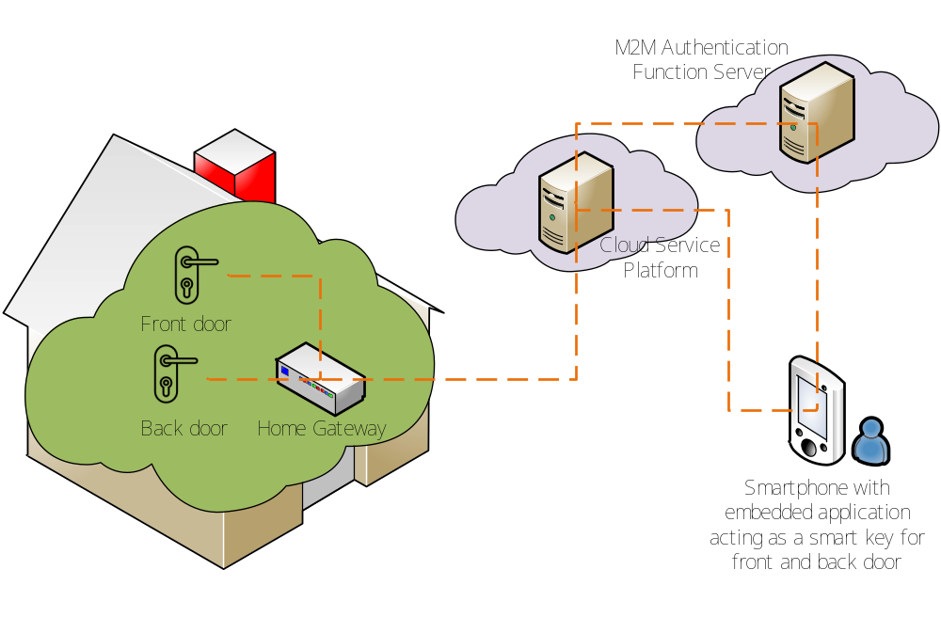
Figure 5.1-1 Overview of remote lights control use case

