CHANGE REQUEST
Meeting:* | SEC 28
Source:* | Huawei
Date:* | 2017-3-17
Contact:* | echo, echo.xubei@huawei.com  Ada, xiaoyang.xiao@huawei.com
Reason for Change/s:* | correct a few descriptions which are noted by Editor.
CR against: Release* | Release 3
CR against: WI* | Active WI 0019  MNT maintenace / < Work Item number(optional)>  STE Small Technical Enhancements / < Work Item number (optional)>  Only ONE of the above shall be ticked
CR against: TS/TR* | TS 0003 v3.1.0
Clauses/Sub Clauses* | 7.3.2.2, 7.3.2.3, 7.3.2.7
Type of change: * | Editorial change  Bug Fix or Correction  Change to existing feature or functionality  New feature or functionality  Only ONE of the above shall be ticked
Post Freeze checking:* | This CR contains only essential changes and corrections? YES NO  This CR may break backwards compatibility with the last approved version of the TS? YES NO  This CR is a mirror CR? YES if YES, please indicate the document number of the original CR: <Document Number) : NO
Template Version:27 May 2015 (Dot not modify)

oneM2M Notice
The document to which this cover statement is attached is submitted to oneM2M. Participation in, or attendance at, any activity of oneM2M, constitutes acceptance of and agreement to be bound by terms of the Working Procedures and the Partnership Agreement, including the Intellectual Property Rights (IPR) Principles Governing oneM2M Work found in Annex 1 of the Partnership Agreement.
GUIDELINES for Change Requests:
Provide an informative introduction containing the problem(s) being solved, and a summary list of proposals.
Each CR should contain changes related to only one particular issue/problem.
In case of a correction, and the change apply to previous releases, a separated “mirror CR” should be posted at the same time of this CR
Follow the principle of completeness, where all changes related to the issue or problem within a deliverable are simultaneously proposed to be made E.g. A change impacting 5 tables should not only include a proposal to change only 3 tables. Includes any changes to references, definitions, and acronyms in the same deliverable.
Follow the drafting rules.
All pictures must be editable.
Check spelling and grammar to the extent practicable.
Use Change bars for modifications.
The change should include the current and surrounding clauses to clearly show where a change is located and to provide technical context of the proposed change. Additions of complete sections need not show surrounding clauses as long as the proposed section number clearly shows where the new section is proposed to be located.
Multiple changes in a single CR shall be clearly separated by horizontal lines with embedded text such as, start of change 1, end of change 1, start of new clause, end of new clause.
When subsequent changes are made to content of a CR, then the accepted version should not show changes over changes. The accepted version of the CR should only show changes relative to the baseline approved text.

Introduction
This contribution is provided to correct a few descriptions which are noted by Editor.
Correct some conventions about “should”.
Delete the figure title in the paragraph.
Correct some descriptions in the procedure for some wrong editorial contenct in the input the SEC-2016-0169R05.
Correct a parameter in a figure which is not accordance with the text.

-----------------------Start of change 1-------------------------------------------

7.3.2.2 Direct Dynamic Authorization
The present document specifies the exchanged parameters and associated processing at the Hosting CSE. The transport of parameters is specified in clause 11.5.2, oneM2M TS-0001 [Error: Reference source not found].
The message flow for the Direct Dynamic Authorization is shown in figure 7.3.2.2-1, and described in the following text.
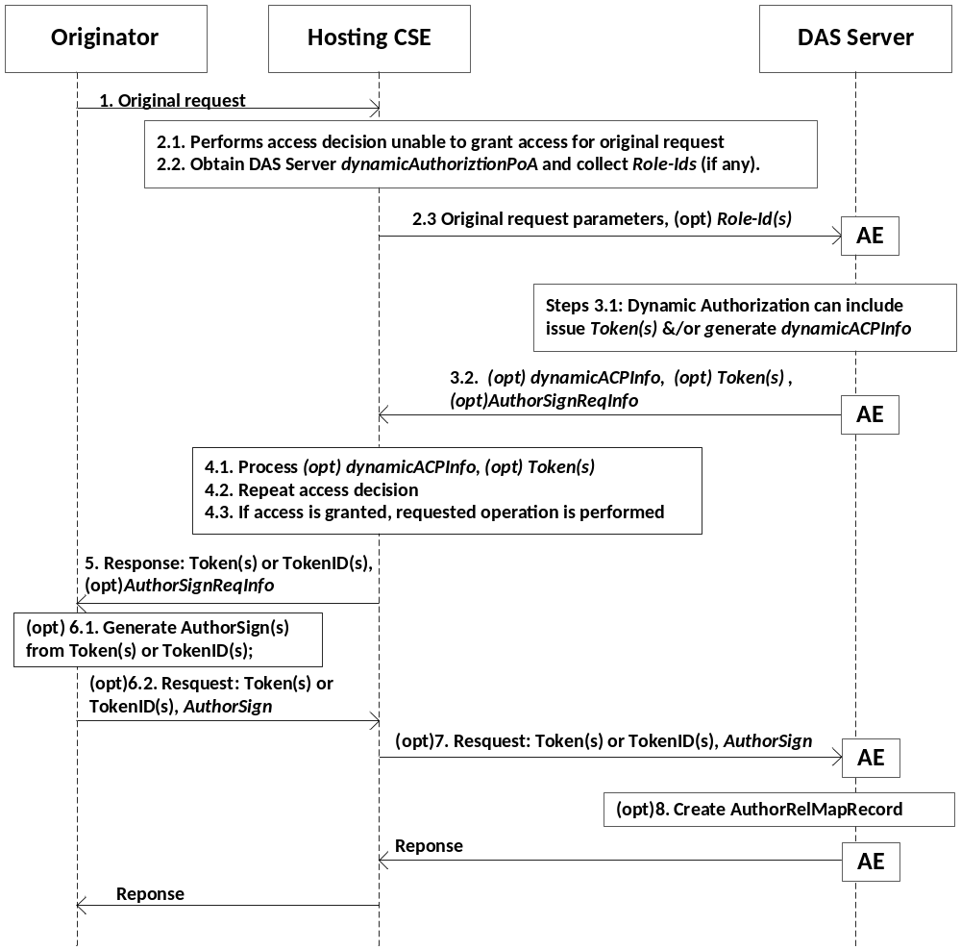
Figure 7.3.2.2-1: Message flow for Direct Dynamic Authorization
1. The Originator sends request (called the request from the Originator for this message flow) to the Hosting CSE. This request may include Tokens or Token-IDs; see the clause 7.3.2.3 "Indirect Dynamic Authorization".
2. Initial Hosting CSE processing:
2.1 If the request from the Originator includes Tokens or Token-IDs then these are processed as described in clause 7.3.2.3 "Indirect Dynamic Authorization". The Hosting CSE evaluates the access decision algorithm, but is unable to grant access for the request from the Originator based on configured access control policies.
2.2 The Hosting HCSE determines the set of DAS Server with which Direct Dynamic Authorization may be performed:
2.2.1 The HCSE examines all accessControlRules for which request satisfies the accessControlOperations and accessControlContexts in the <accessControlPolicy> resources linked to the requested resource. The HCSE collects the set of all Role-IDs in the accessControlOperators of these accessControlRules. This Role-IDs are grouped according to the DAS Server AE-ID identified by the Role-ID.
NOTE 1: Regarding the Role-ID(s) parameter: The Originator would be granted access if a Token(s) is issued which associates the Originator with one or more of the Role-ID(s). Providing this list to the DAS Server allows the DAS Server to select a suitable set of one or more Role-ID(s) to associate with the Originator in Token(s), thereby authorizing the Originator to access the requested resources. The policies configured to the DAS Server would dictate which Role-ID(s) (if any) are included in Token(s) issued to the Originator.
2.2.2 The HCSE shall also collect the set of <dynamicAuthorizationConsultation> resources linked to the requested resource, and group these according to the DAS Server's dynamicAuthorizationPoA attribute of the <dynamicAuthorizationConsultation> resource.
2.3 The Hosting CSE selects a DAS Server (from the set determined in step 2.2) and sends a oneM2M request message containing the information described in table 7.3.2.2-1. The transport of parameters is specified in step 2.3, clause 11.5.2, oneM2M TS-0001 [Error: Reference source not found].
Table 7.3.2.2-1: Information sent from Hosting CSE to DAS Server
during the Direct Dynamic Authorization
Parameter | Description | Mandatory/Optional
Originator | Identifier of the Originator of the request received by the Receiver | M
Originator Resource Type | Type of resource targeted by originated request received by Receiver | M
Operation | Type of operation specified in originated request received by the Receiver | M
Originator IP Address | IP address of Originator of request received by Receiver | O
Originator Location | Location of Originator of request received by Receiver | O
Originator Role IDs | Role IDs of Originator of request received by Receiver | O
Request Timestamp | Timestamp when originated request was received by Receiver | O
Targeted Resource ID | Resource ID targeted by originated request received by Receiver | O
Proposed Privileges Lifetime | Proposed lifetime of authorization privileges requested by the Receiver | O
Role IDs From ACPs | The set of Dynamic Access Roles in the accessControlDynAuthRole parameters associated with the DAS Server AE-ID. | O
Token IDs | The set of token identifiers associated with the Originator | O
AuthorSignIndicator | An indicator included in the request received by Receiver to indicate the capability to sign for creating AuthorRelMapRecord when Originator is an AE. If the Hosting CSE does not support this parameter, then the Hosting CSE shall ignore it. | O

3. DAS Server processing:
3.1 The DAS Server processes the received parameters. The DAS Server may decide to provide Token(s) and/or dynamicACPInfo which will be used by the Hosting CSE to create a dynamic <accessControlPolicy> resource. The DAS Server applies the policies with which it is configured to decide on the appropriate actions.
NOTE 2: The details of this decision are specific to the Dynamic Authorization System being employed; these details are not visible to the oneM2M system, and are not addressed in the present document.
The Token(s) (if any) shall conform to clause 7.3.3.1 "Token Structure", with the following profile:
- The "holder" parameter shall contain the Originator's Absolute CSE-ID or AE-ID received from the HCSE, and may contain other CSE-IDs and AE-IDS.
- The "audience" parameter shall contain only the HCSEs CSE-ID.
The DAS Server shall apply a ESData protection option to the individual Tokens with the following requirements
- The DAS Server may encrypt the Token such that the Token can be decrypted by the Hosting CSE.
- The Hosting CSE shall be able to verify that the DAS Server issued the token.
The ESData processing results in an ESData envelope which is called the ESData-protected Token for the purposes of this message flow.
If the DAS Server decides to authorize the Hosting CSE to create a dynamic <accessControlPolicy> resource, then the DAS Server shall form a dynamicACPInfo parameter containing the following information are listed in table 7.3.2.2-2.
Table 7.3.2.2-2: Information included in the dynamicACPInfo parameter
Parameter | Description | Mandatory/Optional
Granted Privileges | List of granted privileges | O
Privileges Lifetime | Lifetime of granted privileges | O
Tokens | List of issued tokens | O

3.2 The DAS Server shall send the ESData-protected Token(s) (if any) and (optional) dynamicACPInfo parameter via the DAS Server AE to the Hosting CSE. The transport of parameters is specified in step 2.3, clause 11.5.2, oneM2M TS-0001 [Error: Reference source not found]. If the DAS Server receives the AuthorSignIndicator from the Hosting CSE and the DAS server itself also supports to trigger creating the authorization relationship mapping record, then the DAS Server shall send an AuthorSignReqInfo to the Hosting CSE to request the AE to create the authorization relationship mapping record.
4. HCSE Processing:
4.1 The HCSE processes the ESData-protected Token(s) (if present) and dynamicACPInfo parameter (if present):
4.1.1 The HCSE shall perform the following verifications for each ESData-protected Token:
4.1.1.1 The HCSE shall apply ESData processing to the ESData-protected Token to extract the authenticated Token.
4.1.1.2 The HCSE shall perform the following verifications:
4.1.1.2.1 The "issuer" parameter in the Token shall exactly match the identity of the DAS Server.
4.1.1.2.2 The HCSE's CSE-ID shall match the CSE-ID in the "audience" parameter in the Token.
4.1.1.2.3 The "holder" parameter in the Token shall exactly matches the Absolute CSE-ID or AE-ID of the Originator from whom the request was received.
4.1.1.2.4 The HCSE shall verify that the Token has not expired, by comparing the current time to the "notAfter" parameter in the Token.
4.1.1.3 The HCSE shall cache the verified Token, and may later delete the verified Token when the Token expires (as defined in step 4.1.2.4). If the Hosting CSE receives a AuthorSignReqInfo from DAS Server AE, then the Hosting CSE must make sure the Absolute AE-ID of the Originator shall be assigned to the holder attribute of the cached token.

4.1.2 If dynamicACPInfo is provided by the DAS Server, then the Hosting CSE shall create a dynamic <accessControlPolicy> resource matching the dynamicACPInfo.
4.2 The Hosting CSE repeats the access decision mechanism in clause 7.1.4 "Access Control Decision".
4.3 If access is granted, then the Hosting CSE performs the operation requested in the request from the Originator, resulting in the Hosting CSE sending a request to the Originator.
5. The Hosting CSE shall send a response message containing the ESData-protected Token(s) (if present) or TokenID(s), and AuthorSignReqInfo if the Hosting CSE receives and supports the AuthorSignReqInfo from DAS Server AE. If the AuthorSignReqInfo is not included in the response, then the steps 6-8 will not be applied.
6. Originator processing:
6.1 If the Originator receives AuthorSignReqInfo, then the Originator shall generate AuthorSign(s) on Token(s) or TokenID(s) for each Token.
NOTE 3: AuthorSign is a signature generated using the certificate of the AE or a MIC generated using a symmetric key shared between the AE and Hosing CSE. How a symmetric key is distributed to the AE and DAS server is not specified in this document.
NOTE 4: If the Originator includes the AuthorSignIndicator in step 1, but there is no AuthorSignReqInfo included in the response in step 5, then it indicates that the Hosting CSE or the DAS server doesn’t support creating the authorization relationship mapping record.
6.2 The Originator sends the AuthorSign(s) with the corresponding Token(s) or TokenID(s) to the Hosting CSE.
7. The Hosting CSE forwards the parameters from the Originator to the DAS server AE.
8. DAS server AE shall create AuthorRelMapRecord(s) containing the following information listed in table 7.3.2.2-3 for each Token:
Table 7.3.2.2-3: Information included in the AuthorRelMapRecord
Parameter | Description | Mandatory/Optional
SubjectID | Absolute AE-ID of the AE | O
Token | The token issued for the AE | M
SignatureAuthorSign | generated from Token or TokenID | M
ResourceID | the resource ID of the resource AE requests to access | O

7.3.2.3 Indirect Dynamic Authorization
The present document specifies the exchanged parameters and associated processing at the Originator and Hosting CSE. The transport of parameters is specified in clause 11.5.3, oneM2M TS-0001 [Error: Reference source not found].
The message flow for Indirect Dynamic Authorization is shown in figure 7.3.2.3-1, and described in the following text.
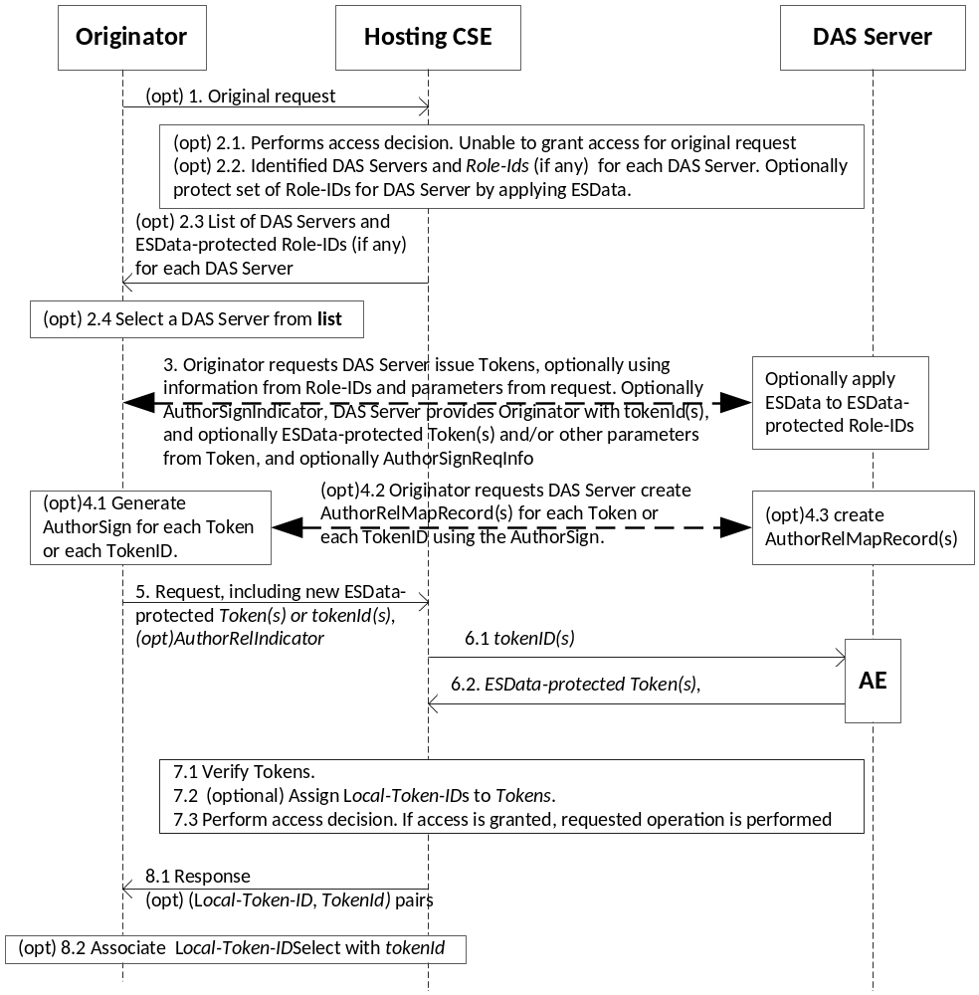
Figure 7.3.2.3-1: Message flow for Indirect Dynamic Authorization
1. (Optional) The Originator sends request to the Hosting CSE. The Originator includes an indication that the Originator is prepared to request Tokens from DAS Servers for this request. This request may include a combination of Tokens, tokenIDs, Local-Token-IDs but this message flow assumes that these do not provide sufficient permissions for accessing the requested resource.
2. (Optional) Initial Hosting CSE processing:
2.1 Hosting CSE performs the access decision for the request from the Originator. This call flow assumes that the request from the Originator is denied as a result of the access decision. The Hosting CSE observes the indication that the Originator prepared to request Tokens from DAS Servers for this request.
2.2 The Hosting CSE forms a list of DAS Server's and associated Role-ID(s) (if any) as described in step 2.2.1 of the Direct Dynamic Authorization in clause 7.3.2.3 "Direct Dynamic Authorization".
For each DAS Server, then Hosting CSE may apply ESData to the set of Role-IDs for decryption by the DAS Server. For example, the ESData may encrypt the set of Role-IDs so they are not visible to the Originator.
2.3 The Hosting CSE shall send an unsuccessful response to the Originator, including the list of DAS Servers and associated set of optionally-ESData-protected Role-IDs.
2.4 The Originator selects a DAS Server identified in the response.
3. The Originator shall interact with the DAS Server to request the issuance of a Token. The Originator can provide the optionally-ESData-protected set of Role-IDS to the DAS Server, and parameters from the original resource access request. If the Originator is an AE and the AE-ID-Stem is assigned by the Registrar CSE of the AE, and the Originator supports to create the authorization relationship mapping record, then the Originator shall provide the AuthorSignIndicator parameter. If the set of Role-IDS is protected using ESData, the DAS Server applies ESData to extract the set of Role-IDS. The DAS Server issues a Token(s) and provides the tokenID(s) and optionally the ESData-protected Token(s) to the Originator. The DAS Server can also provide the Originator with other parameters from the Token; for example, the time window in which the Token is valid. If the DAS Server receiving the AuthorSignIndicator from the Originator, and the DAS server supports creating the authorization relationship mapping record, then the DAS server shall provide the Originator with a AuthorSignReqInfo to request the Originator to return AuthorSign(s) for each Token. This interaction is specific to the Dynamic Authorization System technology being used.

4. If the Originator receives an AuthorSignReqInfo from DAS server, then the Originator shall return the AuthorSign(s) to DAS server:
4.1 The Originator generates AuthorSign(s) on Token(s) or TokenID(s) for each Token.
NOTE 1: AuthorSign are a signature generated using the certificate of the AE or a MIC generated using a symmetric key shared between the AE and DAS server. How a symmetric key is distributed to AE and DAS server is not specified in this document.
4.2 The Originator sends the AuthorSign(s) to DAS server with the corresponding Token(s) or TokenID(s).
4.3 The DAS server shall create AuthorRelMapRecord(s) containing the information listed in table 7.3.2.2-3 for each Token.
5. For request that the Originator wishes to have authorized using an issued Token, the Originator shall add ESData-protected Token provided by the DAS Server or tokenID (if no ESData-protected Token was provided) if the corresponding ESData-protected Token(s) was not provided by the DAS Server. In particular, if the request at step 1 was unsuccessful at step 2.3, then the Originator may repeat the request with new Token(s) and/or tokenID(s). A token may be used in multiple request. If step 4 is performed, then the request shall contain the AuthorRelIndicator to indicate to the Hosting CSE that the relationship between the AE and the Token(s) are maintained in the DAS server.
The Originator shall send the request to the Hosting CSE.
6. (Optional) If the request includes tokenID(s), then for each tokenID the Hosting CSE identifies the corresponding DAS Server AE from which to request the corresponding Token:
6.1 The Hosting CSE sends the tokenID(s) to the DAS Server via a DAS Server AE.
6.2 The DAS Server shall return the corresponding valid ESData-protected Token(s) to the Hosting CSE via the DAS Server AE.
7. Hosting CSE Processing:
7.1 Token Processing:
7.1.1 The Hosting CSE shall apply ESData to the ESData-protected Token(s), either provided in the request or retrieved form the DAS Server, to extract the authenticated Token(s).
7.1.2 If a Local-Token-ID was provided in the request, then the Hosting CSE attempts to retrieve the cached token.
7.1.3 The HCSE shall perform the following verifications for each authenticated and cached token associated with the request:
- The HCSE's CSE-ID shall match one of the Absolute CSE-IDs (optionally including wildcards) in the "audience" parameter in the Token.
- The "holder" parameter in the Token shall exactly match the Absolute CSE-ID or AE-ID of the Originator from whom the request was received.
- The HCSE shall verify that the Token is currently valid and not expired, by comparing the current time to the "notBefore" and "notAfter" parameter in the Token. If a cached Token has expired, then the Token may be removed from the cache.
7.1.4 If any identified Token could not be retrieved in steps 6 or 7.1.2, or if any ESData-protected Token-ID failed verification at step 7.1.1, or if any Token failed the verification at step 7.1.3, then the Hosting CSE shall respond with an error.
7.1.5 The Hosting CSE may cache any new Token(s). If the Hosting CSE receives the AuthorRelIndicator in step 5, then the Hosting CSE must make sure the Absolute AE-ID of the Originator should be assigned to the holder attribute of the cached token.

7.2 The Hosting CSE may assign Local-Token-ID(s) to cached Token(s).
7.3 The Hosting CSE shall perform the access decision as described in clause 7.1.4, including the information in the Token(s) identified in the request. If access is granted, then the requested operation shall be performed.
8. Response:
8.1 The Hosting CSE sends a response to the Originator. For each new Local-Token-ID(s) that has been assigned, the Hosting CSE provides the Local-Token-ID and corresponding tokenID in the response parameters.
8.2 The Originator associates the Local-Token-ID with tokenID. In subsequent requests, the Originator may use the Local-Token-ID instead of the Token or tokenID.

-----------------------End of change 1---------------------------------------------

-----------------------Start of change 2-------------------------------------------

7.3.2.7 AE Authorization Relationship Update

7.3.2.7.1 AE Direct Authorization Relationship Update
This clause specifies the exchanged parameters and associated processing at AE and Hosting CSE.
The message flow for the Direct Authorization Relationship Update is shown in the figure 7.3.2.7-1, which is described in the following text.

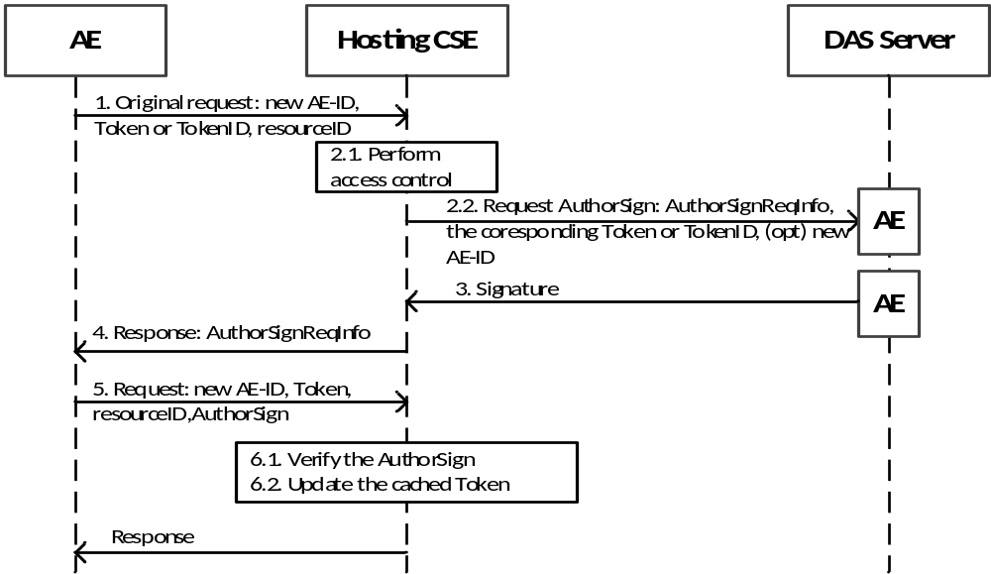

Figure 7.3.2.7-1: AE Direct Authorization Relationship Update
- An AE sends a resource access request message to a Hosting CSE, which carries the new AE-ID, and the Token or the TokenID issued for it.
- The Hosting CSE shall verify the Token or TokenID:
2.1 The Hosting CSE shall verify whether this Token or the Token identified by this TokenID is valid, in this document one way is provided to verify the Token, but there is no limitation on how to verify the Token. the Hosting CSE can search whether there is a cached Token which has the same TokenID as the TokenID received from the AE. If the holder attribute of the cached Token is not equal to the AE-ID of the originator, then the Hosting CSE performs the following steps to verify whether the AE has the possession of the Token.

2.2 The Hosting CSE sends a request message to DAS Server AE to get the value of AuthorSign for this Token, which containing the information: AuthorSignReqInfo, the corresponding Token or TokenID received from the AE.
- The DAS Server AE examines its AuthorRelMapRecord list to find if there is the record whose Token parameter or TokenID of the Token parameter is equal to the Token or TokenID in the request message. If a record exists, then the DAS Server AE returns the Signature parameter to the Hosting CSE.
- The Hosting CSE rejects the request to access the resource, including a AuthorSignReqInfo in the response message to indicate AE to return the AuthorSign for this Token.
- The AE sends the resource access request message again including the information: AuthorSign, resourceID and Token.
- After receiving the AuthorSign, the Hosting CSE shall check whether the AuthorSign is equal to the value of Signature returned from DAS Server AE. If the signatures are identical, then the Hosting CSE shall update the value of the holder attribute of the cached Token on the Hosting CSE to the new AE-ID.
If DAS Server AE doesn’t return a Signature value in step 3 or the result of the comparison in step 6 determines that the signatures are not identical, then the Hosting CSE shall refuse the request with no further process.

7.3.2.7.2 AE Indirect Authorization Relationship Update
This clause specifies the exchanged parameters and associated processing at AE and Hosting CSE.
The message flow for the Indirect Authorization Relationship Update is shown in the figure 7.3.2.7-1, which is described in the following text.

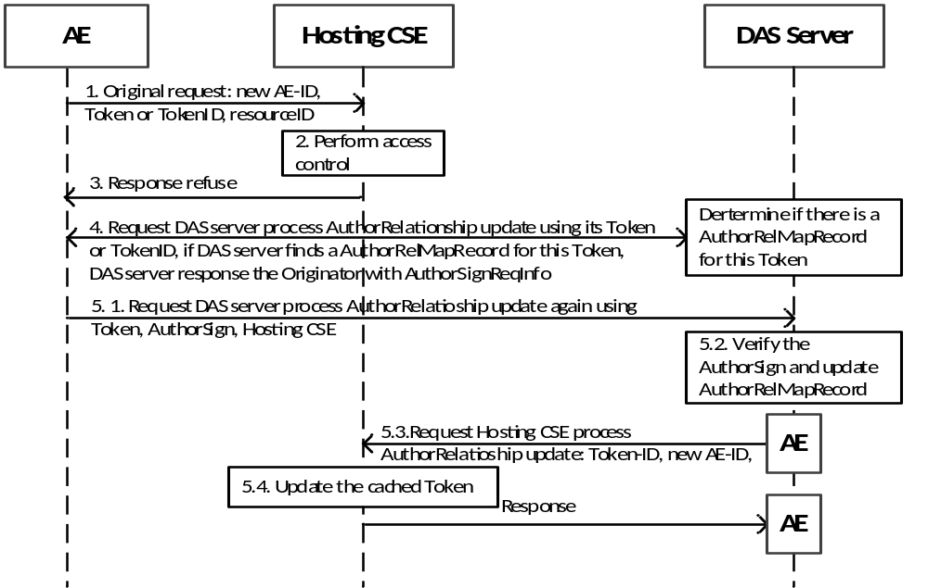
Figure 7.3.2.7-2: AE Indirect Authorization Relationship Update
- The AE sends a resource access request message to the Hosting CSE, which carries the new AE-ID, and the Token or the TokenID issued for it.
- The Hosting CSE verifies the Token or TokenID.
- If the holder attribute of the cached Token is not equal to the AE-ID of the originator, then the Hosting CSE refuses the request to access the resource.
- The AE requests the DAS Server to update the authorization relationship using the Token or TokenID, and the DAS server shall search if there is an AuthorRelMapRecord whose value of the Token parameter or TokenID of the Token parameter is the same with the Token or TokenID received from AE. If the result is ok, then the DAS server shall return an AuthorSignReqInfo to AE to request the AuthorSign of the Token.
- The AE provides the AuthorSign to prove the possession of the Token:
5.1 The AE sends the update request containing Hosting CSE ID, AuthorSign, resourceID and Token.
5.2 After receiving the AuthorSign, the DAS Server shall check if this AuthorSign is equal to the value of Signature parameter in the AuthorRelMapRecord corresponding to this Token.
5.3 If the check result in step 5.2 is true, then the DAS Server AE shall send a request message to the Hosting CSE to update the authorization relationship.
5.4 The Hosting CSE updates the value of the holder attribute of the cached Token locally stored to the new AE-ID.

-----------------------End of change 2---------------------------------------------

CHECK LIST
- Does this change request include an informative introduction containing the problem(s) being solved, and a summary list of proposals.?
- Does this CR contain changes related to only one particular issue/problem?
- Have any mirror crs been posted?
- Does this change request make all the changes necessary to address the issue or problem? E.g. A change impacting 5 tables should not only include a proposal to change only 3 tables. Includes any changes to references, definitions, and acronyms in the same deliverable?
- Does this change request follow the drafting rules?
- Are all pictures editable?
- Have you checked the spelling and grammar?
- Have you used change bars for all modifications?
- Does the change include the current and surrounding clauses to clearly show where a change is located and to provide technical context of the proposed change? (Additions of complete sections need not show surrounding clauses as long as the proposed section number clearly shows where the new section is proposed to be located.)
- Are multiple changes in this CR clearly separated by horizontal lines with embedded text such as, start of change 1, end of change 1, start of new clause, end of new clause.?

