CHANGE REQUEST
Meeting ID:* | SEC #28
Source:* | Wolfgang Granzow, Qualcomm, wgranzow@qti.qualcomm.com  Phil Hawkes, Qualcomm, phawkes@qti.qualcomm.com  Josef Blanz, Qualcomm, jblanz@qti.qualcomm.com
Date:* | 2017-03-30
Reason for Change/s:* | Changes to change text form being non-normative to normative, and vice versa.
CR against: Release* | 2
CR against: WI* | Active <Work Item number>  MNT maintenance / < Work Item number(optional)>  Is this a companion CR? Yes No  Companion CR number: (Note to Rapporteur - use latest agreed revision) Is this a mirror CR? Yes No  Mirror CR number: SEC-2016-0046R01 (Note to Rapporteur - use latest agreed revision)  STE Small Technical Enhancements / < Work Item number (optional)>  Only ONE of the above shall be ticked
CR against: TS/TR* | TS-0003 v3.1.0
Clauses * | 5.1.0, 5.1.2, 6.1.2.2.2, 6.2.3.2, 6.2.5.2, 6.2.6, 6.3.1, 7.1.2-7.1.5, 7.2.1, 7.2.2, 8.1, 8.2
Type of change: * | Editorial change  Bug Fix or Correction  Change to existing feature or functionality  New feature or functionality  Only ONE of the above shall be ticked
Impacted other TS/TR(s)
Post Freeze checking:* | This CR contains only essential changes and corrections? YES NO  This CR may break backwards compatibility with the last approved version of the TS? YES NO
Template Version: January 2017 (Do not modify)

oneM2M Notice
The document to which this cover statement is attached is submitted to oneM2M. Participation in, or attendance at, any activity of oneM2M, constitutes acceptance of and agreement to be bound by terms of the Working Procedures and the Partnership Agreement, including the Intellectual Property Rights (IPR) Principles Governing oneM2M Work found in Annex 1 of the Partnership Agreement.

Introduction
See SEC-2017-0046R01

-----------------------Start of change 1: Clause 5.1.0 -----------------------------------
- The Secure Environment within the CSE is accessed via the Secure Environment Abstraction layer and is expected to provide adequate level of protection to the sensitive information listed in clause 6.2.3.2.

-----------------------End of change 1---------------------------------------------

-----------------------Start of change 2-------------------------------------------

5.1.2 Authorization
The Authorization function is responsible for authorizing services and data access to authenticated entities according to provisioned Access Control Policies (ACPs) and assigned roles.
Access control policy is defined as sets of conditions that define whether entities are permitted access to a protected resource. The authorization function can support different authorization mechanisms, such as Access Control List (ACL), Role Based Access Control (RBAC), etc. The Authorization function could need to evaluate multiple access control policies in an authorization process in order to get a finial access control decision. This process is further described in clause 7 "Authorization".
Authorization evaluation process is based on the Service Subscription resource which specifies what M2M Services and M2M Service roles the authenticated entity has subscribed to and the access control policies associated with the protected resource. The authorization evaluation process can also consider contextual attributes such as time or geographic location.
Prior to authorization mutual authentication between the originator CSE or AE and hosting CSE can be performed as specified in clause 8. Clause 6.1.2.2.1 describes the conditions for when mutual authentication is mandatory. An access control rule can also include an indicator that the access control rule applies only when mutual authentication has been performed successfully and the result of mutual authentication is still current; see clause 7.1.3 for details.

-----------------------End of change 2---------------------------------------------

-----------------------Start of change 3-------------------------------------------

6.1.2.2.2 Authorization to access M2M resources
Once an AE or CSE has been granted access to M2M services, the Access Control decision procedure specified in clause 7.1.5 of the present document is executed before accessing an M2M resource, as specified in oneM2M TS-0001 [Error: Reference source not found].

-----------------------End of change 3---------------------------------------------

-----------------------Start of change 4-------------------------------------------

6.2.3.2 Remote security administration of SE
Security sensitive data and functions that are protected and isolated within the SE may remain remotely accessible to legitimate security administrators after deployment. Remote security administration differs from standard device management by the expectation that a secure channel is intended to be established between the administration server and the Secure Environment of the M2M Node (i.e. the secret used to secure the connection is not available in the M2M node outside of the Secure Environment). Applicable remote security administration protocols are dependent on the risk level of each M2M application and not just on the underlying network technologies. Widespread technologies that enable remote security administration for the different security levels distinguished in oneM2M TR-0008 [Error: Reference source not found] are considered in annex C.

-----------------------End of change 4---------------------------------------------

-----------------------Start of change 5-------------------------------------------

6.2.5.2 Secure Storage
This service provides AEs and CSEs with access to the secure storage capability of the SE. Data securely stored by the AE or CSE is intended to be accessible only through the Security API and by authorized entities. Secure Storage should be managed by the Secure Environment. Securely stored data is intended to remain under the control of the stakeholder owning the data, i.e. the entity that requested the data to be stored within the secure storage, independently of other stakeholders.

---------End of change 5: 6.2.6 Trust Enabler security functions---------------

-----------------------Start of change 6-------------------------------------------
- M2M Authentication Function (MAF), used during the operational phase of M2M Services:
- Master Credentials, used to mutually authenticate CSEs/AEs during the operation phase, are securely stored in a specific infrastructure functionality named M2M Authentication Function (MAF).
- The MAF securely contains the set of Master Credentials that are used for authenticating CSEs/AEs that have been enrolled through the M2M SP or M2M Trust Enabler. The MAF stores the Master Credentials and possibly the identifiers of the associated CSE/AE.
- A single MAF may support all communication security services (SAEF, ESPrim and ESData) or only a selection of them. An MAF providing MAF-based SAEF is operated by the M2M SP, or by an M2M Trust Enabler on behalf of the M2M SP. Other MAF can be operated by M2M Trust Enabler or M2M SP, and there is no assumption of a trust relationship existing between the M2M Trust Enabler and M2M SP in those cases.
- The MAF is also in charge of all security operations involving the usage of the Master Credentials.

-----------------------End of change 6---------------------------------------------

-----------------------Start of change 7-------------------------------------------

6.3.1 Secure Environment
The Secure Environment component is a logical entity that provides Sensitive Functions operating on Sensitive Data, Secure Storage and other resources/functions.
The security sensitive data and security functions contained in M2M field domain nodes are intended to be protected from unauthorized access or alteration, as determined by risk analysis. Sensitive data and functions include security credentials and algorithms that manipulate them. The purpose of the Secure Environment is to provide the required protection level (see table 6.3.1-1) and isolation of security sensitive data and functions within an M2M node. This is especially critical for M2M Nodes that can be remotely or physically accessed by potential attackers.
The choice of a Secure Environment is guided by a risk analysis considering all layers of an M2M application, though it should leverage where possible on capabilities provided by the M2M Service Layer or the Underlying Network, e.g. UICC in 3GPP and 3GPP2 networks, or Trusted Execution Environment requirements.
There is no assumption made on the particular implementation of the Secure Environment. A SE may be implemented as an independent HW Security Element or as an integrated SW function. Each Secure Environment can be associated with one certain Security Level depending on the particular implementation of the SE. Different Secure Environments provide different Security Levels and protection levels as indicated in table 6.3.1-1.
Table 6.3.1-1: Classification of Protection levels
Protection Level | Description
0 | No protection. The data are exposed even without active attacks.
1 | Low protection, data are protected from passive observers but could be exposed by active attacks, be they local or remote.  E.g. software solutions exist that rely on general purpose processing hardware of the supporting equipment.
2 | Medium protection, protection of the data from remote attacks is addressed, but local attacks, especially physical attacks, remain possible, i.e. Medium protection provides countermeasures against software attacks only  E.g. Software solutions to protect data and sensitive functions rely on specific processing providing enforced isolation and enables sensitive code and data to be kept away from an unprotected operating environment, software and memory. The code running in the protected environment is cryptographically verified for integrity assurance.
3 | High protection, addressing both remote and local attacks to access the data, including attacks involving physical access. This includes strong counter measures against software and hardware attacks, such as detection of abnormal operating conditions and scrambling plus hardware masking of the memory and side channel analysis of operations involving sensitive data.

There is intended to be at least one Secure Environment in each M2M node providing secure storage to the local CSEs and AEs, however there could be multiple.

-----------------------End of change 7---------------------------------------------

-----------------------Start of change 8-------------------------------------------

7.1.2 Parameters of the Request message
This clause specifies the parameters of a request message which are evaluated by the access control mechanism.
The data types applicable to these parameters are defined in clause 6.4 of oneM2M TS-0004 [Error: Reference source not found].
The parameters are listed in table 7.1.2-1.

Table 7.1.2-1: Parameters indicated in the request message
Parameter | Description | Mandatory/Optional | Usage in access control mechanism
To | URI of target resource | M | Selection of accessControlPolicy associated with the target resource
From | Identifier representing the originator of the request | M (see Note) | Evaluated against accessControlOriginators in privileges and selfPrivileges attributes
Role IDs | Role IDs of the originator | O | Evaluated against accessControlOriginators in privileges and selfPrivileges attributes
Operation | Requested operation | M | Evaluated against accessControlOperations in privileges and selfPrivileges attributes
Filter Criteria | filterUsage condition tag in Filter criteria | O | Differentiation between Retrieve and Discovery operations
Tokens | ESData-protected Tokens | O | Contains authorization information (e.g. Role-IDs) to be used in the decision for the request
Token IDs | tokenIDs or Local-Token-ID | O | Identifies Tokens containing authorization information (e.g. Role-IDs) to be used in the decision for the request
NOTE: From field is Mandatory in all requests except for AE registration procedure where it is optional, as specified in oneM2M TS-0001 [Error: Reference source not found].

Table 7.1.2-2 lists the context parameters associated with a request message which are evaluated by the access control mechanism. These parameters are not explicitly included in a request message but can be obtained at the receiver and validated against the context policy parameters as given in table 7.1.2-2.
Table 7.1.2-2: Context parameters associated with a request message
Parameter | Description | Usage in access control mechanism
rq_time | Time stamp when the request message was received at the hosting CSE. Obtained by the hosting CSE's system time clock. | Validated against accessControlTimeWindow parameter in an access control rule, see clause 7.1.3
rq_loc | Location information about the originator of the request. Obtained over the Mcn reference point. | Validated against accessControlLocationRegion parameter in an access control rule, see clause 7.1.3
rq_ip | IP source address associated with the IP packets that carry the request message. Obtained over the Mcn reference point. | Validated against accessControlIpAddress parameter in an access control rule, see clause 7.1.3

Tokens, as defined in clause 7.3.3.1 "Token Structure", may be associated with a request message. A Token may be associated with a request as a result of being included in the Tokens primitive parameter of the request message or identified in the Token IDs primitive parameter of the request message. If the Hosting CSE obtained a token from the Dynamic Authorization System (DAS) Server using Direct Dynamic Authorization, then this Token shall be associated with a request if the holder parameter in the Token matches the Absolute AE-ID or CSE-ID of the Originator of the request. Dynamic Authorization is specified in clause 7.3.

-----------------------End of change 8---------------------------------------------

-----------------------Start of change 9: Clause 7.1.3 ----------------------------------
The accessControlTimeWindow parameter represents a list of elements that comply with the extended crontab syntax as defined in clause 7.3.8 of oneM2M TS-0004 [Error: Reference source not found]. It allows definition of periodically recurring time intervals at which access can be granted, when the rq_time parameter associated with the access request message falls into such interval.

-----------------------End of change 9---------------------------------------------

-----------------------Start of change 10: Clause 7.1.3 ------------------------------------
The accessControlObjectDetails attribute specifies a subset of child resource types of the targeted resource to which the access control rule applies. If an access control rule includes accessControlObjectDetails, then childResourceType is specified. An access control rule which does not include any accessControlObjectDetails parameters applies to the child resource types of the target resource. The accessControlObjectDetails parameter is describedin table 9.6.2.4-1 of oneM2M TS-0001 [Error: Reference source not found]. Child resource types listed in the childResourceType component are subject of access control for the Create operation only. Once a child resource is created, the Access Control Policies assigned directly to it apply. The resourceType and specialization element are optional. If either the resourceType or specialization element is present in accessControlObjectDetails, the CSE matches the type of resource or specialization of the targeted resource with the value specified in the resourceType or specialization element. Further checking of childResourceTypeeis done only if the resourceType or specialization match occurs. However, if the resourceType and specialization elements are not provided, then only childResourceType match ie performed.

-----------------------End of change 10 ---------------------------------------------

-----------------------Start of change 11-------------------------------------------

7.1.4 Access Control Decision
The access decision is derived by comparing the parameters associated with a resource access request message as described in clause 7.1.2 with the access control rules included in the privileges or selfPrivileges attributes of all ACP sets assigned to the protected resource by means of the accessControlPolicyIDs, see figure 7.1.1-1.
The result of the access decision algorithm, i.e. the access decision, is the overall result of evaluating the applicable set of access control rules, acrs, against the parameters associated with the access request message. This access decision can be represented by a value of binary data type. The overall result of the access decision algorithm is denoted here with the variable name res_acrs:
The reference access decision algorithm is specified in clause 7.1.5. For any given sets of inputs, an implementation of the access decision processing shall return the same result as the reference access decision algorithm would return for those inputs.
If the access decision algorithm yields the result res_acrs = TRUE, then the access decision for the requested resource shall be "Permit".
If the access decision algorithm yields the result res_acrs = FALSE, or the access decision algorithm is not capable of deriving a final result (e.g. due to indeterminate parameters), then the access decision for the requested resource shall be "Deny".

7.1.5 Description of the Access Decision Algorithm
The reference access decision algorithm specified in this clause combines partial access control results obtained for each of the individual access control rules contained in a privileges or selfPrivileges attribute. Further, if multiple ACP instances are assigned to the protected resource, the reference access decision algorithm combines the partial access control results obtained for the individual ACPs of an ACP set.
The algorithm specified in this clause adopts a "Permit-overrides" combining algorithm with respect to access control rules and ACPs as defined in XACML [Error: Reference source not found]. This algorithm has the following behaviour:
- If a decision is "Permit" for only a single access control rule included in the privileges (or selfPrivileges) attribute of a single ACP, the result is "Permit".
- Otherwise, the result is "Deny".
The logic for evaluating a request against a privilege can be described mathematically as follows. A privileges or selfPrivileges attribute included in an <accessControlPolicy> resource represents a set of access control rules, acrs, which is built as in figure 7.1.5-1.
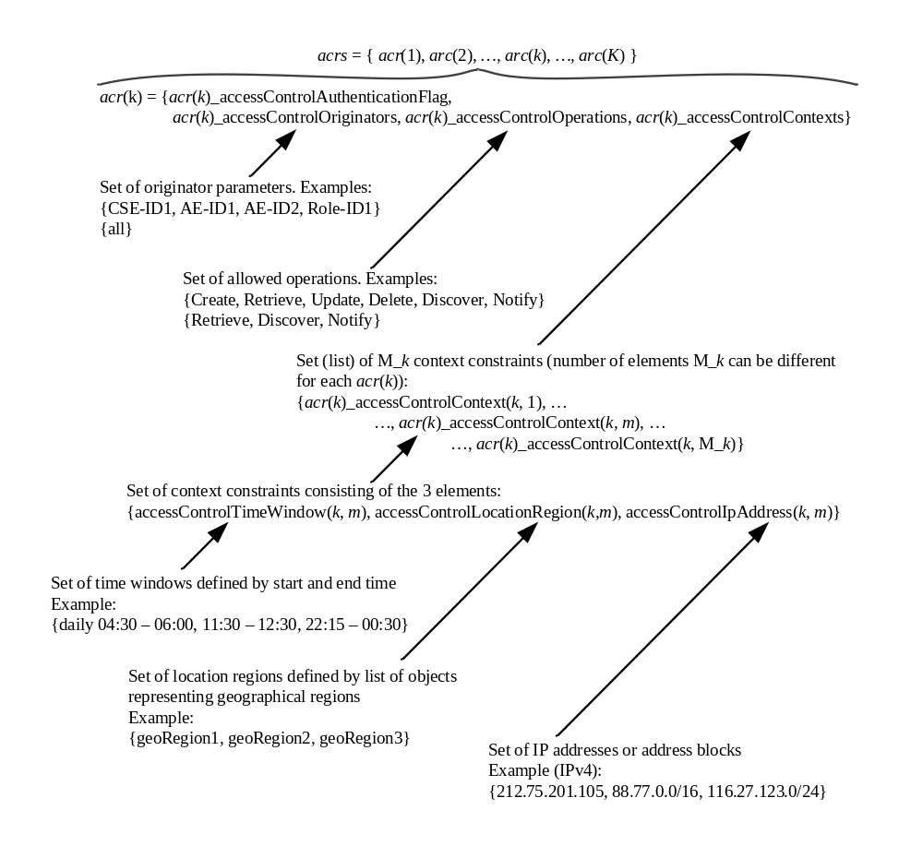
Figure 7.1.5-1: Logic to evaluate privileges in the reference access decision algorithm
The parameters associated with a request, which are evaluated against the parameters contained in the access control rules are specified in clause 7.1.3.
The access decision res_acrs defined in clause 7.1.4 is derived by evaluating whether or not the parameters associated with the request message listed in tables 7.1.2-1 and 7.1.2-2 match any of the access control rules contained in the access control rule set defined in clause 7.1.3 as follows:
res_acrs = res_acr(1) OR res_acr(2) ... OR res_acr(k) … OR res_acr(K),
where res_acr(k) represents the logical evaluation result (i.e. TRUE/FALSE or 1/0) of the request parameters against the k^{th} access control rule in the set acrs, which can be expressed as follows:
res_acr(k) = res_authn(k) AND res_origs(k) AND res_ops(k) AND res_ctxts(k), k = 1…K.
The first partial logical result variable res_authn(k) on the right side of above equation shall be evaluated according to Table 7.1.5-1:
Table 7.1.5-1: Evaluating res_authn(k)
acr(k)_accessControlAuthenticationFlag | rq_authn | res_authn
TRUE | TRUE | TRUE
TRUE | FALSE | FALSE
FALSE | TRUE | TRUE
FALSE | FALSE | TRUE

The remaining 3 partial logical result variables on the right side of above equation can be defined by using the following set function:
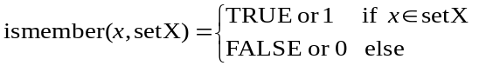
With this definition:
res_origs(k) = ismember(rq_orig, acr(k)_accessControlOriginators)
res_ops(k) = ismember(rq_op, acr(k)_ accessControlOperations)
The third partial logical result res_ctxts(k) is derived as follows
res_ctxts(k) = res_context(k, 1) ... OR res_context(k, m) ... OR res_context (k, M_k),
where:
res_context(k, m) = res_time(k, m) AND res_ip(k, m) AND res_loc (k, m), k = 1…K, m = 1…M_k
and
res_time(k, m) = ismember(rq_time, acr(k)_accessControlTimeWindow(m))
res_ip(k, m) = ismember(rq_ip, acr(k)_accessControlIpAddress(m))
res_loc (k, m) = ismember(rq_loc, acr(k)_accessControlLocationRegion(m))
Thanks to the "Permit-overrides" combining approach, if the access control decision for one access control rule results in res_acr = TRUE, the reference access decision algorithm can stop without evaluating any other applicable access control rules of the current ACP or any other ACPs in the ACP set, and the final access decision is "Permit".

-----------------------End of change 11---------------------------------------------

---------------Start of change 12: Clause 7.2.1 ---------------------------------
0. Security association establishment may be performed. Clause 6.1.2.2.1 describes the scenarios when security association establishment between an AE and CSE is mandatory, and describes the scenarios when security association establishment between an AE and CSE is recommended. The subsequent procedures shall be performed if a security association has been established.
1. The AE sends a request to Hosting CSE via its Registrar CSE as specified in oneM2M TS-0001 [Error: Reference source not found] (Hosting CSE is not represented on this figure and can either be the Registrar CSE or another CSE).
2. The Registrar CSE checks if the value in the From parameter is the same as the ID associated in security association:
3. If the values are not identical, then the Registrar CSE shall send a response with Response Status Code '4106' ("ORIGINATOR_HAS_NOT_REGISTERED").
4. If the values are identical, then the Registrar CSE shall perform the procedures specified in clause 8.2 of oneM2M TS-0001 [Error: Reference source not found]. Depending on the number of Transit CSEs, the Registrar CSE shall either process the request or forward it to the Hosting CSE or to another Transit CSE.

-----------------------End of change 12---------------------------------------------

--------------------Start of change 13: Clause 7.2.2-------------------------------
0. The Target and Originator have previously established a symmetric pairwiseESPrimKey. The Target associates an identity with the symmetric pairwiseESPrimKey.
1. The Originator composes the inner request primitive, encrypts it using ESPrim to form an ESPrim Object, and sends it to the Target as described in clause 8.4.
NOTE: Regardless of whether ESPrim is applied, each Mcc "hop" is always protected using an SAEF, and each Mca "hop" is optionally protected using an SAEF; see clause 6.1.2.2.1.
2. The Target applies the procedures in clause 8.4 to decrypt the ESPrim Object and obtain the inner request primitive.
3. The Target checks if the value in the From parameter is the same as the ID associated with the pairwiseESPrimKey:
4. If the values are not identical, then the Target shall send a response with Response Status Code '4116' (“ESPRIM_IMPERSONATION_ERROR”).
5. If the values are identical, then the Target shall record that the Originator has been authenticated, and performs procedures specified in clause 8.2 of oneM2M TS-0001 [Error: Reference source not found].

-----------------------End of change 13---------------------------------------------

-----------------------Start of change 14-------------------------------------------

8 Security Frameworks

8.1 General Introductions to the Security Frameworks

8.1.0 General
To accommodate the variety of deployment scenarios that can be encountered in M2M applications, the present specification supports a diversity of methods to provision and establish security in M2M systems.

8.1.1 General Introduction to the Symmetric Key Security Frameworks
In the Symmetric Key Security Frameworks, each pair of entities that need to authenticate each other is provisioned with its own shared symmetric key. This is performed through pre-provisioning, e.g. during device manufacturing or deployment, or a remote security provisioning framework.

8.1.2 General Introduction to the Certificate-Based Security Frameworks

8.1.2.0 Introduction
This clause describes the Credential Configuration and Certificate Verification used in the Certificate-Based Security Association Establishment Framework and Certificate-Based Remote Security Provisioning Framework.

8.1.2.1 Public Key Certificate Flavours
The present document defines procedures using the following Public Key Certificate flavours:
- Raw Public Key Certificates:
- Description: A raw public key certificate (IETF RFC 7250 [Error: Reference source not found]) contains only the raw public key, without other information normally provided in a certificate. The raw public key certificate is exchanged in the TLS handshake in the place of a traditional certificate (see IETF RFC 7250 [Error: Reference source not found]).
- Use: A raw public key certificate can be used for authenticating a CSE or AE either during the Association Security Handshake phase of the Certificate-Based Security Association Establishment or during the Bootstrap Enrolment Handshake phase of the Certificate-Based Remote Security Provisioning Framework.
- Device certificates:
- Description: These certificates have a certificate chain to a trust anchor and include one or more globally unique hardware instance identifier (such as the Object Identifier Based M2M Device identifiers discussed in annex H "Object Identifier Based M2M Device Identifier" oneM2M TS-0001 [Error: Reference source not found]) in the subjectAltName extension of the certificate. A device certificate can be used to verify the identity of the hardware instance on which the entity is being executed.
- Use: Device certificates can be used to authenticate a CSE or AE executing on a specific M2M Device. If the M2M device is an ASN or MN (which supports a CSE), then the device certificate is implicitly associated with the CSE that executes on the device. If the device is an ADN (which does not support a CSE) then the device certificate is not implicitly associated with a specific AE executing on the hardware. A device certificate can be used for authenticating a Field Domain CSE either during the Association Security Handshake phase in the Certificate-Based Security Association Establishment Framework or during the Bootstrap phase of the Certificate-Based Remote Security Provisioning Framework.
- CSE-ID certificates:
- Description: These certificates have a certificate chain to a trust anchor and include the public domain name representation of a CSE-ID (see oneM2M TS-0001 [Error: Reference source not found]) in the subjectAltName extension of the certificate. A CSE-ID certificate verifies that the entity presenting the certificate has been assigned a particular CSE-ID.
- Use: A CSE-ID certificate can be used to authenticate a CSE only.
- AE-ID certificates:
- Description: These certificates have a certificate chain to a trust anchor and include the full URI representation of an AE-ID in the subjectAltName extension of the certificate. An AE-ID certificate verifies that the entity presenting the certificate has been assigned a particular AE-ID.
- Use: An AE-ID certificate can be used to authenticate an AE only.
- FQDN certificates:
- Description: These certificates have a certificate chain to a trust anchor and include the FQDN of an M2M Enrolment Function in the subjectAltName extension of the certificate. An FQDN certificate verifies that the entity presenting the certificate has been assigned a particular FQDN.
- Use: A FQDN certificate is used to authenticate an M2M Enrolment Function to an Enrolee during a Bootstrap Enrolment Handshake phase in a Certificate-Based Remote Security Provisioning Framework.
NOTE: The flavours, and the details specific for these flavours, are specified to support a range of deployment models while ensuring that oneM2M entities have clear procedures for authenticating other oneM2M entities using certificates.
The profiles for these certificates are found in clause 10.1.1 "Certificate Profiles".

-----------------------End of change 14---------------------------------------------

-----------------------Start of change 15-------------------------------------------

8.1.3 General Introduction to the GBA (Generic Bootstrapping Architecture) Framework
Generic Bootstrapping Architecture (GBA) is a framework that could be used for Remote Security Provisioning.
In case of scenario where the M2M Service Provider and the operator of the underlying network have an agreement to use the underlying network credentials as the basis for security between a M2M Application Service/Middle Node and Infrastructure Node (including the case that the M2M Service Provider and the operator of an underlying network are actually the same entity), GBA procedure could be used.
It is important that this feature is used only within the scope of an appropriate agreement between the M2M Service Provider and the operator of the underlying network. The normative text for the GBA-Based Security Association Establishment Framework (clause 8.2.2.2) and the GBA-Based Security Bootstrap Framework (clause 8.3.2.2) implicitly assumes that such an agreement is already in place. Since the present document is a technical specification, it does not address the details of such an agreement.
A general introduction to GBA is included in oneM2M TR-0008 [Error: Reference source not found].
After a successful GBA bootstrapping, the M2M Application Service/Middle Node and the BSF share a security association which consists of a bootstrapping transaction identifier (B-TID) and key material (GBA bootstrap Ks).
This security association can be used by the M2M Application Service/Middle Node to derive NAF keys (Ks_(ext/int)_NAF) shared between a M2M Application Service/Middle Node and a M2M Infrastructure Node or an M2M Authentication Function.
There are two modes of GBA: ME-based GBA (GBA_ME) and UICC-based GBA (GBA_U). In case of GBA_ME, one NAF-specific key is derived: the key Ks_NAF. In case of GBA_U, two NAF-specific keys are derived: Ks_ext_NAF (available in the ME) and Ks_int_NAF (which remains inside the UICC).
GBA_U can be performed only when the UICC is GBA aware.
The BSF determines which mode to run based on the UICC capability indicated in the GBA User Security Settings (GUSS).
The usage of GBA_U is recommended since it provides a higher level of security than GBA_ME. The implication of this recommendation is that the entity, AE or CSE, using the GBA_U-based NAF keys should be resident in the UICC.
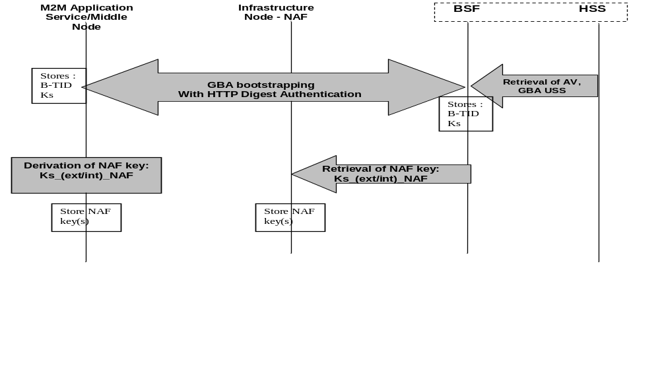
Figure 8.1.3-1: GBA framework. Note that the Network Application Function (NAF) may be an Infrastructure Node or an M2M Authentication Function

8.2 Security Association Establishment Frameworks

8.2.1 Overview on Security Association Establishment Frameworks
The Security Association Establishment Frameworks (SAEF) described in the present document, apply to direct connections on the Mcc, Mcc' or Mca reference points.
The Security Association Establishment Framework end-points are denoted:
- Entity A, which may be an AE or CSE. This entity always acts as the client of the security association (TLS/DTLS session).
- Entity B, which shall be a CSE. This entity always acts as the server of the security association (TLS/DTLS session).
The oneM2M system supports the following Security Association Establishment Frameworks:
- Security Association Establishment Frameworks:
- Provisioned Symmetric Key Security Association Establishment. A symmetric key is provisioned to the entities: this is called the Provisioned M2M Symmetric Key, and denoted Kpsa. The entities authenticate each other by verifying Message Integrity Codes (MIC) in the Security Handshake which were generated using the symmetric key. For more details see clause 8.2.2.1.
- Certificate-Based Security Association Establishment: The entities are each issued with:
- a Private Signing Key that is known only to that entity;
- a Certificate containing the corresponding Public Verification Key; and
- (Optionally) a Certificate Chain from the entity's Certificate to a Root Certificate.
The entities validate each other's Certificate before trusting the Public Verification Keys in the Certificate. Within the Security Handshake, entity A creates a digital signature of the session parameters using its private signing key and entity B verifies the digital signature using entity A's public verification key. Then the roles are reversed: entity B creates a digital signature and entity A verifies it. For more details see clause 8.2.2.2.
- M2M Authentication Function (MAF)-based Security Association Establishment. This Security Association Establishment Framework uses mutual authentication of the entity A and the M2M Authentication Function (MAF) and derive a M2M Secure Connection key (Kc) that the MAF delivers to entity B (via separate mutually-authenticated communication). The entities then authenticate each other using the M2M Secure Connection key (Kc). Each of Entity A and Entity B can use either symmetric key credentials or certificates for mutual authentication with the MAF. For more details see clause 8.2.3.1.
For a more detailed description of the above Security Association Establishment Frameworks, it is useful to compare the following aspects of the Security Association Establishment Frameworks:
- Credential Configuration:
- For the Provisioned Symmetric Key Security Association Establishment Framework, Entity A and Entity B are provisioned with the Provisioned M2M Symmetric Key that entities subsequently use to authenticate each other using pre-provisioning or remote provisioning.
- For the Certificate-Based Security Association Establishment Frameworks, Entity A and Entity B are pre-provisioned with the Credential that the entity subsequently use to authenticate itself to the other entity using pre-provisioning or remote provisioning.
- For the MAF-based Security Association Establishment Framework, the MAF Credential Configuration procedure (clause 8.8.3.1) is performed twice: once to provision credentials for mutual authentication of Entity A with MAF, and once to provision credentials for mutual authentication of Entity B with MAF.
- Identity Configuration: Identity configuration can occur as part of Credential Configuration, or can occur at a later time.
- For the MAF-based Security Association Establishment Framework, the MAF is configured with information about the identities of Entity B and, optionally, Entity A. Clause 8.2.2.3 provides additional details.

- NOTE 1: The current oneM2M specifications do not describe how this information is configured to the MAF.
- Entity A's knowledge of its identity (IdA) has no impact on the security association establishment.
- Entity B shall be configured with its CSE-ID (IdB) prior to Association Configuration.
- Association Configuration:
- Entity A shall be provided with IdB, the CSE-ID for Entity B.
NOTE 2: The present specification does not describe how Entity A is provided with IdB. Example mechanisms could include configuration via remote management, and discovery mechanisms supported by the Underlying Network(s).
- In the case of Certificate-Based Authentication Framework: each entity (Entity A and Entity B) is additionally is configured with the certificate information that the entity subsequently uses to verify the other entity. The necessary certificate information is dependent on the flavour of the certificates, with details provided in clause 8.1.2.4 "Information Needed for Certificate Authentication of another Entity".
- In the case of the MAF-Based Security Association Establishment Framework:
  - The MAF is provided with the identity of Entity B for which the MAF is authorized to facilitate establishing a security association with Entity A.
  - Entity A and the MAF interact, using the MAF Key Registration procedure (clause 8.8.2.7) to establish M2M Secure Connection Key (Kc) and M2M Secure Connection Key Identifier (KcID) and authorize Entity A to establish a security association with Entity B. This step includes mutual authentication using the MAF Handshake Procedure (clause 8.8.2.2). This step includes Entity A providing the MAF with IdB. See Note 2 above,
- Association Security Handshake: Identification, authentication and security context establishment between the entities:
- In the case of the MAF-based Security Association Establishment Framework:
- Entity A provides the M2M Secure Connection Key Identifier (KcID) to Entity B.
- Entity B and the MAF interact using the MAF Key Retrieval procedure (clause 8.8.2.8). This step includes mutual authentication using the MAF Handshake Procedure (clause 8.8.2.2). Entity B forwards KcID to the MAF and, if Entity B is authorized, the MAF returns the M2M Secure Connection Key (Kc) and either IdA or a globally unique identifier for the credential used by the MAF to authenticate Entity A during Association Configuration.
- The M2M Secure Connection Key (Kc) is then used in the Security Handshake for mutual authentication between Entity A and Entity B.
Entity A associates the resulting security context with IdB: the AE-ID or CSE-ID for Entity B established during Association Configuration.
Entity B associates the security context with one of the following:
- A single Absolute CSE-ID, and indication that Entity A is a CSE;
- A single Absolute AE-ID, and indication that Entity A is a AE; or
- A list of allowed Absolute AE-ID values, and indication that Entity A is an AE. This case applies only when Entity A presents a Device Certificate.
The present document provides the following approaches for Entity B to determine the applicable CSE-ID or AE-ID(s) prior to registration:
- If Entity A is authenticated using a CSE-ID certificate (or AE-ID certificate), then Entity B extracts the CSE-ID (or AE-ID respectively) from the certificate and associates the security context with this CSE-ID (or AE-ID respectively), as described in the certificate profile in clause 10.1.1 "Certificate Profiles".
- In all other cases, Entity B forms a globally unique Credential-ID (see clause 10.4 "Credential-ID Details") identifying the credential used by Entity A in the security association establishment mechanism. The Credential-ID identifies one of a Kpsa (in the case of a PSK SAEF), certificate (in the case of a Certificate-Based SAEF) or the Km (in the case of an MAF-Based SAEF). Entity B subsequently determines the CSE-ID or AE-ID(s) which are applicable for this Credential-ID.
- If Entity B assigned the AE-ID(s) corresponding to this Credential-ID, then Entity B is responsible for determining the AE-ID(s) corresponding to this Credential-ID.
- Otherwise, the CSE-ID or AE-ID(s) can be made available to Entity B via one of the following approaches. The M2M SP is expected to ensure one of these approaches will successfully provide the CSE-ID or AE-ID(s) of Entity A.
- If the Security Association Establishment procedure is facilitated by an M2M Authentication Function, then the M2M Authentication Function may be provided with the CSE-ID or AE-ID and the M2M Authentication Function may provide this to Entity B at the same time as Kc is provided to Entity B. The M2M Authentication Function could have been provided with the CSE-ID or AE-ID during provisioning, including the case where the M2M Authentication Function is provided with the CSE-ID or AE-ID during remote provisioning by an M2M Enrolment Function (which is similar to the case described in the following bullet).
- If the Security Association Establishment procedure uses a Provisioned Symmetric Key which was remotely provisioned to Entity A and Entity B, then the M2M Enrolment Function may provide Entity B with CSE-ID or AE-ID during the Remote Security Provisioning procedure.
- If the M2M Service Provider assigns Entity A's entity identifier(s), then the CSE-ID or AE-ID(s) may be securely configured by the M2M Service Provider to Entity B prior to the Association Security Handshake. For example, the CSE-ID or AE-ID(s) may be configured as part of Credential Configuration or Association Configuration. This specification permits using other mechanisms, with the assumption that the mechanism provides authentication, integrity protection and optionally confidentiality.
EXAMPLE 1: If the M2M Service Provider has the opportunity to configure Entity B prior to deployment, then the M2M Service Provider could configure the CSE-ID or AE-ID(s) to Entity B at this time.
EXAMPLE 2: A secure remote management protocol could be used to configure Entity B with the CSE-ID or AE-ID(s). However, this is not currently an interoperable feature as there is no standardized management object facilitating this management.
- In the case that Entity A is an AE and Entity B is a CSE, the applicable AE-ID(s) may be obtained by retrieving the applicable <serviceSubscribedAppRule> resources which are linked to by the ruleLinks attribute of the Entity B's <serviceSubscribedNode> on the IN-CSE as described in clause 10.1.1.2.2 "Application Entity Registration procedure" in oneM2M TS-0001 [Error: Reference source not found].
Figure 8.2.1-1 provides a summary of the above defined three Security Association Establishment Frameworks.
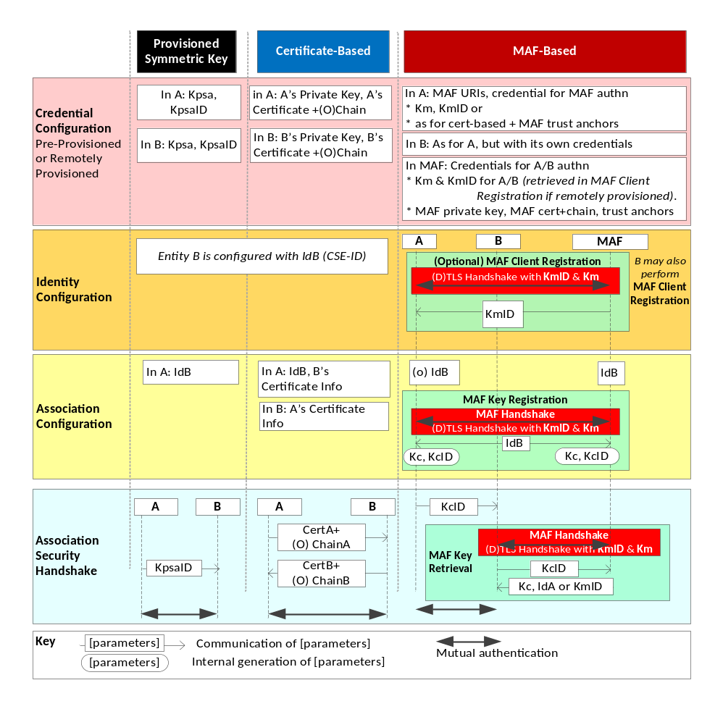
Figure 8.2.1-1: Overview of the Security Association Establishment Frameworks
supported by oneM2M

8.2.2 Detailed Security Association Establishment Frameworks

8.2.2.1 Provisioned Symmetric Key Security Association Establishment Frameworks
This clause describes the Provisioned Symmetric Key Security Association Establishment Framework. This framework enables mutual authentication of two entities corresponding to either two CSEs or a CSE and an AE. The Credential for this framework is a long-term symmetric key that has been provisioned into the entities to be authenticated. This key is called a Provisioned Secure Connection Key and is denoted Kpsa. The provisioning of Kpsa could be a pre-provisioning or a remote provisioning thanks to Remote Security Provisioning Frameworks, as described in clause 8.3. The entities authenticate each other by verifying message authentication codes in the Association Security Handshake which were generated using the Provisioned Secure Connection Key.
NOTE 1: Long term Provisioned Secure Connection Keys can pose a security risk if not adequately secured, and for this reason long term Provisioned Secure Connection Keys are recommended to be stored in Secure Environments.
Figure 8.2.2.1-1 illustrates the sequence of events when using the Provisioned Symmetric Key Security Association Establishment Framework. In this description, "Entity A" and "Entity B" correspond to either two CSEs or a CSE and an AE or an AE and a CSE (respectively).
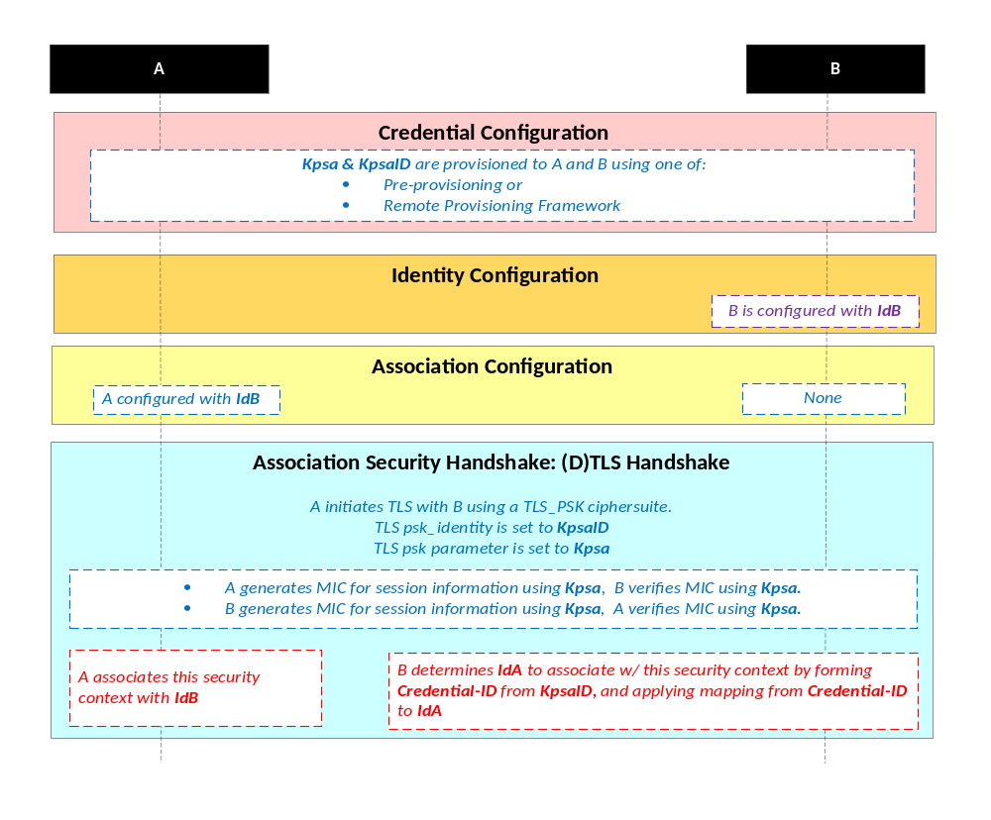
NOTE: The following font colours differentiate the general topic that the text relates to:
Blue italic text highlights details specific to this particular Security Association Establishment Framework.
Purple italic text highlights technical actions that may include steps not specified by oneM2M.
Red italic text highlights security-related properties.

Figure 8.2.2.1-1: The sequence of events when using the Provisioned Symmetric Key
Security Association Establishment Framework
Credential Configuration: The Provisioned Secure Connection Key (Kpsa) and the corresponding Provisioned Secure Connection Key Identifier, denoted KpsaID, are provisioned to both entities either with pre-provisioning or remote provisioning. The format of KpsaID is defined in clause 10.5 "KpsaID Format". If Entity A is a CSE, then Entity A shall also be configured with its CSE-ID (not shown in the figure).
Identity Configuration: See clause 8.2.1.
Association Configuration:
- Entity A shall be configured with Entity B identity (IdB) prior to performing the Association Security Handshake. Entity A shall use this identity for Entity B authenticating using the above arguments. This identity is also used to route the (D)TLS exchange. Entity A shall associate Entity B's identity with messages secured within Security Contexts established using the Provisioned Secure Connection Key Kpsa associated with the Provisioned Secure Connection Key Identifier KpsaID.
- If Entity A is a CSE, then Entity B shall be configured with Entity A's CSE-ID prior to performing the Association Security Handshake. If Entity A is an AE, then Entity B may either be configured with Entity A's identity (IdA) prior to performing the Association Security Handshake, or may determine IdA during registration (Creation of the <AE> resource). Entity B shall use this identity for Entity A authenticating using the above arguments. Entity B shall associate the configured Entity A identity with messages secured within Security Contexts established using the Provisioned Secure Connection Key Kpsa associated with the Provisioned Secure Connection Key Identifier KpsaID.
Association Security Handshake: The entities shall perform a (D)TLS-PSK handshake [Error: Reference source not found] to establish a secure session.
- The "psk_identity" parameter [Error: Reference source not found] shall be set to the value of the Provisioned Secure Connection Key Identifier KpsaID.
- The entities set the "psk" parameter [Error: Reference source not found] to the value of the Provisioned Secure Connection Key Kpsa.
- The (D)TLS cipher suite profile for the Provisioned Secure Connection Key Security Association Establishment Framework shall conform to clause 10.2.2.
- Following successful authentication of Entity B, Entity A shall associate the security context with Id B (Entity B's entity identifier) configured to Entity A during Association Configuration.
- Following successful authentication of Entity A, Entity B shall associate the security context with a CSE-ID or AE-ID:
- If Entity B was already provided with the CSE-ID or AE-ID corresponding to KpsaID, then Entity B shall associate the security context with that CSE-ID or AE-ID.
- Otherwise, Entity B shall associate the security context with the Credential-ID formed from KpsaID as described in clause 10.4 "Credential-ID Details". Entity B shall then determine CSE-ID or AE-ID from the Credential-ID as described in clause 8.2.1 "Overview on Security Association Establishment Frameworks".

8.2.2.2 Certificate-Based Security Association Establishment Frameworks
This clause describes the Certificate-Based Security Association Establishment Framework.
Figure 8.2.2.2-1 illustrates the sequence of events when using the Certificate-Based Security Association Establishment Framework. In this description, "Entity A" and "Entity B" correspond to either two CSEs or a CSE and an AE.
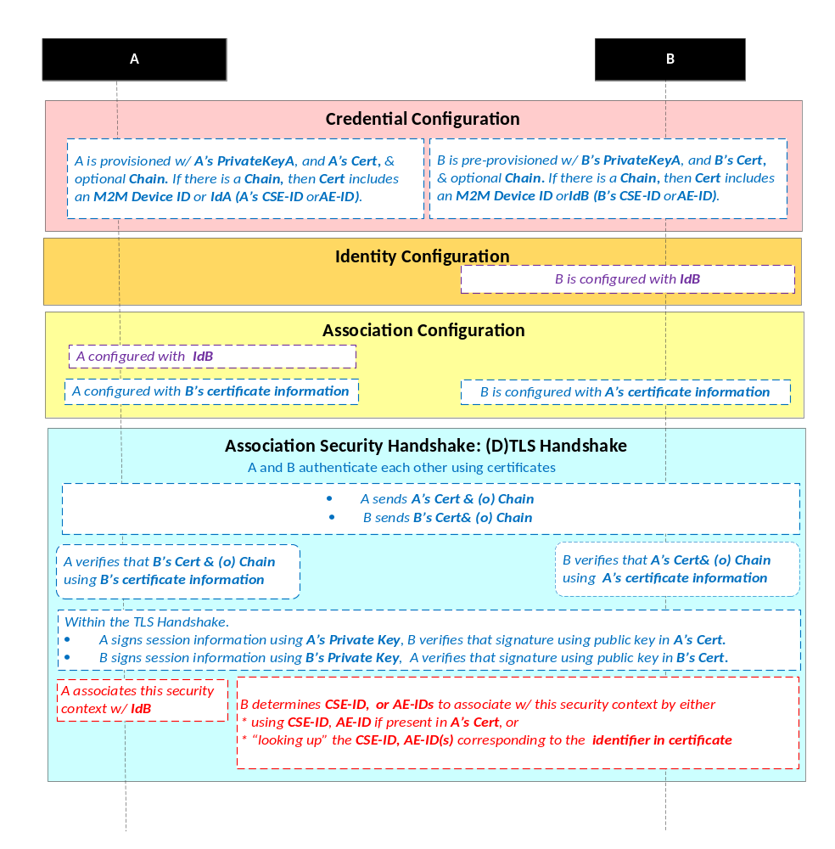
NOTE: The following font colours differentiate the general topic that the text relates to:
Blue italic text highlights details specific to this particular Security Association Establishment Framework.
Purple italic text highlights technical actions that may include steps not specified by oneM2M.
Red italic text highlights security-related properties.

Figure 8.2.2.2-1: The sequence of events when using the Certificate-Based Security
Association Establishment Framework
Credential Configuration: The private keys and certificates for each entity shall be pre-provisioned as described in clause 8.1.2.3 "Credential Configuration for Certificate-Based Security Frameworks". If Entity A is a CSE, then Entity A shall also be configured with its CSE-ID (not shown in the figure).
Identity Configuration: See clause 8.2.1.
Association Configuration: Entity A and Entity B shall be configured with the information needed for the authentication and identification (during Association Security Handshake) of Entity B and Entity A respectively:
- The information configured to Entity A shall include the following arguments:
- Entity B's certificate information: as described in clause 8.1.2.4 "Information Needed for Certificate Authentication of another Entity".
- Entity B's identity (IdB). Entity A shall use this identity for Entity B authenticating using the above arguments. This is used to route the (D)TLS exchange.
NOTE: The Entity A will associate Entity B's identity with messages secured within Security Contexts established in accordance with the configured Entity B's certificate information.
- The information configured to Entity B shall include the following argument:
- Entity A's certificate information: as described in clause 8.1.2.4 "Information Needed for Certificate Authentication of another Entity".
Association Security Handshake:
- Each entity shall verify the other entity's certificate as described in clause 8.1.2.2 "Certificate Verification".
- The entities shall authenticate each other using the validated certificates as specified in TLS 1.2 IETF RFC 5246 [Error: Reference source not found] and DTLS 1.2 IETF RFC 6347 [Error: Reference source not found] specifications.
- The (D)TLS cipher suite profile for the Certificate-Based Security Association Establishment Framework shall conform to clause 10.2.3.
- Following successful authentication of Entity B, Entity A shall associate the security context with IdB (Entity B's entity identifier) configured to Entity A during Association Configuration.
- Following successful authentication of Entity A, Entity B shall associate the security context with a CSE-ID, AE-ID or list of allowed AE-IDs:
- If Entity A establishes a security context by presenting a CSE-ID certificate, then Entity B shall associate the security context with the CSE-ID in the certificate.
- If Entity A establishes a security context by presenting an AE-ID certificate, then Entity B shall associate the security context with the Absolute AE-ID in the certificate.
- If Entity A establishes a security context by presenting a device certificate, then Entity B shall associate the security context with the Credential-ID formed from the globally unique hardware instance identifier in the certificate as described in clause 10.4 "Credential Details". Entity B shall then use Credential-ID to determine the CSE-ID, AE-ID or list of allowed AE-IDs as described in clause 8.2.1 "Overview on Security Association Establishment Frameworks".
- If Entity A establishes a security context by presenting a raw public key certificate, then Entity B shall associate the security context with the Credential-ID formed from the corresponding public key identifier described in clause 10.1.2 "Public Key Identifiers". Entity B shall then use Credential-ID to determine the CSE-ID or AE-ID as described in clause 8.2.1 "Overview on Security Association Establishment Frameworks".

8.2.2.3 MAF-Based Symmetric Key Security Association Establishment Frameworks
This clause describes the MAF-based Security Association Establishment Framework.
This framework uses the MAF Security Framework procedures in clause 8.8, with the following mapping of functional roles:
- Entity A plays the role of the Source End-Point.
- Entity B plays the role of the Target End-Point.
The present clause refers to the entities using only the terminology of Entity A and Entity B.
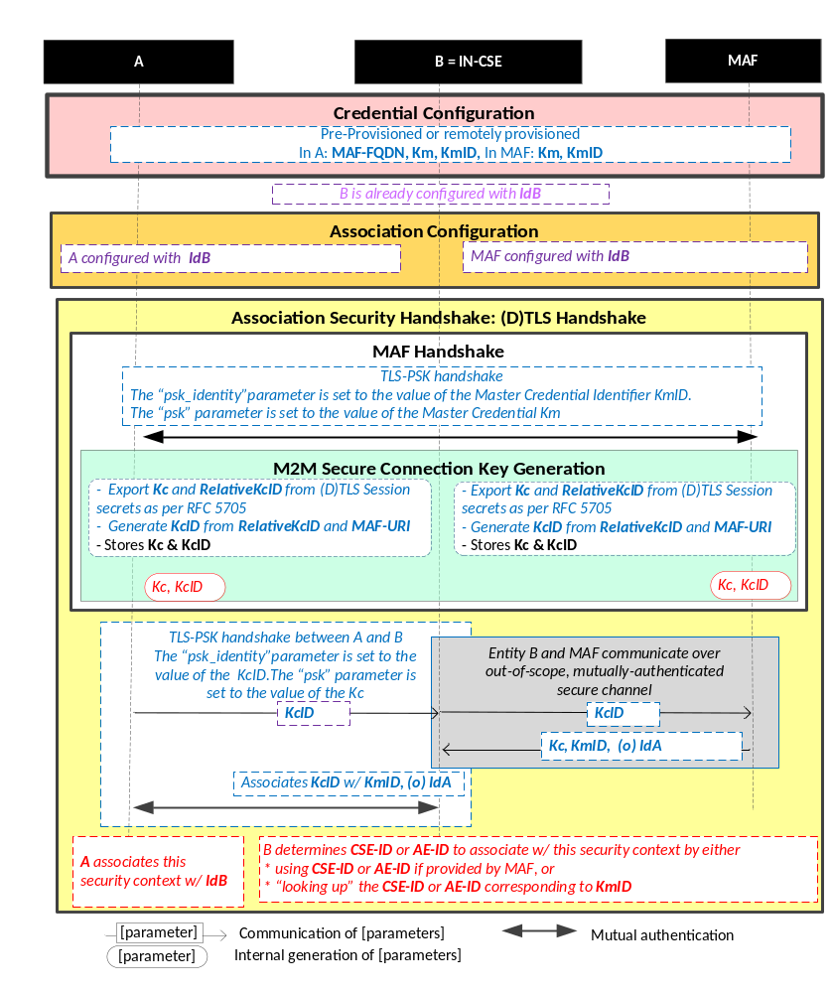
NOTE 1: The following font colours differentiate the general topic that the text relates to:
Blue italic text highlights details specific to this particular Security Association Establishment Framework.
Purple italic text highlights technical actions that may include steps not specified by oneM2M.
Red italic text highlights security-related properties.

Figure 8.2.2.3-1: The sequence of events when using the
MAF-Based Security Association Establishment Framework
Credential Configuration:
- Entity A (and Entity B respectively) shall be individually provisioned with credentials for mutual authentication with the MAF, as described in MAF Credential Configuration (clause 8.8.3.1). Pre-provisioning or remote provisioning may be applied. In the case of remote provisioning of symmetric keys, the MAF retrieves the symmetric keys from the MEF during the MAF Client Registration procedure in Identity Configuration.
Identity Configuration:
- The MAF is expected to be authorized to provide service to Entity A and Entity B.
NOTE 2: The current oneM2M specifications do not describe how this authorization is provided to the MAF.
- The MAF is configured with information about the identities of Entity B and, optionally, Entity A:
  - If Entity A is a CSE, then the MAF is expected to be configured with Entity A's CSE-ID (denoted IdA).
  - If Entity A is an AE, then the MAF is expected to be configured with Entity A's AE-ID (denoted IdA).
  - The MAF is expected to be configured with Entity B's M2M-SP Assigned CSE-ID (denoted IdB).
NOTE 3: The current oneM2M specifications do not describe how this information is configured to the MAF.
- If Entity A (or Entity B respectively) are remotely provisioned with a symmetric key for use with the MAF, then Entity A (or Entity B respectively) shall individually perform the MAF Client Registration procedure (clause 8.8.2.3) with the MAF. This procedure is used to trigger the MAF to (a) retrieve Km from the MEF, and (b) provide the End-Point with the KmID to be used for subsequently authentication with the MAF at step 5.
Association Configuration: Entity A and the MAF shall be configured with the information needed for the authentication and identification during MAF Handshake and Association Security Handshake:
- Authorizing the SAEF:
- Entity A shall be provided with IdB, the CSE-ID for Entity B. See Note 3 in clause 8.2.1.
- The MAF is expected to be configured with the Entity B Identity (IdB) for which it is authorized to provide Kc for an SAEF with Entity A.
- Entity A and the MAF shall establish a mutually authenticated secure channel for communication using the MAF Handshake procedure (clause 8.8.2.2), using the credentials provisioned during Credential Configuration.
- Entity A shall initiate the MAF Key Registration procedure (clause 8.8.2.7) with the MAF. The MAF Key Registration shall include the Security Usage Identifier (SUID) associated with the MAF-Based SAEF and IdB. This procedure results in:
- Entity A and the MAF establishing a M2M Secure Connection Key (Kc) and associated M2M Secure Connection Key Identifier (KcID), corresponding to the output symmetric key and Key Identifier established by the MAF Key Registration procedure.
- MAF providing the lifetime for the M2M Secure Connection Key (Kc).
The SUID limits the scope within which Kc is authorized to be used. In this case, the SUID is used to ensure that the Entity A shall use Kc only with the MAF-Based SAEF.
Association Security Handshake:
- Entity A shall initiate a (D)TLS-PSK handshake with Entity B, according to clause 10.2.2.
- Entity A shall send KcID to Entity B (Infrastructure Node) as the "psk_identity" parameter in a (D)TLS-PSK handshake.
- Entity B recognizes the MAF-FQDN part of KcID in the "psk_identity" parameter, and determines that the corresponding M2M Secure Connection Key (Kc) shall be retrieved from the corresponding MAF. Entity B shall set RelativeKeyID to be the relative part of KcID.
- Entity B and the MAF shall perform the MAF Key Retrieval procedure described in clause 8.8.2.8.
NOTE 1: The MAF Key Retrieval procedure includes establishing a mutually authenticated secure channel for communication using the MAF Handshake procedure (described in clause 8.8.2.2), using the credentials provisioned during Credential Configuration.
Entity B shall provide the RelativeKeyID to the MAF. The MAF returns the output symmetric key value, expirationTime, Security Usage Identifier (SUID), and identity for Entity A to Entity B. The value of Kc shall be set to the output symmetric key value. The Kc Lifetime shall be set to the expirationTime. The SUID limits the scope within which Kc will be used. In this case, the SUID is used to ensure that the Entity B shall use Kc only with the MAF-Based SAEF.
NOTE 2: Assigning Kc Lifetime is the responsibility of the MAF.
- Entity A and Entity B shall complete the (D)TLS-PSK handshake with the "psk" parameter set to the value of the M2M Secure Connection Key (Kc).
- Following successful authentication of Entity B, Entity A shall associate the security context with IdB (Entity B's entity identifier) configured to Entity A during Association Configuration.
- Following successful authentication of Entity A, Entity B shall associate the security context with a CSE-ID or AE-ID:
- If the MAF provided Entity B with a CSE-ID or AE-ID, then Entity B shall associate the security context with that CSE-ID or AE-ID.
- Otherwise, Entity B shall associate the security context with the Credential-ID formed from KmID (provided by the MAF) as described in clause 10.4 "Credential-ID Details". Entity B shall then determines CSE-ID or AE-ID from the Credential-ID as described in clause 8.2.1 "Overview on Security Association Establishment Frameworks".
- Entity A and Entity B may establish a fresh (D)TLS-PSK handshake using Kc at any time within the Kc Lifetime. Once Kc Lifetime expires, then Entity B shall fail the (D)TLS-PSK handshake, which indicates to Entity B that a fresh MAF Handshake is required.

-----------------------End of change 14---------------------------------------------

