CHANGE REQUEST
Meeting ID:* | SEC31
Source:* | Norihiro Okui, KDDI, no-okui@kddi.com  Yutaka Miyake, KDDI, yu-miyake@kddi.com
Date:* | 2017-09-18
Reason for Change/s:* | PPM supports both distributed authorization and dynamic authorization in Rel3
CR against: Release* | 3
CR against: WI* | Active <Work Item number>  MNT maintenance / < Work Item number(optional)>  Is this a mirror CR? Yes No  mirror CR number: (Note to Rapporteur - use latest agreed revision)  STE Small Technical Enhancements / < Work Item number (optional)>  Only ONE of the above shall be ticked
CR against: TS/TR* | TS-0003 v3.4.0
Clauses * | 11
Type of change: * | Editorial change  Bug Fix or Correction  Change to existing feature or functionality  New feature or functionality  Only ONE of the above shall be ticked
Impacted other TS/TR(s)
Post Freeze checking:* | This CR contains only essential changes and corrections? YES NO  This CR may break backwards compatibility with the last approved version of the TS? YES NO
Template Version: January 2017 (Do not modify)

oneM2M Notice
The document to which this cover statement is attached is submitted to oneM2M. Participation in, or attendance at, any activity of oneM2M, constitutes acceptance of and agreement to be bound by terms of the Working Procedures and the Partnership Agreement, including the Intellectual Property Rights (IPR) Principles Governing oneM2M Work found in Annex 1 of the Partnership Agreement.
GUIDELINES for Change Requests:
Provide an informative introduction containing the problem(s) being solved, and a summary list of proposals.
Each CR should contain changes related to only one particular issue/problem.
In case of a correction, and the change apply to previous releases, a separate “mirror CR” should be posted at the same time of this CR
Mirror CR: applies only when the text, including clause numbering are exactly the same.
Companion CR: applies when the change means the same but the baselines differ in some way (e.g. clause number).
Follow the principle of completeness, where all changes related to the issue or problem within a deliverable are simultaneously proposed to be made E.g. A change impacting 5 tables should not only include a proposal to change only 3 tables. Includes any changes to references, definitions, and acronyms in the same deliverable.
Follow the drafting rules.
All pictures must be editable.
Check spelling and grammar to the extent practicable.
Use Change bars for modifications.
The change should include the current and surrounding clauses to clearly show where a change is located and to provide technical context of the proposed change. Additions of complete clauses need not show surrounding clauses as long as the proposed clause number clearly shows where the new clause is proposed to be located.
Multiple changes in a single CR shall be clearly separated by horizontal lines with embedded text such as, start of change 1, end of change 1, start of new clause, end of new clause.
When subsequent changes are made to content of a CR, then the accepted version should not show changes over changes. The accepted version of the CR should only show changes relative to the baseline approved text.

Introduction
PPM is defined as distributed authorization in release 2 at first, but a specification of distributed authorization was postponed to release 3. So, PPM is defined as direct dynamic authorization in release 2. In release 3, specification of distributed authorization is defined.
PPM could support both dynamic authorization and distributed authorization. This contribution provides complete revision about PPM in order to comform to the specification of release 3.

-----------------------Start of change 1-------------------------------------------

11 Privacy Protection Architecture using Privacy Policy Manager（PPM)

11.1 Introduction
This clause provides an architecture for the Privacy Policy Manager (PPM). PPM is a distributed authorization privacy protection architecture using M2M Service Subscriber's privacy preference and service’s privacy policy.
The PPM is a personal data management framework based on the M2M Service Subscriber's privacy preferences and creates access control information from policies agreed by a M2M Service Subscriber. The PPM protects M2M Service Subscriber's personal data from unauthorized parties and unauthorized collection. The PPM may be operated by the M2M Service Provider or a third party acting on behalf of the M2M Service Provider. If the Service Provider provides M2M Service Subscriber’s personal data to the third party, the Service Provider needs to get the M2M Service Subscriber’s consent. In case that the M2M Service Subscriber accepted a privacy policy which indicates provision to third party, the Service Provider could provide the personal data to third party. However, if the privacy policy did not include provision to third party, the Service Provider needs to update the privacy policy and get the M2M Service Subscriber's consent to it.

11.2 Components of PPM

11.2.1 Privacy Preference and Privacy Policy
The PPM shall manage privacy preferences and privacy policies.
- Privacy preference
  - Privacy preference is M2M Service Subscriber's preference regarding the provision of his own personal data to third parties.
  - M2M Service Subscriber creates a M2M Service Subscriber’s privacy preference and registers it to the PPM.
  - List of privacy attributes is described in Annex J.
- Privacy policy
  - Privacy policy describes a required personal data to provide a service to an M2M Service Subscriber by a M2M Service Provider.
  - A M2M Service Provider creates a privacy policy and registers it to the PPM.

  - 11.2.2 Functions of PPM
The PPM may comprise the following functions.
- Sophisticated consent mechanism for matching a M2M Service Subscriber’s privacy preference with the ASP’s privacy policy

- Privacy policy describes required personal data to provide a service to a M2M Service Subscriber by a M2M Service Provider.
- When the M2M Service Subscriber subscribes to a service which is provided by a M2M Service Provider, the M2M Service Provider needs to get the M2M Service Subscriber’s consent to the service’s privacy policy. The PPM provides friendly consent mechanism for M2M Service Subscriber by comparing the privacy preference and the privacy policy.
- This function is described in clause 11.4.1.2.
- Functions of the Policy Decision Point (PDP), Policy Retrieval Point (PRP) for Distributed Authorization, management of AccessControlPolicy resources and Dynamic Authorization System (DAS) Server.

PDP
- When an Originator requests personal data from a Hosting CSE which acts as PEP, the Hosting CSE requests access control decision from the PPM which acts as PDP. The PPM creates <authorizationDecision> from access control information that is created from policies agreed by M2M Service Subscriber and respond <authorizationDecision> to the Hosting CSE.
- Details of PDP and <authorizationDecision> are described in TS-0003 clause 7.5.2 and TS-0001 clause 9.6.42, respectively.

- PRP
- When an Originator requests personal data from a Hosting CSE which acts as PDP, the Hosting CSE requests access control policies from the PPM which acts as PRP. The PPM creates <authorizationPolicy> based on policies agreed by M2M Service Subscribers and respond <authorizationPolicy> to the Hosting CSE.
- Details of PRP and <authorizationPolicy> are described in TS-0003 clause 7.5.3 and TS-0001 clause 9.6.43, respectively.
- Management of AccessControlPolicy resources hosted by CSEs
    - When an Originator requests personal data from a Hosting CSE, and this CSE uses locally stored accessControlPolicy resource to derive the access control decision using the mechanism described in clause 7.1, the PPM may act as an IN-AE which generates and deploys the required accessControlPolicy resources on the respective CSE and assigns appropriate AccessControlPolicyID attributes to resources created by the M2M Service Subscriber.
- Dynamic Authorization modelS
- Direct Dynamic Authorization
    - When an Originator requests personal data from an Hosting CSE, the Hosting CSE requests <dynamicACPInfo> or <token> from the PPM. The PPM creates <dynamicACPInfo> or <token> based on policies agreed by M2M Service Subscribers and respond <dynamicACPInfo> or <token> to the Hosting CSE.
    - Detail of Direct Dynamic Authorization is described in TS-0003 clause 7.3.2.2.
    - Detail of <dynamicACPInfo> and <token> are described in TS-0001 clause 9.6.40 and clause 9.6.39, respectively.
- Indirect Dynamic Authorization
    - Before an Originator requests personal data from a Hosting CSE, the Originator requests <token> or tokenID from the PPM. The PPM creates <token> based on policies agreed by M2M Service Subscribers and respond <token> or tokenID to the Originator. Then, the Originator requests personal data from Hosting CSE with <token> or tokenID.
    - Detail of Indirect Dynamic Authorization is described in TS-0003 clause 7.3.2.3
- Traceability of personal data usage
- PPM shall store the access log that records which Originator accessed which kind of collected data.
- This function is for further study of oneM2M, but this function can be implemented using components that are defined in oneM2M.

11.3 Privacy Policy Management Architecture

11.3.1 Introduction
The PPM manages M2M Service Subscriber’s preference and service’s privacy policy of an M2M Application Service Provider. Basically, one M2M Application Service Provider have one PPM in infrastructure domain and manage status of M2M Service Subscriber consent in the PPM. There are four procedures in the use of the PPM. This clause explains relationships between steps in the PPM scenario and components of oneM2M.

- A M2M Service Subscriber Subscribes M2M Service Provider. .
- The M2M Service Subscriber subscribes to a service offered by an ASP. This may happen concurrently with step 1.

- An AE (IN-AE or field domain AE) requests personal data that are stored in a Hosting CSE.
- The M2M Service Subscriber checks the access log of his/her own personal data and requests the deletion of the collected personal data from the Hosting CSE.

11.3.2 Involved Entities
- M2M Service Subscriber
  - An M2M Service Subscriber can make use of M2M services by subscribing to a service of an ASP which provides functions that control access to information in the IN-CSE.
  - When an M2M Service Subscriber subscribes to service provided by an ASP, the M2M Service Subscriber becomes a data subject.
- Personal Data
  - Personal data is information that can be used on its own, or with other information to identify an individual to form Personally Identifiable Information (PII).
  - A Hosting CSE collects and stores personal data.
  - Examples of personal data: Sensor data, Electrical power consumption, Operating state of air conditioner, etc.
- ADN-AE, ASN-AE
  - An ADN-AE or ASN-AE produces various kinds of data, such as sensor data. An ADN-AE or ASN-AE may also request data from resource hosting CSEs.
  - The ADN-AE or ASN-AE sends the data to a Hosting CSE such as ASN-CSE, MN-CSE or IN-CSE
- Hosting CSE
  - If the Hosting CSE use the PPM as PDP, the Hosting CSE should act as Policy Enforcement Point (PEP).
  - If the Hosting CSE use the PPM as PRP, the Hosting CSE should act as PDP.
  - If the Hosting CSE use the PPM as DAS, the Hosting CSE should configure <dynamicAuthorizationConsultation> resources linked to the requested resource.
    - <dynamicAuthorizationConsultation> resource is described in TS-0001 clause 9.6.40.
- Application Service Provider
  - An Application Service Provide provides services to an M2M Service SubscriberM2M Service Subscriber who joins the M2M Service Provider.
  - An Application Service Provide requests personal data from an M2M Service Provider in order to provide services.
- M2M Service Provider
  - M2M Portal
    - An M2M portal provides a M2M Service Subscriber Interface through which services provided by an M2M Platform may be managed.
    - A M2M Service Subscriber accesses the M2M portal to subscribe to a service offered by an ASP.
- PPM
  - The PPM may include functionality for an automated procedure (out of scope of oneM2M) to create access control policies and to deploy these on CSEs host on policies agreed by a M2M Service Subscriber.
  - If the PPM acts as PDP or PRP, it requires CSE functionality. If the PPM acts as DAS Server, the PPM requires AE functionality.
  - The PPM may providre a M2M Service Subscriber Interface via a PPM portal. A M2M Service Subscriber may access the PPM portal to configure the M2M Service Subscriber’s privacy preference. The PPM portal is out of scope of oneM2M.

- 11.3.3 Management Flow in PPM Architecture

11.3.3.0 Introduction
This clause describes the case where a M2M Service Provider stores personal data.

11.3.3.1 Joining a M2M Service Provider
When a M2M Service Subscriber joins a M2M Service Provider, the M2M Service Subscriber configures privacy preferences using the PPM. A privacy preference explains what kind of data are allowed to be accessed by ASPs. Figure 11.3.3.1-1 illustrates the overview of this process.
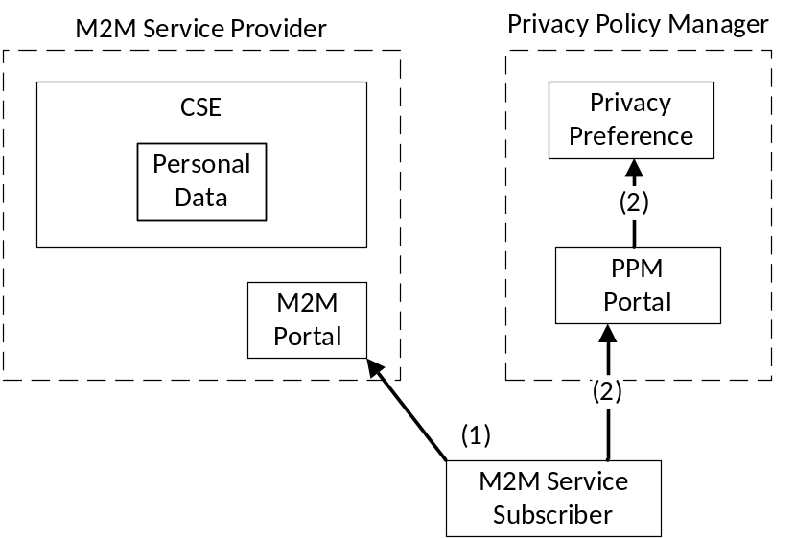
Figure 11.3.3.1-1: A data subject joins a M2M Service Provider
1. A M2M Service Subscriber accesses the M2M portal of a M2M Service Provider
.
This process is typically uses Web access protocols such as HTTP, HTTPS and so on.
- This process is described in clause 11.4.1.2.
2. The M2M Service Subscriber configures a privacy preference and registers it on the PPM portal.
- The M2M Service Subscriber accesses the PPM portal, or the M2M portal redirects the M2M Service Provider to the PPM portal. This process uses Web access protocols.
- This process is described in clause 11.4.1.2.
3. The M2M Service Provider collects and stores data from AEs.

11.3.3.2 Subscription to a service by ASP
The M2M Service Subscriber can subscribe to various kinds of services provided by ASPs through the M2M Service Provider. Service lists are registered on an M2M portal and the M2M Service Subscriber can select services to subscribe to. When the M2M Service Subscriber subscribes to a service, the M2M Service Subscriber needs to accept ASP’s privacy policy. In order for the M2M Service Subscriber to easily understand this policy, the PPM shall create the customized privacy policy based on the privacy policy provided by the ASP and the M2M Service Subscriber's privacy preference. Therefore, the M2M Service Subscriber can control personal data and agreement implies understanding of the privacy policy. Figure 11.3.3.2-1 shows the overview of this process.
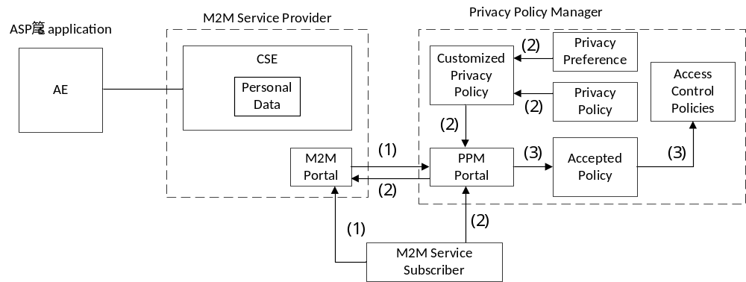
Figure: 11.3.3.2-1: The M2M Service Subscriber subscribes to an ASP's service
1. The M2M Service Subscriber accesses the M2M portal and selects an ASP's service to subscribe. The M2M portal redirects to the PPM portal to get the M2M Service Subscriber’s consent.
- This process typically uses Web access protocols such as HTTP, HTTPS and so on.
- This process is described in clause 11.4.1.1.
2. The M2M Service Subscriber needs to accept a privacy policy to subscribe to the ASP's service. The PPM shall create the customized privacy policy for each M2M Service Subscriber based on the M2M Service Subscriber's privacy preference and service’s privacy policy. It is easy for the M2M Service Subscriber to confirm differences between the privacy preference and the privacy policy and to understand what kind of personal data are collected by the ASP. After the M2M Service Subscriber accepts the privacy policy, the M2M Service Subscriber can subscribe to the ASP's service.
- The function of creating a customized privacy policy is described in clause 11.4.1.3.
3. The PPM shall create or update access control policies using the privacy policy that the M2M Service Subscriber accepted.
- The function of creating or updating access control policies in the PPM may rely on the authorization mechanisms specified in clauses 7.3 and 7.5. The details of the synchronization process are not specified in the present document.

11.3.3.3 Request for personal data to the Hosing CSE

11.3.3.3.1 Introduction
If the ASP needs personal data to provide the service, the ASP requests the personal data from a Hosting CSE in the M2M Service Provider. The PPM shall work as PDP, PRP or DAS Server.
- If the PPM works as PDP, the Hosting CSE acts as PEP and requests <authorizationDecision> from the PPM and controls the data access using them. Figure 11.3.3.3.2-1 illustrates the overview of this process.
- If the PPM works as PRP, the Hosting CSE acts as PDP and requests <authorizationPolicy> from the PPM and controls the data access using them. Figure 11.3.3.3.3-1 illustrates the overview of this process.
- If the PPM works as DAS Server (Direct dynamic authorization), the Hosting CSE checks <dynamicAuthorizationConsultation> and requests <dynamicACPInfo> or <token> from the PPM. Figure 11.3.3.3.4.1-1 illustrates the overview of this process.
- If the PPM works as DAS Server (Indirect dynamic authorization), the ASP requests <token> or tokenID from the PPM. Figure 11.3.3.3.4.2-1 illustrates the overview of this process. (Detail of this request is not specified in oneM2M)

11.3.3.3.2 PPM works as PDP
The PPM shall be implemented as CSE and shall provide an interface that enables access control for personal data using the PPM as PDP.
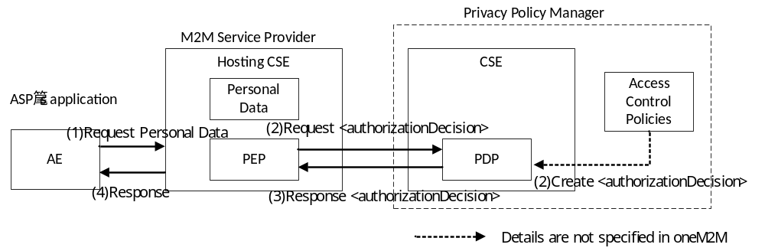
Figure 11.3.3.3.2-1: Request for personal data to the Hosting CSE (the PPM works as PDP)
- The ASP requests personal data from the Hosting CSE in M2M Service Provider.
- PEP in the Hosting CSE requests <authorizationDecision> from the PPM. The PPM shall create <authorizationDecision> using access control policies.
The PPM could use <accessControlPolicy> resources as access control policies. In this case, CSE in the PPM stores <accessControlPolicy>
Detail of creating <authorizationDecision> from access control policies is not specified in oneM2M
- The PPM shall respond <authorizationDecision> to the Hosting CSE.
- If accessing personal data is permitted, the Hosting CSE accesses the personal data and sends the personal data to the ASP as a response.

11.3.3.3.3 PPM works as PRP
The PPM shall be implemented as CSE and shall provide an interface that enables access control for personal data using the PPM as PRP.
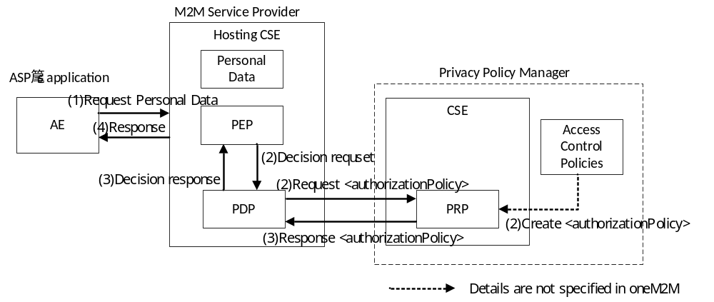

Figure 11.3.3.3.3-1: Request for personal data to the Hosting CSE (the PPM works as PRP)
- The ASP requests personal data from the Hosting CSE in the M2M Service Provider.
- PEP in the Hosting CSE requests access control decision from PDP in the Hosting CSE. Then, the PDP requests <authorizationPolicy> from the PPM. The PPM shall create <authorizationPolicy> using access control information.
The PPM could use <accessControlPolicy> resources as access control policies. In this case, CSE in the PPM stores <accessControlPolicy>
- The PPM respond <authorizationPolicy> to PDP in the Hosting CSE. Then, the PDP decides to permit or deny access to the personal data using the <authorizationPolicy> and sends a result as "Decision Response" to PEP.
- If accessing personal data is permitted, the Hosting CSE accesses the personal data and sends the personal data to the ASP as a response.

11.3.3.3.4 PPM works as DAS Server

11.3.3.3.4.1 Direct Dynamic Authorization
The PPM shall be implemented as AE and shall provide an interface that enables access control for personal data using the PPM as DAS Server.
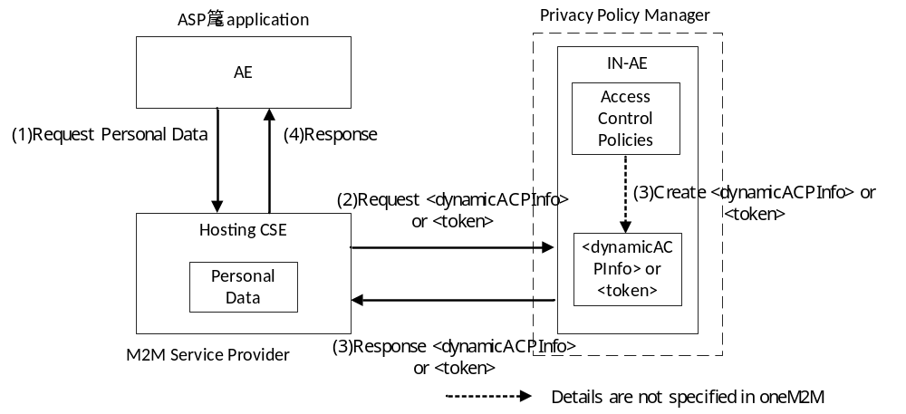
Figure 11.3.3.3.4.1-1: Request for personal data to the Hosting CSE (the PPM works as DAS Server and case of direct dynamic authorization)
- The ASP requests personal data from the Hosting CSE in the M2M Service Provider.
- The Hosting CSE performs procedure of direct dynamic authorization. The Hosting CSE checks <dynamicAuthorizationConsultation> and requests <dynamicACPInfo> or <token> from the PPM.
- The PPM creates <dynamicACPInfo> or <token> based on access control policies and respond <dynamicACPInfo> or <token> to the Hosting CSE.
The PPM could use <accessControlPolicy> resources as access control policies.
- The Hosting CSE make access control decision. If accessing personal data is permitted, the Hosting CSE accesses the personal data and sends the personal data to the ASP as a response.

11.3.3.3.4.2 Indirect Dynamic Authorization
The PPM shall be implemented as AE and shall provide an interface that enables access control for personal data using the PPM as DAS Server. In this clause, some optional procedures of indirect dynamic authorization are omitted and focused on procedures related to the PPM.
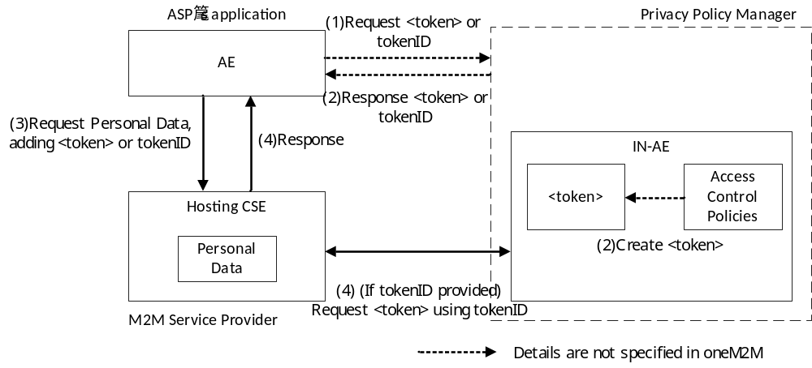
Figure 11.3.3.3.4.2-1: Request for personal data to the Hosting CSE (the PPM works as DAS Server and case of indirect dynamic authorization)
- The ASP requests <token> or tokenID from the PPM.
- The PPM creates <token> and respond <token> or tokenID to the ASP.
Details of above two procedures are not specified in oneM2M.
- The ASP requests personal data from the Hosting CSE with <token> or tokenID.
- The Hosting CSE make access control decision using <token>. If the Hosting CSE receive tokenID, the Hosting CSE requests <token> from the PPM with tokenID. If accessing personal data is permitted, the Hosting CSE accesses the personal data and sends the personal data to the ASP as a response.

-----------------------End of change 1---------------------------------------------

