IoT for Sustainability

oneM2M White Paper

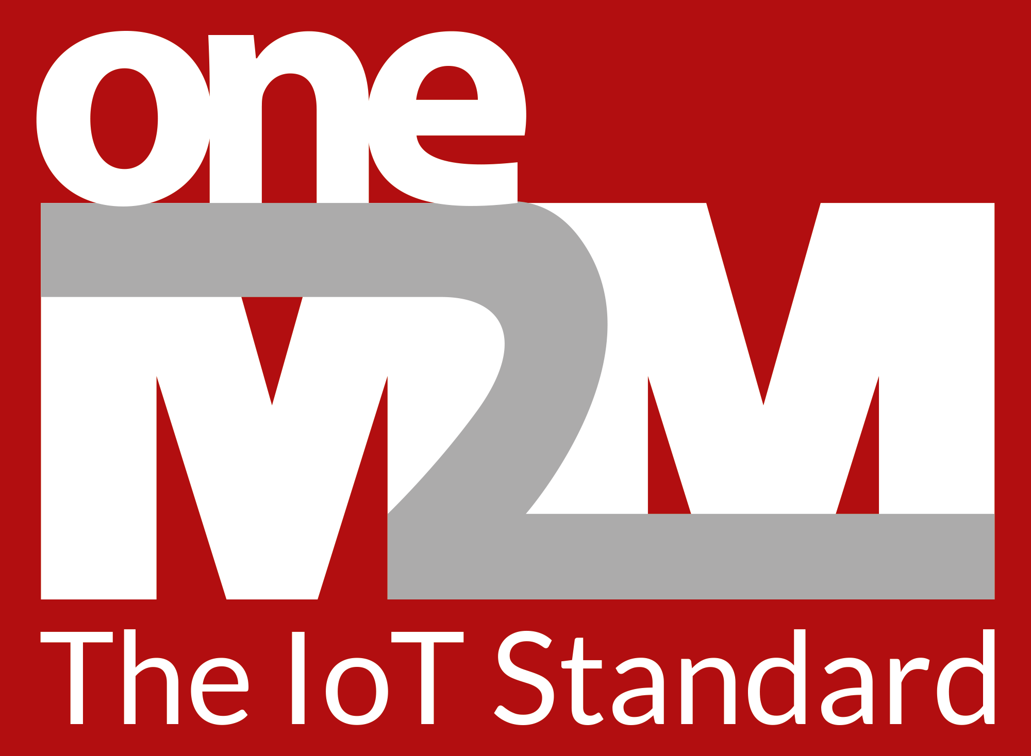

TABLE OF CONTENTS

1. Why is ‘sustainability’ important? 3
1.1 Definition and Scope of Sustainability 3
1.2 Environmental Impact - Key Segments 4
1.3 Market Forces and the Need to Address Sustainability 5
2. Approaches to Sustainability 6
2.1 Macro Drivers 6
2.2 An Example of Regional Action - the EU’s Green Deal 7
2.3 Private Sector Initiatives 8
2.4 Common Themes and Areas for Action 10
3. The Role of IoT in Sustainability 12
3.1 Example Applications of IoT in Enabling Sustainability 14
4. Principles for Sustainable Design 16
4.1. Think Horizontal to Maximize Reuse and Longevity 16
4.2. Principles for Designing Sustainability 17
4.3 Application of Sustainable Technologies 18
5. Future Directions 21
6. Resources 23
6.1 Reading List 23
6.2 Contributors 23

Why is ‘sustainability’ important?

Sustainability is concerned with the well-being of future generations and, in particular, with the treatment of irreplaceable natural resources. It primarily refers to the capacity for the Earth’s biosphere and human civilization to co-exist in the long run.

1.1 Definition and Scope of Sustainability
The multiple aspects of sustainability are often broken down into three areas. These are sometimes referred to as ESG, environment, social, and governance. In a similar way, the Triple Bottom Line is a business concept whereby firms commit to measuring their social and environmental impact—in addition to their financial performance—rather than solely focusing on generating profit, or the standard “bottom line.” It can be broken down into “three Ps”: profit, people, and the planet (or economic, social, and environment). Here, the profit/economic link refers to sustainable actions such as investments related to climate-change mitigation or adaptation. In most cases, these areas and their aspects are also considered in sustainability assessments and sustainability or non-financial reporting guidelines. This is reflected, e.g., in the GRI (Global Reporting Initiative) indices for sustainability reporting.

Typically, environmental aspects include greenhouse-gas emissions, energy consumption (which is also considered in the ISO 50001 Energy Management System, EnMS), water usage and pollution, and waste generation and treatment (the latter are considered in the ISO 14001 Environmental Management System, EMS). Further aspects can include resources scarcity/efficiency, Ozone depletion, hazardous substances (also covered by ISO 14001), and product eco-design. Emissions often cover the three Scopes of the Greenhouse Gas Protocol, for example own operations, logistics and product use phase.

Social aspects typically include labour law (e.g., regarding the ILO convention), health & safety (covered in OHSAS 18001 / ISO 45001), diversity and corporate social engagement. This often extends to the respective measures that are to be taken with regard to the supply chain. The latter, supply chain, is an aspect of increasing importance, as can be seen from the attempts to responsible sourcing and other ongoing initiatives.

Governance or economic aspects include the reporting entity’s organizational structure, including highest governance level responsible for sustainability, assignment of responsibilities, training and aspects like revenue, cost or investment related to climate change and other environmental aspects. The latter is also considered in the TCFD framework (Task force for Climate-related Financial Disclosure) and in the EU Taxonomy. Over time, the Taxonomy will extend this to the aspects of circular economy and governance.

Finally, the circular economy is possibly the most relevant cross-over aspect. It connects environmental aspects like resource efficiency and emissions with the necessary consideration of the entire value chain and new business models that replace the old linear take-make-sell-forget business.

1.2 Environmental Impact - Key Segments

The world emits around 50 billion tonnes of greenhouse gases each year. A useful proxy to rank different industrial sectors according to their impact on sustainability begins with an analysis of their contributions to greenhouse gas emissions. Figure xx illustrates such a breakdown, based on a 2020 analysis from Climate Watch and the World Resources Institute using data for 2016.

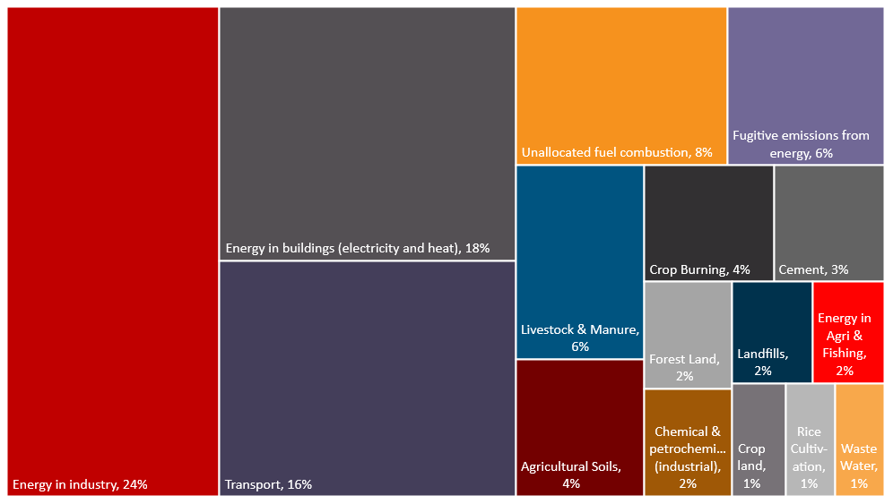
Note: Grassland category (not shown) accounts for <1%
Figure xx: Global Greenhouse Gas Emissions by Sector, (Our World in Data Where do global greenhouse gases come from?)

- Energy (electricity, transport, and heat): 73.2% - energy use in industrial manufacturing processes is a significant contributor to this category, amounting to 24.2% of GHGs. The key industries include iron and steel, and chemical and petrochemicals. The transportation sector contributes 16.2% in this category, driven primarily by fuel emissions from cars, trucks, lorries, motorcycles, and buses. Energy consumption in residential and commercial buildings contributes 17.5% to the category total.

- Direct Industrial Processes: 5.2% - carbon dioxide produced during a chemical process in the production of cement accounts for 3% of this category’s total. The remainder is due to chemical by-products in the chemical and petrochemicals sector.

- Waste: 3.2% - the decomposition of waste matter in wastewater systems and landfills are the two contributors to this category.

- Agriculture, Forestry and Land Use: 18.4% - agriculture, forestry and land use directly accounts for 18.4% of GHGs. Looking across sectors, the food system as a whole – including refrigeration, food processing, packaging, and transport – accounts for around one-quarter of greenhouse gas emissions.

1.3 Market Forces and the Need to Address Sustainability
The concept of sustainability in all its facets is becoming increasingly important for companies across all industries. There are several reasons for this. The consequences of climate change are becoming more tangible by the day and on an international level. Society is also concerned about other far-reaching global problems that can be linked to the loss of biodiversity or to social inequality. This palpability of unprecedented scope means that consumers, regulatory bodies, and the pressure on companies to behave sustainably continues to grow.

Among other factors, end customers are expressing clear preferences for sustainable products and services. This desire is not only relevant in the B2C sector, but runs through the entire market, and is also noticeable in the B2B environment. For example, companies also select their partners and suppliers on the basis of their commitment to sustainability to avoid any negative impact on themselves. This process is turning into a priority as businesses reassess the resilience and sustainability of their supply chains.

Investors are also showing increased interest in the environmental, social and governance performance of companies and have high expectations of them. In order to meet the needs of the market, it is essential to show authentic commitment in order to accelerate the change towards sustainable business.

Global policy actions are also increasing the pressure on companies. Political initiatives, such as the European Green Deal, are increasingly being launched and aim to cut carbon emissions and detach economic growth from resource consumption. In the future, policy actions will increasingly reward sustainable practices while sanctioning activities that are climate-damaging or otherwise unsustainable.

Last but not least, it is important to mention that the private sector and companies operating in it are part of a functioning society and contribute to its maintenance. It is therefore of fundamental importance that companies focus not only on short-term profit, but also on long-term value contribution to society. A functioning society depends on the availability of resources and an ecological balance, and therefore companies must help to ensure that this balance can be maintained in the long term and that natural resources continue to be available.

Cybersecurity programmability in the device lifecycle -> linked to ‘do no harms’ to shared resources such as mobile networks?

Approaches to Sustainability
Between macro to micro level approaches, there are several layers to tackling the sustainability challenge. This section draws on insights from a few of these approaches. Although not an exhaustive review, they illustrate how organizations are acting and they provide the basis for identifying common themes and areas for action.

2.1 Macro Drivers

Almost 200 nations submitted plans to cut greenhouse gas emissions with the Paris Agreement in 2015. Since then, governments, business organizations and segments of the general population have supported the need for action. In 2018, the Intergovernmental Panel on Climate Change (IPCC) warned of worsening conditions if the planet exceeded 1.5 degrees C of warming. To keep within this goal, the IPCC laid out a target of cutting emissions to net-zero by 2050.

Net-zero means a radical change across the entire economy, doing away with fossil fuels and other sources of emissions wherever possible. It involves a future of energy based on renewables, carbon capture and new energy technologies by the 2050s. This is a significant substitution from present day energy sources which are dominated by oil, gas, and coal. For other energy sources, the solution is to match every ton of CO2 emitted with a ton removed from the atmosphere.

Figure XX below provides recommendations from IEA (International Energy Agency) on the path to net-zero emissions (NZE). The various contributors towards the NZE in 2050 include behavioural change, several energy products for different applications and the adoption of newer technologies. Regulatory policies also play a vital role in enabling proliferation of many of these.

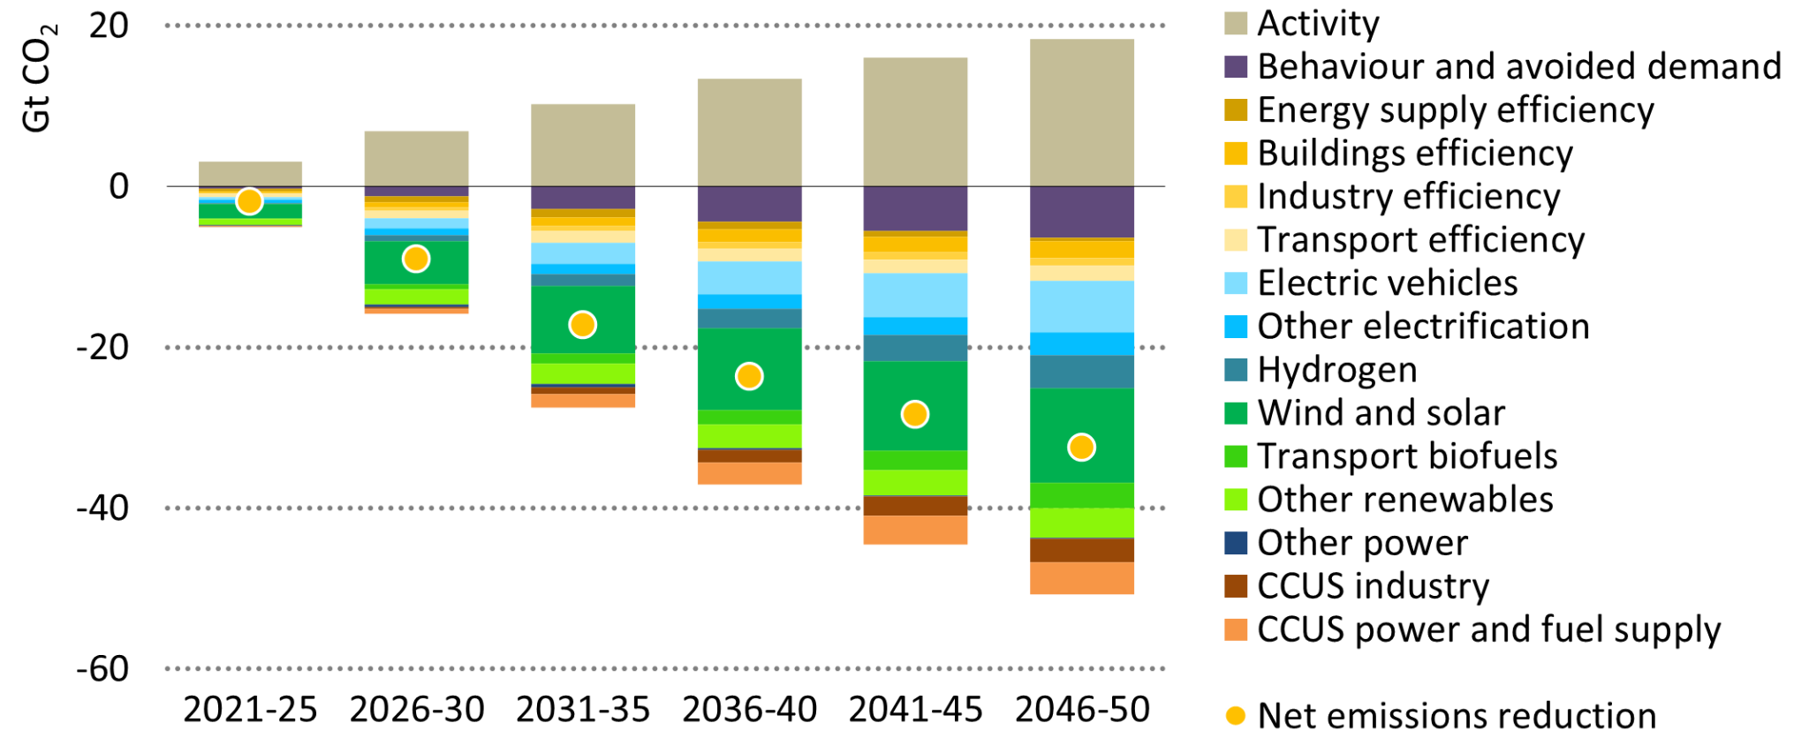
Figure XX: Average annual CO2 reductions from 2020 to NZE in 2050
The rapid deployment of more energy‐efficient technologies, electrification of end‐uses and swift growth of renewables all play a central part in reducing emissions across all sectors in the NZE. By 2050, nearly 90% of all electricity generation is from renewables, as is around 25% of non‐electric energy use in industry and buildings.

Around 2.5% of existing residential buildings in advanced economies are retrofitted each year to 2050 in the NZE to comply with zero‐carbon‐ready building standards (compared with a current retrofit rate of less than 1%). A zero‐carbon‐ready building is highly energy efficient and uses either renewable energy directly or from an energy supply that will be fully decarbonised by 2050 in the NZE (such as electricity or district heat). A zero carbon‐ ready building will become a zero‐carbon building by 2050, without further changes to the building or its equipment.

Government action is central to achieve net‐zero emissions globally by 2050. An unprecedented level of international co‐operation is needed. This will help to accelerate innovation, develop international standards, and facilitate new infrastructure to link national markets. Without the co‐operation assumed in the Net-Zero Emissions scenario (NZE), the transition would be delayed by decades. The following section illustrates how the challenge is being addressed within a regional bloc, through the EU’s Green Deal initiative.

2.2 An Example of Regional Action - the EU’s Green Deal

The European Green Deal is a set of policy initiatives by the European Commission which has the aim of making Europe climate neutral in 2050. The European Commission's climate change strategy, launched in 2020, is focused on a promise to make Europe a net-zero emitter of greenhouse gases by 2050 and to demonstrate that economies will develop without increasing resource usage. It includes measures to ensure that nations that are already reliant on fossil fuels are not left behind in the transition to renewable energy.

The scope of action has a broader footprint than emissions targets. It includes initiatives to promote collaboration and change management at scale as illustrated by the following element in its initial plan of action:

- Invest in environmentally friendly technologies
- Support industry to innovate
- Roll out cleaner, cheaper, and healthier forms of private and public transport
- Decarbonize the energy sector
- Ensure buildings are more energy efficient
- Work with international partners to improve global environmental standards

As a measure of the importance of these issues, funding to support Green Deal initiatives will draw on the EU’s seven-year budget as well as an amount equal to one third of the 1.8 trillion euro investments from the Next Generation EU Recovery Plan.

2.3 Private Sector Initiatives

Investor pressure and sustainability-oriented customer expectations are two factors that are driving private sector change. There, businesses are responding collectively and through individual strategies tailored to their business models and customer base.

In many cases, the definition of sustainability goes beyond environmental impact factors to include societal, stakeholder and organizational governance considerations. This leads to a wider set of parameters to monitor each organization’s performance. The novelty and need for industry wide standards mirror telecommunications sector activities around standardization and certification. This is reflected in the growing role of institutional groups and efforts to define measurement, reporting and certification frameworks.

Institutional Frameworks and Corporate Approaches to Sustainability

There are several different facets to sustainability, environmental, societal, stakeholder engagement and organizational structure factors. The relative importance of these factors to any given organization depends on emissions, environmental impact, and circular economy practices. For the telecommunications sector, the latter is important in terms of raw-materials efficiency.

Practical frameworks to manage sustainability performance generally involve assessment and reporting tools. A starting point for a commercial organization is to begin with the Science Based Targets initiative (SBTi). As time goes by, organizations should plan for more stringent targets, such as those linked to meeting goals related to the 1.5 deg C Climate target.

There is some early thinking from the Task Force on Financial Disclosures (TCFD) and the EU Taxonomy for Sustainable Investments. These are complex reporting frameworks, at a high level.

The Global Reporting Initiative (GRI) is an independent organization with a focus on standardizing the reporting of economic, environmental, and social performance issues. One of the organization’s achievements is the creation of a common language to disclose key performance indicators. This is useful for reporting organizations and for external stakeholders that want to understand and evaluate businesses and governments. Standardization provides a common language to enable reporting and understanding, while a digital approach that makes it straightforward to report data. This combination of factors is key to promoting the wider adoption of sustainability measures and solutions.

Individual corporations are taking different approaches to embed sustainability in their business operations. An informal poll of members participating on oneM2M standardization activities illustrates a range of initiatives:

- The French telecoms operator, Orange, has aligned its goals with the Paris Agreement and the recommendations of IPCC to achieve net zero carbon emissions by 2040. This is 10 years earlier than the objectives set by the rest of the sector. To achieve this, Orange aims to reduce its CO2 emissions by 30% from 2015 to 2025, notwithstanding exponential growth in the volume of data transiting its networks. The company also plans to increase the share of renewable energies, targeting 50% of electricity from renewable sources in the Group's energy mix by 2025 while continuing to improve the efficiency of its networks and buildings.
- From its base in Germany, Deutsche Telekom has set itself strict climate targets. Climate neutrality for its own emissions is to be achieved by 2025 at the latest, and net zero from production to the customer by 2040 at the latest. These targets build on steps already taken by Deutsche Telekom to make its global network entirely green through the use of electricity from renewable sources.

- Beyond corporate commitments to sustainability, another fruitful avenue involves sustainability offerings to customers of Information and Communications Technology (ICT) solutions and service providers.
  - TCS offers an Energy and Emissions accounting solution to achieve energy efficiency, sustainability reporting, carbon neutral goals by reducing emissions and meet financial and sustainability goals. The solution aligns with two of the UN’s SDGs: SDG 12-Responsible Consumption and Production and SDG 13-Climate Action. It connects to a diverse vendor eco-system via multiple connectivity technologies, to link enterprise and operational data sources to AI applications (for predictive analytics) and a reporting dashboard.

  - IoT technologies can help organizations to reduce their consumption of water and chemicals in agriculture, to optimize traffic and parking in large cities and to reduce energy consumption of heating and cooling systems. Orange uses these drivers to design a range of IoT solutions. One example is a smart home solution that allows household occupants to manage home appliances, even at a distance, in order to protect the environment by reducing energy use. Another example involves the community of Saint-Quentin-en-Yvelines which relies on IoT sensors to manage flood risk via a cloud-based platform that reports data to field-operator devices year-round.

  - For the agricultural and confectionery sector, TCS has designed a Farm-to-Fork solution. This helps farmers to enrol in an on-line system for crop harvest data which enables the tracing of location-specific data about agricultural commodities supplied from different parts of the world. The vision of this GIS-powered application is early detection of food toxicity, specifically addressing SDG3: Good Health and Well-being. It also helps in identifying sustainability risks from the supply chain to better manage fluctuating consumer demand, addressing SDG12: Responsible Consumption and Production. The solution framework has broader applications and can be adapted to provide real-time insights on pandemic, natural disaster, and climate-related risks.

- ADVA, the German optical network equipment provider, began its sustainability journey some 8 years ago. One of several ways it approaches the sustainability challenge is to look at the issue from the perspective of costs and revenues related to climate change. In the case of ADVA’s optical networking business, 80% of the climate impact is connected to the operational phase of equipment deployed by its customers. That represents a huge externality for ADVA. Using currently available data, it is impossible to factor what is happening in its customers’ businesses – that is the network operators – and their customers whose usage patterns drive network traffic. ADVA’s strategy is to invest engineering resources to improve the environmental performance of its future product line. At the same time, it also takes action to deal with the (much smaller) emissions footprint associated with its vehicle fleet, for example.

2.4 Common Themes and Areas for Action

Beginning with the 2015 Paris Agreement, there appears to be a clear need for collective and common approaches to address climate sustainability challenges. While this reflects the position of most governments, public awareness of the physical and societal impacts of climate change are adding pressure for government and business to change.

This dynamic has two effects. One is the recognition that fossil fuel dependency is unsustainable and requires a significant course change to substitute renewable sources of energy while engineering new and scalable approaches to sequester carbon from the environment. These rely on a step change in innovation and the use of new technologies. In fact, organizations that make significant use of technology need to modify their ‘do no harm’ strategies and target uses that have a positive impact. That entails a shift from investing in maintaining existing systems and technologies to one of using new technologies.

The second dynamic involves a broadening of the sustainability agenda to include societal and stakeholder issues alongside environmental ones. Businesses are responding by collaborating to develop new measurement and reporting frameworks based on sector-wide agreements or standards. Currently, these focus on data gathered through audits and conventional, financial reporting metrics. In time, the range of measurements is likely to include operational data and more frequent measurement and reporting intervals. This is where ‘digital-ready’ reporting standards and IoT technologies are expected to grow in importance.

ICT solutions and service providers are already offering remote monitoring and data management solutions to their customers. These concepts need to scale and become more widely adopted.

ICT solutions are also deployed by organizations to offer services to their customers. An example is the case of a network equipment provider that supplies a mobile network operator which services its business and consumer customers. There will be an onus on the primary providers to develop approaches that allow the life cycle footprint of their equipment to be assessed. This may involve better data gathering or collaborative approaches along value chains to apportion environmental impact factors.

The Role of IoT in Sustainability
The United Nations’ Environment Program (UNEP) monitors progress on a range of metrics associated with each of the UN’s seventeen Sustainable Development Goals (SDGs). Almost half of these goals contain requirements that can be addressed through the use of IoT technologies and systems.
- SDG2 Zero Hunger calls for the use of sustainable agricultural practices
- SDG 3 Good Health & Wellbeing calls for reductions in mortality linked to air and water pollution
- SDG 6 Clean Water & Sanitation calls for improvements in water quality and resource management
- SDG 7 Affordable & Clean Energy calls for a focus on energy efficiency
- SDG 9 Industry, Innovation & Infrastructure calls for reductions in CO2 emissions via circular economy and new production paradigms
- SDG 11 Sustainable Cities & Communities calls for improvements in public transport and disaster management
- SDG 12 Responsible Consumption & Production emphasizes the need to manage the environmental footprint of materials and influence over domestic consumption
- SDG 17 Partnerships for the Goals promotes the use of environmentally friendly technologies
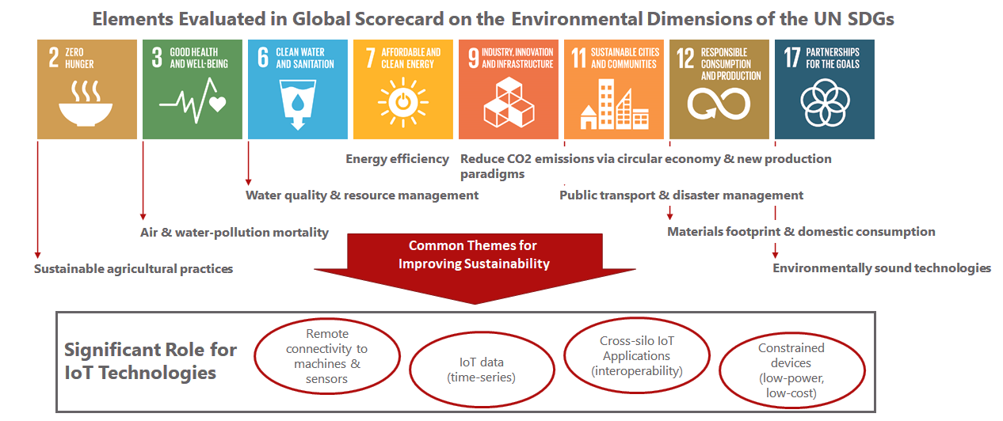

Source: UN Environment Program report on Measuring Progress: Towards Achieving the Environmental Dimension of the SDGS (2019)

While it is possible to customize strategies in each of these categories, areas of commonality create an opportunity for reusable and scalable interventions using IoT capabilities. Four opportunities stand out.
- The first involves the benefits of remote connectivity that bring widely dispersed machines and sensors into closer operational reach.

- The second, which is a consequence of the power of remote connectivity, is the availability and access to IoT data for the remote monitoring and improved decision making of scarce resources.

- As multiple IoT systems are deployed, a third contribution of IoT is the ability to design cross-silo applications. These can involve the sharing of data from a group of IoT sensors across several users and not just for the use of the organization that deployed those sensors. This leads to better use of resources if application developers can avoid having to deploy their own sensors or to deploy sensor systems that may only be used infrequently.

- Finally, new monitoring requirements call for a significant expansion in the number of IoT sensors. These need to be energy friendly, making efficient use of connectivity networks without disrupting other users. This calls for new technologies based on constrained IoT devices combined with capabilities for intelligent connectivity and energy-saving dormancy modes of operation.
In 2020, Deutsche Telekom conducted an online survey with IoT experts on the connection between IoT and sustainability. The results underline the great potential in this context as illustrated below.
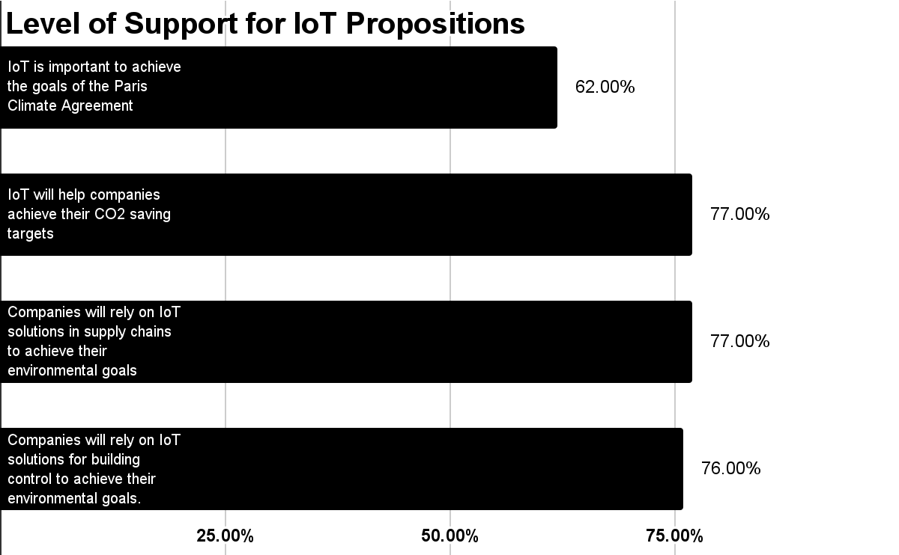
Figure XX: Survey responses from poll of Deutsche Telekom internal experts about IoT and sustainability expectations (2020)

3.1 Example Applications of IoT in Enabling Sustainability
IoT applications hold great potential to enable decarbonization which is set to drive a fundamental transition in several industry sectors. Another area where IoT will have a major sustainability impact is in resource and energy efficiency solutions by making processes leaner and helping organizations to raise the performance threshold for resource conservation. There are numerous use cases that underpin this idea.

An example that demonstrates gains in operational efficiency and resource management involves the Spanish firm Hidroconta which manufactures water meters and irrigation systems. These meters are used by facility management companies and agricultural enterprises. Before they were enabled with IoT capabilities, Hidroconta employees would take meter readings on-site. The time-consuming process meant that agricultural companies lacked the transparency needed to optimize the water supply to their plantations and to organize it more sustainably. Working with Deutsche Telekom, Hidroconta developed IoT-enabled smart meters using Narrow Band IoT (NB-IoT) technology to transfer encrypted, water consumption data at regular intervals to a connected cloud platform. Agricultural enterprises can now access data in the cloud platform at any time from anywhere. They can also specify individual irrigation times remotely and thereby regulate water supply efficiently.

Energy consumption in buildings is one of the top three contributors to GHGs. IoT can play a significant role in embedding sustainability capabilities to create smart buildings. An example of this involves ISS, a global company for technical facility management, catering, cleaning, security, and support with over 480,000 employees. Working with Deutsche Telekom, ISS wanted to provide more transparency around comfort parameters and space utilization in order to conserve resources and reduce costs. Their smart building solution features intelligent sensors to monitor CO2 levels, temperature, humidity, light, noise and building usage. This solution lowers energy consumption, saves resources, lowers costs and increases customer comfort.

Data and Resource Sharing for Smart Regions

Many smart city applications rely on IoT technologies for services that make better use of transport and road-network resources and improve economic efficiency. When combined with an open standards approach, city authorities and transport agencies can share common infrastructure and explore new operating models such as cooperation across boundaries to facilitate commuter journeys and manage traffic at large events.

oneTRANSPORT is a data marketplace service that was initially piloted across four counties in the UK. It used a standards-based platform to source data from over 200 types of data sources such as road traffic sensors, parking occupancy sensors and number-plate recognition systems.
Four counties and the national transport agency shared data, using controllable policies, with specialists in journey-planning data analytics, facilities managers, and AI researchers. Some of the operational benefits included:

- Implementation of a park-and-ride scheme for visitors to the historic university town of Oxford.

- Improvement in road safety and congestion management in Watford town centre when 20,000 additional visitors would travel on Premier League match days.
- Improved site visibility and management of traffic at the Silverstone racetrack during the Formula 1 race weekend. Over this period, over 250,000 visitor trips are made to the event venue. This calls for coordination of temporary road diversions between the private sector and three neighbouring county agencies.

In addition to the benefits of sourcing IoT data and enabling cross-organizational collaboration, this scenario and the three, application use-cases illustrate the benefits of standardization for re-use, scalability, and data interoperability.

Orange is contributing to a European research project, involving 15 partners including the major sea ports of Bordeaux and Thessaloniki. The objective of the project is to define a scientific and technical solution for measuring the environmental impact of commercial harbours, and to identify solutions to reduce their footprint. The solution has been deployed in 4 harbours: Bordeaux, Monfalcone, Thessalonique, Le Pirée. Thanks to IoT sensors and pollution indicators, facilities managers can analyse logistics flows and optimize the organization of harbour activities to reduce pollution.

Circular economy concepts will play an increasingly important role in the coming decades. These will put pressure on linear economy models, based on the take, make, dispose sequence. New strategies will focus on approaches that design for no waste, that use products for as long as possible and which preserve or enhance the value of renewable resources. Such measures will contribute to reductions in energy consumption and increases in the efficiency of resource use, alongside improvements in material efficiency in industry due to innovations. Advanced digital and communication technologies with enhanced connectivity make it possible to optimize operational efficiencies using digital twin technologies on an IoT data platform.

Principles for Sustainable Design

Three factors can have an impact on sustainable IoT systems. The first deals with investment in IoT systems and encourages reuse and sharing by multiple users. It is also an approach that minimizes the risk of ‘orphan’ investments. The second involves the application of principles that promote sustainability by design and where standardization can have a material impact. At the implementation level, the third factor applies to the emerging solutions and technologies that improve sustainability performance. Individually, many of these might have a marginal impact. However, their impact can be considerable when applied together and at scale.

4.1. Think Horizontal to Maximize Reuse and Longevity

There are several common elements to most IoT systems. These include the functions associated with registering device and application identities, for example. Others include remote device management, communications management, and security. Designers should avoid developing IoT applications in isolation and consider how to reuse or share common service functions. This is generally achieved through the use of IoT platforms that contain frequently used developer tools. This approach ensures that multiple users can share a set of common resources and leverage the economies of scale associated with shared platforms and platform-developer expertise.

Smart buildings and cities, which are shared spaces used by multiple user groups, are relevant examples of where this model can be of practical value. These are environments that house multiple IoT applications. There are also dependencies between applications and user groups, between short-term decisions driven by the pace of technology evolution and constraints on the built environment where assets might be designed to last fifty to a hundred years.

In practice, it is a big challenge to engage with smart cities across all the application areas at once, linking areas which have historically been independent silos. Nevertheless, this is a scenario that calls for ‘horizontal thinking’.

Most cities with any track record in this field will have started their smart city journey via a single application, often motivated by a technology-driven means to reduce operating costs. Smart parking, dynamic street lighting and intelligent waste collection are three such examples. The next phase of the smart city journey is typically to build additional applications that leverage early-stage investments. Smart lighting installations, for example, can support environmental monitoring, public safety, and traffic management applications through the addition of sensors and the application of pattern recognition techniques.

Problems may arise when these early commitments begin to limit the ability of a city to improve, innovate and expand its portfolio. This is the dilemma of vertical, single-purpose, fast-to-market strategies that function as silos. With the passing of time, they demand significant new investment in redesign and system integration efforts to avoid becoming ‘orphan’ investments.

When city authorities launch vertical initiatives to address local issues, they should plan for the future where individual applications must scale vertically (e.g., adding more districts to a smart street lighting system) and evolve horizontally. Consider the example of traffic monitoring sensors for a congestion management application. In time, the traffic-related infrastructure could accommodate environmental and other sensors, implying a high potential for re-use at the hardware and communications layers. Furthermore, integration into city planning tools (for housing, green areas, siting of hospitals and aged care centres) can improve citizen health and safeguard wellness in the future. This is where a horizontal design approach from the outset can have long term sustainability impacts by maximizing reuse and fostering the longevity of deployed assets.

4.2. Principles for Designing Sustainability
In addition to using IoT systems to enable applications that have a sustainability impact, it is also important to encourage developers and service providers to design systems based on sustainability principles. These include design for interoperability, scalability, modularity, and re-use.
Interoperability manifests itself in many ways. One example involves the ability to interchange computing and device components from different suppliers. Another example, higher up the IoT solution stack, allows for the exchange of data across application and operational silos. Each of these interoperability facets can benefit from standardization. This is because standardization creates a pathway to scalability, through economies of scale from a large and dynamic supplier base.
Modularity in system and software design helps designers to combine sub-systems. As a design principle, it helps developers to build IoT systems that combine new capabilities with legacy systems. This preserves some value of deployed systems without foreshortening their useful service lives. This is also an aspect of the ‘re-use’ principle. The aim here is to create solutions and sub-systems that other developers can employ to save time and improve their productivity.
The early experience of sustainability in the corporate arena highlights the importance of agreed frameworks and common reporting standards. Examples include the UN’s SDGs, the GRI business reporting framework and new initiatives to guide the investor community on corporate sustainability. These principles are equally applicable for the technology and IoT markets, where early support for standardization at the device and connectivity layers is beginning to extend to data (standards data models), data-sharing (semantic interoperability and data licensing) and data-privacy management topics.

Introduction to the oneM2M standard
In 2012, a group of national standardization bodies launched oneM2M to create a global standard for IoT systems. The solution to widespread adoption and affordability of IoT systems relies on minimizing industry fragmentation from local and national approaches. There was an emphasis on defining a general-purpose framework, or a horizontal architecture, that would be applicable to multiple application verticals. This required an analysis of multiple use-cases, spanning several different vertical domains, to identify commonalities for standardization.
oneM2M employs a three-layer architecture, comprising a middleware capability that resides between an upper, IoT application layer, and a lower layer for devices and connectivity technologies. The middleware comprises a family of common service functions in the form of a toolkit that developers can draw upon, as needed, for their deployment requirements.
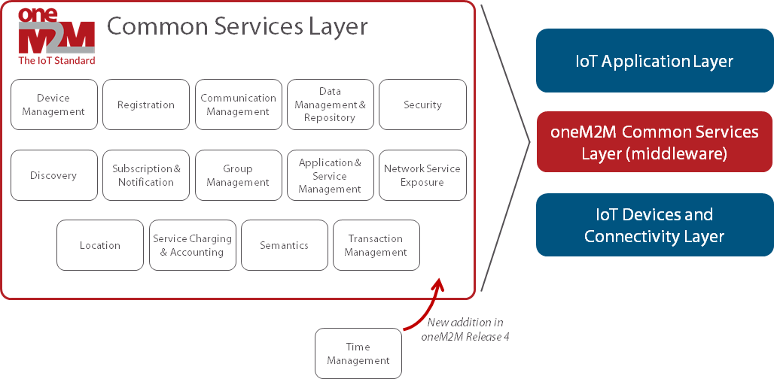
oneM2M is a continuous standardization body that operates to a release cycle (Release 4 shortly to be launched and work is underway on Release 5 features). As a result, the list of common service functions has expanded over time. It now numbers fourteen items with a fifteenth - Time Management - that will be included in Release 4 of the standard.

4.3 Application of Sustainable Technologies
In the past, much discussion focused on efficient hardware designs to improve the energy performance and service life of constrained, IoT devices. In contrast to smartphones that are charged on an almost daily basis, some IoT devices are expected to survive in remote locations for as many as ten years. However, if devices remain connected to the network during times when there are no IoT applications interested in communicating with these devices, then this results in non-optimal consumption of device resources (e.g., battery) and network resources. Likewise, if applications repeatedly poll devices when these devices have no new information to share or the devices are sleeping and not connected to the network, then this also results in non-optimal consumption of device resources (e.g., battery) and network resources. As a result, there is a need for a new set of operational procedures and related technologies. ‘Sleep modes’ are one such method for gathering and sending data without a device needing to be constantly switched on or continuously polling the network. This has a major impact on energy efficiency but requires an agreed handshake between device and network combined with software intelligence to optimize connectivity and data transmission.
If communications between networks and devices can be coordinated, then it is possible to design for energy conservation. In the case of IoT applications operating over cellular networks, 3GPP standards define a northbound API for exposing underlying cellular network functionality to configure ‘sleep mode’ timers for devices. oneM2M has its API for interworking with 3GPP networks which translates 3GPP data structures into a format that IoT developers can use as part of their IoT toolkit. They can therefore define sleep schedules in the context of their application requirements.

In more complex and multiple device scenarios, oneM2M can aggregate and align schedules of devices and the different applications needing to communicate with these devices. This ensures that IoT devices connect to the network at the optimal times to send and receive data from network applications. The complementary nature of 3GPP and oneM2M standards extends the idea of managing networks responsibly as encouraged by the GSMA through its IoT connectivity guidelines to ‘do no harm’ to mobile networks.

Sustainability for IoT devices means the capability to remotely manage IoT devices and for some of them in a long service life to minimize their obsolescence. In this idea, standardisation can be a powerful tool to specify the procedures to re-purpose devices by updating their software with backward compatible enhancements. From a security perspective, oneM2M is making the security protection remotely upgradable by design with features like firmware update that is essential to face new threat surfaces. Keeping security up to date will reduce the pollution created by “things” that become obsolete.
The deployment of IoT applications in operational environments generally involves enhancements to existing assets. This may take the form of retrofitting connectivity technologies to enable data capture and remote actuation. It might also involve capturing data from legacy equipment or sub-systems that may employ proprietary or industry-specific protocols. Examples are the use of OPC-UA for industrial control systems and the OCF framework in smart home appliances.
When new (greenfield) and legacy (brownfield) components are being combined, one approach is to customize integration points. This is not ideal when done on a case-by-case basis. A scalable and general-purpose approach involves the use of interworking standards that support data exchanges between subsystems. This principle is enshrined in the cross-domain hub model that is fundamental to the oneM2M standard as illustrated in Fig YY.

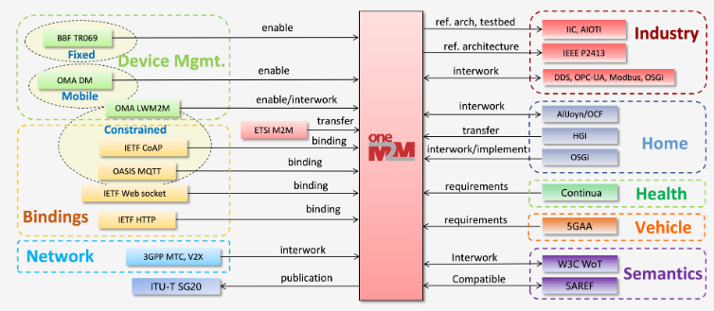

Future Directions

With increasing familiarity about their capabilities, application developers and entrepreneurs will use IoT technologies to capture new sustainability benefits. The family of IoT technologies will, however, continue to evolve in many different directions. Some of these will tackle hardware issues, as in the case of low-energy and ‘non-smart’ devices. Other ideas, drawn from ‘circular economy’ concepts involve re-purposing long service-life devices via programmatic technologies. Others will involve technologies to reduce network energy usage and to protect IoT systems so that their operations remain resilient.

At Orange, research teams are working on the design of the concept of ‘no-energy’ connected objects. These self-powered objects rely on renewable sources of energy and communicate by recycling ambient waves. They are detectable by wireless networks and smartphones in their vicinity.
An experimental project involves the concept of a Crowd-Detectable Zero-Energy-Device (ZED). Such a device harvests solar or ambient light energy to power itself, recycles ambient signals to communicate, and is detectable by a smartphone and the network as soon as it gets close to a smartphone. A transport company attaching a ZED on a package can track it with almost nothing: zero power, zero new signal and zero new network infrastructure, thanks to the anonymous participation of smartphones. Indeed, each time the packet comes across a smartphone connected to the network, the package is automatically detected, located and time-stamped by the network. Prototypes of ZED(s) that reuse ambient TV/4G/5G signals already exist and have been recently demonstrated at the 2021 mobile world congress [1][2].
Beyond innovations around self-powered devices, Orange is pursuing other research on optimizing network energy consumption. One approach that is being tested deals with the practice of using double antennas to double a device’s bandwidth capacity. With the new approach, an object sends two messages with one amplifier and one antenna. It sends the first in the usual way but sends the second without sending anything more information. Instead, it reconfigures the radiation mode of its antenna. Each mode carries a “meaning” in bits.
IoT is a term that is often associated with connected objects that send and receive data. Another way to think of these objects is as resources that can be used to infer and generate contextual information about the environment. Some of this can take the form of static and dynamic environmental data for parameters such as identity, activity context, behavioural context, physiological context, geographical context, and time context. These are inputs for research projects on context identification by deduction, using IoT types of data related to pressure, temperature, humidity, sound, colour, light, electromagnetic field, angular position, and angular speed. These types of data are useful for merging the physical and digital aspects of everyday environments. Integration gives rise to new areas of ubiquitous, sensitive, and environmental computing as well as new forms of interface between applications and users.

Deep integration involving IT (information technology), OT (operational technology) and ET (engineering technology) data from diverse data sources, both from Plant layer (real time data) and from Enterprise layer (transactional data) allows for remote monitoring and management. However, common data model compliant interfaces, ensuring the definition comply with data model standards in terms of semantics, syntax and relationship becomes vital.
Cybersecure interoperability is an important characteristic for a sustainable architecture, one that is scalable, modular, reusable and securely performing. Typical IT-OT convergence results in multiple applications connecting to multiple silos of data sources. In such cases a common services framework shall help in a sustainable architecture, both in terms of quality and economics. Security is also a concern because of the potential for IOT systems to expose new threat services. Left unprotected, vulnerabilities could be exploited in ways that would waste resources.

Resources

6.1 Reading List

- Sustainability Done Sustainably
- Digital Impact and Sustainability Report 2019/20 (bt.com)
- Climate Protection by the IoT (iot.telekom.com)
- Achieving Climate Targets via the IoT (telekom.com)
- People & Planet 2020 (Nokia)
- The 4th Industrial Revolution and the Municipal CEO

6.2 Contributors

Please insert contributor information. Currently arranged alphabetically by Company name

Klaus GROBE, Senior Director of Sustainability, ADVA
Dale SEED, Principal Engineer, Convida Wireless
Ariane FUCHS, Marketing Manager, Deutsche Telekom IoT
Ken FIGUEREDO, Advisor, More-with-Mobile
Marianne MOHALI, IoT Standardization Manager, Orange
Shveta BHARDWAJ, Strategic Consultant, Tata Consultancy Services
Anand SAMPATHARAMAN, Tata Consultancy Services

