INPUT CONTRIBUTION
Group Name:* | ARC-WG
Title:* | Open M2M Architecture
Source:* | Korea Electronics Technology Institute (KETI)
Contact: | Jaeho Kim  Sungchan Choi  Jungwuk Seo  Jaesuk Yun
Date:* | 2013-04-05
Abstract:* | Proposal to open M2M Architecture for supporting Resource registration and discovery globally and providing P2P direct communication
Agenda Item:* | To be defined
Work item(s): | M2M Architecture
Document(s)  Impacted* | Technical Specification - M2M Architecture
Intended purpose of  document:* | Decision  Discussion  Information  Other <specify>
Decision requested or recommendation:* | It is proposed to discuss the rationale of the submitted suggestions and to adopt the conclusions into the TS on Functional Architecture: paragraphs 2.3 and 2.4 of this contribution into the sections 4.1, 4.2, 4.3 and 4.4 of the TS and paragraph 3.2 of this contribution into the section 4.3 of the TS.
oneM2M IPR STATEMENT
Participation in, or attendance at, any activity of oneM2M, constitutes acceptance of and agreement to be bound by all provisions of IPR policy of the admitting Partner Type 1 and permission that all communications and statements, oral or written, or other information disclosed or presented, and any translation or derivative thereof, may without compensation, and to the extent such participant or attendee may legally and freely grant such copyright rights, be distributed, published, and posted on oneM2M’s web site, in whole or in part, on a non-exclusive basis by oneM2M or oneM2M Partners Type 1 or their licensees or assignees, or as oneM2M SC directs.

1 Introduction
In this draft, we present an open M2M architecture special pring Resource registration and discovery in global scale (hhere, Resource means any one f device or, application but, resource cn be any one of, service, content, or conext in future etc.). In addition, this architecture offers machine-to-machine (peer-to-peer) direct direct data communication wherr domain is not in charge of relaying data is neen two machines but it is used for searching resources. The architecture is shown in Figure 1.
In open M2M architecture, Virtual Resource Domainopenhigh- archosed ofcompriseurce Directory, Topicry, and pplication Repository, and Resource Interaction Layer. Resource Df resource registration and dispic Directory eables each resource to be managed as a topic-based manner (for example, topic-based access control and rresource registration & discovery and toccess control). AAppplication Repository provides a function of application registration and discovery procss.
Physical Resource Domainur openM pcal Rrenc cture model is composed o rce Server, Resource Gateway, and Resource End-Point. Each Resource End-Point is can connected to either Rece Gateway or Resource Server according to its communication resource capability. And both Resource ServerServer, asource Gateway, and Re-Point have a binding list and a Resource DB. Prence Domain interacts with Virtuhable M2M Resource Domain throueraction LayerDomain.
property of o2M architEach Rese Gateway, and Resour End-Point has a Resource DB which haveincludeskeeping resource datainformation oofconnected to lower Resource Der Resource DB in Resourc esource data of Ressource End-Point which are connected to it.Through this distributed Resource DB, each reference domain manageresources (reicith previously, methodn manages resource data of connected sensor or actuator.
Each user or machine application canesses resource datas throuh Resourceion LayerDomTo access a resour data, user or machine applications searces a resource in Resource Directory , or TopicDitory, or App Directory. And through resolutiodin and Reraction DoLay or machineapplicatdo not need to not care about urce is, in ant a care about where the ercedirectly ory.
In open M2M architecture, there are two types of communication method to access resource data. In the indirect method, users or machine application can (access)the reource data viathrough re Server or Resource Gateway. In contrast, in the direct method, it can connect (he resorce through a direct peer-to-peer2p connecti.

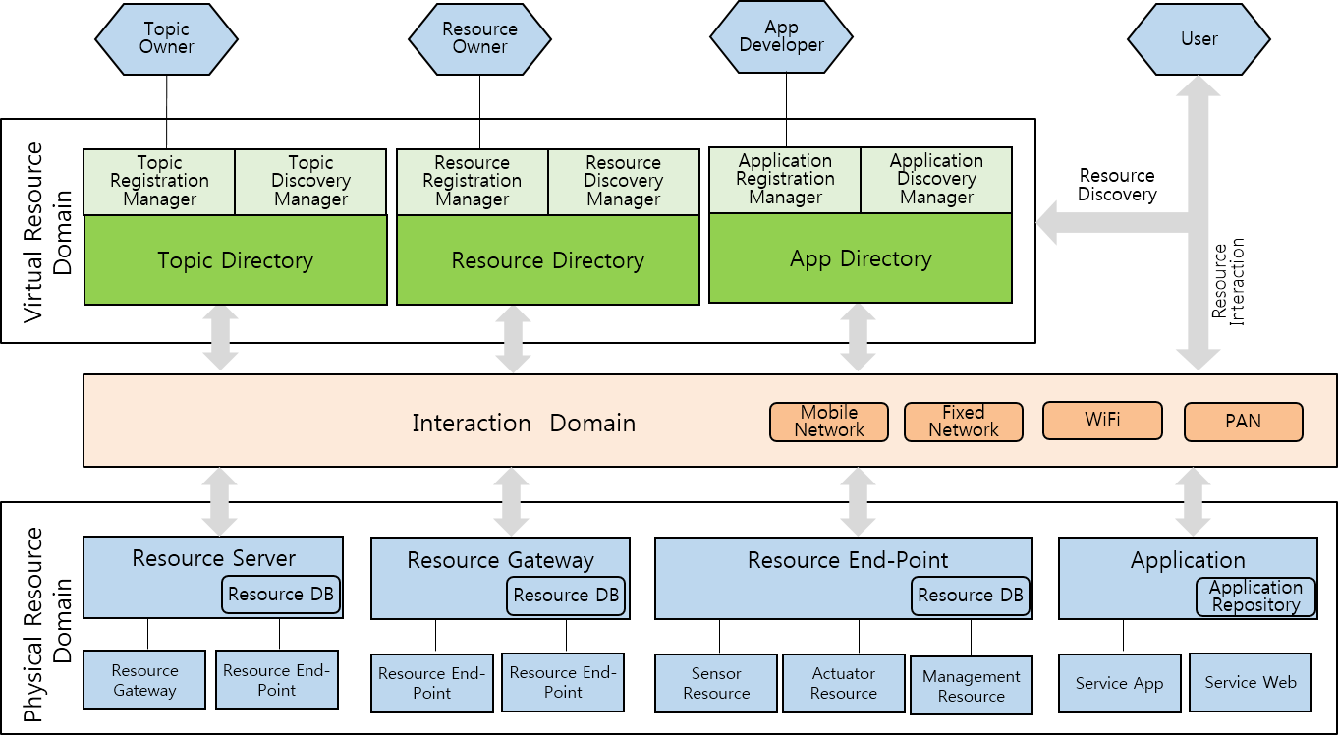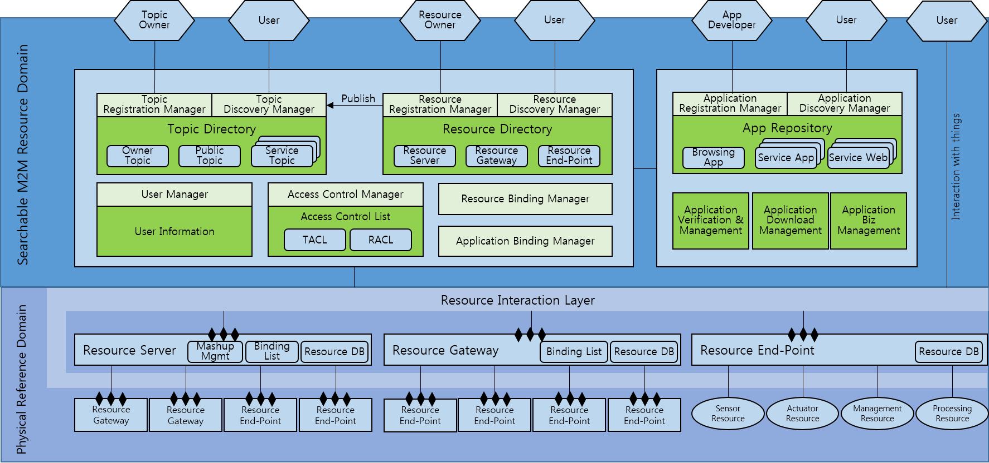
Figure 1

2 Open M2M Architecture
In this paragraph, we will describe features of our opeM architecture start by g
2.1 Virtual Resource Domain
Open M2M architecture provides a process of archatede registration and discovery in a global scale through Virtual Searchable M2M Resou

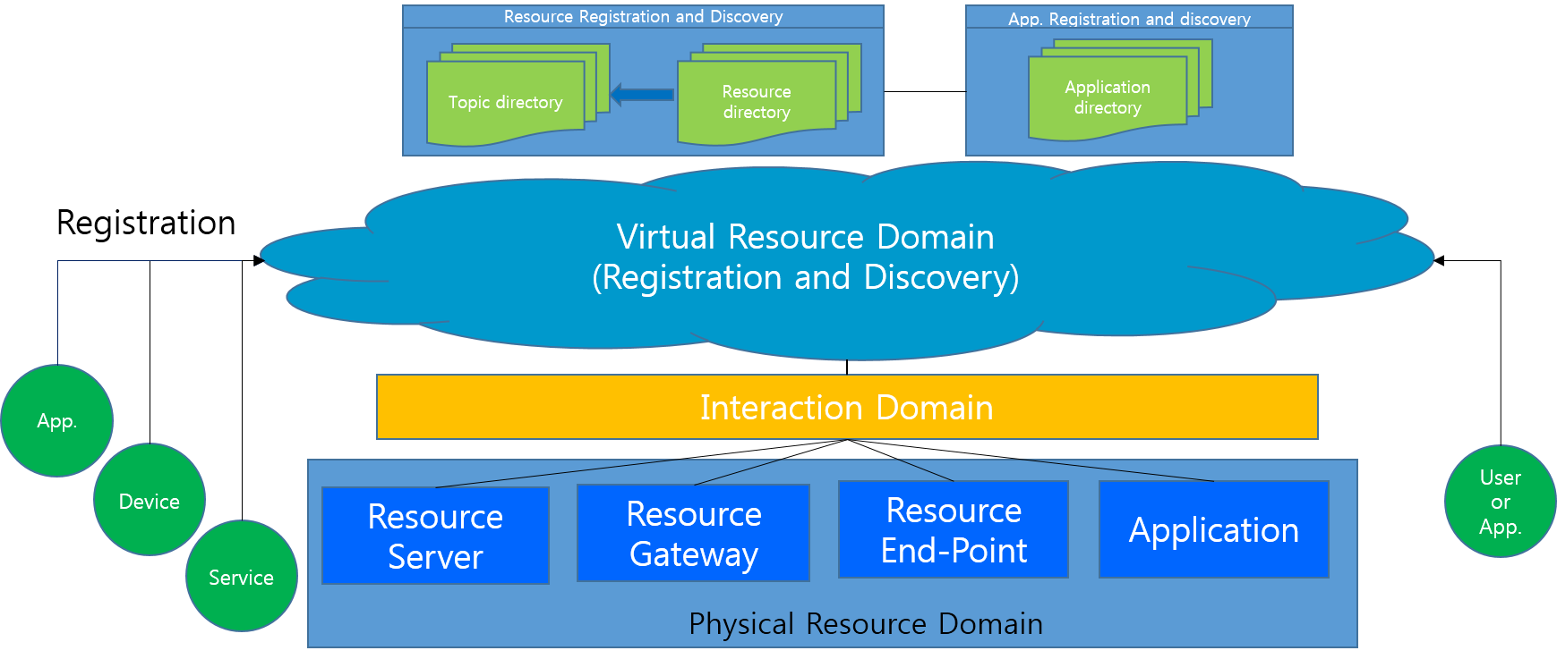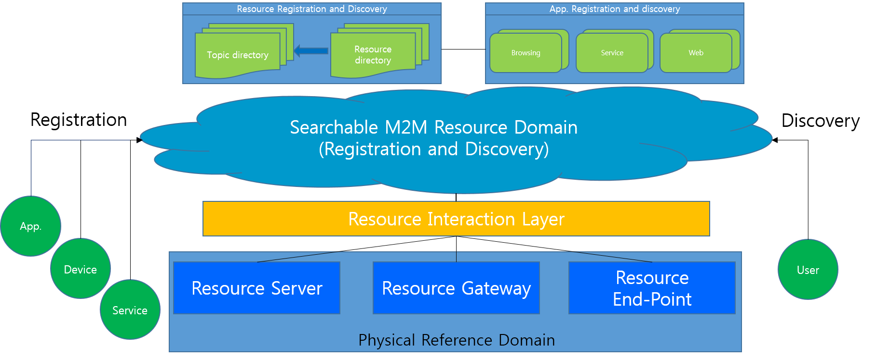
Figure 2

- Virtual Resource Domain is composed of Resource registration & discovery part spacAppliction registration space & dis part.
- Resource registration & discovery part epace is composed of Topic directory and Resource directory.
- Application registration & discovery part is comprised of Application Directory and manager.
- Each resource or application is registered in Virtual Resource Domain, and these resources need to be searchable in global scale.
- Physical Resource Domainais composed of Resource server, Resource gateway, and Resource eEnd-pPoint. ser o Applications can access eah resource data through Resource InterayerDomain afterching resource in Virtual Resource DomainSearchable M2M R

2.2 Topic-based Access Control and Resource Registration & Discovery
This paragraph describes a topic-based resource access control and a topic-based resource registration & discovery in open M2M architecture. This service resides in Resource Registration and Discovery part and interacts with Resource Directory.
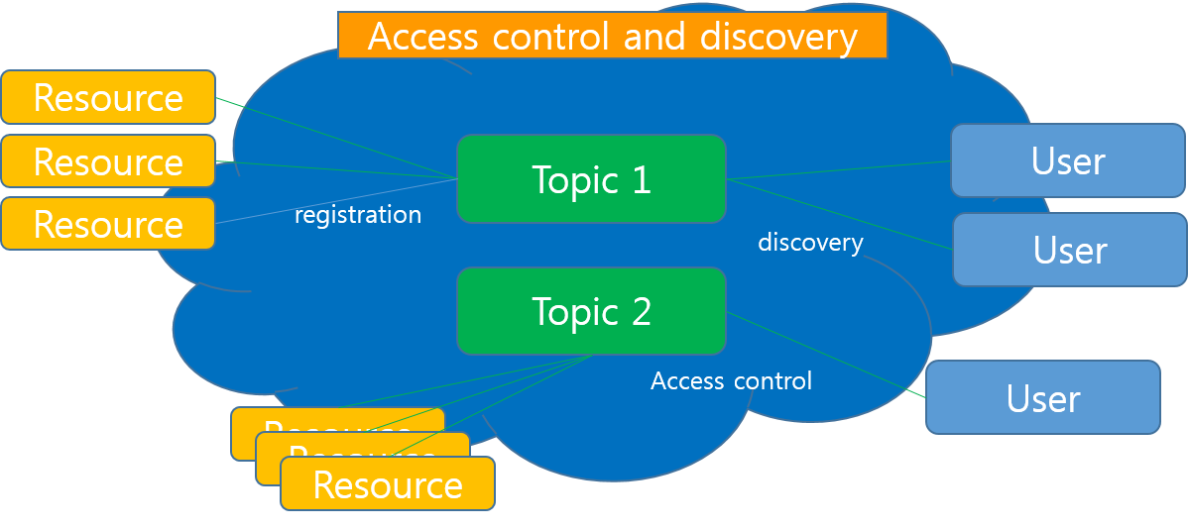
Figure 3

- User or application can search resources associated with a topic based on a opic category-based service (
- User or application can register resources to a topic category-based service.
- Through a topic category-based access controlm eagistee’s access policyanily. (we can eal to each registered resource related towith the topic.
- Topic Directory interacts with Resource Directory

2.3 Supporting P2P iCommuncation for M2M devices
- provides the contact pointpoource that om u. After user searches tsearching ahe resource in the resurce spacuser can actualy to the resource directly as in the form of a p2ion manner.

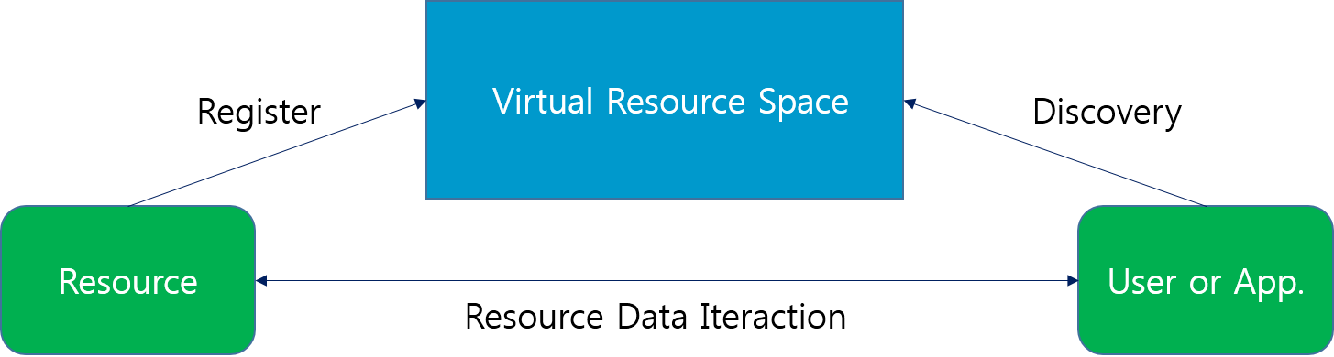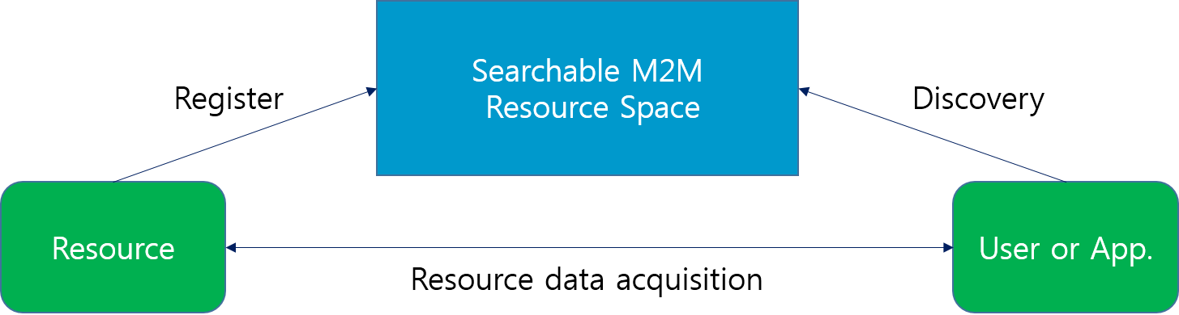
Figure 4
- Virtual Resource Domain provides the point of contact to the resource data that a user or an application requests.
- After searching a resource in the Virtual Resource Domain, a user or an application can connect to the resource to get resource data directly in a point-to-point communication.

2.4 The Structure of M2M Resource DBmanagement
This section describes hierarchicResource DataBf Resoun open M Architecture.

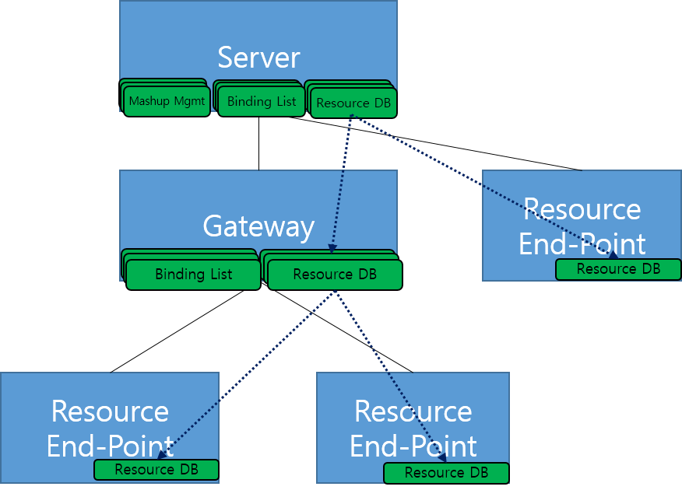
Figure 5

- Resource Server, Resource Gateway, and Resource End-Point have a Resource DB.has a resource information or connected pointer to lower Resource DB. Through this distributed Resource DB, each reference domain manages only lower resources

- Resource Server manages resource data of Resource Gateway or Resource End-Point which are connected to it.
- Resource Gateway manages resource data of Resource End-Points connected to it.
- Resource End-point manages resource data of connected sensor or actuator.

