Work Item
Work Item Title: | Effective IoT Communication to Protect 3GPP Networks
Document Number | WI-00XX
Supporting Members or Partner type 2 | Deutsche Telekom, QualComm, BT, Convida, AT&T, Orange, TIM, Nokia, Hansung University
Date: | 2019-12-02
Abstract: | This Work Item is intended to produce a specification that describes how a oneM2M service layer hosted on a 3GPP Cellular IoT device ensures that the device operates in an efficient manner that applies the requirements described by GSMA TS.34.

oneM2M Copyright statement
No part may be reproduced except as authorized by written permission.
The copyright and the foregoing restriction extend to reproduction in all media.
All rights reserved.

1 Title (Acronym)
Effective IoT Communication to Protect 3GPP Networks (EICP-3GPP)

2 Justification
The oneM2M WI-0037 Interworking with 3GPP Rel-13-15 MTC features (see oneM2M TR-0024) was the basis to initiate consideration of 3GPP TS 23.682 architecture interworking with oneM2M. WI-0058 further addresses 3GPP progress on low power wide area (LPWA) technologies for the Cellular IoT network. This WI will cover explicit operating procedures for oneM2M nodes hosted on Cellular IoT devices.

The GSM Association has created guidelines for efficient IoT device connectivity is GSMA TS.34. The oneM2M standard is well suited to implementing all the relevant recommendations described in GSMA TS34. In this WI we will describe the GSMA guidelines and provide one or more descriptions of oneM2M standard-based solutions that fulfill those GSMA requirements.
For example, as shown in this figure, the GSMA TS.34 architecture is well aligned with the oneM2M architecture.

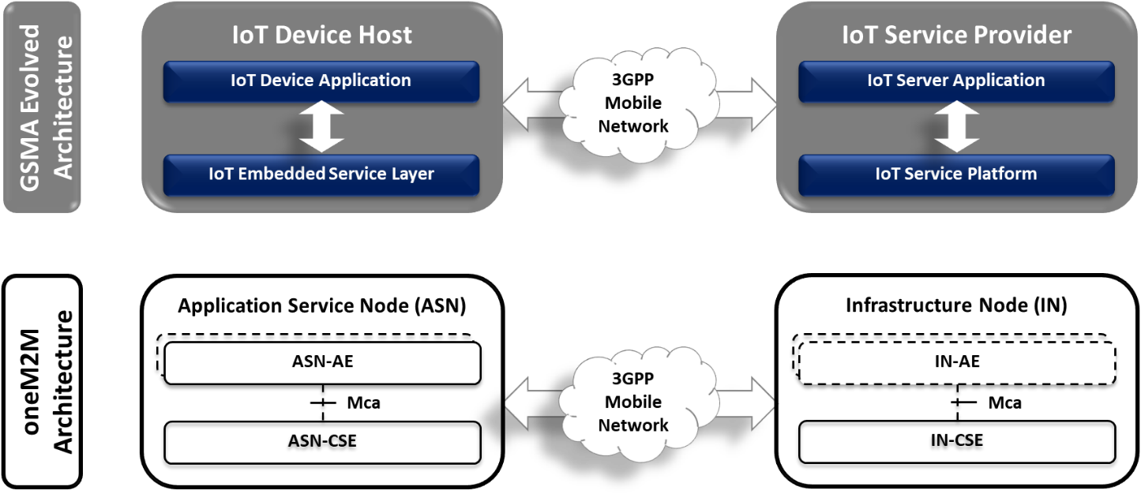
Figure 1 - Evolved GSMA Architecture compared to oneM2M Architecture
Furthermore, GSMA TS.34 has organized the recommended requirements into categories that align with specific IoT Service Platform capabilities (oneM2M capabilities) as well as device capabilities (device management) and Mobile Network Capabilities (TS-0026 oneM2M interworking with 3GPP).
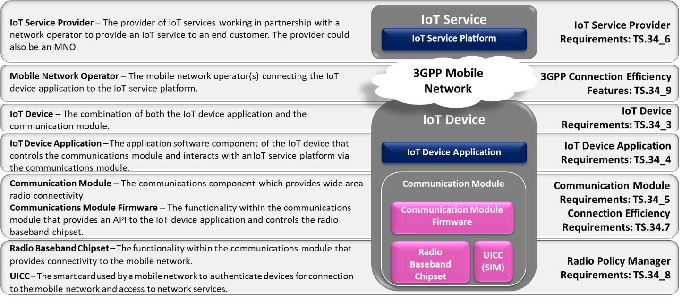

3 Intended Output
Tick all the appropriate cases

X | Change request(s) to existing Technical Specification(s)
X | Change request(s) to existing Technical Reports(s)
 | New Normative Technical Specifications(s)
X | New Permanent Technical Reports(s)
 | New Temporary Technical Reports(s)

4 Impact

4.1 oneM2M Work Items
None

5 Scope
The objective of this work item is to study the GSMA TS.34 requirements and describe how the requirements can be implemented using oneM2M services.
A new Technical Report (TR-00xx) will be generated. If there are gaps in the oneM2M services, solutions to address those gaps will be proposed via STEs of current services.
Depending on this TR, Change Requests to following specifications may be needed:
- Technical Specification TS-0001 on Functional Architecture
- Technical Specification TS-0004 on Service Layer Core Protocol
- Technical Specification TS-0003 on Security
- Technical Specification TS-0026 on 3GPP Interworking
- Technical Specification TS-0025 on Product Profiles
Also, CRs to the following technical reports are expected:
- The Technical Report TR-0024 on 3GPP Interworking
- The Technical Report TR-0047 on developer’s guide of 3GPP interworking

6 Schedule and impacted specifications

New Specifications (if any)
Document  Type | Document  Number* | Title | Schedule (TP No.) |  |  |  | Lead WG | Impacted WGs | Comments
 |  |  | Start | Change Control | Freeze | Approval
TR | TR-00XX | Efficient Communication Using 3GPP Networks | TP#43 | n/a | TP#46 | TP#47 | WG2 | WG3
* Optional for first versions (i.e. before it will be assigned by the secretariat)

CRs to existing specifications (if any)
Impacted  TS/TR | CR number (when known) | Subject of the CR | Approved at plenary# | Impacted WGs | Comments
TS-0001 |  | Enhancements to TS-0001 | TP#47 | WG2
TS-0004 |  | Enhancements to TS-0004 | TP#47 | WG2
TS-0003 |  | Enhancements to TS-0003 | TP#47 | WG2
TR-0047 |  | Enhancements to TR-0047 | TP#47 | WG3
TR-0024 |  | Enhancements to TR-0024 | TP#47 | WG2
TS-0025 |  | Enhancements to TS-0025 | TP#47 | WG3

7 Work Item Rapporteur(s)
rapporteurs: Bob Flynn (Convida)

8 History
Document history
V0.0.1 | 2 December 2019 | Initial proposal
 | 5 December 2019 | Updated proposal additional supporting companies and new WI title
 |  | Uploaded as a permanent document following approval of TP-2019-0xxx

-------------------------------

oneM2M is a trademark of the Partners Type 1 of oneM2M

