Invitation  
to  
oneM2M TP 68 and Stakeholders Day conference

to be held

10 – 14 February 2025

in the IIT Research & Innovation Park, IIT Delhi, New Delhi, Delhi, India

**Dear Sir/Madam**,

Greetings from TSDSI!

Telecommunications Standards Development Society, India (TSDSI) is pleased to invite you to New Delhi for the oneM2M TP#68 and Stakeholders Day.

You are also invited to attend the [oneM2M Stakeholders Day](https://tsdsi.in/event/onem2m-stakeholders-day-24-feb-2023-delhi-india/) on February 12, 2025.

|  |  |
| --- | --- |
| **Meeting Location** | **oneM2M Meeting Contact** |
| [IIT](https://www.ihg.com/holidayinn/hotels/us/en/new-delhi/delap/hoteldetail) Research & Innovation Park,  IIT Delhi Campus  Hauz Khas, New Delhi 110016 | Vijay Madan  (Advisor and Mentor- Services and Solutions  +91 9212 10 46 56  [vijay.madan@tsdsi.in](mailto:vijay.madan@tsdsi.in)  Akash Malik  (Engineer – Standards)  +91 9871 29 60 23  [akash@tsdsi.in](mailto:akash@tsdsi.in) |

|  |  |  |
| --- | --- | --- |
| **Meeting Schedule** | | |
| Monday, Feb 10, 2025 | TP 68 | 09:00 to 17:30 |
| Tuesday, Feb 11, 2025 | TP 68 | 09:00 to 17:30 |
| Wednesday, Feb 12, 2025 | Stakeholders’ Day | 09:00 to 18:00 |
| Thursday, Feb 13, 2025 | TP 68 | 09:00 to 17:30 |
| Friday, Feb 14, 2025 | TP 68 | 09:00 to 17:30 |

|  |
| --- |
| **IMPORTANT NOTE** |
| **ALL DELEGATES attending the meetings should complete the form on the** [**TSDSI Registration/Visa Support Portal**](https://visasupport.in/onem2m-meeting/)**, preferably by 14th December 2024, regardless of whether or not they require the visa support letter. This will help us better prepare and assist you for the purpose of the meetings.**  **For any queries related to registation, visa support, or logistics please email [oneM2M_TP68_support@tsdsi.in](mailto:oneM2M_TP68_support@tsdsi.in) with the subject line “oneM2M TP 68 Support”** |

Please register for the meeting on the oneM2M portal (<http://Member.oneM2M.org>) if you intend to be on site, login to the portal, go to the Meeting tab and click on the “R” for registration next to the TP 68 meeting

If you do not already have a oneM2M portal account please apply by going to the oneM2M portal: <http://Member.oneM2M.org> and request a username and password using the link on the bottom left of the home page ([Get login ID](http://member.onem2m.org/Application/Administration/updatePerson/?personId=-1&requestMember=true&adminMode=false)).

Please note that this is a ‘hybrid’ meeting, and dial-in facilities will be available at certain times throughout the week.

More information about the meeting, accommodation and logistics is provided in the **ANNEX A**.

I look forward to seeing you in Delhi, India!

Yours sincerely,

**Sd/-**

**Kuljit Singh**

**Executive Director, TSDSI**

ANNEX A

Useful Information for the meeting

### **Invitation letter**

All delegates attending the meetings should complete the form on the [TSDSI Registration/Visa Support Portal](https://visasupport.in/onem2m-meeting/), regardless of whether or not they require the visa support letter, latest by 14th December 2024. This will help us better prepare and assist you for the purpose of the meetings.

### **Accommodation**

1. TSDSI recommends [Jaypee Vasant Continental Hotel, New Delhi](https://www.jaypeehotels.com/hotel/jaypee-vasant-continental-new-delhi?utm_source=glopss&utm_medium=affiliate&utm_campaign=campaign&utm_source=glopss&utm_medium=affiliate&utm_campaign=campaign) for the stay, as it is within close proximity to the meeting venue.
2. TSDSI/host has negotiated a discounted tariff for oneM2M delegates and a limited block of rooms are reserved with the discounted tariff from February 09 – 16, 2025. The room tariff includes complimentary BREAKFAST, and INTERNET. The limited no. of rooms with the discounted tariff are available till the **cutoff date - 15th December 2024**. TSDSI encourages the participants to make their hotel reservation before the cutoff date.
3. The Hotel reservation details are mentioned in the table below.

|  |  |
| --- | --- |
| **Hotel:** | [Jaypee Vasant Continental Hotel, New Delhi](https://www.jaypeehotels.com/hotel/jaypee-vasant-continental-new-delhi?utm_source=glopss&utm_medium=affiliate&utm_campaign=campaign&utm_source=glopss&utm_medium=affiliate&utm_campaign=campaign)  Basant Lok, Vasant Vihar, New Delhi, Delhi 110057 |
| **Reservations:** | For making reservations, kindly fill the reservation form in Annex B and send it via email to: [kartikg@jaypeehotels.com](mailto:kartikg@jaypeehotels.com); cc: [anupam.sinha@tsdsi.in](mailto:anupam.sinha@tsdsi.in); [akash@tsdsi.in](mailto:akash@tsdsi.in)  Please identify yourself as a member of the “**TSDSI - oneM2M TP#68 2025**” in your email subject line to avail the discounted room tariff rates.  **Hotel Contact Person**  **Mr. Kartik Gera**  Sr. Manager – Corporate Sales  E:  [kartikg@jaypeehotels.com](mailto:kartikg@jaypeehotels.com), |
| **Room Rate:** | |  |  |  |  | | --- | --- | --- | --- | | **Room Tariff per Day (in INR)** | | | | | **Room Category** | **Single** | **Double** | **TAXEs** | | Deluxe Room | INR 13,500 | INR 14,000 | As Applicable |   Tax: 18% extra on room tariff (present tax rates, may change) |
| **Remarks:** | * Complimentary Breakfast * Complimentary Wi-Fi access * Check-in time is 14:00 hrs on arrival day; Check-out is 12:00 hrs on departure day. Early check-in/late check-out will be given subject to availability. * Payment Mode: The payment shall be made through the online link to be provided by the Hotel after Delegate’s email request for the hotel reservation. * Room Cancellation There are no cancellation charges, if Room booking is cancelled up to Jan.09, 2025. Cancellation after Jan.09, 2025, shall be charged for the full-length hotel stay booked. * All hotel reservation must be made prior to **15th December 2024, the cut-off date.** * TSDSI will not be responsible for reservation confirmations, cancelled / modified reservations, or no-shows. |

### **Local Transport**

### **Nearest Airport**

1. Indira Gandhi International Airport – Terminal 3 **(IGI Airport T3)** is 13 KM from the Hotel Jaypee Vasant Continental and 16 KM from IIT Delhi (meeting venue).
2. The airport is served by several international carriers and is operational throughout. Please refer to <https://www.newdelhiairport.in/>.
3. The airport is served by [Car Rental Services](https://www.newdelhiairport.in/to-and-from-airport-details?cabs) (WTI, Carzonrent) to be booked on arrival at the airport, by Radio taxis (Meru Cabs, Mega Cabs), and by app aggregators (Uber Cabs and Ola Cabs) outside the terminal.

**ROUTE MAP: From Airport to Hotel**

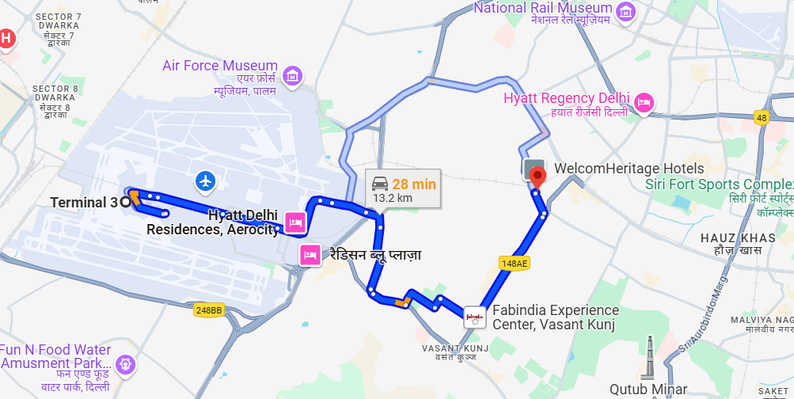

**Meeting Venue**

1. For information on getting to the venue, please refer below -

* Venue: [IIT Delhi Research & Innovation Park](https://fitt-iitd.in/web/sciencepark)
* Address: IIT Delhi Campus, Hauz Khas, New Delhi, Delhi 110016
* Venue google map: <https://goo.gl/maps/CXi7BBXQUbdmHARKA>

1. The meeting venue, i.e. Research & Innovation Park, IIT Delhi is 10 minutes’ drive from the Hotel Jaypee Vasant Continental Hotel.
2. IIT Delhi is also directly connected with the Jaypee Vasant Continental Hotel via Delhi Metro Magenta Line.

|  |  |
| --- | --- |
| **A map with a blue line  Description automatically generatedBy Car** | **A map of a city with a route  Description automatically generatedBy Delhi Metro (DMRC)** |

### **Meeting facilities**

1. Meeting room access Times:

* Morning opening: 09:00
* Evening closing: 18:00

1. Registration: Monday morning at 09:00
2. Free WLAN access will be provided.
3. Paper copies of documents will not be provided.

### **Catering**

Complimentary Coffee/Tea with cookies and Lunch will be served during the meetings in the venue.

### **Wireless LAN & Electricity**

Please be sure you have the correct adapter. Voltage converters will not be provided at the meeting. India's A/C supply is 230V-50Hz. The plug is a "Type D." The image below is a visual representation of the adapter you will need if your equipment does not have the correct plug.



### **Miscellaneous**

* **Currency & Exchange:** The Indian currency is Indian Rupee (code INR).
* **Climate:** <https://www.accuweather.com/en/in/delhi/202396/weather-forecast/202396>
* **Time Zone:** Indian Standard Time (IST) GMT +5:30
* Delhi, the vibrant capital of India, is a city steeped in history and brimming with cultural significance. Known for its seamless blend of the ancient and the modern, Delhi offers a unique journey through time with iconic landmarks like the Red Fort, India Gate, and Qutub Minar. The city also houses India's seat of government and is a major hub for commerce, politics, and innovation. February in Delhi brings mild, pleasant weather with daytime temperatures averaging around 20°C, making it ideal for sightseeing and outdoor activities. From the bustling bazaars of Chandni Chowk to the serene Lotus Temple, Delhi offers a rich tapestry of experiences, offering every visitor a chance to explore India's heritage and dynamic present.

Annex – B

**HOTEL RESERVATION FORM**

|  |
| --- |
| **JAYPEE VASANT CONTINENTAL HOTEL RESERVATION FORM**  **FILL THIS FORM - AND EMAIL YOUR REQUEST TO:** [kartikg@jaypeehotels.com](mailto:kartikg@jaypeehotels.com), cc to [anupam.sinha@tsdsi.in](mailto:anupam.sinha@tsdsi.in); [akash@tsdsi.in](mailto:akash@tsdsi.in) (Please mention TSDSI-oneM2M TP#68 2025 in your email subject line) |
| **oneM2M TP#68 Meeting**  **February 10 - 14, 2025**  **New Delhi, India**   |

**\**Please email this form directly to the above-mentioned email ID.***

***\*Please note the room type & discounted tariff will be available only till the cutoff date – 15th December 2024***

|  |  |  |  |  |  |  |  |  |  |  |
| --- | --- | --- | --- | --- | --- | --- | --- | --- | --- | --- |
| **COMPLETE DETAILS IN FULL (ALL FIELDS MANDATORY)** | | | | | | | | | | |
| **Salutation:** | | | | | | | | | |  |
| **First Name:** | | | | | **Middle Name:** | | | | |  |
| **Last Name:** | | | | | | | | | |  |
| **Contact. No. (with country code):** | | | | | | **Email:** | | | | |
| **ACCOMPANYING PERSON (if any)** | | | | | | | | | | |
| **Salutation:** | | | | | | | | | | |
| **First Name:** | | | | | | | | | | |
| **Last Name:** | | | | | | | | | | |
| **FLIGHT DETAILS (if available)** | | | | | | | | | | |
| **Hotel Check-In Date (DD/MM/YYYY):** | | | **Hotel Check-Out Date (DD/MM/YYYY):** | | | | | |  | |
| **Arrival Date:  (DD/MM/YY)** | | **Flight No:** | | | | | | **Time (HH:MM):** | | |
| **Departure Date:  (DD/MM/YY)** | | **Flight No:** | | | | | | **Time (HH:MM)** | | |
| Airport Pick-up required: | **YES/NO** | | |  | | | Airport Drop required: | | **YES/NO** | |
| **Room type** | **Room Rate** | | | | | | **No. of Rooms Nights Required (fill the number of below)** | | | | |
| Deluxe –Single | INR 13500+ taxes, per night, per room | | | | | |  | | | | |
| Deluxe –Double | INR 14000+ taxes, per night, per room | | | | | |  | | | | |

**JAYPEE VASANT CONTINENTAL HOTEL, NEW DELHI**

**Google Maps**: <https://maps.app.goo.gl/3wZCfJiB3zW3HQX7A>

Strategically located amidst the Diplomatic Enclave of New Delhi, Jaypee Vasant Continental is known for easy accessibility and the finest hospitality services. This deluxe edifice is situated 12 kms from International Airport and 3.2 kms from IIT Delhi Research & Innovation Park, which is the venue of the oneM2M TP 68 meeting.

**Room Inclusions:**

* Buffet Breakfast at designated area.
* Tea/Cofee maker in the room
* 2 bottles of mineral water per day.
* Complimentary Wi-Fi.
* Unlimited access to the swimming pool & gym.

**Terms and conditions**

* The standard check-in time is 1400 hrs on arrival day and the check-out time is 1200 hrs on departure day.
* Early check-in/late check-out is subject to availability and at an additional charge.
* Room extensions will depend on the hotel's availability for that day.
* All no-shows will be charged retention for the entire duration of the stay.
* Bed/Room/Floor preferences are subject to availability.
* Triple occupancy is not allowed.
* Any kind of damages done to the Hotel shall be borne by the guests at the time of check-out.
* The hotel reserves the right to change the rate should there be any change in the dates or room requirement.
* The above rates are exclusive of applicable taxes.
* All the guests staying in the room must provide valid government address proof at the time of check-in.
* Taxes as applicable would be charged extra as per the government policy.

**Reservation, Cancellation policy & No-show Policy**

* No retention charges for cancellationsbefore or on **January 09, 2025**.
* Any cancellation after 09th January 2025 will attract **100% retention** for the entire duration.
* Any **NO SHOW** will attract 100% retention for the entire duration of your stay.