|  |  |
| --- | --- |
| MINUTES | |
| Meeting: | TP 69 online & F2F |
| Chair:  Vice Chair: | Roland Hechwartner, Deutsche Telekom, ETSI  [roland.hechwartner@magenta.at](mailto:roland.hechwartner@magenta.at)  JaeSeung Song, Sejong University, ETSI |
| Secretary: | Karen Hughes, ETSI [karen.hughes@etsi.org](mailto:karen.hughes@etsi.org) |
| Meeting Date: | 2025-03-31 – 2025-04-04 |
| Meeting Details: | Hybrid meeting |
| Intended purpose of  document: | Decision  Discussion  Information  Other <specify> |
| Template Version:23 February 2015 (Do not modify) | |

oneM2M Notice

The document to which this cover statement is attached is submitted to oneM2M. Participation in, or attendance at, any activity of oneM2M, constitutes acceptance of and agreement to be bound by terms of the Working Procedures and the Partnership Agreement, including the Intellectual Property Rights (IPR) Principles Governing oneM2M Work found in Annex 1 of the Partnership Agreement.

1 Opening Plenary

* 1. Welcome

Roland Hechwartner, Deutsche Telekom, the TP Chair, opened the 69th oneM2M Technical Plenary. He thanked those present for attending in person and also those who have dialled in. He also introduced the TP leadership team and thanked KETI and ETRI for hosting this meeting on such a lovely island with such great facilities.

SeungMyeong welcomed everyone on behalf of KETI and ETRI and went through some logistical matters. There will be 2 social dinners during this week one hosted by KETI on Tuesday and on Thursday hosted by TTA.

Jun Seob Lee, ETRI, who is the Working Party 1 Chair introduced himself and explained that the first time he attended oneM2M was the very first TP meeting in Nice in 2012. He welcomed oneM2M to Jeju and was honoured to help host this meeting. He also explained that Kim Hyoung Jun, also from ETRI and the Chair of Study Group 20, will be attending this meeting from tomorrow onwards. Roland thanked him very much for co-hosting oneM2M and was delighted to have such a strong delegation from the ITU-T leadership.

He also advised the delegates to read the legal notices on the cover page of the agenda as well as the statement regarding engagement with companies added to the U.S Export Administration Regulations entity list in oneM2M activities. This may be found on the oneM2M external website: <http://www.onem2m.org/about-onem2m/intellectual-property-rights#EAR>.

* 1. Meeting logistics

**Schedule**

|  |  |  |
| --- | --- | --- |
| TP-2025-0018 | Weekly Schedule TP69 | Roland Hechwartner, TP Chair |

**TP-2025-0018 was NOTED**

Observers

One observer will join later in the week. They are from Juju national university and are already familiar with the oneM2M specifications.

**1.3 Meeting objectives**

**Release 5:**

* freeze of stage 2
* planning of stage 3
* review and update release 5 milestone plan.
* Updated WIs?

**Release 6:**

* Start of stage 1?
* New WIs?
* Discuss and agree on objectives including timeline (i.e. initial milestone plan) for release 6 (apply short development cycle?)

**Elections**

* RDM WG Chair position (1 nomination received)

**Future Meetings**

* Update on 2025 meetings
  + See also [TP-2024-0010R01](https://member.onem2m.org/Application/documentApp/documentinfo/?documentId=36825&fromList=Y) proposed meeting dates for 2025
* First draft of 2026 meeting schedule: see TP-2024-0088-Proposed_meeting_dates_for_2026

**Work Programme Management status:**

* <https://git.onem2m.org/technical-plenary/wpm>

1.4 Collaborations

ETSI: new TC Data (inc. TC SmartM2M)

ITU-T: initial discussion at the opening plenary and finalized during mid-week TP

2 Review & agreement of agenda

|  |  |  |
| --- | --- | --- |
| TP-2025-0021 | Agenda TP69 | Roland Hechwartner, TP Chair |

**TP-2025-0021 was NOTED**

**TP-2025-0021R01 was AGREED**

3 Review & agreement of previous minutes

|  |  |  |
| --- | --- | --- |
| TP-2025-0016R01 | Minutes TP68 | Karen Hughes, ETSI |

Agreed by correspondence

**TP-2025-0016R01 was AGREED**

4 Review of open action status

* Action: Karen to upload the updated WI as agreed in TP-2025-0001R01 – COMPLETED
  + Next steps: convert to Markdown and publish as a web page
* Action: Karen to upload this Release 4 Control Document as a permanent ADM document – ONGOING (waiting for clarification)
* Action: Roland to contact Cristina from the ITU-T to initiate this conversation - COMPLETED
* Action: Roland to ensure that the agenda is distributed in advance so that TSDSI can share with key stakeholders – ONGOING (discussions regarding ITU-T have taken place with TSDSI already)

5 Consideration of input documents / items for action at opening plenary

**Elections**

* RDM WG Chair position (1 nomination received)

There was one nomination received for this position. Roland thanked Massimo for volunteering to stand for a second term and there was strong support expressed by those present in the meeting.

Massimo Vanetti, SBS aisbl was therefore elected by acclamation for a 2nd term as the RDM WG Chair.

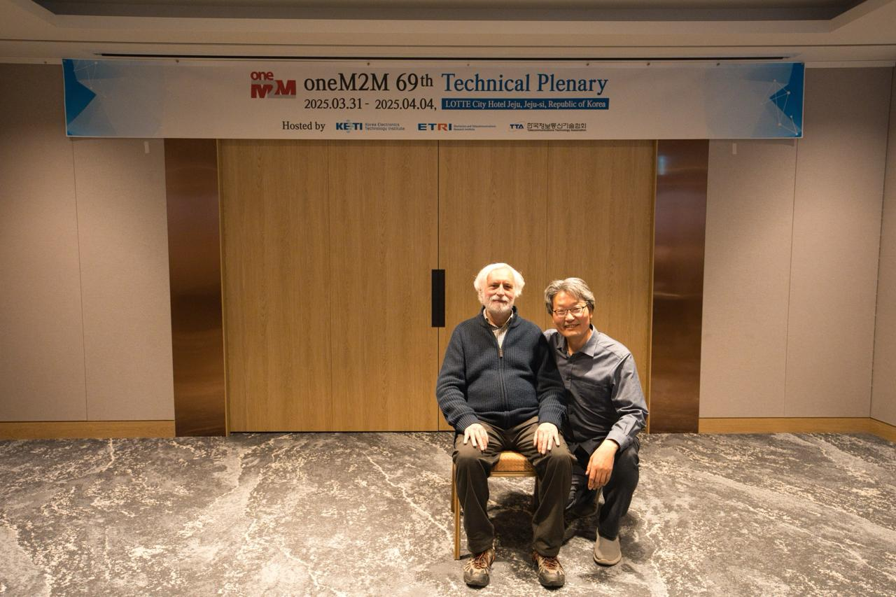

Massimo Vanetti from SBS aisbl, newly re-elected Chair of the RDM Working Group with Michael Kim, from TTA, Secretary of the group.

**Collaborations**

* ETSI: new TC Data

This new Technical Committee has incorporated the ETSI TC SmartM2M as well as ISG CIM amongst others.

More information will be available following the first meeting of this new TC in 2 weeks.

Roland presented the Terms of Reference for information. He pointed out that one interesting bullet point in this ToR is: *Supporting the transposition in ETIS of the outputs of oneM2M*.

Questions raised on how the exchange of information between TC Data and oneM2M on the NGSI LD interworking will continue. It was clarified that there should be no change in the working methods that are currently in place as TC Data will liaise with oneM2M in much the same way as ISG CIM did.

Some questions raised regarding how TSDSI, who are currently working on data models, can work together with TC Data and how can the information be used by other SDOs.

It was clarified that all deliverables from an ETSI Technical Committee are usually open and may be accessed via the ETSI website. The group itself is open to all ETSI members and if TSDSI has some specific interest, they should contact TC Data directly.

More concrete information will be available following the first meeting. JaeSeung will be attending the meeting and is willing to provide some feedback during the next TP meeting in Berlin.

Questions related to the timeline for TC Data work were also asked but unfortunately this is not something that oneM2M can answer. JaeSeung may be able to provide more information on this in Berlin.

5.1 New / updated Work Items

None

5.2 Liaison Statements

None

6 Any other business

|  |  |  |
| --- | --- | --- |
| TP-2025-0017 | Invitation to TP71 Sophia Antipolis France | Karen Hughes, ETSI |

Roland thanked ETSI for hosting oneM2M again in Sophia Antipolis in September.

**TP-2025-0017 was NOTED**

|  |  |  |
| --- | --- | --- |
| TP-2025-0020 | Invitation to TP70 Berlin Germany | Roland Hechwartner, Deutsche Telekom |

Delegates **must** register on the portal prior to the meeting, this is necessary in order to enter the building. If you have not registered in advance, it may take quite some time for you to be able to enter the building (this is important also for entry into the ETSI building in September).

For any local information, Ingo is happy to help the delegates to avoid some dodgy areas as he is based in Berlin (but not in a dodgy area). Note however that the hotels mentioned in the invitation are in safe areas.

**TP-2025-0020 was NOTED**

|  |  |  |
| --- | --- | --- |
| TP-2025-0019 | oneM2M_Releases-Definitions&Process | Roland Hechwartner, TPC (DT) |

**Clarifications:**

***Stage 1, Stage 2 & Stage 3***

* Stage 1 relates to the Requirements and Use Case specifications,
* Stage 2 relates to the Architecture specifications, and
* Stage 3 relates to the Protocols specifications

If some requirements from Stage 1 do not get through to Stage 2, a note may be added to the requirement to explain that it will be included in a future Release.

It was suggested that it may be necessary to the requirements for each Release to see which requirements have not been included in any Release.

***Changes to a ratified release***

* specifications are constantly evolving via the use of CRs, even after ratification
* the cover page of each CR mentions the exact version of the specification being addressed
* the CR is always written against the very latest version of the spec.
* the cover page also indicates whether this change is needed in earlier releases
* if agreed by the WG, mirror CRs will be prepared
* this should also be written against the very latest version of the spec in the earlier release.
* changes are limited to corrections (spelling, grammar, missing information)
* new features may not be retroactively applied to a release

Any Partner who wishes to publish the later versions of the specs may do so, it is up to the individual Partner to decide. There is no rule in oneM2M about this

***TDE WG specifications***

* the TDE WG deals with the oneM2M test specifications
* one set of specifications describe how tests are carried out
* others describe which features must be in the spec to fulfil certain requirements.
* test descriptions are release dependent and these are prepared later once the features and functionalities have been agreed

***CR vs CR pack***

* CR is prepared by a member company (or companies) and discussed by the WG
* once the CR is agreed it is added to the CR pack by the Chair and presented to TP
* TP approves the CR pack

***Partner publication prior to ratification***

* all versions of all oneM2M specifications are available to all Partners via the ftp: [ftp.onem2m.org - /Work Programme/](https://ftp.onem2m.org/Work%20Programme/)
* all latest versions are available via the website: [Published specifications](https://www.onem2m.org/technical/published-specifications)
* if a Partner (or Partners) wish to publish the specs before ratification, they may do so
* need to ensure that:
  + all references are correct and publicly available
  + there are no IPR or copyright issues
* normative references (for example to RFCs) may become obsolete over time so this could be a problem
* suggested adding a disclaimer to say that these references existed at the time of publication by oneM2M

**TP-2025-0019 was NOTED**

|  |  |  |
| --- | --- | --- |
| TP-2025-0022 | LS from oneM2M to ITU-T for adoption of oneM2M Rel 3 and Rel 4 Specifications | Asif, TSDSI |

TS-0024 – OCF was not continued in Rel-4 as the OCF has closed

TS-0013 – this is produced once interop events are being organised which is 2 years ago

TS-0015 – this is independent of the release

It was suggested that, in order to have a good idea of which specs could be brought to the ITU-T for adoption, each WG could go through their specs and decide which are obsolete (i.e. TS-0024) and document the status of each TS. SDS have agreed to do this during this meeting.

It was felt that the next TP meeting (TP 70 in June in Berlin) will be a good time to start preparing the liaison process with ITU-T. Their next meeting is in September.

**TP-2025-0022 was NOTED**

SeungMyeong suggested that an informal group photo should be taken to send to Bob so that he knows that we are all thinking of him and missing his presence, knowledge and humour at the meeting. There was strong support from everyone present – so here we are. This is for Bob!

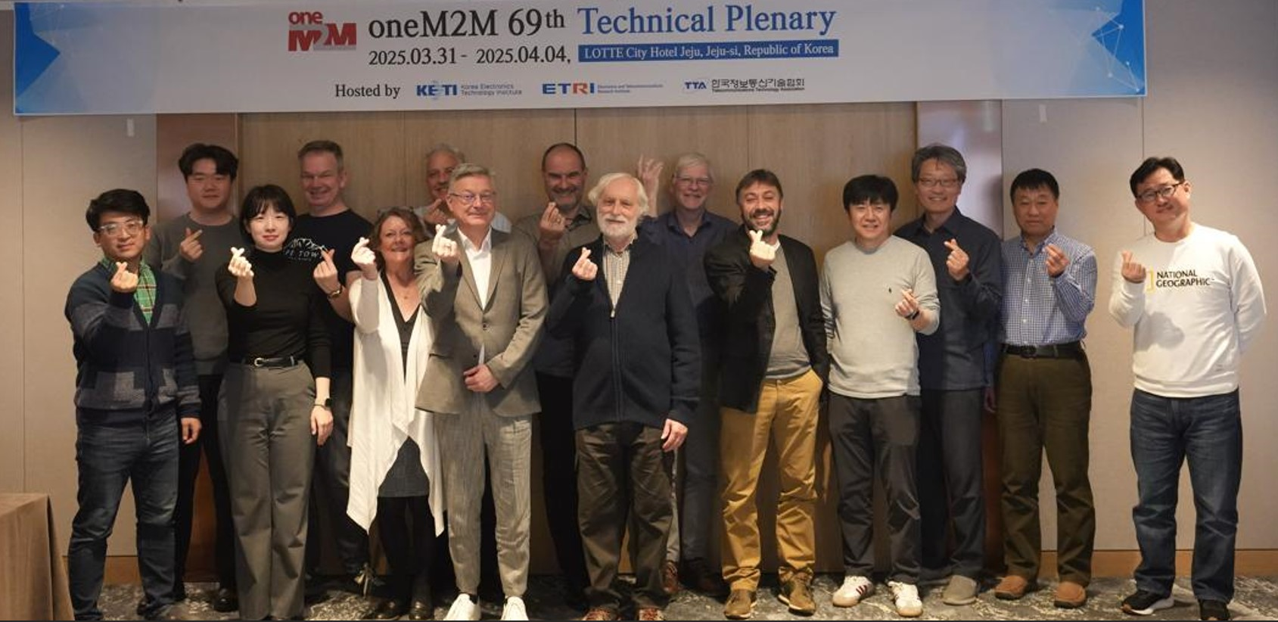

**== Recess ==**

7 Mid-week plenary

7.1 Welcome Back

8 Consideration of input documents / items for action at mid-week plenary

8.1 Collaborations

***STF-ESTIMED***

|  |  |  |
| --- | --- | --- |
| TP-2025-0023 | STF685-ESTIMED Status | Joachim Koss, ETSI STF685 Leader |

Questions raised on how this STF will look for Use Cases. It was clarified that the Use Cases and Requirements may be derived from existing MEC and oneM2M documents. This will be discussed further during the ISG MEC open session at the end of April

Identified several Use Cases for edge and fog computing. Previously these were not analysed in relation to MEC. Should end with software that may be deployed that will work

oneM2M agrees with the report from the STF

**TP-2025-0023 was NOTED**

***ITU-T***

|  |  |  |
| --- | --- | --- |
| TP-2025-0019R02 | oneM2M_Releases-Definitions&Process | Roland Hechwartner, TPC (DT) |

It was agreed that oneM2M needs to:

* agree the timeline for this activity
* agree the list of candidate deliverables
* prepare a Liaison Statement to be sent to the ITU-T
* find supporters within ITU-T, and most importantly,
* ensure we have enough resources to take on the work of preparing the TSs for submission

Roland has reached out to Cristina from the ITU-T and we have two people from ETRI highly placed in ITU-T and these people are happy to support oneM2M in this endeavour. Both Cristina and our ETRI colleagues are willing to participate in some interim online TP meetings to help with the preparation and logistics of what needs to be done by oneM2M.

It is understood that TSDSI have already had some contact with the ITU-T and there was a request that they share the email exchanges with oneM2M so that we are all on the same page with regards to the work to be carried out.

The understanding is that oneM2M will follow the same process as was followed previously. There has been no agreement from the ITU-T to simply reference the work of oneM2M.

The resources needed to carry out this work should be aware of the amount of work that needs to be done:

* every deliverable needs:
  + an A.25 as well as an A.1 (even those that are being revised)
  + a new work item proposal
  + to be checked for differences from the previously transposed version (using revision marks)
  + to be prepared, edited and revised according to questions raised from ITU-T
* The volunteers who are doing this work, should be available to attend each of the SG 20 meetings so that they can answer questions during the meetings
* In addition, each deliverable should have an input contribution from a member of the ITU-T which should quote the LS and be accompanied by the A.25 of the deliverable

It was agreed that volunteers to carry out the work are needed before any of this process can be started.

It was suggested that several TP interim meetings should be held between now and the next F2F TP meeting in Berlin in June. The ITU-T could be invited to exchange feedback and information. However, it was felt that thre is no point in doing this if we do not have the resources to do this work.

It was agreed that a decision will be taken during the closing TP as to if and when the process will be started.

**TP-2025-0019R02 was NOTED**

|  |  |  |
| --- | --- | --- |
| TP-2025-0022 | LS from oneM2M to ITU-T for adoption of oneM2M Rel3 & Rel4 Specifications | Asif, TSDSI |

It was pointed out that some of the documents referenced in the Control Document for Rel-4 are not available on the portal. The reason for this is that each Partner may have a different way of transposing them – i.e. updating the cover page, removing the history box etc. This will affect the final version number.

TSDSI requested that this final version should be made available by the TP secretary rather than having each Partner do the work. This would make it easier for the Partners.

**TP-2025-0022 was NOTED**

***GCF***

There are some LSs which were received by oneM2M from GCF, however no reply LS can be found. TSDSI requested copies of these replies.

(update 2025-04-04: Karen went through meeting minutes and email archives and then provided the answer to Asif (secretary of TDE WG) and advised him that if further resolution is needed, he should raise this issue during a TDE WG meeting.)

TSDSI informed oneM2M that they are looking into a central certification body within India and requested information on who has deployed oneM2M. It was explained that unless those who deploy using oneM2M inform us, we have no way of knowing this information.

JaeSeung, TP Vice Chair, and former TST WG Chair, explained how the certification programme was put in place and how it works:

* + the certification programme was designed based on ISO
  + the certification body designates test house (any test house should also follow ISO rules)
  + the certification body decides testing tools together with test house
  + oneM2M can help to validate testing tools via interoperability testing events, etc.
  + testing tools must use TTCN-3 test suites standardized and developed in oneM2M
  + because of conflict of interest Partner Type 1 shouldn't be a certification body.
    - Typically, 3rd party organization becomes a certification body such as GCF.
  + the test house should be able to carry out
    - interoperability testing
    - conformance testing
    - ensure that they use the valid testing tool
    - must use the test suite developed by oneM2M

He also explained that it is best to avoid any fragmentation of the certification programme.

It was clarified that initially TTA put in place a ‘verification programme’ with 'TTA Verified' logo not a certification programme.

Later TTA verified oneM2M program was migrated to GCF, and became the current GCF oneM2M certification programme.

9 Any other business

There was no other business to discuss so Roland thanked the participants and closed the meeting.

**== Recess ==**

10 Closing plenary

10.1 Welcome Back

Roland opened the meeting and welcomed everyone back. He introduced the agenda for this closing plenary.

11 Consideration of input documents / items for action at closing plenary

11.1 Collaborations

***ITU-T***

|  |  |  |
| --- | --- | --- |
| TP-2025-0029 | oneM2M liaison to ITU-T and follow up discussion 1.0.0 | Asif, TSDSI |

The LS mentioned in this was sent was prior to the ratification of Rel-3 and it was an introduction to the, at the time, current version of Rel-3. The control document refers to the ratified documents. The latest versions are the specifications which have been developed and updated following ratification

The number of resources needed to complete this is very high. There are more than 20 deliverables in each Release to be converted and so far, no volunteers have come forward to carry out the work. Focusing on Release 4 would be a more manageable workload however Release 3 is prevalent in India however as all the Rel-3 capabilities and features are still in Rel-4 which means that Rel-3 is compatible with the later Release.

Questions raised over the inclusion of TS-0013 which is not in the control document. The testing documents are ratified following the interop events. This single document was ratified following the ratification of the entire release. The control document is useful to inform which specifications are contained within a release. The testing documents always come after this. There is no Rel-4 testing specification yet as depends on the member companies who wish to be involved in the testing activities, they need to develop the product profile and bring contributions to the TDE WG. TS-007 and TS-0021 are no longer maintained.

Usually when a document is ratified it is early in the development. There is only one ratification per release but noting prevents the Partners from publishing later versions. As the specs are evolving constantly, it was felt that developers may prefer to go to the oneM2M website with the latest versions of the specs rather than going to the Partners website which may only have the older versions of the same specs.

It was suggested that the control document for Rel-3 should be updated and submitted to TP for agreement and the Partners should be encouraged to publish the lates Rel-3 version on their websites.

It was agreed to have an interim call in late April and invite Cristina from the ITU-T as well as Jun-Seob Lee and Hyoung Jun Kim from ETRI who will be able to give guidance on the work that needs to be done.

Need to make sure that there are volunteers to do this work once concrete steps have been defined for each spec. The next SG20 meeting in September will be attended by SeungMyeong. He will attend online only.

TP 69.1 will be a decision making meeting. Others will be invited to join. Cristina will be invited.

Action TP69-001: Karen to liaise with ETRI and Cristina from the ITU-T to find the best date and then send out the invitation to the TP list - COMPLETED

**TP-2025-0029 was NOTED**

***ISG MEC***

* joint meeting possibility in September – more details to be shared in June

11.2 Reports from Working Groups

Requirements & Domain Models – WG1

|  |  |  |
| --- | --- | --- |
| TP-2025-0027 | RDM_status_report_to_TP69 | RDM Chair |

**TP-2025-0027 was NOTED**

|  |  |  |
| --- | --- | --- |
| TP-2025-0024 | TP69_TS-0023_CR_Pack | RDM Chair |

**TP-2025-0024 was AGREED**

**CR Pack was approved**

|  |  |  |
| --- | --- | --- |
| TP-2025-0025R01 | TP69_TS-0011_CR_Pack | RDM Chair |

**TP-2025-0025R01 was AGREED**

**CR Pack was approved**

|  |  |  |
| --- | --- | --- |
| TP-2025-0026 | TP69_TR-0069_CR_Pack | RDM Chair |

**TP-2025-0026 was AGREED**

**CR Pack was approved**

System Design & Security – WG2

|  |  |  |
| --- | --- | --- |
| TP-2025-0028 | SDS Report to TP69 | SDS Chair |

**TP-2025-0028 was NOTED**

**TP-2025-2028R01 was NOTED**

|  |  |  |
| --- | --- | --- |
| TP-2025-0031 | TP69 TS 0001 CR Pack | SDS Chair |

**TP-2025-0031 was NOTED**

**TP-2025-0031R01 was AGREED**

**CR Pack was approved**

|  |  |  |
| --- | --- | --- |
| TP-2025-0032 | TP69 TS 0004 CR Pack | SDS Chair |

**TP-2025-0032 was AGREED**

**TP-2025-0032R01 was AGREED**

**CR Pack was approved**

Testing & Developers Ecosystem – WG3

|  |  |  |
| --- | --- | --- |
| TP-2025-0030 | TDE_status_report_to_TP69 | JaeSeung Song (Sejong Univ.) |

Roland thanked JaeSeung for standing in for Bob during his convalescence. He also mentioned how good it was to see Bob during his brief appearance at Friday’s TDE meeting.

Questions raised from TSDSI on whether or not there would be an interop event for Release 4? It was clarified that if there is enough interest from member companies, then an interop event can be organized. If there are at least 6 member companies willing to bring their implementations to such an event, then this would be sufficient to organize the event. These companies would need to bring input contributions to the testing specifications so that it can be updated for Rel-4/5.

**TP-2025-0030 was NOTED**

11.3 WPM

|  |  |  |
| --- | --- | --- |
| TP-2022-0111R08 | Release 4 Control Document | TPC |

It was felt that this would be a good start for the discussion for the TP 69.1 meeting towards the end of April.

**TP-2022-0111R08 was AGREED**

12 Review meeting objectives

**Release 5:**

* freeze of stage 2
* planning of stage 3
* review and update release 5 milestone plan.
* Updated WIs?

**Release 6:**

* Start of stage 1?
* New WIs?
* Discuss and agree on objectives including timeline (i.e. initial milestone plan) for release 6 (apply short development cycle?)

**Elections**

* RDM WG Chair position (1 nomination received)

**Future Meetings**

* Update on 2025 meetings
  + See also [TP-2024-0010R01](https://member.onem2m.org/Application/documentApp/documentinfo/?documentId=36825&fromList=Y) proposed meeting dates for 2025
* First draft of 2026 meeting schedule: see TP-2024-0088-Proposed_meeting_dates_for_2026

**Work Programme Management status:**

* <https://git.onem2m.org/technical-plenary/wpm>

It was reported that Volker from ETSI, will provide all the WPM updates from now on. This will be done on the Git. Roland thanked Volker very much for agreeing to take over this role. It was felt that this will be very advantageous for oneM2M.

Action TP69-002: Roland and Volker will align on the outcome of this week’s meeting and decide which documents will target Rel-5 and which will target Rel-6. This may be presented during the TP 69.1.

13 Next meetings

* TP 69.1 in April, virtual meeting.
  + Date confirmed: 30th April 2025
* TP 70 in June, hosted by Deutsche Telekom in Berlin, Germany (TP-2025-0020)
  + Strongly recommend that you register on the portal in advance
* TP 71 in September, hosted by ETSI in France (TP-2025-0017)
  + Strongly recommend that you register on the portal in advance
* TP 72 – decision on details of hosts and location expected at TP70. This meeting might be virtual only.
  + Negotiations ongoing to hold this meeting in Malaysia

14 Any other business

Technical Excellence Award: reminder that the nomination period is now open and will close on 18th June.

15 Closure of meeting

Roland thanked ETRI, KETI, TTA for hosting the meeting in this great location and for the great social events.

He closed the meeting and wished everyone present a safe trip home.