Input Contribution
Meeting ID* | TST18
Title:* | Re-arangement of clause 7 of TS0013
Source:* | Jiaxin Yin, Huawei Technologies Co., Ltd. , yinjiaxin@huawei.com
Uploaded Date:* | 2015-7-10
Document(s)  Impacted* | WI-0022, TS-0013
Intended purpose of  document:* | Decision  Discussion  Information  Other <specify>
Decision requested or recommendation:* | The contribution is about the rearrangement of clause 7 which is the configuration of interoperability testing.
Template Version:23 February 2015 (Dot not modify)

oneM2M Notice
The document to which this cover statement is attached is submitted to oneM2M. Participation in, or attendance at, any activity of oneM2M, constitutes acceptance of and agreement to be bound by terms of the Working Procedures and the Partnership Agreement, including the Intellectual Property Rights (IPR) Principles Governing oneM2M Work found in Annex 1 of the Partnership Agreement.

Introduction
The RESTful architecture follows a good Client-Server style. All request is delivered in the CS format. As a result, for interoperability testing, all request and response can be abstracted as compositions of client and server in different formats. The proposed contribution adds more configuration for the no hop case. And uses configuration of no hop case to form the other configuration in single hop and multihop.

-----------------------Start of change 1-------------------------------------------

7 Configuration

7.1 Test Configuration
    - No hop
      - CFG_NH_01
AE manages resources on registrar CSE (Hosting CSE). In this case, Registrar-CSE is the Hosting CSE of the addressed resource. The configuration is mapped to cases include:
- AE sends Create, Update, Retrieve, Delete requests to the Hosting CSE of the resource.
- The Hosting CSE sends Notify requests to AE.
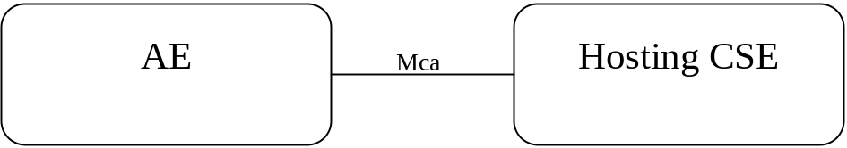

Figure 7.1.1.1-1: CFG_NH_01

      - CFG_NH_02
AE sends primitive to the Registrar-CSE. In this case, the Registrar-CSE is the Transit-CSE of the primitive. The configuration is mapped to cases include:
- AE sends Create, Update, Retrieve, Delete requests to its Registrar CSE. The Registrar CSE is not the Hosting CSE of the addressed resource that the Registrar CSE needs to further forward the request as a Transit CSE.
- The Registrar CSE is forwarding the Notify request to the AE.

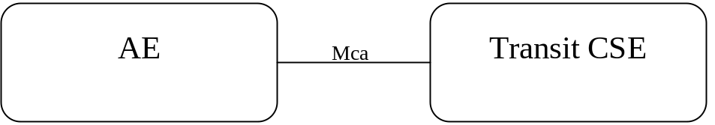

Figure 7.1.1.2-1: CFG_NH_02

      - CFG_NH_03
CSE sends primitive to the Registrar-CSE. In this case, the Registrar-CSE is the Hosting-CSE of the primitive. This configuration is mapped to cases include:
- CSE is the originator to address the resource hosted on its Registrar CSE. The request may be Create, Update, Retrieve, Delete or Notify.
- CSE acts as a Transit CSE to forward the request to the Hosting CSE of the address resource of the request. The request may be Create, Update, Retrieve, Delete or Notify.
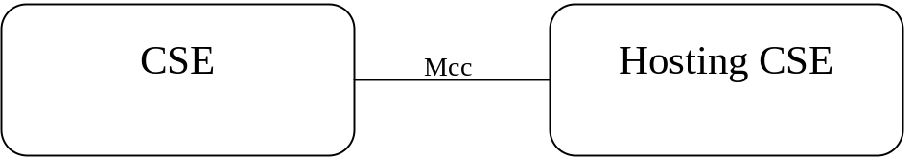

Figure 7.1.1.3-1: CFG_NH_03
      - CFG_NH_04
CSE sends primitive to the Registrar-CSE. In this case, the Registrar-CSE is the Transit-CSE of the primitive. This configuration is mapped to cases include:
- CSE is the originator to send request to its Registrar CSE which is not the host of the addressed resource. The request may be Create, Update, Retrieve, Delete or Notify.
- CSE acts as a Transit CSE to forward the request to its Registrar CSE which is not the host of the addressed resource. The request may be Create, Update, Retrieve, Delete or Notify.
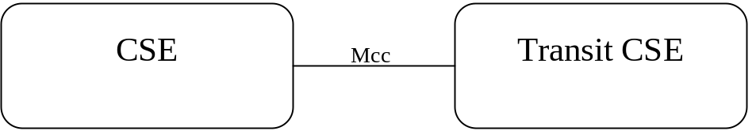

Figure 7.1.1.4-1: CFG_NH_04
      - CFG_NH_05
CSE sends primitive to the Registrar-CSE. In this case, the Registrar-CSE is the Transit-CSE of the primitive. This configuration is mapped to cases include:
- CSE acts as a Transit CSE to forward the request to its Registrar CSE which is not the host of the addressed resource. The request may be Create, Update, Retrieve, Delete or Notify.
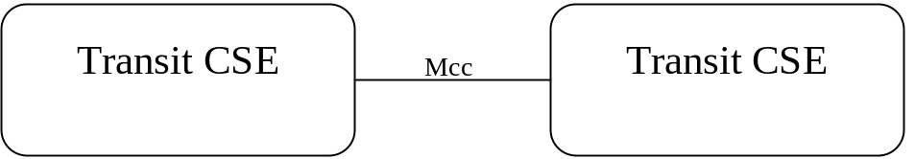

Figure 7.1.1.5-1: CFG_NH_05

    - Single hop
      - CFG_SH_01

CFG_SH_01 is the combination of CFG_NH_02 and CFG_NH_03 where the CSE in CFG_NH_03 is the Transit CSE in CFG_NH_02.
This configuration is mapped to cases include:
- AE is sending CRUD request to the Hosting CSE of the resource. The request is forwarded once by the Registrar CSE of the AE.
- Hosting CSE is sending Notify to AE. The request is forwarded once by the Registrar CSE of the AE.
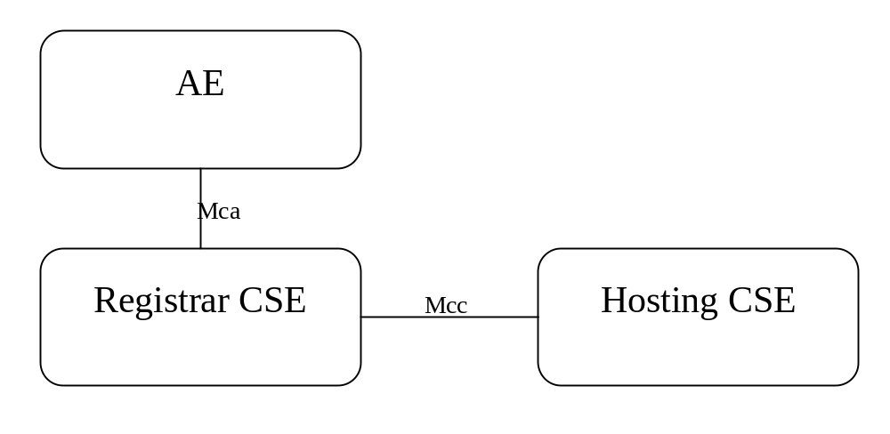

Figure 7.1.2.1-1: CFG_SH_01

      - CFG_SH_02

CFG_SH_02 is the combination of CFG_NH_04 and CFG_NH_03 where the CSE in CFG_NH_03 is the Transit CSE in CFG_NH_04. Note in this configuration, the CSE in CFG_NH_04 cannot be a Transit CSE.
This configuration is mapped to cases include:
- CSE is sending CRUD request to the Hosting CSE of the resource. The request is forwarded once by the Registrar CSE of the CSE.
- Hosting CSE is sending Notify to CSE. The request is forwarded once by the Registrar CSE of the AE.

. 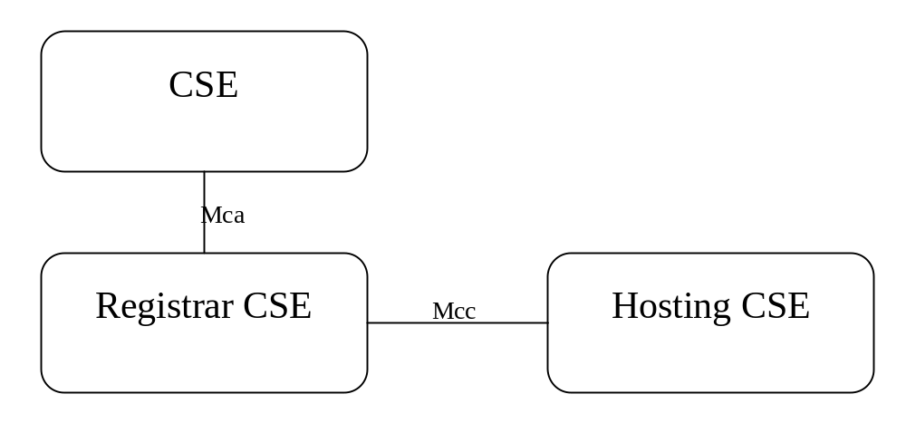

Figure 7.1.2.2-1: CFG_SH_02

    - Multi hops
      - CFG_MH_01
CFG_MH_01 is the combination of CFG_NH_05 and CFG_SH_01 where Registrar CSE in CFG_SH_01 is replaced by CFG_NH_05 multiple times.
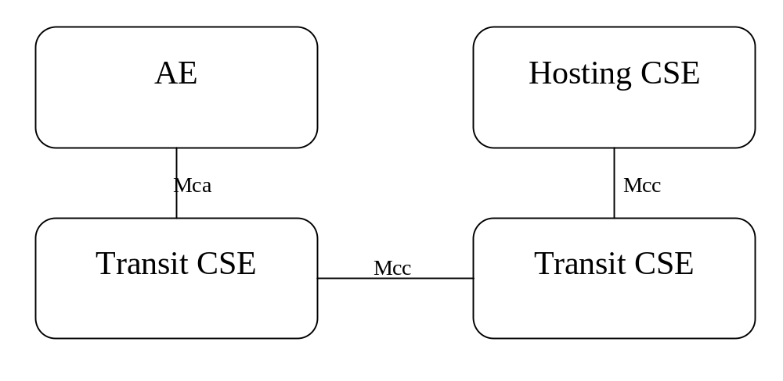

Figure 7.1.3.1-1: CFG_MH_01

      - CFG_MH_02
CFG_MH_02 is the combination of CFG_NH_05 and CFG_SH_02 where Registrar CSE in CFG_SH_02 is replaced by CFG_NH_05 multiple times.
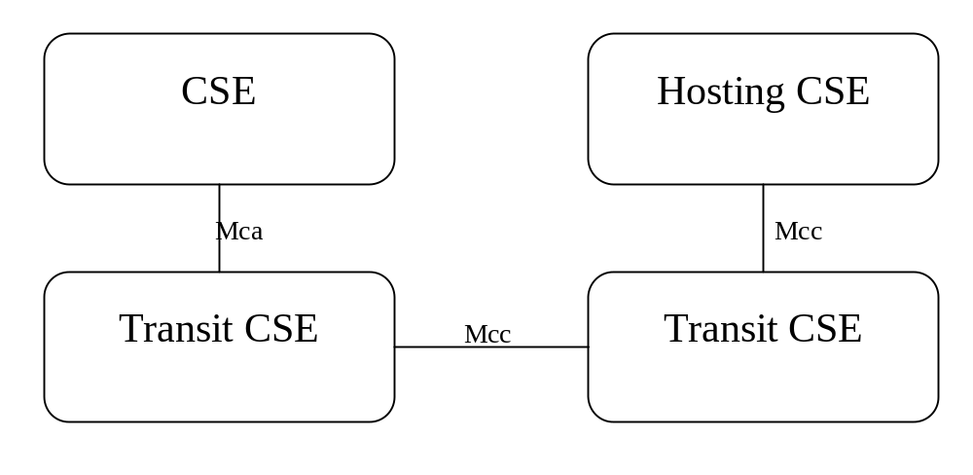

Figure 7.1.3.2-1: CFG_MH_02

7.2 Resources Request examples
In order to ease test setup and execution of the tests, some resource request example may be provided to the users.

-----------------------End of change 1--------------------------------------------

