Input Contribution
Meeting ID* | TST 19.0
Title:* | Developer Guide – Section 5 Usecase and Section 6 Architecture
Source:* | Ting Martin Miao, KETI (TTA) (novamartin@keti.re.kr)  Sung-Chan Choi (csc@keti.re.kr)  Minu Ryu (minu@keti.re.kr)  Jaseho Kim (jhkim@keti.re.kr)
Uploaded Date:* | 2015-09-01
Document(s)  Impacted* | TR-00XX
Intended purpose of  document:* | Decision  Discussion  Information  Other <specify>
Decision requested or recommendation:*
Template Version:23 February 2015 (Dot not modify)

oneM2M Notice
The document to which this cover statement is attached is submitted to oneM2M. Participation in, or attendance at, any activity of oneM2M, constitutes acceptance of and agreement to be bound by terms of the Working Procedures and the Partnership Agreement, including the Intellectual Property Rights (IPR) Principles Governing oneM2M Work found in Annex 1 of the Partnership Agreement.

- Introduction
This contribution proposes an use case with aims at facilitating application developers to develop applications using functionalities provided by an oneM2M service platform.

================ Start of 1st Part: Use case====================================

5 Use case

The current document proposes an use case of remote lights control with aims to provide a guidance for application developers to develop applications.

The current use case enables the remote control of lights via a smartphone or smart tab which embeds with an application that gains access to an oneM2M service platform. The overview of the use case of remote lights control are shown in Figure 5-1. The main components are introduced as follows:
- Light lamps shown in the current use case are deployed at a house and attached to a home gateway. The light lamps are able to interact with an oneM2M platform through a wireless access interface.
- The home gateway is configured to be able to search and connect light lamps into itself and to communicate with an oneM2M service platform in terms of exchanging and storing light lamps states between the light lamps and the oneM2M service platform.
- oneM2M
- service platform provides vertical application services targeted at different field domains, for instance, home, vehicle, and industry. The oneM2M service platform supports a group of common service functionalities such as registration, discovery, data managemet, group management, subscription/notification etc.
- The smartphone application is embedded into a smartphone and acts as a remote light controller with capabilities as the follows:
  - Discovert of light lamps deployed into the home gateway,
  - Sending commands to change light states i.e. on an off, and

  - Retrieval of light states.

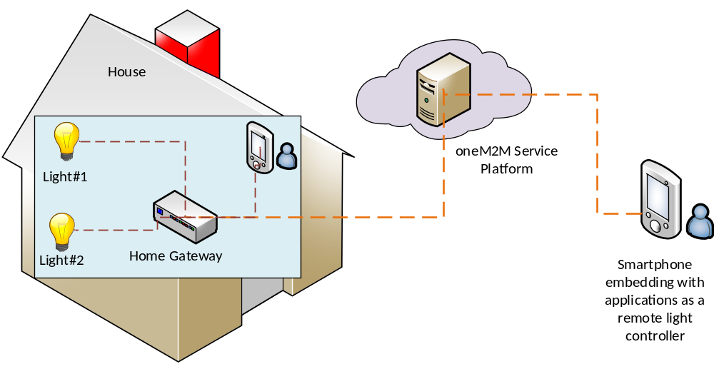
Figure 5-1 Overview of remote lights control use case

================ End of 1st Part: Use case================================
================ Start of 2nd Part: Architecture ============================

6 Architecture
The remote lights control use case shown in Figure 5-1 can be mapped into the oneM2M functional architecture depicted in Figure 6-1.

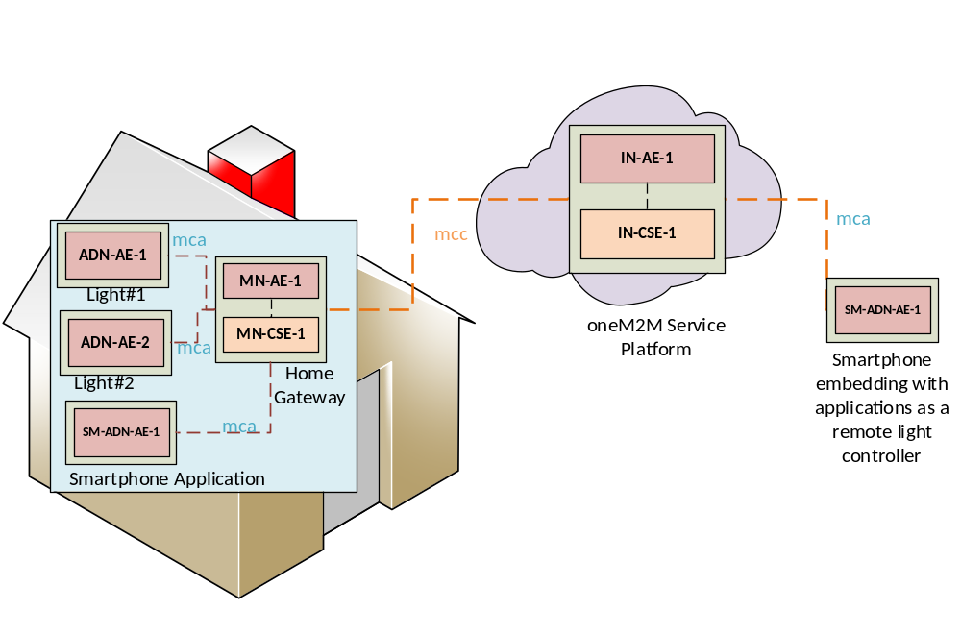
Figure 6-1 oneM2M functional architecture of remote lights control use case

In oneM2M functional architecture two entity roles are defined, one is AE and the other is CSE. Application dedicated devices e.g. light lamps are usually acted as an ADN-AE. Smartphone applications that are embedded into smartphone devices and able to communicate directly with oneM2M service platform can also be acted as an ADN-AE. oneM2M service system is acted as an IN-CSE and the home gateway plays a role of MN-CSE.
- T

- wo reference points, mca and mcc which are defined in the oneM2M functional architecture are used between AE and CSE and between two CSEs in the current use case, respectively. As Figure 6-1 shows, the reference point used between any light application ( AN-AE-1 (orADN-AE-2)) an home gateway MN-CSE-1 is mca while that of between home gateway and oneM2M service platform is mcc.

In summary, applications used in the current use case are classified as follows:
- ADN-AE1: an application embedded in the light lamp Light#1 with capabilities to control light lamp Light#1 and interact with the home gateway MN-CSE through mca reference point;
- ADN-AE2: an application embedded in the light lamp Light#2 with capabilities to control light lamp Light#2 and interact with the home gateway MN-CSE through mca reference point;
- SM-
- ADN-AE1: an smartphone application embedded in the smartphone device with capabilities to interact directly with the oneM2M service platform IN-CSE through mcc reference point and thereby remotely control light lamp Light#1 and Light#2;

- MN-AE-1: a gateway application embedded into the home gateway MN-CSE and interact with MN-CSE through mca reference point.
================ End of 2nd Part: Architecture ================================

