Input Contribution
Meeting ID* | TST 19.0
Title:* | Section 7 Procedures in Application Developer Guide
Source:* | Ting Martin Miao, KETI (TTA) (novamartin@keti.re.kr)  Sung-Chan Choi (csc@keti.re.kr)  Minu Ryu (minu@keti.re.kr)  Jaseho Kim (jhkim@keti.re.kr)
Uploaded Date:* | 2015-09-01
Document(s)  Impacted* | TR-00XX
Intended purpose of  document:* | Decision  Discussion  Information  Other <specify>
Decision requested or recommendation:*
Template Version:23 February 2015 (Dot not modify)

oneM2M Notice
The document to which this cover statement is attached is submitted to oneM2M. Participation in, or attendance at, any activity of oneM2M, constitutes acceptance of and agreement to be bound by terms of the Working Procedures and the Partnership Agreement, including the Intellectual Property Rights (IPR) Principles Governing oneM2M Work found in Annex 1 of the Partnership Agreement.

- Introduction
This contribution introduces a group of high level procedures that are necessary to implement the remote light control use case. Call flows regarding each procedure are also included in the current document.

============= Start of 1st Part: Procedures ====================================

7 Procedures
The deployment of oneM2M standard of present use case requires procedures that are classified as the follows:
- Registration: The current procedure contains light lamps registration, gateway application registration, and accessControlPolicy resource creation for a selective access to data storage resources.
- Initial resource creation: The current procedure contains group resources creation, container resources creation with specific access control policies, content instance resources creation with initial light states, subscription resources creation for notifications.
- Discovery and group resource update: all containers with a specific filter criteria can be discovered by the gateway application and provided as members of group resources.
- Discovery and retrieval lights states: all containers with a specific filter criteria could be discovered and retrieved using resource identities through a smartphone application which gains access to oneM2M service platform and content information could also be retrieved.
- Single light switch on/off: Any light that is discovered by and connected to the smartphone application is able to be switched on and off via a smartphone application.

- Multiple lights switch on/off: More than one lights that are discovered by and connected to the smartphone application are able to be switched on and off together via a smartphone application.

7.1 Call flows
Call flows regarding each procedure involved in the current use case are presented in the following subsections:

7.1.1 Registration
Call flows regarding the registration phase depicted in Figure 7.1.1-1 are ordered as the follows:
- Gateway (MN-CSE-1) registers into an oneM2M service platform (IN-CSE-1).
- Gateway application (MN-AE-1) registers into gateway (MN-CSE-1).
- Light applications (ADN-AE-1 and ADN-AE-2) register into gateway (MN-CSE-1).
- Smartphone application (SM-ADN-AE-1) registers into an oneM2M service platform (IN-CSE-1) and then IN-CSE-1 announces the smartphone application resource (SM-ADN-AE-1) to gateway (MN-CSE-1).
- Gateway application (MN-AE-1) discovers smartphone application (SM-ADN-AE-1) from gateway (MN-CSE-1) with specific filter criteria.

- Gateway application (MN-AE-1) creates accessControlPolicy resource for smartphone application (SM-ADN-AE-1) with granting access to all the light applications (ADN-AE-1 and ADN-AE-2).
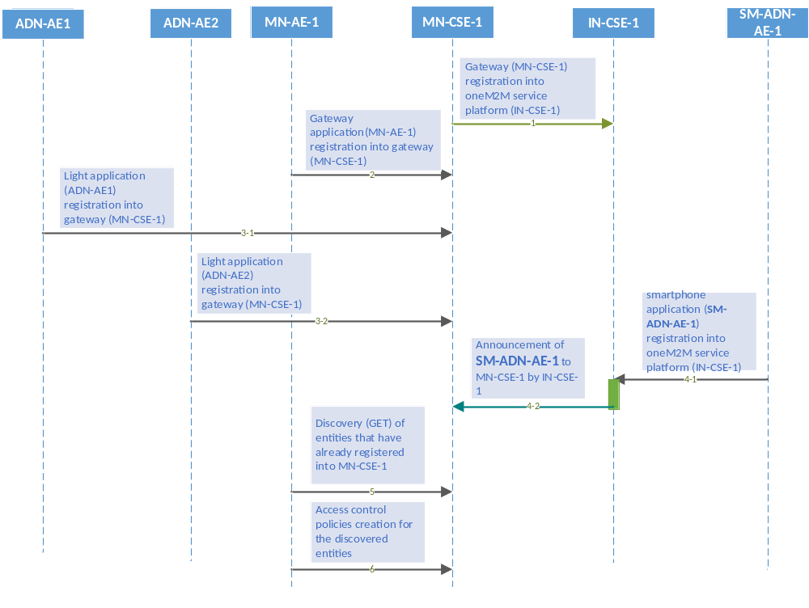
Figure 7.1.1-1 Registration phase call flows
h!!
7.1.2 Initial resource creation
Call flows regarding the initial resource creation phase depicted in Figure 7.1.2-1 are ordered as the follows:
- Gateway application (MN-AE-1) creates two group resources into gateway (MN-CSE-1), one for updating group light state named as LIGHTS_POST and the other one for retrieving group light state named as LIGHTS_GET. The group members will be added from the list of discovered container resources through the discovery process initialized by MN-AE-1. These group resources are both created with the same access control policy.
- Two container resources are created in the gateway (MN-CSE-1) to store the light states under the registered light application ADN-AE-1 and ADN-AE-2, respectively. The containers are created using the same access control policy.
- Content Instance resources are created by light applications (ADN-AE-1 and ADN-AE-2) under each created container to represent the controlled light states.
- Subscription resource creation under the containers in the gateway (MN-CSE-1) so that subscribers i.e. light applications can be notified whenever there is new contentInstance is updated by MN-AE-1 or SM-ADN-AE-1.

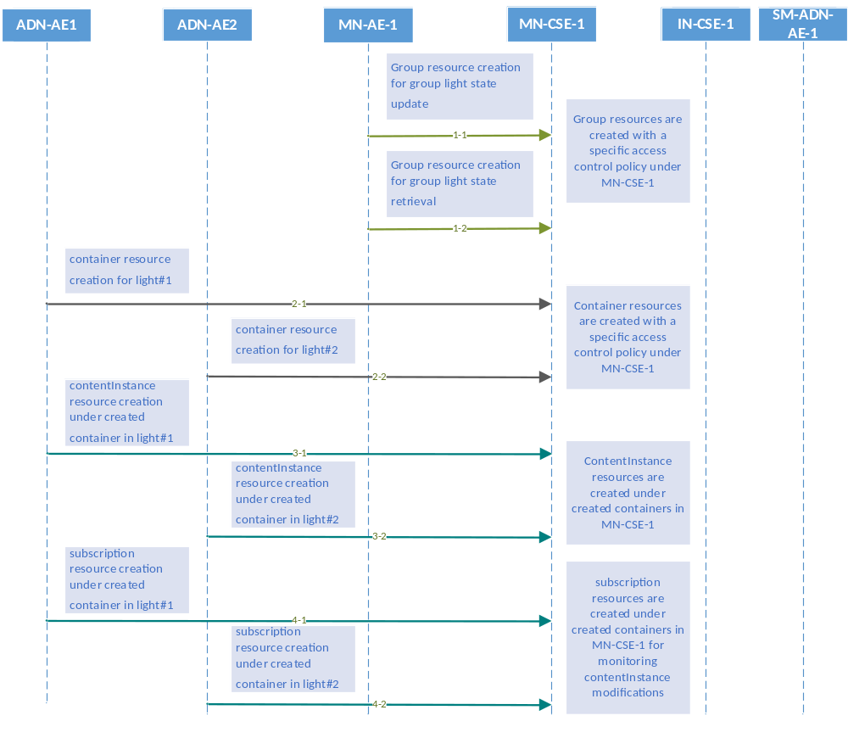
Figure 7.1.2-1 Initial resource creation phase call flows

7.1.3 Discovery and update of group resources
Call flows regarding the discovery and update of group resources phase depicted in Figure 7.1.3-1 are ordered as the follows:
- Gateway application (MN-AE-1) could periodically send a GET request associated with specific filter criteria(s) as given in the FilterCriteria parameter contained in the request message for discovery of container resources stored in the MN-CSE-1 of gateway. A group of filter criteria conditions for retrieve operation defined in the oneM2M functional structure, such as createdBefore, createdAfter, modifiedSince, unmodifiedSInce, label, creator, expireAfter, resourceType etc could be used for the discovery process.
- Gateway (MN-CSE-1) responds with URIs of the discovered container resources, if any, to the gateway application (MN-AE-1) according to the filter criteria(s).
- Gateway application (MN-AE-1) sends a POST request to update the list of the group members of discovered containers providing URIs for contentInstance creation and latest or historical contentInstance resource retrieval. The discovered member URIs are built in the previously created group resources LIGHTS_POST, LIGHTS_GET.
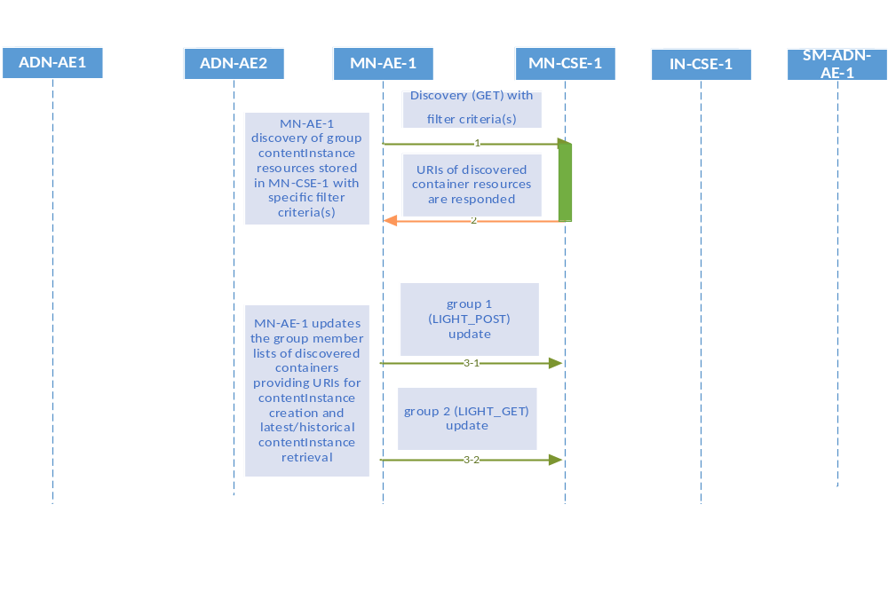
Figure 7.1.3-1 Discovery and group light state update phase call flows

7.1.4 Discovery and retrieval of contentInstance resources
Call flows regarding the discovery and retrieval of contentInstance resource phase depicted in Figure 7.1.4-1 and 7.1.4-2 are ordered as the follows:
- The smartphone application (SM-ADN-AE-1) sends a GET request associated with specific filter criteria(s) as given in the FilterCriteria contained in the request message for discovery of container resources stored in the MN-CSE-1. The SM-ADN-AE-1 could also send a GET request to the MN-CSE-1 for the discovery of group resources stored in the MN-CSE-1.
- The gateway (MN-CSE-1) responds with URIs of the requested container resources under ADN-AE-1 and ADN-AE-2, if any, to the smartphone application (SM-ADN-AE-1). In the case that the SM-ADN-AE-1 sends a discovery request to all group member resources, MN-CSE-1 will respond the SM-ADN-AE-1 with the URIs of discovered group resource of containers, if any.
- Regarding each container URI of ADN-AE-1 and ADN-AE-2, the SM-ADN-AE-1 sends a GET request for retrieval of the latest updated contentInstance from the single light application. In the case of retrieval of group member of content instance resource, the SM-ADN-AE-1 sends a GET request to retrieve a group of contentInstances.
- The smartphone application (SM-ADN-AE-1) is responded with the light state of the requested container.

- 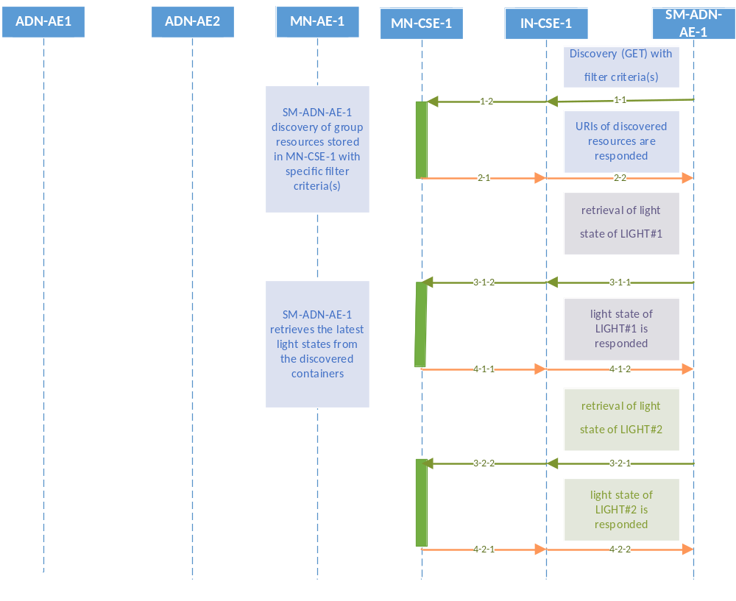
Figure 7.1.4-1 Discovery and single light retrieval phase call flows

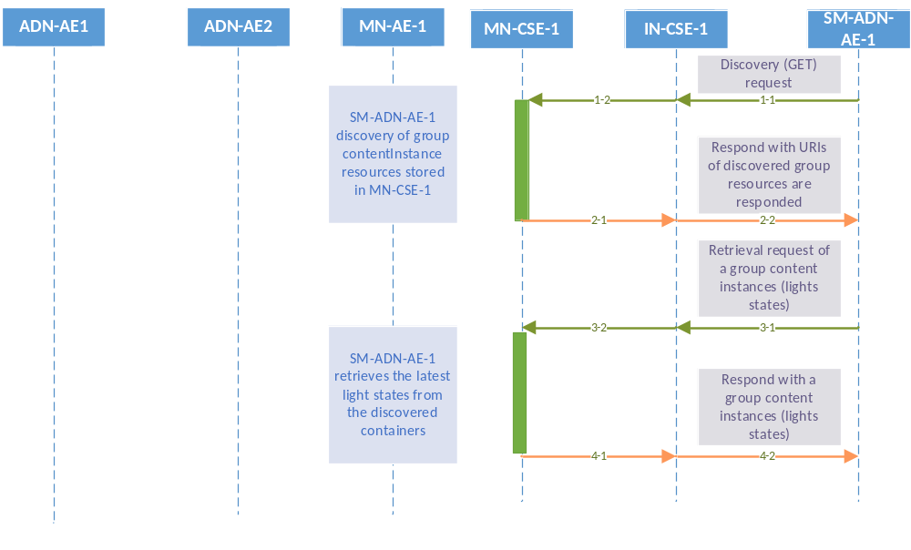
Figure 7.1.4-2 Discovery and a group of lights retrieval phase call flows

7.2 Single light control
Each single light lamp could be controlled remotely through a smartphone embedded with an application gaining access to the oneM2M service platform especially when the application and light bulbs are connected to different network.
service

7.2.1 Remote control
The light remote control enable users to control remotely their light lamps through a smartphone application (SM-ADN-AE-1).
- When the light state is changed by the SM-ADN-AE-1, then SM-ADN-AE-1 creates a new contentInstance under the container stored in the MN-CSE-1.
- The modification on the light state triggers a notification to the subscriber (i.e. ADN-AE-1 or ADN-AE-2) and finally the modified light state is applied to the target light lamp.

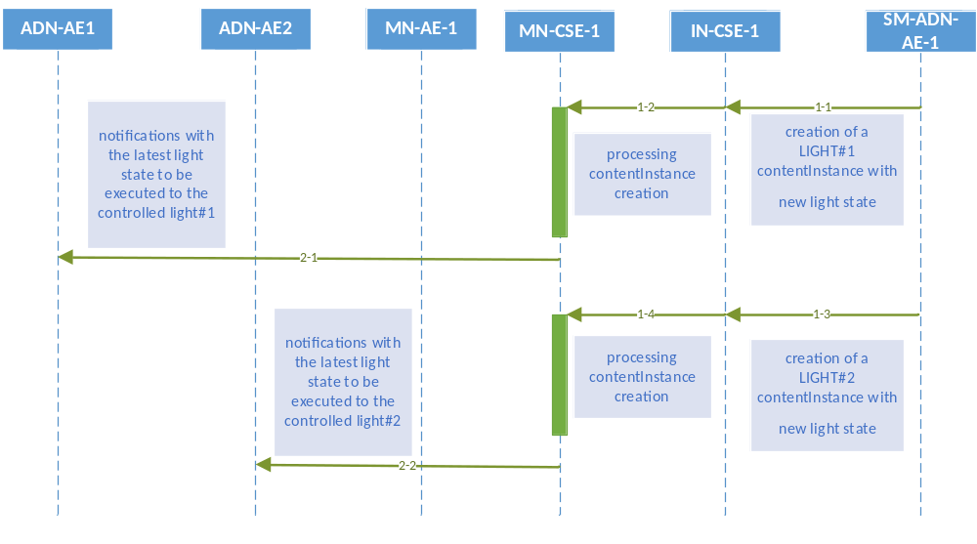
Figure 7.2.1-1 Single light remote control phase call flows

7.3 Multiple lights control
Multiple lights control is supported to enable remote control multiple lights at one time in order to facilitate the light control process.

7.3.1 Remote control
The light remote control enable users to control multiple light bulbs remotely through a smartphone application (SM-ADN-AE-1).
- When the group switch state is changed against a group of lights from the smartphone application (SM-ADN-AE-1), the SM-ADN-AE-1creates a new contentInstance for all group members stored in the gateway (MN-CSE-1).
- The gateway (MN-CSE-1) triggers multiple notifications to each subscriber member including ADN-AE-1 and ADN-AE-2 as a result of the new contentInstance creation. Finally the modified light states are applied to all the target light lamps.

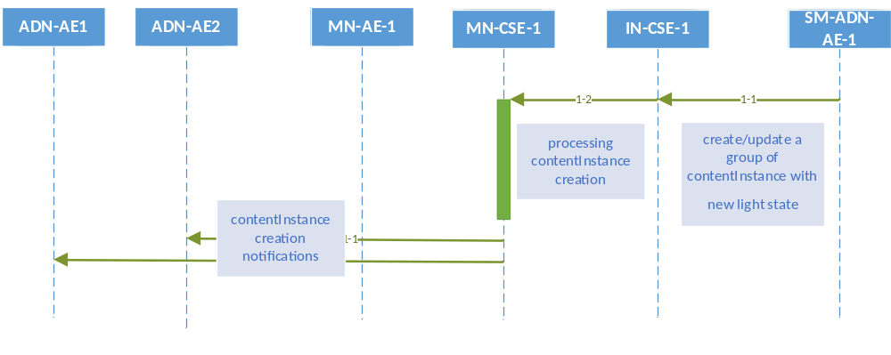
Figure 7.3.1-1 Multiple lights remote control phase call flows

============= End of 1st Part: Procedures ==================================

