Input Contribution
Meeting ID* | TST 19.2
Title:* | Section 7 High level procedures of remote lights control use csae
Source:* | Ting Martin Miao, KETI (TTA) (novamartin@keti.re.kr)  Sung Chan Choi (csc@keti.re.kr)  Minu Ryu (minu@keti.re.kr)  Jaseho Kim (jhkim@keti.re.kr)
Uploaded Date:* | 2015-10-20
Document(s)  Impacted* | TR-00XX
Intended purpose of  document:* | Decision  Discussion  Information  Other <specify>
Decision requested or recommendation:*
Template Version:23 February 2015 (Dot not modify)

oneM2M Notice
The document to which this cover statement is attached is submitted to oneM2M. Participation in, or attendance at, any activity of oneM2M, constitutes acceptance of and agreement to be bound by terms of the Working Procedures and the Partnership Agreement, including the Intellectual Property Rights (IPR) Principles Governing oneM2M Work found in Annex 1 of the Partnership Agreement.

- Introduction
This contribution introduces a group of high level procedures that are necessary to implement the remote light control use case. Call flows regarding each procedure are also included in the current document.

============= Start of 1st Part: Procedures ====================================

7 Procedures
The deployment of oneM2M standard of present use case requires procedures that are classified as the follows:
- Registration: The current procedure contains light lamps registration, gateway application registration, and accessControlPolicy resource creation for a selective access to data storage resources.
- Initial resource creation: The current procedure contains group resources creation, container resources creation with specific access control policies, content instance resources creation with initial light states, subscription resources creation for notifications.
- Discovery of container resource: all containers with a specific filter criteria can be discovered by the gateway application and provided as members of group resources.
- Discovery and retrieval lights states: all containers with a specific filter criteria could be discovered and retrieved using resource identities through a smartphone application which gains access to oneM2M service platform and content information could also be retrieved.
- Single light switch on/off: Any light that is discovered by and connected to the smartphone application is able to be switched on and off via a smartphone application.
- Multiple lights switch on/off: More than one lights that are discovered by and connected to the smartphone application are able to be switched on and off together via a smartphone application.

7.1 Call flows
Call flows regarding each procedure involved in the current use case are presented in the following subsections:

7.1.1 Application registration and Access control policy creation
Call flows regarding the registration phase depicted in Figure 7.1.1-1 are ordered as the follows:
- Gateway (MN-CSE) registers with the oneM2M service platform (IN-CSE).
- Gateway application (MN-AE) registers with the gateway (MN-CSE).
- Light applications (ADN-AE1 and ADN-AE2) register with the gateway (MN-CSE).
- Smartphone application (IN-AE) registers with the oneM2M service platform (IN-CSE) and then IN-CSE announces the smartphone application resource (IN-AE) to the gateway (MN-CSE).
- Gateway application (MN-AE) discovers the smartphone application (IN-AE) from gateway (MN-CSE) with specific filter criteria. The discovered IN-AE could be granted to access to the remote light control service containers.
- Gateway application (MN-AE) creates an accessControlPolicy resource granting all the entities playing roles in the current use case including ADN-AE1, ADN-AE2, MN-AE and IN-AE could access to the created container and content instance resources.
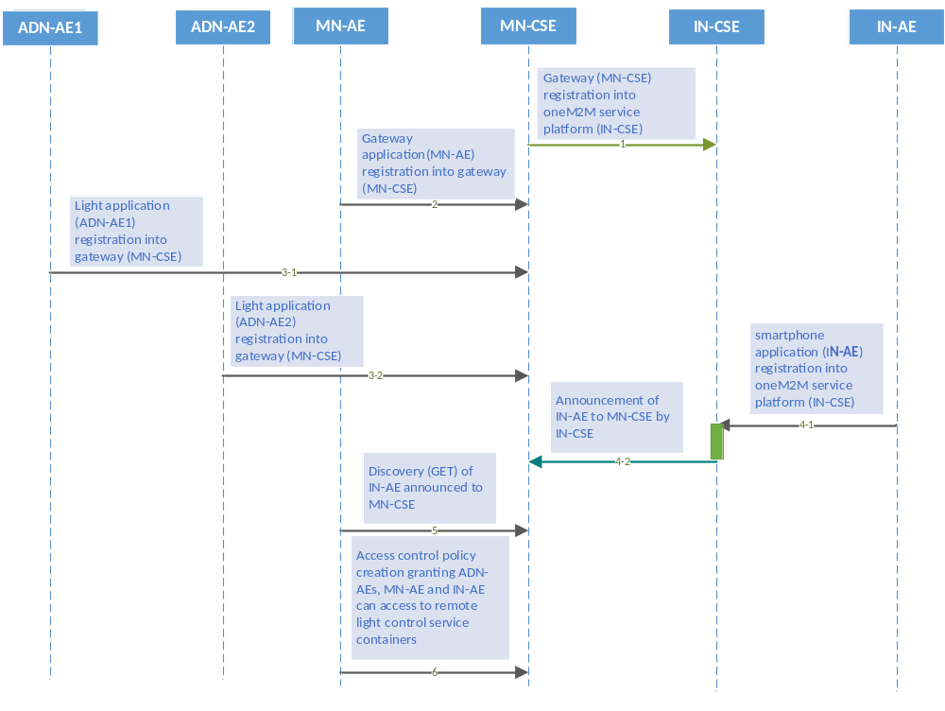
Figure 7.1.1-1 Registration phase call flows

7.1.2 Initial resource creation
Call flows regarding the initial resource creation phase depicted in Figure 7.1.2-1 are ordered as the follows:
- Gateway application (MN-AE) creates two group resources into gateway (MN-CSE), one for updating group light state named as group_for_light_state_update and the other one for retrieving group light state named as group_for_light_state_retrieval. The group members will be added from the list of discovered container resources through the discovery process initialized by MN-AE. These group resources are both created with the same access control policy.
- Two container resources are created in the gateway (MN-CSE) to store the light states under the registered light application ADN-AE1 and ADN-AE2, respectively. The containers are created using the same access control policy.
- Content Instance resources are created by light applications (ADN-AE1 and ADN-AE2) under each created container to represent the controlled light states.
- Subscription resource creation under the containers in the gateway (MN-CSE) so that subscribers i.e. light applications can be notified whenever there is new contentInstance is created by MN-AE or IN-AE.

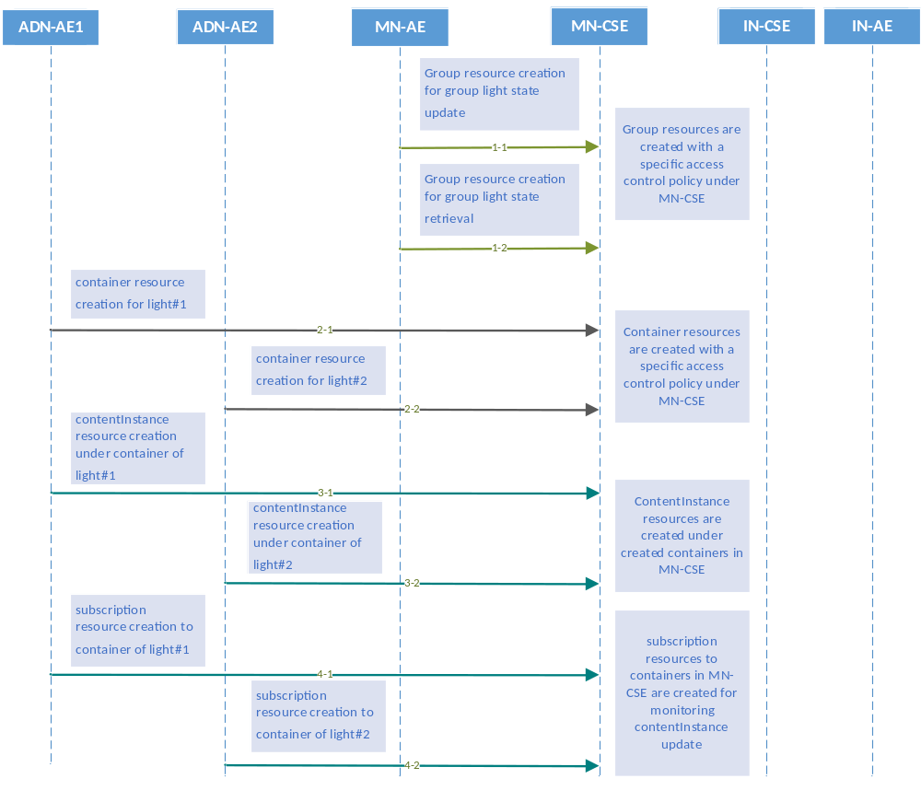
Figure 7.1.2-1 Initial resource creation phase call flows

7.1.3 Discovery of group resources
Call flows regarding the discovery and update of group resources phase depicted in Figure 7.1.3-1 are ordered as the follows:
- Gateway application (MN-AE) could periodically send a RETRIEVE request including the parameter filterUsage and specific filter criteria condition(s) as a query string for discovery of container resources stored in the MN-CSE of gateway. A group of filter criteria conditions for the discovery operation includes createdBefore, createdAfter, modifiedSince, unmodifiedSInce, label, creator, expireAfter, resourceType etc.
- Gateway (MN-CSE) responds with URIs of the discovered container resources, if any, to the gateway application (MN-AE) according to the filter criteria(s).
- Gateway application (MN-AE) could also send a POST request to update the list of the group members with the discovered containers providing URIs for contentInstance creation and latest contentInstance resource retrieval. The discovered member URIs are built in the previously created group resource group_for_light_state_update, and group_for_light_state_retrieval.
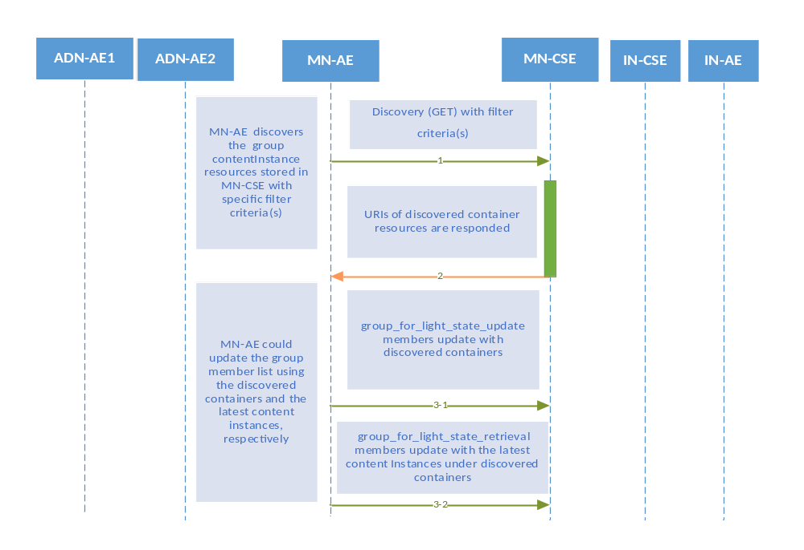
Figure 7.1.3-1 Discovery and group light state update phase call flows

7.1.4 Discovery and retrieval of contentInstance resources
Call flows regarding the discovery and retrieval of contentInstance resource phase depicted in Figure 7.1.4-1 and 7.1.4-2 are ordered as the follows:
- The smartphone application (IN-AE) periodically send a RETRIEVE request including the parameter filterUsage and specific filter criteria condition(s) as a query string for discovery of container resources stored in the MN-CSE of gateway.
The IN-AE could also send a Discovery request to the MN-CSE for the discovery of the group resources located in the MN-CSE.
- The gateway (MN-CSE) responds IN-AE with URIs of the discovered container resources under ADN-AE1 and ADN-AE2, if any.
In the case that when IN-AE sends a Discovery request for the discovery of group resources, the MN-CSE responds IN-AE with the URIs of the discovered group resources located in the MN-CSE, if any.
- The IN-AE sends GET requests for retrieval of the latest contentInstance from each discovered single light container.
In the case of retrieval of a group of the latest content instance resource from the group group_for_light_state_retrieval, the IN-AE could send a fanOutPoint request to the discovered group URI of group_for_light_state_retrieval.
- The IN-AE is responded with the latest light state (s).
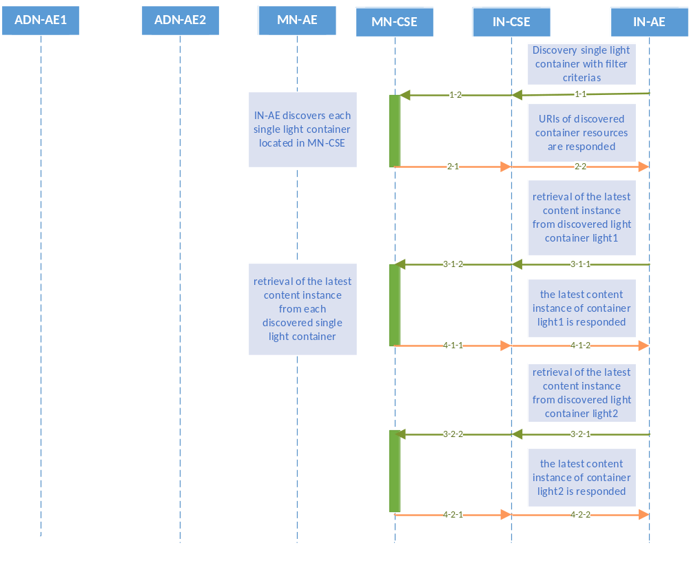
Figure 7.1.4-1 Discovery and single light retrieval phase call flows
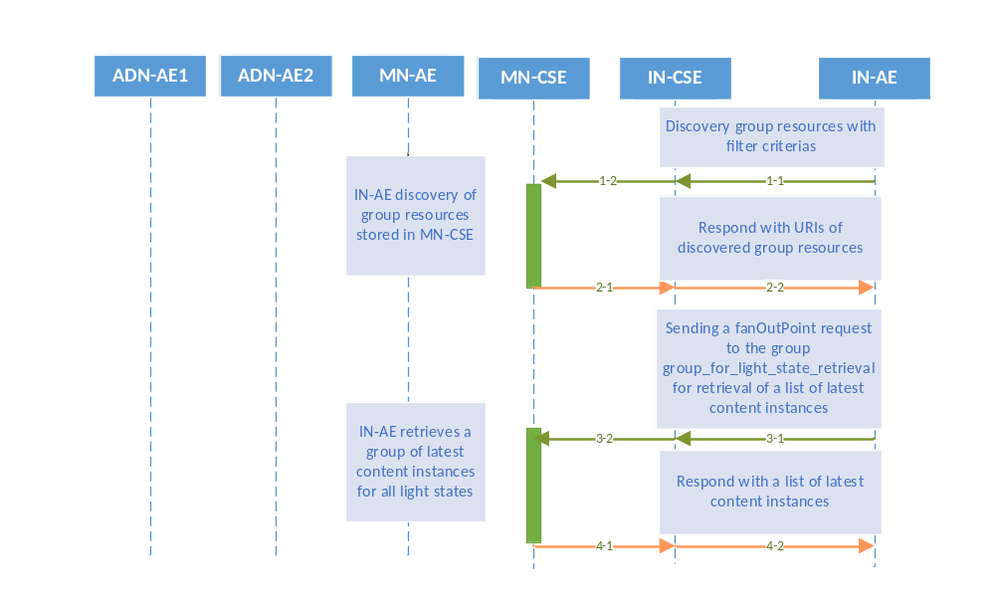
Figure 7.1.4-2 Discovery and a group of lights retrieval phase call flows

7.2 Remote control scenarios
Light lamps are able to be controlled remotely through a smartphone embedded with an application gaining access to the oneM2M service platform especially when the smartphone and light bulbs are connected to different networks. Two scenarios are introduced in the current section as follows:

7.2.1 Single light lamp control
Any single light lamp including Light#1 and Light#2 can be controlled remotely by a human user through a smartphone application (IN-AE). Call flows for single light lamp control depicted in Figure 7.2.1-1 are ordered as follows:
- When the user updates the light lamp state on her/his smartphone, the IN-AE creates a new contentInstance representing a new light state under the targeted container of ADN-AE stored in the MN-CSE.
- If the contentInstance is created sucessfully, the MN-CSE sends a notification to the corresponsding ADN-AE.
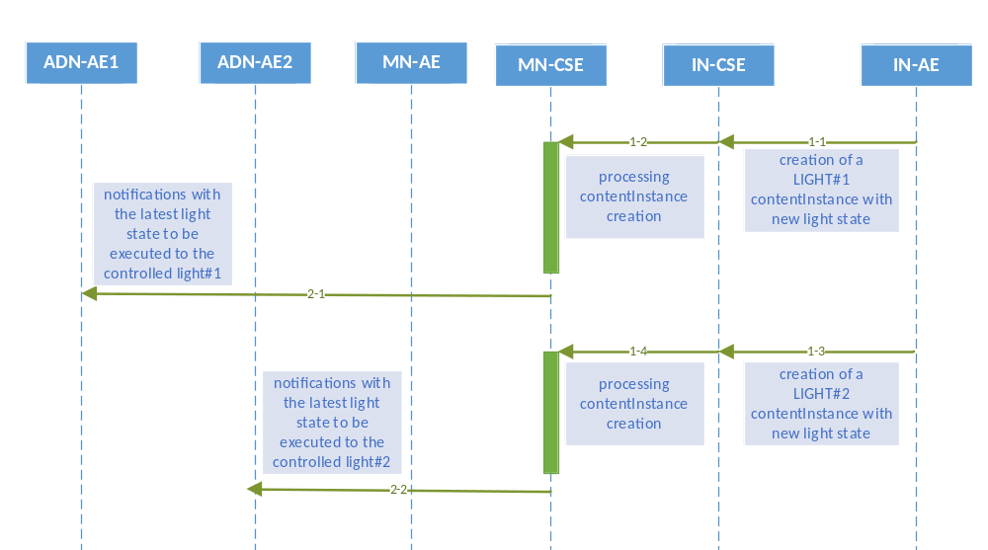
Figure 7.2.1-1 Single light remote control phase call flows

7.2.2 Multiple light lamps control
Multiple light lamps are enable to be controlled remotely at one time in order to facilitate the control process.
The light lamp remote control enable human users to control remotely multiple light lamps through a smartphone application (IN-AE) by sending a single light control command to the oneM2M service platform (IN-CSE). Call flows for multiple light lamps control depicted in Figure 7.2.2-1 are ordered as follows:
- When the user updates a group of light lamp states on her/his smartphone, the IN-AE creates a group of new contentInstances representing a group of new light states under the targeted container stored in the MN-CSE.
- If the contentInstances are created sucessfully, the MN-CSE sends a group of notifications to the corresponsding each ADN-AEs.
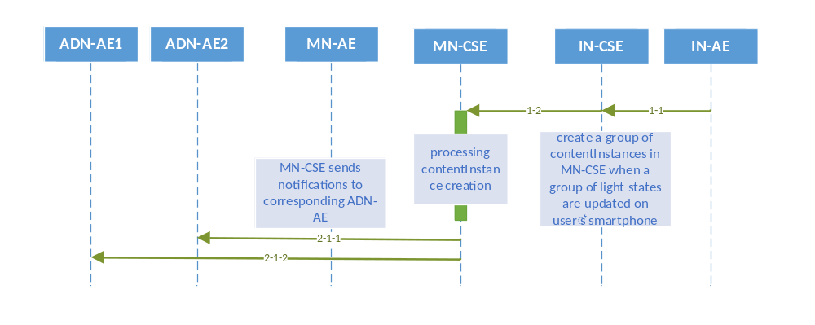
Figure 7.2.2-1 Multiple lights remote control phase call flows

============= End of 1st Part: Procedures ==================================

