Input Contribution
Meeting ID* | TST 27
Title:* | TS-0019-Abstract Test Method - Upper Tester Control Message Format
Source:* | Ting Martin Miao, KETI, martin.miao@keti.re.kr
Uploaded Date:* | 2017-02-11
Document(s)  Impacted* | TS-0019
Intended purpose of  document:* | Decision  Discussion  Information  Other <specify>
Decision requested or recommendation:*
Template Version:23 February 2015 (Dot not modify)

oneM2M Notice
The document to which this cover statement is attached is submitted to oneM2M. Participation in, or attendance at, any activity of oneM2M, constitutes acceptance of and agreement to be bound by terms of the Working Procedures and the Partnership Agreement, including the Intellectual Property Rights (IPR) Principles Governing oneM2M Work found in Annex 1 of the Partnership Agreement.

Introduction
This contribution proposes definitions of upper tester control message format to standardize the format of triggering messages that are used in communication exchange between TTCN-3 Test System and the System Under Test (ADN-AE).

-----------------------Start of change 1--------------------------------------------

5 Abstract Test Method (ATM)

5.4 Ports and ASPs (Abstract Services Primitives)
The oneM2M ATS implements four ports:
- The mcaPort
- The mccPort
- The acPort
- The utPort

5.4.1 mcaPort and mccPort
These ports are used to send and receive the following message sets;
- Request Primitives messages in accordance with oneM2M TS-0004 standard [2].
- Response Primitives messages in accordance with [2].
Two primitives are currently defined for these two ports indicated as Table 1:
- The M2MRequestPrimitive - to send or receive oneM2M messages to/from the IUT. Depending on the IUT to be tested:
  - If the IUT is an AE, these messages are either received or sent by the tester which is associated with the CSE role through the mcaPort.
  - If the IUT is a CSE, these messages are either sent by the tester when it plays the AE role through the mcaPort or received by the tester when it plays the CSE role through the mccPort.
- The M2MResponsePrimitive - to send or receive oneM2M messages to/from the IUT. Depending on the IUT to be tested:
  - If the IUT is an AE, these messages are either sent or received by the tester which is associated with the CSE role through the mcaPort.
  - If the IUT is a CSE, these messages are either sent by the tester when it plays the CSE role through the mccPort or received by the tester when it plays the AE role through the mcaPort.
Both primitives contain another parameters that permits to dynamically configure the test adaptor for every single sending. These parameters are:
- Host: IP address of the IUT
- XML Namespace
- Protocol binding
- Serialization
Table 1 Mapping of TTCN-3 Primitives to oneM2M Service Primitives
TTCN-3 Primitive | oneM2M Message | Direction | IUT
M2MRequestPrimitive | Request Primitive | ←  → | AE
M2MRequestPrimitive | Request Primitive | →  ← | CSE
M2MResponsePrimitive | Response Primitive | →  ← | AE
M2MResponsePrimitive | Response Primitive | →  ← | CSE

5.4.2 utPort

5.4.2.0 Introduction
The utPort has been included in the oneM2M ATS in order to be able to stimulate the IUT and receive extra information from IUT upper layers. The utPort can be applied to automated AE testing shown as section 5.4.2.1.
Editor’s Note: The utPort can also be provided for future extension.

5.4.2.1 Usage for Automated AE Testing
The utPort can be used to implement the automated AE testing when SUT is an AE.
The utPort is in charges of the communication between TTCN-3 Test Component module in Test Sytem and the Upper Tester Application in SUT.
Functionalities that TTCN-3 Test Component module and the Upper Tester Application are required to implement are listed as following:
- Both the TTCN-3 Test Component module and the Upper Tester Transport module open a utPort respecitively to buildd a upper tester transport link between each other;
- TTCN-3 Test Component is able to configure the Test System and send (standardized) triggering commands to the SUT (Upper Tester Application);
- Upper Tester Application can process the triggering command messages received from Test System (TTCN-3 Test Component) and stimulates IUT to act following the corresponding triggering command i.e. sending oneM2M service primitives to Test System through port mca.
Primitives defined for utPort are listed as following:
- The UtStart primitive used to initialize IUT.
- The UtTrigger primitive used to trigger upper layer events in IUT i.e. sending oneM2M service primitives to Test System through mca port.
- The UtStartResult primitive used to receive responses from upper layer result of initialization in IUT.
- The UtTriggerResult primitive used to receive responses from upper layer result of triggering event in IUT.
Editor’s Note: The format of primitives defined for utPort is supposed to be defined here in the future.
The Upper Tester Application in SUT (AE) can be implemented as an embedded source code within an AE. An example for implementation of automated AE test for Re gistration is shown as Figure Y.

SUT

TEST SYSTEM

TTCN-3 Test Component
-

CSE

Upper Tester Application

IUT (AE)

Stimulate Registration

Stimulate Container Create

Registration

Container Create

Trigger Registration

Function call

utPort

utPort

mcaPort

mcaPort

Ut

Mca

Figure Y. An example for automated AE test for Registration

.5.4.2.2 Upper Tester Control Message Format

5.4.2.2.1 Introduction
The upper tester control messages are used by utPort for communication exchange between TTCN-3 Test System (hereafter short for TS) and the Upper Tester (hereafter short for UT) in the System Under Test using UDP/TCP connection. A list of control message types that can be used by utPort includes but not limit to:
- Initiate/Reset that is used by TS to switch on the IUT with the “initial state” or reset the IUT into “initial state”.
- Trigger message is initialized by TS to send a triggering command to the UT and aims to direct the IUT to execute specific tasks.
- Teminate that TS sends close communication notification to the IUT to terminate all communication exchange between each other.
Each control message type maps to particular message formats for exchanging data and those message formats are defined by TTCN-3 primitives such as UtStart, UtStartResult, UtTrigger and UtTriggerResult primitives. Details for the definition of those primitives are to be introduce in section 5.4.2.2.2. A mapping between the upper tester control message type to TTCN-3 primitives are defined as table 5.4.2.2.1-1.
Table 5.4.2.2.1-1 Mapping of TTCN-3 Primitives to oneM2M Service Primitives
Upper Tester Control  Message Type | TTCN-3 Primitives | Direction
Upper Tester Control  Message Type | TTCN-3 Primitives | TS | UT
Initiate/Reset | UtStart Primitive | →
Initiate/Reset | UtStartResult Primitive | ←
Terminate | UtTerminate Primitive | →
Terminate | UtTerminateAck Primitive | ←
Trigger | UtTrigger Primitive | →
Trigger | UtTriggerResult Primitive | ←
Editor’s Note: Additional upper tester control message types might be added later to implement additional functionalities in utPort.

5.4.2.2.2 Control Message Format
The upper tester control message type are stored using one Byte (eight bits) and all integer values are encoded in little-endian byte order (least significant byte first) shown as Figure 5.4.2.2.2-1 and the interger value of each control message is defined at table 5.4.2.2.2-1.
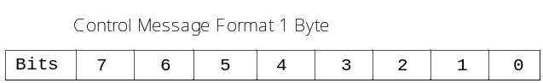
Figure 5.4.2.2.2-1 Control message type format

Table 5.4.2.2.2-1 Upper Tester Control Message Type Value
Control Message Type | Value\Bit | 7 | 6 | 5 | 4 | 3 | 2 | 1 | 0
INNITIATE/RESET | 0x00(0) | 0 | 0 | 0 | 0 | 0 | 0 | 0 | 0
TERMINATE | 0x01(1) | 0 | 0 | 0 | 0 | 0 | 0 | 0 | 1
TRIGGER | 0x02(2) | 0 | 0 | 0 | 0 | 0 | 0 | 1 | 0

-----------------------End of change 1--------------------------------------------

-----------------------Start of change 2--------------------------------------------

5.4.2.2.2 Common Upper Tester Control Primitives

A.1. UtStart and UtStartResult Primitive
UtStart primitive is defined as a request primitive that is initialized by Test System containing initiate command to a target IUT and the UtStartResult primitive is used when the IUT sends back a response as a result of the Initiate request, which indicates the IUT initiate status information. Sending UtStart messge is the fundamental to send Trigger and/or Terminate message to the IUT.
The message flow is shown in Figure A.1-1 and the field values defined in UtStart and UtStartResult primitives are encoded in little-endian byte order (least significant byte first) as depicted in Figure A.1-2 and A.1-3.
Table A.1-1 lists a mapping table that maps each field of UtStart and UtStartResult primitive to oneM2M data types.
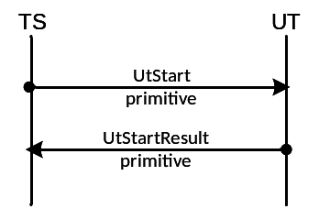
Figure A.1-1 Initiate message flow
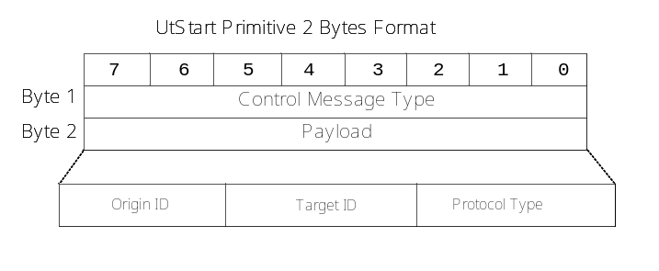
Figure A.1-2 UtStart primitive format
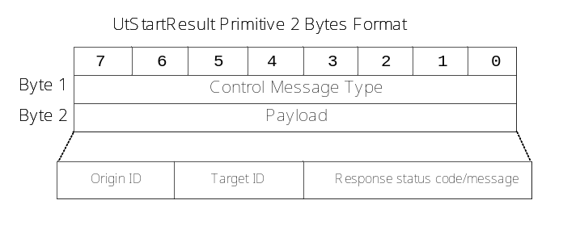
Figure A.1-3 UtStartResult primitive format
Table A.1- Mapping table between each field in UtStart and UtStartResult primitive and oneM2M data types
Field | Mapping to oneM2M data types | Examples
Origin ID | The identity ID of the originator (From attribute) | HTTP X-M2M-Origin header
Target ID | The access address of the target IUT (To attribute) | Target URI
Protocol Type | oneM2M protocol binding | HTTP protocol
Response status code/message | Customized protocol status code and status message* | oneM2M 2006 (INNITIALIZED)
*:Refer to defined status summary table for Upper Tester control.

A.2. UtTerminate and UtTerminateAck Primitive
UtTerminate primitive is defined as a request primitive that is initialized by Test System to terminate the control to the connected IUT and then the IUT sends back a UtTerminate primitive including indication information of closed connection and clear all memory data that in use. The UtTerminate message is only effective to IUT when IUT is connected to the Test System.
The message flow is shown in Figure A.2-1 and the field values defined in UtTerminate and UtTerminateAck primitives are encoded in little-endian byte order (least significant byte first) as depicted in Figure A.2-2 and A.2-3.
Table A.2-1 lists a mapping table that maps each field of UtTerminate and UtTerminateAck primitive to oneM2M data types.
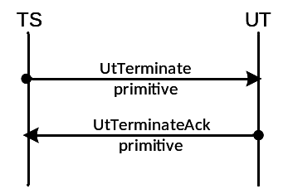
Figure A.2- Terminate message flow
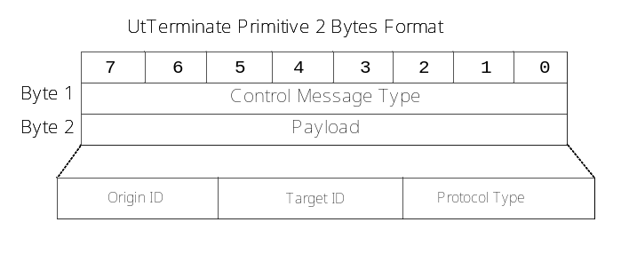
Figure A.2- UtTerminate primitive format
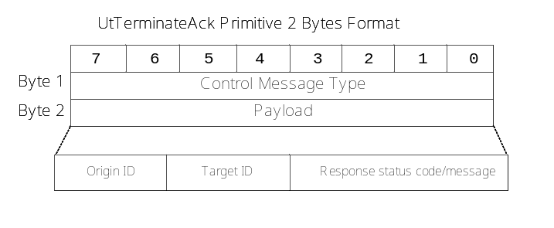
Figure A.2- UtTerminateAck primitive format
Table A.2- Mapping table between each field in UtTerminate and UtTerminateAck primitive and oneM2M data types
Field | Mapping to oneM2M data types | Examples
Origin ID | The identity ID of the originator (From attribute) | HTTP X-M2M-Origin header
Target ID | The access address of the target IUT (To attribute) | Target URI
Protocol Type | oneM2M protocol binding | HTTP protocol
Response status code/message | Customized protocol status code and status message* | OneM2M 2005 (TERMINATED)
*:Refer to defined status summary table for Upper Tester control.

A.3. UtTrigger and UtTriggerResult Primitive
UtTrigger and UtTriggerResult primtives are used for triggering progress as depicted as Figure A.3-1. The UtTrigger primitive is initialized by the Test System to send triggering message to the target IUT. The triggering primitive is stored using two Bytes, one Byte is to store upper tester control message type and the other one Byte stores the payload indicating the concrete triggering information. The UtTriggeringResult primitive contains data indicating the triggering status, such as SUCCESS or FAIL.
Each field value in Figure A.3-2 and A.3-3 is encoded in little-endian byte order (least significant byte first).
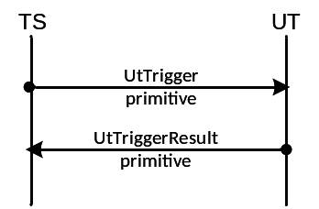
Figure A.3-1 Trigger message flow

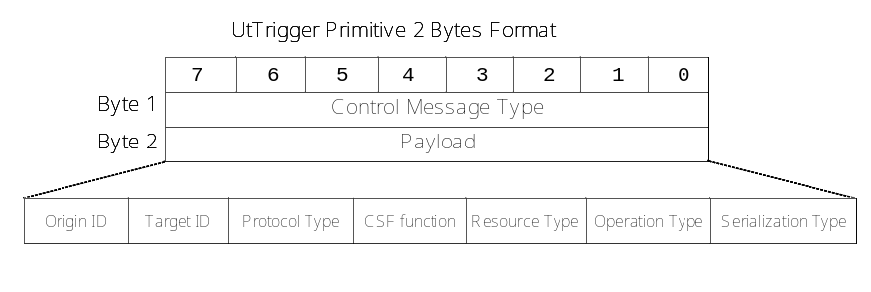
Figure A.3-2 UtTrigger primitive format

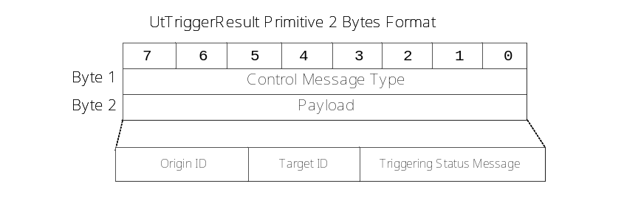
Figure A.3- 3 UtTriggerResult primitive format

Table A.3-1 lists a mapping table that maps each field of UtTrigger and UtTriggerResult primitive to oneM2M data types.
Table A.3- Mapping table between each field in UtTrigger and UtTriggerResult primitive and oneM2M data types
Field | Mapping to oneM2M data types | Examples
Origin ID | The identity ID of the originator (From attribute) | HTTP X-M2M-Origin header
Target ID | The access address of the target IUT (To attribute) | Target URI
Protocol Type | oneM2M protocol binding | HTTP protocol
CSF Function | oneM2M common service function group type | REG, DMR, GMG etc.
Resource Type | oneM2M resource primitive type (m2m:resourceType) | <AE>, <container>, <group>, <fanOutPoint> etc.
Operation Type | oneM2M operation type (m2m:operation) | AE, accessControlPolicy etc.
Serialization | oneM2M serialization type (m2m:serializations) | application/json, application/xml etc.
Response status code/message | Customized protocol status code and status message* | oneM2M 2005 (TERMINATED)
*:Refer to defined status summary table for Upper Tester control.

Appendix:
Summary of status code for upper tester triggering messages
Status Code | Status Message | Interpretation
2005 | TERMINATED | The target IUT is terminated and released from the control of Test System.
2006 | INNITIALIZED | The targeted IUT is connected to and initialized by the Test System
4007 | CONNECT_ERROR | Connection error
… | … | …
Editor’s Note: The table will be updated later!

-----------------------End of change 2--------------------------------------------

