Input Contribution
Meeting ID* | TST 27
Title:* | TR-0037-Smart Farm Example using MQTT Binding Function Call Flow – Initial resource creation
Source:* | Ting Martin Miao, KETI, martin.miao@keti.re.kr
Uploaded Date:* | 2017-Feb-14
Document(s)  Impacted* | TR-0037 v0.0.1
Intended purpose of  document:* | Decision  Discussion  Information  Other <specify>
Decision requested or recommendation:*
Template Version:23 February 2015 (Dot not modify)

oneM2M Notice
The document to which this cover statement is attached is submitted to oneM2M. Participation in, or attendance at, any activity of oneM2M, constitutes acceptance of and agreement to be bound by terms of the Working Procedures and the Partnership Agreement, including the Intellectual Property Rights (IPR) Principles Governing oneM2M Work found in Annex 1 of the Partnership Agreement.

Introduction
This contribution proposes to define function call flows for initial resource creation including container resource for each sensor and actutor as well as subscription resources under interested containers created for sensors and actuators, respectively.

-----------------------Start of change 1--------------------------------------------

7 Function Call Flows

7.2 Initial Resource Generation
A group of resources are required as preconditions to implement services such as data management, subscription and notification etc. Procedures for creating container and subscription resources are stated as following:
- Each sensor (ADN-AE) creates a container resource under its AE resource located in the farm gateway (MN-CSE). The created container resource is used as a repository of environment measurement data and subscription resources are also created under these container resources for monitoring any update to this data repository.
- Each actuator (ADN-AE) creates a container resource unders its AE resource located in the farm gateway (MN-CSE). The created container resource is used as a repository of execution commands for actuators in this use case. Each subscription resource (at least one) is created under each created container resource to trigger actuators using subscription&notificiation mechanism whose working principle is present at section 7.3.
- Each IoT application (ADN-AE) subscribes to a particular container that is created as a repository of environment measurement data for a sensor to monitor the farm environment.
- The farm gateway application (MN-AE) subscribes to a particular container resource that is created for controlling purpose in an AE hosted on actuators to receive notifications which contain triggering commands for a particular actuator.
The function call flows are depicted in Figure 7.2-1.

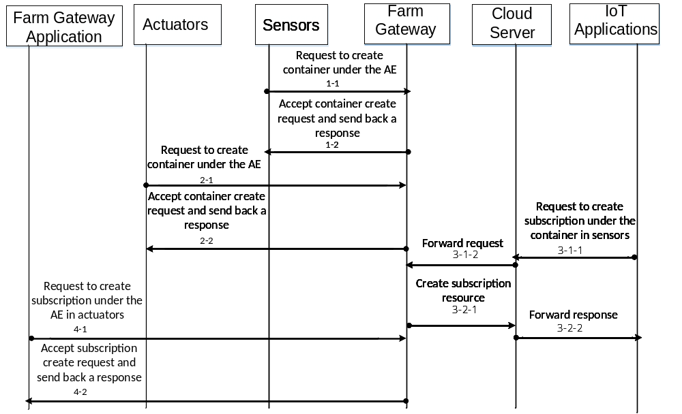
Figure 7.2- Initial Resource Creation Flows
The initial resource creation procedure results generation of hierarchical structure as shown in Figure 7.2-2 for an AE that is hosted on a sensor, an actuator and an farm gateway application, respectively.
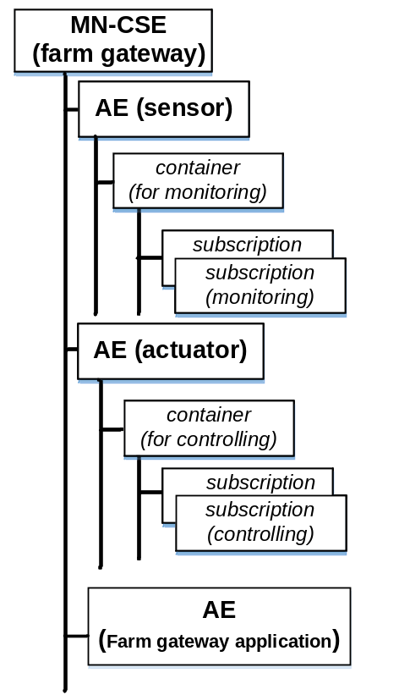
Figure 7.2- oneM2M Resource tree of sensor, actuator and farm gateway application registered into farm gateway

-----------------------End of change 1--------------------------------------------

