CHANGE REQUEST
Meeting:* | TST #29.2
Source:* | ETSI
Date:* | 2017-06-30
Contact:* | Miguel Angel Reina Ortega, ETSI, MiguelAngel.ReinaOrtega@etsi.org
Reason for Change/s:* | Changes from STF531
CR against: Release* | Rel-1
CR against: WI* | Active <Work Item number>  MNT Maintenace / < Work Item number(optional)>  STE Small Technical Enhancements / < Work Item number (optional)>  Only ONE of the above shall be ticked
CR against: TS/TR* | TS-0018-V-0.2.0
Clauses/Sub Clauses*
Type of change: * | Editorial change  Bug Fix or Correction  Change to existing feature or functionality  New feature or functionality  Only ONE of the above shall be ticked
Post Freeze checking:* | This CR contains only essential changes and corrections? YES NO  This CR is a mirror CR? YES NO if YES, please indicate the document number of the original CR:  <Document Number)<CR Number of the original CR to the current Release>
Template Version:23 February 2015 (Dot not modify)

oneM2M Notice
The document to which this cover statement is attached is submitted to oneM2M. Participation in, or attendance at, any activity of oneM2M, constitutes acceptance of and agreement to be bound by terms of the Working Procedures and the Partnership Agreement, including the Intellectual Property Rights (IPR) Principles Governing oneM2M Work found in Annex 1 of the Partnership Agreement.
GUIDELINES for Change Requests:
Provide an informative introduction containing the problem(s) being solved, and a summary list of proposals.
Each CR should contain changes related to only one particular issue/problem.
Follow the principle of completeness, where all changes related to the issue or problem within a deliverable are simultaneously proposed to be made E.g. A change impacting 5 tables should not only include a proposal to change only 3 tables. Includes any changes to references, definitions, and acronyms in the same deliverable.
Follow the drafting rules.
All pictures must be editable.
Check spelling and grammar to the extent practicable.
Use Change bars for modifications.
The change should include the current and surrounding clauses to clearly show where a change is located and to provide technical context of the proposed change. Additions of complete sections need not show surrounding clauses as long as the proposed section number clearly shows where the new section is proposed to be located.
Multiple changes in a single CR shall be clearly separated by horizontal lines with embedded text such as, start of change 1, end of change 1, start of new clause, end of new clause.
When subsequent changes are made to content of a CR, then the accepted version should not show changes over changes. The accepted version of the CR should only show changes relative to the baseline approved text.

Introduction
Changes from STF531

----------------------- Start of change 1 -----------------------

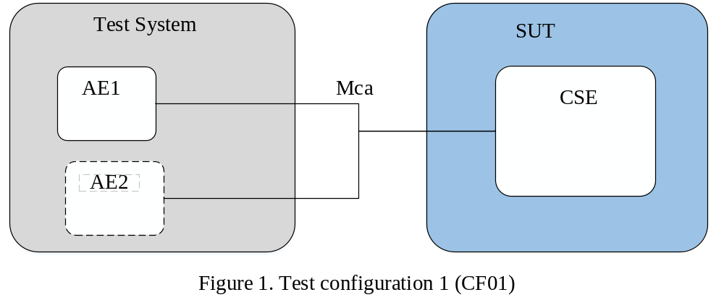
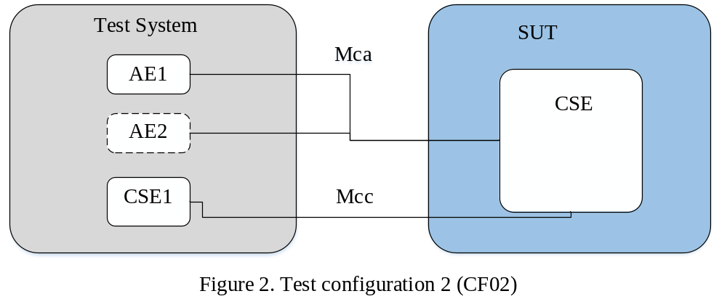
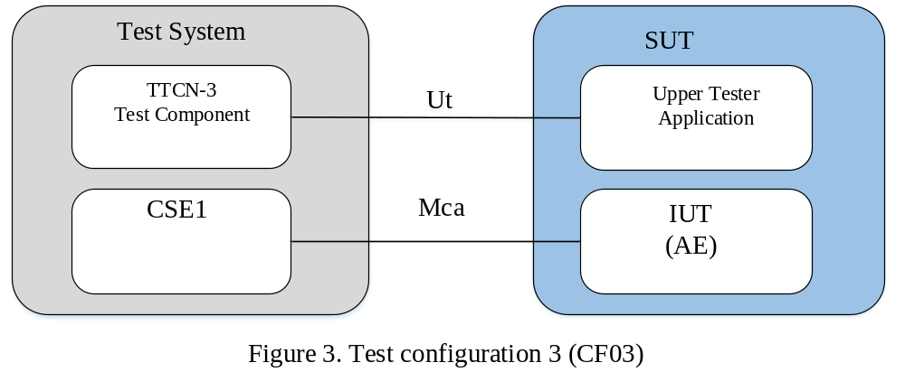
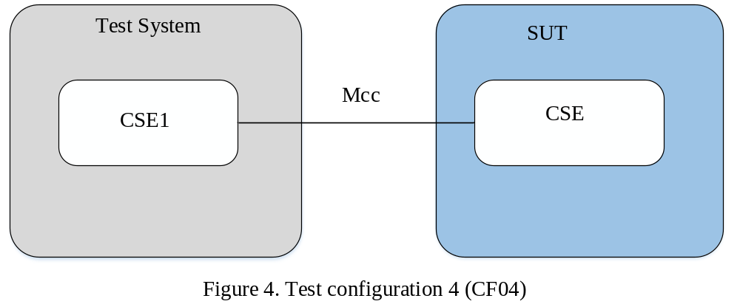

----------------------- End of change 2 -----------------------

----------------------- Start of change 2 -----------------------
TP Id |  | TP/oneM2M/CSE/DMR/RET/BV/015
Test objective |  | Check that the IUT returns successfully the ATTRIBUTE of TARGET_RESOURCE_ADDRESS resource (“To” option) under CSEBase
Reference |  | TS-0001 10.1.2
Config Id |  | CF02
PICS Selection |  | PICS_CSE
Initial conditions | with {  the IUT being in the "initial state"  and the IUT having registered the AE  and the IUT having created a resource TARGET_RESOURCE_ADDRESS of type RESOURCE_TYPE under the CSEBase resource  and the AE having privileges to perform RETRIEVE operation on the resource TARGET_RESOURCE_ADDRESS  }
Expected behaviour | Test events |  | Direction
Expected behaviour | when {  the IUT receives a valid RETRIEVE Request from AE containing  To set to TARGET_ATTRIBUTE_ADDRESS and  From set to AE_ID  } |  | IUT ← AE
Expected behaviour | then {  the IUT sends a valid Response containing  Response Status Code set to 2000 (OK) and  Content containing  RESOURCE_TYPE resource containing  valid ATTRIBUTE attribute  } |  | IUT → AE
Notes: TARGET_ATTRIBUTE_ADDRESS is represented as TARGET_RESOURCE_ADDRESS # ATTRIBUTE
ATTRIBUTE indicates common attribute for all RESOURCE_TYPE resources listed in the table below

TP Id |  | TP/oneM2M/CSE/DMR/RET/BV/016
Test objective |  | Check that the IUT returns successfully the ATTRIBUTE of TARGET_RESOURCE_ADDRESS resource (“Content” option) under CSEBase
Reference |  | TS-0001 10.1.2
Config Id |  | CF02
PICS Selection |  | PICS_CSE
Initial conditions | with {  the IUT being in the "initial state"  and the IUT having registered the AE  and the IUT having created a resource TARGET_RESOURCE_ADDRESS of type RESOURCE_TYPE under the CSEBase resource  and the AE having privileges to perform RETRIEVE operation on the resource TARGET_RESOURCE_ADDRESS  }
Expected behaviour | Test events |  | Direction
Expected behaviour | when {  the IUT receives a valid RETRIEVE Request from AE containing  To set to TARGET_RESOURCE_ADDRESS and  From set to AE_ID and  Content containing  attributeList element containing  ATTRIBUTE name  } |  | IUT ← AE
Expected behaviour | then {  the IUT sends a valid Response containing  Response Status Code set to 2000 (OK) and  Content containing  RESOURCE_TYPE resource containing  valid ATTRIBUTE attribute  } |  | IUT → AE
Notes: ATTRIBUTE indicates common attribute for all RESOURCE_TYPE resources listed in the table below

TP Id |  | TP/oneM2M/CSE/DMR/RET/BV/017
Test objective |  | Check that the IUT returns successfully multiple attributes of TARGET_RESOURCE_ADDRESS resource under CSEBase
Reference |  | TS-0001 10.1.2
Config Id |  | CF02
PICS Selection |  | PICS_CSE
Initial conditions | with {  the IUT being in the "initial state"  and the IUT having registered the AE  and the IUT having created a resource TARGET_RESOURCE_ADDRESS of type RESOURCE_TYPE under the CSEBase resource  and the AE having privileges to perform RETRIEVE operation on the resource TARGET_RESOURCE_ADDRESS  }
Expected behaviour | Test events |  | Direction
Expected behaviour | when {  the IUT receives a valid RETRIEVE Request from AE containing  To set to TARGET_RESOURCE_ADDRESS and  From set to AE_ID and  Content containing  attributeList element containing  ATTRIBUTE_1 name  and ATTRIBUTE_2 name  } |  | IUT ← AE
Expected behaviour | then {  the IUT sends a valid Response containing  Response Status Code set to 2000 (OK) and  Content containing  RESOURCE_TYPE resource containing  valid ATTRIBUTE_1 attribute and  valid ATTRIBUTE_2 attribute  } |  | IUT → AE
Notes: ATTRIBUTE_1 indicates common attribute for all RESOURCE_TYPE resources listed in the table below
ATTRIBUTE_2 indicates common attribute for all RESOURCE_TYPE resources listed in the table below

TP Id |  | TP/oneM2M/CSE/DMR/RET/BO/018
Test objective |  | Check that the IUT responds with an error when the AE tries to retrieve a non-existing attribute of the TARGET_RESOURCE_ADDRESS resource (“single” attribute case) under CSEBase
Reference |  | TS-0001 10.1.2
Config Id |  | CF02
PICS Selection |  | PICS_CSE
Initial conditions | with {  the IUT being in the "initial state"  and the IUT having registered the AE  and the IUT having created a resource TARGET_RESOURCE_ADDRESS of type RESOURCE_TYPE under the CSEBase resource containing  no attribute ATTRIBUTE  and the AE having privileges to perform RETRIEVE operation on the resource TARGET_RESOURCE_ADDRESS  }
Expected behaviour | Test events |  | Direction
Expected behaviour | when {  the IUT receives a valid RETRIEVE Request from AE containing  To set to TARGET_RESOURCE_ADDRESS and  From set to AE_ID and  Content containing  attributeList element containing  ATTRIBUTE name  } |  | IUT ← AE
Expected behaviour | then {  the IUT sends a valid Response containing  Response Status Code set to 4004 (NOT_FOUND)  } |  | IUT → AE

TP Id |  | TP/oneM2M/CSE/DMR/RET/BO/019
Test objective |  | Check that the IUT responds with an error when the AE tries to retrieve a non-existing attribute of the TARGET_RESOURCE_ADDRESS resource (“multiple” attributes case) under CSEBase
Reference |  | TS-0001 10.1.2
Config Id |  | CF02
PICS Selection |  | PICS_CSE
Initial conditions | with {  the IUT being in the "initial state"  and the IUT having registered the AE  and the IUT having created a resource TARGET_RESOURCE_ADDRESS of type RESOURCE_TYPE under the <CSEBase> resource containing  no ATTRIBUTE_1 attribute and  no ATTRIBUTE_2 attribute  and the AE having privileges to perform RETRIEVE operation on the resource TARGET_RESOURCE_ADDRESS  }
Expected behaviour | Test events |  | Direction
Expected behaviour | when {  the IUT receives a valid RETRIEVE Request from AE containing  To set to TARGET_RESOURCE_ADDRESS and  From set to AE_ID and  Content containing  attributeList element containing  ATTRIBUTE_1 name  and ATTRIBUTE_2 name  } |  | IUT ← AE
Expected behaviour | then {  the IUT sends a valid Response containing  Response Status Code set to 4004 (NOT_FOUND)  } |  | IUT → AE

TP Id |  | TP/oneM2M/CSE/REG/CRE/BI/001
Test objective |  | Check that the IUT rejects the create request of <CSEBase> resource.
Reference |  | TS-0001 10.2.3.1, TS-0001 9.6.3, TS-0004 7.4.3.2.1
Config Id |  | CF01
PICS Selection |  | PICS_CSE
Initial conditions | with {  the IUT being in the "initial state"  and the IUT having registered the AE  }
Expected behaviour | Test events |  | Direction
Expected behaviour | when {  the IUT receives a valid CREATE Request from AE containing  To set to CSEBASE_RESOURCE_ADDRESS and  Resource Type set to 5 (CSEBase) and  From set to AE-ID and  Content containing  CSEBase resource representation} |  | IUT ← AE
Expected behaviour | then {  the IUT sends a valid Response containing  Response Status Code set to 4005 (OPERATION_NOT_ALLOWED)  } |  | IUT → AE

TP Id |  | TP/oneM2M/CSE/REG/RET/BV/005
Test objective |  | Check that the IUT accepts a retrieval request of <CSEBase> resource including the cseType attribute
Reference |  | TS-0001 10.2.3.2, TS-0001 9.6.3, TS-0004 7.4.3.2.2
Config Id |  | CF01
PICS Selection |  | PICS_IN_CSE
Initial conditions | with {  the IUT being in the "initial state"  and the IUT having registered the AE  and the AE having privileges to perform RETRIEVE operation on the CSEBase resource  }
Expected behaviour | Test events |  | Direction
Expected behaviour | when {  the IUT receives a valid RETRIEVE Request from AE containing  To set to CSEBASE_RESOURCE_ADDRESS and  From set to AE_ID  } |  | IUT ← AE
Expected behaviour | then {  the IUT sends a valid Response containing  Response Status Code set to 2000 (OK) and  Content containing  CSEBase resource containing  cseType attribute set to 1 (IN_CSE)  } |  | IUT → AE

TP Id |  | TP/oneM2M/CSE/REG/RET/BV/006
Test objective |  | Check that the IUT accepts a retrieval request of <CSEBase> resource and responds with supportedResourceTypes attribute containing a list of the supported resources and pointOfAccess containing the list of physical addresses to be used by Registree to connect to this CSE (e.g. IP address, FQDN).
Reference |  | TS-0001 10.2.3.2, TS-0001 9.6.3, TS-0004 7.4.3.2.2
Config Id |  | CF01
PICS Selection |  | PICS_CSE
Initial conditions | with {  the IUT being in the "initial state"  and the IUT having registered the AE  and the AE having privileges to perform RETRIEVE operation on the CSEBase resource  }
Expected behaviour | Test events |  | Direction
Expected behaviour | when {  the IUT receives a valid RETRIEVE Request from AE containing  To set to CSEBASE_RESOURCE_ADDRESS and  From set to AE_ID  } |  | IUT ← AE
Expected behaviour | then {  the IUT sends a valid Response containing  Response Status Code set to 2000 (OK) and  Content containing  CSEBase resource containing  supportedResourceType set to PX_SRT  pointOfAccess set to PX_POA  } |  | IUT → AE

TP Id |  | TP/oneM2M/CSE/REG/UPD/BI/001
Test objective |  | Check that the IUT rejects the update request of <CSEBase> resource.
Reference |  | TS-0001 10.2.3.3, TS-0001 9.6.3, TS-0004 7.4.3.2.3
Config Id |  | CF01
PICS Selection |  | PICS_CSE
Initial conditions | with {  the IUT being in the "initial state"  and the IUT having registered the AE  }
Expected behaviour | Test events |  | Direction
Expected behaviour | when {  the IUT receives a valid UPDATE Request from AE containing  To set to CSEBASE_RESOURCE_ADDRESS and  From set to AE_ID and  Content containing CONTENT  } |  | IUT ← AE
Expected behaviour | then {  the IUT sends a valid Response containing  Response Status Code set to 4005 (OPERATION_NOT_ALLOWED)  } |  | IUT → AE

TP Id |  | TP/oneM2M/CSE/REG/DEL/BI/001
Test objective |  | Check that the IUT rejects the delete request of <CSEBase> resource.
Reference |  | TS-0001 10.2.3.4, TS-0001 9.6.3, TS-0004 7.4.3.2.4
Config Id |  | CF01
PICS Selection |  | PICS_CSE
Initial conditions | with {  the IUT being in the "initial state"  and the IUT having registered the AE  }
Expected behaviour | Test events |  | Direction
Expected behaviour | when {  the IUT receives a valid DELETE Request from AE containing  To set to CSEBASE_RESOURCE_ADDRESS and  From set to AE_ID  } |  | IUT ← AE
Expected behaviour | then {  the IUT sends a valid Response containing  Response Status Code set to 4005 (OPERATION_NOT_ALLOWED)  } |  | IUT → AE

TP Id |  | TP/oneM2M/CSE/DMR/RET/BV/013
Test objective |  | Check that the IUT returns successfully the TARGET_RESOURCE_ADDRESS resource under CSEBase
Reference |  | TS-0001 10.1.2
Config Id |  | CF02
PICS Selection |  | PICS_CSE
Initial conditions | with {  the IUT being in the "initial state"  and the IUT having registered the AE  and the IUT having created a resource TARGET_RESOURCE_ADDRESS of type RESOURCE_TYPE under the CSEBase resource  and the AE having privileges to perform RETRIEVE operation on the resource TARGET_RESOURCE_ADDRESS  }
Expected behaviour | Test events |  | Direction
Expected behaviour | when {  the IUT receives a valid RETRIEVE Request from AE containing  To set to TARGET_RESOURCE_ADDRESS and  From set to AE_ID  } |  | IUT ← AE
Expected behaviour | then {  the IUT sends a valid Response containing  Response Status Code set to 2000 (OK) and  Content containing  RESOURCE_TYPE resource representation  } |  | IUT → AE

TP Id |  | TP/oneM2M/CSE/REG/CRE/BI/010
Test objective |  | Check that the IUT rejects a create request of <AE> resource that doesn’t include the MANDATORY_ATTRIBUTE.
Reference |  | TS-0001 10.1.1.2.2, TS-0004 7.4.5.2.1
Config Id |  | CF01
PICS Selection |  | PICS_CSE
Initial conditions | with {  the IUT being in the "initial state" and  the IUT having preconfigured AE_ID_stem  }
Expected behaviour | Test events |  | Direction
Expected behaviour | when {  the IUT receives a valid CREATE Request from AE containing  To set to CSEBASE_RESOURCE_ADDRESS and  From set to AE_ID and  Resource Type set to 2(AE) and  Content containing  AE resource containing  no MANDATORY_ATTRIBUTE attribute  } |  | IUT ← AE
Expected behaviour | then {  the IUT sends a valid Response containing  Response Status Code set to 4000 (BAD Request)  } |  | IUT → AE

TP Id |  | TP/oneM2M/CSE/REG/CRE/BV/005
Test objective |  | Check that the IUT accepts a create request of <AE> resource with attributes multiplicity equals to 1 and asking an CSE relative AE_ID by indicating AE_ID_Stem with character ‘C’.
Reference |  | TS-0001 10.1.1.2.2 case c, TS-0004 7.4.5.2.1
Config Id |  | CF01
PICS Selection |  | PICS_CSE
Initial conditions | with {  the IUT being in the "initial state" and  the IUT having preconfigured AE_ID_stem  }
Expected behaviour | Test events |  | Direction
Expected behaviour | when {  the IUT receives a valid CREATE Request from AE containing  To set to CSEBASE_RESOURCE_ADDRESS and  From set to ‘C’ and  Resource Type set to 2(AE) and  Content containing  AE resource representation  } |  | IUT ← AE
Expected behaviour | then {  the IUT sends a valid Response containing  Response Status Code set to 2001 (CREATED) and  Content containing  AE resource containing  ResourceID attribute set to CSE_RELATIVE_AE_ID and  AE-ID attribute set to SP_RELATIVE_AE_ID  } |  | IUT → AE

TP Id |  | TP/oneM2M/CSE/REG/CRE/BV/006
Test objective |  | Check that the IUT accepts a create request of <AE> resource with attributes multiplicity equals to 1 and provided character ‘S’ in AE_ID_Stem ask for a SP_relative_AE_ID.
Reference |  | TS-0001 10.1.1.2.2 case a, TS-0004 7.4.5.2.1
Config Id |  | CF01
PICS Selection |  | PICS_MN_CSE or PICS_ASN_CSE
Initial conditions | with {  the IUT being in the "initial state" and  the IUT having preconfigured AE_ID_stem  }
Expected behaviour | Test events |  | Direction
Expected behaviour | when {  the IUT receives a valid CREATE Request from AE containing  To set to CSEBASE_RESOURCE_ADDRESS and  From set to character ‘S’ and  Resource Type set to 2(AE) and  Content containing  AE resource representation  } |  | IUT ← AE
Expected behaviour | then{  the IUT sends a valid CREATE Request to IN_CSE containing  To set to IN_CSEBASE_RESOURCE_ADDRESS and  From set to IUT_CSE_ID and  Content containing  AEAnnc resource containing  link attribute set to ‘S’  } |  | IUT → IN-CSE

TP Id |  | TP/oneM2M/CSE/REG/CRE/BV/008
Test objective |  | Check that the IUT accepts a create request of <AE> resource with attributes multiplicity equals to 1 without preference of format of AE_ID
Reference
Config Id |  | CF01
PICS Selection |  | PICS_CSE
Initial conditions | with {  the IUT being in the "initial state"  }
Expected behaviour | Test events |  | Direction

TP Id |  | TP/oneM2M/CSE/REG/CRE/BV/002
Test objective |  | Check that the IUT accepts a create request of <AE> resource with attributes multiplicity equals to 1 and provided preprovisioned AE_ID of CSE relative format.
Reference |  | TS-0001 10.1.1.2.2 case d, TS-0004 7.4.5.2.1
Config Id |  | CF01
PICS Selection |  | PICS_CSE
Initial conditions | with {  the IUT being in the "initial state" and  the IUT having preconfigured AE_ID_stem  }
Expected behaviour | Test events |  | Direction
Expected behaviour | when {  the IUT receives a valid CREATE Request from AE containing  To set to CSEBASE_RESOURCE_ADDRESS and  From set to CSE_RELATIVE_AE_ID and  Resource Type set to 2 (AE) and  Content containing  AE resource representation  } |  | IUT ← AE
Expected behaviour | then {  the IUT sends a valid Response containing  Response Status Code set to 2001 (CREATED) and  Content containing  AE resource representation  } |  | IUT → AE

TP Id |  | TP/oneM2M/CSE/REG/CRE/BV/003
Test objective |  | Check that the IUT accepts a create request of <AE> resource with attributes multiplicity equals to 1 and provided preprovisioned SP_relative_AE_ID.
Reference |  | TS-0001 10.1.1.2.2 case b, TS-0004 7.4.5.2.1
Config Id |  | CF01
PICS Selection |  | PICS_MN_CSE or PICS_ASN_CSE
Initial conditions | with {  the IUT being in the "initial state" and  the IUT having preconfigured AE_ID_stem and  the IUT having deregistrated the AE  }
Expected behaviour | Test events |  | Direction
Expected behaviour | when {  the IUT receives a valid CREATE Request from AE containing  To set to CSEBASE_RESOURCE_ADDRES and  From set to SP_RELATIVE_AE_ID and  Resource Type set to 2(AE) and  Content containing  AE resource representation  } |  | IUT ← AE
Expected behaviour | then{  the IUT sends a valid UPDATE Request to IN-CSE containing  To set to AEANNC_RESOURCE_ADDRESS and  From set to IUT_CSE_ID and  Content containing  AEAnnc resource representation  } |  | IUT → IN-CSE

TP Id |  | TP/oneM2M/CSE/REG/CRE/BV/009
Test objective |  | Check that the IUT accepts a create request of <AE> resource with attributes multiplicity equals to 1 and provided preprovisioned SP_relative_ AE_ID.
Reference |  | TS-0001 10.1.1.2.2 case b, TS-0004 7.4.5.2.1
Config Id |  | CF01
PICS Selection |  | PICS_IN_CSE
Initial conditions | with {  the IUT being in the "initial state" and  the IUT having preconfigured AE_ID_stem  }
Expected behaviour | Test events |  | Direction
Expected behaviour | when {  the IUT receives a valid CREATE Request from AE containing  To set to CSEBASE_RESOURCE_ADDRESS and  From set to SP_RELATIVE_CSE_ID and  Resource Type set to 2(AE) and  Content containing  AE resource representation  } |  | IUT ← AE
Expected behaviour | then {  the IUT sends a valid Response containing  Response Status Code set to 2001 (CREATED) and  Content containing  AE resource representation  } |  | IUT → AE

TP Id |  | TP/oneM2M/CSE/REG/CRE/BV/011
Test objective |  | Check that the IUT accepts a create request of <remoteCSE> resource with attributes multiplicity equals to 1.
Reference |  | TS-0001 10.1.1.2.1, TS-0004 7.4.5.2.2, TS-0001 9.6.4
Config Id |  | CF04
PICS Selection |  | PICS_CSE
Initial conditions | with {  the IUT being in the "initial state"  }
Expected behaviour | Test events |  | Direction
Expected behaviour | when {  the IUT receives a valid CREATE Request from CSE containing  To set to CSEBASE_RESOURCE_ADDRESS and  From set to CSE_ID and  Resource Type set to 16(remoteCSE) and  Content containing  remoteCSE resource representation  } |  | IUT ← CSE
Expected behaviour | then {  the IUT sends a valid Response containing  Response Status Code set to 2001 (CREATED) and  Content containing  remoteCSE resource representation  } |  | IUT → CSE

TP Id |  | TP/oneM2M/CSE/REG/CRE/BV/012
Test objective |  | Check that the IUT accepts a create request of <remoteCSE> resource with attributes multiplicity equals to 1 without the preconfigured CSE-ID
Reference |  | TS-0001 10.1.1.2.1, TS-0004 7.4.5.2.2, TS-0001 9.6.4
Config Id |  | CF04
PICS Selection |  | PICS_CSE
Initial conditions | with {  the IUT being in the "initial state"  }
Expected behaviour | Test events |  | Direction
Expected behaviour | when {  the IUT receives a valid CREATE Request from CSE containing  To set to ResourceID_of_CSEBase and  no From and  Resource Type set to 16(remoteCSE) and  Content containing  remoteCSE resource representation  } |  | IUT ← CSE
Expected behaviour | then {  the IUT sends a valid Response containing  Response Status Code set to 2001 (CREATED) and  Content containing  remoteCSE resource representation  } |  | IUT → CSE

TP Id |  | TP/oneM2M/CSE/REG/CRE/BV/015
Test objective |  | Check that the IUT accepts a create request of <remoteCSE> resource with OPTIONAL_ATTRIBUTE.
Reference |  | TS-0001 10.1.1.2.1, TS-0004 7.4.4.2.1, TS-0001 9.6.4
Config Id |  | CF04
PICS Selection |  | PICS_CSE
Initial conditions | with {  the IUT being in the "initial state"  }
Expected behaviour | Test events |  | Direction
Expected behaviour | when {  the IUT receives a valid CREATE Request from CSE containing  To set to CSEBASE_RESOURCE_ADDRESS and  From set to CSE_ID and  Resource Type set to 16(remoteCSE) and  Content containing  remoteCSE resource representation containing  OPTIONAL_ATTRIBUTE attribute  } |  | IUT ← CSE
Expected behaviour | then {  the IUT sends a valid Response containing  Response Status Code set to 2001 (CREATED) and  Content containing  remoteCSE resource representation  } |  | IUT → CSE

TP Id |  | TP/oneM2M/CSE/REG/RET/BV/008
Test objective |  | Check that the IUT accepts an retrieve request of <remoteCSE> resource.
Reference |  | TS-0001 10.1.1.2.1, TS-0004 7.4.4.2.1, TS-0001 9.6.4
Config Id |  | CF01
PICS Selection |  | PICS_CSE
Initial conditions | with {  the IUT being in the "initial state"  and the IUT having registered the ORIGINATOR  and the ORIGINATOR having privileges to perform RETRIEVE operation on the remoteCSE resource  }
Expected behaviour | Test events |  | Direction
Expected behaviour | when {  the IUT receives a valid RETRIEVE Request from ORIGINATOR containing  To set to REMOTECSE_RESOURCE_ADDRESS and  From set to ORIGINATOR_ID  } |  | IUT ← ORIGINATOR
Expected behaviour | then {  the IUT sends a valid Response containing  Response Status Code set to 2000 (OK) and  Content containing  remoteCSE resource representation  } |  | IUT → ORIGINATOR

TP Id |  | TP/oneM2M/CSE/DMR/CRE/BV/017
Test objective |  | Check that the IUT accepts the creation of a RESOURCE_TYPE resource with the optional attribute announcedAttribute provided
Reference |  | TS-0001 10.2.18.4, TS-0001 9.6.1.3.2-1 & TS-0004 7.3.3.10
Config Id |  | CF02
PICS Selection |  | PICS_CSE
Initial conditions |  | with {  the IUT being in the "initial state"  and the IUT having registered the AE  and the IUT having created and announced the PARENT_RESOURCE to the announcement target CSE  and the AE having privileges to perform CREATE operation on the resource PARENT_RESOURCE_ADDRESS  }
Expected behaviour |  | Test events |  | Direction
 | when {  the IUT receives a valid CREATE Request from AE containing  To set to PARENT_RESOURCE_ADDRESS and  From set to AE-ID and  Content containing  RESOURCE_TYPE resource containing  OA_ATTRIBUTE attribute set to VALUE and  announcedAttribute attribute set to OA_ATTRIBUTE and  announceTo attribute set to ANNC_TARGET_CSE_ADDRESS  } |  | IUT ← AE
 | then {  The IUT sends a valid CREATE Request containing  To set to ANNC_TARGET_CSE_ADDRESS and  Content containing  RESOURCE_TYPE announced variant resource containing  MA (mandatory) attributes and  OA_ATTRIBUTE attribute set to VALUE  } |  | IUT → CSE

TP Id | RESOURCE_TYPE | PICS
TP/oneM2M/CSE/DMR/CRE/BV/017_01 | container | PICS_IN_PROFILE
TP/oneM2M/CSE/DMR/CRE/BV/017_02 | contentInstance | PICS_IN_PROFILE
TP/oneM2M/CSE/DMR/CRE/BV/017_03 | group
TP/oneM2M/CSE/DMR/CRE/BV/017_04 | locationPolicy
TP/oneM2M/CSE/DMR/CRE/BV/017_05 | mgmtObj
TP/oneM2M/CSE/DMR/CRE/BV/017_06 | node
TP/oneM2M/CSE/DMR/CRE/BV/017_07 | schedule

TP Id |  | TP/oneM2M/CSE/SUB/BV/020
Test objective |  | Check that the IUT sends the latest notification to the subscriber resource when latestNotify is set to TRUE, the number value of the batchNotify attribute is set to GROUP_LIMIT and when this number has been reached
Reference |  | TS-0001 10.2.12.1
Config Id |  | CF01
PICS Selection |  | PICS_CSE
Initial conditions | with {  the IUT being in the "initial state"  and the IUT having registered the AE1  and the IUT having registered the AE2  and the AE1 having created a <subscribed-to type> resource containing  ATTRIBUTE_NAME set to VALUE_1 and  subscription child resource containing  notificationURI attribute set to AE2_RESOURCE_ADDRESS and  latestNotify attribute set to TRUE and  batchNotify attribute containing  number attribute set to GROUP_LIMIT and  duration attribute set to TIME_LIMIT  and the AE1 having privileges to perform RETRIEVE operation on the subscribed-to resource  and the IUT having received (GROUP_LIMIT – 1) valid UPDATE Requests from AE1_RESOURCE_ADDRESS to subscribed-to resource  and the timer has not reached the TIME_LIMIT duration value  }
Expected behaviour | Test events |  | Direction
Expected behaviour | when {  the IUT receives a valid UPDATE Request from AE1 containing  To set to SUBSCRIBED_TO_RESOURCE_ADDRESS and  From set to AE1_RESOURCE_ADDRESS and  Content containing  <subscribed-to type> resource containing  ATTRIBUTE_NAME attribute set to VALUE_N  } |  | IUT ← AE1
Expected behaviour | then {  the IUT sends a valid Response containing  Response Status Code set to 2004 (UPDATED)  and the IUT sends a NOTIFY Request contaning  Content containing  the latest notification message containing  notificationEvent attribute containing  representation attribute containing  <subscribed-to type> resource containing  All attributes  } |  | IUT → AE1  IUT → AE2

TP Id |  | TP/oneM2M/CSE/SUB/BV/007
Test objective |  | Check that the IUT sends a Notify request to the subscriber resource when eventType attribute is set to "Create_of_Direct_Child_Resource" and a create operation has been performed on the subscribed-to resource
Reference |  | TS-0001 9.6.8-3
Config Id |  | CF01
PICS Selection |  | PICS_CSE
Initial conditions | with {  the IUT being in the "initial state"  and the IUT having registered the AE1  and the IUT having registered the AE2  and the AE1 having created a <subscribed-to type> resource containing  subscription child resource containing  notificationURI attribute set to AE2_RESOURCE_ADDRESS and  eventNotificationCriteria attribute containing  notificationEventType set to 3 (Create_of_Direct_Child_Resource)  and the AE1 having privileges to perform RETRIEVE operation on the subscribed-to resource  }
Expected behaviour | Test events |  | Direction
Expected behaviour | when {  the IUT receives a valid CREATE Request from AE1 containing  To set to SUBSCRIBED_TO_RESOURCE_ADDRESS and  From set to AE1_RESOURCE_ADDRESS and  Content containing  CHILD_RESOURCE_TYPE resource containing  resourceName attribute set to NAME  } |  | IUT ← AE1
Expected behaviour | then {  the IUT sends a valid Response containing  Response Status Code set to 2001 (CREATED)  and the IUT sends a NOTIFY Request contaning  Content containing  Notification message containing  notificationEvent attribute containing  representation attribute containing  CHILD_RESOURCE_TYPE resource containing  All attributes  } |  | IUT → AE1  IUT → AE2

TP Id |  | TP/oneM2M/CSE/DIS/BV/001
Test objective |  | Check that the IUT returns successfully a list all discovered resource addresses
Reference |  | TS-0001 10.2.6 & TS-0004 7.2.3.13
Config Id |  | CF01
PICS Selection |  | PICS_CSE
Initial conditions | with {  the IUT being in the "initial state"  and the IUT having registered the AE  and the IUT having a container resource TARGET_RESOURCE_ADDRESS containing  a child resource and  the AE having privileges to perform RETRIEVE operation  }
Expected behaviour | Test events |  | Direction
Expected behaviour | when {  the IUT receives a valid RETRIEVE Request from AE containing  To set to TARGET_RESOURCE_ADDRESS and  From set to AE_ID and  Filter Criteria containing  filterUsage set to 1 (Discovery Criteria)  } |  | IUT ← AE
Expected behaviour | then {  the IUT sends a valid Response containing  Response Status Code set to 2000 (OK) and  Content containing  URIList representation  } |  | IUT → AE

TP Id |  | TP/oneM2M/CSE/DIS/BV/003
Test objective |  | Check that the IUT returns the empty address list when no result matching with filter criteria is discovered
Reference |  | TS-0001 8.1.3 & 10.2.6 & TS-0004 7.2.3.13
Config Id |  | CF01
PICS Selection |  | PICS_CSE
Initial conditions | with {  the IUT being in the "initial state"  and the IUT having registered the AE  and the IUT having a container resource TARGET_RESOURCE_ADDRESS containing  a child resource and  the AE having privileges to perform RETRIEVE operation  and FILTER_CRITERIA_CONDITIONS not being applicable to the IUT  }
Expected behaviour | Test events |  | Direction
Expected behaviour | when {  the IUT receives a valid RETRIEVE Request from AE containing  To set to TARGET_RESOURCE_ADDRESS and  From set to AE-ID and  Filter Criteria set to FILTER_CRITERIA_CONDITIONS containing  filterUsage set to 1 (Discovery Criteria)  } |  | IUT ← AE
Expected behaviour | then {  the IUT sends a valid Response containing  Response Status Code set to 2000 (OK) and  no Content  } |  | IUT → AE

TP Id |  | TP/oneM2M/CSE/DIS/BV/004
Test objective |  | Check that the IUT returns successfully a list of discovered resource addresses with Non-hierarchical addressing form when the Discovery Result Type is provided in the request
Reference |  | TS-0001 8.1.3 & 10.2.6 & TS-0004 7.2.3.13
Config Id |  | CF01
PICS Selection |  | PICS_CSE
Initial conditions | with {  the IUT being in the "initial state"  and the IUT having registered the AE  and the IUT having a container resource TARGET_RESOURCE_ADDRESS  containing  a child resource and  the AE having privileges to perform RETRIEVE operation  }
Expected behaviour | Test events |  | Direction
Expected behaviour | when {  the IUT receives a valid RETRIEVE Request from AE containing  To set to TARGET_RESOURCE_ADDRESS and  From set to AE-ID and  Discovery Result Type set to 2 (unstructured) and  Filter Criteria containing  filterUsage set to 1 (Discovery Criteria)  } |  | IUT ← AE
Expected behaviour | then {  the IUT sends a valid Response containing  Response Status Code set to 2000 (OK) and  Content containing  URIList representation containing  unstructured addresses of discovered resources  } |  | IUT → AE

TP Id |  | TP/oneM2M/CSE/DIS/BO/006
Test objective |  | Check that the IUT responds with an error when the AE sends requests to discover the resource TARGET_RESOURCE_ADDRESS which does not exist in the Hosting CSE
Reference |  | TS-0001 10.2.6.2, TS-0004 7.3.3.14
Config Id |  | CF01
PICS Selection |  | PICS_CSE
Initial conditions | with {  the IUT being in the "initial state"  and the IUT having registered the AE  and the IUT having not yet created a container resource TARGET_RESOURCE_ADDRESS  }
Expected behaviour | Test events |  | Direction
Expected behaviour | when {  the IUT receives a valid RETRIEVE Request from AE containing  To set to TARGET_RESOURCE_ADDRESS and  From set to AE_ID and  Filter Criteria containing  filterUsage set to 1 (Discovery Criteria)  } |  | IUT ← AE
Expected behaviour | then {  the IUT sends a valid Response containing  Response Status Code set to 4004 (NOT_FOUND)  } |  | IUT → AE

TP Id |  | TP/oneM2M/CSE/DIS/BI/007
Test objective |  | Check that the IUT responds the originator with an error when the originator sends a request including an invalid format of filter criteria to discover the resource TARGET_RESOURCE_ADDRESS
Reference |  | TS-0001 10.2.6, TS-0004 7.3.3.6
Config Id |  | CF01
PICS Selection |  | PICS_CSE
Initial conditions |  | with {  the IUT being in the "initial state"  and the IUT having registered the originator AE  and the IUT having a container resource TARGET_RESOURCE_ADDRESS containing  a child resource and  the AE having privileges to perform RETRIEVE operation  }
Expected behaviour | Test events |  | Direction
Expected behaviour | when {  the IUT receives a valid RETRIEVE Request from AE containing  To set to TARGET_RESOURCE_ADDRESS and  From set to AE_ID and  Filter Criteria set to FILTER_CRITERIA_CONDITIONS not being valid format  } |  | IUT ← AE
Expected behaviour | then {  the IUT sends a valid Response containing  Response Status Code set to 4102 (CONTENTS_UNACCEPTABLE)  } |  | IUT → AE

TP Id |  | TP/oneM2M/CSE/DIS/BV/002
Test objective |  | Check that the IUT returns successfully appropriate list of discovered resource when the filter criteria is provided in the request
Reference |  | TS-0001 8.1.3 & 10.2.6 & TS-0004 7.2.3.13
Config Id |  | CF01
PICS Selection |  | PICS_CSE
Initial conditions | with {  the IUT being in the "initial state"  and the IUT having registered the AE  and the IUT having a container resource TARGET_RESOURCE_ADDRESS containing  a child resource and  the AE having privileges to perform RETRIEVE operation  }
Expected behaviour | Test events |  | Direction
Expected behaviour | when {  the IUT receives a valid RETRIEVE Request from AE containing  To set to TARGET_RESOURCE_ADDRESS and  From set to AE-ID and  Filter Criteria set to FILTER_CRITERIA_CONDITIONS containing  filterUsage set to 1 (Discovery Criteria)  } |  | IUT ← AE
Expected behaviour | then {  the IUT sends a valid Response containing  Response Status Code set to 2000 (OK) and  Content containing  URIList representation  } |  | IUT → AE

TP Id |  | TP/oneM2M/CSE/DIS/BI/008
Test objective |  | Check that the IUT responds the originator with an error when the originator sends a request to discover the resource TARGET_RESOURCE_ADDRESS including two conflicted filter criteria of different type FILTER_CRITERIA_CONDITION_1 and FILTER_CRITERIA_CONDITION_2 (E.G. createBefore < createdAfter)
Reference |  | TS-0001 6.2.5, TS-0004 7.3.3.17
Config Id |  | CF01
PICS Selection |  | PICS_CSE
Initial conditions | with {  the IUT being in the "initial state"  and the IUT having registered the originator AE  and the IUT having a container resource TARGET_RESOURCE_ADDRESS containing  a child resource and  the AE having privileges to perform RETRIEVE operation  }
Expected behaviour | Test events |  | Direction
Expected behaviour | when {  the IUT receives a valid RETRIEVE Request from AE containing  To set to TARGET_RESOURCE_ADDRESS and  From set to AE_ID and  Filter Criteria containing  filterUsage set to 1 (Discovery Criteria) and  having conflict conditions  } |  | IUT ← AE
Expected behaviour | then {  the IUT sends a valid Response containing  Response Status Code set to 4102 (CONTENTS_UNACCEPTABLE)  } |  | IUT → AE

----------------------- End of change 2 -----------------------

CHECK LIST
- Does this change request include an informative introduction containing the problem(s) being solved, and a summary list of proposals.?
- Does this CR contain changes related to only one particular issue/problem?
- Does this change request make all the changes necessary to address the issue or problem? E.g. A change impacting 5 tables should not only include a proposal to change only 3 tables. Includes any changes to references, definitions, and acronyms in the same deliverable?
- Does this change request follow the drafting rules?
- Are all pictures editable?
- Have you checked the spelling and grammar?
- Have you used change bars for all modifications?
- Does the change include the current and surrounding clauses to clearly show where a change is located and to provide technical context of the proposed change? (Additions of complete sections need not show surrounding clauses as long as the proposed section number clearly shows where the new section is proposed to be located.)
- Are multiple changes in this CR clearly separated by horizontal lines with embedded text such as, start of change 1, end of change 1, start of new clause, end of new clause.?

