Input Contribution
Meeting ID* | TST34
Title:* | New test purposes for 3GPP triggering
Source:* | Flynn Bob, Convida Wireless, Flynn.Bob@convidawireless.com  Santhosh Kumar Jagadish <Santhosh.Jagadish@radisys.com>
Date:* | 2018-03-15
Input related to* | TS-0018 V3.0.0
Intended purpose of  document:* | Decision  Discussion  Information  Other <specify>
Impacted other TS/TR(s) | <TS/TR number>, <Version Number>, and <Description on which aspect should be reflected in this TS/TR>
Decision requested or recommendation:* | <A concise statement of the decision required or the recommended action to be taken>
Template Version: January 2017 (Do not modify)

oneM2M Notice
The document to which this cover statement is attached is submitted to oneM2M. Participation in, or attendance at, any activity of oneM2M, constitutes acceptance of and agreement to be bound by terms of the Working Procedures and the Partnership Agreement, including the Intellectual Property Rights (IPR) Principles Governing oneM2M Work found in Annex 1 of the Partnership Agreement.

Introduction
3GPP Interworking is provide in Release 3.0.
This contribution provides some test purposes for the triggering functionality.
Upon review of TS-0026, I found that many of the procedures do not allow for easy/reasonable testing. I am working on contributions to address that. In the meantime, I am writing a test purpose for a single purpose with the intent to be able to identify the additions needed to the test system.

One of the uses of the triggering request is to have the UE re-establish connectivity with the IN-CSE. There is an implicit form of this request (requestReachability is FALSE therefore the IN-CSE initiates the request). There is also an explicit form of this request, an AE sends a <triggerRequest> to the IN-CSE, which is then used by the IN-CSE to generate the request.
Added CFG05 – change 2
TP1 – Check that the IUT sends an explicit 3GPP Device Trigger Request when it receives a valid <triggerRquest> from an AE.
TP2 – Check that the IUT sends an implicit 3GPP Device Trigger Request when it receives a <notification> request targeted for an AE hosted on a UE.
Using – “3GPP” to represent 3GPP Interworking
Additional test purposes
- Check that the IUT sets the triggerStatus attribute of the <triggerRequest> to ERROR_NSE_NOT_FOUND when the SCEF does not respond to the Device Trigger Request prior to the timeout period.

- Check that the IUT sets the triggerStatus attribute of the <triggerRequest> to ERROR_NSE_NOT_FOUND when the SCEF is not reachable to IN-CSE when Device Trigger Request is sent prior to the timeout period.

- Check that the IUT sets the triggerStatus attribute of the <triggerRequest> to TRIGGER_FAILED when the SCEF sends failure statusCode in Device Trigger Response message.

- Check that the IUT sets the triggerStatus attribute of the <triggerRequest> to TRIGGER_FAILED on receiving Device Trigger Response message with error status(UNKNOWN, FAILURE, UNCONFIRMED, TERMINATE) in "deliveryResult" attribute.

- Check that the IUT sets the triggerStatus attribute of the <triggerRequest> to TRIGGER_EXPIRED on receiving Device Trigger Response message with "deliveryResult" attribute set to “EXPIRED”.

- Check that the IUT sets the triggerStatus attribute of the <triggerRequest> to TRIGGER_SUBMITTED on receiving Device Trigger Response message with "SUCCESS" status in "deliveryResult" attribute.

- Check that the IUT sets the triggerStatus attribute of the <triggerRequest> to TRIGGER_DELIVERED on receiving Device Trigger Notification with “SUCCESS” or “CONFIRMED” in “result” attribute.

- Check that the IUT sets the triggerStatus attribute of the <triggerRequest> to TRIGGER_FAILED on receiving Device Trigger Notification with error status(UNKNOWN, FAILURE, UNCONFIRMED, TERMINATE) in “result” attribute.

-----------------------Start of new text 1-------------------------------------------

TP/oneM2M/CSE/3GPP/001
TP Id |  | TP/oneM2M/CSE/3GPP/TRIG/001
Test objective |  | Check that the IUT sends an explicit 3GPP Device Trigger Request when it receives a valid <triggerRquest> from an AE.
Reference |  | TS-0026 7.5.1
Parent Release |  | Release 3
Config Id |  | CFG05
PICS Selection |  | PICS_CSE, PICS_3GPP
Initial conditions | with {  the IUT being in the "initial state"  and the IUT allowing to register an AE1  and the AE1 being hosted on a 3GPP UE  and the IUT allowing to register an AE2  }
Expected behaviour | Test events |  | Direction
Expected behaviour | when {  the IUT receives a valid CREATE request from AE2 containing  To set to AE2_RESOURCE_ADDRESS and  From set to AE2_ID and  Resource Type set to 38 (triggerRequest) and  Content containing  triggerRequest resource representation  } |  | IUT ← AE1
Expected behaviour | then {  the IUT sends a Request to the SCEF containing  3GPP Device Trigger Request message containing  A valid 3GPP Device Trigger Request containing  triggerPayload containing empty  } |  | IUT → SCEF

TP/oneM2M/CSE/3GPP/002
TP Id |  | TP/oneM2M/CSE/3GPP/TRIG/002
Test objective |  | Check that the IUT sends an implicit 3GPP Device Trigger Request when it receives a valid <notification> from an AE.
Reference |  | TS-0026 7.5.1
Parent Release |  | Release 3
Config Id |  | CF05
PICS Selection |  | PICS_CSE, PICS_3GPP
Initial conditions | with {  the IUT being in the "initial state"  and the IUT allowing to register an AE1  and the AE1 being hosted on a 3GPP UE  and the AE1 having subscribed to CONTAINER_RESOURCE_ADDRESS  and the AE1 being not reachable  and the IUT allowing to register an AE2  }
Expected behaviour | Test events |  | Direction
Expected behaviour | when {  the IUT receives the UPDATE request from the AE2 containing  To set to CONTAINER_RESOURCE_ADDRESS containing  From set to AE2_ID and  Content containing  container resource containing  valid labels attribute  } |  | IUT ← AE1
Expected behaviour | then {  the IUT sends a Request to the SCEF containing  3GPP Device Trigger Request message containing  A valid 3GPP Device Trigger Request containing  triggerPayload containing empty  } |  | IUT → SCEF

TP/oneM2M/CSE/3GPP/003
TP Id |  | TP/oneM2M/CSE/3GPP/TRIG/003
Test objective |  | Check that the IUT sets the triggerStatus attribute of the <triggerRequest> to ERROR_NSE_NOT_FOUND when the SCEF does not respond to the Device Trigger Request prior to the timeout period.
Reference |  | TS-0026 7.5.1
Parent Release |  | Release 3
Config Id |  | CFG05
PICS Selection |  | PICS_CSE, PICS_3GPP
Initial conditions | with {  the IUT being in the "initial state"  and the IUT allowing to register an AE1  and the AE1 being hosted on a 3GPP UE  and the IUT allowing to register an AE2  and the IUT having sent a 3GPP Device Trigger Request  }
Expected behaviour | Test events |  | Direction
Expected behaviour | when {  the IUT receives a valid CREATE request from AE2 containing  To set to AE2_RESOURCE_ADDRESS and  From set to AE2_ID and  Resource Type set to 38 (triggerRequest) and  Content containing  triggerRequest resource representation  } |  | IUT ← AE1
Expected behaviour | then {  the IUT sends a Request to the SCEF containing  3GPP Device Trigger Request message containing  A valid 3GPP Device Trigger Request containing  triggerPayload containing empty  } |  | IUT → SCEF

-----------------------End of new text 1---------------------------------------------

-----------------------Start of change 2-------------------------------------------

5.1 Test Configurations
Test configurations are defined to test different entities such as CSE and AE etc.
Figure 1 and Figure 2 show CSE test configurations where CSE as a IUT can be tested against TTCN-3 Test System, which is acting as AE or AE and CSE respectively. Test system may include as well other entities which are necessary for each configuration, i.e. a second AE (AE2) for receiving notifications These entities are represented with dashed rectangles.
Figure 3 shows AE test configuration (CF03) for ADN-AE testing scenario where ADN-AE is IUT and TTCN-3 Test System is acting as a CSE.
Figure 4 depicts test configurations between two CSEs, where one CSE is acting as a Test System, the other is SUT.

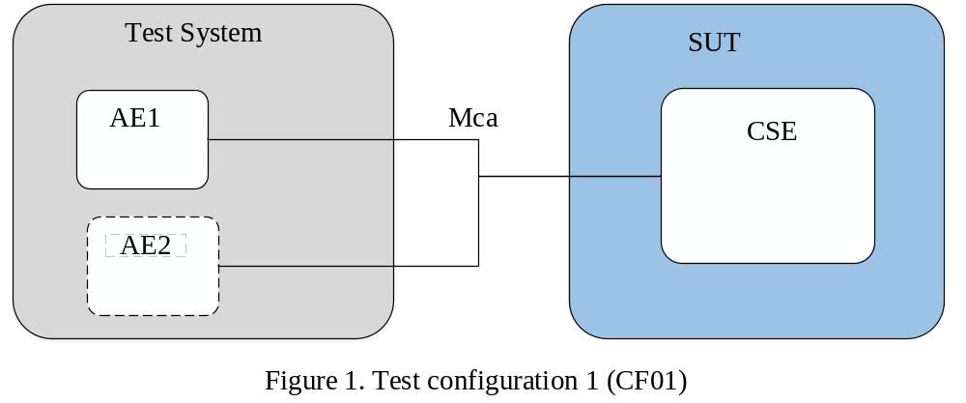
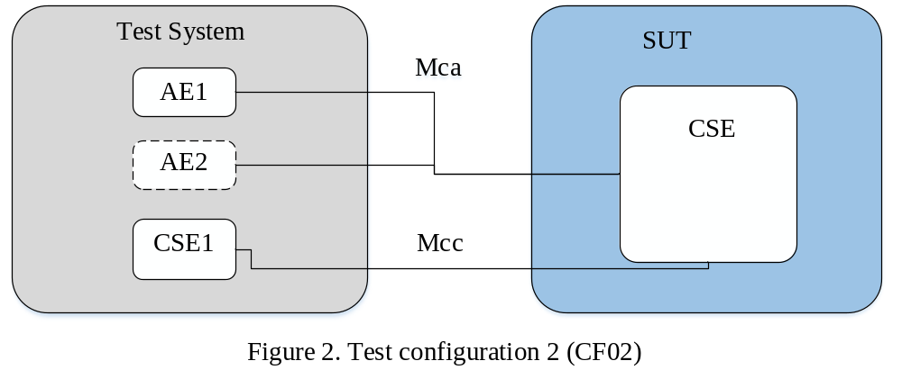
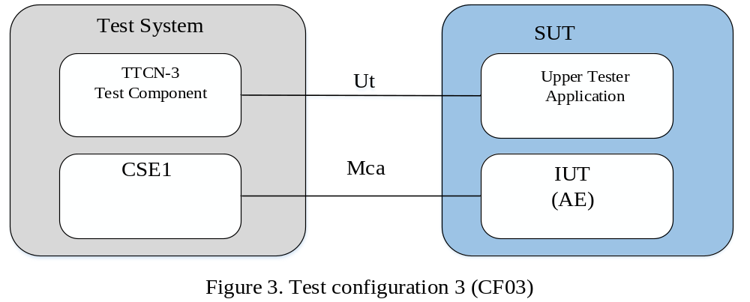
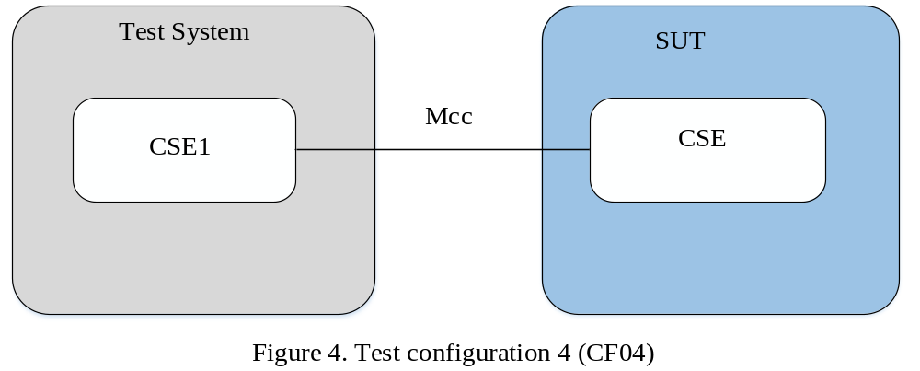
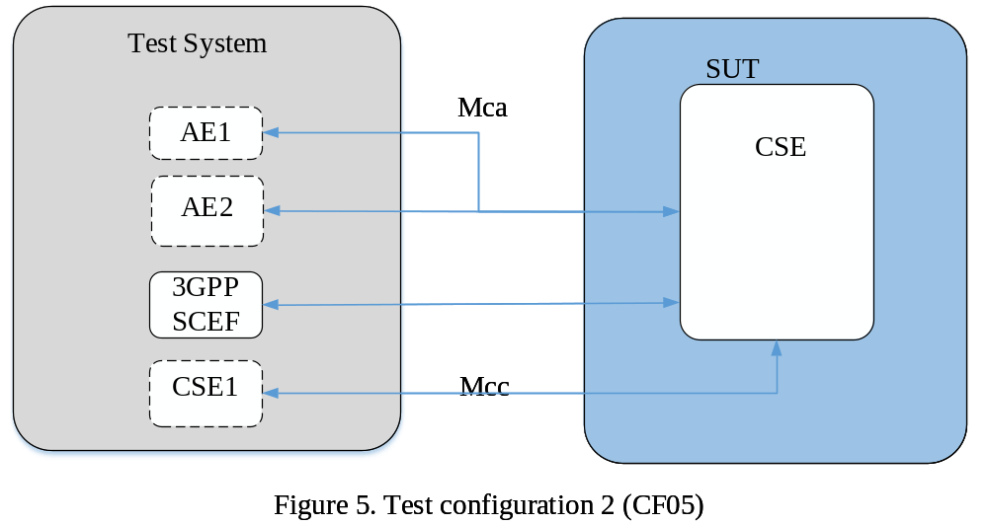

-----------------------End of change 2-------------------------------------------

-----------------------Start of change 3-------------------------------------------

Test Suite Structure (TSS) for oneM2M
The Test Suite Structure (TSS) for oneM2M will be present as bellow:
- Group 1: General Capability (GEN)
  - Subgroup 1.1: Protocol Bindings
  - Subgroup 1.2: Serializations

- Group 2: AE(AE)
  - Subgroup 2.1: General Capability (GEN)
  - Subgroup 2.2: Registration(REG)
  - Subgroup 2.3: Data Management and Repository(DMR)
  - Subgroup 2.4: Subscription and Notification(SUB)
  - Subgroup 2.5: Group Management(GMG)
  - Subgroup 2.6: Discovery(DIS)
  - Subgroup 2.7: Location(LOC)
  - Subgroup 2.8: Device Management(DMG)
  - Subgroup 2.9: Communication Management and Delivery Handling(CMDH)
  - Subgroup 2.10: Security(SEC)

- Group 3: CSE(CSE)
  - Subgroup 3.1 General Capability (GEN)
  - Subgroup 3.2: Registration(REG)
  - Subgroup 3.3: Data Management and Repository(DMR)
  - Subgroup 3.4: Subscription and Notification(SUB)
  - Subgroup 3.5: Group Management(GMG)
  - Subgroup 3.6: Discovery(DIS)
  - Subgroup 3.7: Location(LOC)
  - Subgroup 3.8: Device Management(DMG)
  - Subgroup 3.9: Communication Management and Delivery Handling(CMDH)
  - Subgroup 3.10: Security(SEC)
  - Subgroup 3.11: Resource Announcement (ANNC)
  - Subgroup 3.12: 3GPP Interworking (3GPP)

-----------------------End of change 3-------------------------------------------

