CHANGE REQUEST
Meeting:* | TST TP34
Source:* | BeiXu，Huawei，Echo.xubei@huawei.com
Date:* | 2018-02-20
Contact:* | BeiXu，Huawei，Echo.xubei@huawei.com
Reason for Change/s:* | Add new content for Usecase and Architecture Section
CR against: Release* | <Release3>
CR against: WI* | Active < WI-0058 - 3GPP_&_Cellular_IoT_IWK >  MNT Maintenace / < Work Item number(optional)>  STE Small Technical Enhancements / < Work Item number (optional)>  Only ONE of the above shall be ticked
CR against: TS/TR* | TR-0047-V0_0_2
Clauses/Sub Clauses*
Type of change: * | Editorial change  Bug Fix or Correction  Change to existing feature or functionality  New feature or functionality  Only ONE of the above shall be ticked
Post Freeze checking:* | This CR contains only essential changes and corrections? YES NO  This CR may break backwards compatibility with the last approved version of the TS? YES NO  This CR is a mirror CR? YES if YES, please indicate the document number of the original CR: <Document Number) : NO
Template Version:27 May 2015 (Dot not modify)

oneM2M Notice
The document to which this cover statement is attached is submitted to oneM2M. Participation in, or attendance at, any activity of oneM2M, constitutes acceptance of and agreement to be bound by terms of the Working Procedures and the Partnership Agreement, including the Intellectual Property Rights (IPR) Principles Governing oneM2M Work found in Annex 1 of the Partnership Agreement.
GUIDELINES for Change Requests:
Provide an informative introduction containing the problem(s) being solved, and a summary list of proposals.
Each CR should contain changes related to only one particular issue/problem.
In case of a correction, and the change apply to previous releases, a separated “mirror CR” should be posted at the same time of this CR
Follow the principle of completeness, where all changes related to the issue or problem within a deliverable are simultaneously proposed to be made E.g. A change impacting 5 tables should not only include a proposal to change only 3 tables. Includes any changes to references, definitions, and acronyms in the same deliverable.
Follow the drafting rules.
All pictures must be editable.
Check spelling and grammar to the extent practicable.
Use Change bars for modifications.
The change should include the current and surrounding clauses to clearly show where a change is located and to provide technical context of the proposed change. Additions of complete sections need not show surrounding clauses as long as the proposed section number clearly shows where the new section is proposed to be located.
Multiple changes in a single CR shall be clearly separated by horizontal lines with embedded text such as, start of change 1, end of change 1, start of new clause, end of new clause.
When subsequent changes are made to content of a CR, then the accepted version should not show changes over changes. The accepted version of the CR should only show changes relative to the baseline approved text.

Introduction
This CR is add content for procedure of UE reachability use case.

-----------------------Start of change 1-------------------------------------------

7 Procedures

7.1 UE Reachability monitoring

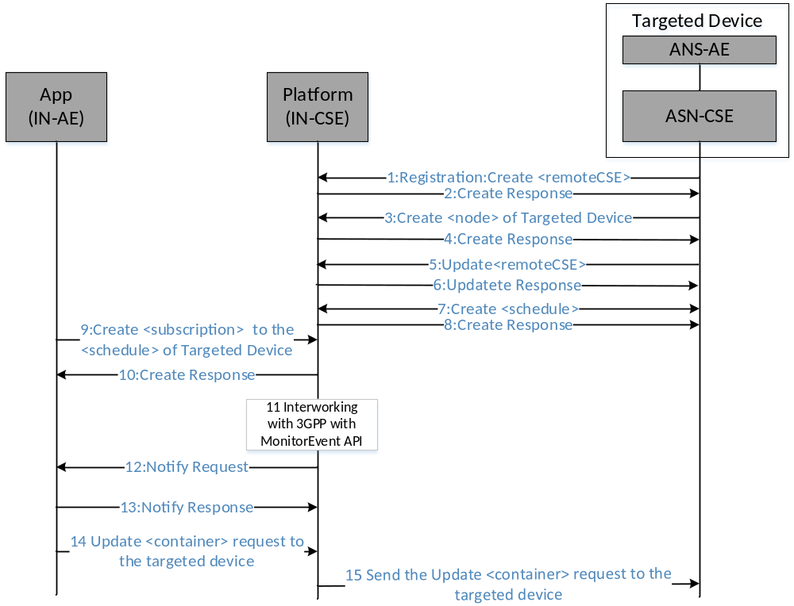
Figure: 7.1-1: Procedure of UE Reachability monitoring
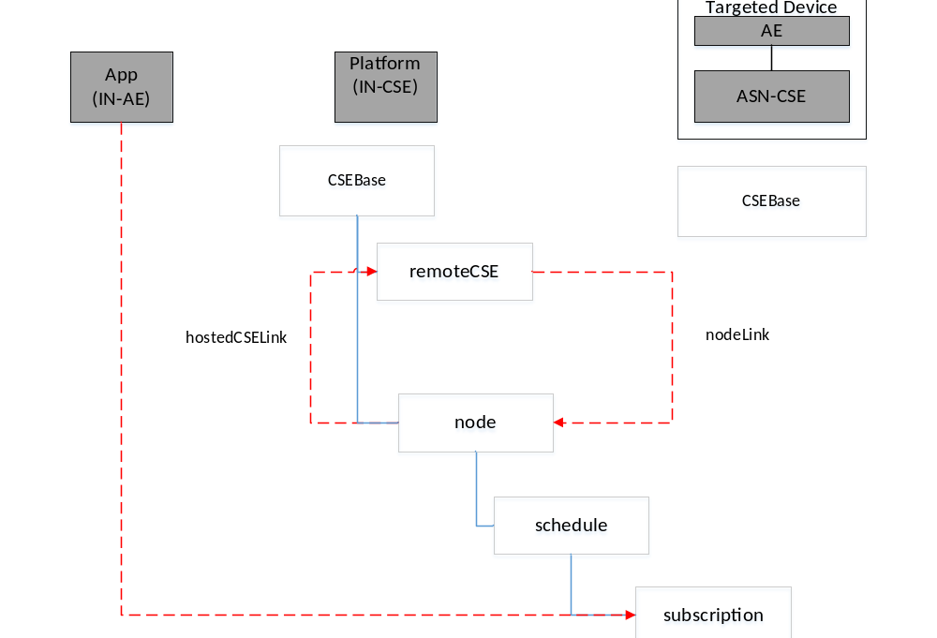 Figure: 7.1-2: Resource structure
1-2: The targeted device (ASN-CSE) with SIM Registers to the platform (IN-CSE) and creates the child resource <remoteCSE> of the resource <CSEBase>. The externalID of the <remoteCSE> should be pre-provsioned in 3GPP network.
3-4: The targeted device (ASN-CSE) creates the child resource <node> of the resource <CSEBase> in the platform (IN-CSE) which hostedCSELink is to its <remoteCSE>.
5-6: The targeted device (ASN-CSE) updats the attribute nodeLink of resource <remoteCSE> to link with the created <node> in step3.
7-8: The targeted device (ASN-CSE) creates the child resource <schedule> of the resource <node> in the platform (IN-CSE).
9-10: The application (IN-AE) creates a <subscription> to the ResourceID of <schedule> of the targeted device in the platform (IN-CSE).
11: The platform (IN-CSE) sends Monitoring Event Subscription to the 3GPP network to monitor the targeted device reachable status. And the platform updates the <schedule> when it receives Monitoring Event Notification from 3GPP network.
12: The platform (IN-CSE) sends the Notify request to the application about the reachable status of the targeted device when receving the notify from the 3GPP network and updating the <schedule>.
13: The application (IN-AE) sends the Notify response to the platform (IN-CSE).
14: The application (IN-AE) sends the <container> Update request including the control command to the targeted device according to the next reachable time of the <schedule>.
15: The platform (IN-CSE) sends the request to the targeted device directly.

-----------------------End of change 1---------------------------------------------

CHECK LIST
- Does this change request include an informative introduction containing the problem(s) being solved, and a summary list of proposals.
- Does this CR contain changes related to only one particular issue/problem?
- Have any mirror crs been posted?
- Does this change request make all the changes necessary to address the issue or problem? E.g. A change impacting 5 tables should not only include a proposal to change only 3 tables. Includes any changes to references, definitions, and acronyms in the same deliverable?
- Does this change request follow the drafting rules?
- Are all pictures editable?
- Have you checked the spelling and grammar?
- Have you used change bars for all modifications?
- Does the change include the current and surrounding clauses to clearly show where a change is located and to provide technical context of the proposed change? (Additions of complete sections need not show surrounding clauses as long as the proposed section number clearly shows where the new section is proposed to be located.)
- Are multiple changes in this CR clearly separated by horizontal lines with embedded text such as, start of change 1, end of change 1, start of new clause, end of new clause.?

