CHANGE REQUEST
Meeting ID:* | TST #37
Source:* | Bob Flynn(bob.flynn@convidawireless.com)
Date:* | 2018-09-10
Reason for Change/s:* | See Introduction
CR against: Release* | Release 3
CR against: WI* | Active <Work Item number>  MNT maintenance / < Work Item number(optional)>  Is this a mirror CR? Yes No  mirror CR number: (Note to Rapporteur - use latest agreed revision)  STE Small Technical Enhancements / < Work Item number (optional)>  Only ONE of the above shall be ticked
CR against: TS/TR* | TR-00XX
Clauses * | 5, 6, 7
Type of change: * | Editorial change  Bug Fix or Correction  Change to existing feature or functionality  New feature or functionality  Only ONE of the above shall be ticked
Impacted other TS/TR(s) | <TS/TR number>, <Version Number>, and <Description on which aspect should be reflected in this TS/TR>
Post Freeze checking:* | This CR contains only essential changes and corrections? YES NO  This CR may break backwards compatibility with the last approved version of the TS? YES NO
Template Version: January 2017 (Do not modify)

oneM2M Notice
The document to which this cover statement is attached is submitted to oneM2M. Participation in, or attendance at, any activity of oneM2M, constitutes acceptance of and agreement to be bound by terms of the Working Procedures and the Partnership Agreement, including the Intellectual Property Rights (IPR) Principles Governing oneM2M Work found in Annex 1 of the Partnership Agreement.
GUIDELINES for Change Requests:
Provide an informative introduction containing the problem(s) being solved, and a summary list of proposals.
Each CR should contain changes related to only one particular issue/problem.
In case of a correction, and the change apply to previous releases, a separate “mirror CR” should be posted at the same time of this CR
Mirror CR: applies only when the text, including clause numbering are exactly the same.
Companion CR: applies when the change means the same but the baselines differ in some way (e.g. clause number).
Follow the principle of completeness, where all changes related to the issue or problem within a deliverable are simultaneously proposed to be made E.g. A change impacting 5 tables should not only include a proposal to change only 3 tables. Includes any changes to references, definitions, and acronyms in the same deliverable.
Follow the drafting rules.
All pictures must be editable.
Check spelling and grammar to the extent practicable.
Use Change bars for modifications.
The change should include the current and surrounding clauses to clearly show where a change is located and to provide technical context of the proposed change. Additions of complete clauses need not show surrounding clauses as long as the proposed clause number clearly shows where the new clause is proposed to be located.
Multiple changes in a single CR shall be clearly separated by horizontal lines with embedded text such as, start of change 1, end of change 1, start of new clause, end of new clause.
When subsequent changes are made to content of a CR, then the accepted version should not show changes over changes. The accepted version of the CR should only show changes relative to the baseline approved text.

Introduction
During TP 36 we decided that this content does not fit into the existing structure of TR-0047 and that a new Dev Guide should be created.

This is reflected in the header information.

-----------------------Start of change 1-------------------------------------------

5. Use case

5.1 Overview
The oneM2M Service Layer can operate over a variety of underlying network connections. This guide focuses on describing a oneM2M based LPWAN Cellular IoT Deployment. The northbound API for applications to interface to a oneM2M Service Layer facilitates horizontal sharing of data across different domains. The services exposed by the oneM2M Service Layer allow working with many types of devices and treating different devices as if they are all the same. oneM2M can interwork to non-oneM2M device (OCF, LWM2M, zigbee, etc.), device management of the devices, grouping of devices, access controls for the devices and others.

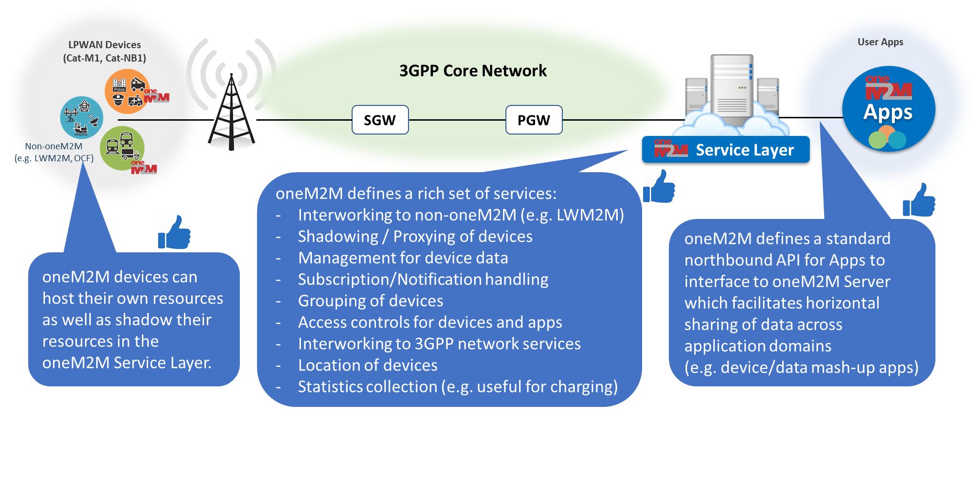
oneM2M Release 3 includes additional support for interworking to underlying 3GPP network services. The new services available support devices located in remote areas where low power and long battery life is necessary.
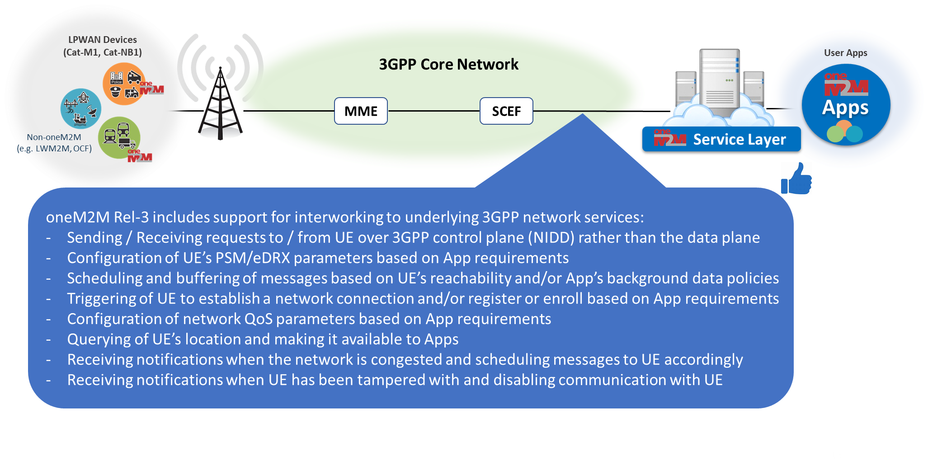

5.1.1 UE Provisioning and Deployment
When new UE based devices are deployed they can be provisioned remotely using the 3GPP identifier assigned by the core network service provider. Using oneM2M APIs a remote device can be provisioned with a designated registrar CSE as needed. Additionally, a device can be remotely reconfigured or decommissioned.

EDITOR’S NOTE – A figure showing remote deployment over a core network is needed
- triggering

5.1.2 UE Long-Life Operations
An AE or CSE hosted on a UE can meet the needs of many different types of use cases. The UE can run in an “always connected mode” that allows the AE or CSE to always be available or reachable from the IN-CSE. The UE can also run in an “connect when needed” mode where the device reachability can be scheduled by the IN-CSE, resulting in much lower power consumption and longer lifetime of the (assumed) battery supply. Using oneM2M APIs the IN-CSE can configure the UE to operate in the mode that best meets the requirements of the application while minimizing the power consumption of the device.

EDITOR’S NOTE: A figure showing the specification of communication patterns for two different device types
- Reachability monitoring
- NPC and communication patterns
- Triggering

5.2 Use Case
This developer’s guide describes how a smart meter system that utilizes the oneM2M 3GPP Interworking capabilities could be deployed. The procedures described can be applied to a variety of use cases such as electrical meters, water meters, parking meters or traffic lighting systems. The oneM2M 3GPP Interworking procedures described below show how to support device deployment and low-power/long battery life communications.
The scenario used to highlight the oneM2M 3GPP Interworking capabilities depicts an application such as a management console that is used to provision and monitor a group of UE devices (some may be NB-IoT devices). The management console communicates with the devices through the oneM2M Service Layer connected the 3GPP Core Network.
Each of these UE devices host a oneM2M ADN or ASN that performs application-specific logic.
EDITOR’S NOTE: Show a picture communicating over the 3GPP CN, with SCS/AS-INCSE an IN-AE (Management console) and devices – ADN and ASN

-----------------------End of change 1---------------------------------------------

-----------------------Start of change 2---------------------------------------------

6. Architecture
The oneM2M service layer can use several interfaces exposed by the 3GPP Core Network, as shown in Figure 1. The features that the 3GPP core network make available are described in clause 5.1.
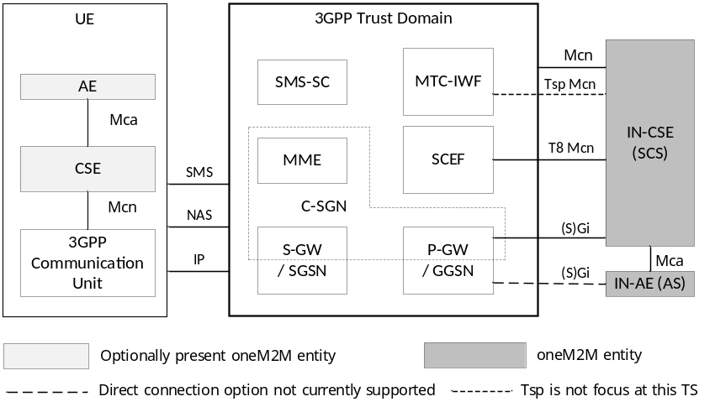
Figure 1
The oneM2M service layer exposes these features to applications through resources and operations, such that the specifics of the 3GPP core network APIs are not needed by the application developer. The goal of this document is to demonstrate the oneM2M resources and procedures that utilize the 3GPP core network APIs.
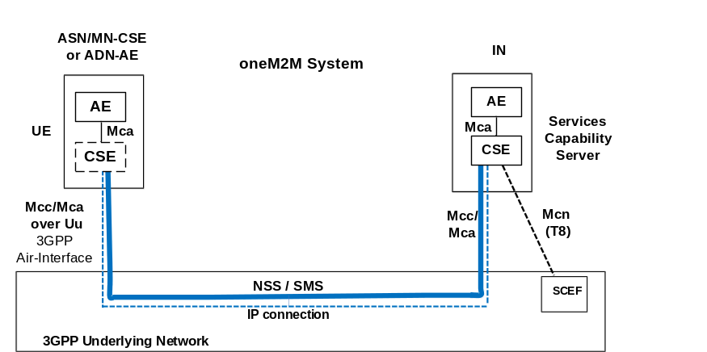
Figure 2

-----------------------End of change 2---------------------------------------------

-----------------------Start of change 3---------------------------------------------

7. Procedures
EDITORS NOTE: Some of the procedures for this use case are the same as described in other developer guides. They are repeated here to make this guide stand alone. If that is not achieved then duplicate procedures should be removed.

EDITORS NOTE: Each section should mention the 3GPP feature that enable or are triggered by the call flows, but this is not intended to show 3GPP call flows. We mention them to make sure that we cover everything that we want to highlight. We can reference TS-0026 if we want.
Need a good intro paragraph
- Management Console Registration: Same as other dev guides. Copy paste later
- Provisioning of UEs: Each UE has one or more AEs and/or a CSE hosted on the device.
  - Provision an AE
  - Provision an ASN / MN-CSE (I think they are the same)
  - Provision multiple AE
  - Provision AE(s) and MN-CSE on same device
  - Provision many devices at the same time (This may be going too far – a higher level API that we should consider, but not need for this Dev Guide)
We can describe some of the resources created in the CSE, like a node and schedule resources, but only as they apply to what the management console should need or be aware of.
- Configure Communication with devices (from 2): Activity Patterns of AE/CSE
  - Communications with these devices – various scenarios
  - Loss of connectivity
  - Reachability
  - Location reporting (one of the UEs should be mobile)
- Device Management – I am trying to use the multi-cast capability (MBMS/external group ID). This could be field domain resource.
  - Change of Registrar CSE
  - Change of CN provider
- Others???

7.1Provisioning of UEs
EDITORS NOTE:Will come back to this –

7.1 Configure Communications with UE devices
Remote devices can have a wide range of different communication patterns, for example the following case describe how often a device needs to be reachable for communication (sending messages to the device) [NOTE – this is for a request reachable device – if the device uses polling channel for requests, this model does not apply (the uplink configuration would have to describe this]:
- Application must always be reachable, for example a smart parkingmeter that has a web based interface for paying the fee which then updates the application with the duration/expiration time.
- Device must be reachable only for short durations periodically (frequently), for example control of a lights on a bridge that control the direction of traffic in the lanes
- Device must be reachable only for short durations periodically (infrequently), for example an environmental sensor in a remote location that reports measurements.
Like the request reachability, a device can have an uplink communication pattern as well, for example:
- Device sends messages periodically (frequently or infrequently) (always connected versus connect when data transfer needed)
- Device sends messages sporadically (as needed) (frequently or infrequently) for example road traffic sensor on a busy road versus and not busy road.
This clause shows how the management console application can describe these communication patterns so that the oneM2M IN-CSE can configure the UE (or the AEs/CSE) accordingly. [The uplink communication pattern is used to configure the AEs/CSE communication (when it sends messages) while the downlink communication pattern is used to configure the UE]
EDITORS NOTE: Add call flows

7.3 Communications with the AE/CSE hosted on a UE device
Communications with a oneM2M entity hosted on a UE device can occur over the following interfaces:
- Mca/Mcc – If the UE is in connected mode and the entity is Request Reachable, then messages targeted to the entity can occur using normal oneM2M Mca/Mcc interfaces.
- Mcn/NIDD – A primitive may be transmitting using the 3GPP SCEF Non-IP Data Delivery (NIDD) functionality.
- Mcn/Triggering – A primitive may be transmitted using implicit triggering enabled by the 3GPP SCEF API
This clause shows how an oneM2M entity hosted on a UE can be configured to receive communications using the above-mentioned interfaces and procedures.
EDITORS NOTE: Add call flows

7.x Call Flow x

-----------------------End of change 3---------------------------------------------

-----------------------Start of change 4---------------------------------------------

8 Implementation

8.1 Introduction
Clause 8 presents necessary procedures required for the implementation of the call flows described in clause 7, including conditions that must be met for the correct implementation of the current use case, and resource tree etc.

-----------------------End of change 4---------------------------------------------

-----------------------Start of change 4---------------------------------------------

-----------------------End of change 4---------------------------------------------

CHECK LIST
- Does this Change Request include an informative introduction containing the problem(s) being solved, and a summary list of proposals.?
- Does this CR contain changes related to only one particular issue/problem?
- Have any mirror CRs been posted?
- Does this Change Request make all the changes necessary to address the issue or problem? E.g. A change impacting 5 tables should not include a proposal to change only 3 tables?Does this Change Request follow the drafting rules?
- Are all pictures editable?
- Have you checked the spelling and grammar?
- Have you used change bars for all modifications?
- Does the change include the current and surrounding clauses to clearly show where a change is located and to provide technical context of the proposed change? (Additions of complete clauses need not show surrounding clauses as long as the proposed clause number clearly shows where the new clause is proposed to be located.)
- Are multiple changes in this CR clearly separated by horizontal lines with embedded text such as, start of change 1, end of change 1, start of new clause, end of new clause.?

