Input Contribution
Meeting ID* | RDM#40
Title:* | Use case: Sending Data between Edge/Fog Nodes for Continuous Service.
Source:* | Youngjin Na, Hyundai Motors, yjra@hyundai.com  Minbyeong Lee, Hyundai Motors, minbyeong.lee@hyundai.com  JaeSeung Song, KETI, jssong@sejong.ac.kr
Date:* | 2019-05-20
Input related to* | TR-0026, Adding new use case about Sending Data between Edge/Fog Nodes for Continuous Service.
Intended purpose of  document:* | Decision  Discussion  Information  Other <specify>
Impacted other TS/TR(s) | TR-0052
Decision requested or recommendation:* | Add new use case of Sending Data between Edge/Fog Nodes for Continuous Service to TR-0026.
Template Version: January 2017 (Do not modify)

oneM2M Notice
The document to which this cover statement is attached is submitted to oneM2M. Participation in, or attendance at, any activity of oneM2M, constitutes acceptance of and agreement to be bound by terms of the Working Procedures and the Partnership Agreement, including the Intellectual Property Rights (IPR) Principles Governing oneM2M Work found in Annex 1 of the Partnership Agreement.

6.XX Sending Data between Edge/Fog Nodes for Continuous Service.

6.XX.1 Description
Vehicle is requested for reliable and safety because it moves dynamic and fast on the road (e.g. highway). So the vehicle (e.g. V2X communication) should be supported continuous service when it is driving and communicating.
For example, there is a vehicle passing by around the Edge/Fog Node A of VRU (Vulnerable Road User) situation.
The Edge/Fog Node A is received data from the Cloud Node by offloading service. The Edge/Fog Node A analyses the road information data (e.g. other vehicles, pedestrian) which is collected by the vehicle. When the vehicle moves from the Edge/Fog Node A to the Edge/Fog Node B, the Edge/Fog Node A sends the data to the Edge/Fog Node B directly without passing the Cloud Node. And when the vehicle arrives around the Edge/Fog Node B, it is received the data from the Edge/Fog Node B. This process can reduce the communication load and keep low latency.
Then the Edge/Fog Node A sends the updated data to the Cloud Node for synchronization.
For continuity of service, it supports service by transmitting between the Edge/Fog nodes without transmitting through Cloud Node.

6.XX.2 Source
RDM-2019-00XX Use case of Sending Data between Edge/Fog Nodes for Continuous Service.

6.XX.3 Actors
- Vehicle: It is an application which is located on the road.
- Edge/Fog Node: It is the Node which computes, stores and analyses data. It is located between Cloud Nodes and end devices.
- Cloud Node: It is the Nodes which manage Edge/Fog Nodes, maintain database of Edge/Fog Nodes and interacts with Application Provider.
- RSU: It is located along vehicular paths and provides connection between vehicles and Edge/Fog Node in a RSU network.

6.XX.4 Pre-conditions
- A vehicle is equipped with sensor and device for road data collect and analysis.

6.XX.5 Triggers
- When the vehicle moves from the Edge/Fog Node A to the Edge/Fog Node B, the Edge/Fog Node A sends the data to the Edge/Fog Node B directly without passing the Cloud Node.

6.XX.6 Normal Flow
- The Cloud Node offloads the Edge/Fog Node information to the Edge/Fog Node B.
- A vehicle collects new data on the road and sends the data to RSU and Edge/Fog Node A.
- After the Edge/Fog Node A analyses the road information data (e.g. other vehicles, pedestrian) which is collected by the vehicle, the Edge/Fog Node A sends the data to Edge/Fog Node B.
- The Edge/Fog Node A sends the data to the Cloud Node for synchronization.
- The Cloud Node offloads the Edge/Fog Node information to the Edge/Fog Node B.
- The Edge/Fog Node B sends the data to the moving application.
- The vehicle collects another new data on the road and sends the data to RSU and Edge/Fog Node B.
- After the Edge/Fog Node A analyses the road information data which is collected by the vehicle, the Edge/Fog Node B sends the data to Edge/Fog Node C.
- The Edge/Fog Node B sends the data to the Cloud Node for synchronization.
- The Cloud Node offloads the Edge/Fog Node information to the Edge/Fog Node B.
- The Edge/Fog Node B sends the data to the moving application.
- The Edge/Fog Node A sends the data to the Cloud Node for synchronization.
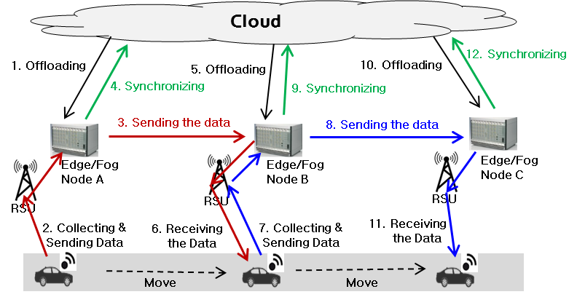
Figure 6.XX.6.1 : Normal Flow - Sending data between Edge/Fog Nodes for continuous service

6.XX.7 Alternative Flow
None

6.XX.8 Post-conditions
None

6.XX.9 High Level Illustration
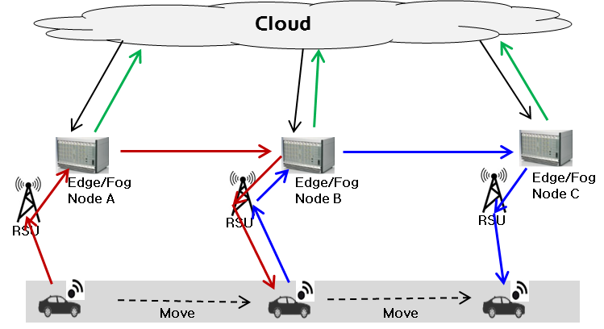
Figure 6.XX.9.1 : High Level Illustration - Sending data between Edge/Fog Nodes for continuous service

6.XX.10 Potential requirements
- The oneM2M System shall enable to send data between Edge/Fog Nodes for continuous service support.
- The oneM2M System shall enable to synchronize data between Edge/Fog Node and Cloud Node when send data between Edge/Fog Nodes.

