-----------------------------------------------------Start of Change----------------------------------------------------------

Input Contribution
Meeting ID* | RDM#40
Title:* | Use case: Offloading with Service Continuity between Edge/Fog Nodes
Source:* | Youngjin Na, Hyundai Motors, yjra@hyundai.com  Minbyeong Lee, Hyundai Motors, minbyeong.lee@hyundai.com  JaeSeung Song, KETI, jssong@sejong.ac.kr
Date:* | 2019-05-20
Input related to* | TR-0026, Adding a new use case about Offloading Service Continuity between Edge/Fog Nodes.
Intended purpose of  document:* | Decision  Discussion  Information  Other <specify>
Impacted other TS/TR(s) | TR-0052
Decision requested or recommendation:* | Add new use case of Sending Data between Edge/Fog Nodes for Continuous Service to TR-0026 Rel-4
Template Version: January 2017 (Do not modify)

oneM2M Notice
The document to which this cover statement is attached is submitted to oneM2M. Participation in, or attendance at, any activity of oneM2M, constitutes acceptance of and agreement to be bound by terms of the Working Procedures and the Partnership Agreement, including the Intellectual Property Rights (IPR) Principles Governing oneM2M Work found in Annex 1 of the Partnership Agreement.

6.XX Offloading Service Continuity between Edge/Fog Nodes

6.XX.1 Description
Vehicular application require fast and reliable communications to ensure safety in very dynamic scenarios (e.g. highway driving). In such conditions supporting continuity of service relies upon optimizations throughout the platform or system, including deployments using offloading at Edge/Fog nodes.
For example, in a VRU (Vulnerable Road User) situation where a vehicle communicates temporarily with Edge/Fog Node A .
The Edge/Fog Node A receives data from the Cloud Node by offloading service. The Edge/Fog Node A analyses the road information data (e.g. other vehicles, pedestrian) which is collected by the vehicle. When the vehicle moves from the Edge/Fog Node A to the Edge/Fog Node B, the offloaded instances running on Edge/Fog Node A should be moved to Edge/Fog Node B without affecting the service. at the same time, when the vehicle is connected to Edge/Fog Node B, it should receive the service from Edge/Fog Node B not from Edge/Fog A.
Edge/Fog offloading should be enabled in order to reduce communication loads and reduce latencies while also ensuring service continuity. by enabling direct communication between adjacent Edge/Fog nodes and synchronization with the central cloud platform .

6.XX.2 Source
RDM-2019-0048R02 Use case of Offloading Service Continuity between Edge/Fog Nodes

6.XX.3 Actors
- Vehicle: Mobile unit travelling along the road.
- Edge/Fog Node: Node which computes, stores and analyses data. It is located between Cloud Nodes and end devices.
- Cloud Node: Centralized Nodes which manages Edge/Fog Nodes, maintains database of Edge/Fog Nodes and interacts with Application Provider.
- RSU: It is located along vehicular paths and provides connection between vehicles and hosts an Edge/Fog Node in a RSU network.

6.XX.4 Pre-conditions
- A vehicle is equipped with sensor for road data collect and analysis and communication capabilities.
- Service related resources are offloaded to RSU hosting Edge/Fog A by the IoT Cloud Node.

6.XX.5 Triggers
- When the vehicle moves from the Edge/Fog Node A to the Edge/Fog Node B, the Edge/Fog Node A sends the data to the Edge/Fog Node B directly without passing the Cloud Node.

6.XX.6 Normal Flow
- The Cloud Node offloads service information to the Edge/Fog Node A.
- A vehicle collects new data on the road and sends the data to the RSU hosting Edge/Fog Node A who analyses the road information data (e.g. other vehicles, pedestrian) which is collected by the vehicle.
- As the vehicle comes in range of other RSUs, the Cloud Node and Edge/Fog Node A make a decision to move offloaded resources to Edge/Fog Node B Then the Edge/Fog Node A sends the data to Edge/Fog Node B.
- The Edge/Fog Node A sends some parts of collected data to the Cloud Node for synchronization.
- The Cloud Node offloads the Edge/Fog Node information to the Edge/Fog Node B to support offloading with service continuity.
- The Edge/Fog Node B sends the data to the application on the moving vehicle.
- The vehicle collects another new data on the road and sends the data to RSU hosting Edge/Fog Node B.
- After the Edge/Fog Node B analyses the road information data which is collected by the vehicle, the Edge/Fog Node B sends the data to Edge/Fog Node C.
- The Edge/Fog Node B sends the data to the Cloud Node for synchronization.
- The Cloud Node offloads the Edge/Fog Node information to the Edge/Fog Node C.
- The Edge/Fog Node C sends the data to the moving application.
- The Edge/Fog Node C sends the data to the Cloud Node for synchronization.
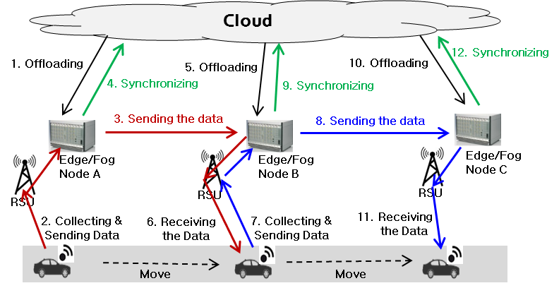
Figure 6.XX.6.1 : Normal Flow – Offloading with Service Continuity between Edge/Fog Nodes

6.XX.7 Alternative Flow
None

6.XX.8 Post-conditions
None

6.XX.9 High Level Illustration
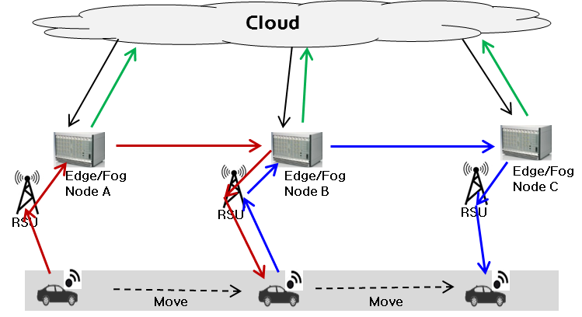
Figure 6.XX.9.1 : High Level Illustration - Offloading with Service Continuity between Edge/Fog Nodes

6.XX.10 Potential requirements
- The oneM2M System shall enable migration of data and context information between Edge/Fog Nodes for continuous services support.
- The oneM2M System shall enable synchronization data between Edge/Fog Node and Cloud Node when migrating data and context information between Edge/Fog Nodes.

-----------------------------------------------------End of Change----------------------------------------------------------

