Input Contribution
Meeting ID* | RDM41
Title:* | Update the figure of AutomationML base structure
Source:* | Chengsui Lu, Hitachi, cslu@hitachi.cn
Date:* | 2019-07-09
Input related to* | WI-0075 Industrial Domain Information Model Mapping & Semantics Support  TR-0049 Industrial Domain Information Model Mapping & Semantics Support
Intended purpose of  document:* | Decision  Discussion  Information  Other <specify>
Impacted other TS/TR(s) | N/A
Decision requested or recommendation:* | To agree on the figure update for AutomationML overview section.
Template Version: January 2017 (Do not modify)

oneM2M Notice
The document to which this cover statement is attached is submitted to oneM2M. Participation in, or attendance at, any activity of oneM2M, constitutes acceptance of and agreement to be bound by terms of the Working Procedures and the Partnership Agreement, including the Intellectual Property Rights (IPR) Principles Governing oneM2M Work found in Annex 1 of the Partnership Agreement.

7.2 AutomationML information model

Editors’ note: The copyright of figures need to be checked with OPC specifications [i.7].

7.2.1 AutomationML Overview

-----------------------Start of Change 1-------------------------------------------
AutomationML (AML) [i.7, i.10] is a scalable, open, neutral, XML based, extendable, and free data exchange format, standardized in IEC 62714. It has been developed in order to support the data exchange in a heterogeneous engineering tools landscape by enabling a discipline and company crossing transfer of engineering data between software tools - in a consistent manner and without data loss. The goal of AutomationML is to interconnect engineering tools in their different disciplines, e.g. plant planning, mechanical engineering, electrical engineering, process engineering, process control engineering, HMI development, PLC programming, robot programming.
With the meta-model, that AML provides, production system structures can be modelled expressed as a hierarchy of AutomationML objects. They can contain geometry and kinematics, logic data (behaviour and sequencing), and relations among AutomationML objects as well as references to information that is stored in external documents. Following this object-oriented paradigm, each AutomationML object can integrate different information with different semantics related to different disciplines and provides an overview of the distributed document architecture of AML.
CAEX (Computer Aided Engineering eXchange), standardized in IEC 62424, is the top level format of AML and is characterized by the four following concepts (see Figure 7.2.1-1), where the AML objects are represented as InternalElements (IE).
- By using RoleClasses (RC), semantics for AML objects can be modeled. RoleClasses describe functions of a physical or logical object independent of a technical implementation. They offer a possibility to specify an object in an abstract way and independent of the manufacturer. They are stored in RoleClass libraries.
- By using InterfaceClasses (IC), the semantics for the interfaces of AML objects can be modeled. InterfaceClasses describe relations of physical or logical objects or references to documents independent of a technical implementation. They are stored in interface class libraries.
- By using SystemUnitClasses (SUC), types or templates of AML objects can be modeled. They are stored in system unit class libraries.
- The InstanceHierachy (IH) stores the actual project.

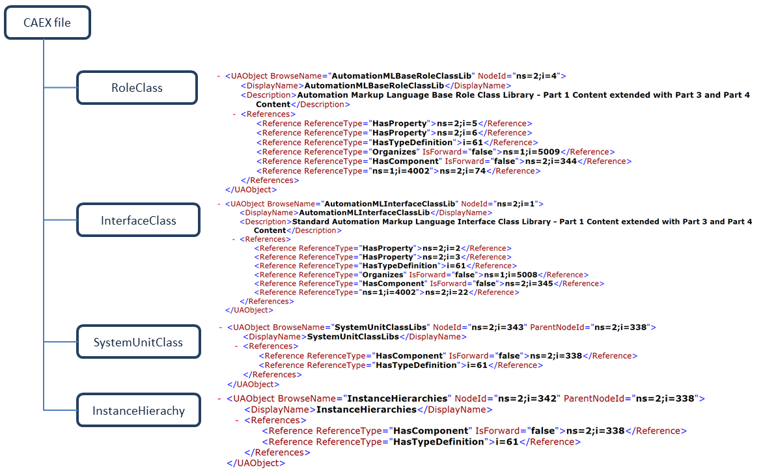
Figure 7.2.1-1: AutomationML base structure
For a consistent data exchange, an object identification concept is essential. The concept, AML provides, specifies that every object shall have an UUID (Universally Unique IDentifier), which shall be kept as long as the object exists. With this ID persistence, it is possible to identify a certain AML object throughout its entire life cycle.
AML mechanism to reference external documents enables the integration of further information aspects to AML objects. Therefore, it provides a special set of interface classes and role classes being used to uniquely identify the document type and the semantics of attached information, e.g. ecl@ss by means of semantic referencing. In case the referenced document has a unique identification concept for its content, also a referencing into the referenced document is possible. Besides AML meta-model, there is the specification for the data exchange format available as well. Since AML is an XML based format, XML specific features are available, like XML encryption, XML signature, or XML serialization.

----------------------- End of Change 1-------------------------------------------

