Input Contribution
Meeting ID* | RDM#42
Title:* | Use case: Vehicle Idling Alarming Service
Source:* | Minbyeong Lee, Hyundai Motor Company, minbyeong.lee@hyundai.com  Youngjin Na, Hyundai Motor Company, yjra@hyundai.com  JaeSeung Song, KETI, jssong@sejong.ac.kr
Date:* | 2019-09-23
Input related to* | TR-0026, Adding a new use case about Vehicle Idling Alarming Service.
Intended purpose of  document:* | Decision  Discussion  Information  Other <specify>
Impacted other TS/TR(s) | TR-00
Decision requested or recommendation:* | Add a new use case,“Vehicle Idling Alarming Service”, to TR-0026 Rel-5.
Template Version: January 2017 (Do not modify)

oneM2M Notice
The document to which this cover statement is attached is submitted to oneM2M. Participation in, or attendance at, any activity of oneM2M, constitutes acceptance of and agreement to be bound by terms of the Working Procedures and the Partnership Agreement, including the Intellectual Property Rights (IPR) Principles Governing oneM2M Work found in Annex 1 of the Partnership Agreement.

6.XX Vehicle Idling Alarming Service

6.XX.1 Description
When a vehicle using a push button starter does not turn off its engine in a parking lot harmful exhaust fume from the vehicle is emitted, which have been linked to many human health problems such as cancer and asthma. The vehicle idling (i.e. running a vehicle’s engine while it is in stationary) causes exhaust gas poisoning and air pollution. It is one of the important environment issues in many countries. Therefore, many countries have regulations limiting idling of some or all vehicles. Nowadays, several car makers provide a function called “automatic ignition shut-off”, which automatically shut-off the engine when the vehicle is at rest during the given amount of time from the user. However, if the user is not staying in the vehicle, there is no way to know whether the operation is successful.
Therefore, if the engine of vehicle is “on” in a parking lot during the configured amount of time and the automatic ignition shut-off function is properly executed, the driver better to know about the status of the execution. For example, when the time for Idling is set to 5 minutes, the user receives an alarm about the Idling via the IoT platform.
For this automatic ignition shut-off, an idling vehicle sends the data (e.g. status of engine, idling time) to the IoT platform periodically. Then the IoT platform internally checks the current idling time with the configured the idling time of the vehicles (e.g. idling duration more than 5 minutes). If the condition is satisfied, the IoT platform sends an alarm to the user’s device about the result of the automatic ignition shut-off execution.
Figure 6.XX.1.1 : Vehicle Idling problem

6.XX.2 Source
RDM-2019-0048R0

6.XX.3 Actors
- Vehicle: A mobile unit travelling along the road.
- IoT Platform: A platform collecting data related to vehicle idling time.
- User: A driver who receives an alarm about the status of vehicle idling.

6.XX.4 Pre-conditions
- The data (e.g. ID) of vehicle is registered in the IoT platform.
- The user sets the notification condition about idling time of the vehicle in the IoT platform.
- The vehicle can confirm its idling status.

6.XX.5 Triggers
- If the vehicle idles more than 5 minutes, the notification condition is satisfied. When the condition of the notification is satisfied, the IoT platform notifies to the user’s device.

6.XX.6 Normal Flow
- The user subscribes to notify the idling time of the vehicle to the IoT platform if the notification condition is satisfied.
- The vehicle sends the data (e.g. status of engine, idling time) to the IoT platform periodically.
- The IoT platform checks the idling time of the vehicle and notification condition (e.g. idling duration more than 5 minutes).
- If the condition is satisfied, the IoT platform notifies to the user’s device.
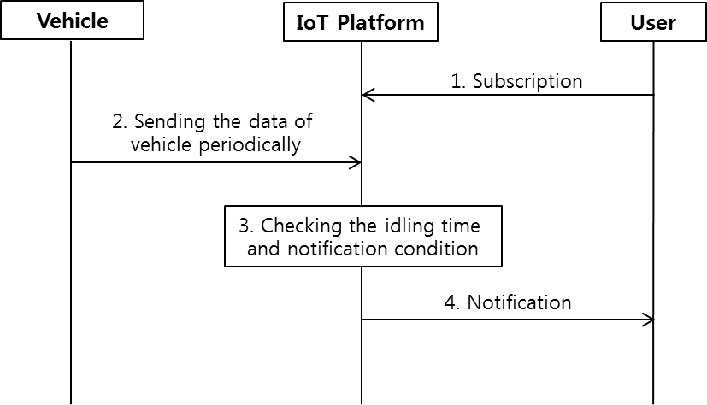
Figure 6.XX.6.1 : Normal Flow – Vehicle Idling Alarming Service

6.XX.7 Alternative Flow
None

6.XX.8 Post-conditions
None

6.XX.9 High Level Illustration
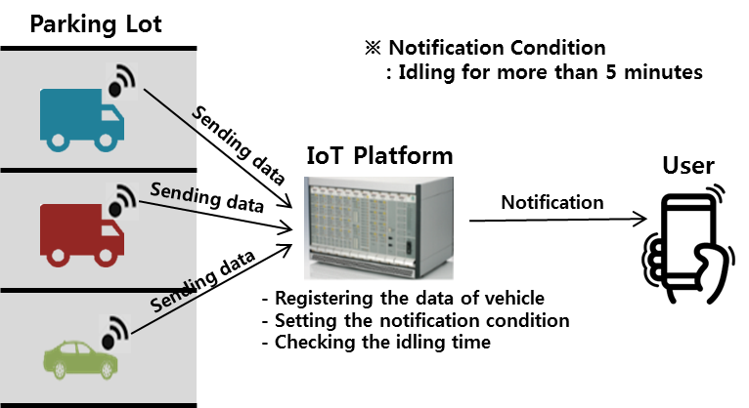
Figure 6.XX.9.1 : High Level Illustration – Vehicle Idling Alarming Service

6.XX.10 Potential Requirements
- The oneM2M system shall enable notification when the condition is maintained for pre-defined time.

