Input Contribution
Meeting ID* | RDM 43
Title:* | Industrial Domain Ontology Mapping
Source:* | Chengsui Lu, Hitachi, cslu@hitachi.cn
Date:* | 2019-12-4
Input related to* | WI-0075 Industrial Domain Information Model Mapping & Semantics Support  TR-0049 Industrial Domain Information Model Mapping & Semantics Support
Intended purpose of  document:* | Decision  Discussion  Information  Other <specify>
Impacted other TS/TR(s) | <TS/TR number>, <Version Number>, and <Description on which aspect should be reflected in this TS/TR>
Decision requested or recommendation:* | To agree on the industrial domain ontology mapping solution between OPC-UA Information Models and oneM2M Base Ontologies.
Template Version: January 2017 (Do not modify)

oneM2M Notice
The document to which this cover statement is attached is submitted to oneM2M. Participation in, or attendance at, any activity of oneM2M, constitutes acceptance of and agreement to be bound by terms of the Working Procedures and the Partnership Agreement, including the Intellectual Property Rights (IPR) Principles Governing oneM2M Work found in Annex 1 of the Partnership Agreement.

8.2 Semantics support by oneM2M
Editors’ note: This sub-clause studies how advanced semantics features in oneM2M e.g. data annotation could enable the industrial domain.

-----------------------Start of Change 1-------------------------------------------
To support semantics features, e.g. semantic reasoning, semantic mashup, etc., in the industrial domain, this clause indicates how map OPC-UA IMs [i.5] to oneM2M Base Ontologies [i.13] represented as OWL file according to the definition of each IM and ontology, as shown in Table 8.2-1.
- OPC-UA Object is mapped to oneM2M Device, similarly as in the subclause 8.1.1.
- OPC-UA ObjectType is mapped to oneM2M Thing, which is a superclass of Device.

- OPC-UA VariableType, which represents the type definition for an OPC-UA Variable, is mapped to oneM2M VariableConversion.
- AOPC-UA DataType, which are used to describe the structure of Variables, is mapped to oneM2M Variable.
- OPC-UA Variable is mapped as oneM2M MetaData, which represents the value.
- OPC-UA Method is mapped to oneM2M Service, which has Object Properties of hasOperation and exposesFunction.
Note 1: OPC-UA ReferenceType is suggested to map with hasThingRelation, that is one of Object Properties of Thing.
Note 2: OPC-UA View is suggested to map to the mashup of a certain group of hasThingRelation.
Table 8.2-1: Mapping Principle between OPC-UA IMs and oneM2M Base Ontologies
OPC-UA IM | oneM2M Base Ontologies
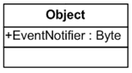 | 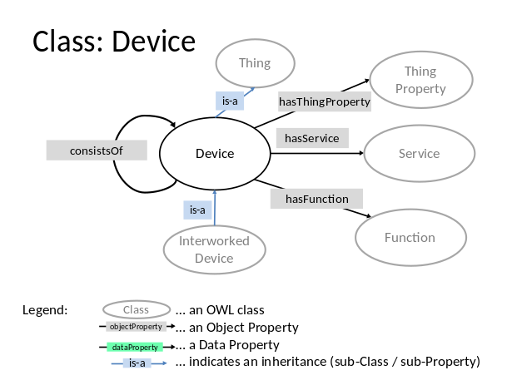
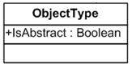 | 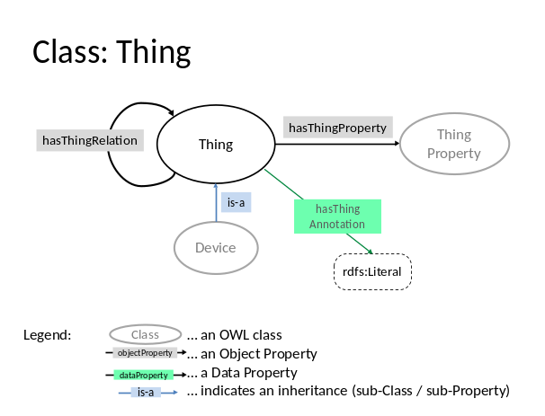
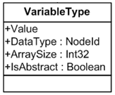 | 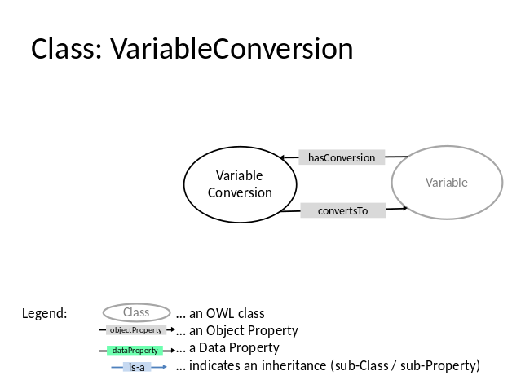
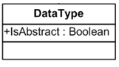 | 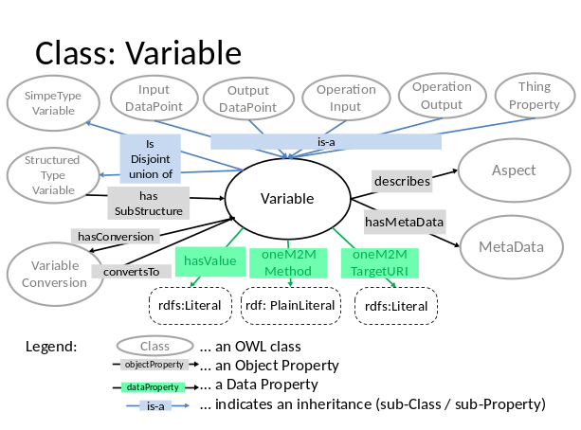
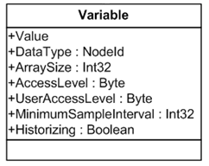 | 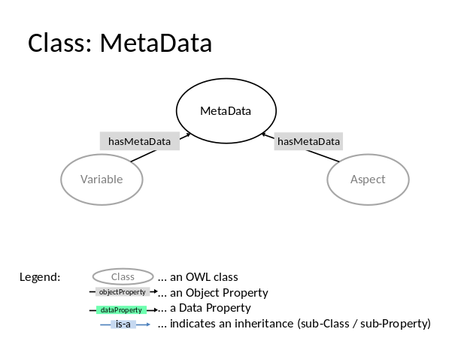
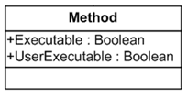 | 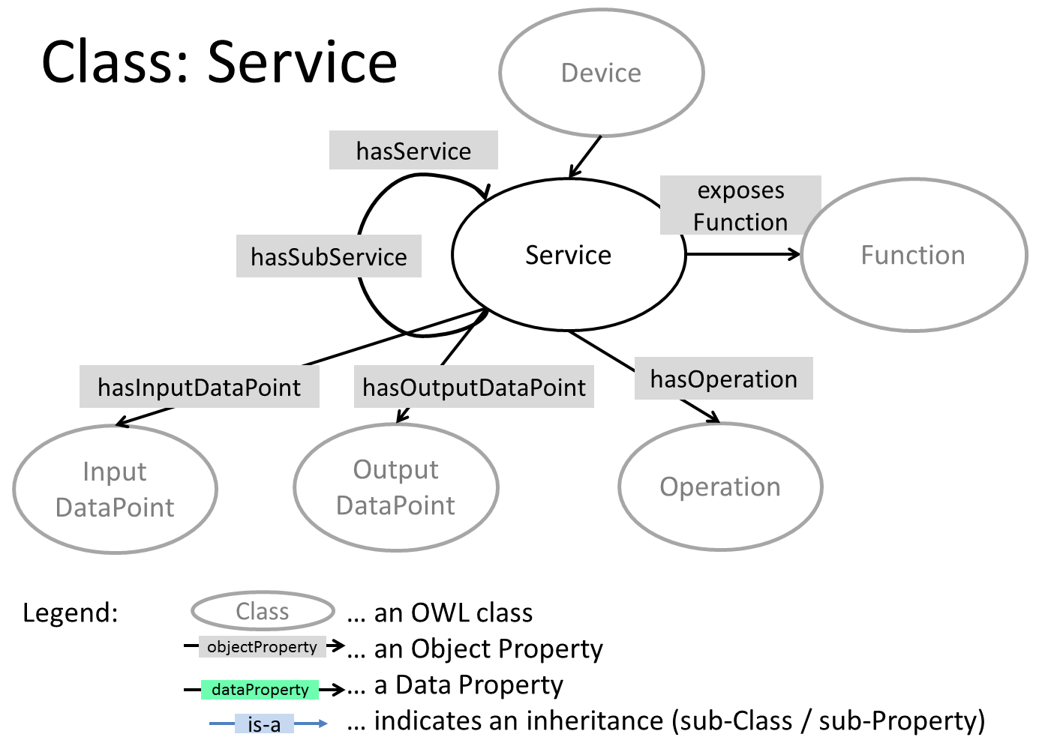
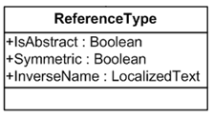 | Thing Object Properties: hasThingRelation
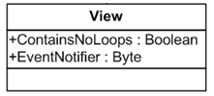 | Mashup of hasThingRelation of Thing Object Properties

Based on the above mapping principle between OPC-UA IMs and oneM2M Base Ontologies, OPC-UA could semantically interwork with oneM2M following [i.14]. Then semantics enhancements [i.15] could be enabled, e.g. semantic access control, semantic query, semantic reasoning, etc., for the industrial domain.

----------------------- End of Change 1-------------------------------------------

-----------------------Start of Change 2-------------------------------------------

2.2 Informative references
[i.13] oneM2M TS-0012: "Base Ontology".
[i.14] oneM2M TS-0030: "Ontology based Interworking".
[i.15] oneM2M TS-0034: "Semantics Support".

----------------------- End of Change 2-------------------------------------------

