Input Contribution
Meeting ID* | RDM#43
Title:* | Wildfire alert service with edge gateway
Source:* | In Song Lee, KETI, insong@keti.re.kr  NakMyoung Sung, KETI, nmsung@keti.re.kr  SeungMyeong Jeong, KETI, sm.jeong@keti.re.kr
Date:* | 2019-12-06
Input related to* | TR-0001 V4.3.0
Intended purpose of  document:* | Decision  Discussion  Information  Other <specify>
Impacted other TS/TR(s)
Decision requested or recommendation:*
Template Version: November 2018 (do not modify)

oneM2M Notice
The document to which this cover statement is attached is submitted to oneM2M. Participation in, or attendance at, any activity of oneM2M, constitutes acceptance of and agreement to be bound by terms of the Working Procedures and the Partnership Agreement, including the Intellectual Property Rights (IPR) Principles Governing oneM2M Work found in Annex 1 of the Partnership Agreement.

Introduction
This contirubtion is containing use case of wildfire alert service with edge gateway.
Please find the detail from the below contents.

=========================== Start of new text1 ===========================

12.xx Wildfire alert service with edge gateway

12.xx.1 Description
Wildfire alert service is designed to detect the fire in advance. The service is provided over the selected area which can be the village, heritage site etc. Once the area is selected, drones distribute sensors over the area. To gather the CO₂ and temperature measurement data from the sensors, edge gateways are installed in the area. When the gateway receive the data from the sensor, the gateway processes the raw data with several functions using machine learning module. Extracting the raw data/transforming into the standardized model, locating the fire, removing malfunction data are performed by the machine learning module. Then the processed data is sent to M2M platform. The platform is connected to the national disaster management system to share the emergency information with relavent stakeholders.

12.xx.2 Source
N/A

12.xx.3 Actors
- disposable IoT sensor: measures CO₂ and temperature periodically to make sure the sensor is working properly.
- edge gateway: serves as a bridge between sensors and the M2M platform. Furthermore, this gateway processes raw data from the sensors and reports it to the platform.
- M2M platform: provides IoT common services functions (e.g. data sharing, subscription/notification).
- local government: sends public warning message as well as cooperates with forestry administration and fire department.

12.xx.4 Pre-conditions
- Sensors report measurement data to the gateway periodically. It gets stored in the M2M platform.
- Each disposable sensor has data container on the M2M platform to save the sensor readings.
- Data models and resource structures are defined on the gateway.
- Sensors are spread over the area and registered to the gateway. The gateway choose the right data model to save the data such as device information, measured data. The data is sent to the M2M platform with the chosen data model.
- Public warning service provider sets subscriptions so that the local government systems can receive notifications in case of emergency

12.xx.5 Triggers
- CO₂ level and temperature get higher than certain threshold(s).

12.xx.6 Normal Flow
1. When the wildfire outbreaks, the sensors near the fire can detect the radical changes of temperature and CO2.
2. The edge gateway verifies that there ourbreaks the wildfire by the machine learning module.
3. The gateway reports information of the fire, such as location of the fire, status of wildfire to the M2M platform.
4. The M2M platform sends the message contains warning information to the local government.
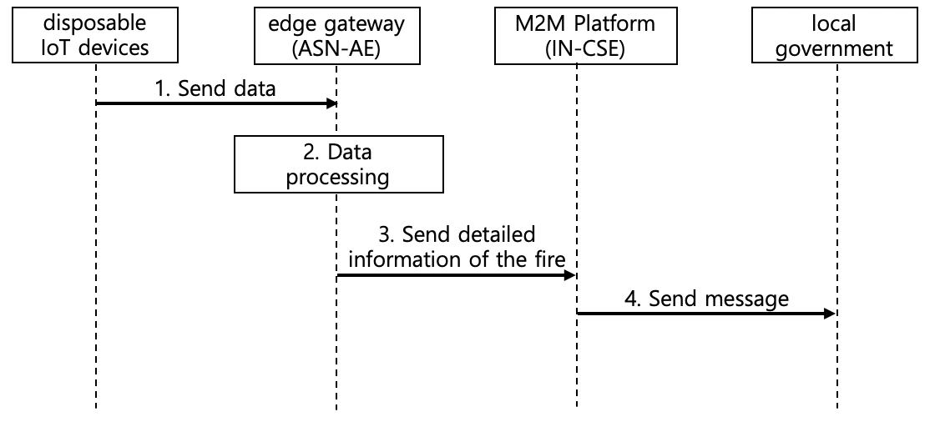

12.xx.7 Alternative Flow
None

12.xx.8 Post-conditions
N/A

12.xx.9 High Level Illustration
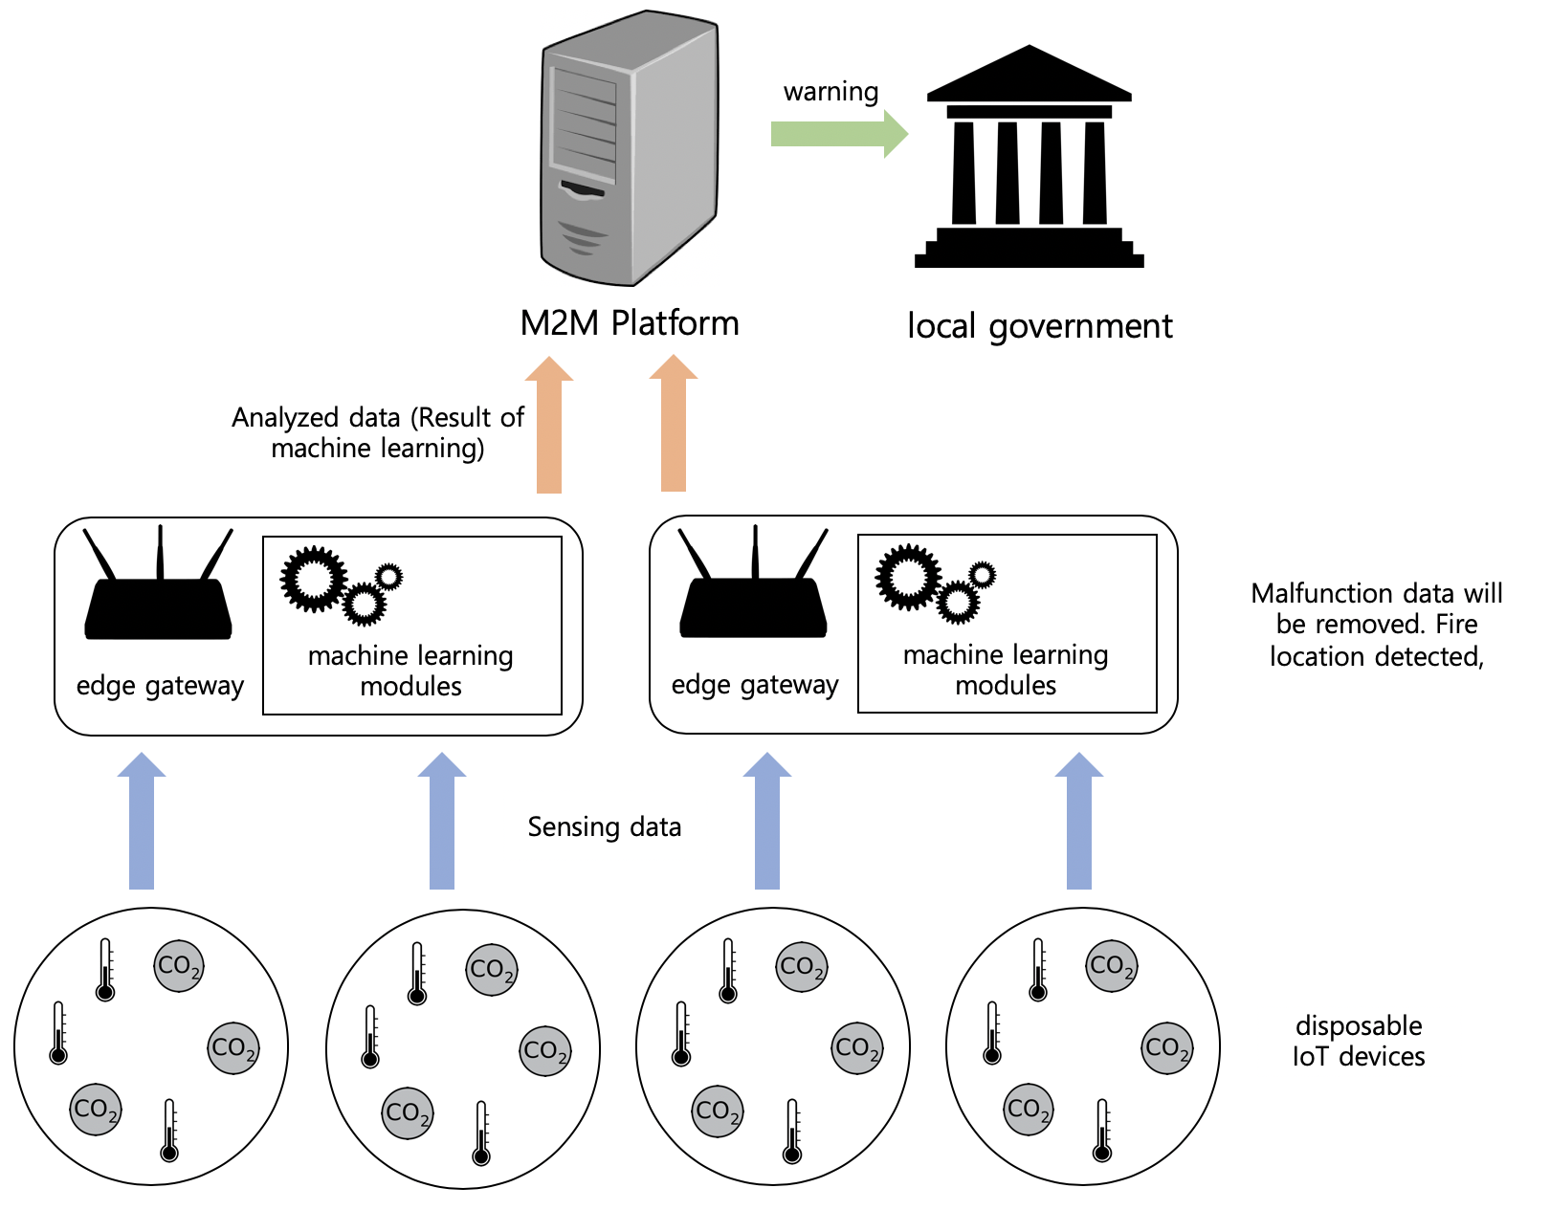
Figure 12.xx.3-1High Level Illustration – Wildfire alert service with edge gateway

12.xx.10 Potential requirements
- The oneM2M System shall be able to store historical geo-location of an entity in a standardized format.
=========================== End of new text1 ===========================

