CHANGE REQUEST
Meeting ID:* | RDM 44
Source:* | Andrew Min-gyu Han, Hansung University,andyhan@hansung.ac.kr  Joong-kwon Lim,Hansung University, naulim@hansung.ac.kr  Yeonsang Koo, LGU+, yskoo@lguplus.co.kr
Date:* | 2020-02-20
Reason for Change/s:* | Add a smart gate machine as a device model of the Railway Domain
CR against: Release* | Release 4
CR against: WI* | Active <WI-0084>  MNT maintenance / < Work Item number(optional)>  Is this a mirror CR? Yes No  mirror CR number: (Note to Rapporteur - use latest agreed revision)  STE Small Technical Enhancements / < Work Item number (optional)>  Only ONE of the above shall be ticked
CR against: TS/TR* | TS-0023 V4.3.0
Clauses *
Type of change: * | Editorial change  Bug Fix or Correction  Change to existing feature or functionality  New feature or functionality  Only ONE of the above shall be ticked
Other TS/TR(s) impacted | N/A
Post Freeze checking:* | This CR contains only essential changes and corrections? YES NO  This CR may break backwards compatibility with the last approved version of the TS? YES NO
Template Version: January 2019 (do not modify)

oneM2M Notice
The document to which this cover statement is attached is submitted to oneM2M. Participation in, or attendance at, any activity of oneM2M, constitutes acceptance of and agreement to be bound by terms of the Working Procedures and the Partnership Agreement, including the Intellectual Property Rights (IPR) Principles Governing oneM2M Work found in Annex 1 of the Partnership Agreement.
GUIDELINES for Change Requests:
Provide an informative introduction containing the problem(s) being solved, and a summary list of proposals.
Each CR should contain changes related to only one particular issue/problem.
If this is a correction, and the change applies to previous releases, a separate “mirror CR” should be posted at the same time as this CR
Mirror CR: applies only when the text, including clause numbering are exactly the same.
Companion CR: applies when the change means the same but the baselines differ in some way (e.g. clause number).
Follow the principle of completeness, where all changes related to the issue or problem within a deliverable are simultaneously proposed to be made e.g. a change impacting 5 tables should not only include a proposal to change only 3 tables. Include any changes to references, definitions, and abbreviations in the same deliverable.
Follow the drafting rules.
All pictures must be editable.
Check spelling and grammar.
Use change bars for modifications.
The change should include the current and surrounding clauses to clearly show where a change is located and to provide technical context of the proposed change. Additions of complete clauses need not show surrounding clauses as long as the proposed clause number clearly shows where the proposed new clause is located.
Multiple changes in a single CR shall be clearly separated by horizontal lines with embedded text such as, start of change 1, end of change 1, start of new clause, end of new clause.
When subsequent changes are made to the content of a CR, then the accepted version should not show changes over changes. The accepted version of the CR should only show changes relative to the baseline approved text.

Introduction
This CR adds a smart gate of passenger card as a device model of the Railway Domain.
The gate is used in subway or metro.
The following image shows an example of the machine.

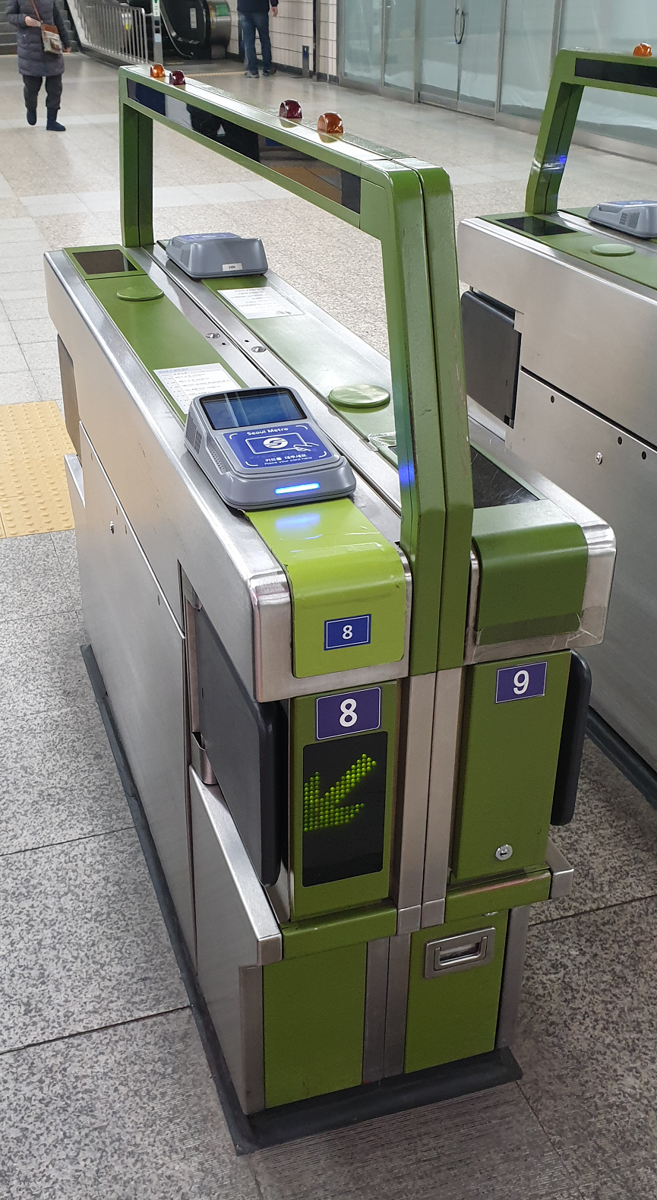 | The machine is consisted of following components:  - binarySwitch  - clock  - touchScreen  - emergencyButton  - audioVolume  - ticketReader  - crossingSensor  - connectivity  - gateState  - directionPanel  - crossingIndicator  - crossingBarrier

-----------------------Start of change 1-------------------------------------------

5.5.8.x deviceSmartGate
A smart gate is a device of the Railway Domain. The gate provides passenger service for checking ticket and control the gate usage. A railway users simply use the gate with their ticket (e.g. passenger card) which havepre-paid card function.
Table 5.5.8.x-1: Modules of deviceSmartGate Device model
Module Instance Name | Module Class Name | Optional | Description
binarySwitch | binarySwitch | false | See clause Error: Reference source not found.
clock | clock | false | See clause Error: Reference source not found.
touchScreen | touchScreen | true | See clause 5.3.1.a.
emergencyButton | pushButton | true | See clause Error: Reference source not found.
audioVolume | audioVolume | true | See clause Error: Reference source not found.
ticketReader | prePaidCardReader | false | See clause 5.3.1.b.
crossingSensor | traceSensor | false | See clause 5.3.1.c.
connectivity | connectivity | false | See clause Error: Reference source not found.
gateState | runState | false | See clause Error: Reference source not found.
directionPanel | directionPanel | true | See clause 5.3.1.d.
crossingIndicatorColour | colour | false | See clause Error: Reference source not found.
crossingIndicatorColourSaturation | colourSaturation | false | See clause Error: Reference source not found.
crossingIndicatorColourBrightness | brightness | false | See clause Error: Reference source not found.
crossingBarrier | crossingBarrier | false | See clause 5.3.1.f.

-----------------------End of change 1---------------------------------------------

-----------------------Start of change 2-------------------------------------------

5.3.1.a touchScreen
This ModuleClass provides the capability to get selections of a user from the pre-defined menus on the screen as parts of a process of charging transportation payment card of the user.
Table 5.3.1.a-2: DataPoints of touchScreen ModuleClass
Name | Type | R/W | Optional | Unit | Documentation
pushed | xs:boolean | R | false |  | This data point indicates the press of the button. (1..N)
positionX | xs:integer | R | false | pixel | This data point indicates the horizontal position of the touching. (1..N)
positionY | xs:integer | R | false | pixel | This data point indicates the vertical position of the touching. (1..N)

-----------------------End of change 2---------------------------------------------

-----------------------Start of change 3-------------------------------------------

5.3.1.b prePaidCardReader
The pre-paid card reader ModuleClass provides functions to read pre-paidNFCrd and indicates its .information
Table 5.3.1.b-3: DataPoints of prePaidCardReader ModuleClass
Name | Type | R/W | Optional | Unit | Documentation
readStatus | xs:boolean | R | false |  | This data point indicates the status of reading the pre-paid card.  “True” means the reader reads the pre-paid card successfully.
cardInfo | xs:integer | R | false |  | The card information is consisted of numbers of integer values. (1..N)
balance | xs:float | RW | false |  | This data point indicates the balance of the pre-paid card.
currency | xs:string | R | true |  | The currency is depended on the country which the card is used.  For example, the currency could be “Dollar” or “$” in US, “Euro” in EU and “Won” in Korea.

-----------------------End of change 3---------------------------------------------

-----------------------Start of change 4-------------------------------------------

5.3.1.c traceSensor
This ModuleClass provides the capabilities to indicate the heading (e.g. status of get-in and get-out) of a pedestrian or a vehicle which crossing a control point (e.g. entrance and gate).
Table 5.3.1.c-4: DataPoints of traceSensor ModuleClass
Name | Type | R/W | Optional | Unit | Documentation
heading | xs:float | RW | true |  | The azimuth of a device measured in degrees to true north. North is 0.0 degrees, east is 90.0 degrees, south is 180.0 degrees, west is 270.0 degrees. A negative value indicates an unknown heading.
headingAccuracy | xs:floatinteger | R | true | deg | The optional current maximum deviation between the heading and the true geomagnetic heading.who is get-in or get-out.

-----------------------End of change 4---------------------------------------------

-----------------------Start of change 5-------------------------------------------

5.3.1.d directionPanel
This ModuleClass displays a signal (e.g. direction arrow) to indicate a gate is permitted to get-in or get-out on a panel.
Table 5.3.1.d-5: DataPoints of directionPanel ModuleClass
Name | Type | R/W | Optional | Unit | Documentation
direction | xs:boolean | RW | false |  | The direction is true, the panel indicates go forward signal or icon. If the direction is false, the panel displays stop signal or icon.
 |  |  |  |  | s the and the other way aroundl tu

-----------------------End of change 5---------------------------------------------

displayl images

-----------------------Start of change 6-------------------------------------------

5.3.1.f crossingBarrier
An active barrier is used to block a pedestrian or vehicle from a control point (e.g. entrance and gate).
Table 5.3.1.f-7: DataPoints of crossingBarrier ModuleClass
Name | Type | R/W | Optional | Unit | Documentation
barrierDefault | xs:boolean | RW | true |  | The value of the barrier default is true, the default status of the barrier is closed and vice versa.
barrierStatus | xs:boolean | RW | false |  | The value of the barrier status is true, the barrier is closed and vice versa.
timer | xs:time | RW | true |  | The timer indicates the duration of barrierStatus is changed. This means that barrierStatus is set to the current value of barrierDefault.barrierDefauleihe value is false, the barrier is opened with the timer duration.

-----------------------End of change 6---------------------------------------------

CHECK LIST
- Does this Change Request include an informative introduction containing the problem(s) being solved, and a summary list of proposals.?
- Does this CR contain changes related to only one particular issue/problem?
- Have any mirror CRs been posted?
- Does this Change Request make all the changes necessary to address the issue or problem? E.g. A change impacting 5 tables should not include a proposal to change only 3 tables?Does this Change Request follow the drafting rules?
- Are all pictures editable?
- Have you checked the spelling and grammar?
- Have you used change bars for all modifications?
- Does the change include the current and surrounding clauses to clearly show where a change is located and to provide technical context of the proposed change? (Additions of complete clauses need not show surrounding clauses as long as the proposed clause number clearly shows where the new clause is proposed to be located.)
- Are multiple changes in this CR clearly separated by horizontal lines with embedded text such as, start of change 1, end of change 1, start of new clause, end of new clause.?

