Input contribution
Use case
Use Case Title:* | Healthcare network and clinical knowledge administration
Group Name:* | RDM
Source:* | INRIA,TIM (on behalf of ETSI STF 589)
Contact: | INRIA  Luigi Liquori, Luigi.Liquori@inria.fr  TIM  Enrico Scarrone, Enrico.scarrone@telecomitalia.it  Joachim Koss (JK consulting), joachim.koss@jk-conpro.de
Date:* | 2020-04-14
Abstract:* | This use case looks at the semantic discovery requirements through a networking environment between people with disease (patients), the elderly, who want to live an independent life while remaining in their homes, special invalid people with a high risk of falling in their homes, doctors/care taking people, people practicing fitness exercises to improve their health, and institutions/organizations, who manage a clinical knowledge & information data basis or analyses of patient data.
Agenda Item:*
Work item(s): | WI-0101 - Advanced Semantic Discovery
Document(s)  Impacted* | TR 001
Intended purpose of  document:* | Decision  Discussion  Information  Other <specify>
Decision requested or recommendation:* | Include in TR 001
'Template Version: January 2019 (do not modify)

oneM2M Notice
The document to which this cover statement is attached is submitted to oneM2M. Participation in, or attendance at, any activity of oneM2M, constitutes acceptance of and agreement to be bound by terms of the Working Procedures and the Partnership Agreement, including the Intellectual Property Rights (IPR) Principles Governing oneM2M Work found in Annex 1 of the Partnership Agreement.

Advanced Semantic Discovery - Healthcare network and clinical knowledge administration.

Description
This use case looks at the semantic discovery requirements through a networking environment between people with disease (patients), the elderly, who want to live an independent life while remaining in their homes, special invalid people with a high risk of falling in their homes, doctors/care taking people, people practicing fitness exercises to improve their health, and institutions/organizations, who manage a clinical knowledge & information data basis or analyses of patient data.
On one side the number of the elderly is increasing permanently, on the other side, the doctors’ anterooms are overcrowded. Therefore, telecare and telehealth systems get more and more important. M2M applications for eHealth support the remote management of patient illnesses by e.g. tracking blood sugar levels, controlling insulin dosage, measuring blood pressure and heartbeat, record infrequent abnormal heart rhythms, etc.
M2M applications for eHealth can enable the elderly to live an independent life and remain in their homes in cases when normally assistance would be needed. Remote monitoring of patient vital signs (e.g. pulse, temperature, weight, blood pressure) minimizes the number of required doctor office visits. Further caretaking measures ensure that patients are taking their medications according to the required schedule and to track the activity level of seniors (e.g. time spent in bed each day, amount of daily movement in their homes) as a way of inferring their overall health and detecting changes that may require a doctor's or some other person's attention.
Various studies have concluded that falls in the home are the most common cause of injury among the elderly population, and one of the leading causes of morbidity and mortality among this population. A so called ‘long lie’ is a fall, in which the person remains on the ground for 5 min or more before being able to get up without assistance, or help arriving, which could detrimentally affect both the psychological as well as physical wellbeing of the individual. Automated fall detection systems are using worn fall detectors, which trigger an alarm, when both the orientation and acceleration forces of the person reach a pre-set threshold. In case of an emergency detection, an alarm will be sent immediately to the emergency service centre, possibly together with pictures or videos, which a camera being installed in the home has taken.
M2M applications for eHealth can be used to record health and fitness indicators such as heart and breathing rates, energy consumption, fat burning rate, etc. during exercise sessions, and to log the frequency and duration of workouts, the intensity of exercises, running distances, etc. When this information is uploaded to a back-end server, it can be used by the user's physician as part of their health profile, and by the user's personal trainer to provide feedback to the user on the progress of their exercise program. It allows adapting exercise programs or physiotherapy more precisely and more quickly to the needs of the patient/user.
This use case assumes that there is an interoperability platform (oneM2M) that offers a standard interface to monitor and control all the eHealth devices regardless of vendor. It is supposed that professional knowledge generation bodies (e.g. colleges/universities) get authorization to access the patient data. They can assist clinicians for the appropriate diagnosis and method of treatment by providing clinical (textual) guidelines and recommendations in order to reduce the risk of medical errors and to assist in decision-making processes.
Assuring interoperability between all the various data producing, data storing, and data processing components, semantic discovery and query mechanisms across and between sensors, devices, APIs and even IoT platforms are essential.

Source
- ETSI SR 003 680: “SmartM2M; Guidelines for Security, Privacy and Interoperability in IoT System Definition; A Concrete Approach”
- ETSI TR 102 732: “Machine-to-Machine Communications (M2M); Use Cases of M2M applications for eHealth”
- AIOTI Report: “IoT Relation and Impact on 5G, Release 2.0”

Actors
- M2M eHealth devices as e.g. wearable sensors, falling detectors, blood pressure meter
- Emergency supervisor
- Doctors and caring people
- Knowledge generation bodies
- M2M Service providers
- M2M Applications e.g. data analytics

Pre-conditions
M2M devices in the patients / the elderly homes and fitness locations have been installed and registered to their corresponding M2M Service Provider. In this use case, the devices are represented by ADN registered to MN-CSEs.
The M2M Application Providers 1, 2 and 3 have relationships one with each other.
The M2M Service Providers 1 and 2 host information on the devices located in the patients / the elderly homes and fitness locations.
The doctors and caring people want to make use of the devices in the patients / the elderly homes and fitness locations in order to check the health or behavioural data of the patients as a way of inferring their overall health and detecting changes that may require a doctor's or some other person's attention.
The emergency supervisor is operating the Intelligent Emergency Response System and manages alarms.
The M2M Service Provider 3 wants to access data from of the M2M Service Providers 1 and 2 in order to manage its knowledge data basis and to update analysis results, recommendations and guidelines.

Triggers
The doctor or caring person, the API “Clinicians patient data analysis” or the M2M Service Provider 3 (further on called “REQUESTER”) sends an Advanced Semantic Discovery Query to the M2M Service Provider 1 or 2 (further on called “REQUEST RECEIVER”). The query contains information about the device to be discovered, e.g., a device type, a localization and other filters criteria, such as performance and priority.

Normal Flow
Following, one example of a typical scenario is described:
- Via a device (e.g., user terminal), which is connected to the API “Hospital”, the doctor or caring person initiates a Advanced Semantic Discovery Query within the domain of the M2M Service Provider 1 to an eHealth device type of a specific group of patients, which enquires information about the pulse, temperature, weight, or blood pressure.
- The API “Hospital” verifies the integrity of the Advanced Semantic Discovery Query and sends a semantic discovery request to the MN-CSE of the specific group of patients.
- The MN-CSE searches for the specific requested type of devices whether they are connected or not.
- If the requested type of devices are connected to the MN-CSE, then it returns the requested information of the devices to the M2M Application.
- If the requested devices are not connected to the MN-CSE, then a negative acknowledge is sent back to the M2M Application.
- The API “Hospital” processes, if necessary, the received information and forwards it to the requesting device of the doctor or caring person.

Alternative flow
Following, one example of an alternative scenario is described:
- An M2M Application of the Service Provider 3 (Clinical knowledge & information) initiates a Advanced Semantic Discovery Query within the domain of M2M Service Providers 2 to find and identify the sensors of their treadmills, which enquires information about activities of users.
- The IN-CSE of the Service Provider 2 verifies the integrity of the Advanced Semantic Discovery Query and distributes it to the MN-CSEs of the fitness locations.
- The MN-CSEs searches for the specific requested type of devices whether they are connected or not.
- If the requested type of devices are connected to the MN-CSE, then it returns the requested information of the devices to the IN-CSE, which forwards it to the requesting Service Provider 3.
- If the requested devices are not connected to the MN-CSE, then a negative acknowledge is sent back to the IN-CSE, which forwards it to the requesting Service Provider 3.
- The requesting M2M Application of Service Provider 3 processes the data and provides them in an appropriate way to the users of the M2M Application (e.g. “Clinicians patient data analysis centre”).

Post-conditions
The REQUESTER (doctors or caring people, the API “Clinicians patient data analysis” or the M2M Service Provider 3) can start to employ the devices based on the Advanced Semantic Discovery Query sent to the M2M Service Provider 1 or 2.

High Level Illustration

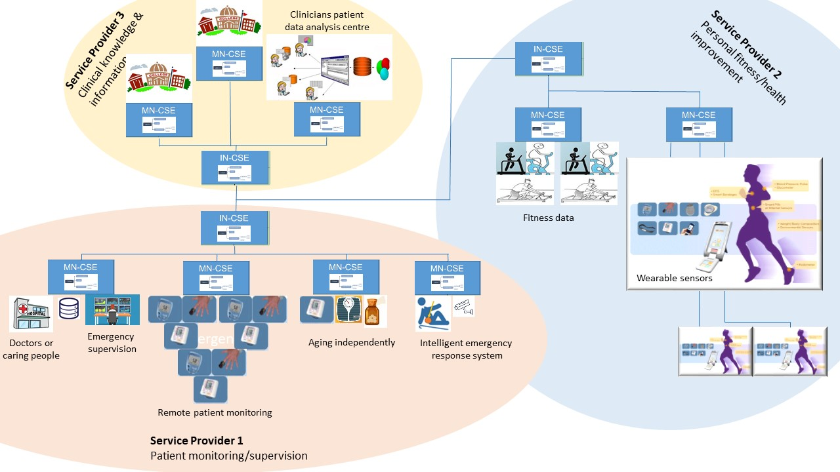
Figure 12.23 Healthcare network and clinical knowledge administration

Potential requirements
The following potential requirements are additional to the ones already identified in clause 12.20.10, 12.21.10 and 12.22.10:

- Advanced Semantic Discovery shall prioritize queries, e.g. to ensure a quick response to urgent situations.
- Advanced Semantic Discovery shall minimize complexity to avoid impacting negatively the oneM2M system performance.

