CHANGE REQUEST
Meeting ID:* | RDM 47
Source:* | Andrew Min-gyu Han, Hansung University,andyhan@hansung.ac.kr  Joong-kwon Lim,Hansung University, naulim@hansung.ac.kr  Yeonsang Koo, LGU+, yskoo@lguplus.co.kr
Date:* | 2020-10-03
Reason for Change/s:* | Changes the battery table for better decription
CR against: Release* | Release 4
CR against: WI* | Active <WI-0084>  MNT maintenance / < Work Item number(optional)>  Is this a mirror CR? Yes No  mirror CR number: (Note to Rapporteur - use latest agreed revision)  STE Small Technical Enhancements / < Work Item number (optional)>  Only ONE of the above shall be ticked
CR against: TS/TR* | TS-0023 V4.5.0
Clauses *
Type of change: * | Editorial change  Bug Fix or Correction  Change to existing feature or functionality  New feature or functionality  Only ONE of the above shall be ticked
Other TS/TR(s) impacted | N/A
Post Freeze checking:* | This CR contains only essential changes and corrections? YES NO  This CR may break backwards compatibility with the last approved version of the TS? YES NO
Template Version: January 2019 (do not modify)

oneM2M Notice
The document to which this cover statement is attached is submitted to oneM2M. Participation in, or attendance at, any activity of oneM2M, constitutes acceptance of and agreement to be bound by terms of the Working Procedures and the Partnership Agreement, including the Intellectual Property Rights (IPR) Principles Governing oneM2M Work found in Annex 1 of the Partnership Agreement.
GUIDELINES for Change Requests:
Provide an informative introduction containing the problem(s) being solved, and a summary list of proposals.
Each CR should contain changes related to only one particular issue/problem.
If this is a correction, and the change applies to previous releases, a separate “mirror CR” should be posted at the same time as this CR
Mirror CR: applies only when the text, including clause numbering are exactly the same.
Companion CR: applies when the change means the same but the baselines differ in some way (e.g. clause number).
Follow the principle of completeness, where all changes related to the issue or problem within a deliverable are simultaneously proposed to be made e.g. a change impacting 5 tables should not only include a proposal to change only 3 tables. Include any changes to references, definitions, and abbreviations in the same deliverable.
Follow the drafting rules.
All pictures must be editable.
Check spelling and grammar.
Use change bars for modifications.
The change should include the current and surrounding clauses to clearly show where a change is located and to provide technical context of the proposed change. Additions of complete clauses need not show surrounding clauses as long as the proposed clause number clearly shows where the proposed new clause is located.
Multiple changes in a single CR shall be clearly separated by horizontal lines with embedded text such as, start of change 1, end of change 1, start of new clause, end of new clause.
When subsequent changes are made to the content of a CR, then the accepted version should not show changes over changes. The accepted version of the CR should only show changes relative to the baseline approved text.

Introduction
This CR is provided to fix some uncertainty of the description of the battery ModuleClass.
The pointed issues are follows:
1) electricEnergy: is the flow of electricity. the walt(W) is voltage * ampere. (W=V*A). In the datapoints table of the battery, there is nothing to show the amount of ampere of the battery except the electricEnergy. Usually, the battery is explained as "input=5V/2A and output=5V/0.5A". In this case, the electricEnergy is 2A when the battery is charging, and the electricEnergy is 0.5A when the battery is discharging.
The current table has some problems because the battery has different input(charging) characteristics and output(discharging) characteristics sometimes as the example above. Due to this reason, this CR suggests the better definition of charging voltage and ampere and discharging voltage and ampere separately.
2) Voltage: It should be V and xs:float. And in the consistency, the electricEnergy should be A and xs:float as well.
3) Material: there are numbers of materials to make batteries. This CR provides the enum of the materials of battery.
4) Definition of battery materials. There are numbers of materials to make battery. In this CR, the enum is defined by selecting “popular” materials.
Here is some examples of the materials defined in Wikipedia. (https://en.wikipedia.org/wiki/List_of_battery_types)

Primary cells or non-rechargeable batteries | Secondary cells or rechargeable batteries | Batteries by application
- Alkaline battery (zinc manganese oxide, carbon)  - Aluminium–air battery  - Atomic battery  - Radioisotope thermoelectric generator  - Betavoltaic device  - Bunsen cell  - Chromic acid cell (Poggendorff cell)  - Clark cell  - Daniell cell  - Dry cell  - Earth battery  - Frog battery  - Galvanic cell  - Grove cell  - Leclanché cell  - Lemon/potato battery  - Lithium battery  - Lithium air battery  - Magnesium battery  - Mercury battery  - Molten salt battery  - Nickel oxyhydroxide battery  - Oxyride battery  - Organic radical battery  - Paper battery  - Pulvermacher's chain  - Silver-oxide battery  - Solid-state battery  - Sugar battery  - Voltaic pile  - Penny battery  - Trough battery  - Water-activated battery  - Weston cell  - Zinc–air battery  - Zinc–carbon battery  - Zinc chloride battery | - Aluminium-ion battery  - Carbon Battery  - Single Carbon Battery  - Dual carbon battery  - Flow battery  - Vanadium redox battery  - Zinc–bromine battery  - Zinc–cerium battery  - Lead–acid battery  - Deep cycle battery  - VRLA battery  - AGM battery  - Gel battery  - Glass battery  - Lithium-ion battery  - Lithium ion lithium cobalt oxide battery (ICR)  - Lithium ion manganese oxide battery (IMR)  - Lithium ion polymer battery  - Lithium iron phosphate battery  - Lithium–sulfur battery  - Lithium–titanate battery  - Thin film lithium-ion battery  - Lithium ceramic battery  - Magnesium-ion battery  - Metal–air electrochemical cells  - Lithium air battery  - Aluminium–air battery  - Germanium air battery  - Calcium air battery  - Iron air battery  - Potassium-ion battery  - Silicon–air battery  - Zinc–air battery  - Tin air battery  - Sodium-air battery  - Beryllium air battery  - Molten salt battery  - Microbial fuel cell  - Nickel–cadmium battery  - Nickel–cadmium battery vented cell type  - Nickel hydrogen battery  - Nickel–iron battery  - Nickel metal hydride battery  - Low self-discharge NiMH battery  - Nickel–zinc battery  - Organic radical battery  - Polymer-based battery  - Polysulfide bromide battery  - Potassium-ion battery  - Rechargeable alkaline battery  - Rechargeable fuel battery  - Sand battery  - Silicon air battery  - Silver-zinc battery  - Silver calcium battery  - Silver-cadmium battery  - Sodium-ion battery  - Sodium–sulfur battery  - Solid-state battery ^{[7]}  - Super iron battery  - UltraBattery  - Zinc ion battery | - Automotive battery  - Backup battery  - Battery (vacuum tube)  - Battery pack  - Battery room  - Battery storage power station  - Biobattery  - Button/coin cell  - CMOS battery  - Common battery  - Commodity cell  - Electric vehicle battery  - Flow battery  - Home energy storage  - Inverter battery  - Lantern battery  - Nanobatteries  - Nanowire battery  - Local battery  - Polapulse battery  - Photoflash battery  - Reserve battery  - Smart battery system  - Watch battery  - Water-activated battery  - Wet cell  - Za

5) Shape: there are many kinds of shape of batteries. The examples of the shape are the cylinder type(AA, AAA and AAAA), Coin-cell (CR2015 and CR2025) and box type(9V battery). Here is a picture inducates several size of Coin cells and 9V batteries. In this CR, the enum is defined by selecting “popular” shapes.

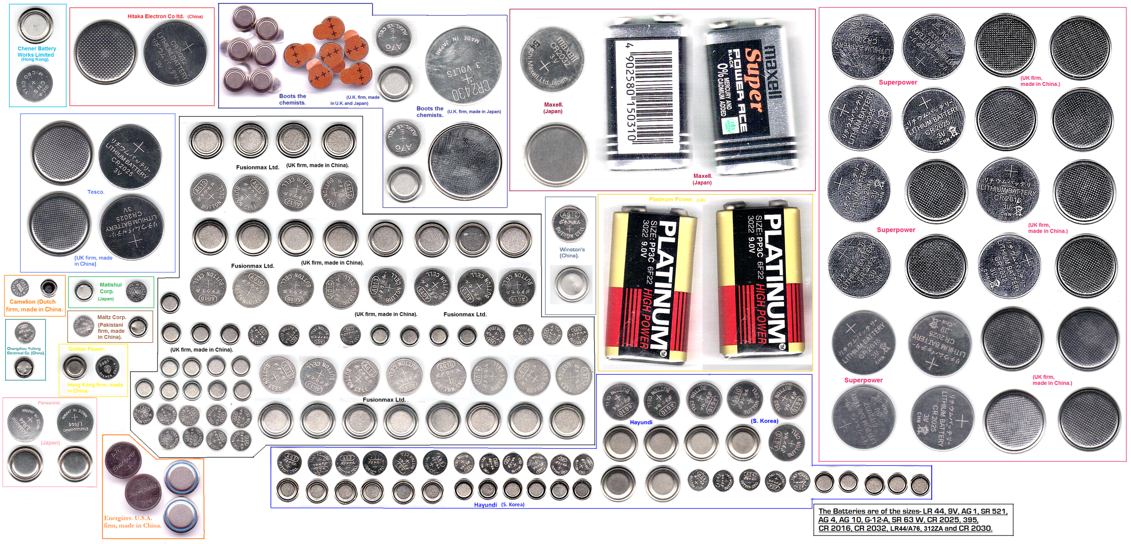

-----------------------Start of change 1-------------------------------------------

5.3.1.10 battery
This ModuleClass provides capabilities to indicate the detection of low battery and gives an alarm if the triggering criterion is met. The level data point in the ModuleClass represents the current battery charge level.
Table 5.3.1.10-1: DataPoints of battery ModuleClass
Name | Type | R/W | Optional | Unit | Documentation
level | xs:integer | R | false |  | The rounded percentage of the current charging level of a battery in the range of [0, 100]. 0 percentage shall mean that no charge remains.
capacity | xs:integer | R | true | mAh | The total capacity of battery in mAh.
rechargeable | xs:boolean | R | true |  | To indicate the battery is rechargeable or not. “True” inducates rechargeable.
charging | xs:boolean | R | True |  | The status of charging. "True" indicates enabled, and "False" indicates not enabled.
discharging | xs:boolean | R | True |  | The status of discharging. "True" indicates charging, and "False" indicates not charging.
lowBattery | xs:boolean | R | True |  | To indicate that the battery is on a low charge level.
batteryThreshold | xs:integer | RW | True |  | When a battery’s “level” is less than “batteryThreshold” then “lowBattery” is set to “True”. This datapoint can be used to raise an alarm, depending on the implementation.
chargingVoltage | xs:float | R | true | V | The voltage to charge the battery
chargingAmpere | xs:float | R | true | A | The ampere to charge the battery
dischargingVoltage | xs:float | R | true | V | The voltage to discharge the battery
dischargingAmpere | xs:float | R | true | A | The ampere to discharge the battery
batteryMaterial | hd:enumBatteryMaterial | R | true |  | The material of the cell of the battery
batteryShape | hd:enumBatteryShape | R | true |  | The size of the battery such as “AAA”.

-----------------------End of change 1---------------------------------------------

-----------------------Start of change 2-------------------------------------------

5.6.x hd:enumBatteryMaterial
Used for the “batteryMaterial” DataPoint of the “battery” ModuleClass.
Table 5.6.x-1 Interpretation of hd:enumBatteryMaterial
Value | Interpretation | Note
1 | Alkaline battery | Primary cells or non-rechargeables
2 | Lithium battery | Primary cells or non-rechargeables
3 | Magnesium battery | Primary cells or non-rechargeables
4 | Mercury battery | Primary cells or non-rechargeables
5 | Nickel oxyhydroxide battery | Primary cells or non-rechargeables
6 | Silver-oxide battery | Primary cells or non-rechargeables
7 | Zinc-air | Primary cells or non-rechargeables
8 | Lead–acid battery | Secondary cells or rechargeables
9 | Lithium-ion battery(Li-ion) | Secondary cells or rechargeables
10 | Lithium-ion polymer battery(LiPo) | Secondary cells or rechargeables
11 | Nickel–cadmium battery(Ni-Cd) | Secondary cells or rechargeables
12 | Nickel–iron battery | Secondary cells or rechargeables
13 | Nickel metal hydride battery(NiMH) | Secondary cells or rechargeables
14 | Nickel–zinc battery | Secondary cells or rechargeables
15 | Rechargeable alkaline battery | Secondary cells or rechargeables

5.6.y hd:enumBatteryShape
Used for the “batteryShape” DataPoint of the “battery” ModuleClass.
Table 5.6.y-1 Interpretation of hd:enumBatteryShape
Value | Interpretation | Note
1 | AA | Cylinder-type AA battery
2 | AAA | Cylinder-type AAA battery
3 | AAAA | Cylinder-type AAAA battery
4 | C | Cylinder-type C battery
5 | D | Cylinder-type D battery
6 | N | Cylinder-type N battery
7 | A23 | Cylinder-type A23 battery
8 | Coin-cell-4 | Coin-cell type 4.8 mm diameter battery
9 | Coin-cell-5 | Coin-cell type 5.8 mm diameter battery
10 | Coin-cell-6 | Coin-cell type 6.8 mm diameter battery
11 | Coin-cell-7 | Coin-cell type 7.9 mm diameter battery
12 | Coin-cell-9 | Coin-cell type 9.5 mm diameter battery
13 | Coin-cell-10 | Coin-cell type 10.0 mm diameter battery
14 | Coin-cell-11 | Coin-cell type 11.6 mm diameter battery
15 | Coin-cell-12 | Coin-cell type 12.5 mm diameter battery
16 | Coin-cell-16 | Coin-cell type 16.0 mm diameter battery
17 | Coin-cell-20 | Coin-cell type 20.0 mm diameter battery
18 | Coin-cell-23 | Coin-cell type 23.0 mm diameter battery
19 | Coin-cell-24 | Coin-cell type 24.5 mm diameter battery
20 | Coin-cell-44 | Coin-cell type 5.4 mm diameter battery
21 | Box-9V | Box type 9V battery
22 | Silver Flat Pack | Flat Box Pack type
23 | Car-battery | Box type 6-cell lead car battery
24 | Custom-made | Custom-made by manutacturer

-----------------------End of change 2---------------------------------------------

CHECK LIST
- Does this Change Request include an informative introduction containing the problem(s) being solved, and a summary list of proposals.?
- Does this CR contain changes related to only one particular issue/problem?
- Have any mirror CRs been posted?
- Does this Change Request make all the changes necessary to address the issue or problem? E.g. A change impacting 5 tables should not include a proposal to change only 3 tables?Does this Change Request follow the drafting rules?
- Are all pictures editable?
- Have you checked the spelling and grammar?
- Have you used change bars for all modifications?
- Does the change include the current and surrounding clauses to clearly show where a change is located and to provide technical context of the proposed change? (Additions of complete clauses need not show surrounding clauses as long as the proposed clause number clearly shows where the new clause is proposed to be located.)
- Are multiple changes in this CR clearly separated by horizontal lines with embedded text such as, start of change 1, end of change 1, start of new clause, end of new clause.?

