CHANGE REQUEST
Meeting ID:* | RDM 47
Source:* | Shane HE, Nokia, shane.he@nokia.com
Date:* | 2020-10-22
Reason for Change/s:* | Adding new sub clauses for clause 11 – Railway domain activities in ITU
CR against: Release* | Release 4
CR against: WI* | Active <WI-0092>  MNT maintenance / < Work Item number(optional)>  Is this a mirror CR? Yes No  mirror CR number: (Note to Rapporteur - use latest agreed revision)  STE Small Technical Enhancements / < Work Item number (optional)>  Only ONE of the above shall be ticked
CR against: TS/TR* | TR-0058 V0.7.0
Clauses * | 11.4
Type of change: * | Editorial change  Bug Fix or Correction  Change to existing feature or functionality  New feature or functionality  Only ONE of the above shall be ticked
Other TS/TR(s) impacted | N/A
Post Freeze checking:* | This CR contains only essential changes and corrections? YES NO  This CR may break backwards compatibility with the last approved version of the TS? YES NO
Template Version: January 2019 (do not modify)

oneM2M Notice
The document to which this cover statement is attached is submitted to oneM2M. Participation in, or attendance at, any activity of oneM2M, constitutes acceptance of and agreement to be bound by terms of the Working Procedures and the Partnership Agreement, including the Intellectual Property Rights (IPR) Principles Governing oneM2M Work found in Annex 1 of the Partnership Agreement.
GUIDELINES for Change Requests:
Provide an informative introduction containing the problem(s) being solved, and a summary list of proposals.
Each CR should contain changes related to only one particular issue/problem.
If this is a correction, and the change applies to previous releases, a separate “mirror CR” should be posted at the same time as this CR
Mirror CR: applies only when the text, including clause numbering are exactly the same.
Companion CR: applies when the change means the same but the baselines differ in some way (e.g. clause number).
Follow the principle of completeness, where all changes related to the issue or problem within a deliverable are simultaneously proposed to be made e.g. a change impacting 5 tables should not only include a proposal to change only 3 tables. Include any changes to references, definitions, and abbreviations in the same deliverable.
Follow the drafting rules.
All pictures must be editable.
Check spelling and grammar.
Use change bars for modifications.
The change should include the current and surrounding clauses to clearly show where a change is located and to provide technical context of the proposed change. Additions of complete clauses need not show surrounding clauses as long as the proposed clause number clearly shows where the proposed new clause is located.
Multiple changes in a single CR shall be clearly separated by horizontal lines with embedded text such as, start of change 1, end of change 1, start of new clause, end of new clause.
When subsequent changes are made to the content of a CR, then the accepted version should not show changes over changes. The accepted version of the CR should only show changes relative to the baseline approved text.

Introduction
This CR is provided to add new text for TR-0058 to address the concern of key issues for railway domain enablement.

-----------------------Start of change 1-------------------------------------------

11.4 ITU

11.4.1 Intorduction
ITU is the United Nations specialized agency for information and communication technologies. Within ITU, the ITU Radiocommunication Sector (ITU-R) plays a vital role in the global management of the radio-frequency spectrum and satellite orbits. There are a group of ITU-R reports that provide study on railway communication system, e.g.,
M.2395 | Introduction to railway communication systems
M.2418 | Description of Railway Radiocommunication Systems between Trainand Trackside (RSTT)
M.2442 | Current and future usage of railway radiocommunication systems between train and trackside

11.4.2 Activities
Report M.2395 focuses on a case study of measurement results of radio communication characteristics between train and ground stations in the millimetric wave frequency ranges for railway deployment scenarios, as well as other types of radiocommunication systems used in railway communications, especially in Japan and Korea (e.g. LTE, VHF, WiBro, LCX).
Report M.2418 provides the architecture, applications, technologies and operational scenarios of Railway Radiocommunication Systems between Train and Trackside (RSTT) for all types of trains (e.g. high-speed trains, passenger trains, freight trains, and metro trains). RSTT provide improved railway traffic control, passenger safety and security for train operations. RSTT carry train control, voice dispatching, command, operational information as well as monitoring data between on-board radio equipment and related radio infrastructure located along trackside. To date, RSTT have included narrowband wireless technologies for carriage of train control, command, and operational information, as well as monitoring data between on-board equipment and related radio infrastructure located along the trackside.
The main elements of the RSTT may consist of on board radio equipment, radio access units and other trackside radio infrastructure. Other systems, such as the core network, etc., are supporting systems for the RSTT.
– Radio access unit: including antenna and base station, to provide radio access to the terminals (especially cab radio)
– On board radio equipment: Radio equipment installed on train as well as handsets (for example, mobile terminals of automatic train control – ATC)
– Other trackside radio infrastructure: Radio infrastructure operating along trackside (for example: shunting radio devices)
A diagram of the main applications of RSTT is illustrated in Fig. X
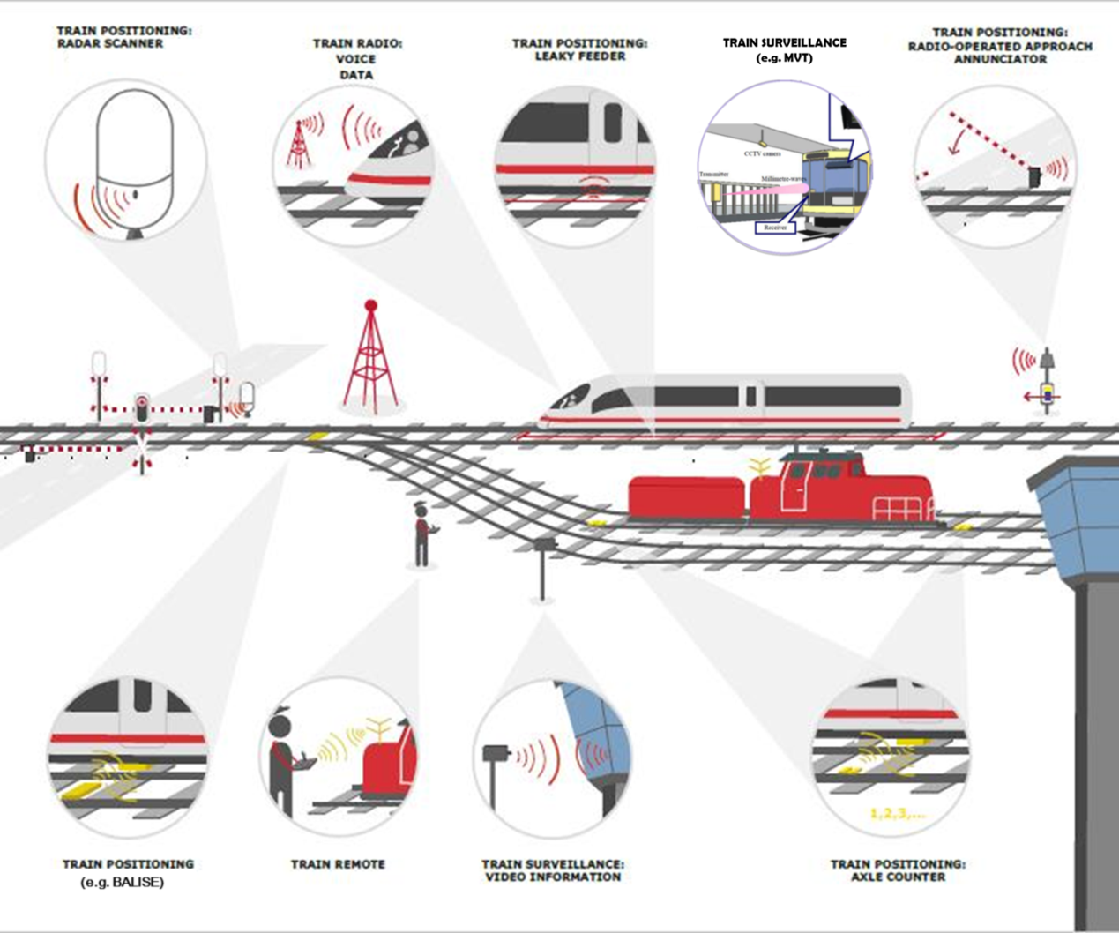
Figure X Main applications of RSTT
Report M.2418 also provides examples of current technologies for RSTT, such as GSM-R, Global System for Mobile Communications – Railway or GSM-Railway is a wireless communications standard for railway communication and applications. As a sub-system of European Rail Traffic Management System (ERTMS), it is used for communication between train and the track. GSM-R is built on GSM technology, and benefits from the economies of scale of its GSM technology.
Report M.2442 addresses the technical and operational characteristics and the spectrum usage of current and planned Railway radiocommunication Systems between Train and Trackside (RSTT) as well as the studies on spectrum needs of RSTT. It provides comprehensive details for radiocommunication systems used for train radio, e.g. which applications of train radio are realized by each system and in which deployment scenarios each system was deployed. This report provides spectrum usage of RSTT by Administrations and some stuies on specture needs of RSTT,
Furthermore, report M.2442 also includes information on evolving technologies for RSTT including technical and operational characteristics of future RSTT in some countries.
In summary, for the industry and radio regulatory organizations, information in these ITU-R Report could be the reference for better understanding the RSTT and could be help to make better access for regional/global spectrum harmonization, and report M.2418 could be the reference for railway domain applications.

-----------------------End of change 1---------------------------------------------

-----------------------Start of change 2---------------------------------------------

2.2 Informative references
[i.6] Report ITU-R M.2395 - Introduction to railway communication systems
[i.7] Report ITU-R M.2418 - Description of Railway Radiocommunication Systems between Train and Trackside (RSTT).

[i.8] Rport ITU-R M.2442 - Current and future usage of railway radiocommunication systems between train and trackside

-----------------------End of change 2---------------------------------------------

CHECK LIST
- Does this Change Request include an informative introduction containing the problem(s) being solved, and a summary list of proposals.?
- Does this CR contain changes related to only one particular issue/problem?
- Have any mirror CRs been posted?
- Does this Change Request make all the changes necessary to address the issue or problem? E.g. A change impacting 5 tables should not include a proposal to change only 3 tables?Does this Change Request follow the drafting rules?
- Are all pictures editable?
- Have you checked the spelling and grammar?
- Have you used change bars for all modifications?
- Does the change include the current and surrounding clauses to clearly show where a change is located and to provide technical context of the proposed change? (Additions of complete clauses need not show surrounding clauses as long as the proposed clause number clearly shows where the new clause is proposed to be located.)
- Are multiple changes in this CR clearly separated by horizontal lines with embedded text such as, start of change 1, end of change 1, start of new clause, end of new clause.?

