

oneM2M
Technical Report
Document Number | oneM2M-TR-0061 -V-0.3.0
Document Name: | Study on ontologies for Smart City Services
Date: | 2021-01-08
Abstract: | < An abstract of the document that may be used to help reader decide whether to read the entire document, and provide information that may be used in subsequent electronic searches>
Template Version: January 2017 (Do not modify)

The present document is provided for future development work within oneM2M only. The Partners accept no liability for any use of this report.
The present document has not been subject to any approval process by the oneM2M Partners Type 1. Published oneM2M specifications and reports for implementation should be obtained via the oneM2M Partners' Publications Offices.

About oneM2M
The purpose and goal of oneM2M is to develop technical specifications which address the need for a common M2M Service Layer that can be readily embedded within various hardware and software, and relied upon to connect the myriad of devices in the field with M2M application servers worldwide.
More information about oneM2M may be found at: http//www.oneM2M.org
Copyright Notification
© 2017, oneM2M Partners Type 1 (ARIB, ATIS, CCSA, ETSI, TIA, TSDSI, TTA, TTC).
All rights reserved.
The copyright and the foregoing restriction extend to reproduction in all media.

Notice of Disclaimer & Limitation of Liability
The information provided in this document is directed solely to professionals who have the appropriate degree of experience to understand and interpret its contents in accordance with generally accepted engineering or other professional standards and applicable regulations. No recommendation as to products or vendors is made or should be implied.
NO REPRESENTATION OR WARRANTY IS MADE THAT THE INFORMATION IS TECHNICALLY ACCURATE OR SUFFICIENT OR CONFORMS TO ANY STATUTE, GOVERNMENTAL RULE OR REGULATION, AND FURTHER, NO REPRESENTATION OR WARRANTY IS MADE OF MERCHANTABILITY OR FITNESS FOR ANY PARTICULAR PURPOSE OR AGAINST INFRINGEMENT OF INTELLECTUAL PROPERTY RIGHTS. NO oneM2M PARTNER TYPE 1 SHALL BE LIABLE, BEYOND THE AMOUNT OF ANY SUM RECEIVED IN PAYMENT BY THAT PARTNER FOR THIS DOCUMENT, WITH RESPECT TO ANY CLAIM, AND IN NO EVENT SHALL oneM2M BE LIABLE FOR LOST PROFITS OR OTHER INCIDENTAL OR CONSEQUENTIAL DAMAGES. oneM2M EXPRESSLY ADVISES ANY AND ALL USE OF OR RELIANCE UPON THIS INFORMATION PROVIDED IN THIS DOCUMENT IS AT THE RISK OF THE USER.

Contents
Contents 3
1 Scope 4
2 References 4
2.1 Normative references 4
2.2 Informative references 4
3 Definitions, symbols and abbreviations 6
3.1 Definitions 6
3.2 Symbols 6
3.3 Abbreviations 6
4 Conventions, 7
5 Existing SmartCity ontologies 7
5.1 Smart City 7
5.1.1 SAREF4City 7
5.1.2 SEAS 9
5.2 Smart Home 12
5.3 Smart Building 12
5.4 Smart Environment 12
5.5 Smart Energy 12
6 Gap Analysis of existing ontology models for smart city domain 13
6.1 Data Consideration for Smart City 13
6.2 Ontology Design Evaluation Criteria 14
6.2.1 General evaluation criteria 14
6.2.2 Granularity based Evaluation criteria 14
6.3 Gap analysis of SAREF ontologies 16
6.3.1 Gap analysis based on completeness 16
6.3.2 Gap analysis based on adaptability 16
6.3.3 Gap analysis based on clarity 16
6.3.4 Gap analysis based on conciseness 17
6.4 Gap analysis of SEAS ontologies 17
6.4.1 Gap analysis based on completeness 17
6.4.2 Gap analysis based on adaptability 17
6.4.3 Gap analysis based on clarity 18
6.4.4 Gap analysis based on conciseness 19
6.5 Gap analysis summary 19
7 Ontologies for SmartCity in oneM2M 20
7.1 Smart City Core Ontology 20
7.2 Smart Home Extension 20
7.3 Smart Building Extension 20
7.4 Smart Environment Extension 20
7.5 Smart Energy Extension 20
Proforma copyright release text block 20
Annexes 21
Annex <y>: Bibliography 22
History 22

1 Scope
The present document …
EXAMPLE: The present document provides the necessary adaptions to the endorsed document.
The Scope shall not contain requirements.

2 References
The following text block applies.
References are either specific (identified by date of publication and/or edition number or version number) or non-specific. For specific references,only the cited version applies. For non-specific references, the latest version of the referenced document (including any amendments) applies.

2.1 Normative references

Normative references are not applicable in the present document.

2.2 Informative references
Clause 2.2 shall only contain informative references which are cited in the document itself.
The following referenced documents are not necessary for the application of the present document but they assist the user with regard to a particular subject area.
[i.1] oneM2M Drafting Rules (http://member.onem2m.org/Static_pages/Others/Rules_Pages/oneM2M-Drafting-Rules-V1_0.doc)
[i.2] ETSI Smart Appliances REFerence (SAREF) ontology
NOTE: Available at https://sites.google.com/site/smartappliancesproject/ontologies/reference-ontology
[i.3] ETSI STF 534
NOTE: Available at https://portal.etsi.org/STF/stfs/STFHomePages/STF534
[i.4] AIOTI WG08 Report on Smart Cities
NOTE: Available at https://aioti.eu/aioti-wg08-report-on-smart-cities/
[i.5] H2020 Lighthouse projects
NOTE: Available at https://smartcities-infosystem.eu/scc-lighthouse-projects
[i.6] SAREF extension for Smart Cities Version 0.8
NOTE: Available at https://w3id.org/def/saref4city
[i.7] Open Geospatial Consortium (OGC) GeoSPARQL - A Geographic Query Language for RDF Data Version 1.0
NOTE: Available at https://www.opengeospatial.org/standards/geosparql
[i.8] W3C Recommendation 19 October 2017: "Time ontology in OWL"
NOTE: Available at https://www.w3.org/TR/owl-time/
[i.9] FOAF Vocabulary Specification 0.99 14 January 2014 - Paddington Edition
NOTE: Available at http://xmlns.com/foaf/spec/
[i.10] Core Public Service Vocabulary Application Profile
NOTE: Available at https://ec.europa.eu/isa2/solutions/core-public-service-vocabulary-application-profile-cpsv-ap_en
[i.11] W3C Semantic Web Interest Group: "Basic Geo (WGS84 lat/long) Vocabulary"
NOTE: Available at https://www.w3.org/2003/01/geo/
[i.12] FIWARE Key Performance Indicator data model
NOTE: Available at https://fiware-datamodels.readthedocs.io/en/latest/KeyPerformanceIndicator/doc/spec/index.html
[i.13] Dublin Core ontology
NOTE: Available at http://www.dublincore.org/specifications/dublin-core/dcmi-terms/terms/LinguisticSystem/
[i.14] W3C Recommendation 16 January 2014: "The Organization Ontology"
NOTE: Available at https://www.w3.org/TR/vocab-org/#class-organizationalunit
[i.15] SEAS ontology Version 1.1
NOTE: Available at https://w3id.org/seas/seas-1.1
[i.16] European ITEA project
NOTE: Available at https://itea3.org/about-itea.html
[i.17] W3C Recommendation 11 December 2012 : "OWL 2 Web Ontology Language Structural Specification and Functional-Style Syntax (Second Edition)"
NOTE: Available at http://www.w3.org/TR/2012/REC-owl2-syntax-20121211/
[i.18] Procedure Execution ontology Version.1.1
NOTE: Available at https://w3id.org/pep/pep-1.1
[i.19] ITEA2 12004 Smart Energy Aware Systems Deliverable 2.2: "The SEAS Knowledge Model"
NOTE: Available at http://www.maxime-lefrancois.info/docs/SEAS-D2_2-SEAS-Knowledge-Model.pdf
[i.20] W3C Recommendation 19 October 2017: " Semantic Sensor Network Ontology"
NOTE: Available at https://www.w3.org/TR/vocab-ssn/
[i.21] R. Arp, B. Smith, A. D.Spear, “Building Ontologies with Basic Formal Ontology” (Book)
[i.22] P. Hitzler, M. Krtzsch, S. Rudolph, “Foundations of Semantic Web Technologies”. (Book)
[i.23] S. Staab, R. Studer, “Handbook on Ontologies” (Book)
[i.24] W3C Recommendation 10 February 2004: “OWL Web Ontology Language Reference”
NOTE: Available at https://www.w3.org/TR/owl-ref/
[i.25] C. Maria Keet, 8 October 2012, “Detecting and Revising Flaws in OWL Object Property”.
NOTE: Available at https://link.springer.com/chapter/10.1007/978-3-642-33876-2_23
[i.26] SEAS Feature of Interest Ontology Version 1.0.
NOTE: Available at https://ci.mines-stetienne.fr/seas/FeatureOfInterestOntology
[i.27] SEAS Evaluation Ontology Version 1.0.
NOTE: Available at https://ci.mines-stetienne.fr/seas/EvaluationOntology-1.0
[i.28] Procedure Execution Ontology Version 1.1.
NOTE: Available at https://ci.mines-stetienne.fr/pep/
[i.29] SEAS Upper Ontology Version 0.10.
NOTE: Available at https://ci.mines-stetienne.fr/seas/UpperOntology
[i.30] The SEAS Device Ontology Version 1.1.
NOTE: Available at https://ci.mines-stetienne.fr/seas/DeviceOntology
[i.31] The SEAS Player Ontology Version 1.1.
NOTE: Available at https://ci.mines-stetienne.fr/seas/PlayerOntology-1.1
[i.32] The SEAS Zone Ontology Version 1.0.
NOTE: Available at https://ci.mines-stetienne.fr/seas/ZoneOntology
[i.33] SEAS-TechnicalSystemOntology Version 0.9.
NOTE: Available at https://ci.mines-stetienne.fr/seas/TechnicalSystemOntology
[i.34] The SEAS Forecasting Ontology Version 1.1.
NOTE: Available at https://ci.mines-stetienne.fr/seas/ForecastingOntology
[i.35] SEAS-WeatherOntology Version 0.9.
NOTE: Available at https://ci.mines-stetienne.fr/seas/WeatherOntology
[i.36] The SEAS Generic Property Version 1.0.
NOTE: Available at https://ci.mines-stetienne.fr/seas/GenericPropertyOntology

3 Definitions, symbols and abbreviations
Delete from the above heading the word(s) which is/are not applicable.

3.1 Definitions
Clause numbering depends on applicability.
- A definition shall not take the form of, or contain, a requirement.
- The form of a definition shall be such that it can replace the term in context. Additional information shall be given only in the form of examples or notes (see below).
- The terms and definitions shall be presented in alphabetical order.
For the purposes of the present document, the [following] terms and definitions [given in ... and the following] apply:
Definition format
<defined term>: <definition>
If a definition is taken from an external source, use the format below where [N] identifies the external document which must be listed in Section 2 References.
<defined term>[N]: <definition>
example 1: text used to clarify abstract rules by applying them literally
NOTE: This may contain additional information.

3.2 Symbols
Clause numbering depends on applicability.
For the purposes of the present document, the [following] symbols [given in ... and the following] apply:
Symbol format
<symbol> <Explanation>
<2nd symbol> <2nd Explanation>
<3rd symbol> <3rd Explanation>

3.3 Abbreviations
Abbreviations should be ordered alphabetically.
Clause numbering depends on applicability.
For the purposes of the present document, the [following] abbreviations [given in ... and the following] apply:

SAREF Smart Appliances REFerence ontology
SAREF4CITY SAREF extension for the smart cities domain
SAREF4ENER SAREF extension for energy domain
SAREF4ENVI SAREF extension for the environment domain
SAREF4BLDG SAREF extension for the building domain
SAREF4INMA SAREF extension for the industry & manufacturing domain
SAREF4AGRI SAREF extension for the smart agriculture and food chain domain
AIOTI Alliance for Internet of Things Innovation
FOAF Friend of A Friend ontology
CPSV Core Public Service Vocabulary
STF Specialist Task Forces
s4city namespaece used in the SAREF4City ontology
SEAS Smart Energy Aware systems
ITEA Information Technology for European Advancement
SDK Software Development Kit
IRI International Resource Identifier
OWL Web Ontology Language
saref namespace used in the SAREF ontology
s4city namespace used in the SAREF4City ontology
seas namespace used in the SEAS ontology
foaf namespace used in the FOAF ontology
pep namespace used in Procedure Execution Ontology, a module of SEAS ontologies

4 Conventions,
The key words “Shall”, ”Shall not”, “May”, ”Need not”, “Should”, ”Should not” in this document are to be interpreted as described in the oneM2M Drafting Rules [i.1]

5 Existing SmartCity ontologies
<Text>
Editor’s Note: In this clause, an explanation about existing ontologies specification will be handled.

5.1 Smart City
<Text>

5.1.1 SAREF4City
5.1.1.1 Introduction
The SAREF4City ontology is an extension of SAREF ontology [i.2] for the smart cities domain. This work has been performed in the context of STF(Special Task Force) 534 [i.3] under ETSI standardization which was established with the goal to create a set of extensions for different domains around a core ontology. The SAREF4City is the extension for smart city and it has been implemented considering the existing usecases and available data models relevant to this smart cities domain. In this regard, the development has been carried out with close collaboration with AIOTI [i.4], the H2020 Lighthouse projects on smart cities [i.5] and the ETSI activities in the smart cities. The ontology is available at SAREF4city Web [i.6].
The SAREF and SAREF4City are developed based on the standard ontologies such as GeoSPARQL [i.7], W3C Time ontology [i.8], FOAF [i.9] to enhance interoperability and consistency in the semantic modelling.
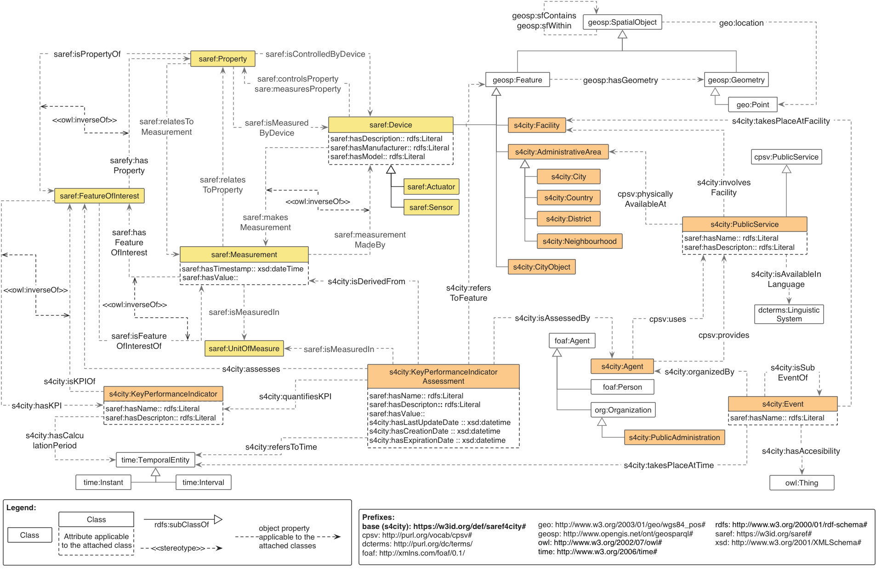
Figure 5.1.1.1-1 SAREF4City Extension [i.6]
5.1.1.2 Descirption
5.1.1.2.1 SAREF4City extension concepts
As shown in the Figure 5.1.1.1-1, the classes with prefix “saref:” represents the concept of SAREF ontology while prefix “s4city:”represents the SAREF4City extension concepts. It can be seen from the figure that the core of SAREF4City extensions involve regional (e.g. Administrative Area, Facility), economic (e.g. Public service, Event), and performance assessment (e.g. Key Performance Indicator, Key Performance Indicator Assessment) aspects.
Besides the concept classes, the relationships (object properties and data properties) have also been reused from existing ontologies. For instance, classes s4city:AdministrativeArea and s4city:PublicService are connected using the object property cpsv:physicallyAvailabeAt that is defined in CPSV ontology [i.10].
The definition of region concepts has been done using GeoSPARQL vocabulary concepts and WGS84 Geo Positioning vocabulary standard [i.11], which are geosp:SpatialObject, geosp:Feature, geosp:Geometry and geo:Point. The SAREF4City extension classes have been defined with rdfs:subClassOf property with the geosp:Feature class. These classes are s4city:AdministrativeArea, s4city:Facility and s4city:CityObject. Furthermore, the more detailed region concepts, such as s4city:City, s4city:Country, have been defined with rdfs:subClassOf property with the s4city:AdministrativeArea class. These concepts have been reused in order to define location properties in different aspects, such as defining location using coordinate system or as a regional area, having other sub-regions defined using geosp:sfWithin or geosp:sfContains.
The next main entity defined in the SAREF4City extension is the s4city:Event class, which links with the relevant classes such as s4city:Facility, s4city:AdministrativeArea, s4city:Agent. The concept definition of s4city:Event has been considered in a social perspective, rather than that of computing. For example a ceremony or an occasion which can take place at some neighbourhood on a given time, by any person or an organization. In such case, assertions can be defined using s4city:Neighbourhood, time:TemporalEntity and s4city:Agent class. However, s4city:Agent class has been generalized for both person and software.
In order to cover economics aspects of service provisioning, s4city:PublicService class has been defined, which has object property relationships with s4city:Agent and other classes related to region concepts. This class can highlight the characteristics of services as a commodity, where it can be offered by some s4city:Agent (e.g. government, person) can be defined using s4city:PublicService class.
Another main concepts defined in this extention includes s4city:KeyPerformanceIndicator and s4city: KeyPerformanceIndicatorAssessment classes. These enable describing performance evaluation of an organization or a relevant activity. This concept definition has been adopted from FIWARE data model specifications [i.12]. These concept classes also cover more of social aspect than that of ICT related systems and computing. However, s4city: KeyPerformanceIndicatorAssessment has relation s4city:isDerivedFrom with saref:Measurement class, which covers more general aspects of measurements relevant to the observations of real world phenomena. These classes are also linked with core SAREF concepts such as saref:FeatureOfInterest and saref:UnitOfMeasure, in order to enhance the expressivity of the key performance evaluation, as well as maintaining the consistency with the SAREF core ontology model. Some examples of these relationships are s4city:isKPIOf, s4city:hasKPI, s4city:assesses, s4city:IsMeasuredIn.
5.1.1.2.2 External Ontology Concept
Other external ontology concepts have been brought into the SAREF4City extension. These ontologies are GeoSPARQL, Dublin Core [i.13], FOAF, W3C Organization [i.14] and Time ontologies, as well as WGS84 Geo Positioning vocabulary and CPSV. The utilized concepts and their relationships with SAREF and SAREF4City can be seen in figure 5.1.1.1-1.

5.1.2 SEAS
5.1.2.1 Introduction
The Smart Energy Aware System (SEAS) [i.15] is the European ITEA project [i.16], which aimed at standardization of energy related information exchange methodologies as well as enhancing interoperability among IT systems. The deliverables of SEAS project were the smart energy API, standard and the SDK. The smart energy API, a semantic information model, connects user intelligently and transparently. The SEAS framework used open architecture to increase interoperability. This work has been examined by adopting in the more than 120 use cases in 6 different categories with 30 ontologies in energy domain. The knowledge model can be expanded for different domains: smart homes, micro grids, electric vehicles, electricity market, distribution and retail operators and clients, weather forecast.
5.1.2.2 Description
5.1.2.2.1 SEAS knowledge model design goal and considerations
The SEAS is based on the OWL 2 DL ontology[i.17]. The practicses, adopted for the development of the knowledge model in SEAS followed semantic web standards, which involved IRI look up, reusing existing ontologies by importing vocabularies and set of logical axioms, versioning of ontology modules, alignment with the existing external ontologies etc.
5.1.2.2.2 SEAS ontology modules relevant to smart city domain
As the knowledge model design principles in SEAS follows modularization, each module focuses on some specific use case. Therefore, a selective set of modules would be utilized based on considered use case for implementation. Since this document focuses on Smart City domain, selective set of modules will be discussed, which are relevant to the scope of this document. The modules and the import sequence can be visualised in figure 5.1.2.2.2-1.
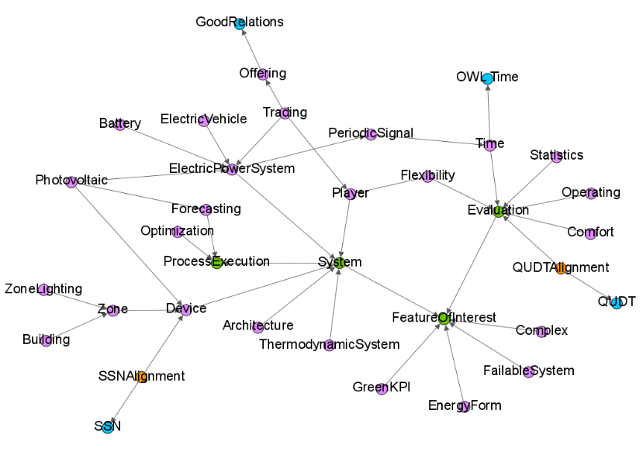
Figure 5.1.2.2.2-1: Core and extended modules[i.19]
In the figure 5.1.2.2.2-1, green nodes are core modules, pink nodes are extended modules and orange nodes are alignment modules respectively. The core of the ontology is composed of four modules:
- Feature Of Interest Ontology
- Evaluation Ontology
- System Ontology
- Process execution platform ontology
These modules define the generic concepts, which are required for defining the baseline of topology. On top of these core modules, the SEAS ontology defines several extended modules (referred to as "vertical" modules in SEAS documentation), that define specific knowledge model based on the core modules of a domain. These modules represent knowledge model for systems and their connections, their properties, devices involving sensors and actuators, region concepts (zone ontology), concept models for energy markets, demands/responses etc.
The module feature of interest ontology describes the considered single or set of feature of interest in the real world environment (e.g. a room, a server, a device, an organization) as well as their properties. These properties can be qualified, quantified, observed and/or based on the related feature of interest in the environment. One unique aspect in this module is that any property can also be defined as feature of interest, to support the idea that properties may also have some properties as the system evolves and new parameters are added in the environment. This module is not dependent on any other modules in the knowledge base.
The module evaluation ontology defines the concepts required for evaluating the properties of feature of interest, which are defined in feature of interest ontology. This module can be adopted to represent the qualitative or quantitative values, unique or constant values, statistical measurements, estimations or forecasts, temporal values and provenance information etc. One property defined in feature of interest ontology can have multiple evaluations defined using evaluation ontology. This module extends only feature of interest ontology as shown in figure 5.1.2.2.2-1.
The module system ontology describes the system knowledge model, which is focused on specific concept representation of feature of interest ontology, as it only imports feature of interest ontology. Here, a system is considered as a part of real world environment that can be virtually isolated. This modules can also be used to define the interactions of the multiple systems through concept representation of connections and connection points defined in it, such as connection, connectedTo, connectionPoint, etc.
The module Procedure Execution Platform Ontology [i.18] is defined an externalized core module, according to project deliverable D2.2 SEAS Knowledge Model document [i.19], as it generalizes the concepts defined in W3C Semantic Sensor Network ontology [i.20] and Semantic Actuator Network ontology. This module defines the concept representation of procedures and its executions. For example, "Sensing" can be defined as pep:Procedure whose execution can be defined as "Observation" using pep:ProcedureExecution, which will be executed by a "Sensor", defined using pep:ProcedureExecutor.
Addition to the core modules above, the SEAS ontology also defines extended ontology modules (reffered as SEAS vertical modules). The modules are divided into two categories based on the portability to different smart city use cases. The table 5.1.2.2.2-1 shows the categorization of these modules.
Table 5.1.2.2.2-1: Categorization of SEAS modules based on smart city Domain
use case independent (cross-cutting) | use case dependent (vertical)
building ontology | communication ontology
city ontology | electric vehicle ontology
device ontology | forecasting ontology
player ontology | street light system ontology
zone ontology | smart meter ontology
generic property ontology | trading ontology
offering ontology | zone lighting ontology
pricing property
statistics ontology
time ontology
One of the essential information regarding smart city domain is the regional concept representation. For the semantic representation of such information, zone ontology, building ontology and city ontology are relevant modules. The module zone ontology defines the knowledge model for regions in more generalized terms, such that it can be used to define from small zones (e.g. room) to large ones (e.g. city). It also defines a sub-zone as well as connected zone relationships among different zones. This module imports system ontology and device ontology. The modules building ontology and city ontology can be considered as extended modules of zone ontology, hence they focuses on respective knowledge representations.
The module device ontology is essential in the aspect of knowledge representations for devices deployed in smart city. The module player ontology focuses on a person or an organization performing a business role. This role can be in terms of offering or execution of a service etc. This is essential module for knowledge representation of an entity, providing a service to users in smart city. Both device ontology and player ontology import system ontology and Procedure Execution Platform ontology, hence the concepts and relationships are extended accordingly.
The other use case independent modules considered for smart city, mostly define the properties and evaluation parameters of the feature of interest. Among these modules, time ontology can be most utilizable, as it will enable knowledge representation of temporal context of evalutations. The module statistics ontology is used to define the statistical evaluations of the properties for the considered feature of interest. The pricing module can be used in relation with player ontology and offering ontology, in order to represent the service provisioning and the respective pricing information. For other types of evaluations, generic property can be utilized, such as direction, length, speed etc.
For use case dependent modules, if a knowledge model specification involves a use case specific feature of interest the module can be utilized. For example, for electric vehicles electric vehicle ontology would be used.

5.1.3 xxxx
Editor’s Note: This clause includes other specification which defines ontology for smart city.

5.2 Smart Home
<Text>
5.2.1 SAREF
5.2.1.1 Introduction

5.2.1.2 Description

5.3 Smart Building
<Text>
5.3.1 SAREF4BLDG
5.3.1.1 Introduction

5.3.1.2 Description

5.4 Smart Environment
<Text>
5.4.1 SAREF4ENVI
5.4.1.1 Introduction

5.4.1.2 Description

5.5 Smart Energy
<Text>
5.5.1 SAREF4ENER
5.5.1.1 Introduction

5.5.1.2 Specification

6 Gap Analysis of existing ontology models for smart city domain

6.1 Introduction

This clause provides the detailed analysis of the limitations in existing ontologies for the smart city domain. The limitations are analysed using principles based on current best practices of ontology design.These principles involve the considerations for topology and structure, terminologies, granularity, logical criteria, etc. The issues highlighted in this study are mainly focused on the selected standard ontology models, considering only smart city domain. Regarding this analysis, scope limitations are identified and discussed to provide more reliable conclusions, considering a controlled environement, as an ontology model always remains the subject to be updated based on the open-world assumption [i.21].

6.2 Data Consideration for Smart City
The main goal of Smart City Ontologies is to enable semantic annotation, interoperability and reusability, for the data generated and exchanged in the smart city information systems. In this regard, the semantic support does not only considers devices, but different others as well. Smart City incorporates different IoT service provisioning, covering multiple domains, such as air-quality, weather, parking, public transportation, electricity, etc. In order to confine the scope of analysis, following aspects have been considered for Smart City domain:
1) Device Aspect
The deployment of IoT devices in Smart City environment emphasizes the need to consider the device aspects in Ontology design and development. In this case, SSN [i.20] and other such standards have been referred, which specifically focused on Knowledge model representing IoT as well as non-IoT device concepts, for example, Input, Output, State, Function, Command, Variable, etc. This information are essential for the interworking with IoT applications. Using this knowledge model, Devices such as, sensors, actuators or any other computation capable IoT device can be represented and the semantically annotated information such as Function and Variable can be reused among devices and systems.
2) Service Aspect
Although oneM2M, SAREF and other IoT standards covers service aspects at architecture level including interfaces and APIs, there is still a need for the semantic representation of the information at higher level for the systems and platforms supporting such IoT network, especially in Smart City domain. For example, Weather and Air-Quality data acquisition through Weather station, Parking Service Provider’s Profile, Parking Congestion Estimation, etc. These information cannot be annotated using above defined concepts. To overcome this limitation, standards such as SAREF and SEAS provide extended knowledge representation for the Smart City domain.
3) Non-IoT Data Aspects
The existing approaches focused on data acquisition and analysis, considering the IoT devices and other embedded systems. However, smart city covers much broader scope, which includes not only the IoT sensor data, but also requires concentration towards static, historical and other data aspects. These includes: statistical evaluations, profile information regarding person, organizations, places, events, contact information, pricing related data, census data, information regarding device and system models, their specifications, compatibility, etc. Hence the considered systems and environments should be able to support all this data representation schemes as well structuring them semantically, to support interoperability.
4) Modularization
Modularization is the key feature that is considered amongst almost all the IoT standards. The main advantage is the optimization in terms of data management, scalability, load balancing, query time, etc. For the efficient ontology management from both design and implementation aspects, we have considered modularization of ontology based on Information domains. The knowledge model has been designed considering two different aspects of representation. One is the Smart City common ontology model, which is the representation of generalized concepts and relationships, and second are the extensions of this model which represents specific domain information such as smart parking ontology, weather ontologym, air-quality ontology, etc.

6.3 Ontology Design Evaluation Criteria

6.3.1 Introduction
This clause describes the required criteria for the principle of ontology design, based on which the existing ontology models have been studied. These requirements are derived based on the best practices of ontology design[i.21, i.22, i.23]. Furthermore, these requirements have been categorized into two types of criteria: general evaluation and evaluation for granularity.

6.3.2 General evaluation criteria
General evaluation criteria involves principles, which are independent of application domains and must be validated in ontology design process.
- Completeness: This involves the essential requirement to provide sufficient conceptual representations that can cover the required domain. Although, this criteria will always be limited to existing reseach in the considered domain, it should be validated against existing knowledge repositories in each stage of ontology design process.
- Adaptability: The concepts of adaptability offers to achieve monotonic revision of ontology. In addition, it also supports to achieve the application goals of integration and scalability. In order to satisfy this criteria, the ontology should anticipate the considered tasks and should adhere to changes as well as extensions. The defined axioms should be stable enough to allow changes and addition of new ones.
- Clarity: This criteria incorporates different considerations in ontology design process. This involves clear and well defined concept classes and relationships representing the considered domain. Specifically, the definitions should be independent of subjectivity and context, should be documented and should be able to convey accurately, the meaning to its considered users.

- Conciseness: The ontology is considered concise if it does not include redundant and irrelevant axioms based on the considered domain. In addition, the relevant and essential axioms used for the concept representation, should be minimal.

6.3.3 Granularity based Evaluation criteria
In addition to the general evaluation criteria defined above, some requirement of particularity must be ascertain for ontology design evaluation. These are specified as follows.
- Logical criteria: that the ontology model should satisfy the basic logical constraints that are consistency and satisfiability. An ontology is inconsistent if it’s axioms does not hold true in any possible world. However, a class may be consistent, but it will be unsatisfiable, if it is evaluated as an empty set in any model. In other words, if any instance is defined for that class, it will be evaluated as unsatisfiable.
- Structural criteria: This criteria validates the ontology structure as a topological arrangement of classes and relationships, evaluating the appropriate knowledge representation.
  - The ontology should contain a valid taxanomy. A taxanomy serves as the backbone of an ontology, where the concept classes form a hierarchy representing a directed acyclic graph with single root class. This hierarchy is developed using at least one of the two relations: Inheritance (is-a subsumption) and composition (part-of subsumption). Generally, the hierarchy follows a direction from generic to specific concepts in inheritance and from aggregated to segregated concepts.
  - The ontology relations should not demonstrate any ambiguity with respect to terminology and direction. In particular, the terminology should be able to distinguish between general and specific concept. In addition, the relationship terminology should also indicate the direction. For example; instead of “subSystem”, the relation should be termed as “subSystemOf”, because it indicates the direction from one class to another.
  - The ontology concepts should not include multiple inheritance. In other words, the taxanomy should not involve any class with multiple parent classes. There are multiple factors considered in order to define this criteria. One is the computation performance, as the time and computation complexity will be reduced in inference as well as reasoning tasks by avoiding multiple inheritance. Second is the design maintenance and update, as the addition and removal of axioms will easier for the designer considering and ontology with single inheritance. Third factor is the consideration of integration and reuse. For example, complexity of ontology mapping, merging and alignment will reduce drastically using the ontology with single inheritance.
- Unique Identification: Each concept and relation in an ontology should be uniquely identified. This is one basic criteria which is essential for the application program, where the processes such as searching and crawling techniques are dependent on the predefined identifiers. In addition, the ontology itself should be associated with unique identifiers, for each version of the defined ontology.
- Role characteristics: The ontology should ascertain role characteristics such as disjointness, transitivity, functional and other such relations where necessary.
  - Disjointness is necessary in concepts where one instance can be represented by only one of two classes. For example: the instance “smart_phone” can only be defined under class “Device” and can never be defined in class “Human_User”. In this case, the property of disjointness should be defined between these two classes.
  - Transitive properties are used for defining sequence of relationship between one or more classes. For example, consider the owl:ObjectProperty “subZoneOf” defined as transitive, having both rdfs:domain and rdfs:range as “Zone” class. Then by defining the relationships “parking_spot subZoneOf parking_lot” and “parking_lot subZoneOf city_district”, the ontology user can infer the relation “parking_spot subZoneOf city_district”.
  - The functional property restricts the owl:ObjectProperty or owl:DatatypeProperty to have single unique relationship for any rdfs:domain associated with it. For example, each instance of class “Device” will have only one relationship “hasID” as owl:DatatypeProperty.
  - There are other role characteristics besides mentioned above, which ensures the completeness at granular level of an ontology. For further details, refer to [i.24].
- Univocity: The terminologies used in an ontology should ascertain univocity. That is, the term used to defined the concepts should communicate one unique meaning. In particular, the terms which are homographs (which have same spelling but different meaning), must include the exact definition to avoid ambiguity. For example, the term “lead” can be interperated as “to guide” or as “the metal”. Therefore appropriate meaning is required for the interpretation. For the case of different terms with same meanings, synonyms should be defined in annotations for the proper usage and to avoid any ambiguities in updating the ontology in future.
- Rigidity: The concept classes in an ontology should ascertain rigidity. For this criteria, the concept definitions must involve essential features without which its’ members can not exist. For example, an IoT device will have all its essential features such, being able to communication through Internet, can perform computation, etc. without which it can not be identified as an IoT device. In addition, it supports the property that a rigit class will always be a subclass of a rigid one. This property can be used to evaluate taxonomy appropriately.
- Singular terminology: The ontology concepts should be defined using singular terminology. Mostly the taxanomy defined in an ontology consists of either inheritance (is-a hierarchy) or composition (part-of hierarchy) of concepts. In such case, the representations are best representated when the defined terms are singular. For example, the relation “parking_lot is_a Zones” clearly shows ambiguous representation.
- Definitions for non-root terms: The ontology should include definitions for atleast all the non-root terms, where the definitions should involve the essential features and avoid circularity. The criteria for defining essential features has been discussed previously. A cicular definition will involve same term used in it’s representation. For example, consider the following definition: “The area which represents Zone.”. This will be a considered as a circular definition of class “Zone”, because it does not stipulate additional information to describe it’s nature or any of it’s essential features. One recommendation to avoid circularity is to include the terminology from the parent or super class, followed by specifying the essential distinguishing features which defines it’s existence. For example, the class “ParkingLot”, which is defined as “The Zone, where cars or other vehicles are left temporarily”, validates the above defined criteria.
The other aspects such as context, representation, modularization, reusability, realism, adherence to reality, etc. vary based on domain and ontology design approach, hence will be discussed according to the relevance.

6.4 Gap analysis of SAREF ontologies

6.4.1 Introduction
This clause provides the detailed analysis of the gaps highlighted in SAREF ontologies considering the smart city domain. Some concepts which are relevant in smart city domain, are not included as part of SAREF4City ontology, however, are defined in SAREF ontology. Therefore, those concept definitions have been considered for the evaluation. The discussion is organised into point-based highlighted gaps and categorized according to the general evaluation criteria defined in clause 6.3.2.
Editor’s note: Examples involved for the respective points will be added later in Annex. The points involving the examples, contain a text label: <Example Reference>

6.4.2 Gap analysis based on completeness
- The class saref:Service is defined as “a representation of a function to a network that makes the function discoverable, registerable, remotely controllable by other devices in the network”. Here, the class covers only some part of computing aspect. There can be other services such as; the ones which are provided as a commodity. Also, in computing concept, there can be other services, which may not consider device aspects, for example, data management and analysis, data security, task monitoring and management, etc. Hence, the other aspects of services are not available, which may cover possible smart city concept representation.

6.4.3 Gap analysis based on adaptability
- SAREF provides relations with external ontology concept representations, which promotes reusability of existing ontologies. However, it lack the structure supporting taxonomy as well as open-ended ontology design process. See example A.1.1 for further details.
- The classes saref:FunctionRelated and saref:BuildingRelated though demonstrate a valid taxonomy, they may not be optimized in terms of usage and concept representations. For example, there will be many cases where a single device will be performing many functions, therefore it will be difficult to create concise assertions for them, using the current taxanomy.
- The axiom ‘saref:DoorSwitch subClassOf( saref:consists of someValuesFrom saref:Switch )’ may lead to inconsistent taxanomy or unsatifiable assertions due to the existence of axiom: ‘saref:DoorSwitch subClassOf saref:Switch’.

6.4.4 Gap analysis based on clarity
- There are different concepts and relationships in SAREF ontologies, in which the terminologies used in their assertions, posses the nature of covering either wider or narrower scope, unlike their respective definitions. Therefore, the constraints applied for the usage of those assertions lack clarity, considering the terminology compared to their respective descriptions. In addition, these terminologies are preoccupied with existing scope limitations. This will increase the uncertainty as well as the complexity to search the assertions relevant to the required usage, as there will be multiple assertions defined in the future, having similar terminologies with different scope limitations. Examples A.1.2-A.1.9 highlight this specific issue.
- The class saref:State is defined as, “The state in which a device can be found …”. First, this definition assert circularity. Secondly, this definition has limited scope as it is only focused on device aspect whereas other events can also have states to define their life cycle in the considered environment. For example, some process or system having state as running, paused, finished, queued, etc.
- The relation saref:isMeasuredIn highlights ambiguity as it includes saref:Commodity as its domain. However, entities such as service as a commodity can not be measured using saref:UnitOfMeasure class.
- The class saref:State should be defined as subClassOf saref:Property, as it should be considered as a property which deals with the state of any entity.
- In certain property definitions, some of the terminology used, highlights uncertainity in identifying their proper usage. See example A.1.10 for further details.

6.4.5 Gap analysis based on conciseness
Based on the current versions of the considered ontology modules, there are no assertions that are evaluated as redundant or irrelevant based on the criteria defined in clause 6.3.2.

6.5 Gap analysis of SEAS ontologies
This clause provides the detailed analysis of the gaps highlighted in SEAS ontologies considering the smart city domain. The following discussion considered the selected SEAS ontology modules that are highly relevant for the smart city domain. This includes all the core SEAS ontology modules as well as some of the vertical domain ontologies. The discussion is organised into point-based highlighted gaps and catagorized in accordance with the general evaluation criteria defined in clause 6.3.2.

6.5.1 Gap analysis based on completeness
- In seas:CityOntology module, there are some missing concept representations identified, with repsect to completing the scope of domain. For example, idustrial area, public area, neighbourhood, etc. Example A.2.1 provides details regarding these missing concepts.
- In seas:BuildingOntology, there are certain definitions, such as, those of seas:BuildingSpatialStructure, seas:BuildingSpace and seas:Ceiling, which do not provide enough details through which its usage can be ascertained. Refer to example A.2.2 for further details.
- Regarding the aspect of completeness in seas:DeviceOntology ontology, there are certain concepts whose representation is not available. Such concepts are discussed in example A.2.3.

6.5.2 Gap analysis based on adaptability
- seas:Property can some times also be declared as seas:FeatureOfInterest. This may create different limitations as well as complexities in terms of ontology extension. For example, if an entity requires representation using properties (i.e owl:ObjectProperty and owl:DataProperty) involving both seas:Property and seas:FeatureOfInterest, then two entities has to be created. In addition, seperate propery has to be defined, which represents the relationship between those two entities. Another complexity can be witnessed in deciding that which class should be used for representation, due to their dual nature of representation. In the class description (defined as a rdfs:comment) of seas:Property, it is well explained that how a seas:Property can be utilized as a seas:FeatureOfInterest. However, the example used in the description leads to another enigma regarding property subsumption, which will be discussed later in this clause. Besides, external applications can not identify this usage using any ontology definition other than the rdfs:comment defined for seas:Property. Hence an agent based application has to rely on Natural Language Processing in order to identify this comprehensive usage of seas:Property.
- seas:PercentageProperty that is subsumed by seas:Property, although is correctly defined based on univocity and rigidity, is too specific to representing the data aspect rather than representing the high level aspects of the properties. This may result in increased complexity in creating relationships between classes of domain seas:FeatureOfInterest, seas:Property and seas:Evaluation. Since it covers only the data aspect of represention, additional assertions will be needed to be defined and related to seas:PercentageProperty. Example A.2.4 discusses this clause in details.
- In the Zone ontology, the properties seas:absoluteHumidity, seas:populationFlow, seas:saturatedVapourPressure and seas:specificHumidity are defined as a sub-property of seas:hasProperty, in seas:FeatureOfInterestOntology module. The property seas:hasProperty has its domain and range defined as seas:FeatureOfInterest and seas:Property respectively. However, the above mentioned properties include both of their domains and ranges as sub-classes of seas:Property. This may result in ambiguity in defining assertions as all the individuals in the property assertion, involving the above mentioned properties, can not be related to each other using the property seas:hasProperty [i.25]. See example A.2.5 for details.
- Certain classes in the modules, seas:PlayerOntology, seas:CityOntology and seas:BuildingOntology, support multiple inheritance, which may cause a drawback for ontology extensions. These classes are seas:Player, seas:Bridge, seas:CarPark, seas:Stadium and class seas:Building.

6.5.3 Gap analysis based on clarity
- Based on the definition, the property seas:value, defined in seas:EvaluationOntology, should be renamed as seas:constantValue, in order to avoid preoccupation of the terms.
- Certain properties in the Procedure Execution Ontology (pep:) module, have unspecified or restricted domains and ranges defined, in contrast of the terminologies used. These properties are pep:hasCommand, pep:hasInput, pep:hasOutput, pep:hasResult, pep:hasSimpleCommand, pep:hasSimpleResult, pep:implements, pep:made and pep:madeby. Example A.2.6 and A.2.7 highlight the particulars of this issue.
- Different SEAS ontologies have used the term “agent” and the class seas:Player in different assertions and descriptions. However there is a potential obscurity between these two terminologies and their usage in SEAS ontologies. The class seas:Player is defined as “One of the important people, companies etc involved in a particular industry, market, situation etc”. There are different SEAS ontology modules, such as seas:OfferingOntology, seas:FlexibilityOntology, seas:BuildingOntology, etc. where seas:Player has been used in object property assertions, while involving the term “agent” in their descriptions. Additionally, the term “agent” used in different places in SEAS, lack proper referencing, as it is important for the user application to identify the exact usage of the considered class. See example A.2.8 for further details.
- The definition for seas:CivilEngineeringWork accentuates subjectivity as it states that it should not be classified under buildings. In this case, there are two situations to be considered. First, this concept implies its existence more towards higher level ontology than seas:BuildingOntology module. Although its existence in seas:BuildingOntology is valid based on logical constraints, users may not expect such class in this ontology. Secondly, alghough it has provided different examples that can be considered as seas:CivilEngineeringWork, based on the open-world assumption, there can be infinite many concepts that may be considered under its definition since the it uses negation for describing it’s essential feature.
- The definition class seas:Garage in seas:BuildingOntology, and the classes seas:Authority, seas:ElectricityMarket and seas:SmartChargingProvider, in seas:PlayerOntology module, accentuates circularity.
- In seas:BuildingOntology module, the classes seas:Laundry, seas:LowEnergyHouse, seas:PassiveHouse, seas:Room and seas:Sauna, involve certain terms in their definitions, which highlights ambiguity in identifying their scope and usage. Example A.2.9 and A.2.10 expand on this discussion.
- In the seas:ZoneOntology, the terminologies used to define the properties seas:absoluteHumidity, seas:area, seas:humidity, seas:population, seas:populationFlow, seas:saturatedVapourPressure, seas:specificHumidity and seas:volume do not specify direction from their respective domains to ranges, which is not in accordance with the best practices of ontology design.
- The seas:CityOntology module definition is stated as: “The SEAS City ontology contains subclasses of zones usefull to describe cities”. However, it does not include the details that which aspect of features can be involved, for example infrastructure, administration, etc. Since the city domain requires extensive conceptual representation, therefore it is important for the user to realize the aspects which the ontology covers.

6.5.4 Gap analysis based on conciseness
Based on the current versions of the considered ontology modules, there are no assertions that are evaluated as redundant or irrelevant based on the criteria defined in clause 6.3.2.

6.6 Gap analysis summary
SAREF and SEAS ontologies and their extensions are aimed at supporting smart systems for different domains. Both standardization work mainly focused on semantic interoperability and reusability as well as on providing common model of consensus. The positive aspect of considering these ontologies is their high relevance towards smart city domain. SAREF has contributed by the development of SAREF4City ontology, specialized for smart city domain and SEAS ontologies involve different modules such as seas:CityOntology, seas:BuildingOntology, seas:PlayerOntology, etc. that support representation of smart city ecosystems. In this regard, these ontologies have been analysed based on the evaluation criteria defined in clause 6.3. Table 6.6-1 provides the overview of the highlighted gaps, identified in the considered ontologies discussed in clause 6.4 and clause 6.5, based on the general evaluation criteria defined in clause 6.3.2.
Table 6.6-1. General Citera Evaluation for SAREF/SAREF4City and SEAS
 | SAREF / SAREF4City | SEAS
Completeness | Missing Concept Representations | Missing Concept Representations
Adaptability | Segregated taxonomy, inconsistency, unoptimized subsumption | Lack of univocity, unoptimized subsumption, improper domain/range definitions in the subsumption of object property, multiple inheritance.
Clarity | Terminology with limited scope, terminology with uncertain meaning and usage in ontology, circularity. | Terminology with contra unclear scope definitions, lack of univocity, circularity, uncertain concept definition and usage based on taxonomy, subjectivity
Conciseness | - | -
Table 6.6-2 provides the overview of the highlighted gaps, identified in the considered ontologies discussed in clause 6.4 and clause 6.5, based on the granular level evaluation criteria defined in clause 6.3.3.
Table 6.6-2. Granularity based Criteria Evaluation for SAREF/SAREF4City and SEAS
 | SAREF / SAREF4City | SEAS
Logical Criteria | Axioms with potential unsatisfiable assertions | owl:objectProperties with potential unsatisfiable assertions
Structural Criteria | Segregated taxonomy, unclear class subsumption | Multiple inheritance, misleading class position in taxonomy with respect to its definition
Unique Identification | - | -
Role Characteristics | - | -
Univocity | Class definition with less optimized usage | Class definitions with similar scope and lack of uniquely identified features
Rigidity | - | Definitions with lack of essential features
Non-singular Terminology | - | -
Definitions for non-root terms | Circular definitions | Circular definitions

7 Ontologies for SmartCity in oneM2M

7.1 Introduction
This clause presents different ontologies, which all together can be considered potential set of ontologies for smart city domain. Due to limitations identified in the ontologies discussed in clause 6, they can not be used directly, to semantically represent the smart city data. In order to support modularization as well as to cover different sub-domains which can potentially be the part of smart city, a common ontology has been proposed, which covers the high level concept definitions. Using those concept definitions, this ontology has been extended by different domain ontologies which semantically represent those sub-domains in smart city.

7.2 Common Ontology
The core ontology, which is termed as common ontology, revolves around six main high level concept classes, which are shown in figure 7.1-1. The oval represents an owl:Class (and will be refered to as class / concept class) and the arrow indicates rdfs:subClassOf relationship, from child to parent class. These classes are considered from Feature of Interest Ontology [i.26], Evaluation Ontology [i.27] and Procedure Execution Ontology [i.28]. The base building block of this common ontology is class FeatureOfInterest and Property. Likewise Feature of Interest Ontology, the class FeatureOfInterest and the Property in the common ontology have similar definitions, however, in any case, a Property can not be considered as FeatureOfInterest. This will ensure consistency and minimized ambiguity in future extensions. Refer to Annex B.1 for the specific definitions of each class.
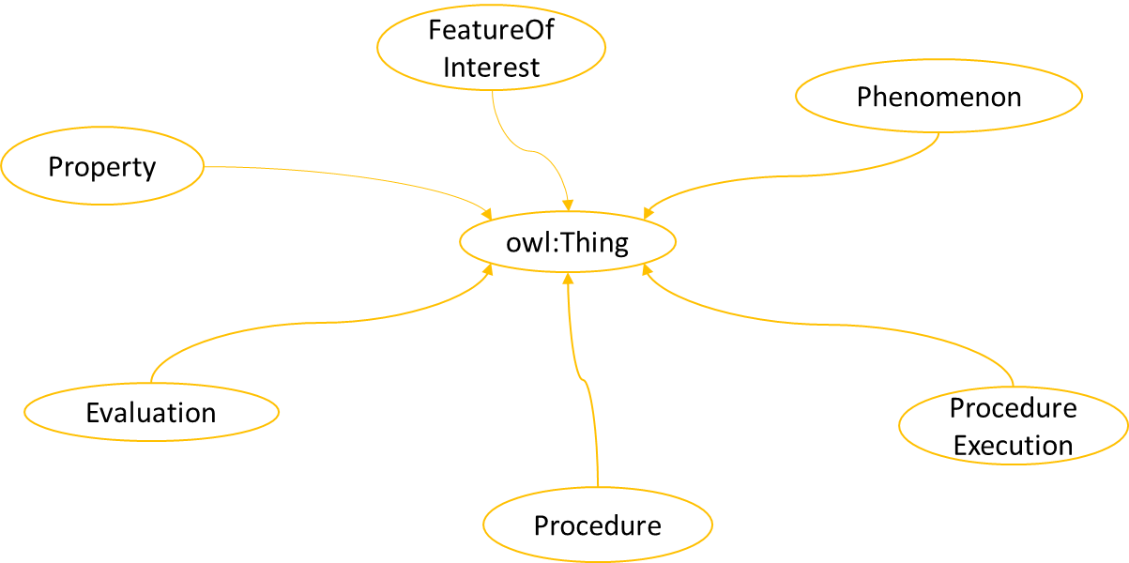
Figure 7.2-1. High level classes in Common Ontology

Based on the terminology, the Evaluation class here covers the broader domain than the one defined in SEAS. In common ontology, Evaluation provides the assessmen of Property, instead of the value of a Property. Although, there exists a owl:ObjectProperty in SEAS, relating Property and Evaluation. However, the main concern is making the scope of Evaluation broader, based on the terminology. Procedure has almost similar definition, only the specific terminologies have been replaced by the phrase “series of steps or actions”, in order to provide a possibility to extend the scope. The class Phenomenon has been considered from SEAS Upper Ontology [i.29]. In order to cover the scope appropriately and provide the definition which distinguishes it from class Observation in SEAS Device Ontology [i.30], it’s definition states Phenomenon it as fact or a situation. In addition, both artificial and natural phenomenon have been considered for the scope.
Different sub classes are further defined to cover different scopes of the higher level classes. Figure 7.2-2 shows the expansion of FeatureOfInterest class. There are some important differences in the taxonomy which are described as follows:
- The taxonomy of ProcedureExecutor is changed from Procedure Execution Ontology, as there it does not have any parent class. This also changes it’s definition as “The System involved in or implementing a Procedure”.
- The above change also affects Player class as it removes the complexity of multiple inheritance, which was the case in SEAS Player Ontology [i.31]. Now it is defined as a subclass of System only and not ProcedureExecutor.
- The definition of Zone is modified from SEAS Zone Ontology [i.32] to “An area or a stretch of a land or space…”. This provides a possibility to cover broader scope.
- AdministrativeArea is a class considered from SAREF4City ontology. This also affects all the subclasses respectively.
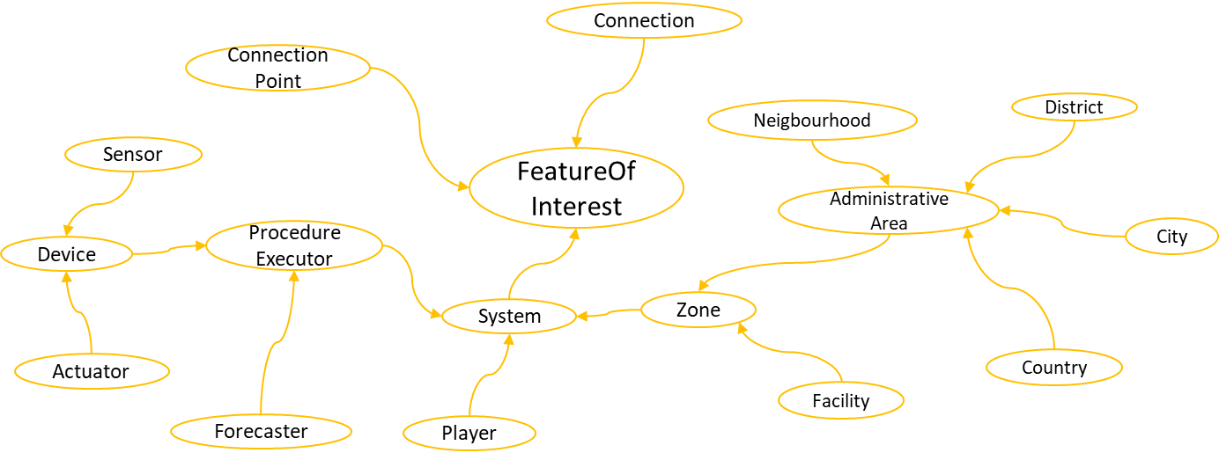

Figure 7.2-2: Taxonomy expansion under Feature of Interest

The expansion of Property and Evaluation class can be seen in figure 7.2-3. The aspects covered and modified are described here as follows:
- DimensionProperty and LocationProperty are newly added classes. They serve the purpose of maintaining the taxonomy in case if additional sub-classes are added.
- State class is considered from SAREF ontology. Its taxonomy is modified from owl:Thing to Property.
- KeyPerformannceIndicator and KeyPerformannceIndicatorAssessment are considered from SAREF4City ontology. Here, they are defined as subclass of Property and Evaluation respectively.
- Service can be one of the most critical concept specifically in this taxonomy. In SEAS Technical System Ontology [i.33], it is defined as a subclass of AbstractEntity. In order to clearify it’s scope to the level of Software Architecture domain, service is defined as Property. The other potential candidate classes, that can be defined as it’s parent class, are Procedure and ProcedureExecution. The reason Service can not be defined as a subclass of either of them is that it can include both aspects in its composition as well as some types of System. Whereas here, it can be considered viable, if it is seen as a characteristic of a System. Now it’s composition can involve relationships with different entities including System, Procedure and ProcedureExecution.

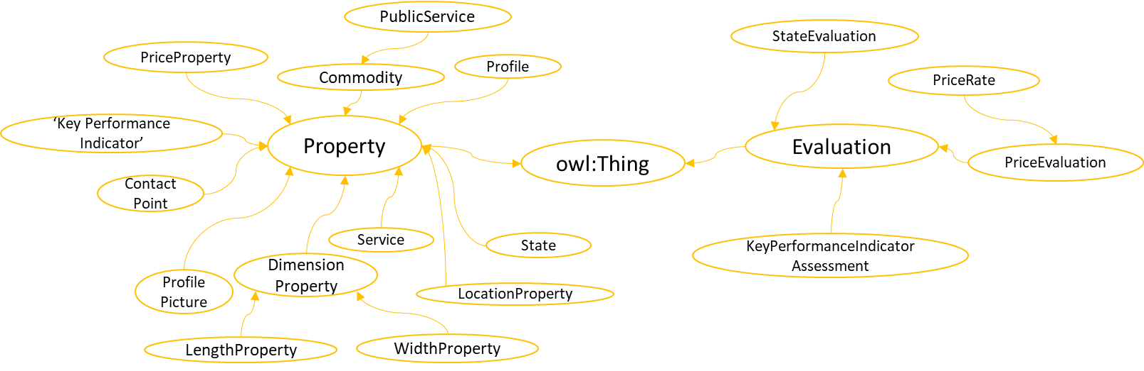
Figure 7.2-3: Taxonomy expansion under Property and Evaluation

Figure 7.2-4 ilustrates the taxonomy expansion under the classes Procedure and ProcedureExecution. Following are the covered aspects along with the modifications from existing ontologies:
- The classes: Actuation, Observation, Forecast and Forecasting have been considered from SEAS Device Ontology and Forecasting Ontology with same concept definitions.
- The classes: Estimation, Estimating and Observing are newly added, which cover some concepts related to ones mentioned above.
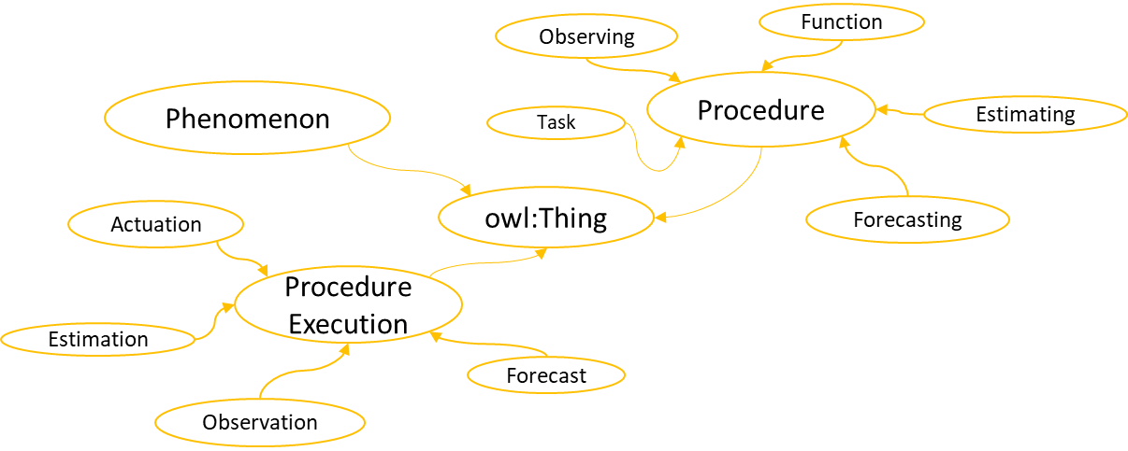
- Task and Function are considered from SAREF with slight modification to broaden their scope. In SAREF ontology, both classes defined their relationship (in class definition) with a Device. However, in case of common ontology, the relationship is defined with ProcedureExecutor, which means that any physical or logical entity capable of executing a procedure can be related with these classes.
Figure 7.2-4 Taxonomy expansion under Procedure and ProcedureExecution

7.3 Smart Parking Extension
This clause describes the extension of Common Ontology for Smart Parking domain, based on following usecase. A parking lot is situated at some location in an urban area, which contains different parking spots. The Parking lot is described with general profile information such as id, contact point, geo location, address, parking service price rate etc. In addition, it involves some status information regarding the parking spot availability. Besides, each parking spot may also contains its individual profile information and have its status update, which is then accumulated to update the status of its respective parking lot. In this case, the services, in terms of both software architecture and commodity are involved. The service as a commodity includes parking service provided to the customer, which also charged with the parking service fee. The services in terms of software architecture includes one, which evaluates the available parking spots, and the other provides the estimated parking congestion.
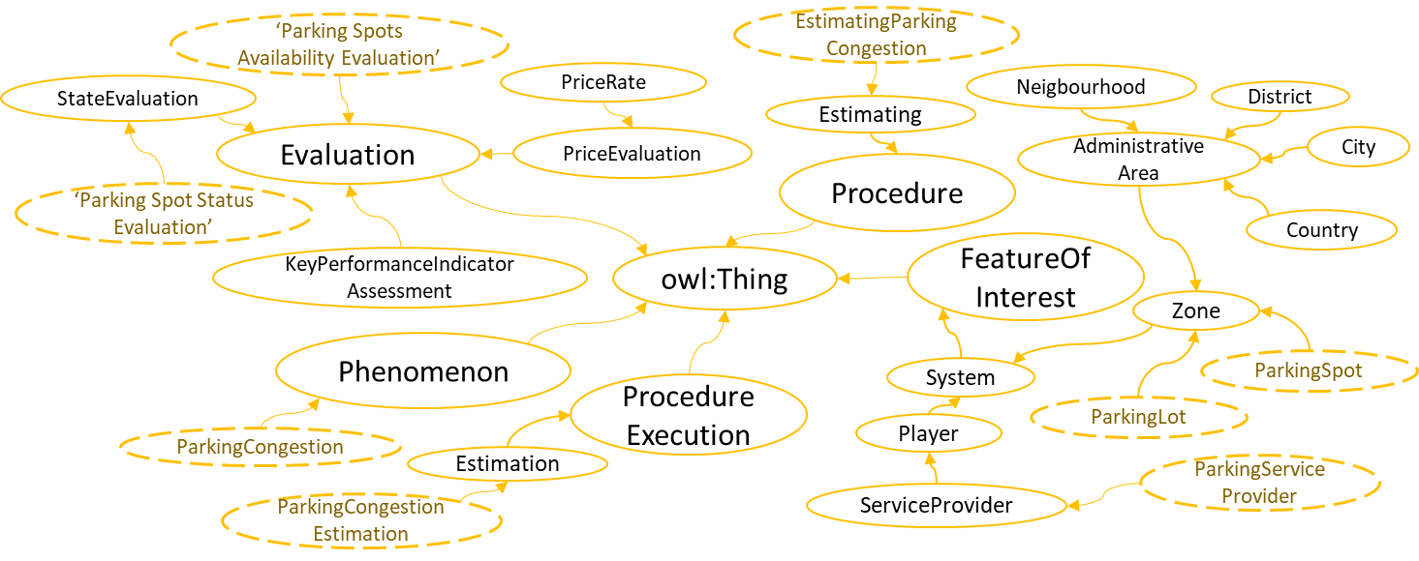
Figure 7.3-1 Extension of Common Ontology for Parking domain based on Feature of Interest, Procedure, Procedure Execution, Phenomenon and Evaluation.
Figure 7.3-1 and 7.3-2 shows the extension of Common ontology for Smart Parking domain. Here the dotted oval represents the owl:Class for parking domain. Here classes ParkingLot and ParkingSpot are described as subclasses of Zone, which also enables them to be represented as both local space and as a System. Profile related information can be stored in ParkingLotProfile and ParkingSpotProfile class. The class ParkingSpotStatus in figure 7.3-2 and the class ParkingSpotStatusEvaluation in figure 7.3-1 relates to the information about a particular parking spot, such that altogether, they provide the information of its availability at particular time stamp. Similarly, the class AvailableParkingSpots in figure 7.3-2 and the class ParkingSpotsAvailabilityEvaluation in figure 7.3-1relates to the information about parking lot, such that, the overall parking spots available in that particular parking lot will be represented here. All this information can be calculated by the instance of class ParkingAvailabilityEvaluationService. In case of ParkingCongestion, the instance of class ParkingCongestionEstimationService will be responsible for execution of procedure of class EstimatingParkingCongestion, and it’s execution related information is represted by the instance of class ParkingCongestionEstimation.
There are some classes in both figures, which are not included in common ontology. These classes are ServiceProvider, PriceEvaluation, PriceRate, PriceProperty and ContactPoint. This is due to the reason that they are more suitable to be the part of some extention than Common ontology. They are considered to be the part of future extensions of ontology.
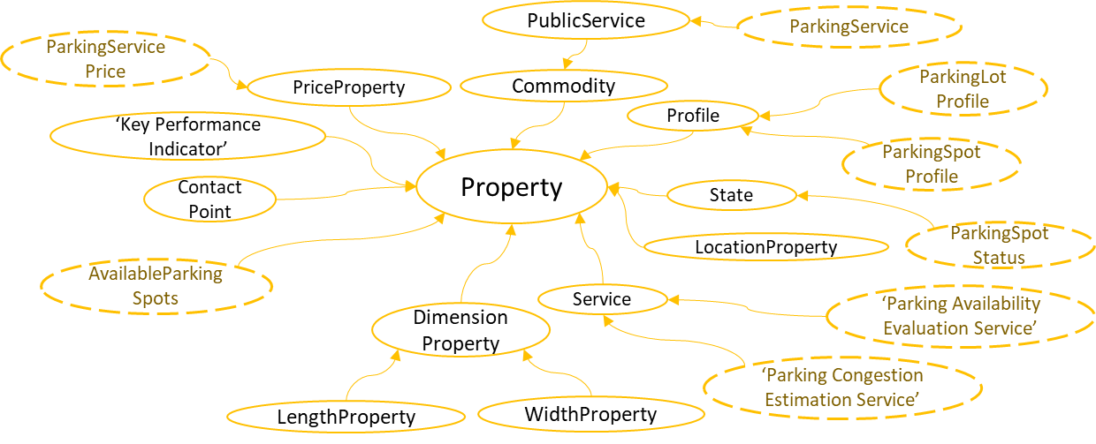
Figure 7.3-2: Extension of Common Ontology for Parking domain based on Property

7.4 Weather Extension
Figure 7.4-1 shows the extension of Common ontology for Weather domain. In this case the ontology covers mostly data aspect, when entiy responsible for data acquisition is a service rather than a device. Here weather is further defined using six different properties: air temperature, humidity, rainfall, wind, snowfall and visibility. Each of these has its own class of type Evaluation and Phenomenon. The classes representing the service responsible for data observation and estimation are WeatherObservationService and WeatherEstimationService respectively. Similarly, there are sublasses defined to represent procedures and their executions for each of two classes of type Service. This ontology can be compared with SEAS Weather Ontology [i.35] where some similarity can be witnessed due to the weather properties considered.
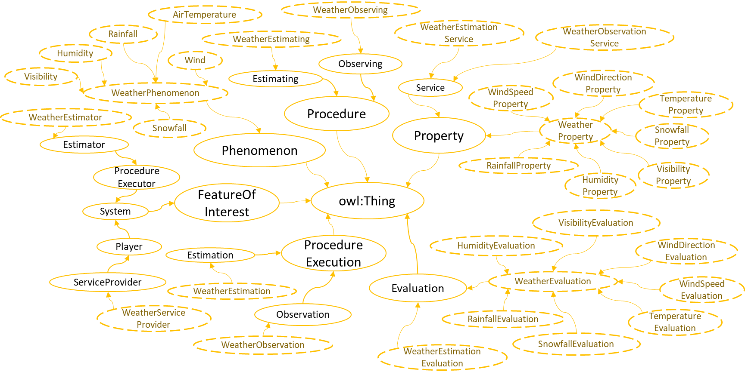
Figure 7.4-1: Weather Extension

7.5 Air-Quality Extension

Figure 7.5-1 shows the extension of Common ontology for Air-Quality domain. The structure is almost similar to that of Weather extension. The main difference is the properties considered for the air-quality data which are: air NO2 level, air O3 level, air CO Level, air SO2 level, air PM25 Level, air PM10 Level. This ontology can be compared with SEAS Generic Property Ontology [i.36] where some similar classes will be witnessed due the considered air-quality properties.
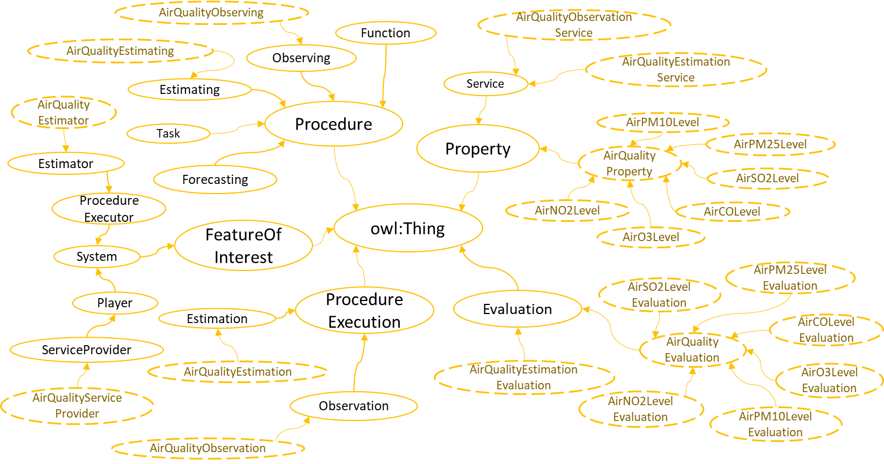
Figure 7.5-1 Air-Quality Extention

The following text is to be used when appropriate:

Proforma copyright release text block
This text box shall immediately follow after the heading of an element (i.e. clause or annex) containing a proforma or template which is intended to be copied by the user. Such an element shall always start on a new page.
Notwithstanding the provisions of the copyright clause related to the text of the present document, oneM2M grants that users of the present document may freely reproduce the <proformatype> proforma in this {clause|annex} so that it can be used for its intended purposes and may further publish the completed <proformatype>.
<PAGE BREAK>
Annexes
Each annex shall start on a new page (insert a page break between annexes A and B, annexes B and C, etc.).
Use the Heading 9 style for the title and the Normal style for the text.

Annex A: Examples of highlighted gaps
Examples of highlighted gaps, for the considered ontologies (SAREF and SEAS ontologies), are as follows.

A.1 Examples of highlighted gaps in SAREF ontologies
- Example A.1.1: In SAREF ontology, the class saref4city:KeyPerformanceIndicator and saref4city:KeyPerformanceIndicatorAssessment can be categorized as Evaluations. But the existing structure defines these classes as separate unique concepts without any more generalized class definition that may be used for the entailment. Reusing or integraging them with other concepts, such as statistical measures or any other quantitative analysis, may position them at same level of subsumption in the taxonomy, hence resulting in highly segregated and less organised ontology structure.
- Example A.1.2: The class saref:Property is defined as “anything that can be sensed, measured or controlled in households, common public buildings or offices”. Here, this does not cover other aspests such as streets, open parking places, parks etc. The nature of the term “Property” can cover larger scopes. Therefore this terminology is pre-occupied with limited scope definition, which limits this ontology for future exention.
- Example A.1.3: The class saref:EventFunction is defined as “a function that allows to notify another device that a certain threshold value has been exceeded”. In this case, this class covers very limited scope as it only includes information related to exceeding thresholds. However, there can be other events such as a user input, an exception or even a value is decreased than the defined threshold.
- Example A.1.4: The property saref:isUsedFor is generic term used to define highly specific relation i.e, “saref:Device saref:isUsedFor saref:Commodity”. In many considered cased this terminology is suitable for wide variety of domains and ranges, such as, “command isUsedFor task”, “measurement isUsedFor event”, “unitOfMeasure isUsedFor Measurement” etc.
- Example A.1.5: The class saref:Profile has limited scope definition as it covers only device profile. There can be different considered environments, users, organizations, etc. that may also require a profile for their related data representation.
- Example A.1.6: The class saref:LevelControlFunction has limited scope definition as it is only focused on actuator. In contrast, many other entities may be required to utilize this class concept such as user or system.
- Example A.1.7: The property saref:hasValue has range xsd:float. However, there can be many possible types for measurement values.
- Example A.1.8: The class saref:Service is defined as “a representation of a function to a network that makes the function discoverable, registerable, remotely controllable by other devices in the network”. Here, the term used is more generic than the concept it represents. There can be other services such as; the ones which are provided as a commodity. Also, in computing concept, there can be other services, which may not consider device aspects, for example, data management and analysis, data security, task monitoring and management etc.
- Example A.1.9: The relationship saref:actsUpon is defined as “a relationship between a command and a state”. However, the term “acts upon” has potential to cover broader scope and may be used to defined other relationships as well. This may cause inconsistency in future ontology extensions or reuse.
- Example A.1.10: The property saref:hasCommand and saref:isCommandOf are inverse of each other. However, the definition of saref:hasCommand is stated as “A relationship between an entity (such as a function) and a command” and of saref:isCommandOf is stated as “A relationship between a command and a function.”. In the formar definition, the term “entity” makes the usage of saref:hasCommand uncertain, as the user may define any other entity that may not be subsumed under saref:Function and in such case the property saref:isCommandOf can not be utilized. Another example is the definition of property saref:hasFunction, which is stated as, “A relationship identifying the type of function of a device”. However the rdfs:range of this property is saref:Function which defines the complete function, rather than the type of the function.

A.2 Examples of highlighted gaps in SEAS ontologies
- Example A.2.1: many classes have been defined to represent different types of roads and paths, however other concepts such as zone based divisions (example: Idustrial area, public area, neighbourhood, etc.) are not available. Since the taxonomy is providing a hierarchy of deductive assertions by subsumption (i.e. generic concept classes to specific ones), the concepts regarding the zone based divisions should reside at the level in between seas:Zone and existing sub classes in seas:CityOntology.
- Example A.2.2: seas:BuildingSpatialStructure is defined as: “A man made structure with spatial properties”. Contraty to this definition, there are many other man made structures having spatial properties, such as statues, bridges, containers, etc. Hence this definition indicates more generalized concept than that of seas:BuildingSpaceStructure. Although, it can be identified through its parent class (seas:BuildingSpace) that this “man made structure” will be specific to building, yet both definitions of seas:BuildingSpace and seas:BuildingSpaceStructure define spatial properties to be their essential feature. Therefore, it becomes complex to identify the exact usage of each of these classes based on their taxonomy and scope definitions.
- Example A.2.3: there can be a device which performs both sensing and actuating functionalities as well as performs some processing, such as statistical analysis, prediction etc. In such case, the properties, such as seas:actsOn, seas:actsOnProperty, seas:observes, seas:observesProperty can not represent the respective relationship as they do not have seas:Device included as rdfs:domain
- Example A.2.4: Consider figure A.2-1, where the orange oval describes the class defined in SEAS ontology and the others as their respective instances. The blue arrow connecting the classes are the object properties defined in SEAS ontology and the dotted arrows are their respective assertions connecting the instances. Based on the usage, it may not be possible to define “WaterLevel” as an instance of seas:PercentageProperty, as it may involve multiple data aspects including percentage. In that case, it becomes necessary that separate instance should be defined to represent the percentage property of “WaterLevel”. In addition, there will be many cases, when instance of seas:Evaluation will be needed to further represent information related to seas:PercentProperty. Based on the existing structure and definitions, one proposed solution is to define seas:PercentageEvalutation instead of seas:PercentageProperty, subsumed under seas:Evaluation in Evaluation Ontology module. In that case, the instance “WaterLevel” will have the direct relationship seas:hasEvaluation with the instance “PercentLevelEvaluation”. Which will reduce instance definitions and hence will reduce the complexity.
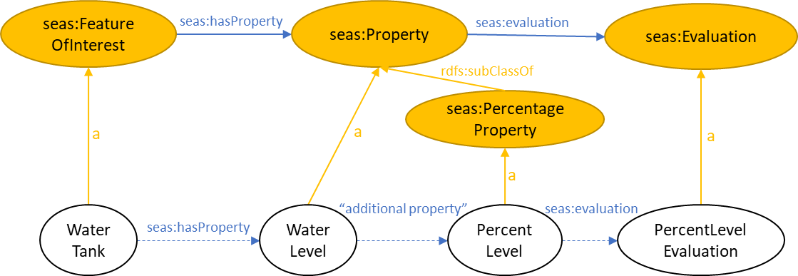
Figure A.2-1: Assertion example
- Example A.2.5: Consider figure A.2-2, where two object properties assertions are compared, which are seas:volume and seas:absoluteHumidity. Both have relation rdfs:subPropertyOf with seas:hasProperty. In figure A.2-2(a), it can be considered as a valid assertion for seas:volume, as both of it’s rdfs:domain and rdfs:range are subsumed under the rdfs:domain and rdfs:range of seas:hasProperty respectively. Whereas for seas:absoluteHumidity in figure A.2-2(b), the assertions are uncertain and complex to realize by the system, because according to description in seas:FeatureOfInterestOntology, seas:Property can also be considered and utilized as seas:FeatureOfInterest, yet any assertion supporting this description is not available
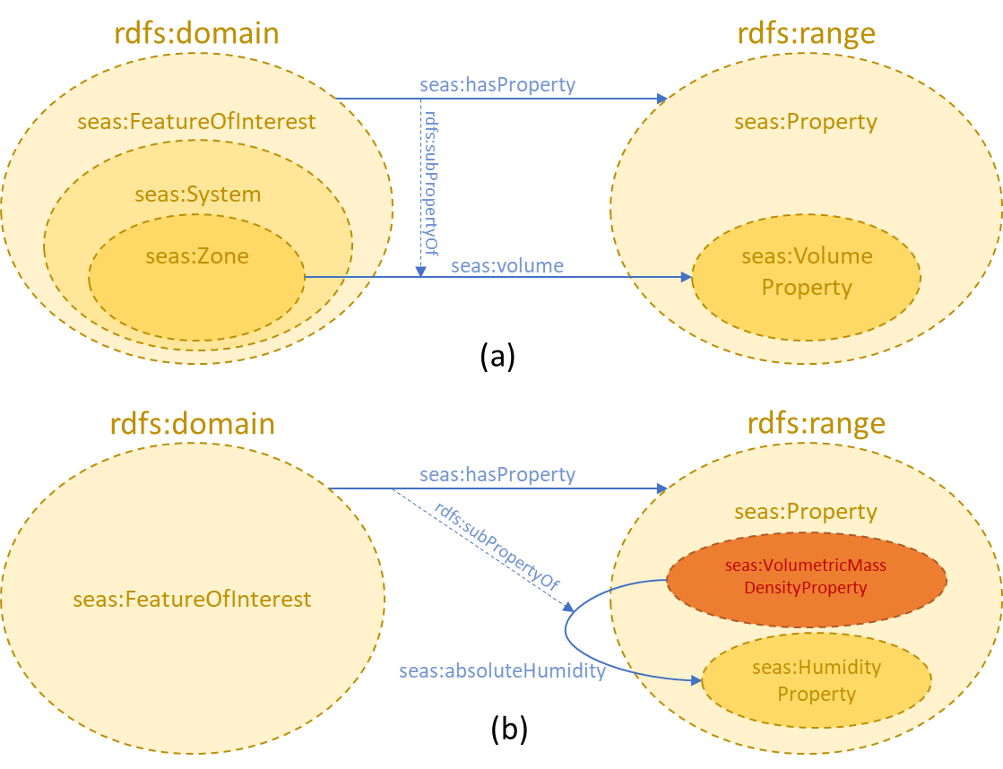
Figure A.2-2: rdfs:domain and rdfs:range assertions of object properties defined in SEAS ontologies
- Example A.2.6: pep:hasInput is described as, “Links a Procedure to the (unique) description of its input”. Whereas, it’s domain and range are not specified.
- Example A.2.7: pep:implementsProcedure can have more clear indication of it’s usage than pep:implements, and this also avoids preoccupation of term implements.
- Example A.2.8: The object property seas:seeks in seas:OfferingOntology is defined as “Links an agent to a procedure it seeks”, while having seas:Player defined as it’s rdfs:domain. The importance of this realization becomes critical in the seas:ComfortOntology module, where it has used the term “agent” referring to foaf:agent. This external class has been imported in this module from Friend Of A Friend (FOAF) ontology, which is defined as “An agent (eg. person, group, software or physical artifact)……. The Agent class is the class of agents; things that do stuff”. The definition of seas:Player does not specify the difference, similarity or any relationship between foaf:Agent and seas:Player.
- Example A.2.9: The class seas:Laundry is defined as, “A room or zone, as in a home or apartment building, reserved for doing the family wash”. Here the term “family wash” highlights ambiguity, as there was no reference available for it’s description. In general laundry is also used in industrial zones where they may process different cloth. Hence based on the terminology, the definition requires more clarity.
- Example A.2.10: The class seas:LowEnergyHouse is defined as, “A house typically consuming half the energy than a norm house”. However, in this ontology the term “building” is refered and defined instead of “house”, as this class is defined as subclass of seas:Building. Same is the case with class seas:PassiveHouse. Generally, house can be considered as more specific concept of building in the taxonomy. Nonetheless, unlike seas:Building, the concept definition of “house” is not available. Although the ontology has defined class seas:SmallHouse, it is not referred in case of seas:LowEnergyHouse.

<PAGE BREAK>

Annex B: Ontology Concept Definitions
This Annex provides the definitions of the concepts proposed in Clause 7.

B.1 Definitions of Classes in Common Ontology
Following table provides the concept definitions of Classes defined in Common Ontology.
Table B.1-3: Class Definitions defined in Common Ontology.
Class | Definition
FeatureOfInterest | A Feature of Interest is an abstraction for real world phenomena (thing, person, event, etc.), who’s definition remains same irrespective of time.  Consider an example, where “Square” is defined is one of the subclasses of Feature of Interest. If through time it changes its shape to rectangle, then it cannot be considered as Feature of Interest. Rather class Quadrilateral will be better definition to cover this phenomenon.
Property | An observable or operable quality or characteristics of Feature of Interest or a Phenomenon, which can be observable, measurable or operable by a Feature of Interest.
Evaluation | An Evaluation contains the assessment or judgement about a Property.
Procedure | A reusable series of steps or actions that can be carried out to achieve results.
ProcedureExecution | The act of carrying out a Procedure.
Phenomenon | Phenomenon is a fact or a situation that is observed to exist or happen, especially the one whose cause or explanation is in question. Phenomenon can be natural or artificial.
PocedureExecutor
Zone | An area or stretch of land or space having a particular characteristic, purpose, or use, or subject to particular restrictions
AdministrativeArea | An Administrative Area is a Zone, covering a region of land for the purposes of administration.
Service | From the perspective of software or system architecture, service is a single or a set of characteristics of a System, with a purpose of enabling clients to perfrom a single or a set of tasks. Here a client can be but not limited to a Procedure, Player or foaf:Person.
DimensionProperty | The Property to define measurable extent of some kind, such as length, breadth, depth, or height.
LocationProperty | The Property defining a particular place or position.
State | A particular condition that someone or something is in at a specific time.
KPI | A Key Performance Indicator (KPI) is a type of Property which used to evaluate success of a Feature of Interest or of a particular activity in which it engages.
KPIAssessment | Represents the assessment of a KPI calculated by a given agent in a given time.
Function | The functionality necessary to accomplish the task for which a Procedure Executor is designed.
Task | A task represents the steps carried out towards the specific goal for which a Procedure Executor is designed (from a user perspective)

<PAGE BREAK>

Annex <y>:
Bibliography
The annex entitled "Bibliography" is optional.
It shall contain a list of standards, books, articles, or other sources on a particular subject which are not mentioned in the document itself.
It shall not include references mentioned in the document.
Use the Heading 9 style for the title and B1+ or Normal for the text.
- <Publication>: "<Title>".
OR
<Publication>: "<Title>".
<PAGE BREAK>

History
This clause shall be the last one in the document and list the main phases (all additional information will be removed at the publication stage).
Publication history
V1.1.1 | <yyyy-mm-dd> | <Milestone>

Draft history (to be removed on publication)
V1.1.1 | <yyyy-mm-dd> | <CR ID> applied – <Summary of changes>
V0.0.1 | 2019-02-22 | Skeleton
V0.1.0 | 2019-05-24 | Incorporated agreed documents from RDM#40  RDM-2019-0049R02-TR-0061_Study_on_SAREF4City  RDM-2019-0053R01-TR-0061_Study_on_SEAS
V0.2.0 | 2020-01-21 | Incorporated agreed documents from RDM#43  RDM-2019-0128R03-TR-0061_Smart_Ontology_Gap_Analysis
V0.3.0 | 2021-01-08 | Incorporated agreed documents from RDM#47.1  RDM-2020-0086R02-Smart_City_Ontologies_for_oneM2M  RDM-2020-0087R02-Examples_for_Gap_Analysis

