Input contribution
Use case
Use Case Title:* | Use case for automatic recognition of identification schemes for heterogeneous IoT identifiers
Group Name:* | RDM#50
Source:* | CMCC
Contact: | Xiaotao Li ( lixiaotao@chinamobile.com)  Yawen Niu (niuyawen@chinamobile.com)  Shujuan You (youshujuan@chinamobile.com)
Date:* | 2021-05-24
Abstract:* | Propose to add the use case for automatic recognition of identification schemes for heterogeneous IoT identifiers. At the present stage, the co-existence of multiple objects tagged by different types of identifiers is becoming the normal. In many IoT scenarios (e.g. commodity source tracing, equipment status management, smart home, etc.), the oneM2M System needs to acquire the detailed description information of multiple objects tagged by different types of identifiers. These heterogeneous identifiers belong to different identification schemes (e.g. EPC, OID, Handle), and these schemes are different in the aspects of encoding lengths, value ranges and structures. It requires different resolution systems to resolve these heterogeneous identifiers respectively. So, if the oneM2M System wants to obtain the profile information about an object, the identification scheme of this object’s identifier should be recognized in advance.
Agenda Item:*
Work item(s): | WI 0015 - oneM2M Use Case Continuation
Document(s)  Impacted* | Technical Specification TR 0001 - oneM2M Use Case Technical Report
Intended purpose of  document:* | Decision  Discussion  Information  Other <specify>
Decision requested or recommendation:* | Approval of the Use Case
Template Version:23 February 2015 (Dot not modify)

oneM2M Notice
The document to which this cover statement is attached is submitted to oneM2M. Participation in, or attendance at, any activity of oneM2M, constitutes acceptance of and agreement to be bound by terms of the Working Procedures and the Partnership Agreement, including the Intellectual Property Rights (IPR) Principles Governing oneM2M Work found in Annex 1 of the Partnership Agreement.

Title
Use case for automatic recognition of identification schemes for heterogeneous IoT identifiers.

Description
In Internet of Things (IoT), a unique identifier is required for each object to serve as a digital identity. An identifier is represented using a sequence of numbers, characters, or a combination of them, and the detailed description information about the identified object can be indexed and discovered. For example, people can get the price, place of origin and manufacturer information of a commodity by scanning the product barcode, and the serial number on the barcode is the Global Standard 1 (GS1) identifier of this commodity. However, due to political, commercial and other reasons, there are thousands even tens of thousands of types of IoT identifiers co-existing in the IoT ecosystem (e.g. EPC, Handle, OID, etc.). These schemes have different encoding lengths, value ranges and structures, and each scheme has its own customized resolution rules. It requires different resolution systems to resolve these heterogeneous identifiers respectively. So, if we want to obtain the profile information about an object, the identification scheme of this object’s identifier should be known in advance.

Currently, the co-existence of multiple objects tagged by different types of identifiers is becoming the norm. It is unrealistic to require all IoT objects to use the same kind of identifier scheme in IoT applications. Therefore, oneM2M System is required to recognize the identification schemes of IoT identifiers to support the unified resolution of heterogeneous IoT identifiers.

Take commodity source tracing for example. The lifecycle of a commodity is composed of a series of processes including material purchase, manufacturing, storage, transportation, sales, etc. In each process, different manufacturers will choose their conventional identification schemes to identify the commodity. If an application wants to acquire the detailed information about this commodity throughout the chain (of processes), the identification schemes of the identifiers in these processes should be known at first. To satisfy the requirements, the oneM2M System shall be able to recognize the identification schemes of these heterogeneous IoT identifiers from different processes.

Source
CMCC

Actors
- Application: a device or a user who wants to recognize the identification scheme of an IoT identifier and configure the identified device in an oneM2M deployment.
- The M2M service platform provided by the M2M service provider.
  - The M2M service platform has a heterogeneous identification function to automatically recognize the identification scheme of an IoT identifier. It’s a service layer functionality provided by the oneM2M System.

Pre-conditions
The identifier recognition model is required to be deployed on the M2M service platform.
Provision the device in oneM2M, which includes:
- Associate with the user profile;
- Provide security credentials.

Triggers
The identification scheme of an object's identifier is required to be automatically recognized.

Normal Flow
The normal message flow is described as follows:
Find the most possible type of the identifier through heterogeneous identification function
Application

M2M service platform
1. Request to recognize the identification scheme of an IoT identifier and configure the identified device
2. Recongize the identification scheme of the identifier through the identifier recognition model
3 Capture the device management information from the vendor based on the identifier and its identification scheme and populate it with new configuration information
3. Return the result
Figure 1.1.6-1: Message flow for automatic recognition of identification schemes for heterogeneous IoT identifiers

1. An application sends a request to the M2M service platform to recognize the identification scheme of an IoT identifier and then configure the device in an oneM2M deployment. The identifier recognition model is deployed on the M2M service platform which manifests as a rule base or a machine learning classification model.
2. After receiving the request, the oneM2M platform inferences the identification scheme of the identifier based on the heterogeneous identification function.
3. Based on the identifier and its identification scheme, the oneM2M platform captures the device management information from the vendor and populates it with new configuration information.
- This identifier becomes a M2M External Identifier (M2M-Ext-ID);
- Populate node resource and device management resources like firmware object, software object, etc.
4. The oneM2M platform returns the result to the application. This can be success or configuration complete message.

Alternative flow
Step 3 above could include an automatic trigger to begin a firmware update with the vendor.
Or the vendor could create some resources on behalf of the device/application..

Post-conditions
None

High Level Illustration

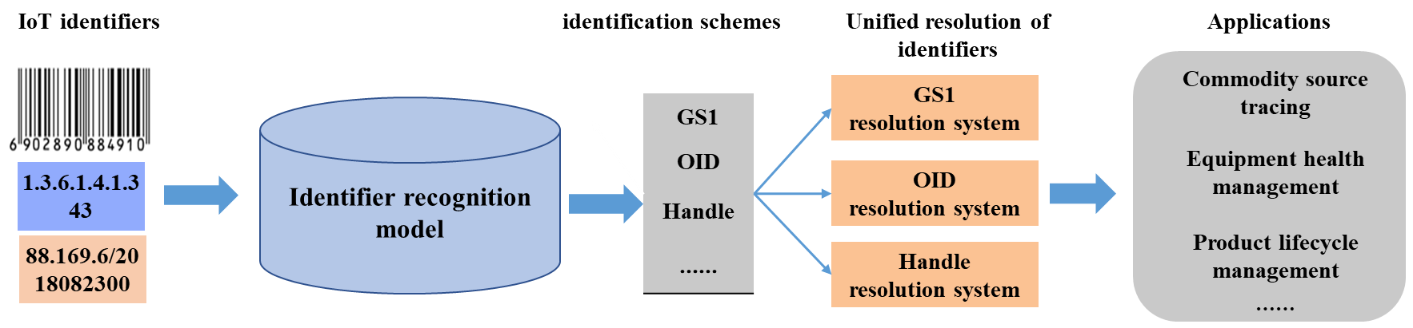

Potential requirements
The oneM2M system shall be able to support heterogeneous identification services, the recognition of external identification systems and converting an object identifier to a compatible identifier recognized by the oneM2M system.

