CHANGE REQUEST
Meeting ID:* | RDM#50
Source:* | Cyrille Bareau, Orange, cyrille.bareau@orange.com  Marianne Mohali, Orange, marianne.mohali@orange.com
Date:* | 2021-06-01
Reason for Change/s:* | See the introduction.
CR against: Release* | Release 4
CR against: WI* | Active WI-0099  MNT maintenance / < Work Item number(optional)>  Is this a mirror CR? Yes No  mirror CR number: (Note to Rapporteur - use latest agreed revision)  STE Small Technical Enhancements / < Work Item number (optional)>  Only ONE of the above shall be ticked
CR against: TS/TR* | TR-0067 v0.1.0
Clauses * | Clause 1, 2.1, 5, 5.2, Annex B and Annex G
Type of change: * | Editorial change  Bug Fix or Correction  Change to existing feature or functionality  New feature or functionality  Only ONE of the above shall be ticked
Other TS/TR(s) impacted | N/A
Post Freeze checking:* | This CR contains only essential changes and corrections? YES NO  This CR may break backwards compatibility with the last approved version of the TS? YES NO
Template Version: January 2020 (do not modify)

oneM2M Notice
The document to which this cover statement is attached is submitted to oneM2M. Participation in, or attendance at, any activity of oneM2M, constitutes acceptance of and agreement to be bound by terms of the Working Procedures and the Partnership Agreement, including the Intellectual Property Rights (IPR) Principles Governing oneM2M Work found in Annex 1 of the Partnership Agreement.
GUIDELINES for Change Requests:
Provide an informative introduction containing the problem(s) being solved, and a summary list of proposals.
Each CR should contain changes related to only one particular issue/problem.
If this is a correction, and the change applies to previous releases, a separate “mirror CR” should be posted at the same time as this CR
Mirror CR: applies only when the text, including clause numbering are exactly the same.
Companion CR: applies when the change means the same but the baselines differ in some way (e.g. clause number).
Follow the principle of completeness, where all changes related to the issue or problem within a deliverable are simultaneously proposed to be made e.g. a change impacting 5 tables should not only include a proposal to change only 3 tables. Include any changes to references, definitions, and abbreviations in the same deliverable.
Follow the drafting rules.
All pictures must be editable.
Check spelling and grammar.
Use change bars for modifications.
The change should include the current and surrounding clauses to clearly show where a change is located and to provide technical context of the proposed change. Additions of complete clauses need not show surrounding clauses as long as the proposed clause number clearly shows where the proposed new clause is located.
Multiple changes in a single CR shall be clearly separated by horizontal lines with embedded text such as, start of change 1, end of change 1, start of new clause, end of new clause.
When subsequent changes are made to the content of a CR, then the accepted version should not show changes over changes. The accepted version of the CR should only show changes relative to the baseline approved text.

Introduction
This CR updates the TR-0067 with last updates proposal

********************* Start of change 1 **********************

1 Scope
The present document is the Technical Report which study the completion of SDT (Smart Device Template) using <flexContainer> resource specializations and the possible migration of the existing device management mdel using Management Object (<mgmtObj>).
This document is initiated in the context of the Management Object Migration [MOM] Work Item (WI-0099) having the following objectives (extract) :
In Release 4, SDT (Smart Device Template) has been extended to include device management functions in addition to the existing services. This justified extension creates a new way to perfom device management compared to the existing Device Management (DMG) Common Service Function (CSF) model using <mgmtObj>.
In order not to live with 2 solutions for the same purpose, the work item WI-0099 proposes to work on a transition phase allowing implementation using DMG <mgmtObj> to migrate towards SDT model.
The scope of the Work Item is to study the Device Management model based on Management Object (<mgmtObj>) model migration towards SDT model.
This action plan includes:
- Provide a temporary TR with a mapping between <mgmtObj> and the SDT DM <flexContainer>;
- List in this TR all the specifications and sections that will have to be updated when <mgmtObj> will be replaced by SDT;
- List in this TR the issues to be resolved by removing the <mgmtObj> after migration and the proposed solutions;
- Depending on the TR outcomes, decide whether <mgmtObj> should be removed or not in OneM2M Release 4.
New tasks may be added during the process if necessary.
This TR intends to provide the study as part of the action plan above.

********************* End of change 1 **********************

********************* Start of change 2 **********************

2.1 Normative references
[1] oneM2M TS-0023: SDT based Information Model & Mapping for Vertical Industries
[2] oneM2M TS-0001: Functional Architecture
[3] oneM2M TS-0004: Service Layer Core Protocol Specification
[4] oneM2M TS-0005: Management Enablement (OMA)
[5] oneM2M TS-0006: Management Enablement (BBF)
[6] oneM2M TS-00014: LWM2M Interworking
[7] oneM2M TS-00022: Field Device Configuration
[8] oneM2M TS-0003: Security Solutions

********************* End of change 2 **********************

********************* Start of change 3 **********************

5 Introduction
In the Release 4 of the TS-0023 [1] specification (SDT-based Information Model and Mapping for Vertical Industries) was introduced a new approach for Device Management, based on Smart Device Template ModuleClasses, a concept that is mapped in oneM2M as <flexContainer> resource specializations.
The benefits of this approach are:
- Unified Device and Service Management of all nodes, including ADN or NoDN devices: it is possible to use the same type of resources for handling both the functional behaviour of devices and their remote management in the usual DM meaning (reboot, firmware update, configuration, log, etc.) Before this, the DM aspect was performed through <mgmtObj> resources, and the functional aspect through <container> or <flexContainer> resources.
- Enhanced expressivity. The SDT design allows a powerful information model to describe devices, with concepts such as Devices, SubDevices, ModuleClasses, Actions, DataPoints and Properties. The <mgmtObj> has a poorer semantics.
- Standardized, flexible, extensible and incremental Data Model. Adding new Devices, ModuleClasses or DataPoints is an easy process, compared with <mgmtObj> resources.
- Automated support for the generation of XML/XSD templates for DM ModuleClasses.
- Possible historization of the updates on DM resources, through the <flexContainerInstance> mechanism.
- Standardized ontological model: the SDT Information Model is aligned with the oneM2M Base Ontology (see clause 8 in TS-0023 [1]).
- Ease of use. For oneM2M application developers, handling <flexContainers> that map ModuleClasses or Actions is quite simple and natural. For example, triggering a [reboot] SDT Action is very similar to calling a method, with a rebootType parameter, and more satisfying / less ambiguous than the [reboot] <mgmtObj> with its 2 writable attributes reboot and factoryReset.
This TR proposes to extend this approach to all <mgmtObj> resources.

********************* End of change 3 **********************

********************* Start of change 4 **********************

5.2 DM Architecture
Currently, the DM Architecture is composed of two parts:
- The <node> and <mgmtObj> model defined in TS-0001 [2] clause 9.6.18.
- The [flexNode] and [DM Module classes] model defined in TS-0023 [1] clause 5.8.
These models coexisted, i.e. an IPE could create a device representation in SDT with a [flexNode] and/or a <node>. This choice was made in order not to modify the <node> resource, but it adds a lot of complexity.
We propose here to move the [flexNode] as child of the <node>, which supposes letting the <node> resource capable of having <flexContainer> children.
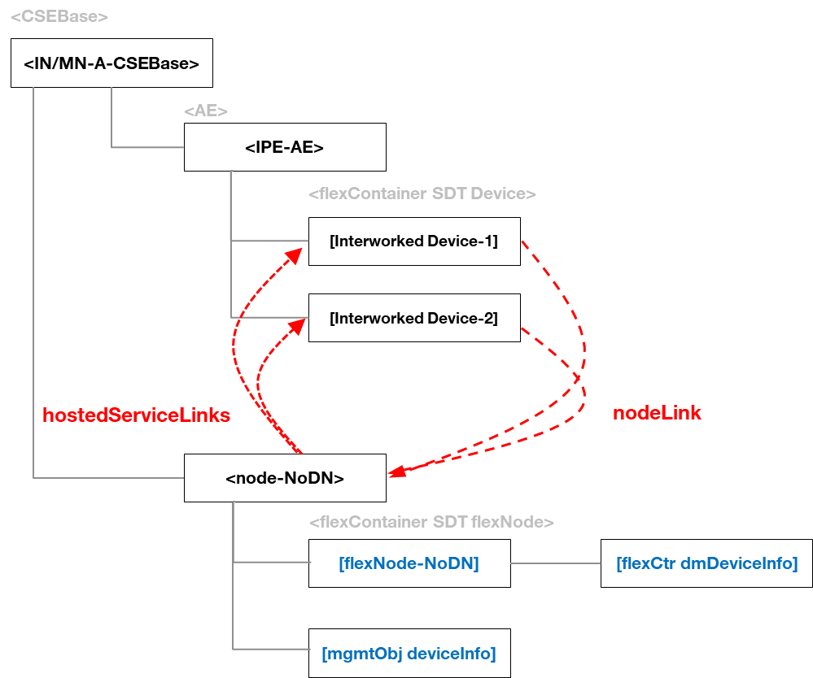
Figure 5.2-1: New DM architecture proposal

The resources in blue in the above figure are not supposed to coexist: either the <node> has <mgmtObj> children such as the [deviceInfo] specialization, or it has a [flexNode] child which is the root of DM <flexContainer> specializations such as [dmDeviceInfo]. We define a [dmBaseModule] SDT module class, mapped as a <flexContainer> specialization, and use the SDT inheritance mechanism to state that the <flexContainer> children of the [flexNode] (now refereed to as DM <flexContainer>) shall extend / inherit from this [dmBaseModule] flexContainer.
This architecture presents three main benefits:
- It forbids having <mgmtObj> resources and their equivalent <flexContainers> at the same level under the <node> resource, which would bring some confusion.
- It maintains most of the current TS-0023 [1] DM architecture (the emplacing of the [flexNode] was not forced), just removing the notion of flexNodeLink that linked an IPE to the associated [flexNode].
- It maintains the current <node> / <mgmtObj> DM architecture, allowing a smoother transition from <mgmtObj>-based to <flexContainer>-based implementations.

********************* End of change 4 **********************

********************* Start of change 5 **********************

Annex B : Proposal for update of TS-0003

In this Annex, are presented the proposed changes to the TS-0003 [8] specification for flexContainer introduction for device management operations.
[Editor's Note]: Determination of changes in TS-0003 [8] is FFS.

********************* End of change 5 **********************

********************* Start of change 6 **********************

Annex G : Proposal for update of TS-0022
In this Annex, are presented the proposed changes to the TS-0022 [7] specification for flexContainer introduction for device management operations.
[Editor's Note]: Determination of changes in TS-0022 [7] is FFS.

********************* End of change 6 **********************

