CHANGE REQUEST
Meeting:* | RDM # 54
Source:* | KETI
Date:* | 2022-05-06
Contact:* | Sunil Kumar, KETI, sunil75umar@keti.re.kr,  NakMyung Sung, KETI, nmsung@keti.re.kr,  SeungMyeong Jeong, KETI, sm.jeong@keti.re.kr
Reason for Change/s:* | Addition of concept definitions and descriptions
CR against: Release* | -
CR against: WI* | Active <WI-0094>  MNT Maintenace / < Work Item number(optional)>  STE Small Technical Enhancements / < Work Item number (optional)>  Only ONE of the above shall be ticked
CR against: TS/TR* | TR-0061-V0.3.0
Clauses/Sub Clauses* | Clause 3 and 7, Annex B
Type of change: * | Editorial change  Bug Fix or Correction  Change to existing feature or functionality  New feature or functionality  Only ONE of the above shall be ticked
Post Freeze checking:* | This CR contains only essential changes and corrections? YES NO  This CR is a mirror CR? YES NO if YES, please indicate the document number of the original CR:
Template Version:23 February 2015 (Dot not modify)

oneM2M Notice
The document to which this cover statement is attached is submitted to oneM2M. Participation in, or attendance at, any activity of oneM2M, constitutes acceptance of and agreement to be bound by terms of the Working Procedures and the Partnership Agreement, including the Intellectual Property Rights (IPR) Principles Governing oneM2M Work found in Annex 1 of the Partnership Agreement.
GUIDELINES for Change Requests:
Provide an informative introduction containing the problem(s) being solved, and a summary list of proposals.
Each CR should contain changes related to only one particular issue/problem.
Follow the principle of completeness, where all changes related to the issue or problem within a deliverable are simultaneously proposed to be made E.g. A change impacting 5 tables should not only include a proposal to change only 3 tables. Includes any changes to references, definitions, and acronyms in the same deliverable.
Follow the drafting rules.
All pictures must be editable.
Check spelling and grammar to the extent practicable.
Use Change bars for modifications.
The change should include the current and surrounding clauses to clearly show where a change is located and to provide technical context of the proposed change. Additions of complete sections need not show surrounding clauses as long as the proposed section number clearly shows where the new section is proposed to be located.
Multiple changes in a single CR shall be clearly separated by horizontal lines with embedded text such as, start of change 1, end of change 1, start of new clause, end of new clause.
When subsequent changes are made to content of a CR, then the accepted version should not show changes over changes. The accepted version of the CR should only show changes relative to the baseline approved text.

Introduction
This document presents some of the major changes and additions of the definition and the elaboration of Common ontologies for Smart Cities. The changes include the detailed discussions regarding the distinguishing features of concepts defined in Common ontology from Smart city point of view. It also involves the definitions of classes and object properties.
- Change 1 includes ordering the list alphabetically as well as defining Namespace prefixes.
- Change 2 includes the description regarding structure and definitions of the concepts in Common Ontology as well as how they differ from the concepts defined in SAREF and SEAS ontologies.
- Change 3 includes the Definitions of classes and object properties of Common Ontology.
- R01 includes the addition of missing concept definitions in Annex B.1 and B,2

----------------------- Start of change 1 -----------------------

3.3 Abbreviations
Abbreviations should be ordered alphabetically.
Clause numbering depends on applicability.
For the purposes of the present document, the [following] abbreviations [given in ... and the following] apply:

AIOTI Alliance for Internet of Things Innovation
CPSV Core Public Service Vocabulary
FOAF Friend of A Friend ontology
IRI International Resource Identifier
ITEA Information Technology for European Advancement
OWL Web Ontology Language
SAREF Smart Appliances REFerence ontology
SAREF4AGRI SAREF extension for the smart agriculture and food chain domain
SAREF4BLDG SAREF extension for the building domain
SAREF4CITY SAREF extension for the smart cities domain
SAREF4ENER SAREF extension for energy domain
SAREF4ENVI SAREF extension for the environment domain

SAREF4INMA SAREF extension for the industry & manufacturing domain
SEAS Smart Energy Aware systems
SDK Software Development Kit

STF Specialist Task Forces

s4city namespace used in the SAREF4City ontology
foaf namespace used in the FOAF ontology
common namespace used in Common Ontology having value:
http://www.city-hub.kr/ontologies/2019/1/common#

3.4 Namespace Prefixes
For the purposes of the present document, the [following] namespace prefixes [given in ... and the following] apply:
common http://www.city-hub.kr/ontologies/2019/1/common# (namespace prefix for Common Ontology)
foaf http://xmlns.com/foaf/0.1/ (namespace prefix for FOAF ontology)
pep https://w3id.org/pep/ (namespace prefix for Procedure Execution Ontology)
saref https://saref.etsi.org/core/ (namespace prefix for SAREF ontology)
s4city https://saref.etsi.org/saref4city/ (namespaece prefix for SAREF4City ontology)
seas https://w3id.org/seas/ (namespace prefix for SEAS ontology)

----------------------- End of change 1 -----------------------

----------------------- Start of change 2 -----------------------

7 Ontologies for SmartCity in oneM2M

7.1 Introduction
This clause presents different ontologies, which all together can be considered potential set of ontologies for smart city domain. Due to limitations identified in the ontologies discussed in clause 6, they can not be used directly, to semantically represent the smart city data. In order to support modularization as well as to cover different sub-domains which can potentially be the part of smart city, a common ontology has been proposed, which covers the high level concept definitions. Using those concept definitions, this ontology has been extended by different domain ontologies which semantically represent those sub-domains in smart city. Refer to Annex B for the complete list of definitions of all the concepts.

7.2 Common Ontology
The core ontology, which is termed as common ontology, revolves around six main high level concept classes, which are shown in figure 7.2-1. The oval represents an owl:Class (and will be refered to as class / concept class) and the arrow indicates rdfs:subClassOf relationship, from child to parent class. These classes are considered from Feature of Interest Ontology [i.26], Evaluation Ontology [i.27] and Procedure Execution Ontology [i.28]. The base building block of this common ontology is class common:FeatureOfInterest and common:Property. Likewise Feature of Interest Ontology, these two classes in the common ontology have similar definitions, however, in any case, a common:Property can not be considered as common:FeatureOfInterest. This will ensure consistency and minimized ambiguity in future extensions. Refer to Annex B.1 for the specific definitions of each class.
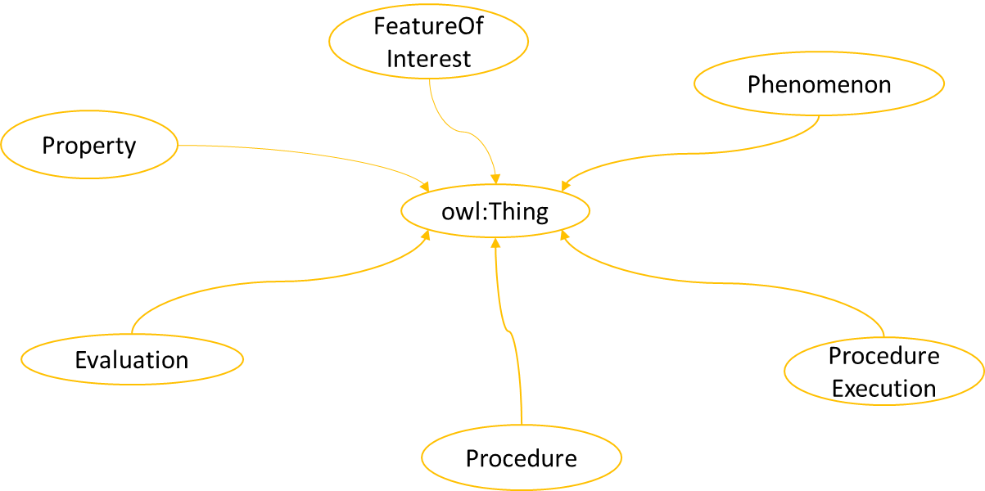
Figure 7.2-1. High level classes in Common Ontology

7.2.1 High level Classes
This clause discusses regarding the high level classes, the main aspects of smart city, which they cover and the major differences from the conceps in SAREF and SEAS ontologies.

7.2.1.1 Feature of Interest, Property and Evaluation
Following points highlight the main aspects covered by each class as well as the key differences to counterbalance the limitations, from smart cities’ point of view.
- The class common:FeatureOfInterest is different than the one defined in SEAS as the characteristics of common:FetureOfInterest defining it’s existence, remains same irrespective of time. But in SEAS it might change if the properties which define its characteristics change with time. However it doesn’t mean that an instance of common:FeaturOo Iterest will never cease to exist. It can cease to exist by being destroyed in some phenomena or an event, and then another common:FeatureO ofnteest having same or different sub type may get recreated.
- In SEAS seas:Property can also be considered as seas:FeatureOf Iterest but Ccomon ontology emphasizes on clear distinction between the two. The existence and definition of a common:FfeatreO of Itert remains consistent irrespective of time and the properties characterising it. Whereas the existence of a common:Pproperty epends on the existence of some common:a FeatureOfI interes A cmon:Pproperty can nt exist without being linked to any common:FfeatureO ofI inerest.
- The conceptualization can be further elaborated using common:Evaluation class, where the properties of a common:FeatureOf Iterest can be enriched with in depth analytical or statistical assessments. Hence the common:Property class complements common:FeatureO ofnteest in terms of characterization and the common:Evaluation class complements common:Propertyies inrms of their analysis and assessments, however, each contains distinct representation of concepts.
- Based on the terminology, the common:Evaluation class here covers the broader domain than the one defined in SEAS. In common ontology, common:Evaluation provides the assessmen of common:Property, instead of the value of a common:Property. Although, there exists a owl:ObjectProperty in SEAS, relating common:Property and common:Evaluation. However, the main concern is making the scope of common:Evaluation broader, based on the terminology.

7.2.1.2 Procedure and Procedure Execution
The concepts of common:Procedure and common:ProcedureExecution are almost same as the ones defined in SEAS ontology. The slight difference of conceptualization is the way seas:Procedure defined in SEAS, compared to the one in Ccmmon ontology. In SEAS, the definition involves the following statement: “It explains the steps to be carried out to arrive at reproducible results”. However, in Common ontology, the results are not necessesarily reproducible. One such example can be the one involving stochastic process. In addition, the specific terminologies have been replaced by the phrase “series of steps or actions”, in order to provide a possibility to extend the scope.
- f7.2.1.3 Phenomenon and Observation
The reason of discussing these two concepts is the similarities in the definitions of common:Phenomenon and common:Observation in SEAS ontology. Following points elaborate the key differences.
- The seas:Phenomenon is defined as “A phenomenon is something that can be observed.” From the terminology’s perspective, seas:Phenomenon and seas:Ooservation both can be considered same as seas:Oobervation can also be considered as “something that can be observed”. Although, the definition of seas:Oobsrvation in SEAS Device Ontology, makes itself distinct from seas:Phenomenon as there, the seas:O obsvation is defined as “the execution of some sensing procedure by some sensor”, it can not be considered wrong if some concept, related to seas:Oobservtion is described as a subclass of seas:Phenomenon. Therefore, to have a clear distinction from common:Observation, common:Phenomenon is defined in comct or a situation” and “natural or artificial”. Whenever a concept related to common:oObservation is defined asa subclass of common:Pphenomenon, it can be regared as natural or an uncontrolable occurance or event, instead of a procedure execution, which can be completely controlled by a procedure executor.
- The scope of seas:Observation is too constrained based on the terminology in SEAS, as it is stated as “An observation is the execution of some sensing procedure by some sensor”. In Common ontology, its scope is broadened by not specifying it as only to be sensed by a sensor, rather it is stated as “ProcedureExecution of monitoring, inspection, examination or recording of some information”. An example can be an observation from a servey data which is collected by user feedback. Such concept can be complex to defined as an seas:Ooservation in SEAS ontology as the device layer involved in the process is obscure, however, a concept of proedure eExector can be defined easily, which is more generic than a concept of dDevic.

7.2.2 Classes Hierarchies
Different sub classes are further defined to further project the scopes of the higher level classes. Based on the high level classes, six different hierarchies are discussed and differentiated in terms of their features, restrictions and relationships with other classes.

7.2.2.1 Feature of Interest Hierarchy
Figure 7.2-2 shows the expansion of common:FeatureOfInterest class. Based on the Smart city domain, common:FeatureOf Iterest involves entities which represent systems, connections and such related concepts. The class common:System cover broader scope as it is based on System Theory, and it is different from the definitions of SEAS and SAREF from following aspects.
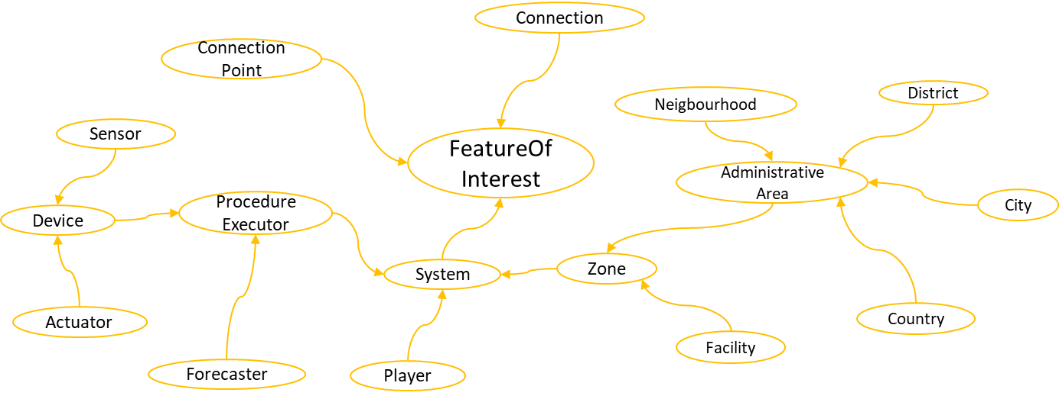
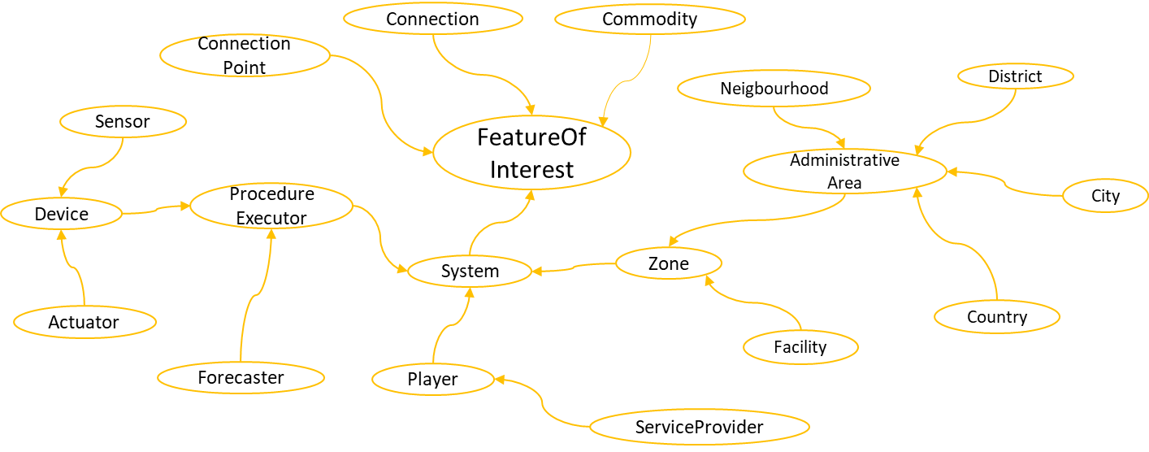
Figure 7.2.2.1-1: Taxonomy expansion under Feature of Interest

There are some important differences in the taxonomy which are described as follows:
- In SEAS and SAREF definitions, a system is defined as “class of systems virtually isolated from the environment”. Here the scope of isolation becomes unclear. In common ontology, a common:Ssstem is not considered isolated in any way, rather it is “described by its boundaries, structure and purpose”, so that it can even be considered as part of the environment, virtually or physically. The Boundaries, structure or purpose can be defined in terms of entities, working as its part, physical boundaries such as borders on a land, types of tasks performed (roles), etc. Furthermore, a common:sSstem can be influenced by the environment in terms of interations or events of any sort.
- In SAREF, for environment ontology extension, there is another concept using same terminology “System”, but defined from computer science’s perspective. The common:System defined in ch more generic perspective and systems focusing on some domains like computer science, can be extended from this class, hence ensuring sound and consistent basis of the concept hierarchy.
- The class common:System is defined as “a group of iteracting or interrelated elements”, (also refered to as sub-systems) which as united, represent the existence of a system. This leads to the concept of sub-systems lying underneath. To represent such concept, the object property common:hasSubSystem has been defined, linking the two systems, where one (sub-system) is involved in the composition (among other sub-systems) of the other common:System. Similarly, the property common:subSystemOf links a sub-system to its super-system. Therefore, these relationships can be used to link systems within systems, in order to define the system hierarchy. Similar properties are also defined in SEAS and SAREF ontologies.
- Connections play vital role in composing the systems and sub-systems. While common:hasSubsystem and common:subSystemOf link the systems vertically in the hierarchy, common:Connection and the related properties can be used to link any common:System, in order to define their interaction with the systems outside or even within the environment (among sub-systems). Figure 7.2.2.1-2 and 7.2.2.1-3 describes the ways in which systems can be connected with each other by using common:Connection and common:Connection oints espectively. The dashed line represents the linke between two classes and the label followed by an arrow, represents the owl:ObjectProperty and its direction respectively, from rdfs:domain to rdfs:range. The distinguishing feature of common:Connection in common ontology here is that it can exist without being connected to any common:Ssystm. Some example can be pending connection between two nodes in the network and a road leading to a dead end.
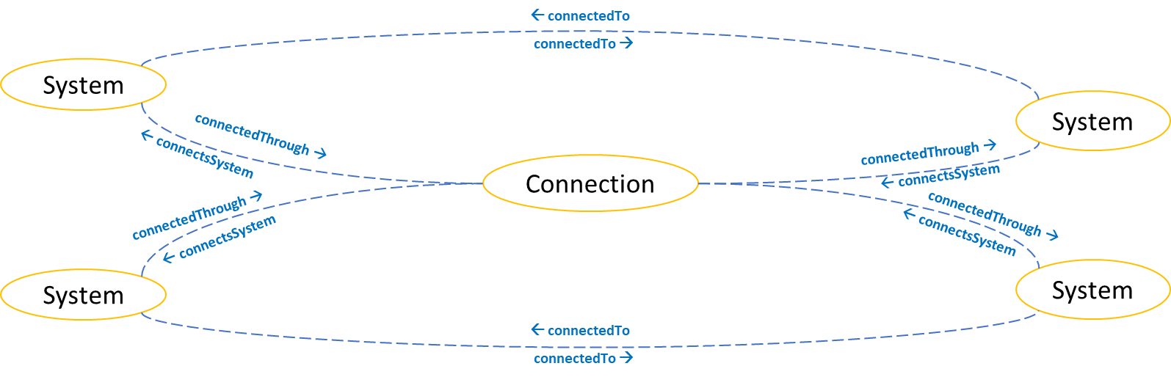
Figure 7.2.2.1-2: Connectivity among Systems using Connection

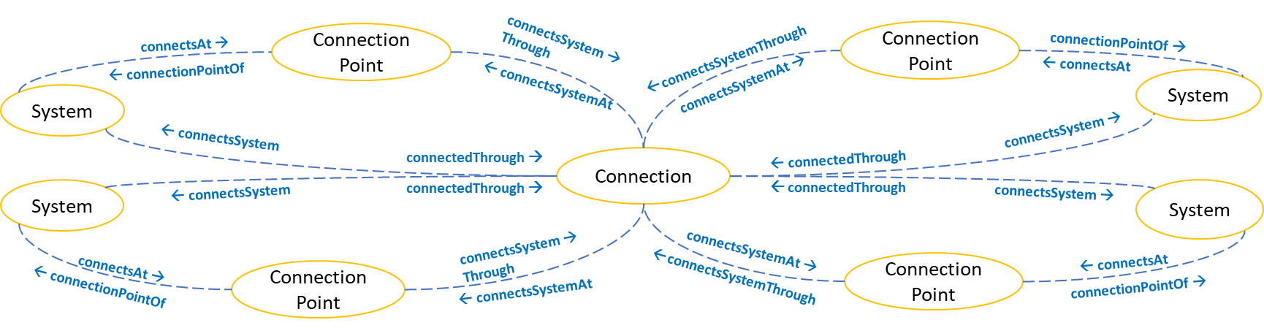
Figure 7.2.2.1-3: Connectivity among Systems using Connection and Connection Point

- The class common:ConnectionPoint can be used to define complex network of systems. This class has slightly different definition from the seas:ConnecitonPoint. In SEAS, a seas:CconnectinP point bengs to or is dedicated to exactly one seas:sSystem. Whreas in common ontology, a common:CconnectionP oint can bellowed to be an independent entity, that is, it can exist without a common:Ssystem. In thisregard the properties common:connectsAt and common:connectionPointOf play a slightly different role in Ccommon ontology.A common:Ssystem connected o a common:cConnection point sing common:connectsAt doesnot mean that the connection point belongs or bound to that specific system. Whereas, a common:CconnectionP point cnnected to common:Ssystem using common:conectionPointOf indicates its ownership by the common:Ssystem. This means, a cmmon:CconnectionP point can eist withouteing linked to a common:Ssystem. In addition, the poperty common:connectsAt indicates that common:CconnectionP point is linkedto some comn:Cconnection.
- Based on the previous discussion, there can be many different types of common:Systems as it covers broad scope. The subclasses of common:System, defined for the smart city domain, can be categorized into three sub domains: Computing domain, geographical and infrastructural domain, and Economical domain as highlighted in Figure 7.2.2.1-43.▪ These three sub-domains can be discussed by describing their respective top level class which are common:ProcedureExecutor, common:Zone and common:Player.
- The class common:ProcedureExecutor has similar definition to pep:ProcedureExecutor in SEAS Procedure Execution Ontology. The main difference is it’s position in the class hierarchy. In SEAS, pep:ProcedureExecutor does not have any parent class, whereas common:ProcedureExecutor is the subclass of common:System. This is possible because of vast scope that the common:System is covering. According to conceptualization in common ontology, a common:Device, common:Ssnsor, common:Aacuator, common:Fforaster etc. is considered as such a common:Ssystm which executes a common:Procedure. For example, a device can involve multiple sensors and actuators, each executing their respective sensing or actuating procedure. In this case they should be considered of type common:ProcedureExecutor. However, in terms of System Theory, these sensors and actuators should be considered as sub-systems of the device. This kind of conceptualization can be well established using Ccommonontology. In addition, the definition is modified to the following: “The System involved in or implementing a Procedure”.
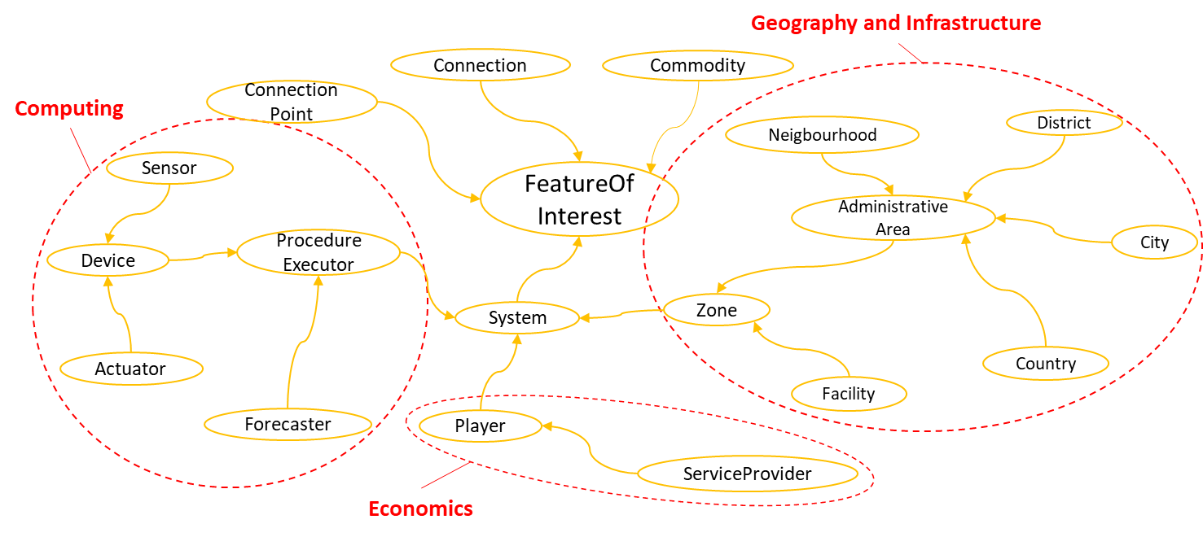
7.2.2.1orizationoSy
Figure 7.2.2.1-4: Categorization of System hierarchy based on domain scope

- The class common:ProcedureExecutor has similar definition to pep:ProcedureExecutor in SEAS Procedure Execution Ontology. The main difference is it’s position in the class hierarchy. In SEAS, pep:ProcedureExecutor does not have any parent class, whereas common:ProcedureExecutor is the subclass of common:System. This is possible because of vast scope that the common:System is covering. According to conceptualization in common ontology, a device, sensor, actuator, forcaster etc. is considered as such system which executes a Procedure. For example, a device can involve multiple sensors and actuators, each executing their respective sensing or actuating procedure. In this case they should be considered of type common:ProcedureExecutor. However, in terms of System Theory, these sensors and actuators should be considered as sub-systems of the device. This kind of conceptualization can be well established using common ontology. In addition, the definition is modified to the following: “The System involved in or implementing a Procedure”.

- One of the top classes in the economical domain the common:Player. The major variation from seas:Player class that the parent class hierarchy. In SEAS ontology, seas:Player has two parent classes, seas:System and pep:ProcedureExecutor. Having seas:System as the parent class is taxonomically explainable, as it can involve devices, people, companies, etc. However, considering this from a economical point, there are very rare cases where pep:ProcedureExecutor can be considered both as an entity which takes part in trade or stock market as well as executes a procedure. Nonetheless, in Common ontology, both common:ProcedureExecutor and common:Player are defined as a sub-class of common:System, whereas, common:ProcedureExecutor expands on a separate branch, covering Computing scope.
- The common:Commodity class has similar concept definition to seas:Commodity in SEAS Trading ontology and saref:Commodity in SAREF core ontology. However, in SEAS it is defined as a subclass of seas:Property. Since a commodity can exist as an independent entity and can have it’s own definitive characteristics, therefore, in common ontology, it is defined as a sub-class of common:FeatureOfInterest.

- The class common:AdministrativeArea is a class considered from SAREF4City ontology. This also affects all the subclasses respectively.

7.2.2.2 Property and Evaluation Hierarchy
In the existing hierarchy, class common:Property and common:Evaluation cover concept representation from different domains including computing, geometry and geography, economics, and other generic concepts which can be used in multiple domains. These concepts are not defined as being focused to describing a specific common:FeatureOfInterest, rather they can be used to cover different aspects of characterization. For example, the common:ContactPoint can include email address or a phone number as a contact information, whereas, in a different scenario, it can include information like ip address as the information to communicate with some device.
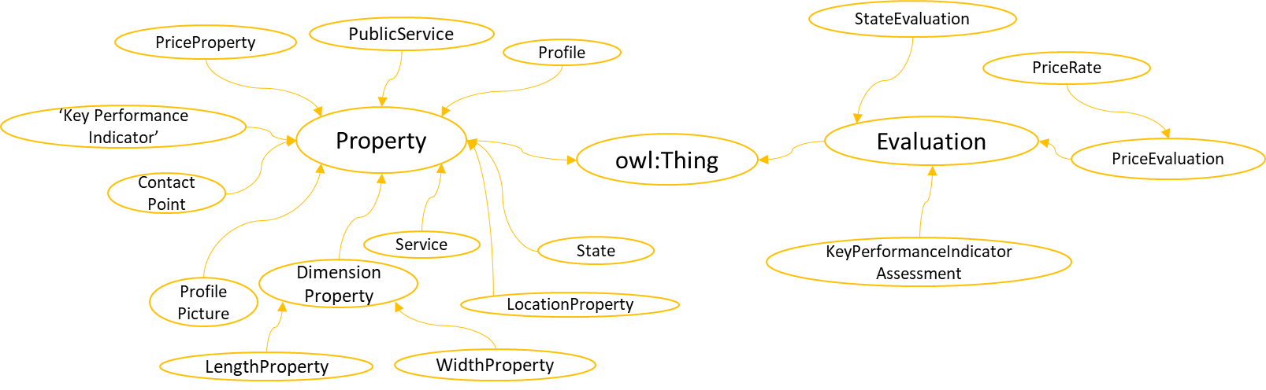
Figure 7.2.2.2-1: Taxonomy expansion under Property and Evaluation

Figure 7.2-2: Taxonomy expansion under Feature of Interest

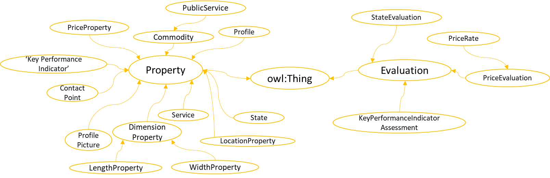
Figure 7.2.2.2-1: Taxonomy expansion under Property and Evaluation

The expansion of common:Property and common:Evaluation class can be seen in figure 7.2-3. The aspects covered and modified are described here as follows:
- The classes common:DimensionProperty and common:LocationProperty are newly added classes. They serve the purpose of maintaining the taxonomy in case if additional sub-classes are added.
- The class common:State is considered from SAREF ontology. Its taxonomy is modified from owl:Thing to common:Property.
- The class common:KeyPerformannceIndicator and common:KeyPerformannceIndicatorAssessment are considered from SAREF4City ontology. Here, they are defined as subclass of common:Property and common:Evaluation respectively.
- Service can be one of the most critical concept specifically in this taxonomy. In SEAS Technical System Ontology [i.33], it is defined as a subclass of seas:AbstractEntity. In order to clearify it’s scope to the level of Software Architecture domain, common:Service is defined as a rdfs:subClassOf common:Property. The other potential candidate classes, that can be defined as it’s parent class, are common:Procedure and common:ProcedureExecution. The reason common:Service can not be defined as a subclass of either of them is that it can include both aspects of common:Procedure and common:ProcedureExecution in its composition as well as some of the types of common:System. Whereas here, it can be considered viable, if it is seen as a characteristic of a common:System. Now it’s composition can involve relationships with different entities including common:System, common:Procedure and common:ProcedureExecution. Table 7.2.2.2-1 shows the list of candidate parent classes in order to determine whether the parent class can completely represent common:Service as it’s subclass by their defining features.
Table 7.2.2.2-1 Candidate parent classes for common:Service
Class/Concept | Defining Features | Matched | Description
FeatureOfInterest | Abstraction of real world phenomena | No | The processes and executions involved are not real world phenomena, rather simulated.
FeatureOfInterest | Who’s definition remains same irrespective of time. | No | There is no specific restriction on a service to remain same irrespective of time.
Property | Observable or operable characteristics of FeatureOfInterest | Yes | A FeatureOfInterest can execute or monitor a service, through which it can interact with other FeatureOfInterest.
Procedure | A reusable series of steps or actions. | Not Always | Service can also involve other aspects such as act of carrying out executions.
Procedure | Steps or actions, carried out to achieve results. | Not Always | Service can also involve other aspects such as act of carrying out executions.
ProcedureExecution | Act of carrying out a procedure. | Not Always | Service can also involve other information like procedures, policies, etc. which is not covered in this scope.
Functiona | Functionality to accomplish a task | Not Always | Service can also involve other information like procedures, policies, etc. which is not covered in this scope.
Task | Steps towards a specific goal. | Not Always | Service can also involve other aspects such as act of carrying out executions.

7.2.2.3 Procedure and Procedure Execution Hierarchy
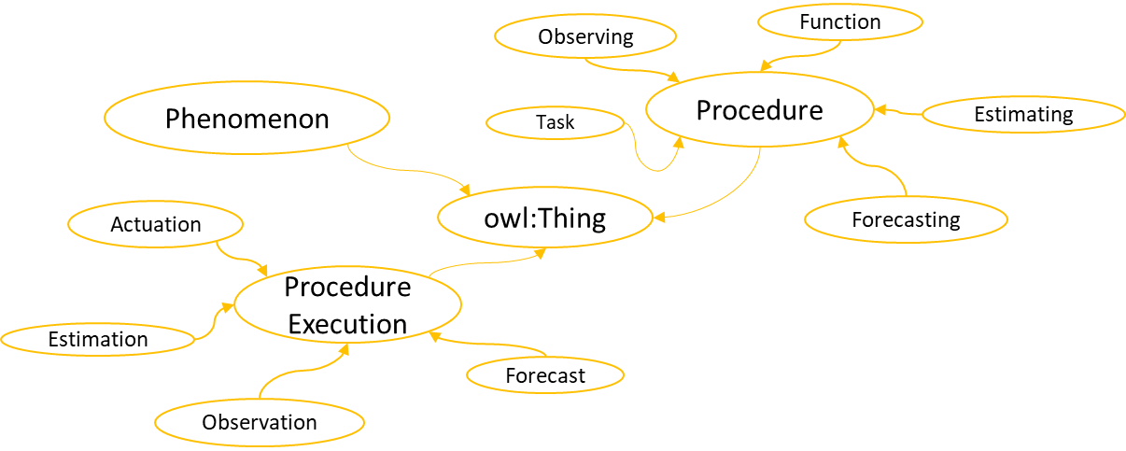
Figure 7.2-4 ilustrates the taxonomy expansion under the classes common:Procedure and common:ProcedureExecution.
Figure 7.2-4 Taxonomy expansion under Procedure and ProcedureExecution

Figure 7.2-3: Taxonomy expansion under Property and Evaluation

Figure 7.2-4 Taxonomy expansion under Procedure and ProcedureExecution
Following are the covered aspects along with the modifications from existing ontologies:
- The classes: common:Actuation, common:Observation, common:Forecast and common:Forecasting have been considered from SEAS Device Ontology and Forecasting Ontology with same concept definitions.
- The classes: common:Estimation, common:Estimating and common:Observing are newly added, which cover some concepts related to ones mentioned above.

- The classes common:Task and common:Function are considered from SAREF with slight modification to broaden their scope. In SAREF ontology, both classes defined their relationship (in class definition) with a common:Device. However, in case of Common ontology, the relationship is defined with common:ProcedureExecutor, which means that any physical or logical entity capable of executing a common:Procedure can be related with these classes.

Figure 7.2.2.3-1 Taxonomy expansion under Procedure and ProcedureExecution

. icThis clause describes the extension of Common Ontology for Smart Parking domain, based on following usecase. A parking
This clause describes the extension of Common Ontology for Smart Parking domain, based on following usecase. A parking
Feature of Interest is different than that in SEAS as the characteristics defining it’s existenceit’s existence remains same irrespective of time. But in SEAS it might change if the properties which define its characteristics change with time. However it doesn’t mean that a Featur of Interest will never cease to exist. It can cease to exist by being destroyed in some phenomena or an event, and then another Feature of Interest having same or different type may get recreated.
The conceptualization can be further elaborated using Evaluation class, where the properties of a Feature of Interest can be enriched with in depth analytical or statistical assessments. Hence the Property class complements Feature of Interest in terms of characterization and the Evaluation class complements Properties in terms of their analysis and assessments, however, each contains distinct representation of concepts.
The concepts of Procedure and Procedure Execution are almost same. The slight difference of conceptualization is the way Procedure defined in SEAS, compared to the one in common ontology. In SEAS, the definition involves the following statement: “It explains the steps to be carried out to arrive at reproducible results”. However, in Common ontology, the results are not necessesarily reproducible. One such example can be the one involving stochastic process.
The reason of discussing these two concepts is the ambiguity in the definition of Phenomenon in SEAS ontology. There it is defined as “A phenomenon is something that can be observed.” From the terminology’s perspective, phenomenon and observation both can be considered same as observation can also be considered as “something that can be observed”. Although, the definition of observation in SEAS Device Ontology, makes itself distinct from Phenomenon as there, the observationit is defined as “the execution of some sensing procedure by some sensor”, it can not be considered wrong if some concept, related to observation is described as a subclass of Phenomenon. Therefore, to have a clear distinction from Observation, Phenomenon is defined in common ontology as “fact or a situation” and “natural or artificial”. Whenever a concept related to observation is defined as a subclass of phenomenon, it can be regarded as natural or an uncontrolable occurance or event, instead of a procedure execution, which can be completely controlled by a procedure executor.
and Respective Relationships
ated concepts. Systems here cove System Theory, and it is different fr definSAREF from followinIn SEAS and SAREF definitions, a systems is defined as “class of systems virtually isolated from the environment”. Here the scope of isolation becomes unclear. In common ontology, a system is not considered isolated in any way, rather it is “described by its boundaries, structure and purpose”, so that it can even be considered as part of the environment, virtually or physically. The Boundaries, structure or purpose can be defined in terms of entities, working as its part, physical boundaries such as borders on a land, types of tasks performed (roles), etc. Furthermore, a system can be influenced by the environment in terms of interations or events of any sort.
ed from computer science’s perspective. The system class defined in common ontology serves a much more generic pepeke computer science, can be extended from thi System is defined as “a group of iteracting or interrelated elements”, (also refered to as sub-systems) which as united, represent the existence of a system. This leads to the concept of sub-systems lying underneath. To represent such concept, the object property common:hasSubSystem has been defined, linking theed two systems, where one (sub-system) is involved in the composition (among other sub-systems) of the other system. Similarly, the property common:subSystemOf links a sub-system to its super-system. Therefore, these relationships can be used to link systems within systems, in order to define the system hierarchy. Similar properties are also defined in SEAS and SAREF ontologies.
The class common:ConnectionPoint can be used to define complex network of systems. This class has slightly different definition from the ConnecitonPoint in SEAS. In SEAS, a connection point belongs to or is dedicated to exactly one system. Whereas in common ontology, a connection point can be allowed to be an independent entity, that is, it can exist without a system. In this regard the properties common:connectsAt and common:connectionPointOf play a slightly different role in common ontology. A system connected to a connection point using common:connectsAt doesnot mean that the connection point belongs or bound to that specific system. Whereas, a connection point connected to a system using connectionPointOf indicates its ownership by the system. This means, a connection point can exist without being linked to a system. In addition, the property common:connectsAt indicates that connection point is linked to some connection.
These three sub-domains can be discussed by describing their respective top level class which are common:ProcedureExecutor, common:Zone, common:Player and common:Comodity.
tor, forcaster etc. is considered as such system which is executes a Procedure. For example, a device can involve multilach executing their respecem Theory, these sensors and actuators should be considered as sub-systems of the device. This kind of conceptualization can be well esy.The class common:Zone defines a system in terms of geographical and infrastructural characteristics. In SEAS Zone ontology, the class seas:Zone is defined as “A part or a section of a building, campus, town, etc.”. However, it does not contain a comprehensive list of examples to clearify it’s scope. For examples the concepts like no-fly zone or quarantine zone may or may not be defined as the sub-clasees. In order to realize this, other concepts and properties need to be analyzed. In common ontology, a zone is defined as an area or a stretch of land having some characteristics, purpose or restrictions. This clearifies the scope definition of common:Zone as different concepts can be represented not only from infrastructure’s perspective, but also covering some aspects which involve geometrical, spatial or logical feature, but cannot be the part of an infrastructure like cities neibourhood etc. The concepts represented by the sub-classes of common:Zone, like common:AdministrativeArea, common:City, etc. are also defined in SAREF4City ontology, however, they are directly extendent from geosp:Feature.
ayer class that the parent class hierarchy. In SEAS ontology, seas:Player has two parent classes, ss:yreExecutor. Having Stelly explainable, as it can involve this from a economical point, there are very rare ca both as an entity which takes part in trade or sdure. Nonetheless, in common ontology, as a sub-class of common:System, whereas, common:Procedureputing scope.The common:Commodity class has similar concept definition to seas:Commodity in SEAS Trading ontology and saref:Commodity in SAREF core ontology. However, in SEAS it is defined as a subclass of seas:Property. Since a commodity can exist as an independent entity and can have it’s own definitive characteristics, therefore, in common ontology, it is defined as a sub-class of common:FeatureOfInterest.
In the existing hierarchy,The class common:Property and common:Evaluation cover concept representation from different domains including computing, geometry and geography, economics, and other generic concepts which can be used in multiple domains. These concepts are not defined as being focused to describing a specific common:FeatureOfInterest, rather they can be used to cover different aspects of characterization. For example, the common:ContactPoint can include email address or a phone number as a contact information, whereas, in a different scenario, it can include information like ip address as the information to communicate with some device.

This clause describes the extension of Common Ontology for Smart Parking domain, based on following usecase. A parking lot is situated at some location in an urban area, which contains different parking spots. The Parking lot is described with general profile information such as id, contact point, geo location, address, parking service price rate etc. In addition, it involves some status information regarding the parking spot availability. Besides, each parking spot may also contains its individual profile information and have its status update, which is then accumulated to update the status of its respective parking lot. In this case, the services, in terms of both software architecture and commodity are involved. The service as a commodity includes parking service provided to the customer, which also charged with the parking service fee. The services in terms of software architecture includes one, which evaluates the available parking spots, and the other provides the estimated parking congestion.
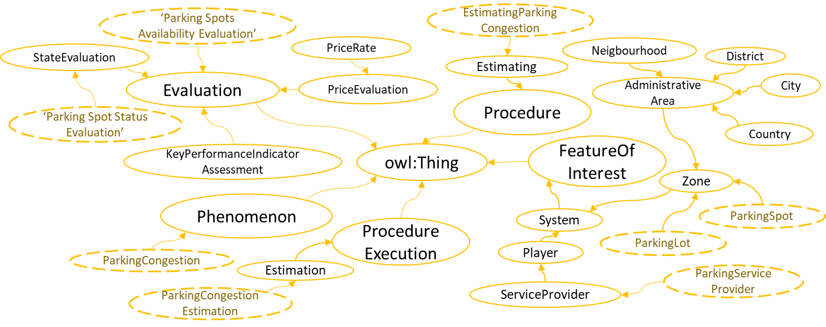
Figure 7.3-1 Extension of Common Ontology for Parking domain based on Feature of Interest, Procedure, Procedure Execution, Phenomenon and Evaluation.
Figure 7.3-1 and 7.3-2 shows the extension of Common ontology for Smart Parking domain. Here the dotted oval represents the owl:Class for parking domain. Here classes parking:ParkingLot and common:ParkingSpot are described as subclasses of common:Zone, which also enables them to be represented as both local space and as a common:System. Profile related information can be stored in parking:ParkingLotProfile and parking:ParkingSpotProfile class. The class parking:ParkingSpotStatus in figure 7.3-2 and the class parking:ParkingSpotStatusEvaluation in figure 7.3-1 relates to the information about a particular parking spot, such that altogether, they provide the information of its availability at particular time stamp. Similarly, the class parking:AvailableParkingSpots in figure 7.3-2 and the class parking:ParkingSpotsAvailabilityEvaluation in figure 7.3-1relates to the information about parking lot, such that, the overall parking spots available in that particular parking lot will be represented here. All this information can be calculated by the instance of class parking:ParkingAvailabilityEvaluationService. In case of parking:ParkingCongestion, the instance of class parking:ParkingCongestionEstimationService will be responsible for execution of procedure of class parking:EstimatingParkingCongestion, and it’s execution related information is represted by the instance of class parking:ParkingCongestionEstimation.
There are some classes in both figures, which are not included in common ontology. These classes are ServiceProvider and PriceRate. This is due to the reason that they are more suitable to be the part of some extention than Common ontology. They are considered to be the part of future extensions of ontology.
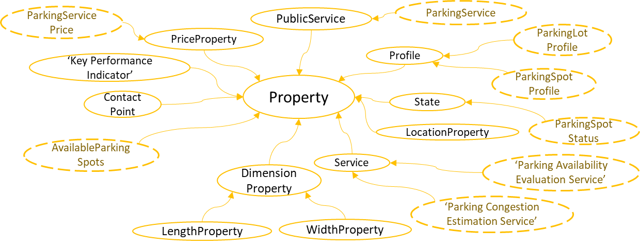
Figure 7.3-2: Extension of Common Ontology for Parking domain based on Property

7.4 Weather Extension
Figure 7.4-1 shows the extension of Common ontology for Weather domain. In this case the ontology covers mostly data aspect, when entiy responsible for data acquisition is a service rather than a device. Here weather is further defined using six different properties: air temperature, humidity, rainfall, wind, snowfall and visibility. Each of these has its own class of type common:Evaluation and common:Phenomenon. The classes representing the service responsible for data observation and estimation are weather:WeatherObservationService and weather:WeatherEstimationService respectively. Similarly, there are sublasses defined to represent procedures and their executions for each of two classes of type common:Service. This ontology can be compared with SEAS Weather Ontology [i.35] where some similarity can be witnessed due to the weather properties considered.
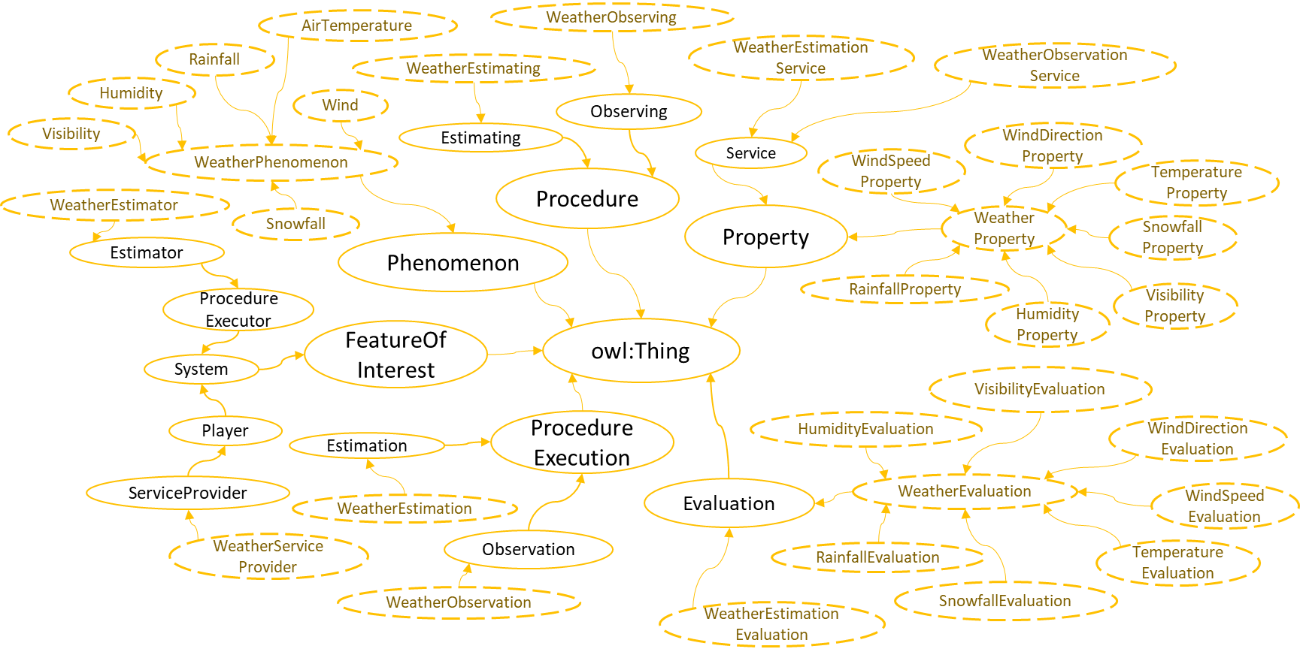
Figure 7.4-1: Weather Extension

7.5 Air-Quality Extension

Figure 7.5-1 shows the extension of Common ontology for Air-Quality domain. The structure is almost similar to that of Weather extension. The main difference is the properties considered for the air-quality data which are: air NO2 level, air O3 level, air CO Level, air SO2 level, air PM25 Level, air PM10 Level. This ontology can be compared with SEAS Generic Property Ontology [i.36] where some similar classes will be witnessed due the considered air-quality properties.
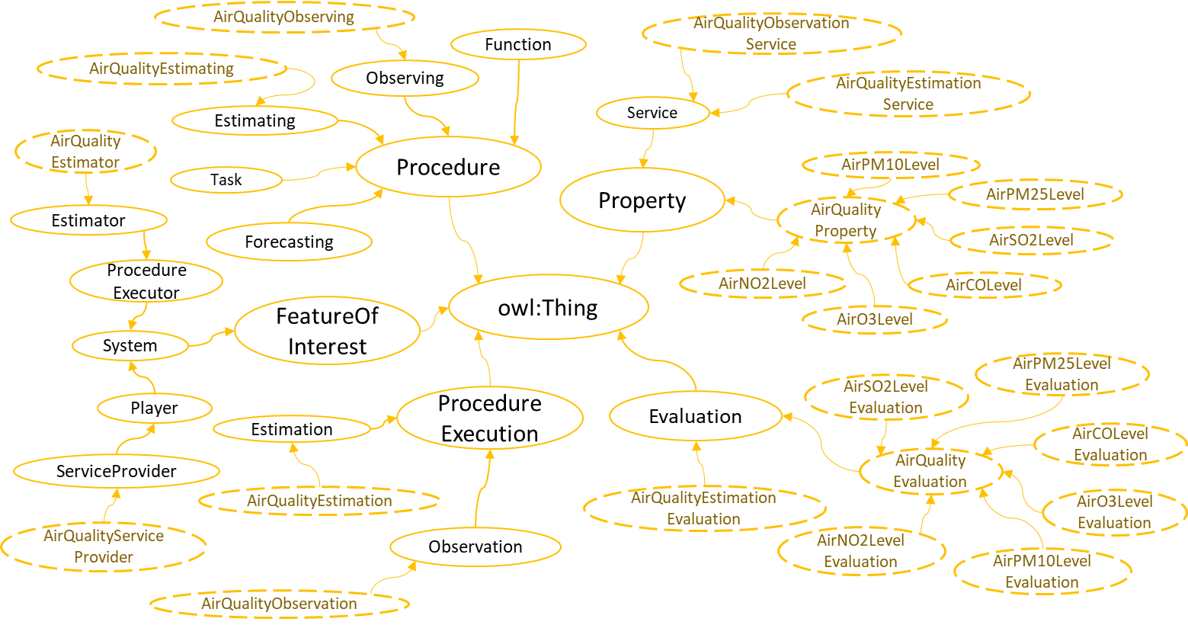
Figure 7.5-1 Air-Quality Extention

----------------------- End of change 2 -----------------------

----------------------- Start of change 3 -----------------------

Annex B: Ontology Concept Definitions
This Annex provides the definitions of the concepts proposed in Clause 7.

B.1 Definitions of Classes in Common Ontology
Following table provides the concept definitions of Classes defined in Common Ontology.
Table B.1-1: Class Definitions defined in Common Ontology.
Class | Definition
Actuation | Actuation is a Procedure Execution of some Procedure, by an Actuator, and has an influence on the environment. NOTE: Unlike seas:Actuation, common:Actuation does not define Actuating Procudure as an only class bound to be involved in the execution.  i
Actuator | An Actuator is a Device that implements one or many Actuation, based on some Procedure.
AdministrativeArea | An Administrative Area is a Zone, covering a region of land for the purposes of administration.
City | A City is a permanent and densely populated Administrative Area focused on urbanization. Unlike rural areas, cities generally have extensive and well organized systems for housing, transportation, sanitation, utilities, land use, production of goods and communication.
Commodity | Commodity is a Feature of Interest, which represents a marketable good or resource, having substantial fungibility.NOTE: It should be changed to subclass of Feature of Interest rather than Property.
 | A Connection is a Feature of Interest, which represents the connectivity between two or more instances of a System.
ConnectionPoint | A Connection Point is a Feature of Interest, which represents a common point of connectivity among Connections and Systems. It may or may not also be controlled by a N can be Systems connected through a Connection without using a Connectio Similalthrough which the System allows the other Systems to be connected through one or more Connections.N can be Systems connected through a Connecti
ContactPoint | Contact Point is a Property, which represents the information required to communicate with certain types of Feature of Interests, such as Player and Facility.NOTE: It is different than one in SAREF as it focuses on more generalized entities to communicate with instead of BAN. Not completed yet!
ry | A country (sometimes also called a state or a nation) is an Administrative Area which has its own government and acts as a political entity in the world.
Device | Device is a physical or tangible System which is built to execute one or more procedures to perform certain tasks. The execution of this device may or may not impact the phyiscal world.NOTE: One example is sensors, which is only collecting data.
ionPro | The Property to define measurable extent of some kind, such as length, breadth, depth, or height.
District | A District is an Administrative Area in a Country, which has some distinguishing feature from surrounding areas or is used for some official purpose, managed by local governing authorities.
Estimating | Estimation is a Procedure, which includes the steps to calculate the average or rough evaluation of some Property such as: Width Property, Length Property, Location Property, Price Property, etc. It can be executed by EstimationNOTE: Does not exist in saref or seas.
 | Estimation is a Procedure Execution of an average or rough evaluation of some Property like Width Property, Length Property, Location Property, Price Property, etc. It’s outcome can be come Evaluation.NOTE: Does not exist in saref or seas. Categorizes processes which estimate something.
 | An Evaluation contains the assessment or judgement about a Property.
Facility | Facility is a Zone, which represents a A place, amenity, or piece of equipment provided for a particular purpose.NOTE: sameAs saref:Facility
A Feature of Interest is an abstraction for real world phenomena (thing, person, event, etc.), who’s definition remains same irrespective of time.
Consider an example, where “Square” is defined ais one of the subclasses of Feature of Interest. If through time it changes its shape to rectangle, then it cannot be considered as Feature of Interest. Rather class Quadrilateral will be better definition to cover this phenomenon.
Forecast | Forecast is a ProcedureExecution of Forecasting Procedure, which involves prediction or estimation of future events or trends. It can be executed by a Forcaster.NOTE: Since Forcaste is one kind of estimation (as it is rough, not exact), so it should be made a subclass of Estimation.
 | A Forecaster is a Procedure Executor, which implements some Forecasting procedure, and may generate Forecasts.NOTE: Same as seas:Forcast
 | Forecasting is a Procedure, which includes the steps to predict or estimate some information in a future event or trend.NOTE: it can be more than predicting a state of a property unlike seas:Forecasting, for example: state of Parking Lot where Parking Lot is a Zone, not a Property.
 | The functionality necessary to accomplish the task for which a Procedure Executor is designed.
KPI | A Key Performance Indicator (KPI) is a type of Property which used to evaluate success of a Feature of Interest or of a particular activity in which it engages.
KPIAssessment | Represents the assessment of a KPI calculated by a given agent in a given time.
LengthProperty | Length Property is a Dimension Property, which specifies the length or the extent of some Feature Of Interest from one end to another.
LocationProperty | The Property defining a particular place or position.
Neighbourhood | Neighbourhood is a Zone representing a geographically localised community, with considerable face-to-face social interactions among the inhabitants. A Neighbourhood usually is situated in an Administrative Area or some other localization such as village.
Observation | Observation is a ProcedureExecution of monitoring, inspection, examination or recording of some information in a Phenomenon or event.NOTE: is sameAs seas:Observation but it is not limited to be executed only by Device type Sensor.
 | Observing is a Procedure, which includes the steps to monitor, inspect, examin or record some information in a Phenomenon or event.NOTE: seas:Sensing can be considered as more focused class of common:Observing as it focuses on Sensing functionalities from a device perspective.
 | Phenomenon is a fact or a situation that is observed to exist or happen, especially the one whose cause or explanation is in question. Phenomenon can be natural or artificial.
Player | Player is a System, which represents a company, organization or an individual that has influence within an activity, industry or type of work.NOTE: sameAs seas:Player
 | A System, involved in the execution or implementation of a Procedure.
PriceEvaluation | The Evaluation, which describes the assessment or judgement about Price Property.NOTE: same as seas:PriceEvaluation.
 | PriceProperty is a Property, which describes the cost or value of certain types of Feature of Interests like Commodity, that can be measured certain Currency.
PriceRate | Price Rate is a Price Evaluation, which specifies the per unit cost of specific Feature of Interest. Here the unit can be specified in terms of a Currency or some other means of payment.
Procedure | A reusable series of steps or actions that can be carried out to achieve results.
ProcedureExecution | The act of carrying out a Procedure.
Profile | Profile is a Property which describes the important or relevant facts to characterize a particular System.  NOTE: has broader scope than saref:Profile
ProfilePicture | Profile Picture is a Property, which represents an image for the characterization of a Feature of Interest.
Property | An observable or operable quality or characteristics of Feature of Interest or a Phenomenon, which can be observable, measurable or operable by a Feature of Interest.
PublicService | Public Service is a Property, which represents acts or performences by a Service Provider, to provide value to the customer, and which has a transaction cost.NOTE: Now Public Service is no longer a subclass of Comodity
r | Sensor is a Device which, based on some procedure, performs one or many Observation of a physical Phenomenon from the environment.
Service | From the perspective of software or system architecture, service is a single or a set of characteristics of a System, with a purpose of enabling clients to perfrom a single or a set of tasks. Here a client can be but not limited to a Procedure, Player or foaf:Person.
State | A particular condition that someone or something is in at a specific time.
StateEvaluation | State Evaluation is an Evaluation, which describes the assessment or judgement about a State.NOTE: Different Properties are present in SEAS such as stateChangeFrequency and stateDuration, which provide evaluation about a State. So in order to arrange these types of evaluation StateEvaluation Class is defined.
 | System is a group of interacting or interrelated elements (sub systems) that act according to the set of rules to form a unified Feature of Interest. A system in an environment, is described by its boundaries, structure and purpose and is influenced by the environment.NOTE: This definition is based on the System Theory.
 | A task represents the steps carried out towards the specific goal for which a Procedure Executor is designed (from a user perspective)
WidthProperty | Width Property is a Dimension Property, which specifies the width or the horizontal extent taken at right angles to the length of some Feature Of Interest.
Zone | An area or stretch of land or space having a particular characteristic, purpose, or use, or subject to particular restrictions

B.2 Definitions of Properties in Common Ontology
Following table provides the concept definitions of Object Properties defined in Common Ontology.
Table B.1-2: Class Definitions defined in Common Ontology.
Object Property | Definition
acceptsCurrencyConnection | This Object Property links an individual of type common:PriceRate to an individual of type saref:Currency, indicating currency accepted for business.  Domain: common:PriceProperty  Range: common:PriceRateNOTE: new conceptCocommon:FeatureIn which nces of common:SystemRepresents a uni-directional relroperty, where one individual is derived from can be transitive between 3 oin: common:PropertyNOTE: unlike seas:derivesFrom, common:derivesFrom is not symmetric and represents only one directional relationship. Means A derives from B, does not implicitly mean that B derives from A..
This Object Property links an individual of type common:System to an individual of type common:Connection, describing it’s connectivity using a connection, to other systems of the environment. A single connection can be used to connect more than two systems to represent common or sharing connectivity among systems.
Domain: common:System
Range: common:ConnectionNOTE: describes the notion of common connectivity among systems.
Represents a relationship of connectivity between the individuals of type common:System. This property can be used to only state the connectivity between two systems, but can not represent the features such as mode or end of connectivity. This property is Symmetric. If systems are using common mode of connection, then this property can be used to specify connected pairs of systems through that connection.
Domain: common:System
Range: common:SystemNOTE: same as seas:connectedTo
This Object Property links an individual of type common:ConnectionPoint to an individual of type common:System. This property indicates a point of connectivity for a particular system. However, multiple connection point can belong to a single System.
Domain: ConnectionPoint
Range: SystemNOTE: described the cardinality restrictions
ctsAt | This Object Property links an individual of type common:System to an individual of type common:ConnectionPoint. It does not directly complements common:connectionPointOf relationship, as it indicates connectivity when the linked connection point is also linked with some connection. If not, then it is recommended to used common:connectionPointOf instead, to show the relationship between a system and a connection point.  Domain: common:System  Range: common:ConnectionPointNOTE: the relationship have slightly different concept representation than those in seas.
This Object Property links an individual of type common:Connection to an individual of type common:System. This relationship complements common:connectedThrough relationship between same individuals, linked using common:connectedThroughthis property.
Domain: common:Connection
Range: common:SystemNOTE: described that which property it is complementing.
This Object Property links an individual of type common:Connection to an individual of type common:ConnectionPoint. This relationship complements common:connectsSystemThrough relationship between same individuals, linked using common:connectsSystemThroughthis property.
Domain: common:Connection
Range: common:ConnectionPointNOTE: described that which property it is complementing.
This Object Property links an individual of type common:ConnectionPoint to an individual of type common:Connection. Through this property it can be described that which systems are connected together through the specific connections and connection points.
Domain: common:ConnectionPoint
Range: common:ConnectionNOTE: same as seas:connectsSystemThrough
This Object Property links an individual of type common:Service to an individual of type common:ProcedureExecutor, representing a service utilizing the procedure executor, who will perform certain procedure executions.
Domain: common:Service
Range: common:ProcedureExecutor
consumesService | This Object Property link an individual of type common:System to an individual of type common:PublicService. This defined the consumer relationship for a particular service.  Domain: common:System  Range: common:PublicService.NOTE: new concept.
t | Any individual can be linked to define its relationship with an individual of type common:ContactPoint, to associate contact information.  Range: common:ContactPointNOTE: new concept
This Object Property links an individual of type common:Profile to an individual of type common:PublicService or common:Service. This represents a defining the service description which may include information such as nature, scope, policies, etc.
Domain: common:Profile
Range: common:Service OR common:PublicServiceNOTE: service information needs to stored in profile information. This relationship fulfils the purpose.
A Connection is a common:FeatureOfInterest, which represents the connectivity between two or more instances of common:SystemRepresents a uni-directional relationship between individuals of type common:Property, where one individual is derived from the other. This relationship can be transitive between 3 or more individuals of type Property, having the direction towards the property specificed as a range.
Domain: common:Property
Range: common:PropertyNOTE: unlike seas:derivesFrom, common:derivesFrom is not symmetric and represents only one directional relationship. Means A derives from B, does not implicitly mean that B derives from A..
atedOn | This Object Property links an individual of type common:Estimation to an individual of type time:Instant, representing time of estimation.  Domain: common:Estimation  Range: time:InstantNOTE: new concept
ion | This Object Property links an individual of type common:Evaluation to an individual of type time:TemporalDuration, indicating the duration of evaluation.  Domain: common:Evaluation  Range: time:TemporalDuration
evaluatesProperty | This Object Property links an individual of type common:System to an individual of type common:Property.  Domain: common:System  Range: common:PropertyNOTE: New concept.
evaluationOf | This Object Property links an individual of type common:Evaluaition to an individual of type common:Property. This relationship complements common:hasEvaluation relationship between same individuals.  Domain: common:Evaluation  Range: common:Property.N
executionDuration | This Object Property links an individual of type common:ProcedureExecution to an individual of type time:TemporalDuration, indicating duration of execution.  Domain: common:ProcedureExecution  Range: time:TemporalDurationNOTE: new concept
This Object Property links an individual of type common:ProcedureExecution to an individual of type time:Instant, indicating the time of execution.
Domain: common:ProcedureExecution
Range: time:InstantNOTE: new concept
This Object Property links an individual of type common:Zone to an individual of type common:ZoneBasedLocation, representing the location information in terms of Zones, such as Neighborbood, City, Country etc.
Domain: common:Zone
Range: common:ZoneBasedLocationNOTE: need to define the ZoneBasedLocation.
This Object Property links an individual of type common:Procedure to an individual of type saref:Command, representing the commands to be executed, specified inside the procedure.
Domain: common:Procedure
Range: saref:Command
hasDateCreated | Any individual can be linked to define its relationship with an individual of type time:Instant, representing date of creation.  Range: time:InstantNOTE: in SAREF it is directly defined as data property
Any individual can be linked to define its relationship with an individual of type time:Instant, representing the date of modification.
Range: time:InstantNOTE: in SAREF it is directly defined as data property
Represents a uni-directional relationship between an individual of type common:Property to anan individual of type common:Evaluation, which evaluates that particular property. There can be multiple evaluations of a property, which can be represented using this relationship.
Domain: common:Property
Range: common:RangeNOTE: changed the naming terminology of seas:evaluation to hasEvaluation.
icePr | Any individual can be linked to define its relationship with an individual of type common:PriceProperty, to represent its cost.  Range: common:PricePropertyNOTE: unlike seas:price, here we did not confined the range to just Comodity because, there can be case when an entity such as Device can be represented as Comodity.
ceRate | This Object Property links an individual of type common:PriceProperty to an individual of type common:PriceRate, indicating price rate. This property extends common:hasEvaluation.  Domain: common:PriceProperty  Range: common:PriceRateNOTE: new concept
tionPoint | This Object Property links an individual of type common:FeatureOfInterest to a single unique individual of type common:Property. This represents the relationship with the Properties that characterized some Feature of Interests. This property is Functional as well as Inverse Fuctional.A soperty ca  Domain: common:FeatureOfInterest  Range: common:PropertyNaddednectionPoint is a common:FeatureOfInterest, which represents a point thro
hasState | This Object Property links an individual of type common:FeatureOfInterest to an individual of type common:State  Domain: common:FeatureOfInterest  Range: common:StateNOTE: In saref the domain of the State is more confined to the Device.
teEval | This Object Property links an individual of type common:State to an individual of type common:hasStateEvaluation.  Domain: common:State  Range: common:StateEvaluationNOTE: new concept
Represents a uni-directional relationship between individuals of type common:System, where the individual in the domain is composed of the one specified in range (the sub-system). However, this does not restrict that the sub-system is essential for the existence of super-system. This relationship can be transitive between 3 or more individuals of type common:System, having direction towards the sub-systems.
Domain: common:System
Range: common:SystemNOTE: described the relationship showing composition and the characteristics of being transitive.
This Object Property links an individual of type common:ProcedureExecutor, which implement a procedure, to an individual of type common:Procedure. A An individual of type common:pProcedure eExecutor can implement have 0 to multipleany p common:implements relationships with different individuals of type common:Procedures, which can be representated using this relationship. Similarly, a single procedure can involve multiple procedure executors.
Domain: common:ProcedureExecutor
Range: common:ProcedureNOTE: described cardinality restrictions which were not discussed in seas.
rofilePic | This Object Property links an individual of type common:Profile to an individual of type common:ProfilePicture.  Domain: common:Profile  Range: common:ProfilePicture
isAboutPhenomenon | Any individual can be linked to define its relationship with an individual of type common:Phenomenon. This relationship can represent a natural, artificial or conceptual involvement of an entity in a phenomenon.  Range: common:PhenomenonN
isExecutedBy | This Object Property links an individual of type common:ProcedureExecution to an individual of type common:ProcedureExecutor, specifying and authorizing the procedure executor to perform the execution.  Domain: common:ProcedureExecution  Range: common:ProcedureExecutor
isLocatedAt | This Object Property links an individual of type common:FeatureOfInterest to an individual of type common:LocationProperty, representing the location information of a feature of interest.  Domain: common:FeatureOfInterest  Range: common:LocationPropertyNOTE: unlike SAREF, this property has more generic domain: common:FeatureOfInterest  need to change the domain of this property in our last version of ontology.
This Object Property links an individual of type common:PublicService to an individual of type common:LocationProperty. This indicates the location/locations where a public service can be offered or is allowed to offer.
Domain: common:PublicService
Range: common:LocationPropertyNOTE: new concept.
This Object Property links an individual of type common:PublicService to an individual of type common:Zone, represting the availability of a public service in the specified zones.
Domain: common:PublicService
Range: common:ZoneNOTE: new concept
This Object Property links an individual of type common:PublicService to an individual of type common:ServiceProvider. This relationship complements common:offersService relationship between same individuals, linked using this property.
Domain: common:PublicService
Range: common:ServiceProvider.NOTE: new concept
ion | This Object Property links an individual of type common:PublicService to an individual of type time:TemporalDuration. This can be used to defined the duration of the availability of the public service to be offered.  Domain: commonPublicService  Range: time:TemporalDurationNOTE: new concept.
This Object Property links an individual of type common:PublicService to an individual of type time:Instant. This can be used to defined multiple time instants of the availability of the public service or the log, when the service was offered.
Domain: common:PublicService
Range: time:InstantNOTE: new concept.
This Object Property links an individual of type common:Property to single uniquean individual of type common:FeatureOfInterest. This relationship complements common:hasProperty relationship between same individuals, linked using this pcommon:hasProperty. This property is Functional as well as Inverse Functional. .
Domain: common:Property
Range: common:FeatureOfInterestNOTE: described that which property it is complementing.
This Object Property links an individual of type common:Observation to an individual of type time:Instant, representing the time of observation.
Domain: commonObservation
Range: time:InstantNOTE: new concept
This Object Property links an individual of type common:ServiceProvider to an individual of type common:Service. Through this property, a service provider can offer multiple services. However, a single service can be offered by only one service provider at a time. Though, here can be multiple entities representing a single service provider (hence can be represented by common:hasSubSystem relationship).
Domain: common:ServiceProvider
Range: common:PublicServiceNOTE: new concept.
n | This Object Property links an individual of type common:ProcedureExecutor to an individual of type common:LocationProperty, indicating the location, where the procedure executor is operating.  Domain: common:ProcedureExecutor  Range: common:LocationPropertyNOTE: new concept
This Object Property links an individual of type common:ProcedureExecutor, which executes a pProcedure, to an individual of type common:ProcedureExecution. Multiple procedure executors can perform a single procedure execution (representing the concepts parallel processing). individuals of type common:ProcedureExecutor can have this relationship with a specific individual of type common:ProcedureExecution. Also, multiple individuals of type common:ProcedureExecution can be linked with a specific individual of type common:ProcedureExecutor.
Domain: common:ProcedureExecutor
Range: common:ProcedureExecutionNOTE: there is no time restriction applied here to cover broadervast scope. Concepts like parallel execution can be represented using this relationship.
This Object Property links an individual of type common:System to an individual of type common:Service or common:PublicService, indicating the type of service which a system can provide.
Domain: common:System
Range: common:Service OR common:PublicServiceNOTE: There are two kinds of services and based on that two kinds of entities that can support their respective service provisioning. One is common:PublicService (form economics perspective) and other is common:Service (from computing perspective). This property fulfils both perspective at higher level and can be adapted based on the situation. If the individual belongs to common:Service range then a system can be focused on domains like common:ProcedureExecutor and common:Forecaster. If the individual belongs to common:PublicService range, then a system can be focused on domains like common:ServiceProvider. In the case of mutual exclusiveness, this property can be extended to different properties where the domains and ranges will be more confined. Such type of mutual exclusive relationship can not be applied to classes common:Service and common:PublicService, taking into account the possibility that an individual may represent a service belonging to both common:Service and common:PublicService.

subSystemOf | Represents a uni-directional relationship between individuals of type common:System, where one individual (the sub-system) takes part in the composition of the other. This relationship can be transitive between 3 or more individuals of type common:System, having direction towards the systems specified in range. This relationship complements common:hasSubSystem relationship between same individuals, linked using common:hasSubSystemthis property.  Domain: common:System  Range: common:SystemNOTE: unlike the concept of subsystems in seas, here ther properties of subsystems may or may not contribute to the ones of super-systems. They may effect only certain number of systems. Also here, the concept focuses on composition aspect of Systems, which is not specified in seas. Also it does not restrict that a sub-system will be essential for the existence of super-system.  Also, described that which property it is complementing.
This Object Property links an individual of type common:Service to an individual of type common:ProcedureExecution, indicating which procedures can be executed by this service.
Domain: common:Service
Range: coomon:ProcedureExecutionNOTE: new concept
This Object Property links an individual of type common:ProcedureExecution, which involves a Procedure, to an individual of type common:Procedure. A procedure execution can utilize multiple procedures and similarly a procedure can be a part of multiple procedure executions.
Domain: common:ProcedureExecutionor
Range: common:ProcedureNOTE: described the cardinality restrictions.to be done

----------------------- End of change 3 -----------------------

CHECK LIST
- Does this change request include an informative introduction containing the problem(s) being solved, and a summary list of proposals.?
- Does this CR contain changes related to only one particular issue/problem?
- Does this change request make all the changes necessary to address the issue or problem? E.g. A change impacting 5 tables should not only include a proposal to change only 3 tables. Includes any changes to references, definitions, and acronyms in the same deliverable?
- Does this change request follow the drafting rules?
- Are all pictures editable?
- Have you checked the spelling and grammar?
- Have you used change bars for all modifications?
- Does the change include the current and surrounding clauses to clearly show where a change is located and to provide technical context of the proposed change? (Additions of complete sections need not show surrounding clauses as long as the proposed section number clearly shows where the new section is proposed to be located.)
- Are multiple changes in this CR clearly separated by horizontal lines with embedded text such as, start of change 1, end of change 1, start of new clause, end of new clause.?

