MINUTES
Meeting title: | RDM 68.1
Chair: | Massimo Vanetti, SBS aisbl, massimovanetti@gmail.com
Secretary: | Michael KIM, TTA
Meeting Date: | 2025-03-05
Intended purpose of  document: | Decision  Discussion  Information  Other <specify>

oneM2M Notice
The document to which this cover statement is attached is submitted to oneM2M. Participation in, or attendance at, any activity of oneM2M, constitutes acceptance of and agreement to be bound by terms of the Working Procedures and the Partnership Agreement, including the Intellectual Property Rights (IPR) Principles Governing oneM2M Work found in Annex 1 of the Partnership Agreement.

1 Opening of the meeting

1.1 Welcome
Massimo Vanetti, RDM Chair, opened the meeting and welcomed the delegates. Participants were advised to read the oneM2M legal notice on the cover page of the agenda.

2 Review & Approval of Agenda
There was no agenda.

3 Review & Approval of Previous Minutes
RDM-2025-0022 | RDM #68 Minutes | Michael KIM(Secretariat)

4 Review of open actions & WI status
There are no open actions and the WI status was not discussed.

5 Contributions

5.1 Contributions

Discussion on TR-0001

RDM-2025-0023 | TR-0001_v5_2_0_baseline | Andreas Kraft (Exacta)
Andreas presented a new baseline(v5.2.0), integrating a change request from Luigi and Bob. Updates included definiton of terms and abbreviations, typo, etc.
The group agreed to this baseline, with plans to convert it to markdown.
RDM-2025-0023 was AGREED

Discussion on TS-0023

Andreas shows merging markdown activity on TS-0023.

Discussion on Advanced semnatic discovery (WI-0101)

Lugini Vanetti proposes to start to discuss about advanced semnatic discovery updating the following documents.
- TS-0001 new fnctionality of advanecd semantic discovery.
- TS-0002 new normative technical requirements to achieve advanecd semantic discovery.
- TS-0004 new communications and query protocols to achieve advanecd semantic discovery.
- TS-0012 new ontologies for advanecd semantic discovery
- TS-0034 new semantic enablements to achieve advanecd semantic discovery.
- TR-0045 new developer gide implementing semantics.

The meeting outlined a plan to consolidate ASD(advanecd semantic discovery) across documents:
- TS-0001: Already includes ASD resources; minor checks needed.
- TS-0034: Agreed CRs exist but aren’t integrated. Andreas volunteered to check and create a Release 5 baseline, with Luigi offering support.
- TS-0004: Lacks ASD procedures; Luigi and Massimo volunteered to draft content, aligning with TS-0034. A two-step approach was proposed: consolidate existing content, then enhance.

The meeting solidified a structured plan to integrate ASD into Release 5, with clear roles and a timeline targeting TP-69. Collaboration and resource consolidation were emphasized, alongside optimism for practical implementations like ACME.

Andreas verifies TS-0034 CRs, create v5.0 baseline; share workflow document as followed.

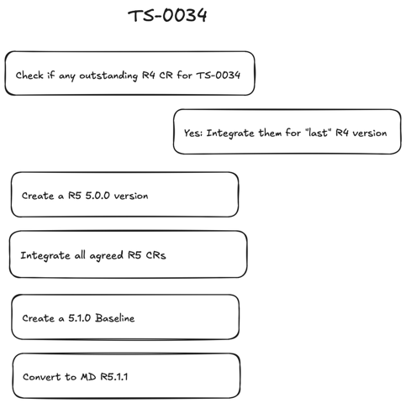

5.2 Open Discussion

Roland announced that TP-69 will be in Berlin (Deutsche Telekom), with a potential quantum computing tour.

6 Planning for next Meetings

6.1 Future TP Meetings
- TP#69. Feb 31- March 4 2025, Jeju Island, Korea.

6.2 Next Conference Calls
- RDM# 68.2 (2025-03-20 13:00-15:00 UTC)

7 Any other business
None

8 Closure of meeting
The Chair thanked the participants and closed the meeting.

