CHANGE REQUEST
Meeting ID:* | RDM 69
Source:* | Ingo Friese, Deutsche Telekom AG, Ingo.Friese@telekom.de
Date:* | 2025-04-01
Reason for Change/s:* | Adding AI Compression Use-Case
CR against: Release* | R6
CR against: WI* | Active WI-0110  MNT maintenance / < Work Item number(optional)>  Is this a mirror CR? Yes No  mirror CR number: (Note to Rapporteur - use latest agreed revision)  STE Small Technical Enhancements / < Work Item number (optional)>  Only ONE of the above shall be ticked
CR against: TS/TR* | TR-0069
Clauses *
Type of change: * | Editorial change  Bug Fix or Correction  Change to existing feature or functionality  New feature or functionality  Only ONE of the above shall be ticked
Other TS/TR(s) impacted | none
Post Freeze checking:* | This CR contains only essential changes and corrections? YES NO  This CR may break backwards compatibility with the last approved version of the TS? YES NO
Template Version: January 2020 (do not modify)

oneM2M Notice
The document to which this cover statement is attached is submitted to oneM2M. Participation in, or attendance at, any activity of oneM2M, constitutes acceptance of and agreement to be bound by terms of the Working Procedures and the Partnership Agreement, including the Intellectual Property Rights (IPR) Principles Governing oneM2M Work found in Annex 1 of the Partnership Agreement.
GUIDELINES for Change Requests:
Provide an informative introduction containing the problem(s) being solved, and a summary list of proposals.
Each CR should contain changes related to only one particular issue/problem.
If this is a correction, and the change applies to previous releases, a separate “mirror CR” should be posted at the same time as this CR
Mirror CR: applies only when the text, including clause numbering are exactly the same.
Companion CR: applies when the change means the same but the baselines differ in some way (e.g. clause number).
Follow the principle of completeness, where all changes related to the issue or problem within a deliverable are simultaneously proposed to be made e.g. a change impacting 5 tables should not only include a proposal to change only 3 tables. Include any changes to references, definitions, and abbreviations in the same deliverable.
Follow the drafting rules.
All pictures must be editable.
Check spelling and grammar.
Use change bars for modifications.
The change should include the current and surrounding clauses to clearly show where a change is located and to provide technical context of the proposed change. Additions of complete clauses need not show surrounding clauses as long as the proposed clause number clearly shows where the proposed new clause is located.
Multiple changes in a single CR shall be clearly separated by horizontal lines with embedded text such as, start of change 1, end of change 1, start of new clause, end of new clause.
When subsequent changes are made to the content of a CR, then the accepted version should not show changes over changes. The accepted version of the CR should only show changes relative to the baseline approved text.

Introduction
Introduction of AI model compression for transmission
R01:
- M -> m in metaverse
- Add to codecs also algorithms
- Revise “must” towards normal verbs
- In the figure change from retrieve to response or return according to TS-001
- There should be an additional figure (one without and one with Orchestrator)
- There should be no optional actors
- The negotiation phase should be added

-----------------------Start of change 1-------------------------------------------

7.3 Use Case #3 – Compressed transmission of AI models in Metaverse scenarios
7.3.1 Description
In metaverse use cases, continuous learning is vital, as user behavior, content, and language patterns evolve constantly. AI models that learn continuously create more immersive, intelligent, and personalized virtual worlds. However, training AI models in metaverse scenarios often requires significant computational resources, typically available only in data centers equipped with GPUs or TPUs. Clients, such as XR headsets or edge servers, often lack the necessary processing power to train models locally. To overcome this limitation, models are trained centrally in the cloud and then distributed to multiple users. For example, personalized NPCs (non-player characters) may be trained centrally but continue learning locally from user interactions. This approach enhances adaptability but also comes with challenges. The transfer of AI models consumes bandwidth and energy, generates network traffic, and increases costs, especially as models grow in size.
To address these issues, AI model compression becomes crucial. Compressing models before transfer (e.g., through pruning, quantization, entropy coding or knowledge distillation) reduces their size, making transmission more efficient. Alternatively, on-the-fly compression allows for dynamic adaptation based on network conditions. Once received, the models are decompressed for use on the client device.
7.3.2 Scope
This use case focuses on the integration and utilization of existing compression methods within transmission protocols, ensuring that AI models can be efficiently delivered to clients with minimal impact on bandwidth, latency, and energy consumption. The specific compression techniques themselves are out of scope and are only mentioned to provide context and illustration.
7.3.3 Actors
- Model Provider (AI Model Server) – The central entity that manages and provides the trained AI model.
- Client (AI Model Consumer) – The device or application that downloads and utilizes the model.

- Orchestrator (AI Model Deployment Manager) – A system coordinating the distribution of AI models.

7.3.4 Pre-Conditions
- AI models are compressible. The feasibility of compression depends on factors such as the model’s architecture, training framework, and the chosen compression codec or algorithm.
- The AI Model Server supports model compression. It has the capability to apply compression techniques before transmission.
- The AI Model Consumer supports model decompression. It isable to restore the compressed model to a usable state.
7.3.5 Triggers
- A new AI model version is available and needs to be distributed.
- A client requests an updated AI model from the server.
- Bandwidth limitations require on-the-fly compression before transmission.
7.3.6 Normal Flow
Figure: 7.3.6-1 shows the direct download message flow to request a compressed AI model directly from the AI model server.
- Step 1: The AI Model Consumer (Client) requests for model XYZ and specifies that it should be compressed. The request includes the client's compression preferences, which may consist of one or multiple parameters.
- Step 2: If the AI Model Server cannot meet the client’s compression requirements, it offers alternative options. The client can select an alternative, receive the uncompressed model, or cancel the request. This negotiation step is optional and may not occur in every request.

- Step 3: The AI Model Server either returns a pre-compressed version of model XYZ or compresses the uncompressed version on-the-fly based on the specified parameters before returning it to the client.
- Step 4: The AI Model Consumer decompresses the compressed model XYZ.

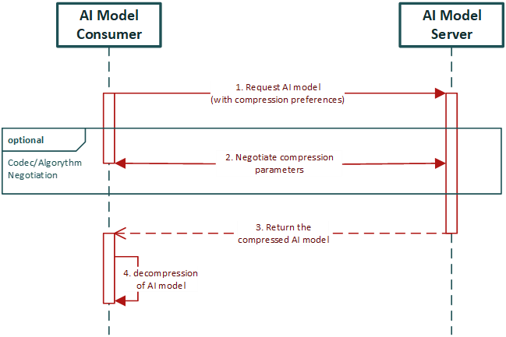
Figure: 7.3.6-1 Flow to request a compressed AI model as a direct download from the AI model server.

7.3.7 Alternative Flow
AI models can be pre-compressed with different parameter sets and stored in various locations. If no compressed version is available, a capable server can compress the model on the fly. An AI Model Deployment Manager (orchestrator) handles this process by selecting the appropriate model, providing the reference, and triggering compression when needed.
Figure 7.3.7-1 illustrates the message flow for requesting a compressed AI model from the AI Model Server via the AI Model Deployment Manager.
- Step 1: The AI Model Consumer (Client) requests model XYZ from the AI Model Deployment Manager and specifies the desired compression settings, which may include one or multiple parameters.
- Step 2: The AI Model Deployment Manager processes the request, negotiates model retrieval, and evaluates available models across different server locations. If the requested compression settings cannot be met, it offers alternatives. The client can choose an alternative, receive the uncompressed model, or cancel the request. This negotiation step is optional.
- Step 3: The AI Model Deployment Manager returns a server reference and the negotiated compression parameters.
- Step 4: The AI Model Consumer requests the AI model from the referenced AI Model Server, including all negotiated parameters.
- Step 5: The AI Model Server dynamically compresses the requested model (if no pre-compressed variant exists) and delivers the compressed version to the AI Model Consumer.
- Step 6: The AI Model Consumer decompresses the compressed model XYZ.

Figure: 7.3.7-1 Flow for requesting a compressed AI model from the AI model server via the AI model deployment manager.
7.3.8 Post-conditions
Non

-----------------------End of change 1---------------------------------------------

CHECK LIST
- Does this Change Request include an informative introduction containing the problem(s) being solved, and a summary list of proposals.?
- Does this CR contain changes related to only one particular issue/problem?
- Have any mirror CRs been posted?
- Does this Change Request make all the changes necessary to address the issue or problem? E.g. A change impacting 5 tables should not include a proposal to change only 3 tables?Does this Change Request follow the drafting rules?
- Are all pictures editable?
- Have you checked the spelling and grammar?
- Have you used change bars for all modifications?
- Does the change include the current and surrounding clauses to clearly show where a change is located and to provide technical context of the proposed change? (Additions of complete clauses need not show surrounding clauses as long as the proposed clause number clearly shows where the new clause is proposed to be located.)
- Are multiple changes in this CR clearly separated by horizontal lines with embedded text such as, start of change 1, end of change 1, start of new clause, end of new clause.?

