CHANGE REQUEST
Meeting ID:* | RDM 70
Source:* | Ingo Friese, Deutsche Telekom AG, Ingo.Friese@telekom.de
Date:* | 2025-06-17
Reason for Change/s:* | Adding AI Compression Use-Case – Illustration and potential requirements
CR against: Release* | R6
CR against: WI* | Active WI-0110  MNT maintenance / < Work Item number(optional)>  Is this a mirror CR? Yes No  mirror CR number: (Note to Rapporteur - use latest agreed revision)  STE Small Technical Enhancements / < Work Item number (optional)>  Only ONE of the above shall be ticked
CR against: TS/TR* | TR-0069
Clauses *
Type of change: * | Editorial change  Bug Fix or Correction  Change to existing feature or functionality  New feature or functionality  Only ONE of the above shall be ticked
Other TS/TR(s) impacted | none
Post Freeze checking:* | This CR contains only essential changes and corrections? YES NO  This CR may break backwards compatibility with the last approved version of the TS? YES NO
Template Version: January 2020 (do not modify)

oneM2M Notice
The document to which this cover statement is attached is submitted to oneM2M. Participation in, or attendance at, any activity of oneM2M, constitutes acceptance of and agreement to be bound by terms of the Working Procedures and the Partnership Agreement, including the Intellectual Property Rights (IPR) Principles Governing oneM2M Work found in Annex 1 of the Partnership Agreement.
GUIDELINES for Change Requests:
Provide an informative introduction containing the problem(s) being solved, and a summary list of proposals.
Each CR should contain changes related to only one particular issue/problem.
If this is a correction, and the change applies to previous releases, a separate “mirror CR” should be posted at the same time as this CR
Mirror CR: applies only when the text, including clause numbering are exactly the same.
Companion CR: applies when the change means the same but the baselines differ in some way (e.g. clause number).
Follow the principle of completeness, where all changes related to the issue or problem within a deliverable are simultaneously proposed to be made e.g. a change impacting 5 tables should not only include a proposal to change only 3 tables. Include any changes to references, definitions, and abbreviations in the same deliverable.
Follow the drafting rules.
All pictures must be editable.
Check spelling and grammar.
Use change bars for modifications.
The change should include the current and surrounding clauses to clearly show where a change is located and to provide technical context of the proposed change. Additions of complete clauses need not show surrounding clauses as long as the proposed clause number clearly shows where the proposed new clause is located.
Multiple changes in a single CR shall be clearly separated by horizontal lines with embedded text such as, start of change 1, end of change 1, start of new clause, end of new clause.
When subsequent changes are made to the content of a CR, then the accepted version should not show changes over changes. The accepted version of the CR should only show changes relative to the baseline approved text.

Introduction
Introduction of AI model compression for transmission

-----------------------Start of change 1-------------------------------------------

7.3.9 High Level Illustration
The primary objective of this use case is to illustrate the compression and decompression of AI models. The oneM2M framework enables the management of AI models, including the uploading and downloading of large model files. To optimize bandwidth usage and reduce transmission time, these models can be compressed prior to transfer or transmitted in an already compressed form.
As discribed in Neural Network Coding (NNC) standard ISO/IEC 15938-17 (MPEG-7 Part 17) [i.10], this can be achieved through a combination of compression techniques including quantization, pruning, and entropy-based encoding. These methods make it possible to reduce the size of AI models to a single-digit percentage of their original size for transmission, without significantly affecting model accuracy.
Model compression is typically fast enough to be performed ad hoc upon request, enabling on-demand compression prior to transmission.
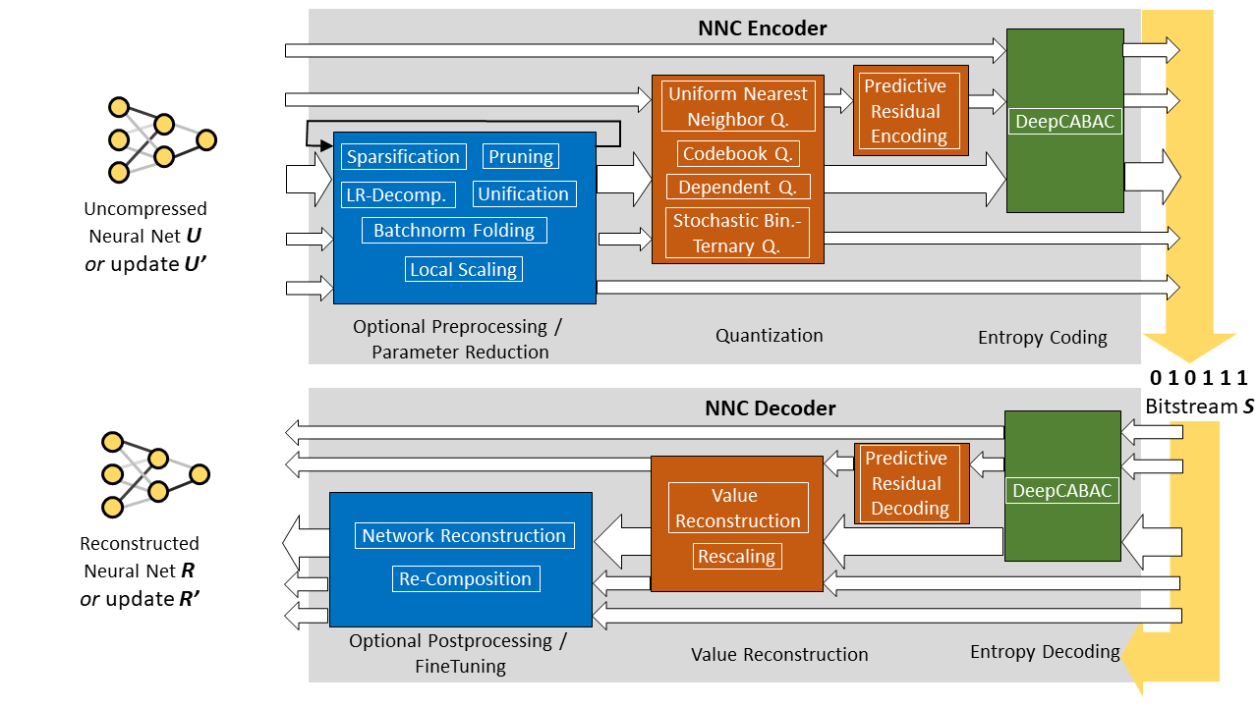
Figure 1: NNC overview
NNC defines a series of processing steps and coding tools for compressing neural networks. As illustrated in Fig. 1, the input can be a standard trained model or an updated version based on a previous base model.
Key processing steps include:
- Parameter Reduction: Techniques such as sparsification, pruning, unification, and decomposition reduce model size. These may involve zeroing out weights, grouping similar parameters, or eliminating redundant ones.
- Decomposition: Matrix operations like low-rank approximations restructure model weights and may also support quantization techniques such as batchnorm folding or local scaling.
- Parameter Quantization: Reduces parameter precision using methods like uniform or codebook-based quantization, enabling more efficient inference.
- Predictive Residual Encoding: Encodes model updates incrementally, useful in scenarios like federated learning.
- Entropy Coding: Compresses quantized data. NNC includes DeepCABAC, enhanced with temporal modeling for sequential updates.

7.3.10 Potential Requirements
- The oneM2M system should support AI model compression and decompression, allowing models to be compressed on demand at the request of an application or user.

-----------------------End of change 1---------------------------------------------

-----------------------Start of Changes to References Clause -------------

2.1 Normative references
The following referenced documents are necessary for the application of the present document.
[1] oneM2M Drafting Rules (http://www.onem2m.org/images/files/oneM2M-Drafting-Rules.pdf))

2.2 Informative references
[i.10] White paper on Neural Network Coding from ISO/IEC JTC 1/SC 29/AG 03
Note: Available at https://www.mpeg.org/standards/MPEG-7/17/

-----------------------End of Changes to References -------------

CHECK LIST
- Does this Change Request include an informative introduction containing the problem(s) being solved, and a summary list of proposals.?
- Does this CR contain changes related to only one particular issue/problem?
- Have any mirror CRs been posted?
- Does this Change Request make all the changes necessary to address the issue or problem? E.g. A change impacting 5 tables should not include a proposal to change only 3 tables?Does this Change Request follow the drafting rules?
- Are all pictures editable?
- Have you checked the spelling and grammar?
- Have you used change bars for all modifications?
- Does the change include the current and surrounding clauses to clearly show where a change is located and to provide technical context of the proposed change? (Additions of complete clauses need not show surrounding clauses as long as the proposed clause number clearly shows where the new clause is proposed to be located.)
- Are multiple changes in this CR clearly separated by horizontal lines with embedded text such as, start of change 1, end of change 1, start of new clause, end of new clause.?

