Input Contribution
Meeting ID* | SDS 39
Title:* | Industrial Domain Information Model Mapping
Source:* | Chengsui Lu, Hitachi, cslu@hitachi.cn  Miao Jiang, Hitachi, miaojiang@hitachi.cn
Date:* | 2019-02-18
Input related to* | WI-0075 Industrial Domain Information Model Mapping & Semantics Support  TR-0049 Industrial Domain Information Model Mapping & Semantics Support
Intended purpose of  document:* | Decision  Discussion  Information  Other <specify>
Impacted other TS/TR(s) | <TS/TR number>, <Version Number>, and <Description on which aspect should be reflected in this TS/TR>
Decision requested or recommendation:* | To agree on the industrial domain Information Model mapping solution.
Template Version: January 2017 (Do not modify)

oneM2M Notice
The document to which this cover statement is attached is submitted to oneM2M. Participation in, or attendance at, any activity of oneM2M, constitutes acceptance of and agreement to be bound by terms of the Working Procedures and the Partnership Agreement, including the Intellectual Property Rights (IPR) Principles Governing oneM2M Work found in Annex 1 of the Partnership Agreement.

2 References

2.2 Informative references

-----------------------Start of Change 1-------------------------------------------
[i.12] oneM2M TS-0023: "Home Appliances Information Model and Mapping".

----------------------- End of Change 1-------------------------------------------

8 Design principle of IM mapping and semantics support
Editors’ note: This clause includes 2 phases of work. Phase 1: IM mapping. Phase 2: Study on semantics support.

8.1 Mapping to oneM2M resources
Editors’ note: OPC-UA and ISA-95 are the highlighted models for mapping due to wide adoptions and significance in the concept of value chain integration. There is no intention to devalue other data models.

-----------------------Start of Change 2-------------------------------------------

8.1.1 OPC-UA IM mapping
OPC-UA IM is introduced and studied in the clause 7.1, and TR-0018 “Industrial Domain Enablement” [i.5] clause 10.3.3.
Considering the definition of IMs, e.g. Instances, Types and References, etc., we designed the principle of mapping OPC-UA IM to unified oneM2M IM in vertical domains using SDT 4.0 [i.11] as in Table 8.1.1-1.
Note that both OPC-UA ObjectType and VariableType should be mapped to oneM2M ModuleClass.
Also note that OPC-UA DataType should be mapped to oneM2M DataType, which is a field of Action and DataPoint.
Table 8.1.1-1: OPC-UA and oneM2M IMs Mapping
OPC-UA IM | oneM2M IM
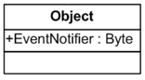 | 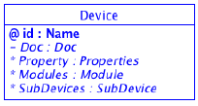
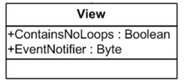 | 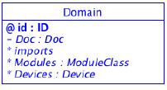
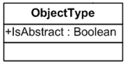  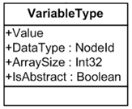 | 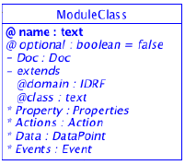
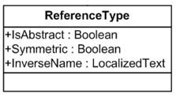 | 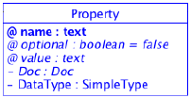
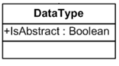 | DataType: DataType
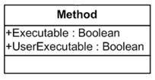 | 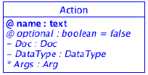
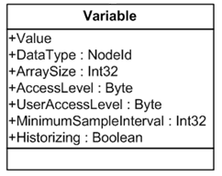 | 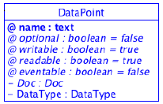

Based on the above OPC-UA and oneM2M IMs mapping design, OPC-UA IM could be further mapped to oneM2M resources following the principles provided in [i.12] clause 6.

----------------------- End of Change 2-------------------------------------------

