CHANGE REQUEST
Meeting ID:* | SDS#40
Source:* | Kenichi Yamamoto, KDDI, kc-yamamoto@kddi.com
Date:* | 2019-05-08
Reason for Change/s:* | The CR is to add PFD Management API for 3GPP interworking
CR against: Release* | Release 4
CR against: WI* | Active WI-0058  MNT maintenance / < Work Item number(optional)>  Is this a mirror CR? Yes No  mirror CR number: (Note to Rapporteur - use latest agreed revision)  STE Small Technical Enhancements / < Work Item number (optional)>  Only ONE of the above shall be ticked
CR against: TS/TR* | TR-0024 3GPP Interworking v2.4.0
 | 8.x
Type of change: * | Editorial change  Bug Fix or Correction  Change to existing feature or functionality  New feature or functionality  Only ONE of the above shall be ticked
Other TS/TR(s) impacted | N/A
Post Freeze checking:* | This CR contains only essential changes and corrections? YES NO  This CR may break backwards compatibility with the last approved version of the TS? YES NO
Template Version: January 2019 (do not modify)

oneM2M Notice
The document to which this cover statement is attached is submitted to oneM2M. Participation in, or attendance at, any activity of oneM2M, constitutes acceptance of and agreement to be bound by terms of the Working Procedures and the Partnership Agreement, including the Intellectual Property Rights (IPR) Principles Governing oneM2M Work found in Annex 1 of the Partnership Agreement.
GUIDELINES for Change Requests:
Provide an informative introduction containing the problem(s) being solved, and a summary list of proposals.
Each CR should contain changes related to only one particular issue/problem.
If this is a correction, and the change applies to previous releases, a separate “mirror CR” should be posted at the same time as this CR
Mirror CR: applies only when the text, including clause numbering are exactly the same.
Companion CR: applies when the change means the same but the baselines differ in some way (e.g. clause number).
Follow the principle of completeness, where all changes related to the issue or problem within a deliverable are simultaneously proposed to be made e.g. a change impacting 5 tables should not only include a proposal to change only 3 tables. Include any changes to references, definitions, and abbreviations in the same deliverable.
Follow the drafting rules.
All pictures must be editable.
Check spelling and grammar.
Use change bars for modifications.
The change should include the current and surrounding clauses to clearly show where a change is located and to provide technical context of the proposed change. Additions of complete clauses need not show surrounding clauses as long as the proposed clause number clearly shows where the proposed new clause is located.
Multiple changes in a single CR shall be clearly separated by horizontal lines with embedded text such as, start of change 1, end of change 1, start of new clause, end of new clause.
When subsequent changes are made to the content of a CR, then the accepted version should not show changes over changes. The accepted version of the CR should only show changes relative to the baseline approved text.

Introduction
This contribution proposes functionality to enable an IN-CSE to request that a SCEF sends PFD (Packet Flow Description) for the detection of application traffic provided by a 3rd party service provider.

-----------------------Start of change 1-------------------------------------------

8.x PFD Management

8.x.1 Description
The 3GPP SCEF functionality described in 3GPP TS 29.122 [i.Error: Reference source not found] supports APIs for PFD management. PFD (Packet Flow Description) is a set of information enabling the detection of application traffic including PFD ID, description of the application flows, URL and a Domain name as defined in 3GPP TS 23.682 [i.5]. Based on the agreement between ASP and MNO, the PFD can be designed to convey proprietary extension for proprietary application traffic detection mechanisms. 5G NEF API described in 3GPP TS 29.522 [i.Error: Reference source not found] also supports the PFD management API.
The PFD management enables 3GPP Network Entities to perform accurate application detection when PFDs are provided by an ASP (via the SCEF) and then to apply enforcement actions as instructed in the PCC (Policy and Charging Control)/ADC (Application Detection and Control) Rule. Each PFD may be identified by a PFD ID, which is unique in the scope of a particular application identifier. There may be different PFD types associated to an application identifier.
A MNO is able to configure pre-defined or dynamic PCC/ADC Rules in the 3GPP Network Entities that include at least an application identifier for service data flow or application detection, charging control information, i.e. charging key and optionally the Sponsor identifier or the ASP identifier or both. Depending on the service level agreements between the MNO and the ASP, it may be possible for the ASP to provide individual PFDs or the full set of PFDs for each application identifier maintained by the ASP to the 3GPP Network Entities via the SCEF. The PFDs become part of the application detection filters in the 3GPP Network Entities and therefore are used as part of the logic to detect traffic generated by an application. The ASP may remove or modify some or all of the PFDs which have been provisioned previously for one or more application identifiers.
Below are some possible use cases for use of the PFD management API.
- Use case 1: Time interval coordination with application prioritization.
In this use case, an ASP provides road map application service and in-vehicle application service to vehicles. The road map application, which might not be required to support low-latency communication is based on data collected by vehicle on-board cameras/sensors (e.g. video camera, radar, LIDAR, GPS). Thus, the road map application indicates a low-priority category. On the other hand, in-vehicle application contains vehicular state (e.g. fuel state, battery charging alert, warning of oil pressure, current mileage count) and might be required to support low-latency communication. Therefore, the in-vehicle application indicates a high-priority category. The ASP wants to coordinate the time intervals for their applications depending on each application prioritization.
Firstly, the ASP sends a PFD information for the road map/ in-vehicle application, which contain external application identifiers, URLs of each applications, flow descriptions (e.g. protocol, server IP and server port for UL/DL application traffic) and PFD time intervals (Road Map application is set to 500 seconds and In-vehicle application is set to 10 seconds) to a vehicle. The communication procedure between the ASP and the vehicle is out of scope of the present document. Then, the vehicle sends a PFD create request for the road map/ in-vehicle application to an IN-CSE. The IN-CSE configures the PFD create request based on the request from the vehicle and sends it to an SCEF. The SCEF negotiates 3GPP Network Entities, sets the time interval of the road map application to 1,000 seconds and sends a PFD create response to the IN-CSE. Based on the response, the IN-CSE updates the PFD time interval of the road map application and the vehicle utilizes the road map /in-vehicle application with the PFD time interval configuration.
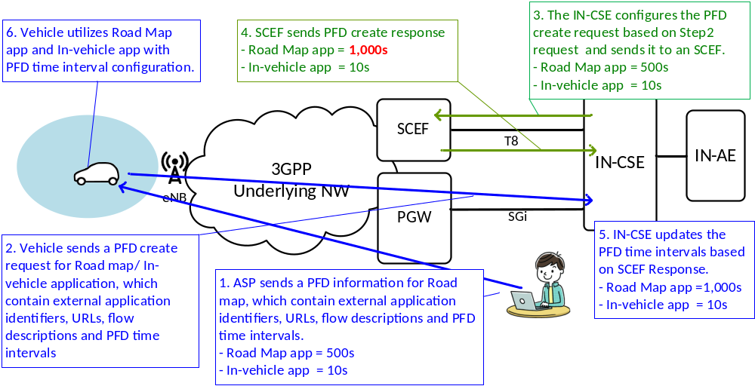
Figure 8.x.1-1: Use case 1: Time interval coordination with application priority
- Use case 2: Time interval coordination with application prioritization (IN-CSE pre-configuration).
In this use case, the ASP pre-configures PFD information to the IN-CSE in order to minimize the amount of processing/ data in a vehicle.
Firstly, the ASP sends a PFD information to an IN-CSE as pre-configuration. The ASP also sends external application identifiers for the road map/ in-vehicle application to a vehicle. The communication procedures between the ASP and the vehicle /IN-CSE are out of scope of the present document. Then, the vehicle sends a PFD create request for the road map/ in-vehicle application to an IN-CSE, which contain external application identifiers. The IN-CSE configures the PFD create request based on the request from the vehicle and the pre-configured PFD information in the IN-CSE. After this, the procedures are the same as shown in the Use case 1.
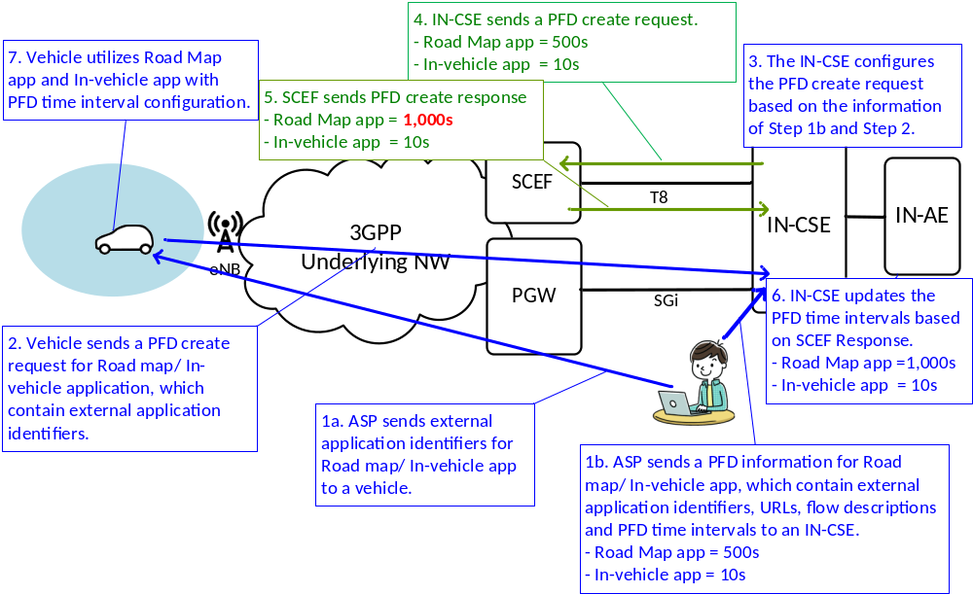
Figure 8.x.1-2: Use case 2: Time interval coordination for application priority (IN-CSE pre-configuration)
- Use case 3: Dynamic coordination of the time interval for each application depending on Underlying Network congestion
PFD Management API supports the time interval coordination for applications. However, the API does not have the information related network congestion. This use case introduces dynamic coordination of the time intervals for each application depending on Underlying network congestion. Regarding collection of network congestion information, Network Status Report API or Monitoring Event API (Number of UEs in an Area) may be applicable.
Step 1 in Figure 8.x.1-3 is the same as shown in the Use case 1. In Step 2, the vehicle send a PFD create request for the road map application, which contains external application identifiers, URLs of each applications, flow descriptions and PFD time intervals and a network monitoring indicator to an IN-CSE. If the network monitoring indicator is set to enable, the IN-CSE may identify the location of each vehicle by using the location technology (e.g. Cell-ID, assisted-GPS, and fingerprint) of 3GPP Underlying Network, retrieves congestion status for Area A and B with Network Status API or Monitoring Event API (Number of UEs in an Area) and identifies Area A as High Congestion and Area B as Low Congestion. So, the time interval of the application in Area A is set to a value larger than the PFD time interval allocated by the SCEF (e.g. Area A is 2,000s, Area B is 1,000s). Note that the policy for updating the time intervals depending on congestion levels is based on SLA between ASP and MNO, and is outside the scope of the present document. Finally, vehicles utilize the road map application with the time interval configuration allocated in each area.
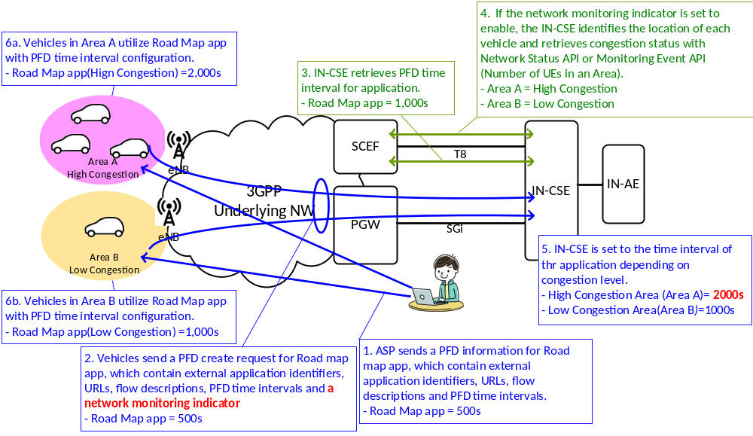
Figure 8.x.1-3: Use case 3: Dynamic coordination of the time intervals for the application depending on Underlying network congestion
- Use case 4: Dynamic coordination of the time interval for each application with Edge/Fog Computing
This use case applies the PFD Management with Edge/Fog Computing, not only to mitigate the burdens on the IN-CSE, but also to coordinate the time intervals for each application depending on the network congestion in the coverage area of each Fog Node.
Step 1 in Figure 8.x.1-4 is the same as shown in the Use case 1. In Step 2, the vehicle send a PFD create request for the road map application to a MN-CSE (Fog Node). The MN-CSE (Fog Node) configures the PFD create request based on the request from the vehicle and sends it to an SCEF. The SCEF negotiates 3GPP Network Entities, sets the time interval of the road map application to 1,000 seconds and sends a PFD create response to the MN-CSE (Fog Node). The congestion level in the coverage area of MN-CSE-B is relatively low. On the other hand, the congestion level in the coverage area of MN-CSE-A is relatively high. So, the time interval of the application in MN-CSE-A is set to a value larger than the PFD time interval allocated by the SCEF (e.g. MN-CSE-A is 2,000s, MN-CSE-B is 1,000s). Note that the policy for setting the time intervals depending on Fog Nodes is based on SLA between ASP and MNO, and is outside the scope of the present document. Finally, vehicles utilize the road map application with the time interval configuration allocated in each area.
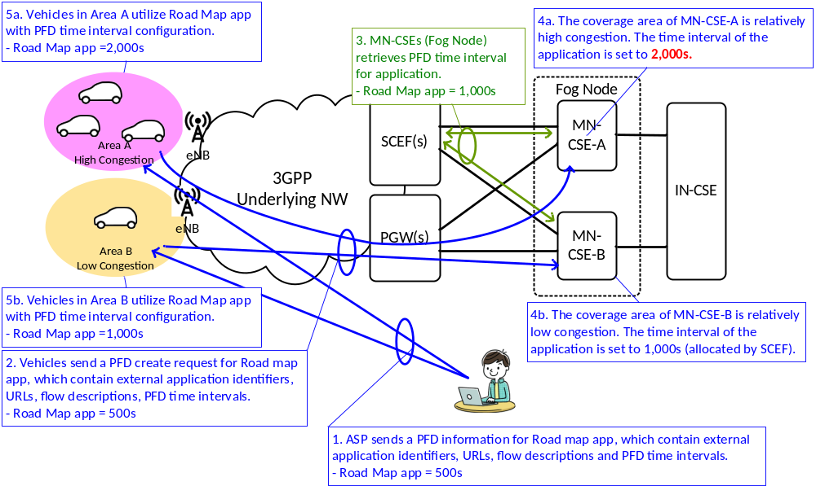
Figure 8.x.1-4: Use case 4: Dynamic coordination of the time intervals for the application with Edge/Fog Computing
- Use case 5: PFD management for a group member
If the IN-CSE uses a PFD management for a group of vehicles, it is assumed that they are managed together using a <group> resource and that they may be identified in the 3GPP Underlying Network by a common External Group Identifier.

8.x.2 Feature Gap Analysis
The 3GPP defined term “SCS” and “AS” in the flows corresponds to oneM2M IN-CSE and oneM2M IN-AE, respectively. The service flows defined in 3GPP TS23.682 [i.5] are used in the following section as informative information only. The oneM2M focus is on the T8 API of SCEF.

8.x.2.1 PFD management via SCEF
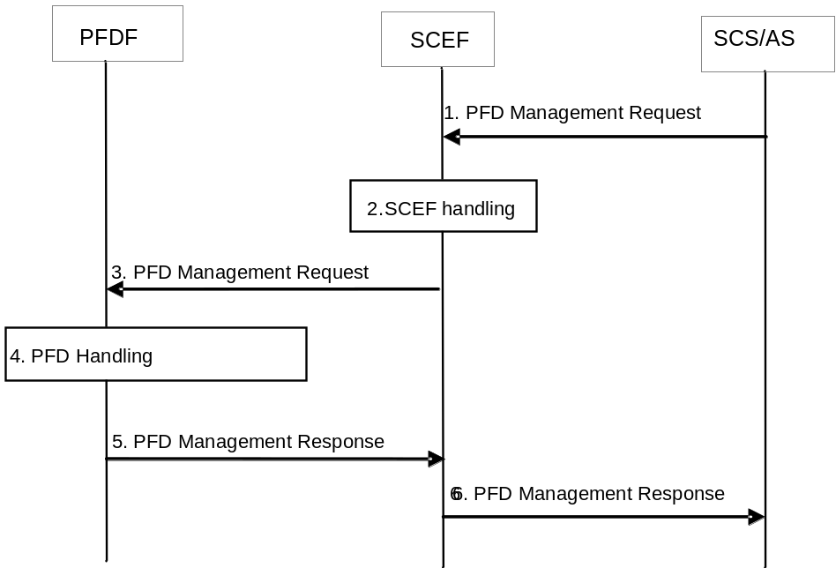
Figure 8.x.2.1-1: PFD management via SCEF [i.5]
Figure 8.x.2.1-1 illustrates the procedure of PFD management via SCEF, described in 3GPP TS23.682 [Error: Reference source not found] and 3GPP TS29.122 [i.18]. This procedure is used by the SCS/AS to manage PFDs into the operator network via SCEF.
Step 1: The SCS/AS sends a PFD Management Request (SCS/AS Identifier, external Application Identifier(s) and one or more sets of PFDs and PFD operation for each Application Identifier, Allowed Delay) message to the SCEF. The external Application Identifier(s) will be provided by an SCS/AS that is known at the SCEF, so that the SCS/AS and the MNO has an SLA in place. PFD operation indicates that the PFD is to be created, updated or removed in the operator's network. The Allowed Delay is an optional parameter. If the Allowed Delay is included, it indicates that the list of PFDs in this request will be deployed within the time interval indicated by the Allowed Delay.
Step 6: The SCEF sends a PFD Management Response (Cause) message to the SCS/AS to provide the feedback of the handling result for the PFD Management Request.
For the response to a PFD Management create request, the SCEF sends an HTTP response to the SCS/AS with a corresponding status code as described in 3GPP TS29.122 [i.18]. The SCEF also includes PFD report(s) with a list of external Application Identifier(s) and result(s) in the body of the HTTP response if some application(s) are not provisioned successfully (i.e. the PFDF returns failure and/or the SCEF does not accept the PFD provisioning (e.g. one or more external Application Identifiers in the request are already present in existing transactions)). If the provisioning of all application(s) fails (i.e. the PFDF returns failure and/or the SCEF does not accept the PFD provisioning), the SCEF responds with 500 status code, and include the attribute "pfdReports" with the corresponding failure code as described in 3GPP TS29.122 [i.18] and the external Application Identifier(s) for which the provisioning has failed. When the allowed delayed cannot be satisfied, i.e. it is smaller than the caching time configured in fetching PFD, "cachingTime" attribute will be included.
For the response to a PFD Management update request, the SCEF sends an HTTP response to the SCS/AS with a corresponding status code as described in 3GPP TS29.122 [i.18]. The SCEF also includes PFD report(s) with a list of external Application Identifier(s) and result(s) in the body of the HTTP response if some application(s) are not provisioned successfully (i.e. the PFDF returns failure and/or the SCEF does not accept the PFD provisioning (e.g. one or more external Application Identifiers in the request are already present in existing transactions)). If the provisioning of the application fails (i.e. the PFDF returns failure or the SCEF does not accept the PFD provisioning), the SCEF rejects the request with a corresponding status code, and include the attribute "pfdReports" with the corresponding failure code as described in 3GPP TS29.122 [i.18] and the external Application Identifier for which the provisioning has failed. When the allowed delayed cannot be satisfied, i.e. it is smaller than the caching time configured in fetching PFD, "cachingTime" attribute will be included.
For the response to a PFD Management delete request, the SCEF sends an HTTP response to the SCS/AS with a corresponding status code as described in 3GPP TS29.122 [i.18].
Table 8.x.2.1-1, Table 8.x.2.1-2, Table 8.x.2.1-3 and Table 8.x.2.1-4 shows the attributes for the PFD management API, as described in 3GPP TS 29.122 [i.Error: Reference source not found].
Table 8.x.2.1-1: Attributes for PFD management
Attribute name | Cardinality | Description
pfdDatas | 1..N | Each element uniquely identifies the PFDs for an external application identifier. Each element is identified in the map via an external application identifier as key. The response shall include successfully provisioned PFD data of application(s).
pfdReports | 0..N | Supplied by the SCEF and contains the external application identifiers for which PFD(s) are not added or modified successfully. The failure reason is also included. Each element provides the related information for one or more external application identifier(s) and is identified in the map via the failure identifier as key.
self | 0..1 | Link to the resource "Individual PFD Management Transaction".  This parameter shall be supplied by the SCEF in HTTP responses.
supportedFeatures | 0..1 | Used to negotiate the supported optional features of the API as described in TS29.122 [i.18].This attribute shall be provided in the POST request and in the response of successful resource creation.

Table 8.x.2.1-2: Attributes for PfdDatas
Attribute name | Cardinality | Description
externalAppId | 1 | Each element uniquely external application identifier
self | 0..1 | Link to the resource "Individual Application PFD Management". This parameter shall be supplied by the SCEF in HTTP responses.
pfds | 1..N | Contains the PFDs of the external application identifier. Each PFD is identified in the map via a key containing the PFD identifier.
allowedDelay | 0..1 | Indicates that the list of PFDs in this request should be deployed within the time interval indicated by the Allowed Delay. It indicates the length of time in seconds.
cachingTime | 0..1 | SCEF supplied property, inclusion of this property means the allowed delayed cannot be satisfied, i.e. it is smaller than the caching time, but the PFD data is still stored.

Table 8.x.2.1-3: Attributes for Pfds
Attribute name | Cardinality | Description
pfdId | 1 | Identifies a PFD of an application identifier.
flowDescriptions | 0..N | Represents a 3-tuple with protocol, server ip and server port for UL/DL application traffic. The content of the string has the same encoding as the IPFilterRule AVP value as defined in IETF RFC 6733. (NOTE)
urls | 0..N | Indicates a URL or a regular expression which is used to match the significant parts of the URL. (NOTE)
domainNames | 0..N | Indicates an FQDN or a regular expression as a domain name matching criteria. (NOTE)
NOTE: One of the properties "flowDescriptions", "urls" or "domainNames" will be included.
Table 8.x.2.1-4: Attributes for PfdReports
Attribute name | Cardinality | Description
externalAppIds | 1..N | Identifies the external application identifier(s) which PFD(s) are not added or modified successfully
failureCode | 1 | Identifies the failure reason
cachingTime | 0..1 | It shall be included when the allowed delayed cannot be satisfied, i.e. it is smaller than the caching time configured in fetching PFD.

Table 8.x.2.1-5 shows the Failure code for representing the failure reason of the PFD management, as described in 3GPP TS 29.122 [i.Error: Reference source not found].
Table 8.x.2.1-5: Failure code of the PFD management
Enumeration value | Description
MALFUNCTION | This value indicates that something functions wrongly in PFD provisioning or the PFD provisioning does not function at all.
RESOURCE_LIMITATION | This value indicates there is resource limitation for PFD storage.
SHORT_DELAY | This value indicates that the allowed delay is too short and PFD(s) are not stored.
APP_ID_DUPLICATED | The received external application identifier(s) are already provisioned.
OTHER_REASON | Other reason unspecified.

Figure 8.x.2.1-2 shows an example of PFD Managenent Request for creation, which contains 2 external applications identifiers. Each application has 2 PFDs.
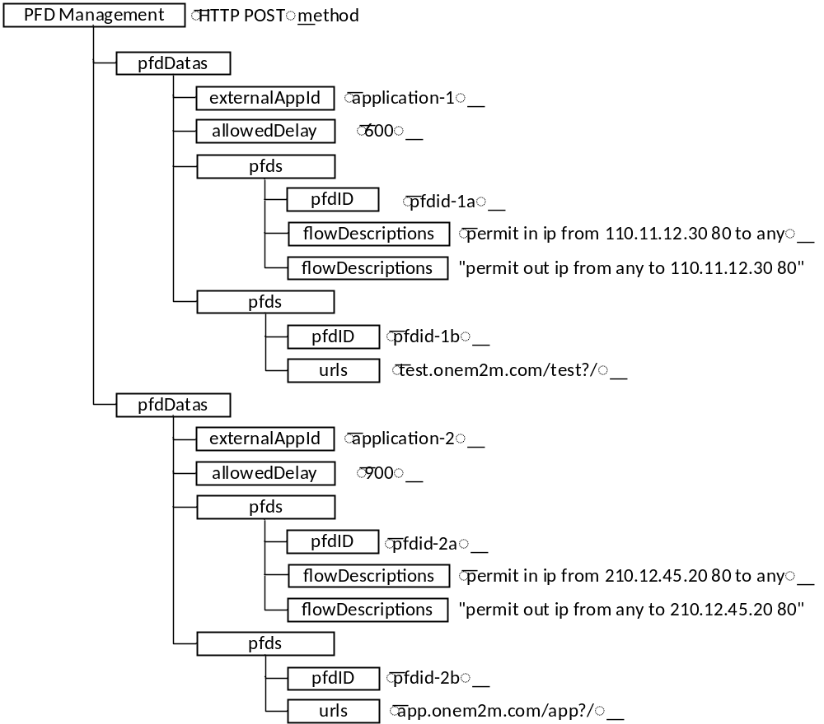
Figure 8.x.2.1-2: Example of PFD Management Request for creation
Figure 8.x.2.1-3 shows an example of the response to the PFD Management Request described in Figure 8.x.2.1-2, which is applicable if all application(s) are provisioned successfully:

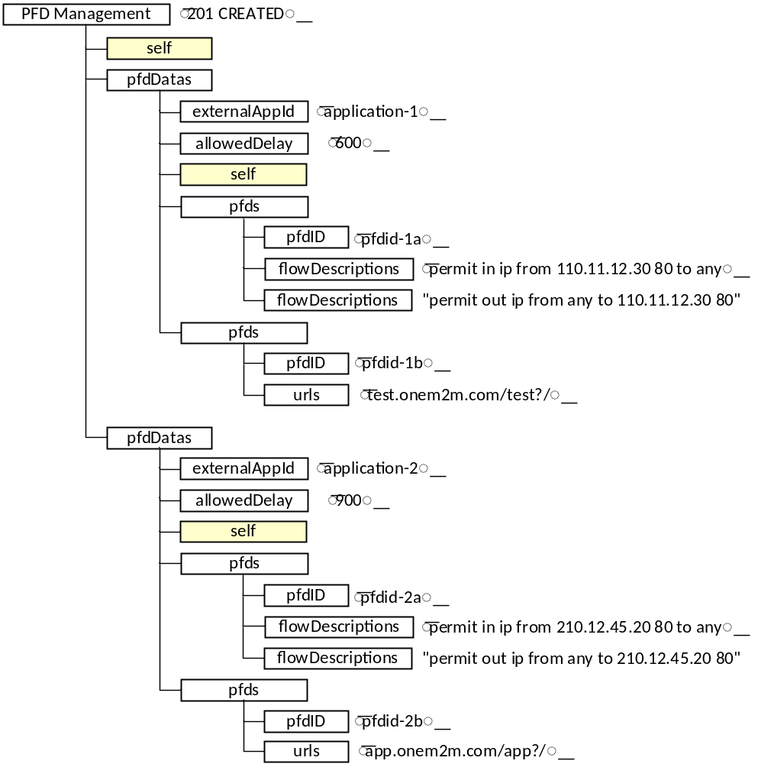
Figure 8.x.2.1-3: Example of a PFD Managenent Response for creation (all application(s) are provisioned successfully)
Figure 8.x.2.1-4 shows an example of the response to the PFD Managenent Request described in Figure 8.x.2.1-2, which is applicable if some application(s) are not provisioned successfully:
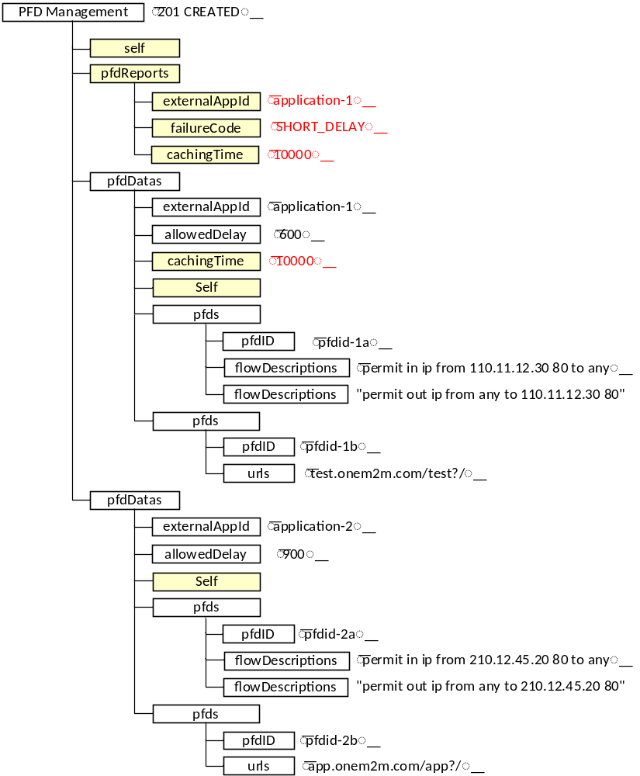
Figure 8.x.2.1-4: Example of a PFD Managenent Response (some application(s) are not provisioned successfully)
Figure 8.x.2.1-5 shows an example of the response to the PFD Managenent Request described in Figure 8.x.2.1-2, which is applicable if the provisioning of all application(s) fails:
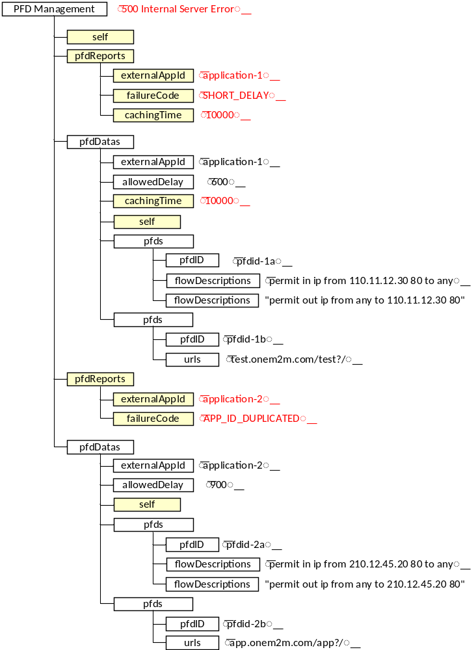
Figure 8.x.2.1-5: Example of a PFD Managenent Response (the provisioning of all application(s) fails)

8.x.3 Key Issues and Requirements

8.x.3.1 Key SCEF NorthBound API Requirements
N/A

8.x.3.2 Potential impact on SCEF SouthBound Interface
N/A

8.x.3.3 Further 3GPP requirements and clarifications
N/A

8.x.3.4 oneM2M Key Issues
- Provide support for PFD Management.

8.x.4 oneM2M Solutions

8.x.4.1 Solution 1

8.x.4.1.1 Impacted Resources and Attributes
This clause proposes a new resource <PFDManagement> as a child of <remoteCSE> and <AE> resources for support of PFD Management functionality. The attributes of <PFDManagement> resource are exemplified below:
- M2M-Ext-App-ID: application-1
- appTimeDuration: 600
- appPFDId: pfdID-1a
- appFlowDescriptions: permit in ip from 10.68.28.39 80 to any,
permit out ip from any to 110.11.12.30 80
- appURLs: test.onem2m.com/test?/

8.x.4.1.1.1 New Resource Type: <PFDManagement>
The <PFDManagement> resource is a child of <remoteCSE> or <AE> and is used to request that the IN-CSE retrieves PFD information from Underlying Network. The resource provides the description of packet data as part of the application detection filters in an Underlying Network Entities.
Table 8.x.4.1.1.1-1: New Attributes of <PFDManagement> Resource
Attributes of <PFDManagement> |  | Multiplicity | RW/  RO/  WO | Description | <PFDManagement> Attributes
M2M-Ext-App-ID |  | 1 | RW | Supported when Registrar CSE is an IN-CSE. It is used by an M2M Service Provider (M2M SP) when services targeted to a M2M Device, are requested from the Underlying Network. It is assumed to uniquely identify an M2M Application in a given context. | OA
appTimeDuration |  | 0..1 | RW | Indicates the time duration for PFDs. | OA
appFlowDescriptions |  | 0..n | RW | Represents a 3-tuple with protocol, server ip and server port for UL/DL application traffic (NOTE). | OA
appURLs |  | 0..1 | RW | Indicates a URL or a regular expression which is used to match the significant parts of the URL for application (NOTE). | OA
appDomainNames |  | 0..1 | RW | Indicates an FQDN or a regular expression as a domain name matching criteria (NOTE). | OA
monitorEnable | 0..1 |  | RW | Indicates the type of network monitoring request.  - enable congestion status in an area  - enable number of devices in an area | OA
NOTE: One of the attributes "appFlowDescriptions", " appURLs" or “appDomainNames” will be included.

8.x.4.1.1.2 Modified <remoteCSE> resource
New child resources as shown in the table below.
Table 8.x.4.1.1.2-1: New Child Resources of <remoteCSE>
New Child Resources of <remoteCSE> | Child Resource Type | Multiplicity | Description
[variable] | <PFDManagement> | 0.. n | See clause 8.x.4.1.1.1.

8.x.4.1.1.3 Modified <AE> resource
New child resources as shown in the table below.
Table 8.x.4.1.1.3-1: New Child Resources of <AE>
New Child Resources of <AE> | Child Resource Type | Multiplicity | Description
[variable] | <PFDManagement> | 0.. n | See clause 8.x.4.1.1.1.

8.x.4.1.2 Proposed Flow

8.x.4.1.2.1 PFD management
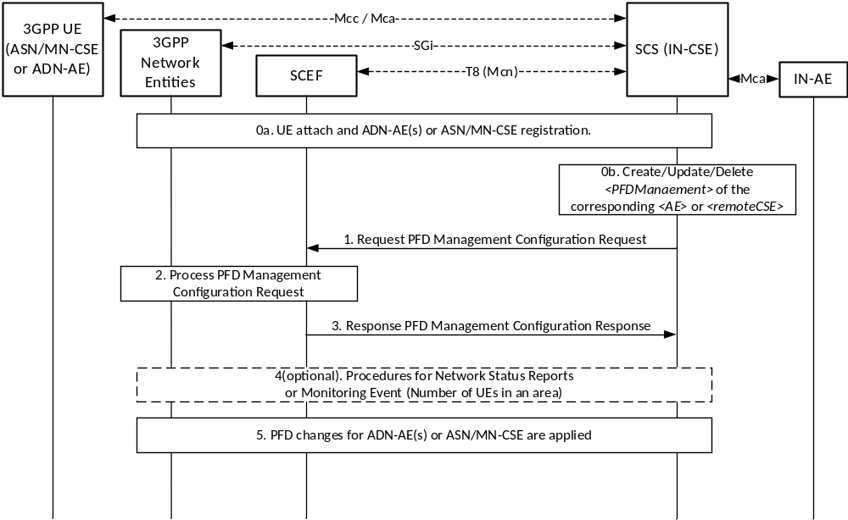
Figure 8.x.4.1.2.1-1: Procedure for PFD Management
Pre-conditions:
There is a relationship in place between an ASP and a MNO allowing the IN-CSE to request PFD Management Configuration. The method for establishing this relationship is outside the scope of the present document.
Step 0: UE Attach and oneM2M Registration Procedures
Step 0a: The UE attaches to the 3GPP network and the ADN-AE(s) or ASN/MN-CSE hosted on the UE perform the oneM2M registration procedure as detailed in clause 6.3 of TS-0026 [i.20]. The IN-CSE hosts the corresponding <AE> or <remoteCSE> resources and an associated <node> resource for the registree. During this procedure, the ADN-AE(s) or ASN/MN-CSE can create <PFDManagement> resource indicating the anticipated PFD Management.
Step 0b: The anticipated PFD Management behavior of the ADN-AE or ASN/MN-CSE may be changed by creating/updating/deleting the <PFDManagement> resource.
Step 1: IN-CSE sends a PFD Management Configuration Request for create/update/delete
This step is triggered by the create/update/delete of <PFDManagement> resource of either the <AE> or <remoteCSE> resource. The IN-CSE derives the PFD Management from the <PFDManagement> resource.
The IN-CSE selects the SCEF based on the M2M-Ext-ID’s of the registree ADN-AE(s) or ASN/MN-CSE (e.g. either a DNS lookup on the M2M-Ext-ID or the based on the domain portion of the M2M-Ext-ID’s.).
Step 1a: When the first <PFDManagement> resource for a given a UE is initially configured, the IN-CSE will generate a PFD Management Configuration creation request that contains the following information as specified in 3GPP TS 29.122 [i.18]:
- An HTTP POST method will be used.
- URI will be set to {apiRoot}/3gpp-pfd-management/v1/{scsAsId}/transactions/. The {apiRoot} and {scsAsId} segments are configured based on Service Provider and MNO policies.
- The request payload will include a PfdManagement data structure as specified in 3GPP TS 29.122 [i.Error: Reference source not found] with the following attributes:
  - pfdDatas – It uniquely identifies the PFDs for an external application identifier. It is identified in the map via an external application identifier as key. The IN-CSE will configure the pfdDatas as follows:
    - externalAppId will be set to the M2M-Ext-App-ID.
    - allowedDelay may be optionally set to the appTimeDuration. It indicates that the PFD in this request will be deployed within the time interval.
    - Pfds – contains the PFD of the external application identifier. Each PFD is identified in the map via a key containing the PFD identifier. The IN-CSE will configure the pfds as follows:
      - pfdid will be set to the PFD identifier. The value of this PFD identifier will be based on internal IN-CSE policies.
      - flowDescriptions may be optionally set to the appFlowDescriptions. It provides description of the application flows. Each flow will include a direction (uplink or downlink), source and destination IP address, protocol, and source and destination ports.
      - urls may be optionally set to the appURL.
      - domainNames may be optionally set to the appDomainNames.
  - supportedFeatures is not supported by the present document and will not be included.

Figure 8.x.4.1.2.1-2 is an example of PFD Management Configuration creation request mapped from <PFDManagement> resource.
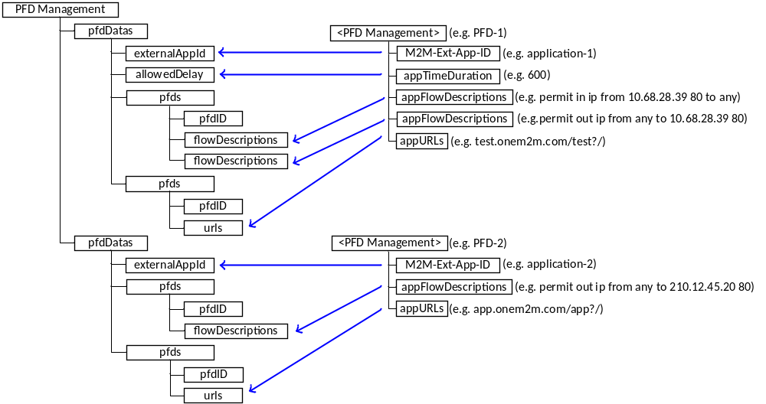
Figure 8.x.4.1.2.1-2: Example of PFD Management Configuration creation request mapped from <PFDManagement> resource.
Step 1b: Once a PFD Management Configuration has been created, the IN-CSE will keep it updated in order to update the full set of PFDs of an existing resource or partially update PFDs (i.e. add/update/remove PFDs). To perform the update, the IN-CSE will generate a PFD Management Configuration update request that contains the following information as specified in 3GPP TS 29.122 [i.Error: Reference source not found].
- An HTTP PUT method will be used.
- URI will be set to {apiRoot}/3gpp-pfd-management/v1/{scsAsId}/transactions/{transactionId}/applications/{appId}. The {apiRoot} and {scsAsId} segments are configured based on Service Provider and MNO policies. The {transactionId} and {appId} segment are configured by the SCEF and returned to the IN-CSE in the PFD Management Configuration creation response.
- The request payload will include an updated PfdManagement data structure as specified in 3GPP TS 29.122 [i.18]. The configuration of the individual PfdManagement attributes will follow the same rules as specified in the PFD Management Configuration create request above.
Step 1c: If the IN-CSE may generate a PFD Management Configuration delete request that contains the following information as specified in 3GPP TS 29.122 [4].
- An HTTP DELETE method will be used.
- URI will be set to {apiRoot}/3gpp-pfd-management/v1/{scsAsId}/transactions/{transactionId}. The {apiRoot} and {scsAsId} segments are configured based on Service Provider and MNO policies. The {transactionId} segment is configured by the SCEF and returned to the IN-CSE in the PFD Management Configuration creation response.
Once a PFD Management Configuration has been deleted, the IN-CSE can create a new PFD Management Configuration, using the same procedure described above.
Step 2: SCEF processes the PFD Management Configuration Request
The SCEF processes the PFD Management Configuration Request together with the 3GPP network entities as described in 3GPP TS 29.122 [i.Error: Reference source not found].
Step 3: SCEF sends a PFD Management Configuration Response for create/update/delete
The SCEF authorizes the request and responds to acknowledge it accepted and processed the request.
Step 3a: A response to a PFD Management Configuration create request includes the following information:
- If all application(s) are provisioned successfully, the response payload will include a PfdManagement data structure as specified in 3GPP TS 29.122 [i.Error: Reference source not found] that includes the attributes present in the request along with the following additional attributes:
  - A response code of 201 CREATED
  - The URI of the PFD Management resource created by the SCEF. The URI is returned in the HTTP Location header with a format of {apiRoot}/3gpp-pfd-management/v1/{scsAsId}/transactions/{transactionId}. The {apiRoot} and {scsAsId} segments are configured based on Service Provider and MNO policies. The {transactionId} segment is configured by the SCEF.
  - self is configured with a URI to link to the resource "Individual PFD Management Transaction" created by the SCEF for the request.
  - pfdDatas includes the attributes present in the request along with the following additional attributes:
    - self is configured with a URI to link to the resource "Individual Application PFD Management" created by the SCEF for the request.

- If some PFD(s) are not provisioned successfully (i.e. the PFDF returns failure and/or the SCEF does not accept the PFD provisioning (e.g. one or more external Application Identifiers in the request are already present in existing transactions)), the response payload will include a response code of 201 CREATED, the PFD Management Configuration create response above and the following additional attributes as specified in 3GPP TS29.122 [i.Error: Reference source not found]. In this case, the IN-CSE may identify it as a successful response and continue the procedure for the PFD(s) which have been provisioned successfully.
  - pfdReport includes the attribute with a list of failed external Application Identifier(s) and the corresponding failure code (e.g. MALFUNCTION, RESOURCE_LIMITATION SHORT_DELAY, APP_ID_DUPLICATED).
  - When the allowed delayed cannot be satisfied, i.e. it is smaller than the caching time configured in fetching PFD, cachingTime attribute will be included in the pfdReport attribute and the pfdDatas attribute. In this case, the IN-CSE will update the appTimeDuration attribute of <PFDManagement> resource.
- If the provisioning of all PFD(s) fails (i.e. the PFDF returns failure and/or the SCEF does not accept the PFD provisioning), the SCEF will return a respond code of 500 Internal Server Error. The response payload will also include the PFD Management Configuration create response above and the following additional attributes as specified in 3GPP TS29.122 [i.Error: Reference source not found]. In this case, the IN-CSE may attempt to retry PFD Management Configuration requests but these details are out of scope of the present document.
  - pfdReport includes the attribute with a list of failed external Application Identifier(s) and the corresponding failure code (e.g. MALFUNCTION, RESOURCE_LIMITATION SHORT_DELAY, APP_ID_DUPLICATED).
  - When the allowed delayed cannot be satisfied, i.e. it is smaller than the caching time configured in fetching PFD, cachingTime attribute will be included in the pfdReport attribute and the pfdDatas attribute.
- Figure 8.x.4.1.2.1-3 is an example of the PFD Management creation response mapped to <PFDManagement> resource (some application(s) are not provisioned successfully).
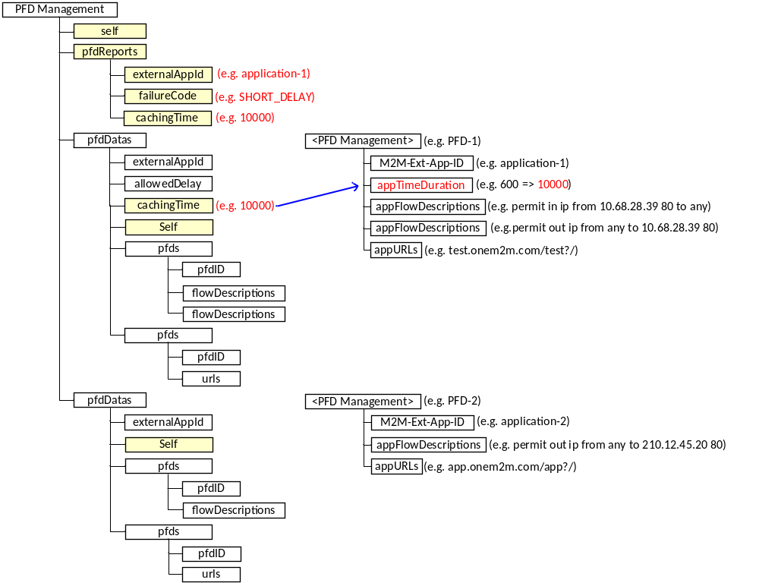
Figure 8.x.4.1.2.1-3: Example of PFD Management creation response mapped to <PFDManagement> resource (some application(s) are not provisioned successfully)
Step 3b: A response to a PFD Management update request includes the following information:
- If all application(s) are provisioned successfully, the response payload will include a response code of 200 OK and follow the same rules as specified in the PFD Management Configuration create response above.
- If some PFD(s) are not provisioned successfully, the SCEF will include a response code of 200 OK and follow the same rules as specified in the PFD Management Configuration create response above. In this case, the IN-CSE may identify it as a successful response and continue the procedure for the PFD(s) which have been provisioned successfully.
- If the provisioning of all PFD(s) fails, the SCEF will reject the request with a corresponding status code and follow the same rules as specified in the PFD Management Configuration create response above. In this case, the IN-CSE may attempt to retry PFD Management Configuration requests but these details are out of scope of the present document.
Step 3c: A response to a PFD Management delete request includes the following information:
- A response code of 204 NO CONTENT
- The response will not contain a payload
See clause 8.3 of TS-0026 [i.20] for a list of possible error scenarios and error handling options for the IN-CSE.
Step-4 (Optional): Procedures for Network Status Reports and/or Monitoring Event (Number of UEs in an area)
If the monitorEnable of <PFDManagement> resource is set, the IN-CSE maps the attributes to following 3GPP SCEF APIs:
- If the monitorEnable attribute is set to “enable congestion status in an area”, the IN-CSE identifies the parameter for Network Status Report API and communicates with SCEF by using the procedures for the Network Status Reports API described clause 7.8 of TS-0026 [i.20].
- If the monitorEnable attribute is set to “enable number of devices in an area”, the IN-CSE identifies the parameter for Monitoring Event API (Number of UEs in an area) and communicates with SCEF by using the Monitoring Event (Number of UEs in an area) as described in clause 8.13.
- The IN-CSE may identify a geographic area for those APIs based on the location of ADN-AE(s) or ASN/MN-CSE by using the location technology (e.g. Cell-ID, assisted-GPS, and fingerprint) of 3GPP Underlying Network. But these details are out of scope of the present document.
Step-5: PFD changes for the ADN-AE(s) or ASN/MN-CSE are applied
After the response in step 3, the ADN-AE(s) or ASN/MN-CSE hosted on the UE will utilize the latest values provided by the <PFDManagement> resource.
The IN-CSE may update the appTimeDuration attribute of the <PFDManagement> resource depending on congestion levels in Step 4. The policy is based on SLA between ASP and MNO, and is outside the scope of the present document.

-----------------------End of change 1---------------------------------------------

CHECK LIST
- Does this Change Request include an informative introduction containing the problem(s) being solved, and a summary list of proposals.?
- Does this CR contain changes related to only one particular issue/problem?
- Have any mirror CRs been posted?
- Does this Change Request make all the changes necessary to address the issue or problem? E.g. A change impacting 5 tables should not include a proposal to change only 3 tables?Does this Change Request follow the drafting rules?
- Are all pictures editable?
- Have you checked the spelling and grammar?
- Have you used change bars for all modifications?
- Does the change include the current and surrounding clauses to clearly show where a change is located and to provide technical context of the proposed change? (Additions of complete clauses need not show surrounding clauses as long as the proposed clause number clearly shows where the new clause is proposed to be located.)
- Are multiple changes in this CR clearly separated by horizontal lines with embedded text such as, start of change 1, end of change 1, start of new clause, end of new clause.?

