CHANGE REQUEST
Meeting ID:* | TP40
Source:* | Zhen Liao, CAICT, liaozhen@caict.ac.cn
Date:* | 2019-05-12
Reason for Change/s:* | Edit text of TR-0055 V0.2.0
CR against: Release* | Release 4
CR against: WI* | Active <Work Item number>  MNT maintenance / < WI-0082-3GPP V2X Interworking>  Is this a mirror CR? Yes No  mirror CR number: (Note to Rapporteur - use latest agreed revision)  STE Small Technical Enhancements / < Work Item number (optional)>  Only ONE of the above shall be ticked
CR against: TS/TR* | TR-0055 V0.2.0
Clauses * | 5.1
Type of change: * | Editorial change  Bug Fix or Correction  Change to existing feature or functionality  New feature or functionality  Only ONE of the above shall be ticked
Post Freeze checking:* | This CR contains only essential changes and corrections? YES NO  This CR may break backwards compatibility with the last approved version of the TS? YES NO
Template Version: January 2019 (do not modify)

oneM2M Notice
The document to which this cover statement is attached is submitted to oneM2M. Participation in, or attendance at, any activity of oneM2M, constitutes acceptance of and agreement to be bound by terms of the Working Procedures and the Partnership Agreement, including the Intellectual Property Rights (IPR) Principles Governing oneM2M Work found in Annex 1 of the Partnership Agreement.
GUIDELINES for Change Requests:
Provide an informative introduction containing the problem(s) being solved, and a summary list of proposals.
Each CR should contain changes related to only one particular issue/problem.
If this is a correction, and the change applies to previous releases, a separate “mirror CR” should be posted at the same time as this CR
Mirror CR: applies only when the text, including clause numbering are exactly the same.
Companion CR: applies when the change means the same but the baselines differ in some way (e.g. clause number).
Follow the principle of completeness, where all changes related to the issue or problem within a deliverable are simultaneously proposed to be made e.g. a change impacting 5 tables should not only include a proposal to change only 3 tables. Include any changes to references, definitions, and abbreviations in the same deliverable.
Follow the drafting rules.
All pictures must be editable.
Check spelling and grammar.
Use change bars for modifications.
The change should include the current and surrounding clauses to clearly show where a change is located and to provide technical context of the proposed change. Additions of complete clauses need not show surrounding clauses as long as the proposed clause number clearly shows where the proposed new clause is located.
Multiple changes in a single CR shall be clearly separated by horizontal lines with embedded text such as, start of change 1, end of change 1, start of new clause, end of new clause.
When subsequent changes are made to the content of a CR, then the accepted version should not show changes over changes. The accepted version of the CR should only show changes relative to the baseline approved text.

Introduction
This CR is edit text for TR-0055 V0.2.0 in chapter 5.1 to keep consistency.

-----------------------Start of change 1-------------------------------------------

This document introduces a baseline architecture for supporting 3GPP V2X service interworking. It describes how the oneM2M system can leverage the 3GPP V2X related features and services that 3GPP added in releases 15.
Figure 5.1-1 shows, at a high level, how 3GPP interfaces with external entities. A more detailed picture can be found in 3GPP TS 23.285 [3]. There are two modes of operation for V2X communication, namely over the PC5 and over LTE-Uu. LTE-Uu can be unicast and/or MBMS. These two operation modes can be used by a UE independently for transmission and reception, e.g. a UE can use MBMS for reception without using LTE-Uu for transmission. A UE can also receive V2X messages via LTE-Uu unicast downlink.

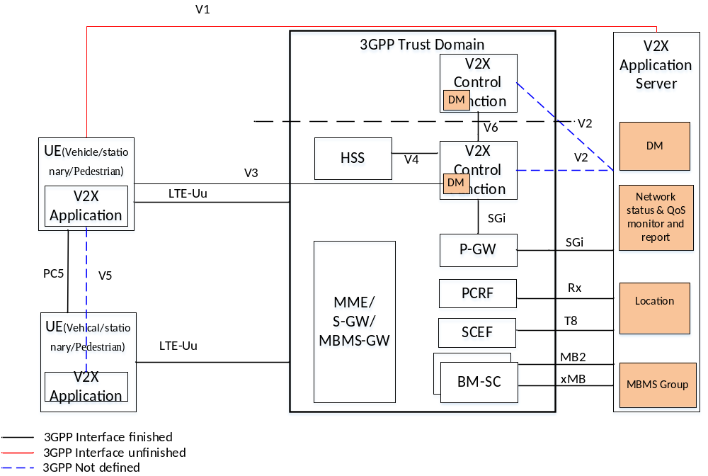

Figure 5.1-1: 3GPP V2X Related Interfaces
V2X Control Funtion is used to provision the UE with necessary parameters in order to use V2X communication over V3 reference point by OMA-DM protocol.
The V2X Application Server supports the V2X service parameter provision, location reporting, MBMS group and network status & QoS monitoring and report functions according to 3GPP TS 23.285[2] and 3GPP TR23.795[3].
The UE is used to communicate with V2X Control Function via V3 referenct point to exchange the V2X control information, communicate with V2X Application Server via V1 reference point by MBMS or Unicast, and communicate with other UEs over the PC5 or LTE-Uu interface. The UE type can be vehicle, stationary or pedestrian.
Notes：
- 1 In 3GPP R15 it is assumed that there is only one logical V2X Control Function in each PLMN that supports V2X Services.
- 2 There are multiple BM-SCs in a given PLMN.

-----------------------End of change 1---------------------------------------------

CHECK LIST
- Does this Change Request include an informative introduction containing the problem(s) being solved, and a summary list of proposals.?
- Does this CR contain changes related to only one particular issue/problem?
- Have any mirror CRs been posted?
- Does this Change Request make all the changes necessary to address the issue or problem? E.g. A change impacting 5 tables should not include a proposal to change only 3 tables?Does this Change Request follow the drafting rules?
- Are all pictures editable?
- Have you checked the spelling and grammar?
- Have you used change bars for all modifications?
- Does the change include the current and surrounding clauses to clearly show where a change is located and to provide technical context of the proposed change? (Additions of complete clauses need not show surrounding clauses as long as the proposed clause number clearly shows where the new clause is proposed to be located.)
- Are multiple changes in this CR clearly separated by horizontal lines with embedded text such as, start of change 1, end of change 1, start of new clause, end of new clause.?

