Input Contribution
Meeting ID* | SDS#41
Title:* | TR-0036 Seongnam Commuter Parking Service
Source:* | InSong Lee, KETI, insong@keti.re.kr  SeungMyeong Jeong, KETI, sm.jeong@keti.re.kr
Date:* | 2019-07-10
Input related to* | TR-0036
Intended purpose of  document:* | Decision  Discussion  Information  Other <specify>
Impacted other TS/TR(s) | <TS/TR number>, <Version Number>, and <Description on which aspect should be reflected in this TS/TR>
Decision requested or recommendation:* | <A concise statement of the decision required or the recommended action to be taken>
Template Version: November 2018 (do not modify)

oneM2M Notice
The document to which this cover statement is attached is submitted to oneM2M. Participation in, or attendance at, any activity of oneM2M, constitutes acceptance of and agreement to be bound by terms of the Working Procedures and the Partnership Agreement, including the Intellectual Property Rights (IPR) Principles Governing oneM2M Work found in Annex 1 of the Partnership Agreement.

Introduction
To provide more case study in TR-0036, the Seongnam Commuter Parking Service has been described.
Details are in the below contents.

-----------------------Start of new text 1-------------------------------------------

2.2 Informative references
Clause 2.2 shall only contain informative references which are cited in the document itself.
The following referenced documents are not necessary for the application of the present document but they assist the user with regard to a particular subject area.
[i.x1] European Commision: SynchroniCity (https://cordis.europa.eu/project/rcn/206511/factsheet/en)
[i.x2] OCEAN Developers: Mobius (http://developers.iotocean.org/archives/module/mobius)
[i.x3] The GeoJSON Specification (RFC 7946) (https://tools.ietf.org/html/rfc7946)
-----------------------End of new text 1-------------------------------------------

-----------------------Start of new text 2-------------------------------------------

6.6 Seongnam Commuter Parking Service
The Seongnam is one of the pilot cities in EU Horizon 2020 SynchroniCity project [i.x1] and deployed commuter parking service. SynchroniCity is the large scale pilot project for smart cities that develops data driven solution based on the technical approachs, common APIs and data models, from the Open & Ageile Smart Cities network (OASC). Korean consortium contributes to have oneM2M based SynchroniCity framework and a pilot service.
The Seongnam is located from southeast Seoul. The Yatap region in Seongnam has been chosen as the testbed for commuter parking service because it has big public transportation infrastructure. Under the ground, the Yatap subway station of Bundang line which bounds for Seoul is located. Near the Yatap station, there are several bus stops for more than 160 intercity and intracity bus lines. There is also the express bus terminal that connects to most of the cities in Korea. More importantly, there are three public parking lots near the station and such a good infrastructure people park their cars and transfer to the public transportation.
The commuter parking service works on Mobius and SynchroniCity platform. The Mobius[i.x2] from OCEAN[i.x2] is open source implementation for oneM2M IN-CSE. Mainly, oneM2M application has been provided which interworks with Mobius directly. To have SynchroniCity framework, Mca-NGSI adaptor was also offered and the test application has also been demonstrated that calls NGSI APIs on Orion Context Broker. The service provides the following information: real-time parking availability on parking lots near Yatap station, commute routes such as minimizing transfer time and transportation information, such as estimated arrival time of a subway, the operation schedule of buses.
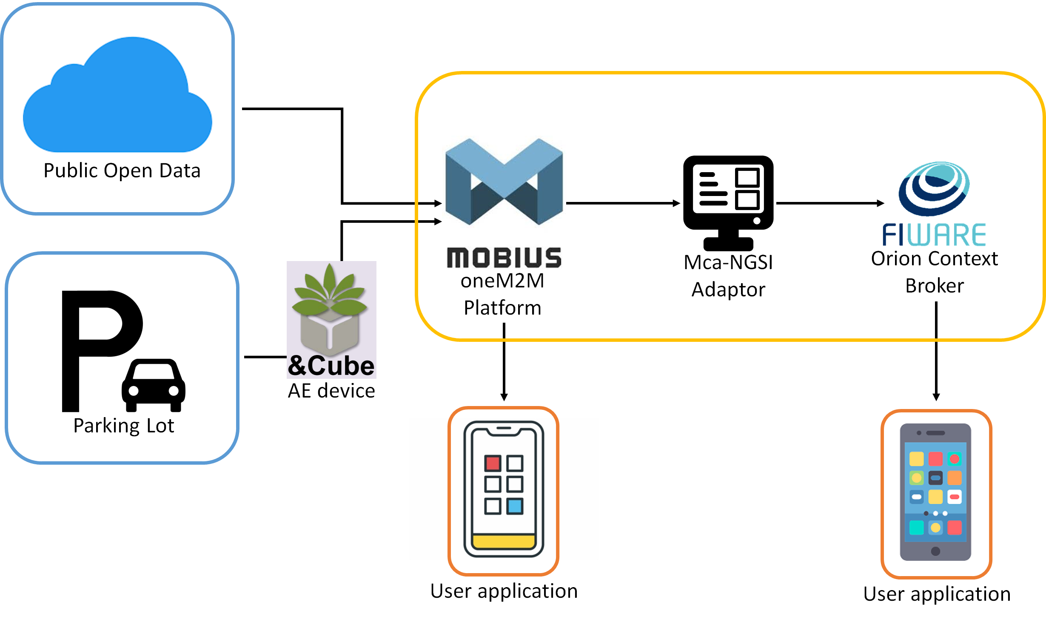
Figure 6.6-1 Commuter Parking Service Architecture
Figure 6.6-1 shows the architecture of the commuter parking service. The Mobius supports flexContainer resources to store application data such as parking status, parking fee, contact point, time schedule of buses in custom attributes. Before mapping into flexContainer specialization types, data models were defined for parking lot, parking spot, subway station, intercity bus itenary, intracity bus itenary and bus stop.
To offer the same data to two different applications, the Mca-NGSI Adaptor has been developed as an interworking proxy between Mobius and Orion Broker. The proxy implements the subscription and notification feature. Whenever the data is created or updated on the Mobius, the proxy gets data from a notification and send the data over NGSI interface to save data as NGSI Entity instance on the Orion Broker.
Basic parking application features are supported e.g. showing parking lot availability, routing. Also a user can configure transfer information so the application shows next transit time while parking. When there’s not enough time and few free parking spots, the user should choose the further parking lot not to miss a long-range bus in every two hours.
The parking application shows a map and supports location-based service by using the geo-query on the Mobius. oneM2M Rel-3 still does not support geolocation specific features except the locationPolicy resource type and this resource type only offers acquiring location data. Therefore missing geo-query feature with location format as GeoJSON[i.x3] has been implemented as Mobius extension.
In the application, to get a list of parking lots in a rectangle area, the application sends a geo-query with “contains” function [ref] with polygon geometry data (e.g. GPS coordinates). Geo-query is added in the existing Filter Criteria parameter. When the Mobius gets that geo-query, it searches parking lot <flexContainer> resources that have location attribute having longitude and latitude within the polygon given in the request using “ST_Contains” geospatial function in the database query.
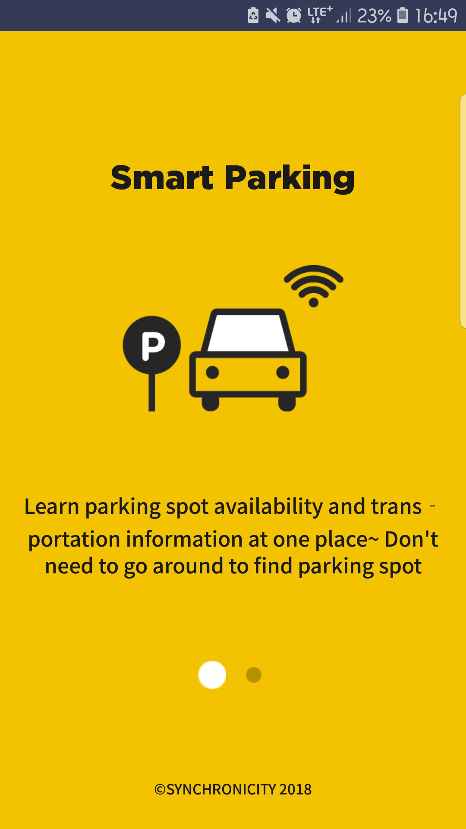 | 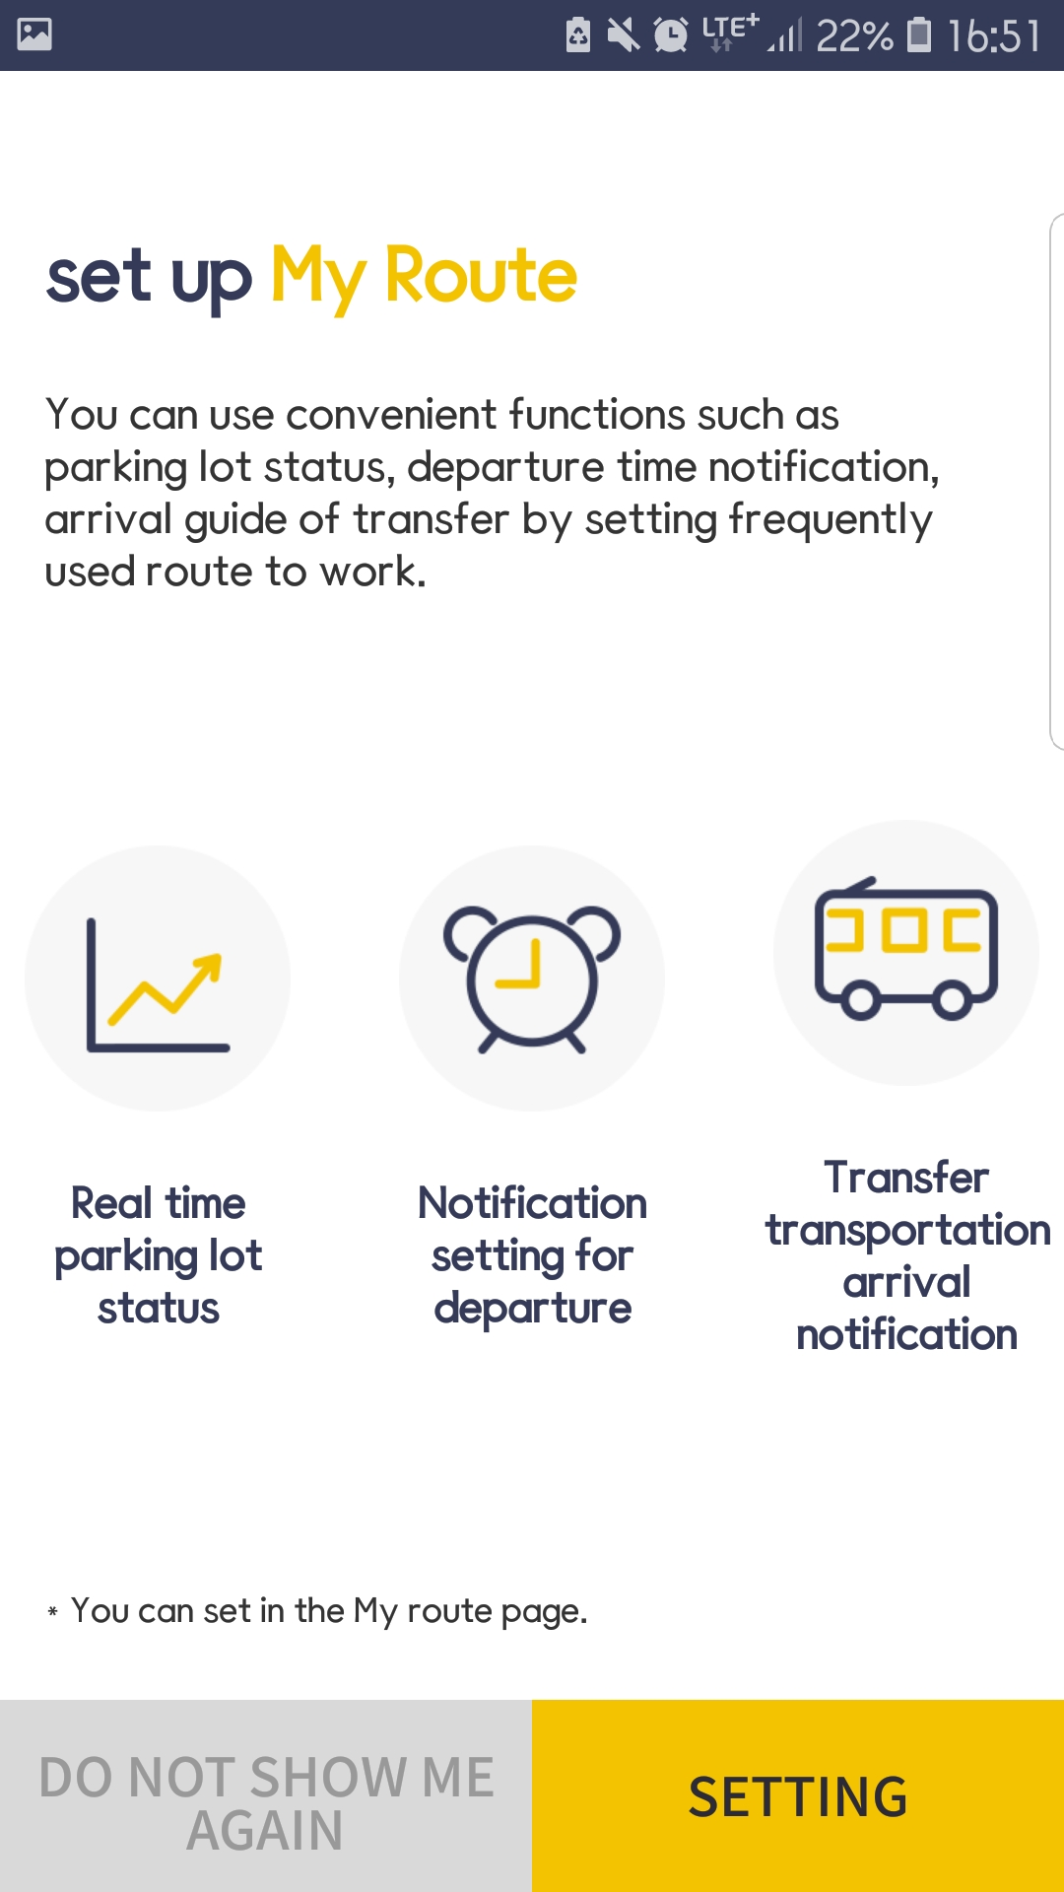 | 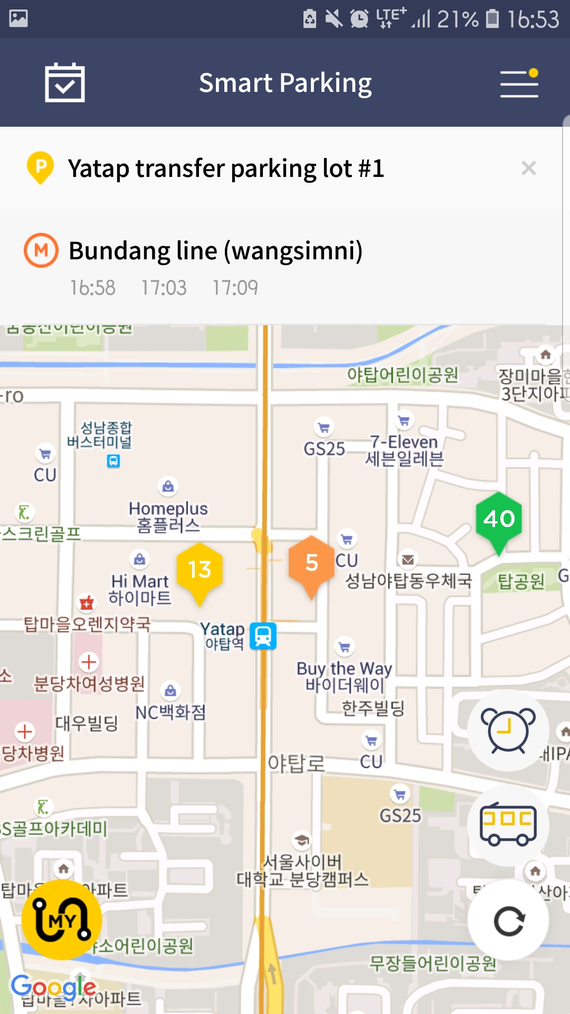 | 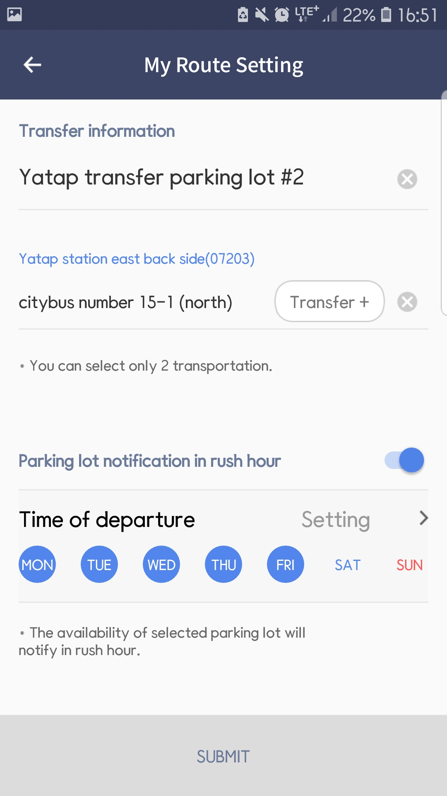
Figure 6.6-2 Commuter Parking Application
Figure 6.6-2 shows screen captures from user application that directly working with the Mobius with oneM2M APIs. Except the geo-location specific feature, this application uses exising oneM2M APIs like subscription/notification, container/contentInstance and flexContainer.
-----------------------End of new text 2-------------------------------------------

